Zara Khan
2404947
Matthew Archer

Question 4: ‘The Future is Ours’
What does the phase ‘Design for Planet’ mean to you? Outline your discussion with reference to current environmental, political, or social design issues that urgently require addressing, and discuss the tools and approaches you might use to consider these issues over the duration of your future design/make career.

Contemporary product and furniture design is dominated by mass production, trends and modernisation causing common aesthetics and forms. Minimalism, neutral colour palettes and anonymous forms are the features of this commercial design culture resulting in products that feel a lack of identity, cultural relevance and emotional connection. Reintroducing personality and cultural richness into pieces, whilst also working alongside technological and societal advancements, will revive the needed human connection with design. This essay discovers the ways in which identity driven design may shape a more expressive future by looking at the works of designers Gio Ponti, Nipa Doshi & Jonathan Levien and Ini Archibong who all believe in identity coinciding with innovation. The selected case studies demonstrate how culture based design can extend beyond surface decoration into the conception of meaningful and forward thinking products rich in symbolism, history and lived experience.
Culture is not just a stylistic application to a product, rather it is a meaning that encompasses society, tradition, language and history. John Heskett says, “Design is one of the basic characteristics of what it is to be human, and an essential determinant of the quality of human life.” (Heskett, 2005, 2) if design is the humanisation of the world around us, then cultural identity is inseparable from its purpose. Cultural identity isn’t just about aesthetics of an object, but how it is understood, used and valued within a community. Furthermore, objects carry memory and social meaning capable of evoking emotion and belonging, creating culturally embedded experiences.
Yet throughout the twentieth century, industrial design strived for universality. Business developed items that could be marketed globally, looking to move past specificity of design through neutral aesthetics, shapes and minimum cultural reference. Post 1945 saw a surge in willingness to integrate contemporary design into homes, seeing it as a relief pushing past the comfort of suburban homes. However, this new arrival of modernity didn’t have intentions of providing personal design, “It was clear that consumption, rather than production, was seen as a key to Britains future and that it needed to operate within a context of educated taste, or ‘good design’ which, at that time, meant a preference for the modern style.” (Dobinson, 2022, 166) With the development of modernity came the loss of identity. The Bauhaus movement had a profound impact on modernity by promoting a new approach to design that emphasised functionality and simplicity. Understandably, mass production of products and furniture allowed for costs to reduce and be accessible for all. The introduction of machinery revolutionised design, with Van De Velde being enamoured by it and recognising its potential whilst also stating, “By rejecting machine techniques the English arts and crafts designers had produced work that only a rich and cultured elite could afford”. (Gillian, 1968, 38) Finding the harmony of culturally rich design that can be manufactured at an affordable level is the approaching challenge.
In response, there has been an increased interest in design rooted in narrative, locality and cultural hybridity through recent decades. Early postmodern groups, most famously Memphis, aimed to challenge the constraints of modernist neutrality by championing colour, decoration and expressive irreverence. Contemporary designers have extended this through cross-cultural storytelling and material innovation. This change is best examined by the artists featured in this essay. By blending cultural identification with contemporary manufacturing processes, they illustrate that personality and character do not need a rejection of modernity. Instead, they reveal a more complex possibility: that forward thinking design may maintain its technological advancement while being profoundly human, emotionally rich and culturally grounded.

Gio Ponti
Gio Ponti is recognised as one of the most influential figures in Italian Design based on his uniting of Italian cultural expression with industrial modernism. His vision centred elegance and craftsmanship. “The architect must despise what is “passing” (stylistic and formal aesthetics) and must look for what “remains” in life. Then he will find form (which will be what remains as life passes; a lovely contradiction).” (Ponti, 1960, 99) Ponti rejected conformity, emphasising the need to appreciate craftsmanship that came before “The architect of today, the college architect, must learn from all the artisans”, “He must learn things made by hand. Nothing, if not first in our hands.” (Ponti, 1960, 96) And this can be applied to all design, without learning from tradition, design would be left baseless.
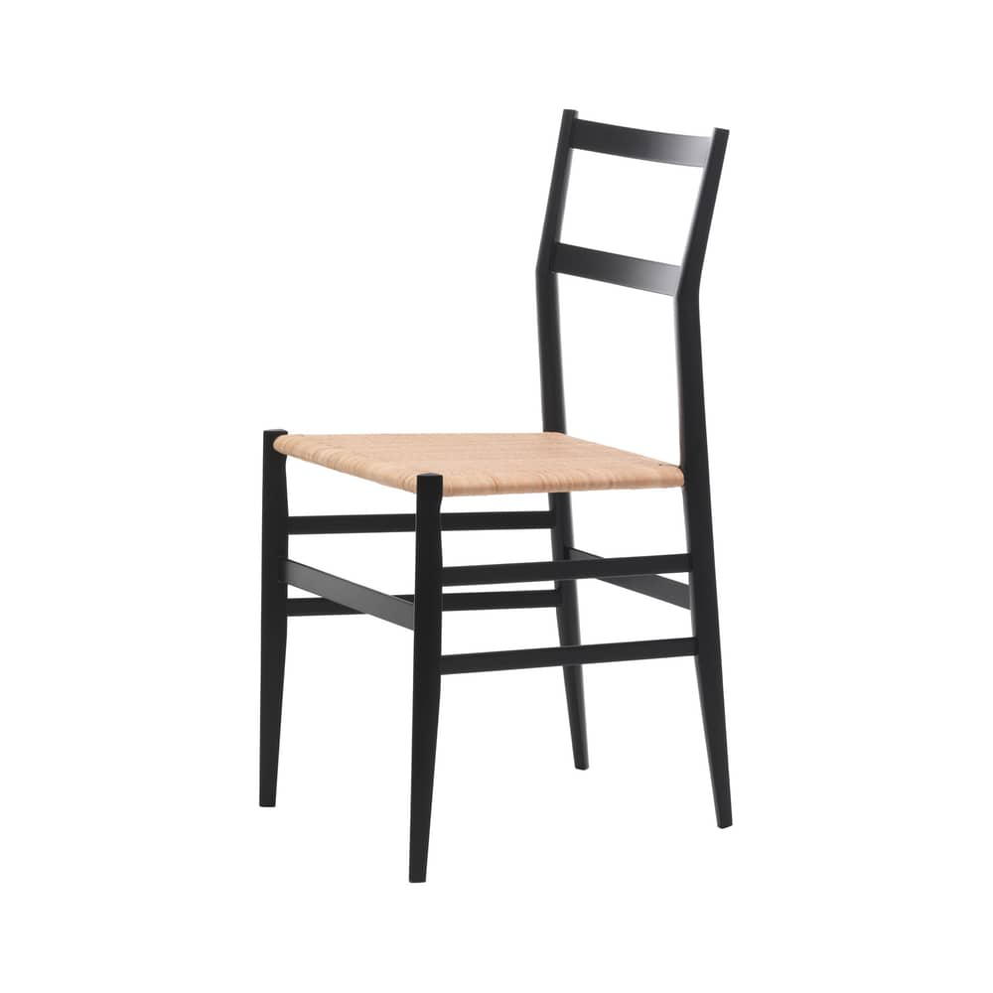 Superleggera Chair

The Superleggera chair exemplifies Ponti’s philosophy of reducing form while retaining expressive personality. Inspired by the traditional Chiavari chair, Ponti translated a local craft into an industrial object. The lightweight frame symbolised Italian ingenuity and technical mastery which was needed due to the smaller constructed apartments and post war baby boom and has continued to sell for its lightweight and affordability. Ponti argued that ‘lightness’ is a virtue, connecting the objects physical qualities with broader cultural ideals. Despite its simplicity, the triangular legs, bold geometry and refined joints imbed distinct cultural identity.

Diamond Table
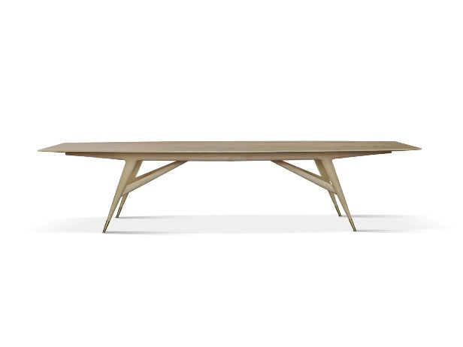

The diamond table is a piece that illustrates Ponti’s fascination of faceted geometries and lightness. This piece is evidence of how geometric expression can integrate with Italian workmanship. The diamond form tapered legs and faceted surfaces are reminiscent of Italian architectural geometry found in modernist buildings, also during a time that sought to reclaim national identity following the war. Ponti follows this notion by contributing a shape that feels both traditional and futuristic. The mix of wood craftsmanship and modern construction convey personality and demonstrates how cultural identity can be embodied in simple forms. “personality then lies not in the character of each detail but in the simple fact that he authored the work.”

Ponti Cabinets for Fornasetti (1950s)
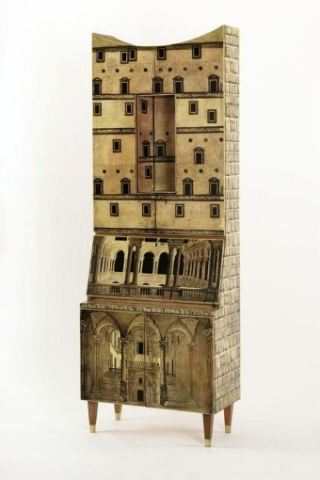
Made during the 1950s, Ponti’s cabinets show an intricate partnership between archtectual structure and graphic artistry. Piero Fornasetti used his characteristic décor, while ponti provided the peoportioned and simple shapes, turning practical into expressive, culturally rich pieces. Ponti’s dedication to lightness is reflected in the cabinets rectangular body, tapering legs and slim frame. Fornasetti’s vision of classical ruins or trompe-l’oeil architectural facades was made possible in this structural restriction. Fornasetti’s themes and Ponti’s geometry work together to make extravagant, yet contemporary, pieces.
For Ponti, these cabinets were more than just decorative furniture, they expressed a concept that everyday objects can improve household life with humour, story and cultural memory. With this being a key aspect of Italian design, “The essence of Italian design has been an ability to blend humor and excitement with a thorough but unstuffy respect for tradition.” (Weaving, 2002, 31) Ponti and Fornasetti promoted emotional involvement balanced with practicality. The partnership challenged the modernist assumption that decoration is superficial. Rather than clashing with structure, decoration turns into a kind of narrative that enhances it.

Nipa Doshi and Jonathan Levien
Nipa Doshi and Jonathan Levien, who collaborate as Doshi Levien, offer a very relevant viewpoint on modern cultural identity in furniture and product design. Their studio represents what Bhabha (1994) calls the “third space”. This is an interconnected cultural zone where new identities are formed “conceptualising an international culture, based not on the exoticism of multi-culturalism or the diversity of cultures, but on the inscription and articulation of cultures hybridity.” (Bhabha, 1994, 38) Their work combines European industrial craft, global material technology and Indian visual culture rather than a single cultural lineage. This combination serves as an effective framework for culturally layered design and mirrors contemporary lived experiences.

Charpoy Collection for Moroso
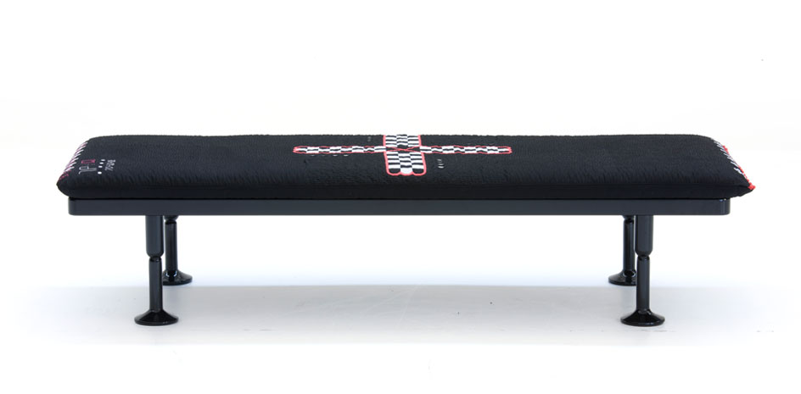
The Charpoy Collection reinterprets the traditional Indian Charpoy bed by using contemporary upholstery, digitally printed materials and a modern structure. Rather than giving a nostalgic connection, Doshi & Levien utilise current materials to emphasise the charpoy’s visual language. Within this thoughtful design are features that originate from different cultural practices as part of India and Italy. This reinterpretation makes an ordinary product with cultural roots into a design to be received globally. The designers integrate embroidery inspired by the Gujarati textiles which emphasises the emotional depth and narrative of hand crafting traditions. Merging history with contemporary design, the Charpoy becomes more than just a reimagined piece. It works as a statement about how culture and design as a hybrid can be acknowledged and advanced through thoughtful reinterpretation rather than imitation. This is an important development in design, “the picture of design and designers is constantly being repainted” (9, 9) and encouraging the hybrid development will allow for a different view of design.

Capo Chair for Cappellini
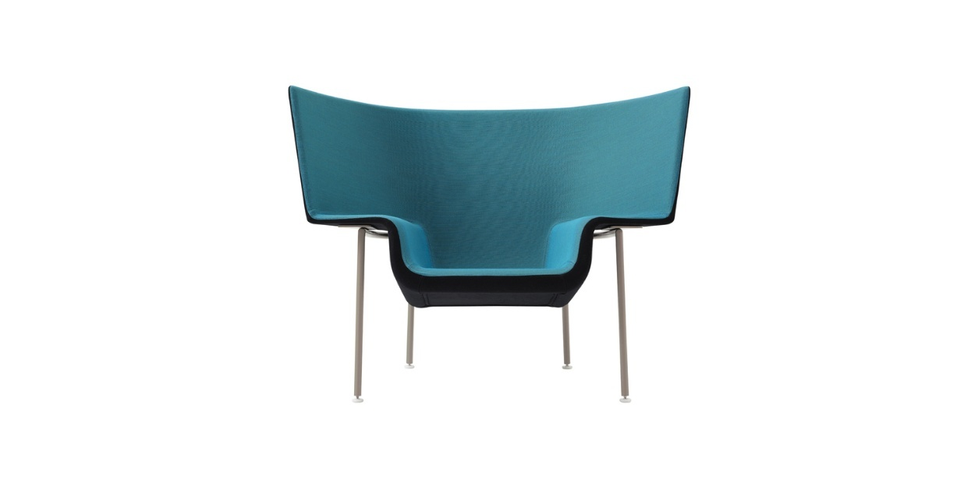

The capo chair is another refined exploration of cultural hybridity. This design takes inspiration from a cape or protective garment, providing the shape of a gently curved shell that wraps subtly around the user. This form is made with a throne-like appeal, evoking a sense of security and authority, referencing the designers interests in symbolic language of objects and personal space. Doshis Indian heritage and Leviens craft of Italian woodworking traditions inform the piece’s balance between structure and softness. Whilst the form suggest the elegant garments found in Indian royalty, the craftsmanship is strong and representative of contemporary European manufacture.
The chairs moulded shell shows sophisticated industrial processes whilst the base echoes Leviens craft knowledge. There are available upholstery variations that allow for either maximalist or minimalist, communicating the Doshi & Levien’s belief of furniture expressing personality through surface and texture. The Capo chair occupies a thoughtful space between cultural reference and modern typology neither imitating tradition or abandoning it. Instead, it transforms the conception of status into a functional object that is for both domestic and commercial interiors.
Shanty Cabinet for BD Barcelona
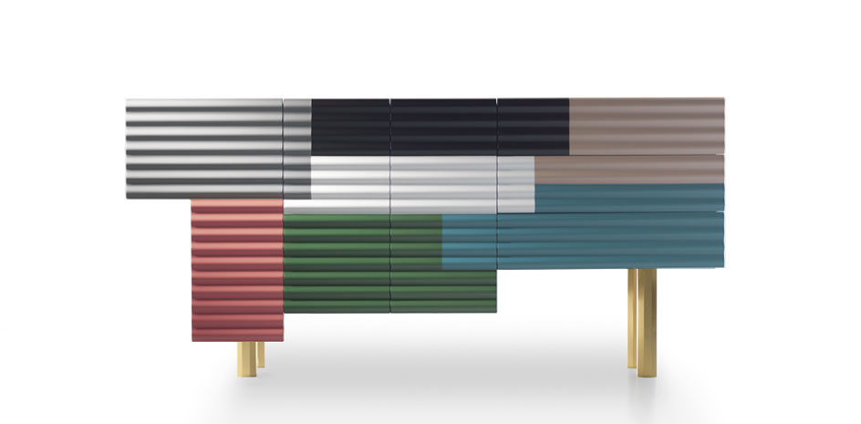

The shanty chair is a clever interpretation of the cultural significance of impromptu building and the beauty of flaws. The collection draws inspiration from the buildings that may be seen in informal communities. These structures are usually constructed from corrugated metal sheets, layered materials and salvaged wood. Rather than glorifying poverty, Doshi and Levien recast these textures and asymmetries into a playful, modern design language. This piece transforms the patchwork character of shanty buildings into and expressive piece by evoking visual energy through the use of panels overlapping irregularly overlapping each other.
Made with quality materials and joinery, the chair transform what is commonly seen as “rough” or “temporary” into a long-lasting, stylistic piece of furniture. With the duos continuous interest in cultural references and sophisticated manufacturing, they have shown the conflictions between the strength of precision-made furniture and unstructured building. The shanty chair challenges the conventional ideals of luxury and perfection by demonstrating that cultural individuality, irregularity and resourcefulness can become important design advantages within contemporary product design.

Ini Archibong
Ini Archibong addresses design through the lens of narrative and spirituality. His work typically evokes the traditions and mythology of African diaspora, integrating them with craftsmanship and contemporary manufacturing. Archibong aims to restore harmony between people and the world around them by positioning products as holders of meaning. His approach represents a lyrical but technologically fluent approach to connecting product design with cultural feeling.
The Orion Table for Classicon
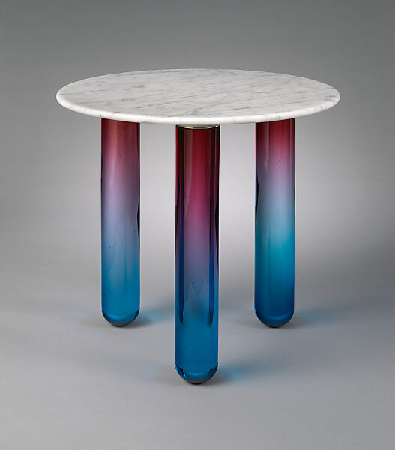
A notable illustration of how Ini Archibong incorporates Mythology, spiritual symbolism and cultural memory into modern furniture is the Orion Table from the Sé collection. This table is inspires by celestial bodies, specifically the Orion constellation, which reflects Archibong’s interest in West African storytelling. This is an item that is produced through the contrast of weight, translucency, solidity and brightness.
Archibong refers to design as “modern mysticism” and the Orion Table’s appearance supports this idea. It refers to African craft forms without copying them. Instead, proportion and symbolism are used to convey cultural identity. The product is a work that combines contemporary workmanship with renowned imagination

Vernus Lighting Collection for Sé
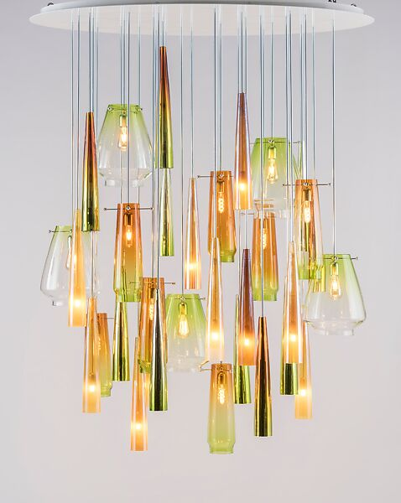
Ini Archibongs Venus Collection delves further into mythology, sensuality and expressiveness. The collection draws inspiration from the goddess Venus, emphasising luminosity, curvature and flowing forms evident of Archibong’s skill at fusing material innovation with narrative. Modern fixtures mixed with hand blown glass embraces the combination of production and handmade traditions. Archibong uses abstract forms to express archetypes like beauty, fertility and creation instead of direct references to African patterns. This method allows for identity to flow through the piece rather than just ornamentation and allows us reflection into the culture that we live with, “the most prosaic interaction with material and visual culture is laced with significance.” (Sparke, 2013, 64)

Below the Heavens Collection for Sé
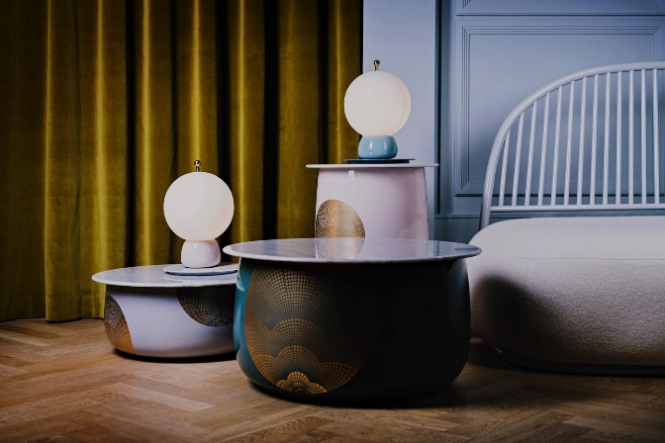

Ini Archibongs 2019 collection, Below the Heavens, carries on his quest for material refinement, spiritual narrative and symbolism. Archibongs investigation of transcendence ,where form becomes a vehicle for cultural and emotional meaning, is the foundation of the collection. Through elongated forms, flowing surfaces and finishes, pieces like the Luna Chair and the Minerva Armchair convey this paradox and create am ambiance that is both earthly and otherworldly.
Archibong achieves a pleasing design through use of materials, thoughtful forms and hand worked features. These futures evoke elevation to furniture design through the expressive power of craft and manufacturing. Rather than directly referencing African motifs, Archibong channel’s identity through form. The result is a collection that challenges the norms of furniture into an object filled with narrative, craftsmanship and material innovation
Throughout the works of Ponti, Doshi & Levian and Archibong there is a shared notion: design can act as vessels of identity, culture, narrative and emotion whilst incorporating modern contemporary factors. Design can be expressive, symbolic and characterful whilst utilising new technologies and manufacturing. With these designers, I recognise a path for my own practice where cultural reference isn’t superficial but embedded into form and techniques. The challenges moving forward allow for a larger development of this idea, current technology will enhance the abilities of integrating identity within with a powerful synergy. Design is able to reclaim its place as a cultural and emotional medium.

Bibliography
Heskett, J. (2005) Design: A very short introduction. Oxford: Oxford University Press.
Aso, T. Rademacher, C. Dobinson, J. (2022) History of Design and Design Law: An International and Interdisciplinary Perspective.
Gillian, N. (1968) The Bauhaus. London, Studio Vista.
Ponti, G. (1960) In Praise of Architecture. New York, F.W. Dodge Corp.
Weaving, A. (2002) Living Modern: bringing modernism home. San Francisco: Chronicle Books
Homi K. BhaBha. (1994) The Location of Culture. Routledge.
Sparke, P. (2013) An introduction to design and culture : 1900 to the present. Abingdon, Oxon ; New York : Routledge

