Modern Technologies in the Workplace | January 7  2019
This report is going to look at the use and effectiveness of modern technologies in workplaces. It is also going to look at possible disadvantages, ethical issues as well as at data protection regulations. |  | Module N. BMSK4003 Digital Skills and Research Methods by Damian Hay 1713550

Contents
Introduction 2
Modern Technologies 2
Web Based Emails an Overview 2
Advantages of Web Emails 3
Disadvantages of Web based Emails 3
Figure 1 3
Social Networking Tools 4
Advantages of Social Networks 4
Disadvantages 5
Whatsapp An Overview 6
Figure 2 7
Figure 3 8
Advantages 9
Disadvantages 9
Web-Based Emails and whatsapp a Comparison 9
Data Protection Regulation 10
Ethical Issues 10
Recommendations 11
Conclusions 11
Bibliography 12

Introduction
This report is a summary of modern workplaces’ means of communication, such as emails, social media, smart phones and tablets. It is an overview of how web-based applications impact nowadays workplaces. Another aim of this report is to include ethical, security and privacy issues attached to the use of the above mentioned modern technologies.
Last but not least, for the purpose for the purpose of this report a professional on-line presence has been created in order to provide practical examples for this study.
The report will also provide a general comparison between the uses of social networks in particular Whatsapp and Web Based emails in workplaces. To conclude, recommendations will be given.

Modern Technologies

Web Based Emails an Overview
Web based emails, are emails users can access from any device that is connected to the internet.
To be able to use web emails, users need to create an account with a web email provider. Web emails are largely used for both personal and professional needs.
Web emails can be very useful in a workplace. For example, (Chaffey and Amy Laurens., 2003) shows a number of options email can be used to reach external customers. Possibly, the same options could be used within a workplace to reach their employees in the following way:
• Regular Emails to keep employees updated about the workplace, training opportunities and available position within the company.
• E-Mails discussion lists, for example, in relation to employee’s ideas, plans, changes and support for professional improvements.
• E-mails for promotions to engage with a wide range of customers that may be involved with the company such as customers, recruitment agencies, potential new employees and potential new business available for present and future collaborations.

Advantages of Web Emails
- The ability to keep in touch with a large pool of people within the workplace
- Keeping track of important information and emails by creating an archive folder
- Cheap to run

Disadvantages of Web based Emails
- It may not be easy to understand the right frequency email should be sent out at. (Chaffey and Amy Laurens., 2003)
- Emails may be ignored especially when too many are sent out. (Chaffey and Amy Laurens., 2003)
- Emails may not be engaging enough. (Chaffey and Amy Laurens., 2003)
- There may be serious data protection breach of regulations, especially when credit card information are shared via email
Below is a picture of how a web based email can be used for important communication in a workplace. The email is sent from a web based business called “Retro”. It was sent via a mobile.

Figure 1
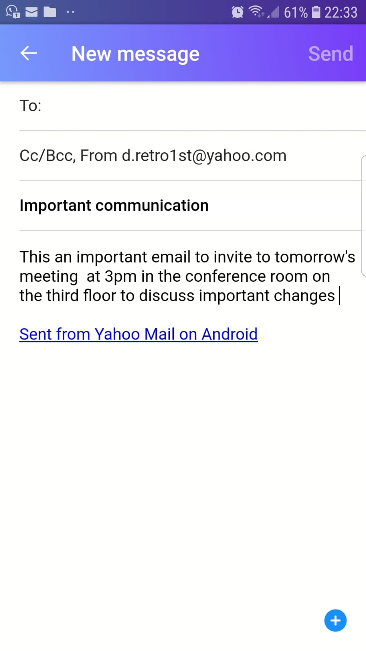

Social Networking Tools
Nowadays, there is a wide range of social networks available for different uses and purposes. There a varied number of social networks such as:
- Twitter
- Whatsapp
- Instagram
- LinkedIn
Social networks are used by virtually by everyone. Many workplaces from profit to nonprofit use social networking as a business tool because of the ability to engage to many people. Moreover, users have become indispensable to business by uploading their feedbacks and ideas onto social networks. (Evans, 2011)
An example described by (Evans, 2011), Starbucks benefited from customers’ feedback by creating an internal social networking tool called “My Starbucks Idea” platform. The platform has been a success since it has opened. It has provided numerous direct ideas and tips on how the business could be improved. To top it all off, a considerable number of those ideas have been implemented by Starbucks. Therefore, Starbucks way of using a social network tool, could highlight how the same platform could be used in workplaces to make improvements based on employees’ feedbacks, idea and tips. In addition, a similar tool could be used to make public announcements within the workplace in regards to birthdays, individual achievements, rewards available training and positions. This may help a workplace to create a culture of togetherness and rewards based of collective and individual efforts and accomplishments. Last but not least, from a workplace viewpoint social network connects employees to the cycle. (Evans, 2011)

Advantages of Social Networks
- It is easy to create content and publish personal and business content
- The possibilities to create connections are boundless
- Open access to information providing workplaces conduct transparency and visibility.
- Ability to improve services, safety and working environment through instants comment and feedbacks such at tweets.
- Fast
- Instant complaints handling, customers and in workplaces employees can be the most valuable source of assistance for both general and specific improvements.

Disadvantages

- Difficult to manage expectations
- Vulnerable to public negative feedbacks
- Data protection
- Unwanted exposure within the workplace especially if it is public outside the workplace itself

Whatsapp An Overview

Whatsapp, it is widely known and used by many people. Whatsapp has a wide range of options. For example, users can create groups’ chats. Group chats can be great for real time communication, conversations, ideas and tips. In addition, you can upload photos, share links. To be able to use Whatapp a user needs a phone that is connected to the internet.
Below an example of how whatsapp can be used to improve and enhance instant communication in the workplace. These two Whatsapp Figures show how two managers can communicate in real time about what is happening in the very moment. Also, it shows how they can use it to report
- Maintenance issues
- How an issues has been located
- How an issues has resolved
- How an issues has logged for record purposes
- Heads-Up
- Meetings
- Communications
- Updating
- Keeping a manger engaged with their employees

The two figures show only one of the many ways whatsapp can be used, which is a workplace internal communication chat group between two members. In this case the manager and owner of the company and one of their employees.

Figure 2

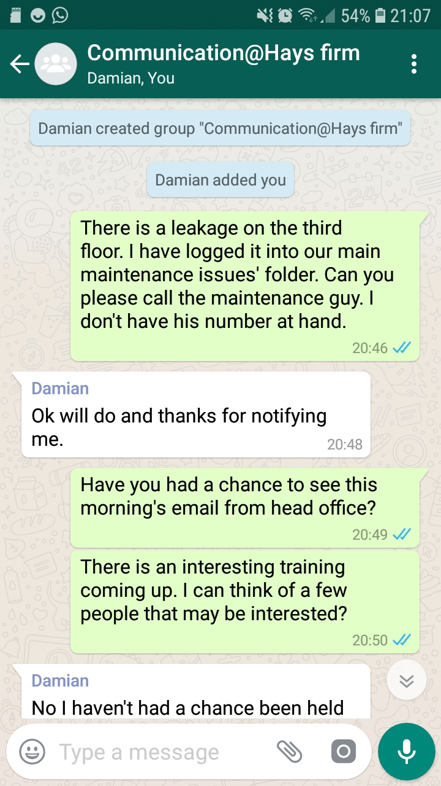
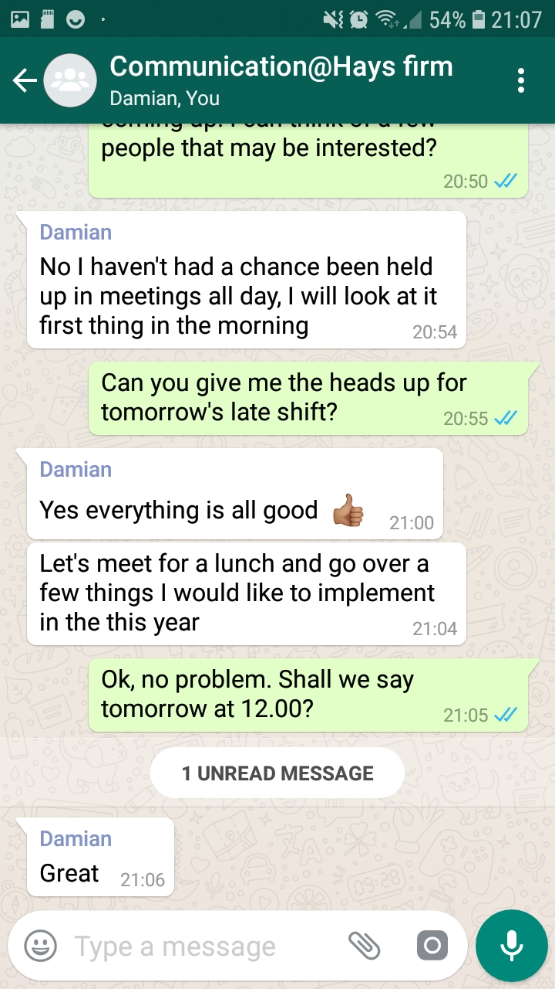

Figure 3

Advantages
- Easy to use
- Cheap to run
- Easy access
- Wide range of options
- Material can be uploaded and shared at once

Disadvantages
Employees may be reluctant to leave contact number for work reasons especially if they have to use their personal phone.
Data protection is at risk
Privacy may be at risk especially because whatsapp can have a tracking option to see who and when a message was read.
Ethical issues may arises especially if employees feel like they have to join the social network even when they do not want to

Web-Based Emails and whatsapp a Comparison
Both web based emails and whatsapp can be valuable tools in modern workplaces.
Both technologies can be accessed from a wide range of devices such as
- Tablets
- Mobile Phones
- Computers
- Laptops
- Smart Watches
These two tools share very common features such as being able to archive conversation or emails.
They also have similar if not the same looking icons such as the magnifying lens as a word or emails search tool. In addition, both of them have similar writing options as
- Different fonts
- Bold fonts
- Spelling check
- Bullet points
- Text Highlighter Options
- Emoticons
- Attach link
- Select multiple contacts for communications to be sent to an audience
As opposed to web based emails whatsapp requires an user to make his contact number available and public. In fact, this could be the case when employees have to use their personal phone and phone number... Therefore, there may be privacy issues related to it. (wiebe, 2017)
All in all, from experience and personal use there are not many differences between the two tools.

Data Protection Regulation
Data Protection regulation is very important to ensure users’ privacy is respected. Also, data protection regulation is important for ethical reasons concerning everybody, even those that may not use modern technology in their lives and workplaces. (Wiebe, 2017)
There is a EU framework around data protection. This framework has been used to avoid confusion amongst different countries’ provisions. (Wiebe, 2017)
Part of the regulation looks at the following
- The way data is stored
- The way date is reproduced
- The way data is shared
- The way data is used and for what purposes
Ideally, everywhere and in the specific case of this report workplaces should provide free and access to this information to all the users in the workplace.
Where is not possible to be accessed directly by a user, the workplace should be able to provide the users with this information. (Wiebe, 2017)

Ethical Issues
Ethical issues around the subject of social network use in workplaces are all important factors to consider. There is a duty of care toward the users to upload true information to their knowledge. This is why to an extent social networks involve a great deal of public communication. (Parsons, n.d.)
It is also very important to consider the language it is used in these social network interactions. (Parsons, n.d.)
For example language to avoid in workplaces and professional settings are
- Informal language
- Abusive Language
- Incentives Language
- Bullying
- Sharing sensitive information about the others within the workplace
It is also important to consider that a number of offensive and insensitive links and images can be uploaded, in most cases without restrictions. In some cases content can be deleted. It should not have to happen, nonetheless. It is paramount, that a workplace as an ethic of conduct in regards to the use of social networks for workplaces purposes.
When a workplace decides to use any of the media networking and modern technologies devices, should state very clearly what is allowed and what is not. In addition, it should be clear what the consequences are for those who exhibit poor behaviour and ignores those directions.
Furthermore, having a clear and strong ethical culture is important for the safety and wellbeing of the workplace and of all the individuals that create it/

Recommendations
Both web based emails would be recommended as useful tools in workplaces.
There are many others that can be used and that would be equally useful. However, for the purpose of this study only two, namely web based emails and wathsapp have been used to draw attention to how modern technologies can be used in workplaces.
Also, has explained in this report, it is of absolute importance that the workplace and all the people involved in it, respect and understand data protection. It is also vital that they understand the ethical issues attached to it.

Conclusions
After reading the current literature on social network and modern technology in the workplace it could be said there are an infinite number of possibilities. Modern technologies have changed how we see the world, how we operate in the workplace. Moreover, it has opened up a whole new world to all the users. Nowadays, it is possible thanks to the use of modern technology to do things that were unthinkable not long ago. Naturally, there are drawbacks as well such as how to use modern technology in a sensitive way that does not impact the users and workplaces negatively. It is of vital to make sure the data protection regulations are known and read to avoid legal actions that could impact workplaces negatively.

Bibliography

Chaffey, D. and Amy Laurens. (2003). Total e-mail marketing. Routledge.
Evans, D. (2011). Social media marketing. Hoboken, N.J.: Wiley Pub. Inc.
Wiebe, a. (2017). Open data protection: study on legal barriers to open data sharing : data protection and. Göttingen: Universitätsverlag Göttingen
Parsons, P. (n.d.). Ethics in public relations.

