NAME: Yeray Escribano Granada

STUDEN ID: 1908260

GROUP: 11

MODULE TITLE: BMSW4003 Digital Skills and Research Methods

ASSIGNMENT TITLE: Digital Skills and Research Methods

LECTURE NAME: Balan Kandasamy

Table of Contents
Introduction 3
Aim and Objectives 3
Research Rationale 4
Literature Review 4
Research Gap 7
Research Methodology 7
Result and Discussion 9
Conclusion 13
References 14

Introduction
The aim of the research report is to enhance the digital skill of the students and develop their knowledge about the impact of effective analysis of information and its transformation into knowledge. The Research report addresses the significance of Virtual Learning Environment or VLE. Since the last twenty years, VLE or Virtual Learning Environment has transformed the method of learning and teaching. In previous years the way of teaching-learning was conducted only through face to face conversations and using conventional ways. The modern era introduced the online mode of learning to make teaching and learning more convenient for the students. The enhancement of the internet and online tools can help the students to enhance their knowledge and learn efficiently. One of the important online learning platforms is known as VLE or the virtual learning environment. The virtual learning environment is a virtual space that helps the students and teacher to share and represent their activities and resources and they also will be able to have communication and interaction with each other through this VLE platform.

Aim and Objectives
Research Aim
The primary research aim of the report is to enhance the digital skills of the students. The report also aims to provide an understanding of the significance of the VLE or the virtual teaching method on students learning. Also, the main aim of the report is to identify the obstacles encountered by the student while using VLE (Hlosta et al. 2018).

Research Objectives
In general, the objectives of this report are;
- To understand the significance of VLE on learning.
- To investigate whether the VLE or virtual learning environment is able to develop motivation in student learning (Goeser et al. 2018).
- To gather more data about the influence of the virtual learning environment from the perspective of students.
- To understand the obstacles faced by the students while using a VLE system.

Research Rationale
The reason for conducting this study is to evaluate the value of the VLEs to support the learning and teaching process. Determining the vast modification and utilisation of advanced technology and digital resources in this digital era is very crucial to research on the student’s use of the Virtual Learning Environment (De Boer, Wesselink and Vervoorn, 2016). This will help to evaluate the impact and frequency of release in the development of the activities and academic assessment. This research report used both quantitative and qualitative research approaches to understand the value of VLEs.

Literature Review
The Mode of Virtual Learning
The continuous growth in conversational technology has expanded the demand for learning everything virtually. Virtual Learning includes the relation and interconnection of learners in both the synchronous and asynchronous. The asynchronous virtual learning includes delivered coursework through web, messages, and emails. It helps the student to interact through their computer without concern about time and distance. The student can use the internet as a tool for supporting them in completing their online course at their own pace (Annansingh, 2019). While the synchronous way of learning requires face to face interaction via videoconferencing and chatting that lets the student discuss and address their understanding and questions in real-time. The teachers are also able to answer the questions of the students using the videoconferencing or chat system. The example of two common synchronous modes of learning is Google Hangout, Moodle and Skype.

Significance of VLE of the Virtual Environment of Learning
Virtual education environment has a pivotal role to play in students' education. The functions of the virtual learning environment are managing and planning various activities, and lessons related to education, assessing various materials of digital learning like videos, images, podcasts, group-discussion and chat with teachers about several questions related to study, providing grades performance feedback and assessing the performance of the student, conducting live learning lessons, etc. As per Chen (2016), VLE opens several opportunities for teachers and students as well as the education administration to overcome several challenges related to studies
Flexibility: The VLE is very flexible in terms of time. The student can get easy access to several learning materials, through a digital platform with the help of VLC. Also, the students will be able to do other activities, like watching videos or reading for understanding their study topic more prominently.
Affordable: VLE also helps foreign students to save their campus fee. They don't have to invest a large amount of money to travel and live in a different country. They can conduct their studies at the comfort of their own pace.
Accessible: The virtual learning environment made learning is your for students. The students are able to attend their studies without attending the classrooms (Bello, Otobo and Eru, 2018). They will be able to get high-quality learning and teaching in remote areas. Even students from various countries can be benefited by using a virtual learning environment.
Management: It is efficient and convenient for the teachers to plan their lessons, managing their work related to administration, track all the performance and activities of the students, provide them feedback and engage with them with the help of virtual learning environments.
Several research studies have proven that VLE assists students to engage in education that is personalized. Meanwhile, it helps the teachers to make themselves free from all the management tasks related to classrooms. Various studies reported that students find it a more convenient and positive experience (Becerra-Romero, Díaz-Rodríguez and González-Estrada, 2019). The teachers also stated that VLE helps them to save their time to plan and teach lessons; it allows them to concentrate on coaching an individual student to accomplish their full potential.

However, the virtual learning environment has several disadvantages also. Below the report discussed the advantages and disadvantages of VLE in the field of education.

Advantages | Disadvantages
Virtual learning environment flexible for the students use. | It requires high-quality self-discipline for the students.
The students are able to have location independence. | It has limited learning activities. One cannot perform a chemical experiment through VLE.
The utilization of virtual learning environments can augment their management. | Virtual learning environment systems offer various tools to conduct communication group discussion live lessons and chats. However, it is unable to provide the same engagement level as face to face interaction.
The teacher can engage the students through various online activities. | It requires a lot of investments from the education university or institution. The student also has to invest in personal computers and free internet access to conduct classes in VLEs.
The teacher and students both have access to various digital learning materials | The virtual learning environment provides delete answers. Students can ask a direct question to teachers and get immediate answers while studying in the classroom, but while using online mode for education it needs the time flexibility of the teacher.
Table 1: The Importance and Challenges of Virtual Learning Environment
(Source: Schuster et al. 2016)

Therefore it can be stated that the VLE impacts both teachers and students. It is the responsibility of the student to use digital learning materials for their studies. It also influences the learning style of the student as they are coming from the traditional learning system, VLEs will help them to transform their learning style into a modern learning system. For the teachers, virtual learning is a new competency as it needs great flexibility and digital materials knowledge. VLE -learning and teaching method should implement pedagogical principles that are based on social constructionism as an approach.

Research Gap
In the educational sector, the use of digital technology has augmented in the past years. The virtual reality is proving itself to provide an excellent experience to the students. The research gap in the conducted research was in the disclosure of the expanded reality in the educational sector and the enthusiasm of the students to adopt digital technologies (Kristóf andTóth, 2019). However, the expanded virtual reality is still unknown and conducting the above research becomes the gap in this research.

Research Methodology
Research Design
This Research report utilizes the quantitative research methods; it mainly conducted an illustrative qualitative study. The research used both primary and secondary data primary instruments that have been utilized in conducting the qualitative study are interviewing and survey and attended by various numerical data like past integers and numbers. To collect the primary data a questionnaire interview was conducted with the students of the University of Wales Trinity Saint David London campus. The secondary data are taken from several online publications and published research materials on this discussion topic (Gorgônio et al. 2017). For the questionnaire survey, 5 questions using the Likert-type scale structure were conducted.

Research Sample
The population of the research report is the students of the University of Wales Trinity Saint David London campus, who have learnt using the VLE learning environment. For the survey, the researcher chooses fourth-semester students because they are currently learning a subject using Moodle as VLE. The data collected using the questionnaire method.

Data Collection and Analysis
The data collection for this research report was done in the method of qualitative research. In this method, a direct interview through questionnaire was taken with the students of the university. The obtained outcomes from these questionnaires were utilised to identify the perspective of the students about using Moodle. Both primary and secondary data collection methods were used to understand the perspective of the students.

Primary Data: These data were collected through questionnaire responses from the students of the university.

Secondary Data: These data were collected from previously published and digitally available websites and documents.

1. I am ___________________ years old. | Response
a) 25 or less
b) 26-35
C) 36-45
d) 46-55
e) 56 or more
Total

2. I am ___________________. | Response
Male
Female
Total

3. Moodle has a powerful design and covers most of the educational needs. | Response
Agree
Strongly Agree
Neutral
Strongly Disagree
Disagree
Total

4. Moodle is a beneficial online MLS that helps to learn efficiently online. | Response
Agree
Strongly Agree
Neutral
Strongly Disagree
Disagree
Total

5. Moodle made the fear of learning disappear due to the virtual learning environment. | Response
Agree
Strongly Agree
Neutral
Strongly Disagree
Disagree
Total
Table 2: Questionnaire for the Primary Research
(Source: By the Researcher)

Result and Discussion
After analysing the research report the key findings are described here. From the secondary source of data, it can be stated that more than 80% of the students agreed that the internet is a beneficial tool for them to conduct studies and learning through various activities. Less than 10% of students commented that they observe the internet as an unknown or confusing resource of learning (Kiat et al. 2016).

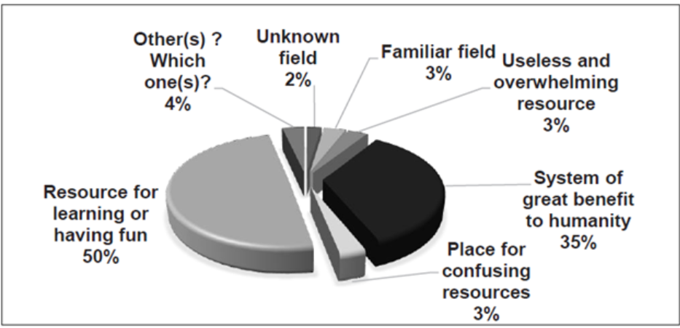
Fig 1: Students Response for the Benefits of Internet
(Source: Kiat et al. 2016)
From figure 2, it can be depicted that approximately 99% of the students responded that the competence of computers is high or medium.
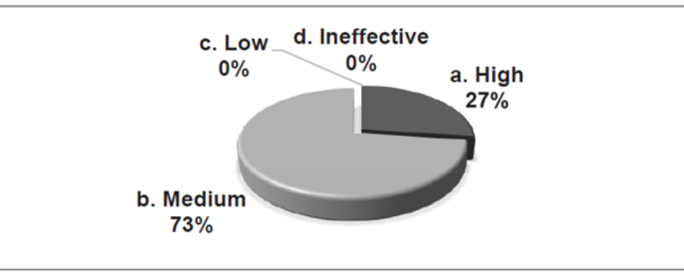
Fig 2: Competence of Computer
(Source: Kiat et al. 2016)
Based on the data from figure 3, it is notable that approximately 90% of the students believe that the internet is a beneficial tool for learning and teaching. While less than 5% of the students view the internet as a negative source for learning.

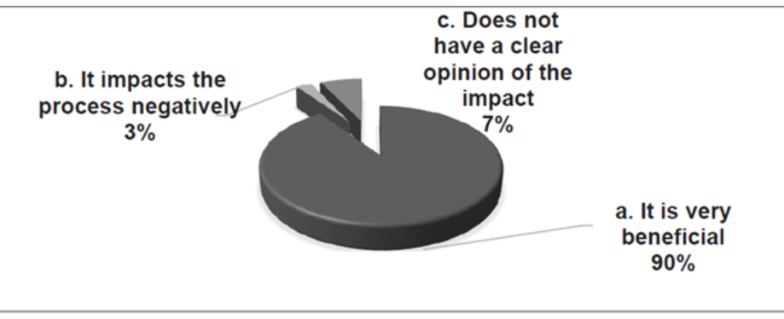
Fig 3: Students Opinion about the Benefits of Internet
(Source: Kiat et al. 2016)

1. Moodle has a powerful design and covers most of the educational needs.
After analyzing the primary research data, it can be observed that 95% of the students strongly agreed on this question, while the other 5% agreed on it. From this, it is understandable that Moodle or Virtual Learning Environment has the ability and design to help the students cover their educational requirements.

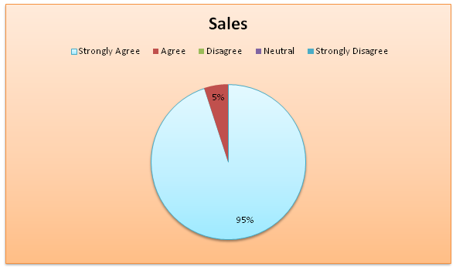
Fig 4: Student’s Response for the Survey Questions
(Source: By the Researcher)

2. Moodle is a beneficial online MLS that helps to learn efficiently online.
The students responded to this question effectively. 55% of the students among them strongly agreed on this and 30% of the students agreed on this. While the other 15% of the students chose the neutral answer.
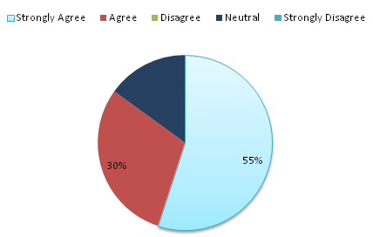
Fig 5: Student’s Response for the Survey Questions
(Source: By the Researcher)

3. Moodle made the fear of learning disappear due to the virtual learning environment.

For this question, the students in the majority (40%) strongly agree for the fact that virtual learning made their fear of learning disappear. While 15% remain neutral, 35% of students agreed on this fact. However, 10% of students disagree with the fact that their learning fear has disappeared due to the use of Moodle.

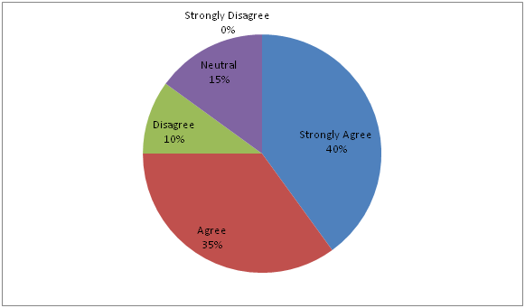
Fig 6: Student’s Response for the Survey Questions
(Source: By the Researcher)

Conclusion
The VLE or Virtual Learning Environment has made the life of the students much easier and simple. The theories, concepts, and complex studies become convenient and efficient to digest. With the augmentation of VLE students and teachers find it extremely helpful to teach and learn at the comfort of their own pace. Even the students lost their fears towards study due to this. Nevertheless, the students have to follow self-discipline and some limitations to use this Virtual Learning Environment to enhance and achieve their full potential.

References
Ali, D.F., Omar, M., Mokhtar, M., Ali, M., Suhairom Abd Halim, N.D., Shukor, N.A. and Abdullah, Z., 2017. Enhancing students’ mental rotation skills in engineering drawing by using virtual learning environment. Man in India, 97(17), pp.161-170.
Annansingh, F., 2019. Mind the gap: Cognitive active learning in virtual learning environment perception of instructors and students. Education and Information Technologies, 24(6), pp.3669-3688.
Becerra-Romero, A., Díaz-Rodríguez, M. and González-Estrada, O.A., 2019, January. Development of a virtual learning environment for the subject numerical methods under Moodle. In Journal of Physics: Conference Series (Vol. 1161, No. 1, p. 012010). IOP Publishing.
Bello, R.W., Otobo, F.N. and Eru, E.J., 2018. Virtual learning environment-Some realities. International Research Journal of Advanced Engineering and Science. ISSN (Online), pp.2455-9024.
Chen, Y.L., 2016. The effects of virtual reality learning environment on student cognitive and linguistic development. The Asia-Pacific Education Researcher, 25(4), pp.637-646.
De Boer, I.R., Wesselink, P.R. and Vervoorn, J.M., 2016. Student performance and appreciation using 3D vs. 2D vision in a virtual learning environment. European Journal of Dental Education, 20(3), pp.142-147.
Goeser, P.T., Hamza-Lup, F.G., Johnson, W.M. and Scharfer, D., 2018. VIEW: A virtual interactive web-based learning environment for engineering. arXiv preprint arXiv:1811.07463.
Gorgônio, F.L., Vale, K.M., Silva, Y.K.N. and Silva, H.M., 2017. Grouping students for cooperative and collaborative learning: Challenges and trends in virtual learning environments. In IEEE World Engineering Education Conference, Santos, Brazil. Retrieved from http://edunine. eu/edunine2017/proc/works/33. Pdf.
Hlosta, M., Herrmannova, D., Vachova, L., Kuzilek, J., Zdrahal, Z. and Wolff, A., 2018. Modelling student online behaviour in a virtual learning environment. arXiv preprint arXiv:1811.06369.
Kiat, L.B., Ali, M.B., Halim, N.D.A. and Ibrahim, H.B., 2016, October. Augmented reality, virtual learning environment and mobile learning in education: a comparison. In 2016 IEEE Conference on e-Learning, e-Management and e-Services (IC3e) (pp. 23-28). IEEE.
Kristóf, Z. and Tóth, K., 2019. Developing and examining a virtual learning environment. Hungarian Educational Research Journal, 9(3), pp.511-526.
Schuster, K., Groß, K., Vossen, R., Richert, A. and Jeschke, S., 2016. Preparing for industry 4.0–collaborative virtual learning environments in engineering education. In Engineering Education 4.0 (pp. 477-487). Springer, Cham.

