Student Name: Esther Okunuga
Student ID: 2509873
Module Name: Introduction to Health and Social Care
Module Code: LCHS4003
Lecturer's Name: Oluwadamilola Tayo

Contents
1. Introduction 3
2. Importance of Effective Communication 3
3. Importance of Good Administrative Skills 6
4. Importance of Working Collaboratively 8
5. Conclusion 9
References 10

1. Introduction
This report is a critical analysis of the health and social care that can be given to Mr Ahmed, a 68-year-old Bengali-speaking man that has just left the hospital after a stroke. He is given domiciliary care thrice a day that will help him with personal care, taking medication, and preparing meals. The areas of professional practice covered in the report are effective communication, good administrative skills such as record keeping and collaborative multi-agency working. These are discussed in connection to the Equality Act 2010, the Data Protection Act 2018, the communication model introduced by Berlo and the academic literature.
A near miss was witnessed when the care agency failed to visit the home and Mr Ahmed was not taken to take his medication in time. This indicates a definite lapse in communication among professionals: the care worker did not visit, and neither reported nor recorded the missed visit, the care agency coordinator did not follow up, and the broader multidisciplinary team (MDT) was not notified. This communication, documentation and coordination failure exemplify the importance of all three areas discussed in this report to patient safety and effective professional practice. The aim of this report is to critically analyse how communication, administrative skills and collaborative working impact the safety and quality of care in Mr Ahmed’s case. The report will examine communication, administrative practices and multidisciplinary working, followed by a critical evaluation of failures and recommendations for improvement.

2. Importance of Effective Communication
Safe and ethical health and social care practice is based on effective communication. It is the accurate, respectful, and clear flow of information between professionals and service users as well as their families (Arnold and Boggs, 2020). Communication is especially important in the case of Mr Ahmed since he has limited fluency in English and since his cognitive and physical stroke have caused cognitive and physical impairments.
Kaldjian (2021) argues that one of the most common and avoidable factors that lead to medical errors is communication failures and that they directly translate into patient harm and a loss of trust in healthcare services. This is directly applicable to the case of Mr Ahmed, in which there was no effective communication between the care worker and the agency coordinator, which led to the absence of follow-ups on the case of the missed visit. The World Health Organization (WHO, 2021) estimates that unsafe care affects 1 in 10 patients globally, with communication failures identified as a leading contributing factor.

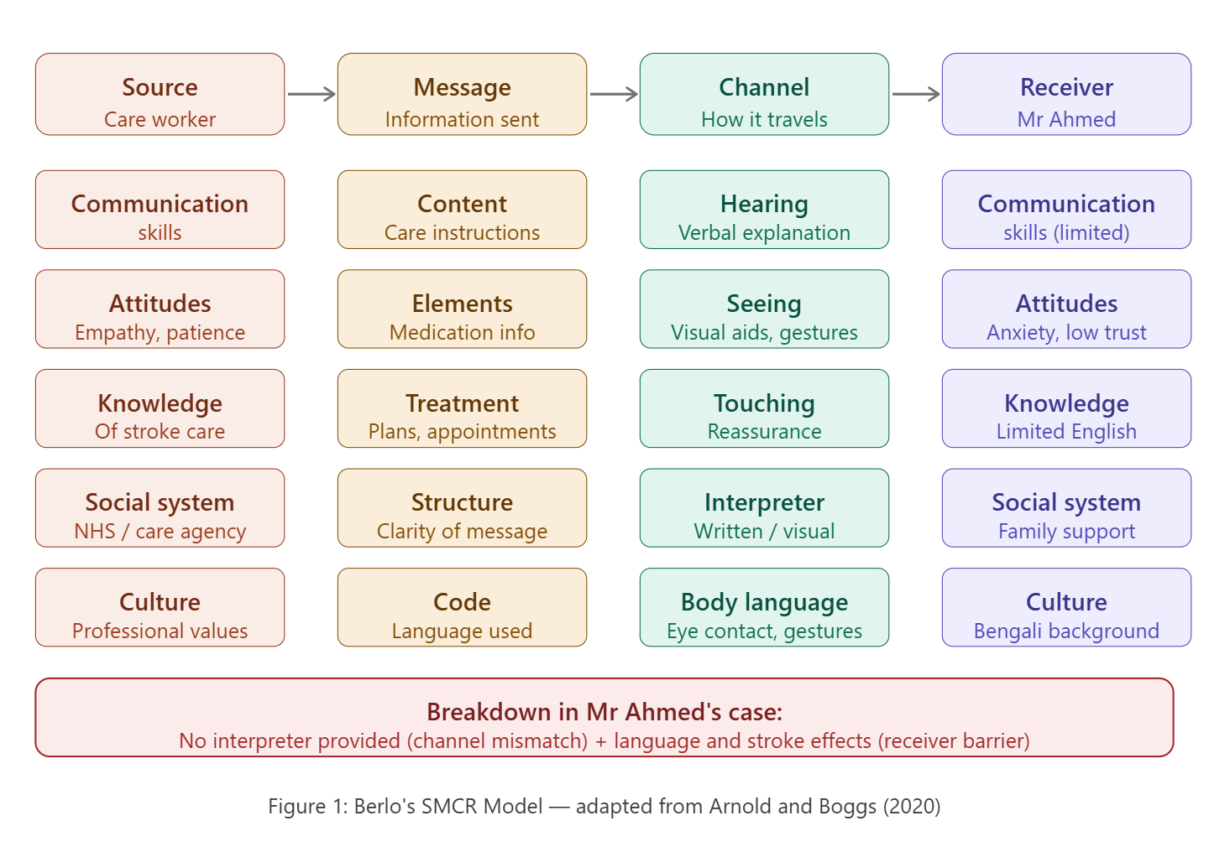
Figure 1: Berlo's SMCR Model applied to Mr Ahmed's care context
(Source: Arnold and Boggs, 2020)
The teaching session has examined the work of Berlo, the Source-Message-Channel-Receiver (SMCR) model, which can help to comprehend the communication in the care of Mr Ahmed. The model is based on the idea that successful communication relies on the skills, attitudes, knowledge, social system, and culture of the source and receiver (Arnold and Boggs, 2020). When applied to the case of Mr Ahmed, the care worker (source) will be required to modify the message by using simple words and visual aids, choose the optimal channel like a professional interpreter or picture board, and consider the fact that Mr Ahmed has a limited ability to communicate in English and post stroke impairments as a receiver. Although the model offered by Berlo is a useful tool of analysis, the limitation is that it is a considerably linear concept of communication and does not comprehensively cover the dynamic, emotional, and relational aspects of care interactions.
Eye contact, open and relaxed body language, nodding to show listening, not rushing or dismissing body language are particularly effective in communication with stroke patients who may have aphasia or limited verbal skills. In a systematic review of more than 300,000 participants, Al Shamsi et al. (2020) verified that members of limited English proficiency always have worse care outcomes in the absence of proper communication support, such as medication non-adherence and extended hospitalization.
The Equality Act 2010 imposes a legal obligation on healthcare providers to make reasonable adjustments to meet the communication needs of individuals with communication needs due to disability or language differences. This involves the provision of interpreter services (professional interpreters), translated information, and the availability of care plans. The non-compliance with these requirements is not only a violation of the law but also a moral fault that has a direct negative effect on patient dignity and safety. NHS England (2023) affirms the idea that culturally competent and linguistically accessible communication is one of the essential principles of person-centred care. In the case of Mr Ahmed, an example of reasonable adjustments is the provision of a professional interpreter speaking Bengali, medication prescriptions and visual communication aids translated into Bengali. Lack of this will result in confusion in taking instructions about the medication. The wife of Mr Ahmed can serve as an informal interpreter, but this can be very risky. Clinical errors can happen due to family members not consciously providing information or distorting it. This is an indication that informal interpretation is not a safe method and inconsistent with professional practice.

3. Importance of Good Administrative Skills
Skills in administration in health and social care include proper record keeping, proper scheduling, proper documentation of the care offered and proper reporting of incidences. Such skills are not only bureaucratic, but they are directly connected with patient safety and professional accountability. The missed home visit and delayed medication in the case of Mr Ahmed is an important administrative error that has serious clinical implications.
A missed or delayed dose of medication is very important to a stroke patient. The recovery of stroke is usually accompanied by the obligation to take the medicines prescribed by the doctor, such as anticoagulants to avoid blood clots, antihypertensives to regulate blood pressure, and antiplatelet drugs. Any dose omission may put one at risk of a secondary stroke, blood pressure exacerbation, heart related issues, or readmission to the hospital (WHO, 2021). Mutair et al. (2021) define poor documentation as the main reason why medications are missed in the community care setting as they state that without the right and timely records, care workers and supervisors cannot detect or rectify gaps in care delivery. Mutair et al. (2021) found that over 60% of medication errors in community care were linked to incomplete documentation.
NHS England (2022) reported that medication errors cost the NHS approximately £98.5 million annually, the majority of which were linked to poor documentation and missed administration records. Record-keeping should be correct, timely and legible. The NHS (2022) sets out that all care records should be completed at the time of care or as soon as possible afterwards, must be factual and non-judgmental, and must be accessible to authorised members of the care team. In the case of Mr Ahmed, the missed visit was not recorded by the care worker, and the agency had no live visit log, which meant that the medication delay was not noticed until it was at a risk of compromising his health.

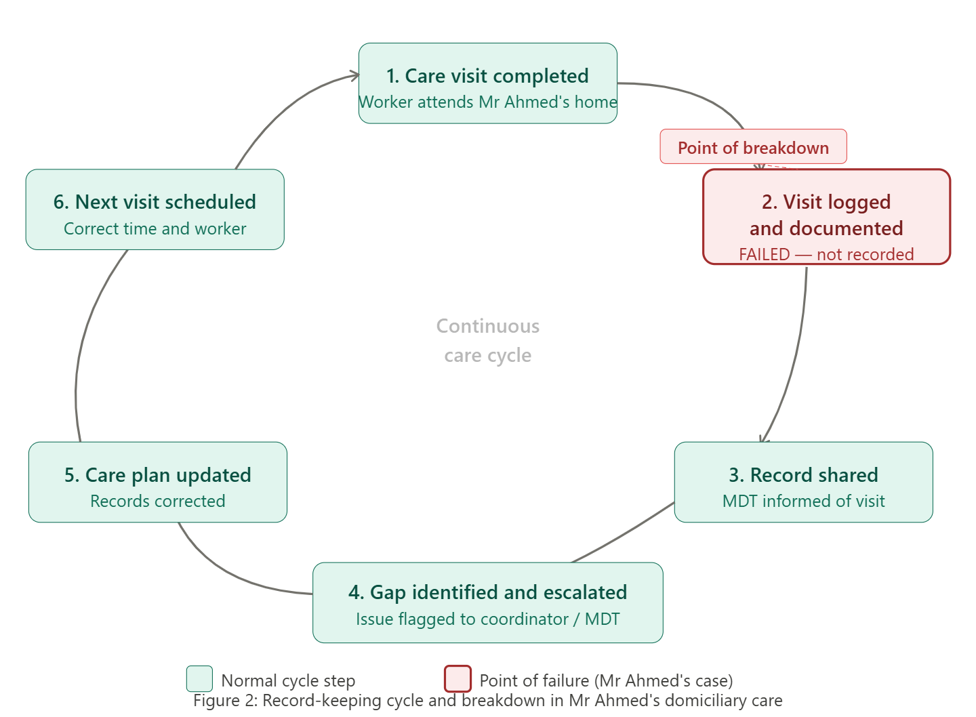
Figure 2: The record-keeping cycle in domiciliary care and the point of breakdown in Mr Ahmed's case
Data Protection Act 2018 gives the legal framework of how patient records should be stored, processed and shared. It stipulates that data is gathered on identified, legitimate purposes; maintained precise and current; conserved and only retrieved by qualified workers. This practically implies that the care records of Mr Ahmed should be kept confidential and can be disclosed only to the individuals directly engaged with his care and stored in secure, GDPR-compliant systems. Violation of the Data Protection Act 2018 may lead to regulatory fines on organisations and, more importantly, result in victims of the breach being vulnerable patients who may suffer as a result of inaccurate or loss of information.
In a systematic review, Manias, Kusljic and Wu (2020) concluded that structured documentation tools, electronic medication administration records, and multidisciplinary record-sharing have a significant impact on reducing medication errors. They also warn, though, that electronic systems can only be effective when employees are properly trained to operate them, and that training in technology may not be effective without training of the staff. Ho and Burger (2020) also showed that positive outcomes of enhancing the medication administration documentation protocol in a community hospital environment resulted in a 17% decrease in adverse drug events, which undoubtedly reflects the quantifiable effect of well-developed administrative systems on patient safety.

4. Importance of Working Collaboratively
Multi-agency or multidisciplinary team (MDT) working is the collaboration of various professionals to provide holistic, person-centred care. Mr Ahmed MDT consists of his GP, district nurse, domiciliary care workers and a speech and language therapist. Collaborative working did not work well in the case of Mr Ahmed. The missed visit shows a failure in MDT coordination, in which no professional detected, amplified or acted on the lack of care. This indicates that there is no shared responsibility and ineffective communication systems.
In a systematic review of ten studies, Kongkar et al. (2025) discovered that interdisciplinary team-based care is significantly more effective in patient, interpersonal, and organisational levels of chronic-disease patients. Kongkar et al. (2025) found that patients receiving interdisciplinary team-based care showed a 25% reduction in hospital readmission rates. At the patient level, it enhances self-management and health outcomes. At interpersonal level, it enhances the joint decision-making among professionals. These results confirm the thesis that in the case of Mr Ahmed, the risk of such care gaps as the fact that the home visit was not conducted could be mitigated by enhancing the coordination of MDT. This may have severe repercussions, such as medication delays, worsening of health conditions and high chances of readmission to the hospital. It identifies a lack of organisational responsibility and continuity of care.
High levels of collaboration working should be adopted. Digital care records would be shared and real-time updates would be seen by all MDT members. There should be a designated care coordinator to supervise the care of Mr Ahmed and to follow up on the visits that were missed. There should be escalation mechanisms that ensure that missed visits are reported and addressed immediately. Also, real-time monitoring systems, like electronic visit tracking, might help keep such cases unnoticed. If these systems had been in place, the missed visit in Mr Ahmed’s case could have been identified and resolved promptly, preventing risk to his health.

5. Conclusion
This report has critically discussed three fundamental areas of professional practice in health and social care in the case of Mr Ahmed. The key to safe, accessible and dignified care of patients with varied linguistic backgrounds is effective communication supported by the SMCR model of Berlo and the Equality Act 2010. Nonetheless, communication should be seen as an individual capability and organisational task, which necessitates structural support in the form of interpreter services and sufficient time on the part of the staff.
The medication safety and avoiding care gaps are directly connected to good administrative practice regulated by the Data Protection Act 2018 and the NHS standards. The lost visit and subsequent delay to administration of medications in the case of Mr Ahmed illustrate the dire clinical implications of ineffective documentation. Lastly, MDT collaboration is essential to holistic care, but it must have well-defined structures, records, and roles to be safely implemented.

References
Al Shamsi, H., Almutairi, A.G., Al Mashrafi, S. and Al Kalbani, T. (2020) ‘Implications of language barriers for healthcare: a systematic review’, Oman Medical Journal, 35(2), e122. Available at: https://doi.org/10.5001/omj.2020.40 (Accessed: 19 April 2026).
Arnold, E.C. and Boggs, K.U. (2020) Interpersonal relationships in nursing. 8th edn. St. Louis: Elsevier.
Data Protection Act 2018 (2018) London: UK Government. Available at: https://www.legislation.gov.uk/ukpga/2018/12/contents (Accessed: 19 April 2026).
Equality Act 2010 (2010) London: UK Government. Available at: https://www.legislation.gov.uk/ukpga/2010/15/contents (Accessed: 19 April 2026).
Ho, J. and Burger, D. (2020) ‘Improving medication safety practice at a community hospital’, BMJ Open Quality, 9, e000987. Available at: https://doi.org/10.1136/bmjoq-2020-000987 (Accessed: 19 April 2026).
Kaldjian, L.C. (2021) ‘Communication about medical errors’, Patient Education and Counseling, 104(5), pp. 989–993. Available at: https://doi.org/10.1016/j.pec.2020.11.035 (Accessed: 19 April 2026).
Kidd, M., Bates, S.M. and Greenfield, D. (2025) ‘Improving primary care through multidisciplinary teamwork’, International Journal for Quality in Health Care, 37(1), mzaf021. Available at: https://doi.org/10.1093/intqhc/mzaf021 (Accessed: 19 April 2026).
Kongkar, R., Ruksakulpiwat, S., Phianhasin, L., Benjasirisan, C., Niyomyart, A., Ahmed, B., Puwarawuttipanit, W., Chuenkongkaew, W. and Adams, J. (2025) ‘The impact of interdisciplinary team-based care on the care and outcomes of chronically ill patients: a systematic review’, Journal of Multidisciplinary Healthcare, 18, pp. 445–457. Available at: https://doi.org/10.2147/jmdh.s497846 (Accessed: 19 April 2026).
Kwame, A. and Petrucka, P.M. (2021) ‘A literature-based study of patient-centered care and communication in nurse–patient interactions’, BMC Nursing, 20, 158. Available at: https://doi.org/10.1186/s12912-021-00684-2 (Accessed: 19 April 2026).
Manias, E., Kusljic, S. and Wu, A. (2020) ‘Interventions to reduce medication errors in adult medical and surgical settings’, Therapeutic Advances in Drug Safety, 11. Available at: https://doi.org/10.1177/2042098620968309 (Accessed: 19 April 2026).
Mutair, A.A., Alhumaid, S., Shamsan, A., Zaidi, A.R.Z., Mohaini, M.A., Mutairi, A.A., Rabaan, A.A., Awad, M. and Al-Omari, A. (2021) ‘The effective strategies to avoid medication errors and improving reporting systems’, Medicines, 8(9), p. 46. Available at: https://doi.org/10.3390/medicines8090046 (Accessed: 19 April 2026).
NHS England (2022) Safe and effective clinical record keeping. Available at: https://www.england.nhs.uk (Accessed: 19 April 2026).
NHS England (2023) Person-centred care and communication standards. Available at: https://www.england.nhs.uk (Accessed: 19 April 2026).
World Health Organization (2021) Global patient safety action plan. Geneva: WHO Press. Available at: https://doi.org/10.4060/CB7694EN (Accessed: 19 April 2026).

