Student FEEDBACK FORM

This section details the extent to which the assessment criteria are demonstrated by you, which in turn determines your mark. The marks available for each category of skill are shown. Lecturers will use the space provided to comment on the achievement of the task(s), including those areas in which you have performed well and areas that would benefit from development/improvement.

Generic Assessment Criteria | Marks available | Marks  awarded
1. Engagement with Literature Skills
.
 | 5
2. Knowledge and Understanding Skills

 | 20
3. Cognitive and Intellectual Skills

 | 25
4. Practical Application Skills

 | 25
5. Transferable Skills for Life and Professional Practice

 | 25

Assessment Mark (Assessment marks are subject to ratification at the Exam Board. These comments and marks are to give feedback on module work and are for guidance only until they are confirmed. ) | Late Submission Penalties (tick if appropriate) |  | %
 | Up to 1 week late (40% Max) |  | %
 | Over 1 week late (0%) |  | %

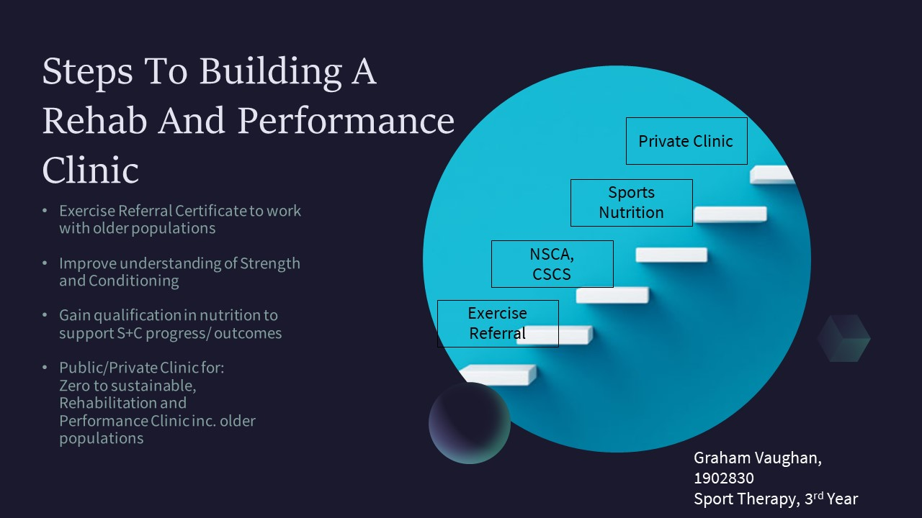

Graham Vaughan, 1902830
Learning Needs Analysis
6060 Professional Practice

Over the years, especially during my time in kitchens as a chef, I had started to understand that the human body when left unattended will develop aches and pains from everyday life. What I hadn’t known then was that there was something that could be done about it. After finishing full time work as a chef, I began to look at way to deal with my aches and pains. I even checked myself into the physio at the hospital hoping that they could offer treatment or guidance to help in relieving my grievances. This didn’t happen as they were looking gross inadequacies in my movement and joints. After that I approached massage therapists for treatment which only yielded transient effects. I found most help through self-treatment such as trigger point therapy and foam rolling, though not sufficient to reduce all pain. Through these avenues I learned that many pain and niggles are due to musculoskeletal (MSK) issues. Often, but not always, these could be approached with some treatment and targeted exercise. It took a few years but managed to find that there were courses to learn how to assess, treat injuries, and prescribe exercise for MSK pain. One of which was Bsc. (Hons) Sport Therapy degree at UWTSD.

Over the last two years my interests have been taken by resistance training (RT) for health in the general public and in older population, assessment of injury and rehabilitation, and performance. A lot of this has come from personal experience and from my brother who have both reduced aches and pains in our lives with strength training. And also shown by Bennie et al. (2020), RT has been historically overlooked in favour of running, cycling, swimming, and sport despite the proven health benefits. Within ten years my goal will be to running my own performance and rehabilitation clinic, catering towards rehab and resistance training in older populations but not limited to. As a side, I would like to work with athletes engaging in climbing and water sports.

On the way to get there I will have to meet some criteria though some will be optional but still worthwhile to pursue. One of the first steps will be to acquire Exercise Referral certification. This will allow me to work with older populations. It may be achievable sooner than expected as the there is a chance that our lecturer for Exercise and Specific Populations is working to get the module work outside accredited as and attain a certification for it. If this doesn’t happen the YMCA offers one that I will be eligible as I have a Level 2 Gym Instructor certification, which is the prerequisite. One reason I would like to work on this route is that I see on the street many older people that have difficulty moving around and doing day to day activities, including my mother’s reduced abilities. Since resistance training has been shown to be an incredible intervention that can reduce, and possibly reverse, loss of muscle strength and mass (sarcopenia), and the consequences such lowered independence and mobility, frailty, and reduction in quality of life (Fragala et al., 2019). Strengthening exercises as an intervention could prevent many from having to deal with these problems but also help to slow down or reverse these issues and help manage chronic diseases (Fragala et al., 2019). I want to contribute to society by reducing the need to rely on the medical system for issues that could be prevented or managed by exercise.

During this time in university, we may have the opportunity to work with Peter Herbert and his work with strength and power training for elderly for one of our modules. This would also offer much needed experience, both in theory and practical, leading to working clients in the future. As an adjunct to this within the next two to three years I plan to expand my knowledge and skill base in strength and conditioning by taking the National Strength and Conditioning Association’s Certified Strength and Conditioning Certification. Though not fully necessary, I believe it will enhance my ability to offer appropriate service to my clients.
In three to five years, I plan to work towards a nutrition qualification to supplement even more effective training and rehabilitation. As a key component of anabolism for recovery from training, rehab, and surgery, nutrition holds a place in health and performance no matter the age (Papadopoulou, 2020). I feel this will give a better, rounded offering to my clients allowing them greater results. An accredited course is offered by the YMCA and as the conditions of participation have already been met through the Level 2 Gym Instructor, there are no other boundaries to applying beside expense.

During my time of building my skills and qualifications toward opening my own performance and rehab clinic with I would like to work with a professional climbing team, such as Team GB, to hone these skills with performance athletes and work in a sport in enjoy. Alongside working with climbing athletes, I will open a private practice working with older populations in order to improve their general health and strength. I feel the personal reward of seeing someone improve and regaining aspects of their mobility and life would be extraordinary.

Within ten years I would like to see myself running a private clinic for performance and rehabilitation not just for the general public but also encouraging older people to engage further in resistance training whether they are inactive to start with or already active and want to achieve higher performance. One question I have yet to answer is where to continue my work. As I am originally from Bermuda, I still have an urge to return and live with my family there. Considering there is a high prevalence of type two Diabetes Mellitus on the island I believe my move there could serve a great function in alleviating some of the stress on the medical system and community through training and education.
Overall, I plan to continue learning and gaining skills to improve myself and better serve those seeking my services, creating an impeccable environment for them to start, regain or continue pursuit of their idea of performance. I look forward to working with those going from zero to sustainable, from injury to return to daily activities, or those seeking higher performance.

Word count: 1066
References

Fragala, M.S., Cadore, E.L., Dorgo, S., Izquierdo, M., Kraemer, W.J., Peterson, M.D. and Ryan, E.D., (2019). “Resistance training for older adults: position statement from the national strength and conditioning association.” The Journal of Strength & Conditioning Research, 33(8).

Haff, G.G. and Triplett, N.T. eds., (2015). Essentials of strength training and conditioning 4th edition. Human kinetics.

Papadopoulou, S.K., (2020). “Rehabilitation for Injury Recovery of Athletes: The Role of Macronutrient Intake.” Nutrients, 12(8), p.2449.

