Name: Norbert Ibeawuchi Orji
Student ID: 1816289
Module Code: Mental Disorders and Psychopathology
Module Title: BMHP6006_BIRM
Lectures Name: Chloe Harries
Assignment Title: Component 2-Written Report

.

Table of Content
.
1. Introduction 2
2. Definition and Classification – (Schizophrenia) 3
Classification 3
3. Diagnosis of Schizophrenia 4
4. Treatment 7
5. Measurements of Rehabilitations 10
Cognition Remediation 10
6. Recommendation for Future Practice 11
7. Conclusion 13
8. References 14

1. Introduction
This report provides about one mental illness and explains the term mental illness or mental disorders, commonly known as psychiatric disorders. Mental is the incomplete or altered development of the Mind that is characterised by skills impairment during the development period and affects the level of intelligence (Gross, 2020) In this report, one of the most severe long-term mental disorders, schizophrenia, is widely described. It is the most common mental illness encountered by clinicians during their practice. Schizophrenia is a psychiatric illness that causes emotional disruptions, cognition, and psychosocial and occupational functioning. This disease is mainly characterised by hallucinations, delusion, loss of interest in daily activities, social loneliness, and not caring about personal hygiene (Fortinash & Holoday-Worret, 2012) It also highlights the systems or methods that are widely used for the classification of psychiatric disorders, such as the ICD-10 and DSM-5 and explains the importance of both these systems in the classification of schizophrenia.
Moreover, an overview of schizophrenia, its prevalence, types, and the factors such as environmental, genetic and biological which contribute to the onset of the disease. This report also included the classification of schizophrenia into various types according to ICD-10 (World Health Organisation) WHO. In this context, the diagnostic criteria explained by both systems, ICD-10 and DSM-5 for schizophrenia, were discussed and compared. Furthermore, this report also provides a detailed insight into the treatment approaches for mental disorders mainly related to schizophrenia. The role of contemporary approaches such as rehabilitation in improving the diseases. Finally, measures, future recommendation required to improve the treatment of schizophrenia, and conclusion

2. Definition and Classification – (Schizophrenia)
Smitha Bhandari (2022), schizophrenia is a medical condition or mental illness that impairs the brain’s normal functioning and interferes with the person’s thinking, feeling and action.
According to Burgin et al., (2022) The lifetime prevalence of schizophrenia is about 1%, the primary reason for a health care burden(reference). It typically appears in early adulthood and results in long-term impairment in social and occupational functions. Schizophrenia reduce life expectancy by 15 years. Moreover, there is a 5 to 10% risk of death by suicide (NIH, 2022).

Classification
According to WHO (2022), the ICD-10 (International Classification of Diseases, Tenth Revision, Clinical Modification) system is widely used for diagnosing, coding and treating procedures for different diseases. ICD-10 is set by WHO based on the data collected from various countries. The section of ICD, which is related to psychiatric disorders, lies in section V with the heading Mental and behaviour disorder. Schizophrenia is classified under code F20 of section V of ICD-10. According to ICD-10, it is further classified into different types, which are mentioned below:
“F20.0 Paranoid schizophrenia
F20.1 Hebephrenic schizophrenia
F20.2 Catatonic schizophrenia
F20.3 Undifferentiated schizophrenia
F20.4 post-schizophrenic depression
F20.5 Residual schizophrenia
F20.6 Simple schizophrenia
F20.8 Other schizophrenia
F20.9 Schizophrenia, unspecified.”
On the other hand, DSM (The Diagnostic and Statistical Manual of mental health) is the official classification system used in the USA for clinical diagnosis of mental disorders. The fourth version of the DSM includes the different types of schizophrenia. However, DSM -V removed all types Zachar et al., (2015) argued that types due to the heterogeneous nature of conditions and their historical insignificance in clinical practice. In DSM, classification is done based on reliability that includes both interrater reliability and temporal reliability. On the other side, ICD allows the clinician to make a judgement that helps in classification as it does not rely on the clear diagnostic criteria unless validated. Through DSM, diagnosis is more accurate (Valle, 2020)

3. Diagnosis of Schizophrenia
There is no specific diagnostic test available for schizophrenia nhs.uk, (2022) Psychiatrists usually diagnose it through the assessment procedure. Special diagnostic tools will be used to facilitate the diagnosis and treatment. For the diagnosis of schizophrenia, doctors perform physical and laboratory examinations, service user medical, psychiatric and family history and then diagnose based on any formal system (Lake, 2012). The physical examination is usually performed at first and is helpful in the identification of symptoms and other related problems. Routine blood tests help differentiate conditions with similar symptoms, such as drug and alcohol abuse. Some medication interactions, such as cardiovascular medications and corticosteroids, can also result in the appearance of schizophrenia-like symptoms. The diagnostic procedure further involved the brain imaging studies such as Magnetic resonance imaging (MRI) MRI or Computerised tomography (CT) -scan to rule out the abnormalities that result in the appearance of schizophrenia-like symptoms. After that, the doctor asked about any distressing experiences and perceptions of the service user, further checking the service user’s mental status by asking about thoughts, delusions, hallucinations and mood. After all these events, the criteria of ICD-10 or DSM-5 to mark the checklist for the appeared symptoms and then clearly identified the disease (Shoeibi et al., 2021)
In Europe, Schizophrenia is diagnosed based on ICD-10. The general criteria for the diagnosis of schizophrenia are (Gaebel et al., 2020).
At least one of the symptoms from the following must be present
- Thought echo, withdrawal, insertion or broadcasting
- Delusion of influence, control or passivity related to body movement or actions, thoughts
- Hallucinations voices that cause changes in the behaviour of patients
- Delusions that remain persistent and are impossible to occur.
Or any two symptoms must be present from the given below
- A hallucination remains persistent for at least one month and occurs with delusion or overvalued ideas.
- Incoherence, neologism or disturbance in speech.
- Catatonic behaviour
- Negative symptoms (such as lack of interest (apathy), difficulty in speech and blunting in speech).
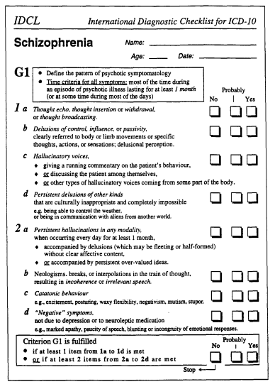
Figure 1: An example of an ICD-10 criteria checklist
Source: (Castagnini et al., 2017)

The general criteria as described by DSM-5 for the diagnosis of schizophrenia are:
At least two or more symptoms from the following must be present for a month, and at least one of these must be (1), (2), 0r (3):
- Hallucinations
- Delusions
- Incoherence or derailment (disorganised speech)
- Catatonic behaviour (grossly disorganised behaviour)
- Negative symptoms, such as diminished emotional expression.
(1) Disturbance in one or more major areas of functioning for a significant amount of time since the disturbance began. For example, self-care or interpersonal relations, and work. Children or adolescents, fail to achieve expected academic or occupational functioning levels.
(2) Some signs of the disturbance must continue for at least six months. This 6-month period must comprise one month of symptoms that meet criteria A and the period of residual symptoms. During the residual period, the disorders’ signs may manifest in negative symptoms.
(3) Bipolar disorders or depressive disorders and schizoaffective disorders are psychiatric illnesses that share similar traits but differ significantly. These diseases must be ruled out

- Active phase symptoms never showed a major depressive or manic episode
- A depressive or manic episode occurs during active phase symptoms. It is for short durations of time.

- The disorder is not due to the physiological effects of a substance (such as drug use or medications) or another medical complication.
- Suppose the persons have a history of autism spectrum disorders or communication disorder. In that case, the diagnosis of schizophrenia is made only if the hallucinations, delusions or any other symptoms are present for a minimum of one month.

Also, some specifications must be considered when diagnosing schizophrenia. These specifications include specifying the severity as well as categorising episodically (Davidson, 2019).

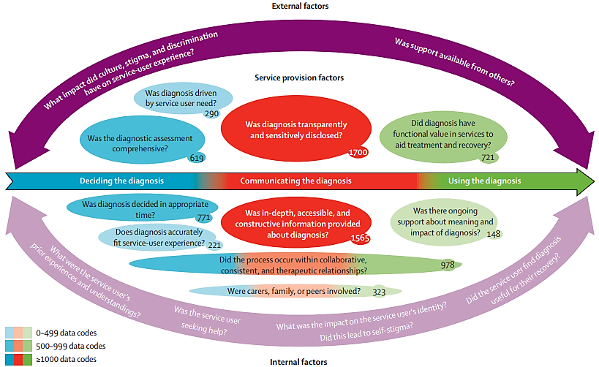
Figure 2: Factors which contribute to mental health diagnosis as experienced by services user (Gibbons et al., 2016)
The community mental health team (CMHT) provide secondary care services to users with mental illness. CMHTs usually consist of various mental health professionals, including psychiatrists, psychologists, mental health nurses or community psychiatric nurses, occupational therapists, pharmacists, counsellors, psychotherapists, social workers and other laboratory staff (Roth et al., 2021).

4. Treatment
Early identification and treatment result in a better outcome. Schizophrenia has no cure available. However, the proper treatment, including medication and rehabilitation, can help in the recovery of the individual to live a productive and independent life in the community (Kane et al., 2019) Treatment options for schizophrenia, include:
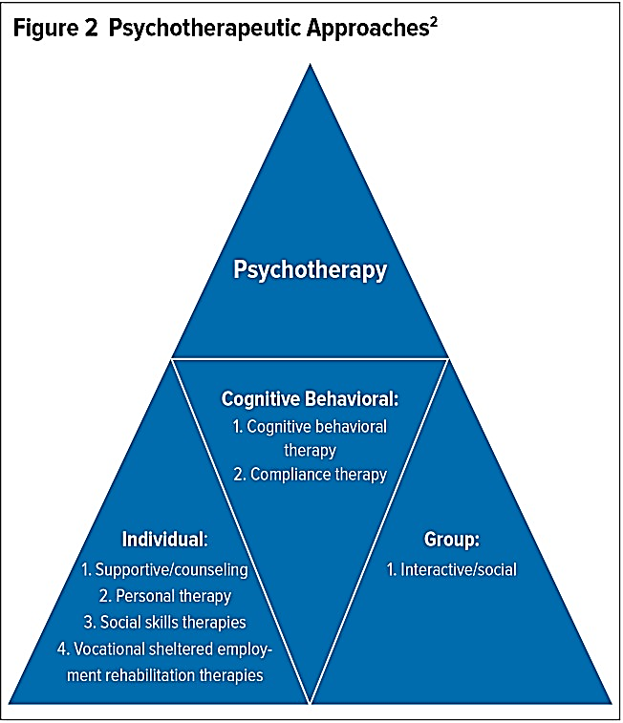
Figure 3: Different non-pharmacological treatment approaches for schizophrenia
Source: (Ganguly, Soliman and Moustafa, 2018)
Psychotherapeutic Approaches
Recent research suggests that psychosocial interventions based on community can improve the condition of patients with schizophrenia and other severe mental illness. Psychotherapeutic Approaches may be grouped into three categories: cognitive behaviour, individual and group. These include psychoeducation programs, cognitive therapy, social skills training programs, family intervention and assertive community treatment (ACT). Psychosocial treatments, combined with pharmacological treatments, improve the prognosis and prevent illness chronicity of schizophrenic patients (Chien et al., 2013). These psychosocial treatments help schizophrenic patients cope better with the symptoms of the diseases, such as hallucinations or delusions. The significant advantage of these non-pharmacological therapies is that they make the service user adhere to their medications, reduce their symptoms, and provide a cost-effecient approach to the good level treatment for schizophrenia. The rate of non-adherence service users in schizophrenia is very high for various reasons. Some people deny their illness, and others may experience adverse effects. Community-based treatment of schizophrenia mainly uses different categories of psychosocial interventions that have evidence of efficacy in symptom control and relapse prevention. The categories of psychosocial intervention include cognitive therapy (such as cognitive behaviour theory or cognitive remediation therapy), .Psychoeducation programs, social skills, training programs, case management or ACT and family interventions (Ganguly, Soliman and Moustafa, 2018). Psychosocial treatment of schizophrenia has the disadvantage of not serving in acute episodes, control of symptoms, and prevention of relapses. (Rubin et al., 2013).

Pharmacological Therapy
Antipsychotic drugs mainly focus on reducing the symptoms of the disease. These drugs are also known as neuroleptics or tranquillisers. These drugs are used as an initial treatment for acute schizophrenia. These drugs work by blocking dopaminergic pathways in the brain. Most patients with schizophrenia require antipsychotic agents as it is necessary to implement an effective rehabilitation program. Medication is vital, especially within the five years of the onset of the first acute episode, because at this time, most illness-related changes occur in the brain. No specific medications are available for schizophrenia. These drugs are suggested to reduce the suffering of the patients and improve their cognition and social functioning (Stępnicki, Kondej and Kaczor, 2018). Neuroleptics provides short-term relief from the positive symptoms of schizophrenia such as hallucinations, delusion and thought disorders and helps prevent relapse. These drugs have significantly less or no effects on the negative symptoms of schizophrenia. Acute schizophrenic patients generally respond well to these treatments compared to chronic schizophrenic patients. Antipsychotic drugs are further classified into Typical and atypical antipsychotics. Antipsychotics cause a variety of symptoms which are different for both types (Correll and Schooler, 2020).
Sartorius (2022) stated that treatments of schizophrenia result in better outcomes if the patients actively participate and perform their duties actively. Previously, patients with schizophrenia were placed in an asylum and treated with a high dose of sedative drugs restricting their psychotic behaviour. Furthermore, these patients were also treated with cold and electroconvulsive therapy or ECT. Thomann et al. (2017) reported that ECT results in a break in the patient’s back. Physical side effects related to tension (nausea, headache, jaw aches, and muscle aches. Cognitive side effects as confusion. However several attempts has been made to improve and reduce the risk of ECT such as unilateral ECT in which electric current is applied only on one side of the brain , development of type of ECT called ultrabrief pulse. Other improvements include greater uniformity of informed consent across institutions, an increasing number of national locations at which clinicians can get specialized ECT training.
An evidence-based study conducted by Krause et al. (2018) reported that the antipsychotic drug clozapine helps in reducing the negative symptoms, which psychosocial interventions and other antipsychotic drugs cannot reduce.

5. Measurements of Rehabilitations
The rehabilitations measures in schizophrenic patients aim to help them resume their social activities and work and perform independently in society. Medical treatments help in the 60 % recovery of the patients, but rehabilitation interventions are vital for complete recovery and relapse prevention. Schizophrenic patients even show impairments in some functions after the clinical improvements. However, the rehabilitation interventions for different patients are different. Understandings the need of Schizophrenic patients and their caregiver also help in the understanding of the rehabilitation need for further implementation of psychosocial interventions (Kirsh et al., 2019).

Cognition Remediation
It is a behaviour-based training intervention that aims to improve cognitive processes such as memory, executive functions and social cognition. This help in the reduction of the impact of cognitive impairment in daily life. However, Sathienluckana et al. (2018) argue the benefits of cognition remediation and state that pharmacological treatment (Anticholinergic medication) decreases the benefits of cognition remediation and other psychosocial interventions. Medical treatment should be significantly less during cognition remediation. Ahmed et al. (2015) claimed that cognitive remediation provides benefits to schizophrenic patients. When combined with psychiatric rehabilitation, their benefits increase to functioning. Further, Wykes, Crowther and Reeder (2016) argued for the importance of cognition remediation and stated that cognition remediation is ineffective on symptoms. Furthermore, Kim et al. (2018) claimed that it is only effective in fewer symptoms patients.
Psychoeducation
This therapy involves the collaborative work between mental health professionals and schizophrenic patients to share the burden of the illness and work for the patient’s recovery. Caqueo-Urízar et al. (2015) stated that the primary goal of psychoeducational programs is to help schizophrenic patients and their families to understand their disease and the treatments, also cooperate with the caregivers and participate in improving the quality of life and treatments. Morin and Franck (2017) reported that psychoeducation programs help patients to adhere to treatments, reduce the relapse rate and increase social functioning.
Cognitive Behaviour Therapy
A psychotherapeutic approach that helps patients to improve their thinking has a negative effect on behaviour and emotions. This therapy helps identify abnormal or disturbing thoughts and replaces them with more objective and realistic thoughts. An evidence-based study conducted by Correll et al. (2018) reported that the majority of the people treated with CBT as standard care showed improvement and fewer relapses of the symptoms.
CBT is a group of therapies that help modify behaviour and thoughts through learning. Laws et al. (2018) concluded that CBT has significantly fewer benefits. However, the conclusion was contested by Gates et al. (2017), who reported that social skills training has significant effects on behavioural skills. Batinic (2019) limit the efficacy of CBT by concluding that CBT has no effects on negative symptoms of schizophrenia.
Evaluation of response to treatment is essential after diagnosis and treatment plan. It helps track the patient’s progress to determine the effectiveness of the care plan. The response is improvement in schizophrenic patients, although it can continue to exhibit some symptoms. In clinical practice, the various scales are more widely used to evaluate the response of the treatment, such as the Brief psychiatric scale, BPRS (measure the reduction from initial score), positive or negative syndrome scale (PANSS), the global assessment of functioning (GAF) and the Clinical Global Impression Scale (CGI). There is no cut-off value for the reduction of symptoms from the initial is available, which creates a problem. 25% reductions on BPRS /PANSS scale correspond to the minimal improvement, while 50 reductions correspond to much improvements in schizophrenic patients. In chronic patients, significantly less reduction is also considered as significant (McCutcheon, Marques and Howes, 2020).
Although medications and supportive therapies do not affect social skills, cognitive impairments and interaction disorders, rehabilitation tools target these easily.

6. Recommendation for Future Practice
A literature review in this report on medical approaches to treat schizophrenia help in providing better information on the current treatments and the limitations of schizophrenia. Combining antipsychotics with other psychotropic drugs show significant results in lessening relapse, however the are side effects New antipsychotics are continually used in treating schizophrenia, but it is necessary to conduct clinical trials and select those psychotic drugs for treatment with fewer side effects. Also, further research is a need to set the dosage of these drugs according to the illness conditions (Shimomura et al., 2020).
A deep understanding of the functional, molecular and pathophysiological nature of schizophrenia, helps in the treatment approaches that help in the earlier prognosis and prevent further progression of the illness. It also helps develop personalised treatments according to patients’ characteristics and illness conditions. To facilitate schizophrenic patients with personalised treatment. It is essential to engage them in collaboration and inform them about the decision of treatment preferences and needs, the pros and cons of the given treatments and the other treatment options available for different stages of the disease (Szkultecka-Dębek et al., 2015).
It is recommended that those treating people with schizophrenia engage in collaborative and informed decision-making by evaluating each patient’s treatment needs and preferences, the effects and limitations of current treatments, and alternative treatment options at various stages of the illness to facilitate personalised treatment.
Alternative medical treatments showed minimal effects if they were singly but more significant results when given with medical treatments. So, psychosocial interventions and medication should be further calculated to strengthen their satisfactory outcomes in schizophrenic patients (NIH, 2022).
Evidence-based studies showed that psychosocial interventions significantly impact the improvement of psychotic s symptoms and their functioning. Therefore, these interventions are widely used in treating schizophrenic patients. Further study is required to improve them by identifying the effective or therapeutic components of these interventions. It leads to the improvement in their combined use and the cost-effectiveness in treating schizophrenic patients. Progressive impairments in cognitive functions and persistent negative symptoms are significant challenges in treating schizophrenia. It can be overcome by using new pharmacological strategies such as 5HT1A, dopamine receptors and glutamate agonists that have evidence to reduce negative symptoms and improve cognitive functions (Asher, Patel and De Silva, 2017).
Further research is required to fight these two deficits in schizophrenic patients. Further, more new strategies would be required to detect risks and signs of schizophrenia. Early detection and treatment of schizophrenia can reduce its progression into severe behaviour and cognitive problems.

7. Conclusion
It is concluded from the above reports that schizophrenia is a complex mental disorder with various causes. The history of schizophrenia is ancient, but the term is new. It is also the most common severe mental disorder characterised by hallucinations, delusion and impairments in cognitive functions. This report further highlights the essential criteria for the diagnosis of schizophrenia according to the two most widely used systems, ICD-10 and DSM-5. It highlights the importance of ICD-10, the most commonly used system for diagnosing and treating schizophrenia, as this system was made based on the data collected from different countries.
Moreover, this report contains information on different types of schizophrenia as ICD-10 classifications and provides alphanumeric codes. This report further presented a detailed overview of the treatment approaches for schizophrenia and reported that no specific medication is available for complete treatment. However, rehabilitation is essential in the recovery from schizophrenia. Schizophrenia affects the cognition, social work and life of the person. So, recovery treatment must include an emphasis on these aspects. According to the literature, many psychological interventions or rehabilitation showed valuable effects on cognitive and social work impairments.
However, further measurements needed to improve the treatment include a combination of antipsychotics and psychotropic drugs that help eliminate psychiatric symptoms. Generalisation techniques (home-based exercise) are needed as they help patients practice skills in natural situations. A patients-focused perspective must be followed to increase the satisfaction of the patients. More excellent knowledge and efforts are required to suggest effective rehabilitation therapy. Moreover, developing of community-based clinical strategies for the most important is identifying early signs and symptoms and providing early treatment, as this help in the recovery of schizophrenic patients because neurological damage is fast in the early stages. (Onitsuka et al., 2022).

8. References
Ahmed, A.O., Hunter, K.M., Goodrum, N.M., Batten, N.J., Birgenheir, D., Hardison, E., Dixon, T.
and Buckley, P.F. (2015) ‘A randomised study of cognitive remediation for forensic and mental
health patients with schizophrenia’. Journal of psychiatric research, 68, pp.8-18.
Asher, L., Patel, V. and De Silva, M.J. (2017) ‘Community-based psychosocial interventions for
people with schizophrenia in low and middle-income countries: systematic review and meta
analysis’. BMC psychiatry, 17(1), pp.1-15.
Baklund, I., Dammen, T., Moum, T., Kristiansen, W., Duarte, D., Castro-Marrero, J., Helland, I. & Strand, E. (2021) Evaluating Routine Blood Tests According to Clinical Symptoms and Diagnostic Criteria in Individuals with Myalgic Encephalomyelitis/Chronic Fatigue Syndrome. Journal of Clinical Medicine. 10 (14). p. 3105. [Online]. DOI: 10.3390/jcm1014310 9 (Accessed: 23 July 2022)..
Batinic, B. (2019) ‘Cognitive models of positive and negative symptoms of schizophrenia and
implications for treatment’. Psychiatria Danubina, 31(suppl 2), pp.181-184.
Burgin, S., Reniers, R. & Humpston, C. (2022) Prevalence and assessment of self-disorders in the schizophrenia spectrum: a systematic review and meta-analysis. Scientific Reports. 12 (1). [Online]. DOI: 10.1038/s41598-022-05232-9.
Caqueo-Urízar, A., Rus-Calafell, M., Urzúa, A., Escudero, J. and Gutiérrez-Maldonado, J. (2015) ‘The role of family therapy in the management of schizophrenia: challenges and solutions’. Neuropsychiatric disease and treatment, 11, p.145.
Castagnini, A.C. and Fusar-Poli, P. (2017) ‘Diagnostic validity of ICD-10 acute and transient
psychotic disorders and DSM-5 brief psychotic disorder’. European Psychiatry, 45, pp.104-113
Chien, W.T., Leung, S.F., Yeung, F.K. and Wong, W.K. (2013) ‘Current approaches to
treatments for schizophrenia spectrum disorders, part II: psychosocial interventions and patient-
focused perspectives in psychiatric care.’ Neuropsychiatric disease and treatment, 9, p.1463.
Correll, C.U. and Schooler, N.R. (2020) ‘Negative Symptoms in Schizophrenia: A Review and
Clinical Guide for Recognition, Assessment, and Treatment’. Neuropsychiatric disease and
treatment 16 pp 519-534.
Correll, C.U., Rubio, J.M. and Kane, J.M. (2018) ‘What is the risk‐benefit ratio of long‐term
antipsychotic treatment in people with schizophrenia?’ World Psychiatry, 17(2), pp.149-160.
Davidson, M. (2019) ‘Cognitive impairment as a diagnostic criterion and treatment target in
schizophrenia’. World Psychiatry, 18(2), p.171.
Gaebel, W., Kerst, A. and Stricker, J. (2020) ‘Classification and diagnosis of schizophrenia or
other primary psychotic disorders: changes from ICD-10 to ICD-11 and implementation in
clinical practice.’ Psychiatria Danubina, 32(3-4), pp.320-324
Ganguly, P., Soliman, A. and Moustafa, A.A. (2018) ‘Holistic management of schizophrenia
symptoms using pharmacological and non-pharmacological treatment’. Frontiers in public
health, 6, p.166.
Gibbons, R.D., Weiss, D.J., Frank, E. and Kupfer, D. (2016) ‘Computerised adaptive diagnosis
and testing of mental health disorders’. Annual review of clinical psychology, 12, pp.83-104.
Gross, R. (2020) Psychology: The Science of Mind and Behaviour 8th Edition. London: Hodder Education.
Fortinash, K. & Holoday-Worret, P. (2012) Psychiatric mental health nursing. St. Louis, Mo.: Elsevier Mosby.
Kane, J.M., Agid, O., Baldwin, M.L., Howes, O., Lindenmayer, J.P., Marder, S., Olfson, M., Potkin, S.G. and Correll, C.U. (2019) ‘Clinical guidance on the identification and management of treatment-resistant schizophrenia’. The Journal of clinical psychiatry, 80(2), p.2783.
Kim, E.J., Bahk, Y.C., Oh, H., Lee, W.H., Lee, J.S. and Choi, K.H. (2018) ‘Current status of
cognitive remediation for psychiatric disorders: a review’. Frontiers in psychiatry, 9, p.461.
Kirsh, B., Martin, L., Hultqvist, J. and Eklund, M. (2019) ‘Occupational therapy interventions in
mental health: A literature review in search of evidence’. Occupational Therapy in Mental
Health, 35(2), pp.109-156.
Krause, M., Zhu, Y., Huhn, M., Schneider-Thoma, J., Bighelli, I., Nikolakopoulou, A. and Leucht,
S. (2018). ‘Antipsychotic drugs for patients with schizophrenia and predominant or prominent
negative symptoms: a systematic review and meta-analysis.’ European archives of psychiatry
and clinical neuroscience, 268(7), pp.625-639.
Lake, C. (2012) Schizophrenia is a misdiagnosis. New York: Springer.
Laws, K.R., Darlington, N., Kondel, T.K., McKenna, P.J. and Jauhar, S. (2018) ‘Cognitive Behavioural Therapy for schizophrenia-outcomes for functioning, distress and quality of life: a meta-analysis’. BMC psychology, 6(1), pp.1-10.
McCutcheon, R.A., Marques, T.R. and Howes, O.D. (2020) ‘Schizophrenia—an
overview’. JAMA psychiatry, 77(2), pp.201-210.
Morin, L. and Franck, N., (2017) Rehabilitation interventions to promote recovery from
schizophrenia: a systematic review’. Frontiers in psychiatry, 8, p.100.
NHS UK (2022) Diagnosis - Schizophrenia [Online]. Available from https://www.nhs.uk/mental-health/conditions/schizophrenia/diagnosis/#:~:text=There's%20no%20single%20test%20for,schizophrenia%20is%20treated%2C (Accessed: 23 July 2022)
NIH (2022) Schizophrenia. [Online] National Institute of Mental Health (NIMH). Available at:
https://www.nimh.nih.gov/health/statistics/schizophrenia (Accessed 19 July 2022).
.Onitsuka, T., Hirano, Y., Nakazawa, T., Ichihashi, K., Miura, K., Inada, K., Mitoma, R.,
Yasui‐Furukori, N. and Hashimoto, R. (2022) ‘Toward recovery in schizophrenia: Current
concepts, findings, and future research directions’. Psychiatry and clinical neurosciences.).
Roth, C., Wensing, M., Kuzman, M.R., Bjedov, S., Medved, S., Istvanovic, A., Grbic, D.S.,
Simetin, I.P., Tomcuk, A., Dedovic, J. and Djurisic, T. (2021) ‘Experiences of healthcare staff
providing community-based mental healthcare as a multidisciplinary community mental health
team in Central and Eastern Europe findings from the RECOVER-E project: observational
intervention study’. BMC psychiatry, 21(1), pp.1-15
Rubin, A., Trawver, K. & Springer, D. (2013) Psychosocial treatment of schizophrenia. Hoboken, N.J.: Wiley.
Sartorius, N. (2022) ‘Patient-reported outcomes in psychiatry’. Dialogues in clinical neuroscience.
Sathienluckana, T., Unaharassamee, W., Suthisisang, C., Suanchang, O. and Suansanae, T.
(2018) ‘Anticholinergic discontinuation and cognitive functions in patients with schizophrenia: a
pharmacist–physician collaboration in the outpatient department’. Integrated pharmacy research
& practice, 7, p.161.
Shimomura, Y., Kikuchi, Y., Suzuki, T., Uchida, H., Mimura, M. and Takeuchi, H. (2020)
Antipsychotic treatment in the maintenance phase of schizophrenia: an updated systematic
review of the guidelines and algorithms’. Schizophrenia Research, 215, pp.8-16.
Shoeibi, A., Sadeghi, D., Moridian, P., Ghassemi, N., Heras, J., Alizadehsani, R., Khadem, A.,
Kong, Y., Nahavandi, S., Zhang, Y.D. and Gorriz, J.M. (2021) ‘Automatic diagnosis of
schizophrenia in EEG signals using CNN-LSTM models’. Frontiers in Neuroinformatics, 15.
Stępnicki, P., Kondej, M. and Kaczor, A.A., (2018) ‘Current concepts and treatments of
schizophrenia’. Molecules, 23(8), p.2087.
Smitha Bhandari (2022). Mental Health and Schizophrenia. [Online] WebMD. Available at:
https://www.webmd.com/schizophrenia/mental-health-schizophrenia (Accessed 21 July 2022)
Thomann, P.A., Wolf, R.C., Nolte, H.M., Hirjak, D., Hofer, S., Seidl, U., Depping, M.S., Stieltjes,
B., Maier-Hein, K., Sambataro, F. and Wüstenberg, T. (2017) ‘Neuromodulation in response to
electroconvulsive therapy in schizophrenia and major depression’. Brain stimulation, 10(3),
pp.637-644.
Valle, R. (2020) ‘Schizophrenia in ICD-11: Comparison of ICD-10 and DSM-5’. Revista de
Psiquiatría y Salud Mental (English Edition), 13(2), pp.95-104.
Wykes, T., Crowther, A. and Reeder, C. (2016). ‘A Metacognitive Approach to Cognitive
Remediation.’ Cognitive Remediation to Improve Functional Outcomes, p.88.
WHO (2022) Schizophrenia. [Online] Available at:
https://www.who.int/news-room/fact
sheets/detail/schizophrenia (Accessed 10 June 2022).
Zachar, P., Stoyanov, D., Aragona, M. & Zhablenski, A. (2015) Alternative perspectives on psychiatric validation. Oxford: Oxford University Press..

