Vivien Tam (2505794)

Date: 19/11/2025
HTML & CSS Web Development
ACCA4023

Contents
Introduction 2
Requirements 3
Implementation 4
Validation 10
Evaluation 12
Comparison 14
Conclusion 15
References 16
Appendices 17

Introduction
This report consists of the design, implementation, and evaluation of a website that I created using raw HTML and CSS. The website focuses on Hong Kong cuisine, with particular attention to hotpot, dim sum, and street food. The intended audience for this website includes anyone interested in exploring different cuisines or prospective travellers to Hong Kong. Since this website was developed as part of the Introduction to Web and Database Concepts course at university, lecturers and reviewers are also considered targeted viewers.
The report first briefly describes the implementation of the website, with screenshots included to better explain my ideas. A detailed evaluation is then provided based on website usability, accessibility, and search engine optimization (SEO). Industry standards such as ISO 9241-11 for usability, WCAG 2.1 for accessibility, and general SEO practices are applied to support the evaluation. Finally, future improvements are discussed, and comparisons are made with the BBC and Wikipedia websites to highlight best practices in professional web development.

Requirements
This report is based on the website created for the assignment, which demonstrates proficiency in web design and the use of HTML and CSS. The website introduces Hong Kong cuisine, focusing on hotpot, dim sum, and street food. The purpose of the website is to reflect my computing and design skills by creating a website using raw HTML and CSS with Microsoft Visual Studio Code.
The intended audience includes anyone interested in learning more about Hong Kong cuisine and travellers looking for food recommendations in Hong Kong. Lecturers and peers are also intended viewers to review my coding skills and provide feedback.
The project also focuses on practical learning outcomes, including understanding semantic HTML, implementing CSS layout techniques, and applying usability, accessibility, and SEO principles in real-world scenarios. Testing and validating code to ensure compliance with web standards is also part of the project.

Implementation
Home Page-
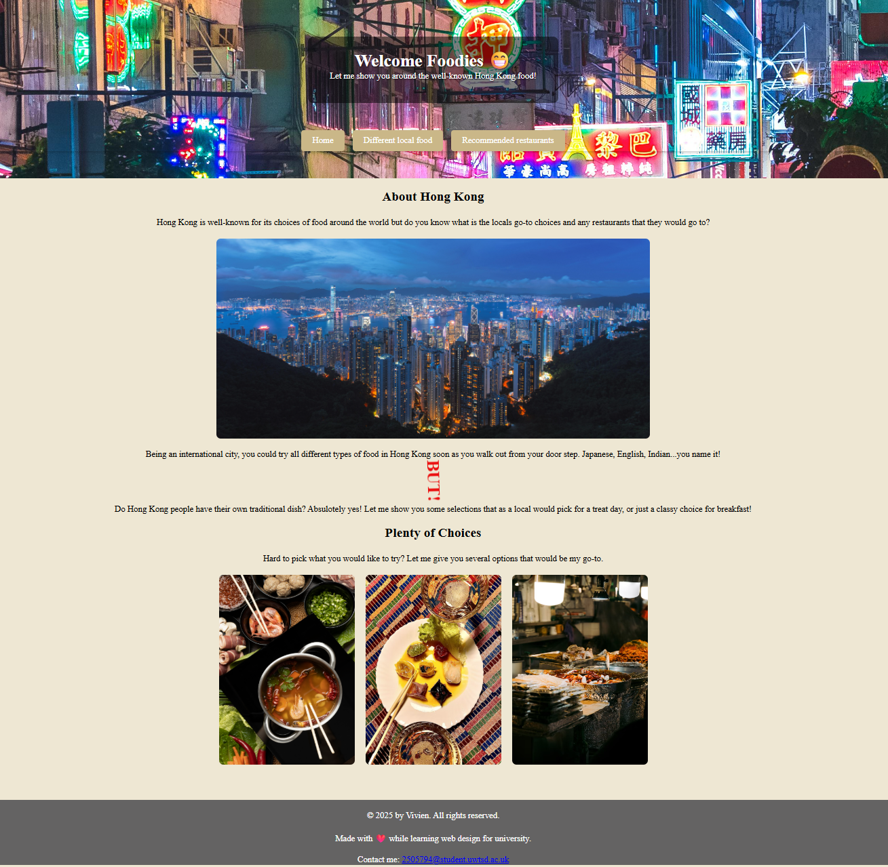
I used an image of a Hong Kong street view as the header image. Another image is included in the body to provide a wider view of what users can expect if they visit Hong Kong. At the bottom of the homepage, a clickable image row allows users to navigate to other pages. The images provide a brief overview of the food they could try, and a hover description appears so users can see the name and description of each type of meal.

Image Row-
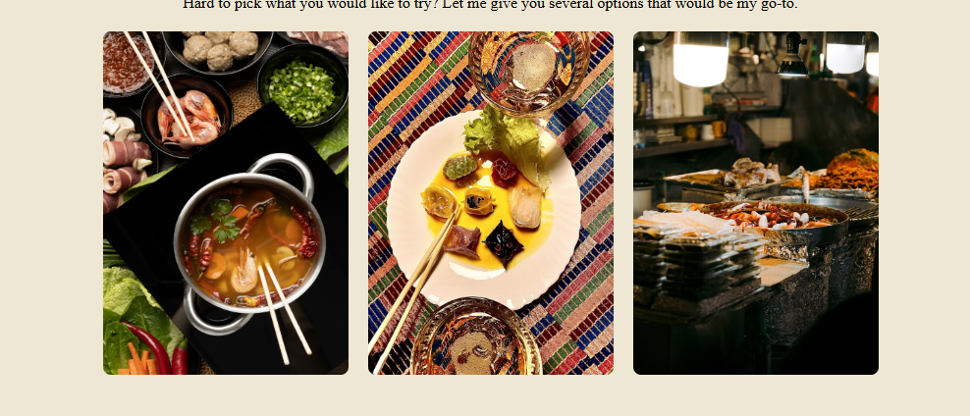
The clickable image row links to individual pages for hotpot, dim sum, and street food. The hover descriptions help users identify the type of food before clicking, making the navigation intuitive and simple.
Different local food-
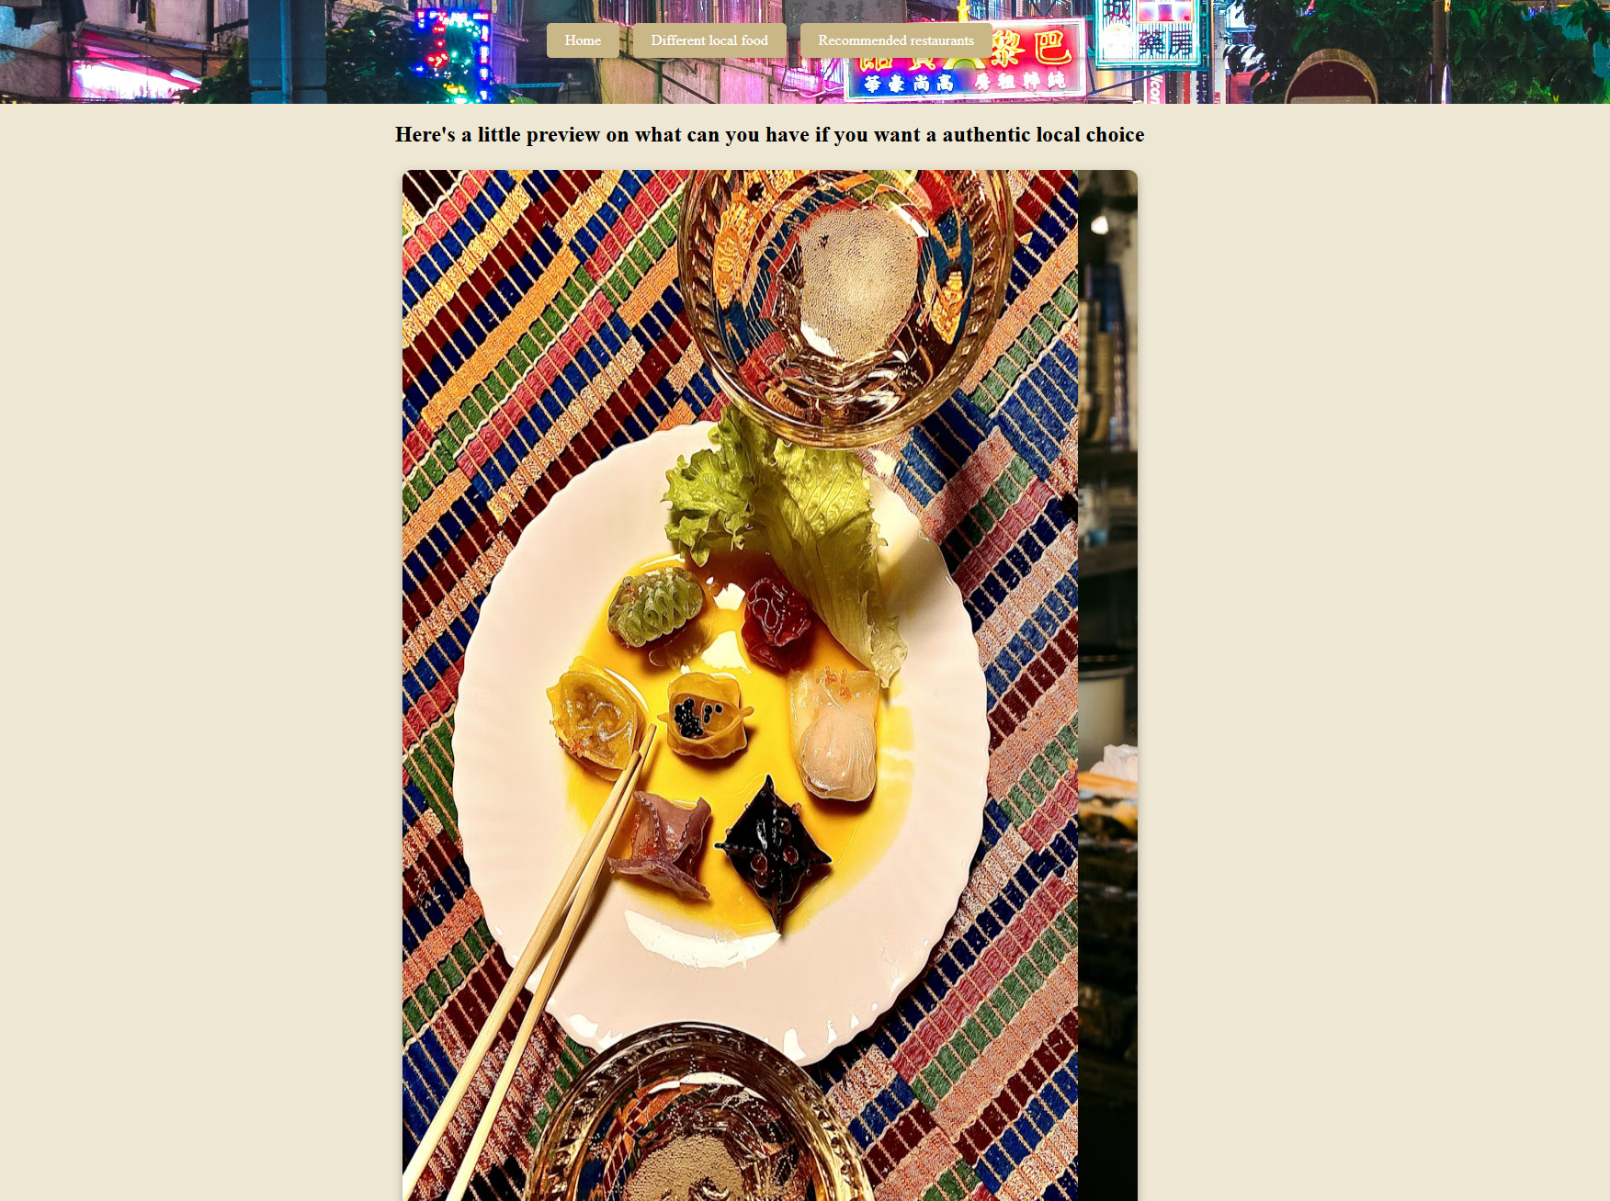
On the “Different Local Food” page, I included a sliding image box for a few photos that slide automatically. This provides larger and clearer images so users can better see what to expect from Chinese cuisine. The sliding effect adds a small interactive element that makes the page more engaging.
Recommended restaurants-
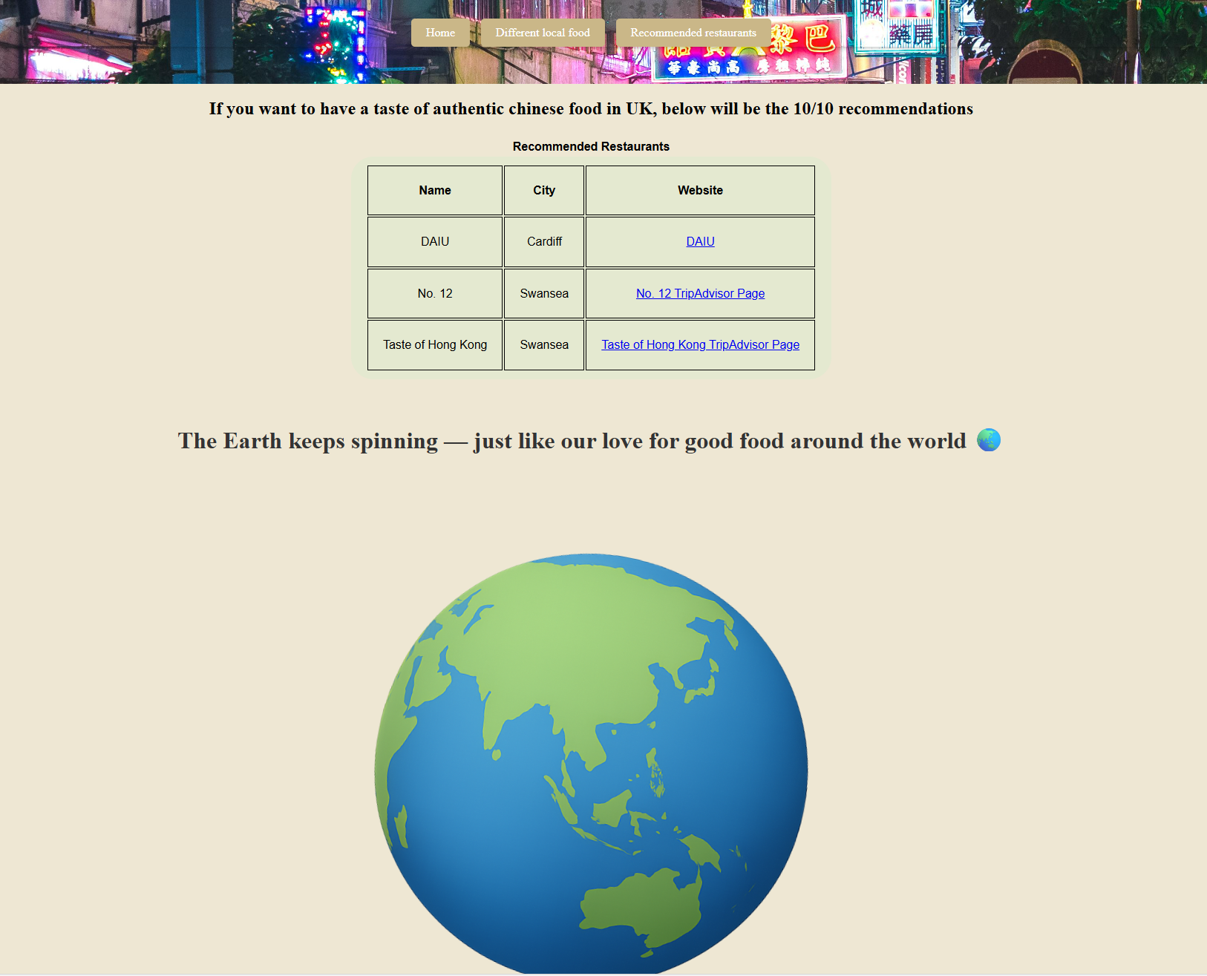

On this page, I created a table that lists recommended local restaurants, including their names, brief locations, and links to their websites. A spinning earth animation is also included to emphasize the international nature of cuisine and make the website more visually interesting.

Hotpot-
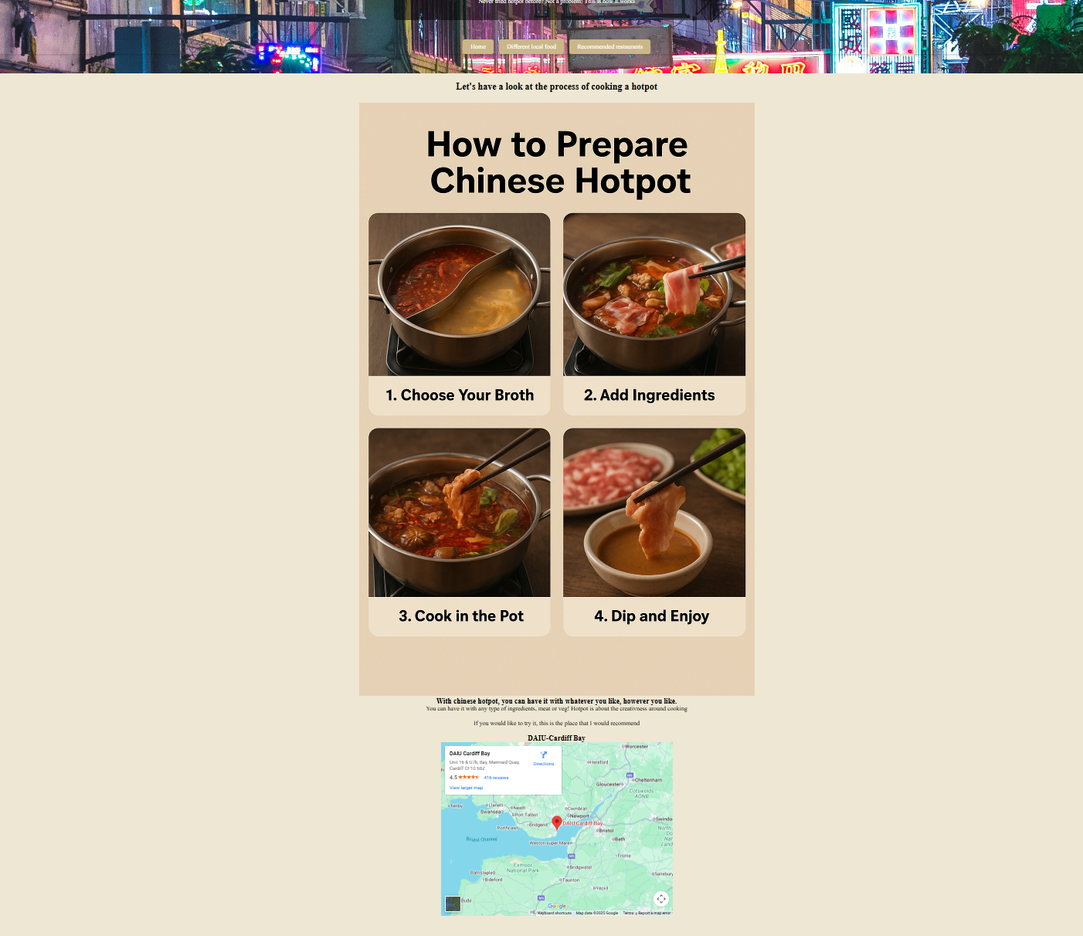
This page includes images showing how to prepare and eat hotpot. An embedded map at the bottom shows the locations of recommended restaurants, which adds practical value for users.

Dim sum-
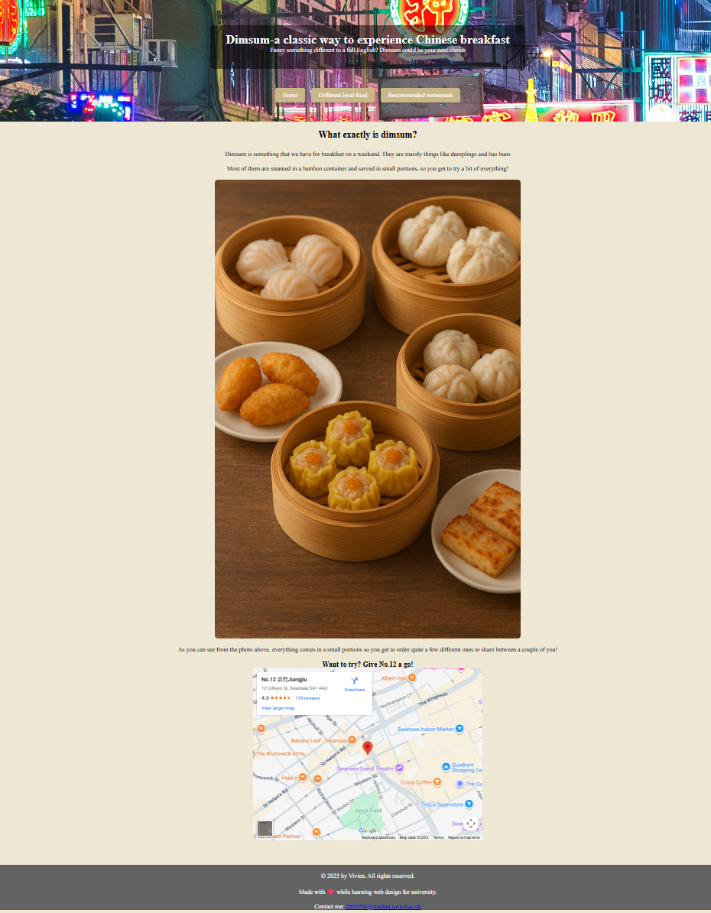
Similar to the hotpot page, images show the food, and an embedded map highlights recommended restaurant locations.

Street food-
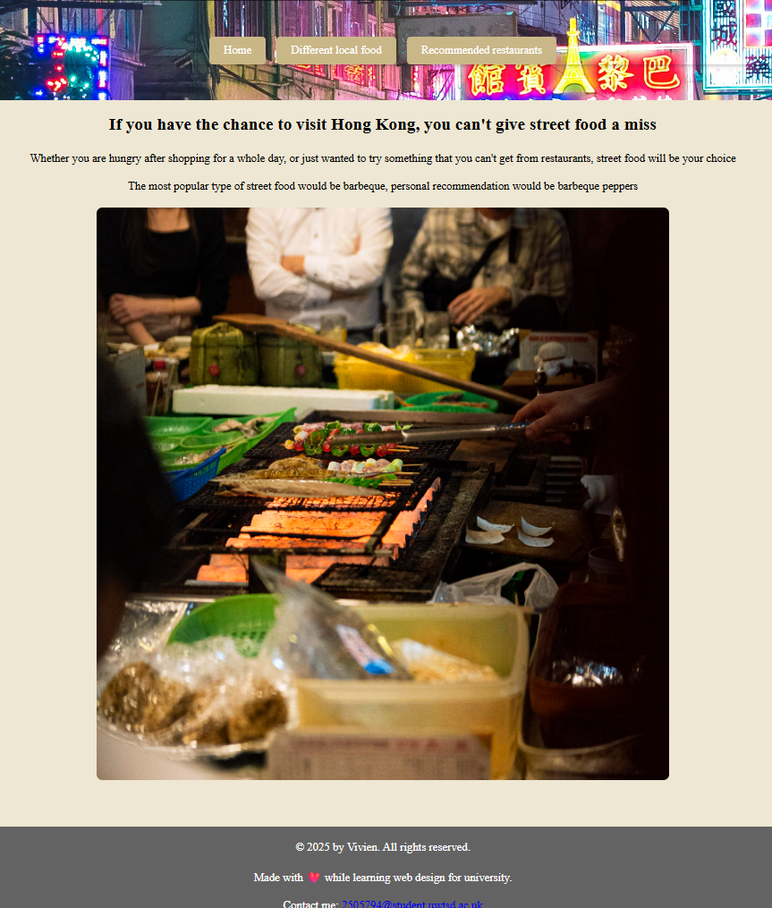
Images of street food are included, with a brief description at the top of the page. The layout is consistent with the other pages, keeping the design simple and easy to navigate.

Validation
I have validated my website after the completion of coding.
HTML
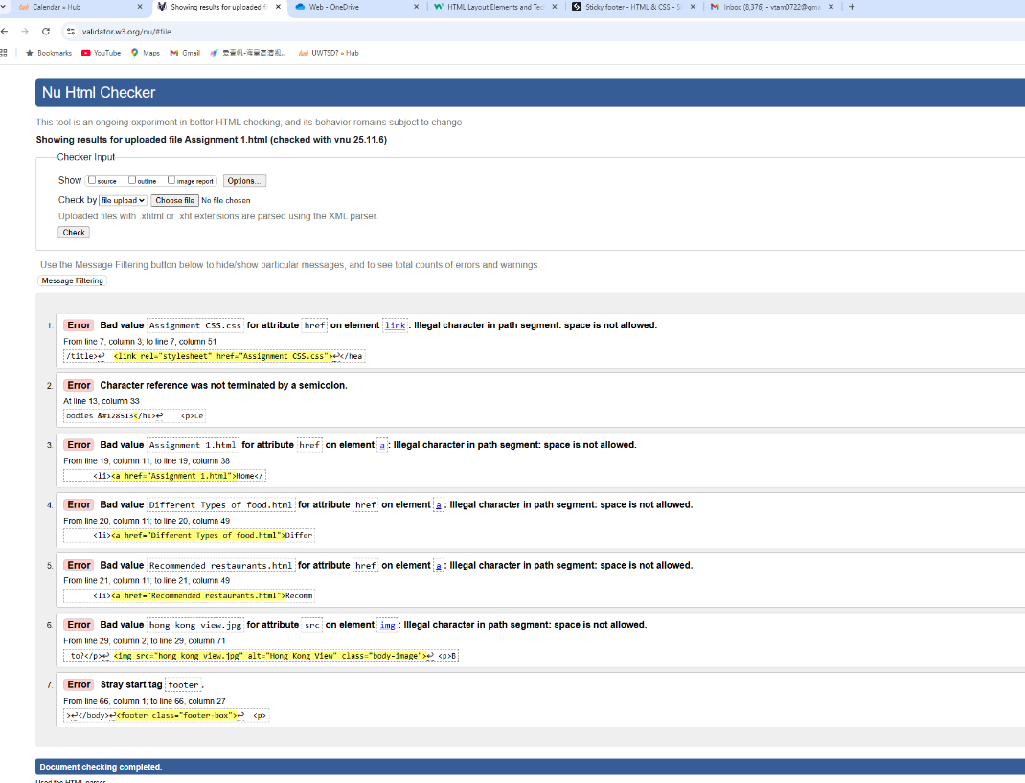
After finishing the coding, I validated my website. On the homepage HTML file (Assignment_1), seven errors were detected. Most of these were due to spaces in file names. I renamed all the documents using underscores, which solved these errors.
There was also a missing semicolon error, which I added to fix the issue.
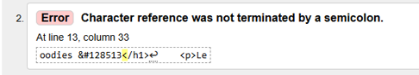
The semicolon then has been added to the HTML and rectified the error.
The last error reported a stray <footer> start tag. Initially, the footer was placed outside the <body> section. I fixed this by moving the footer section inside the <body>.
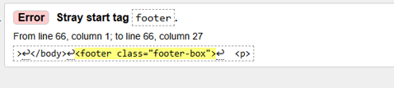
CSS
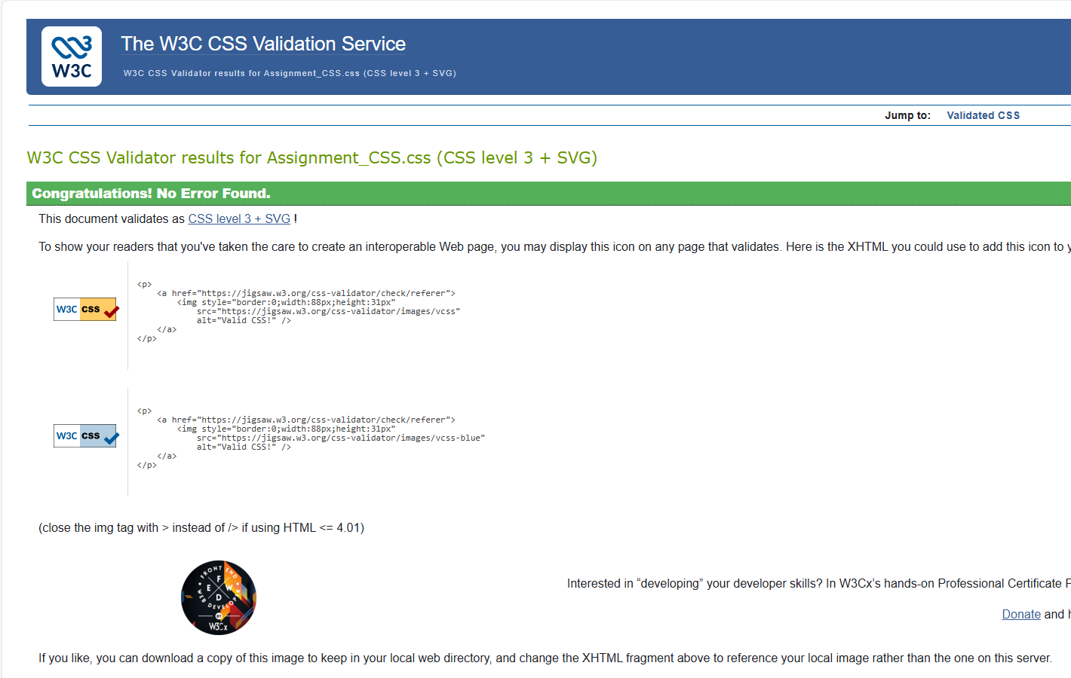
CSS validation using the W3C service detected no errors. The CSS ensured consistent styling, proper layout rendering, and compatibility across different browsers. I also tested the website manually on multiple browsers and devices to confirm responsive behaviour and correct display of images, headings, and navigation.
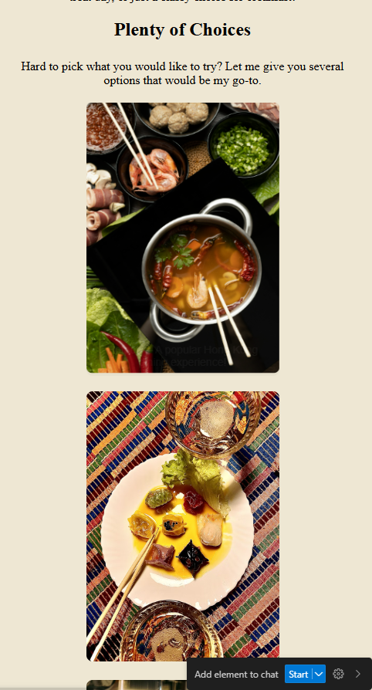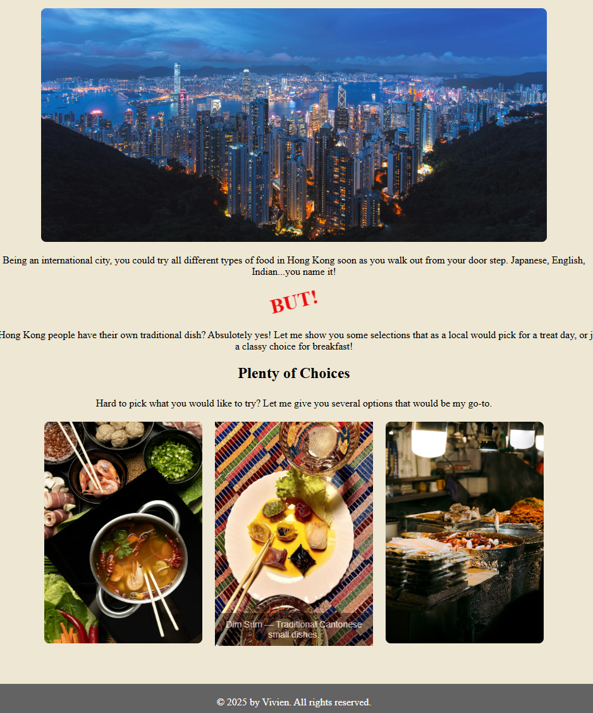

Evaluation
Usability:
Website usability is important because it shows whether a website is easy to use. There’s been more focus recently on whether websites are user-friendly, but developers still face challenges when improving interfaces [1]. According to ISO 9241-11, usability is “the extent to which a product can be used by specified users to achieve specified goals with effectiveness, efficiency and satisfaction in a specified context of use” [2].

I have reviewed a study in relation to how visual design elements (such as images, icons, colours, layout) are used in e-learning interfaces. It has found that when a website has interactive visual elements, it will increase the engagement of users and visual learning process where there are meaning images attached to a website but only if it is not cluttered as overuse of decorative elements could create cognitive load and can be distracting. [3]
For my website, I added a navigation row in the header, letting users switch pages freely. This improves the user experience and makes the website more interactive.
For my website, I added a navigation row in the header, allowing users to freely switch between pages. This improves the user experience and makes the website more interactive.
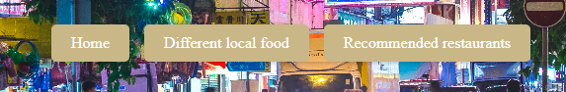
I also used a <meta> viewport tag to make the layout responsive, so content adjusts to different screen sizes and devices.
Future improvements could include adding an active page indicator to show which page the user is on and making the navigation bar “sticky” so it stays at the top while scrolling. Adding small interactive elements like tooltips could also make the site feel more dynamic.

Accessibility:
The W3C defines web accessibility as: “Web accessibility means that websites, tools, and technologies are designed and developed so that people with disabilities can use them” [4]. Accessibility includes visual, auditory, and cognitive considerations to ensure all users can access content. According to P. Brophy and J. Craven’s study, the have defined web accessibility as people that has wide range of disability, such as visual impairment, hearing, motor and cognitive issues will be able to use the website effectively. Common poor structures have been found such as insignificant navigation structure, images without alternative text and inconsistent page layout and labelling. It was recommended to adapt WCAG consistently and apply accessibility testing tools to ensure the website reaches its best accessibility [5].
I included the lang attribute in my HTML to help screen readers interpret text correctly. The layout flows logically from header to body to footer.
All links are active, and the background and text colours have good contrast, which I checked using an online contrast tool to meet WCAG standards.
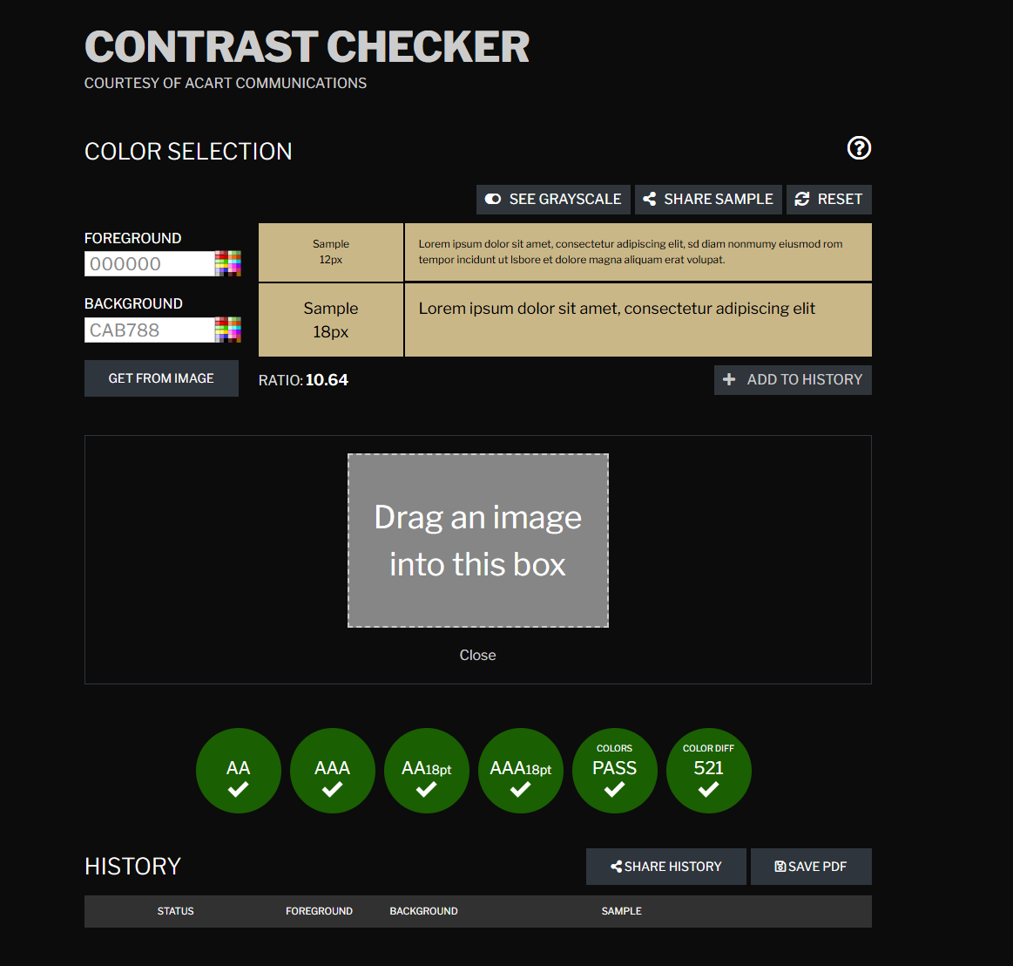
Future improvements could include testing with screen readers like NVDA or Voiceover to make sure the reading order is correct. Alt text for images could also be more detailed to help screen readers describe content more accurately.

Search Engine Optimisation (SEO):
SEO is about using techniques to help websites appear higher in search results [6]. Key areas include meta tags, headings, image alt text, and descriptive links. S. Bahri & D. Purba has conducted a SEO research on what techniques can be integrated into web design to improve visability on search engines. Google webmaster, Google Analytics and SEO analytics tools were applied to analyse meta tags. It is found that after applying the SEO techniques, websites have significantly improved visibility on search engines. [7]
On my website, I added headings on all pages, descriptive alt text for images, and clear file names. This makes it easier for search engines to understand what the website is about.
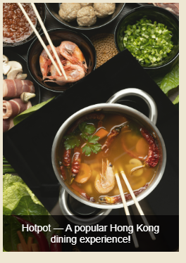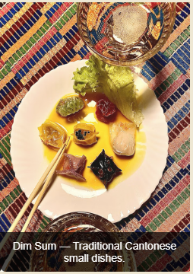
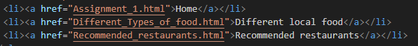
Future improvements could include adding meta description tags for each page, more text content, and internal links between pages to improve visibility. Using structured data could also help search engines index the content better.

Comparison
To further evaluate and identify improvements, I compared my website with the BBC and Wikipedia websites.
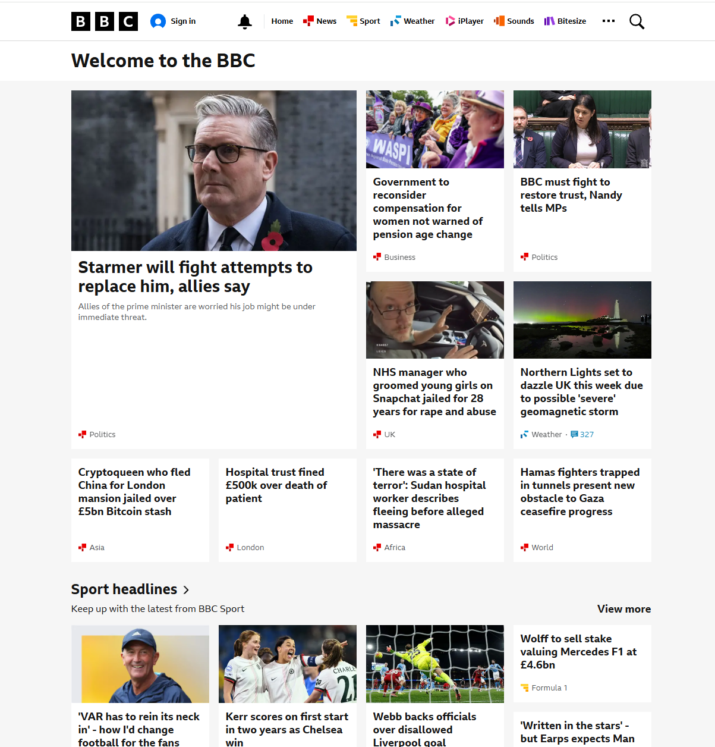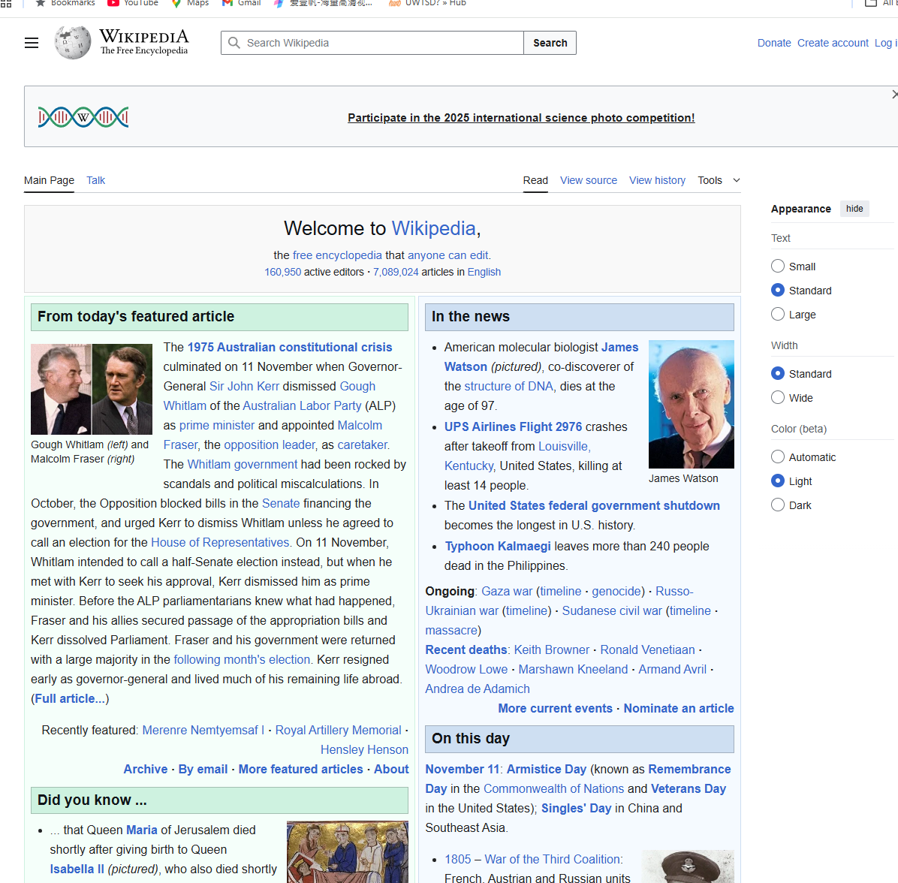

My website is basic, with only five pages, while BBC and Wikipedia have thousands. Their layouts are more complex, with multiple navigation tabs and interactive features. Both websites are responsive and adjust automatically for different devices, giving users a smoother experience.
Wikipedia offers multilingual pages, allowing users to view the same topic in different languages. Both BBC and Wikipedia use high-contrast colours and fonts, following WCAG guidelines. Users can adjust text size, background colour, and window width on Wikipedia, and text-to-audio features are available for both. My website currently only includes basic accessibility features.
I used basic SEO features like headings, alt text, and descriptive file names. In comparison, Wikipedia and BBC include optimized metadata, internal and external links, and extensive content that helps them rank higher in search engines [8][9]. Their websites are more discoverable and fully developed.
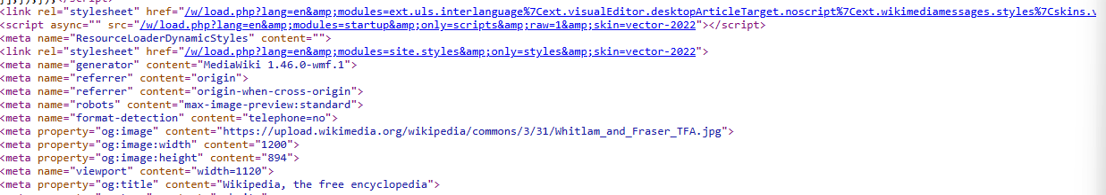
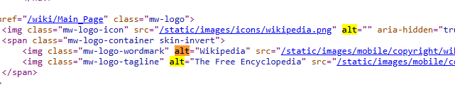

Conclusion
The website shows how HTML and CSS can be used to create a functional and visually appealing site about Hong Kong cuisine. It covers basic usability, accessibility, and SEO, giving users an interactive and educational experience.
For future improvements, I could make the website more user-friendly by adding interactive features and a sticky navigation bar. Accessibility could be improved by testing with screen readers and refining alt text. SEO could be enhanced with meta descriptions, internal links, and more text content.
Comparing my website to BBC and Wikipedia shows there’s room to grow, especially in scalability, accessibility features, and advanced SEO.
Overall, this project meets the course objectives and provides a solid foundation for further development in web design.

References
[1] S. Al-Khalifa and A. Al-Ajlan, “Evaluation of usability factors in e-learning websites based on ISO 9241-11,” International Journal of Human-Computer Interaction, vol. 34, no. 5, pp. 456–470, 2018.
[2] International Organization for Standardization, ISO 9241-11: Ergonomic Requirements for Office Work with Visual Display Terminals (VDTs) – Part 11: Guidance on Usability, Geneva, Switzerland: ISO, 1998.
[3] Adnan, A. S., Ali, M., & Ahmad, R. (2015). The utilisation of visual elements on interface design of e-learning application. In A. Zaidi, K. A. Rahman, N. Z. Abidin, S. Z. Mohid & S. M. Sofi (Eds.), Proc. of the International Conference on Information Technology & Society (IC-ITS 2015) (pp. 273–279).
[4] World Wide Web Consortium, “Introduction to Web Accessibility,” Web Accessibility Initiative (WAI), Mar. 7 2024. [Online]. Available: https://www.w3.org/WAI/fundamentals/accessibility-intro/
[5] P. Brophy and J. Craven, "Web Accessibility," Library Trends, vol. 55, (4), pp. 950-972, 2007. Available: https://www.proquest.com/scholarly-journals/web-accessibility/docview/220456200/se-2. DOI: https://doi.org/10.1353/lib.2007.0029.
[6] V. Beal, “SEO Dictionary: 85 Search Engine Optimization Phrases Defined,” Webopedia, May 24 2021. [Online]. Available: https://www.webopedia.com/reference/seo-dictionary/
[7] S. Bahri and D. E. R. Purba, “Website information system design with SEO techniques (Search Engine Optimization),” Jurnal INFOKUM, vol. 9, no. 2, pp. 79–88, 2021.
[8] British Broadcasting Corporation (BBC), BBC News Online. [Online]. Available: https://www.bbc.co.uk/ [Accessed: 12Nov2025
[9] Wikimedia Foundation, Wikipedia – The free encyclopedia. [Online]. Available: https://www.wikipedia.org/ [Accessed: 12Nov2025]

Appendices
Home page-
<!DOCTYPE html>
<html lang="en">
<head>
<meta charset="UTF-8">
<meta name="viewport" content="width=device-width,initial-scale=1.0">
<title>Food Around the World - Hong Kong</title>
<link rel="stylesheet" href="Assignment_CSS.css">
<link rel="icon" type="image/x-icon" href="icon.png">
</head>
<body>
<header class="header-image">
<div class="header-box">
<h1>Welcome Foodies &#128513;</h1>
<p>Let me show you around the well-known Hong Kong food!</p>
</div>

<nav>
<ul class="topnav">
<li><a href="Assignment_1.html">Home</a></li>
<li><a href="Different_Types_of_food.html">Different local food</a></li>
<li><a href="Recommended_restaurants.html">Recommended restaurants</a></li>
</ul>
</nav>
</header>
<main>
<h2>About Hong Kong</h2>
<p>Hong Kong is well-known for its choices of food around the world but do you know what is the locals go-to choices and any restaurants that they would go to?</p>
<img src="hong_kong_view.jpg" alt="Hong Kong View" class="body-image">
<p>Being an international city, you could try all different types of food in Hong Kong soon as you walk out from your door step. Japanese, English, Indian...you name it!</p>
<h2 class="spin-text">BUT!</h2>
<p>Do Hong Kong people have their own traditional dish? Absulotely yes! Let me show you some selections that as a local would pick for a treat day, or just a classy choice for breakfast!</p>
<h2>Plenty of Choices</h2>
<p>Hard to pick what you would like to try? Let me give you several options that would be my go-to.</p>
<div class="image-row">
<div class="image-container">
<a href="hotpot.html">
<img src="hotpot.jpg" alt="Hotpot" class="clickable-image">
<div class="image-description">Hotpot — A popular Hong Kong dining experience!</div>
</a>
</div>
<div class="image-container">
<a href="dimsum.html">
<img src="dimsum.jpg" alt="Dim Sum" class="clickable-image">
<div class="image-description">Dim Sum — Traditional Cantonese small dishes.</div>
</a>
</div>
<div class="image-container">
<a href="streetfood.html">
<img src="streetfood.jpg" alt="Street Food" class="clickable-image">
<div class="image-description">Street Food — Classic Hong Kong snacks loved by locals.</div>
</a>
</div>
</div>
<footer class="footer-box">
<p>© 2025 by Vivien. All rights reserved.</p>
<p>Made with ❤️ while learning web design for university.</p>
<p>Contact me:
<a href="mailto:2505794@student.uwtsd.ac.uk">2505794@student.uwtsd.ac.uk</a>
</p>
</footer>
</main>
</body>
</html>
Different Types of food-
<!DOCTYPE html>
<html lang="en">
<head>
<meta charset="UTF-8">
<meta name="viewport" content="width=device-width,initial-scale=1.0">
<title>Food Around the World - Hong Kong</title>
<link rel="stylesheet" href="Assignment_CSS.css">
<link rel="icon" type="image/x-icon" href="icon.png">
</head>

<body>
<header class="header-image">
<div class="header-box">
<h1>There's a lot of choices you can have when it comes to food in Hong Kong.</h1>
</div>

<nav>
<ul class="topnav">
<li><a href="Assignment_1.html">Home</a></li>
<li><a href="Different_Types_of_food.html">Different local food</a></li>
<li><a href="Recommended_restaurants.html">Recommended restaurants</a></li>
</ul>
</nav>
</header>

<main>
<h2> Here's a little preview on what can you have if you want a authentic local choice</h2>
<div class="slideshow">
<div class="slides">
<img src="hotpot.jpg" alt="Hotpot">
<img src="dimsum.jpg" alt="Dim Sum">
<img src="streetfood.jpg" alt="Street Food">
<img src="traditional-japanese-food-court.jpg" alt="street food">
<img src="buffet-business-delicious-table-service.jpg" alt="street food 2">
<img src="woman-shops-food.jpg" alt="street food 3">
</div>
</div>
<h2>While Hong Kong is well-known the be the international city, you could pretty much have a lot of choices by your doorstep</h2>

<footer class="footer-box">
<p>© 2025 by Vivien. All rights reserved.</p>
<p>Made with ❤️ while learning web design for university.</p>
<p>Contact me:
<a href="mailto:2505794@student.uwtsd.ac.uk">2505794@student.uwtsd.ac.uk</a>
</p>
</footer>
</main>
</body>
</html>

Recommended Restaurants-
<!DOCTYPE html>
<html lang="en">
<head>
<meta charset="UTF-8">
<meta name="viewport" content="width=device-width,initial-scale=1.0">
<title>Food Around the World - Hong Kong</title>
<link rel="stylesheet" href="Assignment_CSS.css">
<link rel="icon" type="image/x-icon" href="icon.png">
</head>

<body>
<header class="header-image">
<div class="header-box">
<h1>Recommended restaurants</h1>
</div>

<nav>
<ul class="topnav">
<li><a href="Assignment_1.html">Home</a></li>
<li><a href="Different_Types_of_food.html">Different local food</a></li>
<li><a href="Recommended_restaurants.html">Recommended restaurants</a></li>
</ul>
</nav>
</header>

<h2>If you want to have a taste of authentic chinese food in UK, below will be the 10/10 recommendations</h2>

<table class="table">
<caption><strong>Recommended Restaurants</strong></caption>
<thead>
<tr>
<th>Name</th>
<th>City</th>
<th>Website</th>
</tr>
</thead>

<tbody>
<tr>
<td>DAIU</td>
<td>Cardiff</td>
<td><a href="https://daiu.co.uk/cardiff-bay/" target="_blank">DAIU</a></td>
</tr>

<tr>
<td>No. 12</td>
<td>Swansea</td>
<td><a href="https://www.tripadvisor.co.uk/Restaurant_Review-g186466-d33353908-Reviews-No_12_Jiangjiu-Swansea_Swansea_County_South_Wales_Wales.html" target="_blank">No. 12 TripAdvisor Page</a></td>
</tr>

<tr>
<td>Taste of Hong Kong</td>
<td>Swansea</td>
<td><a href="https://www.tripadvisor.co.uk/Restaurant_Review-g186466-d33086739-Reviews-Taste_Of_Hong_Kong-Swansea_Swansea_County_South_Wales_Wales.html" target="_blank">Taste of Hong Kong TripAdvisor Page</a></td>
</tr>
</tbody>
</table>

<section class="earth-section">
<h2 class="earth-note">The Earth keeps spinning — just like our love for good food around the world 🌏</h2>
<img src="earth.png" alt="Spinning Earth" class="spinning-earth">
</section>

<footer class="footer-box">
<p>© 2025 by Vivien. All rights reserved.</p>
<p>Made with ❤️ while learning web design for university.</p>
<p>Contact me:
<a href="mailto:2505794@student.uwtsd.ac.uk">2505794@student.uwtsd.ac.uk</a></p>
</footer>
</body>
</html>

Hotpot-
<!DOCTYPE html>
<html lang="en">
<head>
<meta charset="UTF-8">
<meta name="viewport" content="width=device-width,initial-scale=1.0">
<title>Food Around the World - Hong Kong</title>
<link rel="stylesheet" href="Assignment_CSS.css">
<link rel="icon" type="image/x-icon" href="icon.png">
</head>

<body>
<header class="header-image">
<div class="header-box">
<h1>Hotpot-where you can cook your own food while eating!</h1>
<p>Never tried hotpot before? Not a problem! This is how it works</p>
</div>

<nav>
<ul class="topnav">
<li><a href="Assignment_1.html">Home</a></li>
<li><a href="Different_Types_of_food.html">Different local food</a></li>
<li><a href="Recommended_restaurants.html">Recommended restaurants</a></li>
</ul>
</nav>
</header>

<main>
<h2> Let's have a look at the process of cooking a hotpot</h2>
<img src="hotpot_instruction.png" alt="hotpot instruction" class="body image">
<h3> With chinese hotpot, you can have it with whatever you like, however you like.</h3>
<p> You can have it with any type of ingredients, meat or veg! Hotpot is about the creativness around cooking</p>
<p> If you would like to try it, this is the place that I would recommend</p>
<h3>DAIU-Cardiff Bay</h3>
<iframe src="https://www.google.com/maps/embed?pb=!1m18!1m12!1m3!1d640822.4031858415!2d-2.3127709231415388!3d51.14143212492981!2m3!1f0!2f0!3f0!3m2!1i1024!2i768!4f13.1!3m3!1m2!1s0x486e039a00d289c9%3A0xdc0f9dfd388efc67!2sDAIU%20Cardiff%20Bay!5e0!3m2!1sen!2suk!4v1762610287979!5m2!1sen!2suk" width="600" height="450" style="border:0;" allowfullscreen="" loading="lazy" referrerpolicy="no-referrer-when-downgrade"></iframe>
<footer class="footer-box">
<p>© 2025 by Vivien. All rights reserved.</p>
<p>Made with ❤️ while learning web design for university.</p>
<p>Contact me:
<a href="mailto:2505794@student.uwtsd.ac.uk">2505794@student.uwtsd.ac.uk</a></p>
</footer>
</main>
</body>
</html>

Dimsum-
<!DOCTYPE html>
<html lang="en">
<head>
<meta charset="UTF-8">
<meta name="viewport" content="width=device-width,initial-scale=1.0">
<title>Food Around the World - Hong Kong</title>
<link rel="stylesheet" href="Assignment_CSS.css">
<link rel="icon" type="image/x-icon" href="icon.png">
</head>

<body>
<header class="header-image">
<div class="header-box">
<h1>Dimsum-a classic way to experience Chinese breakfast</h1>
<p>Fancy something different to a full English? Dimsum could be your next choice</p>
</div>

<nav>
<ul class="topnav">
<li><a href="Assignment_1.html">Home</a></li>
<li><a href="Different_Types_of_food.html">Different local food</a></li>
<li><a href="Recommended_restaurants.html">Recommended restaurants</a></li>
</ul>
</nav>
</header>

<main>
<h2>What exactly is dimsum?</h2>
<p> Dimsum is something that we have for breakfast on a weekend. They are mainly things like dumplings and bao buns</p>
<p>Most of them are steamed in a bamboo container and served in small portions, so you get to try a bit of everything!</p>
<img src="dimsum_photo.png" alt="dimsum" class="body-image">
<p>As you can see from the photo above, everything comes in a small portions so you get to order quite a few different ones to share between a couple of you!</p>
<h3>Want to try? Give No.12 a go!</h3>
<iframe src="https://www.google.com/maps/embed?pb=!1m18!1m12!1m3!1d2477.2457738367298!2d-3.952357123373226!3d51.61870687183882!2m3!1f0!2f0!3f0!3m2!1i1024!2i768!4f13.1!3m3!1m2!1s0x486ef533bf849567%3A0x91befb5de806d91d!2zTm8uMTIg6K6y56m2SmlhbmdqaXU!5e0!3m2!1sen!2suk!4v1762611505753!5m2!1sen!2suk" width="600" height="450" style="border:0;" allowfullscreen="" loading="lazy" referrerpolicy="no-referrer-when-downgrade"></iframe>

<footer class="footer-box">
<p>© 2025 by Vivien. All rights reserved.</p>
<p>Made with ❤️ while learning web design for university.</p>
<p>Contact me:
<a href="mailto:2505794@student.uwtsd.ac.uk">2505794@student.uwtsd.ac.uk</a>
</p>
</footer>
</main>
</body>
</html>

Street food-
<!DOCTYPE html>
<html lang="en">
<head>
<meta charset="UTF-8">
<meta name="viewport" content="width=device-width,initial-scale=1.0">
<title>Food Around the World - Hong Kong</title>
<link rel="stylesheet" href="Assignment_CSS.css">
</head>

<body>
<header class="header-image">
<div class="header-box">
<h1>Street food-Craving for a late night snack? Give that a go!</h1>
</div>

<nav>
<ul class="topnav">
<li><a href="Assignment_1.html">Home</a></li>
<li><a href="Different_Types_of_food.html">Different local food</a></li>
<li><a href="Recommended_restaurants.html">Recommended restaurants</a></li>
</ul>
</nav>
</header>

<main>
<h2>If you have the chance to visit Hong Kong, you can't give street food a miss</h2>
<p>Whether you are hungry after shopping for a whole day, or just wanted to try something that you can't get from restaurants, street food will be your choice</p>
<p>The most popular type of street food would be barbeque, personal recommendation would be barbeque peppers</p>
<img src="traditional-japanese-food-court.jpg" alt="street food type 1" class="body image" style="width:800px; height:800px; border-radius:8px;">
</main> <footer class="footer-box">
<p>© 2025 by Vivien. All rights reserved.</p>
<p>Made with ❤️ while learning web design for university.</p>
<p>Contact me:
<a href="mailto:2505794@student.uwtsd.ac.uk">2505794@student.uwtsd.ac.uk</a>
</p>
</footer>
</main>
</body>
</html>

CSS-
.header-image {
background-image: url('street.jpg');
background-size: cover;
background-position: center;
color: white;
text-align: center;
padding: 80px 20px 40px;
position: relative;
}

.header-box {
display: inline-block;
background-color: rgba(0, 0, 0, 0.5);
padding: 20px 40px;
border-radius: 10px;
color: white;
text-align: center;
margin-bottom: 20px;
}

.header-box h1, .header-box p {
text-shadow: 1px 1px 3px rgba(0,0,0,0.7);
}

* {
margin: 0;
padding: 0;
box-sizing: border-box;
}

.header-image {
display: block;
width: 100%;
height: auto;
border: none;
}

header {
color: rgb(255, 255, 255);
padding: 40px 20px 20px;
text-align: center;
margin-bottom: 20px;
}

nav {
padding: 10px 0;
z-index: 10;
position: relative;
margin-top: 20px;
}

.topnav {
list-style-type: none;
display: flex;
justify-content: center;
padding: 0;
margin: 0 auto;
background: none;
border-radius: 8px;
box-shadow: 0 2px 5px rgba(0,0,0,0.2);
max-width: 100%;
gap: 15px;
}

.topnav a {
text-decoration: none;
color: rgb(255, 255, 255);
background-color: #cab788;
padding: 10px 20px;
border-radius: 5px;
transition: background-color 0.3s ease, transform 0.2s ease;
display: inline-block;
}

.topnav a:hover {
background-color: #dddddd;
color: rgb(75, 42, 42);
transform: scale(1.05);
}

body {
text-align: center;
background-color: #eee7d3;
padding: 20px;
}

h2 {
margin-bottom: 25px;
}

.table {
margin-bottom: 50px;
}

p {
margin-bottom: 20px;
}

.spin-text {
display: inline-block;
font-size: 2em;
color: #eb0d0d;
animation: spin 8s linear infinite;
}

@keyframes spin {
from {
transform: rotateY(0deg);
}
to {
transform: rotateY(360deg);
}
}

.body-image {
width: auto;
max-width: 800px;
height: auto;
display: block;
margin: 20px auto;
border-radius: 8px;
}

.image-row {
display: flex;
justify-content: center;
gap: 20px;
flex-wrap: wrap;
margin: 20px 0;
}

.clickable-image {
width: 250px;
height: 350px;
border-radius: 8px;
cursor: pointer;
transition: transform 0.2s ease, opacity 0.2s ease;
}

.image-container {
position: relative;
display: inline-flex;
overflow: hidden;
}

.image-container img {
width: 250px;
height: 350px;
border-radius: 8px;
transition: transform 0.3s ease;
}

.image-container:hover img {
transform: scale(1.05);
}

.image-description {
position: absolute;
bottom: 0;
width: 100%;
background: rgba(0, 0, 0, 0.7);
color: #fff;
text-align: center;
padding: 10px;
opacity: 0;
border-radius: 0 0 8px 8px;
transition: opacity 0.3s ease;
font-size: 14px;
font-family: 'Arial', sans-serif;
}

.image-container:hover .image-description {
opacity: 1;
}

.clickable-image:hover {
transform: scale(1.05);
opacity: 0.9;
}

.footer-box {
position: relative;
left: 0;
bottom: auto;
width: 100%;
background-color: rgb(100, 99, 99);
color: white;
text-align: center;
}

.footer-box {
margin-top: 60px;
padding-top: 20px;
}

.footer-box a:hover {
color: #fff;
text-decoration: underline;
}

.slideshow {
width: 800px;
height: 1200px;
overflow: hidden;
margin: auto;
border-radius: 10px;
box-shadow: 0 4px 10px rgba(0,0,0,0.3);
}

.slides {
display: flex;
width: 100%;
animation: slide 12s infinite;
}

.slides img {
width: 100%;
height: auto;
}

@keyframes slide {
0% { transform: translateX(0%); }
33% { transform: translateX(-100%); }
66% { transform: translateX(-200%); }
100% { transform: translateX(0%); }
}

.table{
max-width: 800px;
margin: auto auto 0;
background-color: #e4e9d0;
color: #000000;
padding: 10px 20px;
text-align: center;
border-radius: 30px;
border-style: ridge;
font-family: 'Arial', sans-serif;
line-height: 1.6;
border: 100px;
}
table, th, td {
border: 1px solid;
padding: 20px;
}

.earth-section {
display: flex;
flex-direction: column;
align-items: center;
text-align: center;
margin-top: 40px;
margin-bottom: 40px;
padding: 10px 0;
}

.spinning-earth {
width: 800px;
height: 800px;
border-radius: 50%;
object-fit: cover;
animation: spin 40s linear infinite;
transition: transform 0.2s ease-in-out;
}

.spinning-earth:hover {
animation-play-state: paused;
transform: scale(1.02);
}

@keyframes spin {
from { transform: rotate(0deg); }
to { transform: rotate(360deg); }
}

.earth-note {
font-size: 2rem;
color: #333;
margin-top: 8px;
}

@media (prefers-reduced-motion: reduce) {
.spinning-earth {
animation: none;
}
}

