
Skills for the Workplace
Module Assignment Submission
Student Name: | Nicola Dacosta
Student Number: | 2016821
Module No: | BMSK4006
Module Title: | Part 1 Business Plan

Statement of Confirmation of Authenticity
By the act of making this submission, the student declares that this is the work of the student named above. The work has not, in whole or in part, been knowingly presented elsewhere for assessment, or where assessment has been built on a previous assessment, this has been identified. Where materials have been used from other sources it has been properly acknowledged. If this statement is untrue, the student acknowledges that an assessment offence has been committed.
Attention is drawn to the plagiarism and unfair practice policies of both the University and of ILM.

Contents
Business Plan for Brown as a Berry Spray Mobile Tanning 3
Executive Summary 3
Business Industry overview 3
Customers of spray tanning services 5
Get accredited training 5
Purchasing equipment 6
Advertising and promoting 6
Marketing Analysis and competition 7
Key strengths over the competition 9
Ownership and Management plan 9
Sales and distribution 11
Operations Supplies 12
My financial cost one-time purchases 12
My recurring purchases (monthly) 13
My Financial Statement 14
Conclusion 16
References 16

Business Plan for Brown as a Berry Spray Mobile Tanning

Part 1

Executive Summary

Following business plan for a spray tanning mobile business located in Cardiff and surrounding areas. The purpose of starting this type of service is to offer a sunless spray tanning experience within the beauty industry.

One of the major trends of the 20th century is the importance of appearance. If you look good you feel good. The aim of this business immediately plays a role in this trend. People will do anything to improve their appearance and mobile spray tanning is an inexpensive way of achieving this. The Main Goal of this business is to maximize profits, satisfy my customers and be flexible offering a mobile service.

Market research suggests that customers prefer a natural looking sunless spray tan but want to avoid skin damage and health problems by avoiding a sunbed or sunbathing. The legal form of this business will be a sole proprietorship (just me) with a view to possibly incorporate a limited company further down the line, when the business expands, earns more money, and becomes more profitable.

Business Industry overview

Brown as a berry is a start-up company. I will be financing this venture through my savings and my costs will be explained in the financial section of this report. According to a study by the oxford academy the benefit of sunless tanning is to deliver a cosmetically acceptable skin colour and a natural looking tan giving a generally safer alternative for clients who seek a suntanned appearance. (Rogers, 2005, pg. 84)

Being Beautifully bronzed never goes out of fashion as everyone feels better with a natural looking tan. It is fun, Satisfying, and versatile, giving the client a relaxing and a feel-good factor. It is perfect for all ages with some clients wanting a subtle glow whilst others wanting to be as dark as possible. A recent study showed that having a regular spray tan can help establish a positive body image and can give individuals more confidence. (Yoo & Hur, 2014, pg 12)

It is important to choose quality over price as quality tan solutions usually don't have any added preservatives, synthetic dyes and are usually organic non fragranced with no alcohol this is a crucial factor as synthetic dyes can cause reactions and permanently stain clothing. Fragrance which requires alcohol to make it is very drying to customers skin and can leave skin patchy and scaly. Another smart way to tan is to make sure your spray machine and equipment are performing well, and you keep on top of any problems to make sure you are not damaging your spray tan system and are giving the quality tan that is expected. (Williams, 2014, pg 56).

Spray tanning is a stable industry with clients always wanting to look their best. Generally setting up a mobile tanning business is relatively simpler than other start-ups as you do not have to worry about rental cost and utility bills. My services will be unique to others because of the following features:

*Charging less than other mobile spray tan companies

*Create offer that are hard to ignore

*Focus on superior customer service

Customers of spray tanning services

My customers will mainly be adults and young people including men and women. My insurance will cover an age group of 18 plus due to insurance I cannot spray pregnant women within their first trimester or anybody with any underlying lung or certain health conditions.

I will also be aiming for a target audience of mainly female professionals and stay at home mums in their 20s, 30s and 40s. I will be looking to develop a regular customer base allowing clients to become comfortable and familiar with me as well as making a regular profit. I will be aiming to create the best experience for my clients from start to finish by making sure my customers are treated as if they are the only ones I have.

My clients will benefit from my business idea, Mobile spray tanning will allow clients to have a spray tan in the comfort of their own home or office or anywhere else for that matter. Unlike a typical tanning studio being mobile gives the flexibility of going to your clients giving them the convenience and hassle-free spray tan experience.

Get accredited training

Finding the most suitable training learning different things:
- Safety
- Customer care
- Skin preparation
- Details about ingredients
- Techniques of solution application
- Insurance

Purchasing equipment

- Spray tan machine
- Spray tan gun
- Spray tan tent
- Disposable products (hair nets, latex gloves, sticky feet, facemask)
- Tanning solutions and lotions/barrier creams

Advertising and promoting

- Local online directories
- Local newspapers
- Social media platforms
- Business cards
- Word of mouth

One in every three women has tried self-tanner research shows and the sunless tanning market is expected to reach all-time highs by the year 2030! Franzino, A (2021) This is good news for brown as a berry meaning it will continue to grow, Suntans now have golden brown hues as opposed to the orangey looking fake tans from 15 years ago. So, people are taking advantage of getting a tan without the harm of UV rays. Start-up costs are cheap and can be made back quickly. Since brown as a berry is mobile there are no overhead costs for rent and utilities that you would incur from having a physical shop. There is a high potential for growth as once my client base has grown so can my business prosper the main aim being to open a physical store. Other services such as spray tanning booths, body wraps, waxing and eyelash extensions can be added once I am in a physical salon enabling me to increase my profits.

Marketing Analysis and competition

The target market for this business will be in Cardiff south Wales although I will also cover Penarth which is the vale of Glamorgan Wales and surrounding areas to make my business demographically more available.

A lot of our clients are conscious of their appearance and well-being, so by promoting mobile tanning at dermatology clinics, beauty salons and hairdressers will help reach a lot of our targeted customers.

We will target the younger generation through social media platforms like twitter and Facebook and reach out to the older generation by placing an advertisement in the newspaper as most newsreaders are in their mid-twenties and up.

I will also advertise the company's logo, phone number as a decal on my car as it is a mobile business. I will also have a Facebook page as an online contact as this is a free alternative to having a website.

Promotions and coupons will also be offered that coincide with other companies. An example of this would be to have a haircut in various salons that would give you a 25% discount off your spray tan allowing clientele from these companies to maybe become my customer as well.

I will also be offering a “Refer-a-Friend” program that will give both clients a £10 discount especially around busier periods like the summer season, Festive season and special occasions like prom and weddings.

My projected expenses are detailed under the financial section but in short, a year's worth of marketing will cost around £300 for business cards, newspaper advertisement and brochures. My spray tan solution and equipment will all be sienna tan and I will be charging between £15 and £20 in Cardiff and surrounding areas. For mobile companies, the price can be as expensive as £40 per tan so by charging £20 per tan still offers a great profit as well as being considerably cheaper than mobile competitors and in line with any tanning salons.

As there are a lot of people who find mobile companies to be expensive by offering a cheaper high-quality tan with brown as a berry,
they will be more likely to tan with us.
This will help to get as many clients as possible and as a new company offer a quality treatment to get clients to become loyal and continue coming back.

USP

What customers want? | What competitors do well? | What do you do well?
A great natural tan  Comfort and Convenience  A pleasant environment  Reasonable price | Salon based with alternative treatments  Well established | Mobile and flexible  Provide services at discounted rates to regular customers  Use high quality products

Key strengths over the competition

Business  Organisation | Cardiff Mobile Spray tan | Sunkissed Mobile spray tanning | Brown as a Berry
Core Strengths | *Experience of more than 5 years  *Well known and established on social media | *Flexible working times  *Offers alternative services (lash extensions) | *Lowest prices in the market  *High quality service  *Sienna Tan Products used

Ownership and Management plan

The legal structure of this business will be a sole proprietorship, it will be just myself meaning a simplified business ownership it will have fewer registration fees, easier processes, and less requirements for business taxes. Being a sole trader also gives me the power to make all the decisions pertaining to my business and I would be personally entitled to all the profits I make after paying any outstanding tax requirements.

Regulations:
All mobile spray tanning technicians need to obtain a qualification in spray tanning, which I already have completed and have a diploma. Insurance is also needed; public liability insurance is an absolute must for a new spray tanning business venture. This not only protects you, but also your clients giving them a piece of mind that you are professional in what you do. Also being self-employed i would have to declare my income and register with HMRC for tax purposes. Below is my spray tan certificate along with my nail technician certificate.

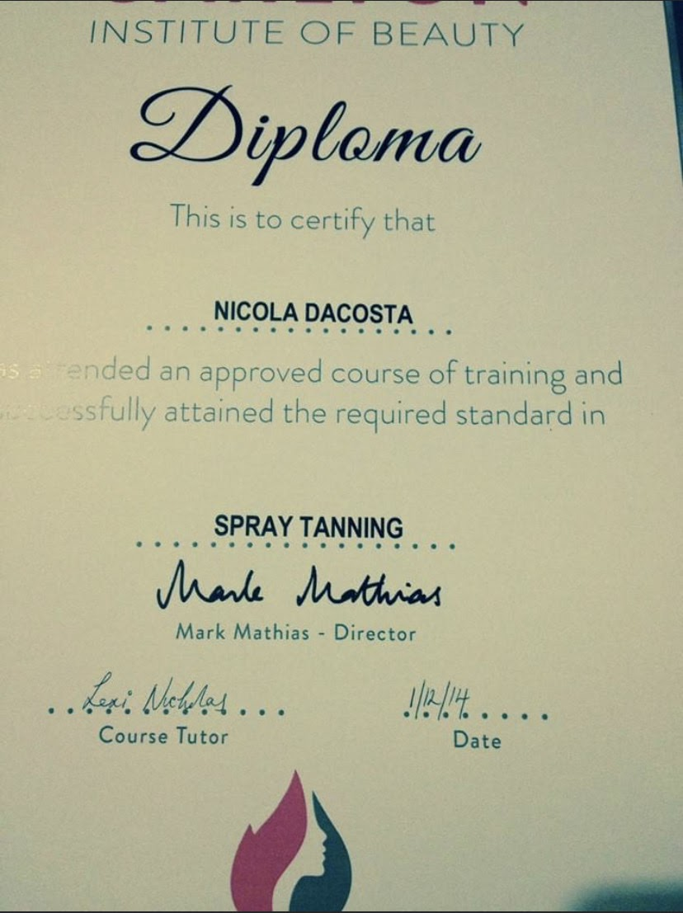
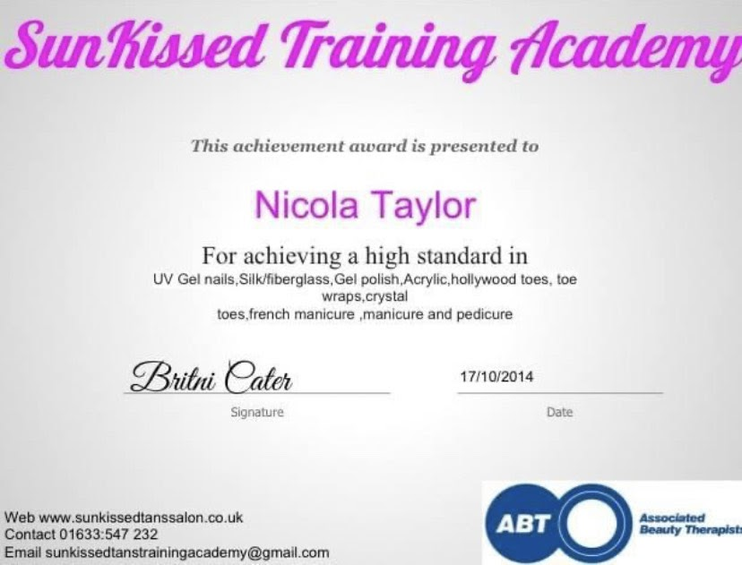

I have also completed my spray tan and nail training certificate. This will be essential and very useful for when I want to expand my services and possibly open a salon to maximise my profits and present a lot more business opportunities.

Sales and distribution

Sales and distribution service for brown as a berry will be done by visiting clients in their homes. When my business develops, and I have a regular customer base I can think about opening a salon or employing new spray tan technicians who can be paid hourly as well as receiving tips. However right now I will be working alone and building my business so will not have to worry about rent or salaries for others.

Although there are other mobile spray tanning companies, brown as a berry stands out as I am considerably cheaper than the competition and I will be focusing on the individual's needs giving them a lasting impression rather than giving everybody the same treatment.

Operations Supplies

Operations Supplies will be purchased from a tanning distributor called Sienna Supply at wholesale costs. Sienna is a website that sends catalogues to tanning businesses, so it is easily available. It is possible to negotiate a deal on pricing once we become a regular customer from this distributor. Trying out different brands of supplies and seeing which customers most prefer will help keep customers satisfied, rather than simply purchasing the same product repeatedly.

Durability is also something that will have to be tested (the spray tan machine, foot pads and spray tent), I will also be looking at tanning solution things to consider is colour i.e. how long it lasts, easy application and smell I will initially be using sienna products only however when business picks up I can open my options more and maybe look at different suppliers and a variety of solutions allowing me to expand my services.

My financial cost one-time purchases

My financial cost one-time purchases will be spray tan machine £200 pop up spray tent 2 at £50 each; £100 so my total one-time purchases will be £300 although I may have to repurchase in a few years down to wear and tear.

My recurring purchases (monthly)
My recurring purchases (monthly) Hair nets 100 at £10 per pack Foot pads 100 pairs at £20 per pack Tanning solution 5 litres at £57.54 each; £287.70 One Extra solutions barrier cream 500ml at 15.53 each Latex gloves 200 at £5 per pack. (Total £338.23)
(I will be doing 5 tans per day at £20 per tan so my monthly income will be £2000) Business cards will be 250 for £10 = £60 yearly (will repurchase every 2 months) My brochures 250 for £10 = £60 yearly (will repurchase every 2 months) Newspaper ads 12 at £15 each; £180 (one per month for a year) Car decal: £20 social media free.
The marketing business cards i am going to use will be at a cost of £10 for 250 cards. The cost for leaflets will be £10 for 250 leaflets and a newspaper ad will cost £180 per year. Social media will be free as i will be using Facebook, Instagram and twitter I also will need to include petrol costs of £30 every two weeks and to have my car decal will be £20. My public liability insurance will cost £100 per year this will be essential for any possible claims or accident/spillage with tanning solution.
Total marketing costs: £320 per year. Other Costs Petrol: £30/every 2 weeks; £60 per month; Public liability insurance: £8.33 per month; £820 per year.
My Profit Projection and sales for 1 litre of tanning solution is a cost of £57.54. The recommended amount of spray tan is about 50-70mls per spray tan depending on the size of the client. It is best and more cost effective to spray a fine light mist only once. This will allow for 20 spray tans per 1 litre of sienna tanning solution. I will be purchasing 5 litres so upon start-up expected tans per week will be aiming to spray 25 clients per week which will increase my profit to £25 x 25 clients = £500 per week give me a profit of £2000 gross per month: £24000 first year profit. Product Purchase Price is £57. 54 x 5 = £287.70 for spray solution and hair nets 100 for £10, foot pads 100 for £25, latex gloves 200 at £5 per pack and finally barrier cream 500ml at 15.53 so this will cost £338.23 per month. However, this is a profit projection that does not account for discounts such as the £10 off refer-a-friend program, or if I decide to sell or offer other services, products in the future.
Activities | Cost
Purchase of Tanning equipment | £300
Materials | £4058.76
Advertising | £320 (this is for the first year)
Insurance and petrol | £820
Total costs (Annually) | £5498.76

My Financial Statement

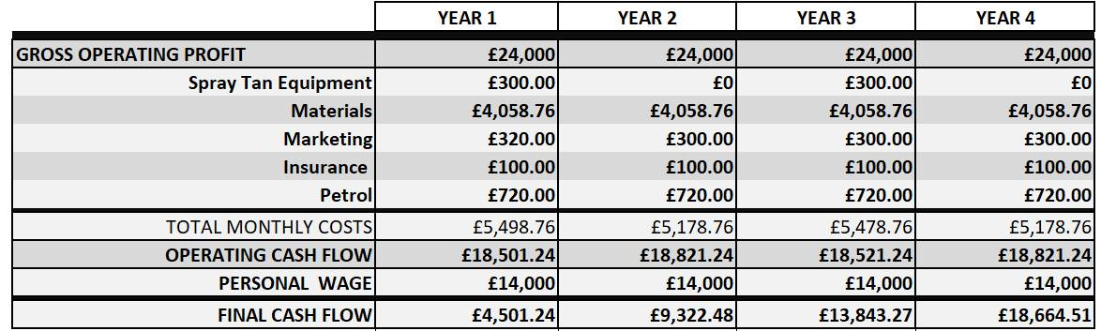

Action plan
- Register for self-assessment with HMRC and take out public liability insurance and open a bank account.
- Creating pages and accounts on social media sites utilizing Facebook, twitter and Instagram will help me raise awareness of my company. I will also use these platforms to offer introductory offers and any special offers and announce my opening day.
- Create business cards and leaflets and distribute to hair and nails salons and any dermatology clinics to advertise my business and increase awareness.
4.Purchase all spray tanning equipment and other materials and create an inventory so I can keep up to date with any materials and products that is needed and prevent any stock going missing this will also help me track how much stock is being sold and by purchasing regularly make sure its fresh and not past it expiry date.
5. Decide what working hours of operation will be and be as flexible as possible to ensure I hit maximum profits also working out if i will have a day off in the week this allows clients to know when brown as a berry will be closed.
6. Produce a newspaper advertisement and decide which newspaper to have it posted in including my logo name and contact details price and opening date allowing potential customers when and how much a tan with me would be.
7. I make sure I promote my business through network. Finally, August 5th is my opening king to expand my customer base.

Conclusion

The business idea aims to deliver a mobile sunless experience to the public in the comfort of their own homes. There are a lot of sunless tanning businesses around the globe and its only going to keep growing with a desire for people to look good becoming increasingly more popular. Although there will be fierce competition, I will step up my game in my marketing and my spray tanning skills.

As a conclusion, my spray tanning business has all the components of a successful business. Cardiff is a city full of students and woman who love to be tanned and keep up with their appearances. As previously mentioned, this will help my business to thrive and reach its true potential. My business can compete with other similar businesses due to its originality and my previous experience. With my estimated cash flow figures it is evident that my spray tan business will make an investment return and profit annually. My business will break the milestones I have set out in this plan.

References
Yoo, J. Hur, W. (2014) ‘Body-tanning attitudes among female college students,’ Psychology reports, Vol 114 No2 585-596
Rogers, C., (2005) ‘Spray-on tanning,’ Aesthetic Surgery Journal, Vol 25 No 4
Williams, M., (2014) ‘Smarter Spray Tanning,’ Professional Beauty Journal, Vol 16 No 7

