

DOCTOR OF BUSINESS ADMINISTRATION

QUANTITATIVE RESEARCH METHODS
(LCDB7011_LON)

LECTURER
Dr. RAVSHONBEK OTOJANOV

TOPIC
QUANTITATIVE ANALYSIS ON THE SUSTAINABILITY OF THE FRANC ZONE

NAME AND STUDENT ID
Francine TAGOUDI SILATSA MAFOUGANG (2306963)

6953 Words

ABSTRACT

Originating during colonisation, the CFA Franc remains the sole colonial currency still in circulation across fourteen Sub-Saharan African countries, collectively known as the Franc zone. Since 1945, it has been pegged to the French Franc and, from 1999, to the Euro. The currency endures, largely due to the account of operation mechanism (Nubukpo, K. 2015), which positions France as the custodian of its stability.
This topic aims to underscore the significance of currency in the economic progression of transitioning nations. It seeks to evaluate the economic advantages and disadvantages of the CFA Franc within the Franc zone. Furthermore, it provides economic, political, and historical rationales to assess the neo-colonial view of the CFA Franc. The goal is to ascertain the CFA Franc's effect on the economies within the Franc zone.
Several questions arise. What are the economic repercussions of the CFA Franc within the Franc zone? What monetary and fiscal policy frameworks are associated with the CFA Franc, and what are their consequences? How does the CFA Franc influence the economic trade of the Franc zone countries? Does the CFA Franc promote trade with numerous partners to benefit the Franc zone? Or does the CFA Franc act as a tool to continue a system of exploitation, favouring the interests of a metropolis that history has maintained at the forefront of the Franc zone?
These considerations lead us to scrutinise the CFA Franc's role in the Franc zone as the central research issue. The thesis employs both positivism and interpretivism as research philosophies and utilises quantitative and qualitative methods for its methodological approaches.

INTRODUCTION

In the international arena, the current climate is predominantly shaped by rapid changes, which heighten the risks of financial instability and exchange rate fluctuations. These conditions have bolstered theories advocating for the efficacy of regional monetary unions in addressing global economic challenges. Participation in a monetary union offers significant benefits, such as lowered transaction costs and diminished uncertainties regarding exchange rate fluctuations, elimination of exchange rates within the union, and bolstered confidence in policy direction (Zhao and Kim, 2009). These theories underpinned the creation of regional monetary systems, with the Euro and the CFA Franc being the two largest globally.
The CFA Franc was inaugurated in 1945, by decree N° 45-0136, initially representing the Franc of the French Colonies of Africa. In 1958, it was renamed the Franc of the French African Community. Subsequently, in 1960, following independence, it was designated the Franc of the African Financial Community, XOF in West Africa and the Franc of the Financial Cooperation in Central Africa, XAF in Central Africa. It serves as the currency for 14 Sub-Saharan African countries, all part of the Franc zone. The currency's distinction lies less in its historical inception than in the durability of its fixed exchange rate regime, which is among the most stable worldwide (Gulde and Tsangarides, 2008). Remarkably, despite significant global upheavals and transformations, its rate has only been altered once, with the devaluation in 1994.
The Franc zone is split into two African monetary zones. The West African Economic and Monetary Union utilises the CFA franc (XOF) in Benin, Burkina Faso, Côte d'Ivoire, Mali, Niger, Senegal, Togo, and Guinea Bissau. On the other hand, the Central African Economic and Monetary Union employs the CFA franc (XAF) in Cameroon, Congo, Gabon, Equatorial Guinea, Central African Republic, and Chad.
The Franc's zone stability is attributed to its monetary cooperation with France via the operating account mechanism, which ensures a fixed exchange rate between the CFA Franc and the Euro (Nubukpo, K. 2007). This mechanism acts as a form of monetary stability insurance with the French treasury, requiring a 50% deposit of foreign exchange reserves by the central banks within the zone. However, this arrangement has sparked numerous controversies regarding the Franc zone. Some authors and economists interested in the subject argue that the fixed parity regime of the CFA Franc, supported by the operating account mechanism, is suboptimal (Owoundi, 2001). Others contend that the monetary stability argument is merely a facade to lend credibility to a monetary policy that is overly restrictive and primarily serves the interests of European entities (Tinel, B. 2016). These critics focus on the CFA Franc's role in economic development, arguing that it is incompatible with Africa's potential growth.
Other scholars examine the currency's political aspects, critiquing the historical underpinnings of Franco-African relations. They argue that the French treasury's oversight is merely a modern form of the paternalism practiced by Elysée authorities, coining the term monetary servitude to describe this neo-colonial holdover. Conversely, some liberal economists and writers, who view what others describe as the continuation of an imbalanced relationship, see it instead as an expression of multilateral solidarity (Hugon, P. 1999).
The utilisation of the CFA Franc currency as a mechanism for domination or economic development is grounded in various observations, particularly from analysing the economic growth of the Franc zone. As Africa progresses with emerging powers like China, which nearly rivals France's influence (La Tribune, 2013), the perceived decline in French influence after the dissolution of the old Foccart networks is offset by the increasing power of French companies. These companies retain a significant market share in the Franc zone (Adjagbe, M. 2009). For instance, France has surpassed China in Côte d'Ivoire with a 14% market share versus 6%, in Senegal with 17% compared to 10%, and in Gabon with 33% against 8% (La Tribune, 2013). Alexandre Vilgrain, president of the French Council of Investors in Africa, has claimed that French firms are unmatched in Africa (French Council for Investment in Africa, 2013). These insights are crucial for understanding the enduring economic relations between France and its African partners, including the historical “privilege of the flag” (Gounin, Y. 2009, p.27), which limited colonies' trade with other nations.
Currently, France exerts a significant influence on the daily management of the CFA Franc. The French public treasury guarantees its convertibility, affording France preferential access to the board of directors of the central banks that issue the CFA Franc. This role is contentious, particularly since the currency and public development aid were considered vital for French subsidiaries in Africa to undertake major infrastructure projects shortly after independence (Glaser and Smith 2005). The purpose of this study is to assess the economic advantage and inconvenient of using the CFA Franc in the 14 countries.
Problem Statement: The investigation focuses on the CFA Franc's role within the Franc zone.
Research Objectives: This topic contributes to the body of literature emphasising the importance of currency in the economic progress of transitional countries. It provides a framework conducive to analysing the influence of monetary and fiscal policies on the Franc zone's economic growth. It sheds light on both internal and external elements that contribute to the Franc zone's lack of development.
Research Questions: For this assignment, one question will be posed: What are the economic effects of the CFA Franc on the Franc zone?
Aim: The objective is to determine the CFA Franc's economic impact on the Franc zone.
Hypothesis: The CFA Franc has not fostered economic growth in the Franc zone since its inception, particularly in recent times.
LITERATURE REVIEW

The theory of currency
According to Aristode, currency is the property that is at the same time means of payments, unit of account and reserve of values. Moreover, perceived by Hicks (1967), currency is what currency does. Furthermore, currency represents a timeless invention, the traces of which date back to the very birth of humanity and which, surprisingly, is not attributable to any society (Théret, 2008). It is, de facto, a privileged instrument guaranteeing trade. At least it is the universal aspect that it presents since everywhere it acts as operator of social belonging, mediation in the most diverse social exchanges within which it operates as a representative of the social totality (Ibid). However, to limit its definition to this aspect would be to underestimate one of the most complex terms in the economy. Given the multiplicity of these characters, it seems difficult to conceptualise it without failing to remove some of these fundamental constituents. This is what Charles Rist (1938) claimed by refusing to comment on a possible definition to be given to the term. For him, to try to give a definition to currency would be to discard so many characteristics of real currencies, that it will no longer represent much interest.
Lacking a universally accepted definition and to maintain logical consistency, this discussion adopts the definition from Diallo (2002), which identifies currency as legal tender, a medium of payment sanctioned by a legal system as valid for settling a financial obligation. Currency typically encompasses both notes and coins, issued by a country's sovereign authority and obligatory for acceptance when offered in repayment of a debt within the jurisdiction of that authority. This definition underscores that a significant aspect of state sovereignty is embodied in its currency. The domestic control of currency thus becomes a fundamental expression of a state's sovereignty. Furthermore, it is a common practice for a state to claim exclusive control over monetary privileges. Globally, states establish their own currencies, exclusively determining their value and deciding on their participation in the foreign exchange market.
Regarding the CFA Franc, the scenario is distinct. All fourteen nations utilising this currency have chosen to relinquish its management and entrust it to the treasury of their previous coloniser. However, a nation cannot surrender control of its currency without also ceding a substantial part of its sovereignty (Ibid). Consequently, several authors, identifying as pan-African or neo-pan-African, have portrayed the CFA Franc as a colonial currency designed to maintain the status quo from 1960. The body of literature on the CFA Franc is diverse, reflecting the subject's complexity through its multi-disciplinary critiques.
Economically, the CFA Franc is seen as a factor stalling the economies within its zone (Nubukpo, K. 2015). Proponents of this view have levelled criticism based on the Optimal Currency Area theory, sparking a debate over the necessity of an Africa-exit.
The theory of the Optimal Currency Area
The theory, formulated by Robert Mundell in the 1960s and revisited by Ott and Vignolles in 2012, assesses a region's readiness for a monetary union. It uses criteria to evaluate the advantages for nations and multinational entities adopting a shared currency or fixed exchange rate. Mundell asserted in 1961 that the level of benefits each state receives from the union is a crucial factor for a region's optimality. He maintained that if a fixed exchange rate or a common currency provides more benefits than the primary macroeconomic adjustment mechanism, the exchange rate, the region could be considered an Optimal Monetary Zone. He highlighted the necessity of labour mobility to compensate for the lost opportunity of adjusting the exchange rate.
The Optimal Monetary Zone theory, which will be expanded upon by authors following Mundell's lead, includes Mackinnon's 1963 contribution to this traditional line of thought. He broadens the criteria for optimality by introducing the degree of openness—the ratio of exchangeable to non-exchangeable goods—as a crucial factor in the decision to form a monetary union. He also posits that the volume of trade between states should affect this decision. Essentially, the more open a state is, indicated by a higher ratio, the greater the benefits it reaps from a fixed exchange rate regime (Bourginat, 1992). On the other hand, closed states with a lower ratio find more advantage in a flexible exchange rate regime. His reasoning stems from the idea that in an open economy, exchange rate fluctuations can significantly impact the overall price level (Laurent Joye, 2014). These fluctuations can shift the relative prices of tradable and non-exchangeable goods, leading to potential disruptions in resource distribution. Furthermore, in such economies, a fall in the exchange rate that diminishes the demand for external goods would require a significant increase in demand for non-exchangeable goods to sustain the same real income level. This could lead to substantial price and wage adjustments, detrimental to the economy's competitive edge (Ibid). Mackinnon's conclusion is that the more open economies are and the more they engage in trade with each other, the stronger the case for them to form a monetary union, which would provide a buffer against the negative impacts of exchange rate fluctuations.
Kenen (1969) posits that a monetary union is feasible when there is significant diversification in the production structures of countries. He critiques Mundell's model (1961) and expands on McKinnon's (1963) work. Kenen contends that factor mobility alone should not determine the suitability of a region for a monetary union, as other factors can compensate for the costs of foregone exchange rate adjustments (Bamba, 2004). His diversification theory is grounded in the Law of Large Numbers (Kenen, 1998), which he asserts is effective in mitigating macroeconomic disturbances.
Cooper (1977) and Kindleberger (1986) advanced this theory by suggesting that a modern measure of a monetary union's viability is the homogeneity of national preferences. They argue that the alignment of economic preferences among nations, including both consumer choices and joint economic policies, should gauge the optimality of a currency union. According to Bamba (2004), countries with robust trade relationships and common preferences for private and public goods are more inclined to establish an optimal currency area.

Limitations of the theory of the Optimal Monetary Zone
Empirical evidence from the Franc zone indicates a lack of genuine mobility of production factors within the region, as shown by certain economists (Ondo Ossa, 2000). They argue that insufficient legislation and regulations hinder labour mobility (Nubukpo, 2013). This contrasts with Musugaie (2010), who takes a broader view of labour mobility, concluding that the Franc zone only partially and unsatisfactorily meets the mobility criterion, despite significant mobility in West Africa. He also notes that military conflicts, social and political unrest, and economic changes, along with bureaucratic barriers, obstruct this mobility (Ibid).
The McKinnon model, when applied to the Franc zone, suggests incompatibility. Ondo Ossa (2000) showed that the ratios of external trade to GDP and intra-zonal trade to external trade were low between 1995 and 1996, before the Euro's introduction, advocating for a flexible exchange rate. Diop (2017) observed that the Franc zone's homogenous productive structures result in a lack of export diversification, hindering intra-regional trade development. Kenkouo (2014) examined the effects of external shocks on the Central African Economic and Monetary Union economies, particularly inflation driven by oil production and exports, finding that short-term global oil price increases had minimal impact on the region.
In the long term, however, inflation is expected to spread throughout the region. Guillaumont and Jeanneney (2017) studied the effects of a reverse shock, supporting their theory with empirical research on the Central African Economic and Monetary Union countries.

The theory of neo-colonialism
The term “France-Africa” epitomises the complex and evolving relationship between France and its former colonies, which were on the brink of inevitable independence. This transitioned from the direct control by the metropolis over its colonies to a collaborative form of domination, with independence still tethered to the motherland. “France-Africa” signifies the unseen bond that persists between France and its ex-colonies, a byproduct of colonial detachment initiated at the dawn of their independence in 1960. Traditionally overseen by the legendary African cell of the Élysée, which lacked legal status (Gounin, Y. 2009), it was under Jacques Foccart, the renowned “Mr. Africa,” that this cell became instrumental in shaping France's policy towards Africa.
The rationale for this term was to maintain the old colonial hierarchy, which was predominantly advantageous to France, while ensuring that the elites of these decolonised nations had a share in the national cake. “Access to the State as a prerequisite for direct access to economic resources” (Médard, J. F. 1990: 93); hence, through Foccart, France installed and removed the leaders of these countries, strictly speaking, based on their alignment with French interests. Consequently, electoral fraud was orchestrated to ensure that the elected president was the candidate preferred by France. Robert Bourgi exposed a more secretive aspect of this network, revealing the use of tactics characteristic of clandestine organizations and societies: establishing intelligence networks, assessing the political stances of colonial administrators and officials, and efforts to penetrate the African business sector (Médard, J. F. 2002).
These strategies not only enabled control over the African political landscape but also, more importantly, oversight of all potential markets within it. Consequently, anyone opposing this system was systematically removed in the most severe manner. Thomas Sankara of Burkina Faso experienced this when he chose to align with Gaddafi, who was notably distant from France (Verschave 1999). The “France-Africa” power brokers indeed preferred his removal, welcoming his successor into their fold (Ibid).
Given the French interests, it is pertinent to discuss them as they are crucial in understanding France's role in Africa. As a colonial ruler, France's economy was partially developed through the exploitation of inexpensive raw materials and wealth from its controlled territories (Capron, 2009). Thus, the establishment of a French pre-square acted as a continuum, enabling the operation of its economy by procuring raw materials at reduced costs, with a focus on energy sources. Subsequently, numerous economic agreements were established, ensuring that metropolitan companies-maintained control over the market for exploiting such resources (Noirot, T. 2012). These companies included Elf, AREVA, and CFAO, specialising in the sectors of mining, oil, distribution, and trade.
During this era, economic nationalism flourished, intertwining the triumphs of French corporations with the nation's success (Capron, M. 2009). Amidst the Cold War, the Gaullist Republic sought dominance, viewing its African influence as a strategic asset akin to the atomic bomb (Gounin, Y. 2009), a tool for rebalancing global power. The CFAF, pegged first to the French Franc and later the Euro, aimed to curb the influence of other powers in Sub-Saharan Africa (Migani, G. 2012).
Furthermore, this currency offered French firms a competitive edge, as countries within the Franc zone prioritized them for international orders. Described by Noirot (2012) as a straitjacket, it effectively granted French businesses a monopoly in African markets. French economic nationalism blurred the lines between corporate and national success and was intolerant of foreign firms gaining an upper hand. Such scenarios were seen as assaults on national sovereignty, prompting governmental countermeasures reminiscent of Thomas Sankara's approach. In the 1990s, French companies expanded in Africa, leveraging structural adjustment programs initiated by Bretton Woods institutions to cement their presence. The privatisation wave that followed saw a significant influx of French companies and capital in the Franc zone. In Ivory Coast, for instance, this enabled the Bouygues group to secure major economic sectors, such as the Ivorian Electricity.

The system of the monetary servitude
Initially, the principles behind the CFA Franc were intended to significantly benefit the economies of its member countries. Yet, some studies have shown that they might have the opposite effect. A stark difference is seen in the policies the Franc zone has adopted to maintain this currency. To ensure a fixed parity with the Euro and unrestricted convertibility, the Franc zone has enacted a series of public policies that predominantly favour Northern countries. Among these, liquidity management policy stands out. The West African Economic and Monetary Union's approach exemplifies this mechanism, which largely benefits European companies. According to Nubukpo (2011), since 1989, the West African Economic and Monetary Union has been pursuing a competitive disinflation policy aimed at maintaining the currency's internal and external stability, primarily through key interest rates. The goal is to adjust interest rates to align actual inflation with the target inflation rate. For instance, raising the interest rate is expected to reduce the inflation rate, with a target set at 2% (Tadenyo, Y.D. 2015).
The rationale for this policy stems from a monetary perspective on inflation, which posits a direct link between changes in the money supply and inflation rates (Sall, A.K. 2016). Specifically, an increase in liquidity is believed to fuel inflation, while a decrease should help maintain lower inflation levels. In line with this theory, the central bank implemented a restrictive monetary policy (Dembo Toe and Hounkpatin, 2007) aimed at reducing liquidity within the union. To curb the money supply, it targeted the primary sources of its expansion: net external assets and, predominantly, domestic credit (Ibid). Consequently, banks in the region have become more stringent in their lending criteria. This has led to a restrictive monetary policy that curtails the banks' role in funding economic development in the area. Evidence of this is seen in the credit-to-economy-to-GDP ratio, which measures the proportion of bank lending in the zone's GDP, increasing from 14% in 2000 to 18% in 2009 (Trinnou and Igue, 2015).
Empirical studies (Tadenyo, Y.D. 2015) indicate that economic growth in the West African Economic and Monetary Union region, both short-term and long-term, is largely driven by investment, primarily sourced from credit within the economy (Nubukpo, K. 2012). Consequently, stricter credit conditions result in diminished local investment, thereby hindering West African Economic and Monetary Union's development. The Central Bank of the West African Economic and Monetary Union, by enforcing this policy, opts to compromise the economic growth of the West African Economic and Monetary Union economies for the sake of monetary stability, prioritising stability overgrowth fuelled by domestic investment. This policy disproportionately benefits foreign investors who, with substantial financial resources, can directly invest in the West African Economic and Monetary Union nations. Thus, the region's development becomes heavily reliant on external factors, notably foreign direct investment, especially from the Euro area due to exchange rate parity and free transferability, as well as public development assistance.
Official Development Assistance differs from Foreign Direct Investment, highlighting the neo-colonial aspect of financial aid, or more specifically, the dependency it creates for recipient countries. Official Development Aid, as argued by dependency theorists, incorporates a tied-aid mechanism in the financial interactions between France and its former colonies, ensuring France's control over the African nations receiving this aid. Thomas Noirot (2012) described this aid as a tool for France to secure contract execution by its companies in the aid-receiving countries. This practice was evidenced by the funding of projects like the Ivorian metro. During the Cold War, France increased aid to allied regimes in Francophone Africa (Hugon, P. 2007) to deter them from engaging with the Soviets or Americans. This aid often took the form of conditional loans tied to the procurement of French goods and services.

RESEARCH PHYPLOSOPHY

The Ontology Approach relates to diverse opinions on the validity of the Franc zone and the CFA Franc. Regarding the Franc zone, debate centres on its role, with some scholars considering it an OMZ and others challenging this notion. The CFAF is perceived by some as a remnant of colonialism, while others see it as a sign of multilateral cooperation. This part of the study will employ qualitative methods and adopt interpretivism as its philosophical framework.
The Epistemology Approach deals with authors' varying views based on data about the CFA Franc's capacity to promote development in the Franc zone, marked by conflicting opinions of the CFA Franc as either a cause of macroeconomic instability or a factor of stability. The research questions will be tackled using quantitative methods and a positivist philosophical outlook.
The Axiology Approach focuses on the study's ability to inform African governments, traders, and economists that the Franc zone needs to adapt to survive the global financial shifts threatening its existence. This adaptation should acknowledge and address the system's shortcomings considering continuous contextual changes.

Methodology
Indeed, this thesis integrates both positivism and interpretivism as its research philosophies, applying quantitative and qualitative methods accordingly. Nonetheless, for this assignment, the study focuses on quantitative methods using SPSS and maintains positivism as its ideological approach to tackle the research issue.

Data collection
The study employs secondary quantitative data over a twenty-year period, from 2003 to 2023, involving fourteen countries within the Franc zone, as obtained from the World Bank. The countries include Benin, Burkina Faso, Cameroon, Congo, Côte d'Ivoire, Central African Republic, Chad, Equatorial Guinea, Gabon, Guinea Bissau, Mali, Niger, Senegal, and Togo.
It is essential to recognise that this dataset encompasses twenty macroeconomic indicators for each of the fourteen member nations of the Franc zone, such as: Agriculture, forestry, and fishing, value added (% of GDP); Central government debt, total (% of GDP); Exports of goods and services (% of GDP); Final consumption expenditure (% of GDP); External balance on goods and services (% of GDP); Expense (% of GDP); Gross national expenditure (% of GDP); Industry (including construction), value added (% of GDP); Imports of goods and services (% of GDP); Merchandise trade (% of GDP); Net acquisition of financial assets (% of GDP); Revenue, excluding grants (% of GDP); Stocks traded, total value (% of GDP); Tax revenue (% of GDP); Trade (% of GDP); Trade in services (% of GDP); Current account balance (% of GDP); Net lending (+) / net borrowing (-) (% of GDP); Foreign direct investment, net inflows (% of GDP); and Foreign direct investment, net outflows (% of GDP).
Upon collecting the data, it was evident that some indicators were missing from the Excel file. This necessitated codification. For the absent indicators, a placeholder value (99) was designated, and a measurable scale was developed for the subsequent transfer of the Excel sheet to SPSS.

DATA INTERPRETATION – TESTS OF CORRELATION

At this stage, it is crucial to reemphasise our distinct hypothesis: the CFA Franc has not promoted economic growth in the Franc zone since its creation, especially in recent times.

The objective of this study is to determine the validity of our hypothesis. Through subsequent correlation and regression analyses using SPSS, we will ascertain whether the CFA Franc has indeed failed to stimulate economic growth in the Franc zone since its establishment, particularly in contemporary periods.

Firstly, let us examine whether there is a correlation between the CFA Franc currency and the Franc zone from 2003 to 2023.

Simple diagram
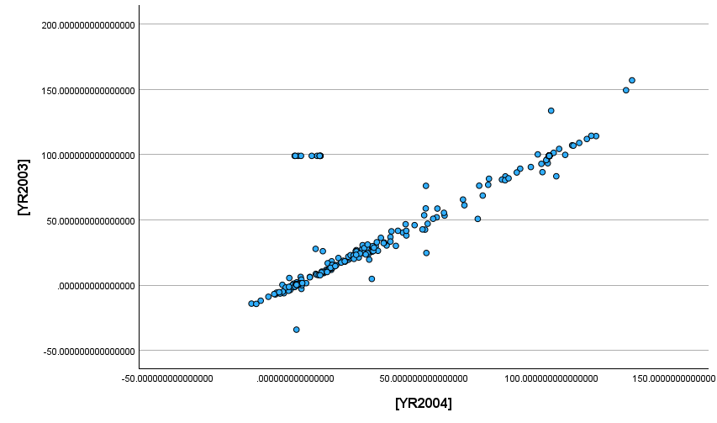
The preliminary basic diagram indicates a high positive correlation between the CFA Franc and the Franc zone from 2003 to 2004, despite a few outliers that are deemed insignificant.

Scatter diagrams
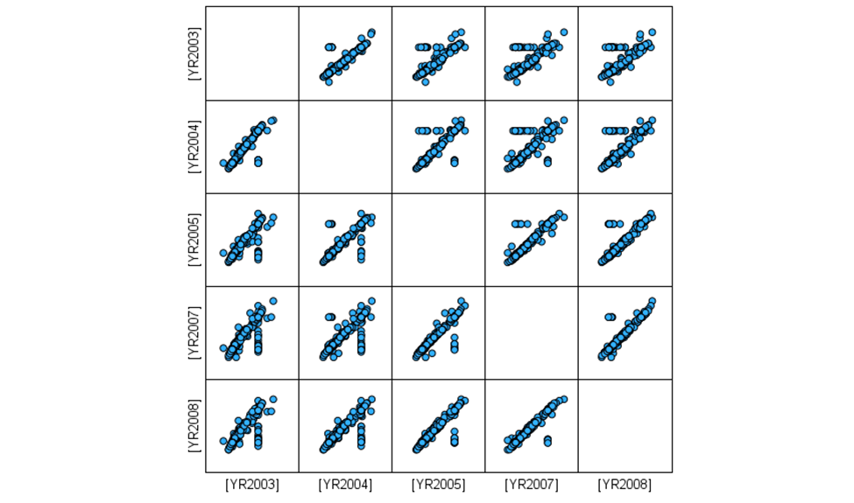
A clear, linear arrangement of points ascending with few outliers, signifies a high positive correlation between 2003 and 2008. Consequently, the second diagram which is a scatter diagram also indicates a high positive correlation between the CFA Franc and the Franc zone from 2003 to 2008.

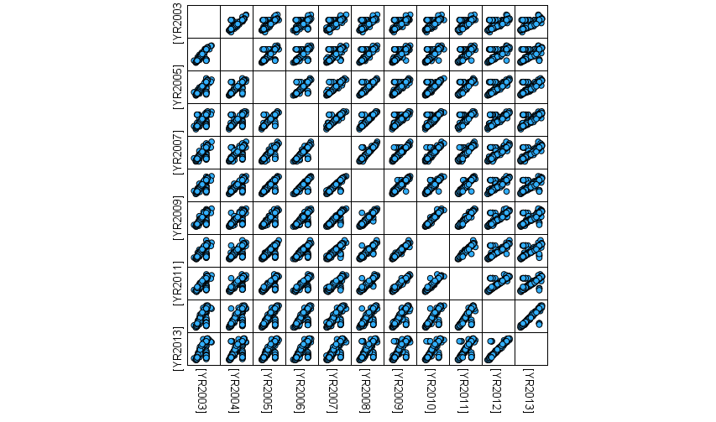
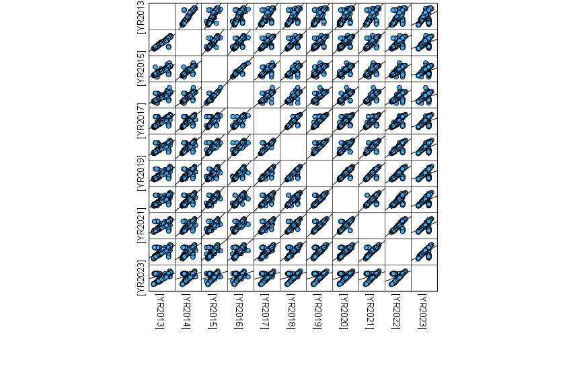
The third and fourth diagrams, which are scatter plots covering the periods 2003-2013 and 2013-2023 respectively, both show a high positive correlation with a few outliers. Thus, from 2003 to 2023, there is a high positive correlation between the CFA Franc and the 14 countries in the Franc zone.
To summarise, our four diagrams (simple graph and three scatter plots) demonstrate a robust positive correlation between the CFA Franc and the Franc zone. This suggests a relation between the CFA Franc and the Franc zone over the period from 2003 to 2023.

Correlations
- Correlations vary between -1 and 1, if 0 is not a correlation
- For correlations, Sig value must be equal or less than 0.05
The Pearson correlation analysis involves non-parametric tests on 20 macroeconomic indicators of the CFA Franc across 14 Sub-Saharan African countries from 2003 to 2023. The significance (Sig) value is consistently less than 0.001 throughout this period. Moreover, the correlation, while always positive, shows annual fluctuations and a slight downward trend over time. For instance, the correlation started at 0.912 in 2004, denoting a very strong relationship between the CFA Franc and the twenty macroeconomic indicators. It then gradually declined, with values ranging from 0.897 to 0.722 between 2005 and 2014, indicating a substantial relationship. Finally, it decreased steadily from 0.693 to 0.421 between 2015 and 2023, suggesting a moderate relationship.
In conclusion, the Sig value < 0.001 and the fluctuating positive correlations over the 20-year period indicate a consistent positive relationship, suggesting that regression analysis would be appropriate.
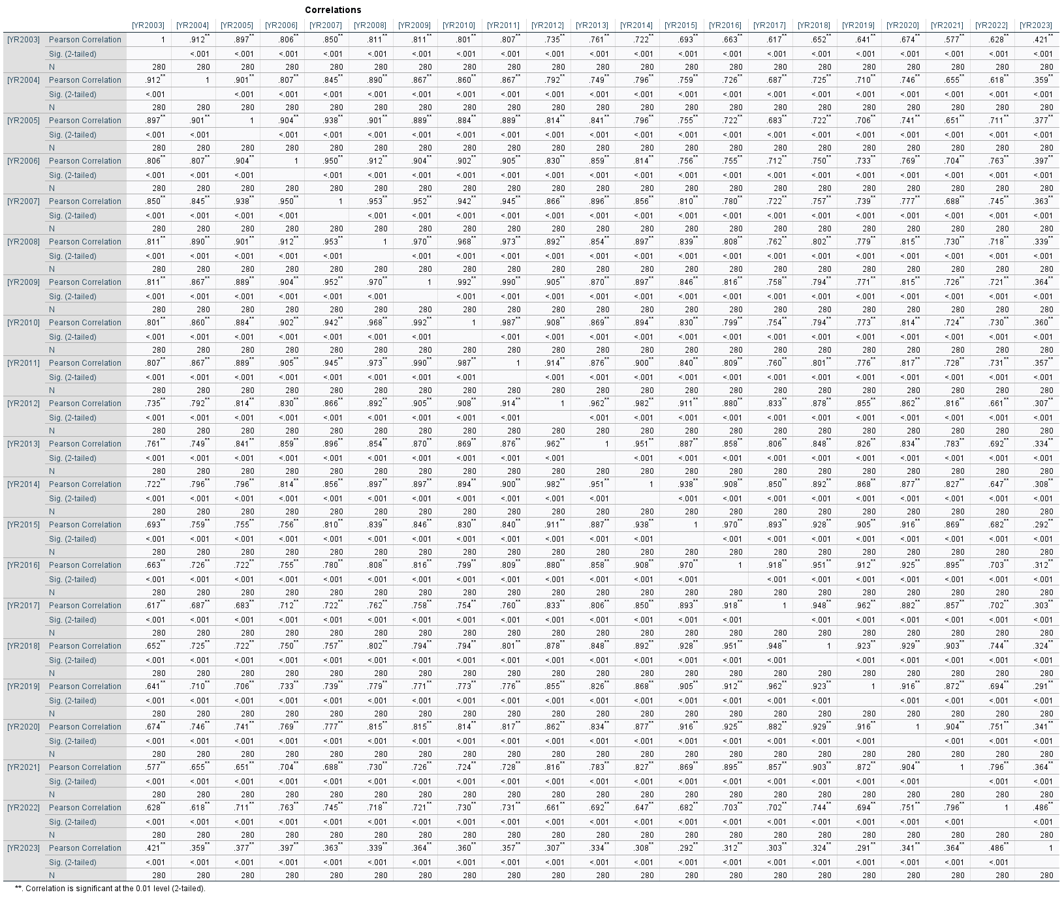

Casewise diagnostics
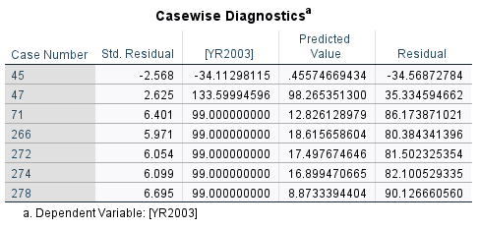
The table presents data associated with a dependent variable marked as [YR2003]. It enumerates cases (such as 45, 47) and their respective standardised residuals set at 2 SDs, predicted values, and residuals. Such data is commonly utilised to evaluate the accuracy of a statistical model and to pinpoint any outliers or instances where the model's predictions deviate markedly. For instance, for Case 45, the forecasted value is 0.456, the measured value is -34.113 and the residual is -34.569, suggesting the model significantly underestimated this value. Cases 71, 266, 272, 274, and 278 exhibit elevated standardized residuals, signifying they are outliers with potential substantial effects on the regression model.

The Spearman’s rank correlation
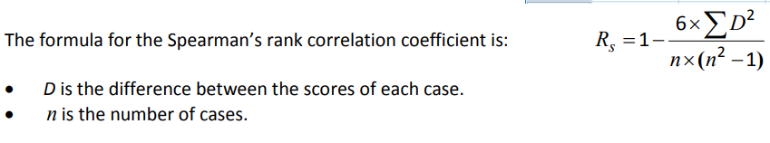
Following the formula for the Spearman’s rank correlation coefficient, let calculate Rs:
Rs = 1 – / 6 .(0.057)2 : 6.401 .((6.401)2 – 1)
= 1 – / 6 .(0.003249) : 6.401 .(40.972801 -1)
= 1 – / 0.019494 : 6.401 .(39.972801)
= 1 - / 0.019494 : 255.84797
= 1 - 0.0000762 = 0.999238
Based on our calculations and using 2 standard deviations, the Spearman's rank correlation coefficient is approximately equal to 0.999238. Fortunately, considering all variables or standard deviations from 2003 to 2023 and using SPSS, the interpretation aligns with the explanation provided for Pearson's correlation coefficient on page 17.

Indeed,
- Correlations vary between -1 and 1, if 0 is not a correlation
- For correlations, Sig value must be equal or less than 0.05
The Spearman’s correlation analysis involves non-parametric tests on 20 macroeconomic indicators across 14 Sub-Saharan African countries from 2003 to 2023. The significance (Sig) value is consistently less than 0.001 throughout this period. Moreover, the correlation, while always positive, shows annual fluctuations and a slight downward trend over time. For instance, the correlation started at 0.905 in 2004, denoting a very strong relationship between the CFA Franc and the Franc CFA. It then gradually declined, with values ranging from 0.889 to 0.721 between 2005 and 2014, indicating a substantial relationship. Finally, it decreased steadily from 0.660 to 0.355 between 2015 and 2023, suggesting a moderate relationship.
In conclusion, the Sig value < 0.001 and the fluctuating positive correlations over the 20-year period indicate a consistent positive relationship, suggesting that regression analysis would be appropriate.

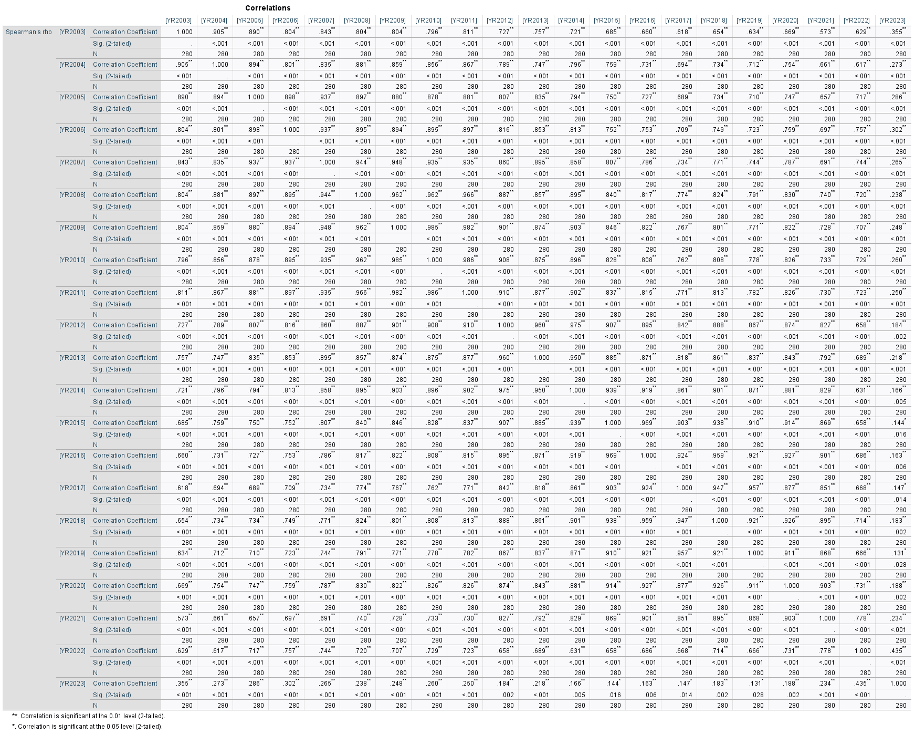
DATA INTERPRETATION – REGRESSION ANALYSIS

R Square
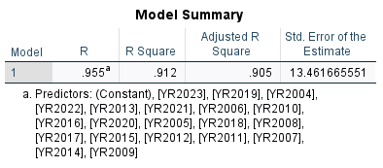
The table summarises a regression analysis, which is a statistical method used to examine the relationship between a dependent variable more independent variable. The R value of 0.955 indicates the correlation coefficient, denoting a very strong positive correlation between the predictors, which are the years, and the dependent variable. The Adjusted R Square value of 0.905 is the R Square adjusted for the number of predictors in the model, providing a more accurate measure by penalising the inclusion of non-contributing predictors. This suggests that nearly 90.5% of the variance is explained, considering the number of predictors. Lastly, the Standard Error of the Estimate at 13.46 represents the average deviation of the observed values from the regression line, with a lower number indicating a better fit of the model.
The R value of 0.955, as the correlation coefficient, reflects the strength and direction of the linear relationship between the observed and predicted values. A value close to 1 suggests a strong positive correlation. The R Square value of 0.912 indicates the proportion of variance in the dependent variable that can be predicted from the independent variables. It assesses how well the predictors explain the variability of the outcome. In this case, 91.2% of the variance is accounted for by the model. This means that about 91.2% of the variation in the 20 macroeconomic variables of the CFA Franc explained or influenced the economic development of the Franc zone. The remaining 8.8% could be attributed to other variables not included in this study.

Anova
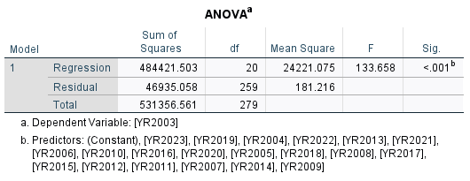
The table presents the results of an ANOVA test, which evaluates whether the means of more independent groups are significantly different. The Regression (484421.503) represents the variation accounted for by the model. The Residual (46935.058) is the variation not explained by the model. The Total (531356.561) is the overall variation in the dataset. The Regression (20) is the number of predictors in the model. The Residual (259) is the total number of observations minus the number of predictors and one. The Total (279) is the total number of observations minus one. The Regression (24221.075) is the Regression Sum of Squares divided by its degrees of freedom. The Residual (181.216) is the Residual Sum of Squares divided by its degrees of freedom. The F (133.658) is the F-statistic, which is the Mean Square Regression divided by the Mean Square Residual, assessing the model's fit. The Sig. (<.001) is the p-value, with a value below .001 indicating statistical significance, suggesting that the predictors have a significant impact on the dependent variable.

Coefficients
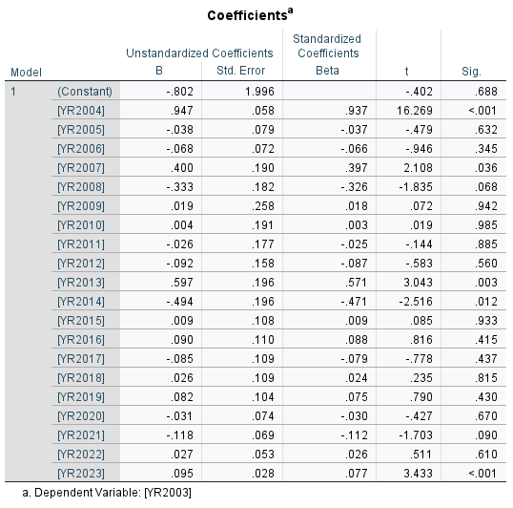
This table presents the results of a regression analysis, highlighting the coefficients for each year from 2004 to 2023. For example, the coefficient for [YR2004] is 0.947, indicating that a one-unit increase in [YR2004] results in a 0.947 unit increase in [YR2003], assuming all other variables are held constant. The standard error for [YR2004] is 0.058, suggesting a precise estimate. Standardized Coefficients (Beta) represent the strength and direction of the relationship between the predictors and the dependent variable, standardized to a mean of 0 and a standard deviation of 1. The Beta for [YR2004] is 0.937, showing a strong positive relationship. The t-value for [YR2004] is 16.269, which is significantly high. Significance (Sig.): The p-value indicates the probability that the coefficient is different from zero by chance. A value below 0.05 is typically considered statistically significant. The p-value for [YR2004] is <0.001, implying a highly significant correlation. Significant Predictors: [YR2004], [YR2007], [YR2013], [YR2014], and [YR2023] have p-values below 0.05, identifying them as significant predictors of [YR2003]. This analysis helps identify the years that have a significant impact on the dependent variable and the magnitude of these effects.
According to the formula representing by y = a + bx
YR2003 = - 0.802 + 0.947.YR2004 + (-0.038). YR2005 + (-0.68). YR2006 + 0.4.YR2007 + (-0.333).YR2008 + 0.19.YR2009 + 0.04.YR2010 + (-0.026).YR2011 + (-0.092).YR2012 + 0.597.YR2013 + (-0.494).YR2014 + 0.09.YR2015 + 0.090.YR2016 + (-0.085).YR2017 + 0.026.YR2018 + 0.082.YR2019 + (-0.031).YR2020 + (-0.118).YR2021 + 0.027.YR2022 + 0.095.YR2023

CONCLUSION

The study addresses the neo-colonial aspect of currency, revealing that the CFA Franc extends beyond colonial borders to represent a significant economic influence, as noted by Derbie (2007). This influence is rooted in the exploitation of colonies for the benefit of the metropolis. The existence of two separate central banks within the zone harks back to the structures of the colonial empire. Moreover, the acronym CFA, originally standing for “French Colony of Africa,” persists. Although its meaning has evolved, it still evokes the historical status of these countries as dependencies of France in the public consciousness. This is further emphasised by the fact that foreign exchange reserves are held in the French treasury, the currency is printed in Auvergne, France, and France retains a veto in the central banks' administration of the Franc zone, all reinforcing the neo-colonial narrative.
Additionally, the current study aims to validate a specific hypothesis: the CFA Franc has not facilitated economic growth in the Franc zone since its inception, particularly in recent times. An examination of extensive quantitative data, which includes 20 macroeconomic indicators across the 14 Franc zone member countries using SPSS, indicates a strong positive correlation between the CFA Franc and the Franc zone's economy, allowing for regression analysis. A thorough and structural regression analysis has determined that the CFA Franc negatively affects the Franc zone's economic development, thus affirming or validating the hypothesis conclusively.

RECOMMANDATIONS

The issue with the CFA Franc is emblematic of a broader global challenge, as it represents the link between local problems and their global repercussions. It underscores the importance of managing public policies even in the most distant regions of the world, as these can trigger significant shifts that lead to worldwide effects. The impact of persisting with the CFA Franc, despite its clear shortcomings, has extended far beyond the borders of the nation’s using this currency. Consider the migration crisis in Europe and the associated poverty issues.
Addressing these crises requires tackling problems like the CFA Franc, which necessitates public policies that restrict credit availability in the economy, thereby hindering job creation and adversely impacting economic development in the Franc Zone.
While this assignment does not advocate for the ultimate step of abandoning the CFA franc, recognising the potential benefits a shared currency can offer to evolving economies, it does contend that the member states utilising this currency must initiate comprehensive restructuring. Primarily, they should continue and complete the process of Africanising the currency that commenced at independence. To accomplish this, redefining France's role in Africa should be a priority. This objective could be realised by concentrating on three main strategies (Le Monde Afrique, 2017): eliminating France's veto power, transferring control of foreign exchange reserves to the two central banks of the region, and negotiating a limited capacity for central banks to issue currency, coupled with a competitive bidding process for currency printing.
Furthermore, these states should reconsider the structure of monetary zones, giving precedence to economic integration that enhances the zones' suitability. This could involve grouping countries with similar trade preferences and economic goals. Lastly, central banks should aim for goals that align with an African developmental outlook.

REFERENCES

Adjagbe, M. (2009), The underside of Operation Licorne in Côte d’Ivoire: for a new geopolitical reading of French interventions in Africa. Africa Development, 34(2)
Bamba, L. (2004), Analysis of the convergence process in the UEMOA zone (No. 2004/18), Research Paper, UNU-WIDER, United Nations University (UNU)
Bour, H. (1992). Maastricht and the theory of optimal currency zones, Revue française d'économie, 7(3), 3-27
Capron, M. (2009), From France-Africa to corporate social responsibility, The dynamics between firms, the State and social movements in France, United Nations Research Institute for Social Development, 3-4
Debrie, J. (2007). Geohistory of a technical layout: borders and networks in continental “French-speaking” West Africa. Flux, (4), 49-58.
Diallo, O. (2002). The anchoring of the CFA franc to the euro, Consequence for West African sub-regional integration (Doctoral dissertation, University of Geneva)
Emmanuel Moussone, "Market and investment potential of the countries of the Economic and Monetary Community of Central Africa (CEMAC)", Market and organizations 2011/2 (No.14), pp.33-56
France 24. (2017). Eliminating or renaming the CFA franc: Emmanuel Macron does not say "no". At https://www.france24.com/fr/20171129-afrique-franc-cfa-emmanuel-macron-changement-perimetre-nom
French Investment Council in Africa (2013), French companies unbeatable in Africa
Gnansounou, S. U., and Verdier-Chouchane, A. (2012), Real effective exchange rate misalignment: When will the CFA franc needs to be devalued again? African Development Bank.
Gulde, M. A. M., and Tsangarides, M. C. G. (2008), The CFA franc zone: common currency, uncommon challenges. International Monetary Fund
Guillaumont, P. and Jeanneney, S. G. (2013), Monetary cooperation agreements of the franc zone: assets and constraints. Clermont-Ferrand: Ferdi, Working Paper, (65)
Gounin, Y. (2009). France in Africa: The fight of the Ancients and the Moderns. Louvain-la-Neuve, Belgium: De Boeck Supérieur. doi:10.3917/dbu.gouni.2009.01.
Hugon, P. (1999), The franc zone in the time of the euro, KARTHALA Editions
Hugon, P. (2007), France’s economic policy in Africa, African policy, (1), 54-69
La Tribune Afrique. (2013). French companies reconquering Africa, At http://www.latribune.fr/actualites/economie/france/20131204trib000799270/les-entreprisesfrancaises-a-la-reconquete-de-l-afrique.html
Laurent Joye, T. (2014), Theory of monetary zones: critique of orthodoxy and prospects for redesign.
Mbemba, A. (2011). Fiscal Policy in Selected African Countries: The CFA Franc Zone. International Journal of Economics and Finance, 3(2), 101
Médard, J. F. (2002). “Politics is at the end of the network”. Questions on the Foccart method, The Notebooks of the Centre for Historical Research, Archives, (30)
Migani, G. (2012). Sékou Touré and the contestation of the colonial order in sub-Saharan Africa, 1958-1963. World(s), 2,(2), 257-273. doi:10.3917/mond.122.0257.
Musungaie, A. (2010). Monetary integration in Africa: particularities and economic rationality. Reflections and perspectives of economic life, volume xlix,(4), 83-92. doi:10.3917/rpve.494.0083.
Noirot, T. (2012), French companies in Africa, Plunder against transparency. Outre-Terre, (3), 537-546.
Nubukpo, K. (2007). The Effectiveness of Monetary Policy in Situations of Uncertainty and Extraversion: The Case of the West African Economic and Monetary Union (WAEMU). The European Journal of Development Research, 19(3), 480-495.
Nubukpo, K. (2013). Fifty Years of West African Monetary Union: What Have We Learned? Revue d'économie financière, 110,(2), 145-164. doi:10.3917/ecofi.110.0145.
Nubukpo, K. (2015). The CFA franc, a brake on the emergence of African economies? Political Economy, (4), 71-79.
Ondo Ossa, A. (2000), Monetary zone and exchange rate crisis: the case of the African franc zone. Cahiers du SISERA/Secretariat d'appui institutionnel pour la recherche économique en Afrique; 2000/1
Ott, A. C., and Vignolles, B. (2012), What is an optimal currency area? Crossed views on economics, (1), 31-32
Ramdé, M. (2004), The limits of international regional integration: the case of the Economic Community of West African States (ECOWAS).
Rist, C. (1938), History of the doctrines relating to credit and currency from John Law to the present day
Sall, A. K. (2016), The prospects for inflation targeting in the countries of the West African Economic and Monetary Union (WAEMU) (Doctoral dissertation, University of Orléans)
Smith, S., and Glaser, A. (2005), How France lost Africa. Calmann-Lévy
Tadenyo, Y. D. (2015), “Impact of BCEAO Interest Rate Shocks on Inflation Evolution in the WAEMU Zone: Implications for the Pursuit of a Price Stability Objective”, BCEAO. Economic and Monetary Review, (18)
Trinnou G. M, (2015). Charlemagne B. Igue. “Bank credit risk and monetary policy in the West African Economic and Monetary Union (WAEMU)”, BCEAO Economic and Monetary Review, (18)
Yao, S. P. (2011). The CFA Franc: A Colonial Currency that is Delaying Africa’s Development. European Review of Social Law, 145
ZHAO, Xiaodan and KIM, Yoonbai. Is the CFA Franc Zone an Optimum Currency Area? World Development, 2009, vol. 37, no. 12, pp. 1877-1886.

