University of Wales Trinity Saint David
Wales Institute of Science and Art


Application of CAE
Processes
Structural & Fluid Analysis
ACHA 6010

Ben Ellis-Jones
2204298
15/12/2024
Contents
1 Introduction 2
1.1 Objective of the Assignment 2
1.2 Overview of CAE Processes in Engineering 2
1.3 Importance of Kinematics, Structural, and Thermal Analysis 2
1.4 Outline of Report Structure 2
2 1. Modelling and Assembly 2
3 Kinematic Simulation and Structural Analysis 2
3.1 Kinematic Analysis 2
3.2 Static Structural Analysis 2
3.3 Thermal Considerations 2
4 Optimistation and improvement 2
4.1 Iterative Design Process 2
4.2 Performance Improvements 2
4.3 Fatigue Analysis 2
5 Validation testing 2
5.1 Simplified Test Case 2
5.2 Analytical and Software Comparison 2
5.3 Mesh Independence Study 2
5.4 Boundary Condition Influence 2
2.1 Kinematic Analysis 2
6 2.2 Static Structural Analysis 2
7 2.3 Thermal Considerations 3
8 3. Optimization and Improvement 3
9 References 1

Introduction

Objective of the Assignment
- To simulate testing of engine internals in a computational environment
- To perform a kinematic analysis under realistic operating conditions on the piston
- To perform a static structural assessment on one the piston
- to improve the structural performance of the piston
- mass optimisation

Overview of CAE Processes in Engineering

Computer aided engineering (CAE) tools are useful because they streamline the design process. The CAE process allows engineers to quickly tweak their designs without the need for physical prototypes. Physical prototypes and tests can be expensive and time consuming, by using CAE instead of multiple prototypes, the cost, material use and time taken for the design process can be reduced.
Potential design flaws can be identified and corrected early in the process, preventing costly changes during later stages of development.
CAE allows the design team to quickly test and compare different materials and geometry for the part or system that they are working on.

Importance of Kinematics, Structural, and Thermal Analysis

Kinematic Analysis
“Kinematics is the branch of mechanics that deals with the motion of objects without considering the forces that cause the motion” (Discover Engineering, n.d.)
Kinematic analysis allows the user to understand the motion of components within a system including displacement, velocity, acceleration and joint interaction.
In this case, the kinematic analysis will be used to find the forces acting on the piston when it experiences peak total force which will be used as boundary conditions for later calculations.

Structural Analysis
Structural analysis is used to gather the effect of external loads on a component. Structural analysis can give important outputs such as stress, strain and deformation.
Stress output from structural analysis is used to detect weak points or stress concentration in a part. Once a section of the geometry where stress is concentration is observed the design can be edited to better deal with the peak stress that was observed.
The piston head is subjected to high compressive and tensile forces during operation, so deformation is expected. If the peak deformation is too high, then the piston head will begin to interact with the cylinder walls created additional friction leading to increased wear and lower force from the every combustion event acting on the crankshaft. (Asahi KASEI, n.d.)

Thermal Analysis
Thermal analysis is used to understand how heat is distributed across a part or system. Understanding the peak temperature and how temperature dissipates through your part is critical information when trying to prevent overheating. Adaptations including material changes and cooling systems can be implemented where necessary if the peak temperature is excessive.

Outline of Report Structure

1.4 Modelling and Assembly

The computer aided design (CAD) parts that have been used throughout this project were provided by Andrew Noble via Microsoft Teams.
Figure name | Image
Figure 1-Piston | 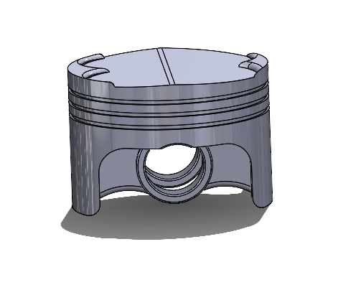
Figure 2-Gudgeon pin | 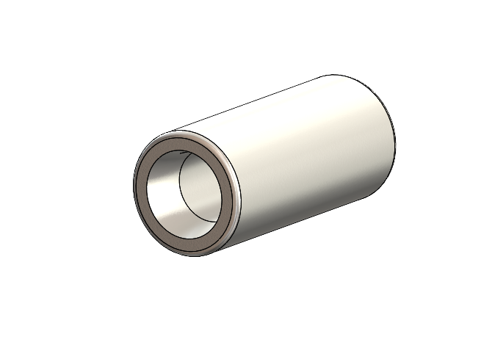
Figure 3-Connecting Rod | 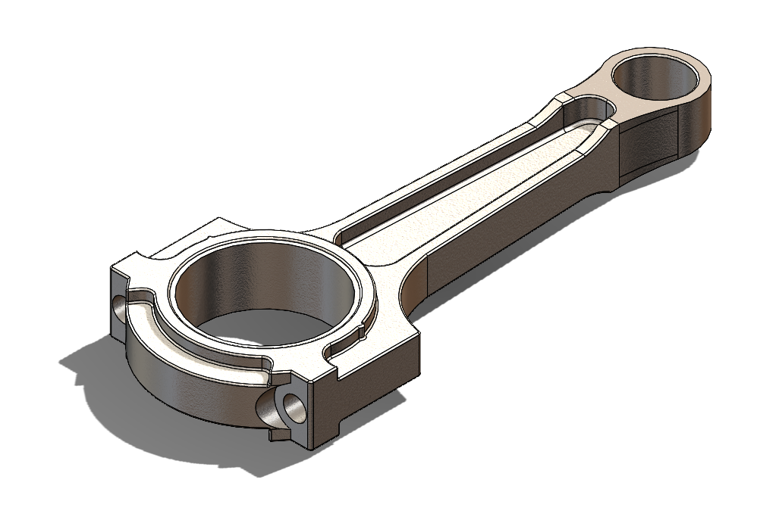
Figure 4- Crank shaft | 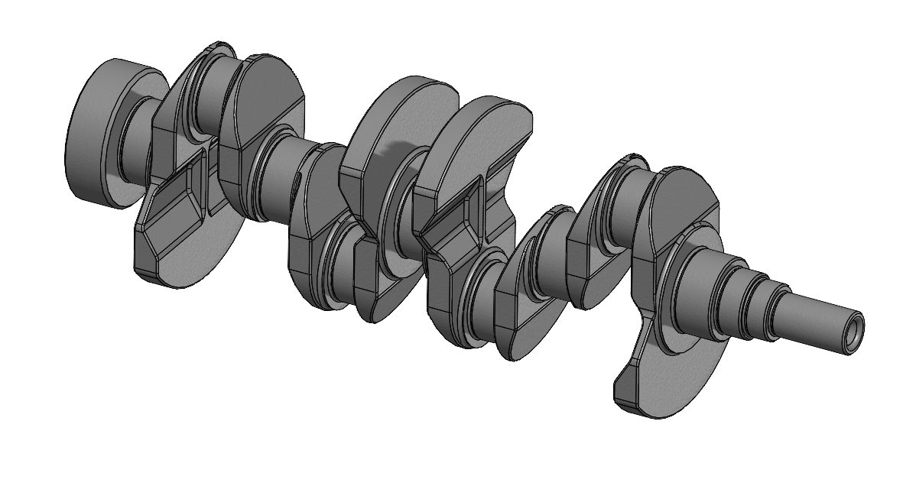
Figure 5-Assembly | 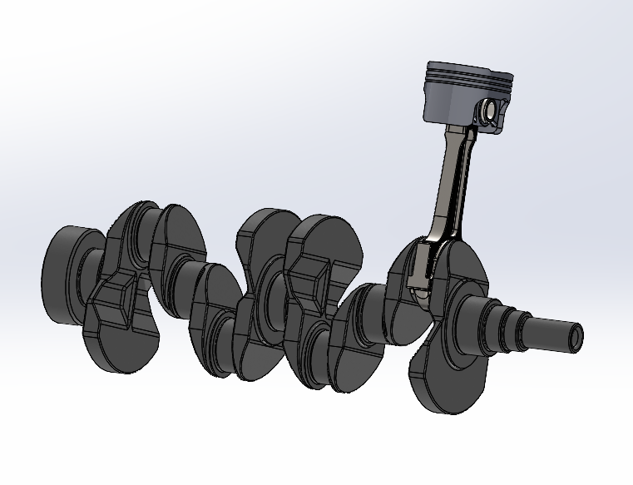

Validation testing
The purpose of validation a model is to ensure that the model with produce accurate data.
The purpose of any CAE model is to predict the behaviour of a part or system under a specific or multiple different conditions. The reason for validating a model is to ensure that the model produces data that closely aligned with the real world.
This is done by selecting a scenario where the output can be calculated using a known and proven equation. The scenario will be solved using CAE and maths and the results can be compared. Because the maths is known to be correct, it can be used as a goal/target for the model. Without proper validation, the model might produce inaccurate results. Important decisions such as material selection and geometry of a part are made based of the results from CAE.
The output from CAE is the condition the part will be under including stress, strain, temperature and many more If the CAE is producing inaccurate data, the part/ system will be designed to cope with conditions that do not align with the real world. This will lead to the part being designed to cope with conditions it may never see for example if the peak stress in the model is higher than in the real world then the part will be designed with thicker geometry or with a material with a higher young’s modulus to cope with this stress that it will never see, this part will be heavier than it needs to be because the CAE was incorrect and/or not properly validated.

Bending cantilever with axil force

Figure 6-The analytical solution for the axial force case
The Bending cantilever with axil force uses a stainless-steel cuboid that is fixed at one end and has a force with components of 1600N in the x (horizontal) and -7650N in the z (vertical) direction acting on the other end as shown in figure 7. By applying a force at one end and a fixing at the other, the beam is bent. By using the equation shown in figure 6, the analytical result was 3557.478mm of deflection. By using a mesh size of 25mm, the model produces a peak deformation of 3555.5mm. This data means that the model is only 0.56% and operates at a high degree of accuracy. This means that ANSYS can accurately model using axial forces and fixed supports.

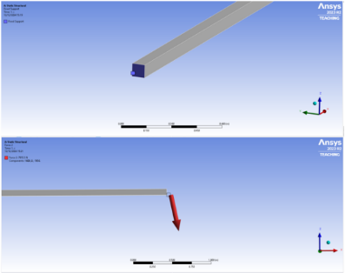
Figure 7-Boundary condition on the cantilever beam

Cantilever with uniform Load
The Cantilever with uniform load uses a stainless-steel cuboid that is fixed at one end and has a continuous pressure of 2750 Pa on its top face. This pressure will create deformation across the cantilever. The analytical result is shown in figure 9 and shows the result of 157.143mm. Figure 8 shows the models deformation output of 157.15mm. This model is accurate to 0.0045 %. This means that ANSYS can accurately model using pressures and fixed supports.
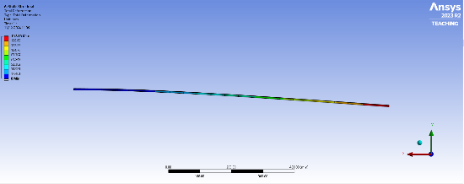
Figure 8- Cantilever with uniform Load model result

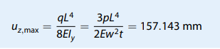
Figure 9- analytical solution for the uniform load case

Bimetallic
The Bimetallic strip uses an assembly comprised of 2 beams that are identical in geometry but made from 2 different materials with different thermal expansion coefficients. The beam is fixed at one end and the ambient temperature is increased from 22 degrees to 122 degrees (and increase of 100 degrees). As the temperature of the materials, they will deform at different rates causing that beam to bend. Figure 11 shows the analytical result of 7.05mm of deformation. Figure 10 shows that the model produced an output of 7.12mm of deformation. This model is accurate to 0.98%. This means that Analysis can perform thermal loading tests to a inaccuracy of less than 1%.

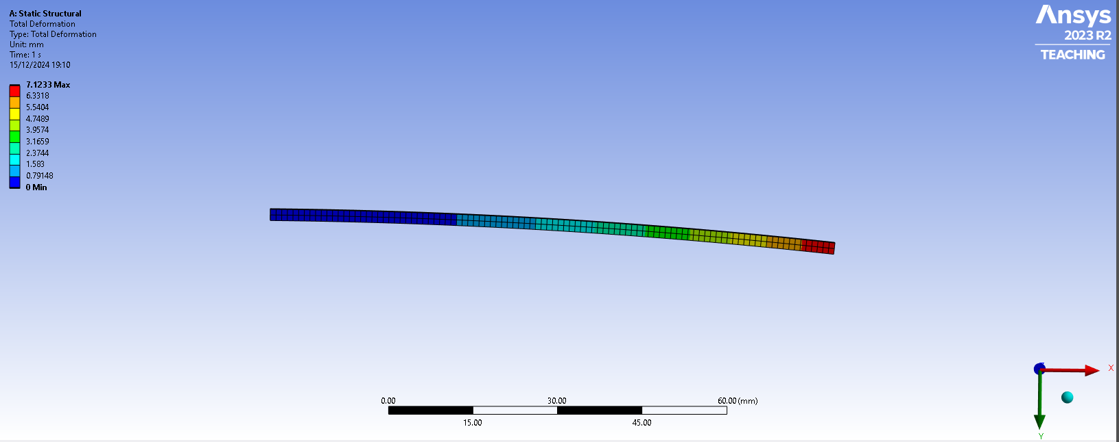
Figure 10-Bimetalic strip model results
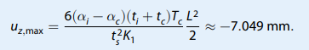
Figure 11- analytical result from the bimetallic strip case

Mesh independence study
The aim of a mesh independence study is to find the point where the output is independent of the mesh size.
By using smaller element sizes in a mesh, the software is able to more accurately represent the geometry of the part in question. Larger mesh sizes tend to oversimplify the geometry leaving areas with less accurate representation of the geometry. More elements in a model means more data points on the geometry allowing the software to generate an accurate result. (FEA tips, 2019) .
This mesh independence study has used the Bending cantilever with axil force validation example from the ACHA6010 Structural Design Fluid Analysis Teams channel. The Bending cantilever with axil force uses a stainless-steel cuboid that is fixed at one end and has a force with components in the x and -z direction acting on the other end as shown in figure 1.

Figure 2 was sourced from the Bending cantilever with axil force validation example from the ACHA6010 Structural Design Fluid Analysis Teams channel and shows the analytical result which is 3557.478mm. This is a larger value than the model calculates at every mesh size used in this mesh independence study. The trend in figure 2 shows that the deformation is converging on the mathematical result. This means that when solely looking at deflection, the finer the mesh the better but when you also look at the equivalent stress, this changes.
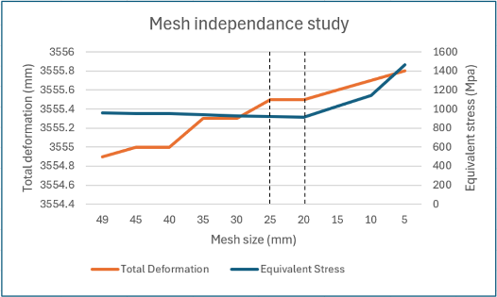
Figure 12-A graph showing Total deformation and Equivalent stress against mesh size
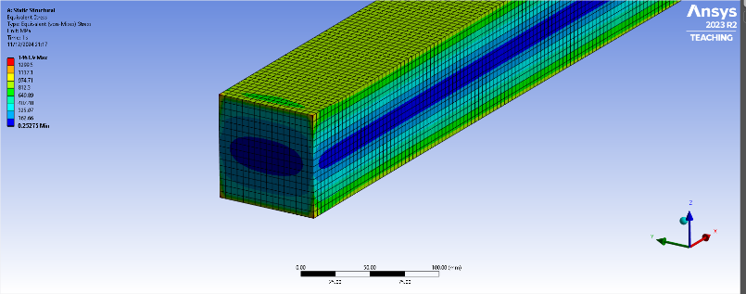

Figure 13-Localized peak stress

When the mesh size is 20mm or larger, the peak equivalent stress value is relatively unaffected. This is the section where the total deformation is independent of the mesh size. When the mesh size is below 20mm, the stress begins to rise.
The peak stress is observed at each 4 corners of the beam that has a fixed support acting on as seen in figure 4. This fixed support makes the face infinitely rigid. When using smaller mesh sizes, the dissipation of the stress caused by this constraint becomes less gradual concentrating the stress in a smaller area and causing unrealistic and bloated peak stress values as seen in figure 2 with mesh sizes below 20mm.
The ideal mesh size is 20mm. this is because between 50mm and 20mm because this is where the Equivalent stress is independent of the mesh size and the deformation gets more accurate as you decrease the mesh size so the smallest mesh size where the equivalent stress is independent of the mesh size is 20mm.
A model with a simple mesh will solve fast but will not be as accurate as a model using a more complex mesh. On the other hand, as the mesh gets more and more complex, the longer it will take to generate an output. By plotting equivalent stress and solving time against the element size it will be possible to identify the point where the increase in result accuracy is outweighed by the additional solving time. This is the principle behind a convergence study, the goal of a convergence study is “to balance the complexity of the model with it’s solve time” (Gardiner, 2017). This is the natural progression to a mesh independence study but not something that this report will go into.

2.2 boundary condition influence
Boundary conditions are the constraints that are applied to the model to simulate the desired real-world scenarios. Different boundary conditions need to be applied to simulate different scenarios.
Boundary conditions include fixed supports, applied force, applied loads, applied temperature, atmospheric temperature, part/system geometry, material selection and everything necessary to accurately recreate the desired scenario.
For example, look at a bending cantilever that is used in the mesh independence study in this report. The cantilever is fixed at one end free to deform under stress at the other. Because the boundary conditions accurately simulate the real-world scenario that it is modeling, the output of peak deformation was accurate to 0.56% when compared to the mathematical solution.
Boundary conditions are critical because they directly affect the outcome. If the boundary conditions are incorrect, for example the force applied to the cantilever is too high, then the beam see a higher peak deformation as seen in figure 14 the peak deformation has risen to 4656.1 and the model now has 30.9% inaccuracy.
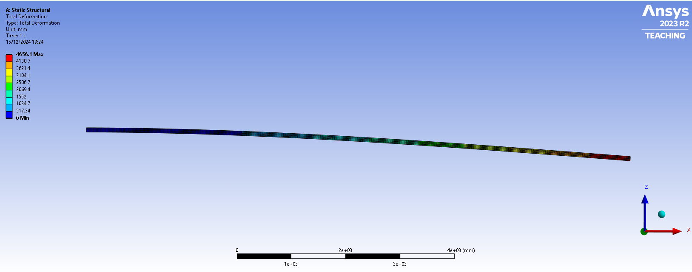
Figure 14- Bending cantilever case with incorrect boundary conditions

Material selection

The most commonly used materials in piston manufacturing is Cast Iron and aluminum alloys. This project has evaluated a cast iron, aluminum and steel alloy. (BECU china rapid prototyping shop, n.d.).
All material data has been gathered using Granta Edu pack.
 | Output Data
Material property | Deformation | Temperature | Stress
young’s modulus | high->low | Neutral | High->high
tensile strength | high->low | Neutral | High->high
PR | High->high | Neutral | Neutral
fatigue strength at 10^7 cycles | Neutral | Neutral | High->high
thermal conductivity | Neutral | high->low | Neutral
specific heat capacity | Neutral | High->high | Neutral
thermal expansion coefficient | Neutral | High->high | Neutral

Table 1- the affect material properties have on each model output

 | Material
Material property | Steel alloy | Cast Iron alloy | aluminium alloy
young’s modulus (Gpa) | 201-212 | 165-178 | 66.6-70
tensile strength (Mpa) | 570-700 | 500-600 | 290-338
Poisson's ratio | 0.29 | 0.275 | 0.33
fatigue strength at 10^7 cycles (Mpa) | 288-334 | 224-248 | 112-131
thermal conductivity (W/m^2) | 37-49 | 33-39 | 152-169
specific heat capacity (J/kg.°C) | 460-500 | 460-495 | 878-914
thermal expansion Coeff ( Strain/°C) | 11.-13.0 | 10-12.5 | 22.7-23.9
Mass (kg) | 0.74228 | 0.67336 | 0.2560
Price by mass (£/kg) | 0.653-0.856 | 0.222-0.321 | 1.52-1.75
total price | 0.56005026 | 0.18281724 | 0.41864175

Table 2- a table showing material property of all materials this project looks into

Cast iron and graphite – EN GJL 500/7 nodular graphite
The addition of graphite to the iron helps the alloy to better deal with the extreme thermal loads that a piston experiences in its daily operation.
Specific heat capacity is a value that represents the change in external temperature necessary to increase the temperature of that material by one degree Celsius. A high specific heat capacity means more energy is needed to heat up a material. Graphite has a specific heat capacity that is significantly higher than iron at 710 J/kg C raising the specific heat capacity of En GJL 500/7 to 460-500 J/kg C.
There are 2 main types of graphite-iron alloys which are nodular and flake. They differ in how the graphite is implemented into the iron. Flake is when the graphite forms a flake like structure, this is less favourable because it can create stress concentration points, making the material more brittle. Nodular graphite is spherical rather than flake-like which improves the materials ability to perform under high stress due to the removal of the stress concentration points created by the flake like structure of graphite.
GJL 500/7 was the best selection from Granta for this application. 500 refers to the refers to the minimum tensile strength of the material in MPa * when looking at the material properties Granta states that the tensile stress is between 500-600Mpa. The 7 refers to the percentage of elongation relative to its own length that the material can withstand before failure (Steel number , n.d.). other options included 600/3, 900/2, 800/2 and 450/10 and more. A piston experiences extreme forces, high tensile strength reduces the total deformation. Less deformation a good quality for a piston head to have because the stable geometry allows the cylinder and piston head to fit together more precisely under all levels of stress. 2 % deformation does not leave a large enough margin for error.
The Cast Iron alloy is the cheapest option by far.

Aluminium 6061 T6
Aluminium 6061T6 has the highest specific heat capacity, higher than graphite at 878-914 (J/kg.°C). this means that under intense thermal load it will heat up the least out of the 3 materials chosen.
It has a thermal expansion coefficient of over double the two other materials. Thermal expansion coefficient is the amount deformation caused by every increase in °C. whilst it is resistance to temperature change, the material deforms significantly more when it is heated.
Poisson’s ratio is the ratio of vertical deformation applied for every unit of lateral deformation created. Aluminium has the highest ratio at 0.33.
The Aluminium alloy is has the lowest young’s modulus, the lowest tensile strength and the lowest fatigue strength at 10^7 cycles. This suggests it will perform poorly in the deformation testing and would perform poorly in fatigue testing when compared to the other materials.

Steel – AISI8620 normalized low alloy steel
Steel is a strong material that can easily withstand the high forces that act on a piston. The steel alloy has the highest tensile strength, the highest modulus of elasticity and the highest fatigue strength at 10^7 suggesting that it is the most durable material in this selection. Whilst it strongest material, it is the most expensive per kg and the heaviest material. Its high strength means that whilst it is the heaviest material, there will be areas of geometry that can be removed or edited to save weight. The steel alloy has similar properties to the iron alloy in thermal conductivity, thermal expansion and specific heat capacity.

Methodology

The desired output from the model was to understand the thermal loading, deformation and stress that the piston will experience in operation.
All geometry was provided to me and all material data was imported from Granta Edu pack.
The aim of the ridged dynamics was to export the peak force acting on the piston caused by 4000 RPM rotation of the crank shaft. This data will be an important boundary condition in the static structural testing.
The aim of the steady state thermal was to find what temperatures the piston will experience in its operation. The boundary conditions were set using the information in table 3 which was provided by Andrew Noble as convections.
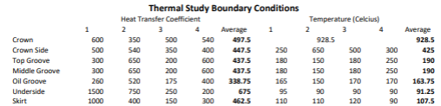
Table 3- Heat transfer coefficient and temperature data

The static structural testing uses the ridged dynamics data to apply the peak force that the piston experiences and the thermal loading data to calculate the total deformation and equivalent stress.

Results

Aluminium

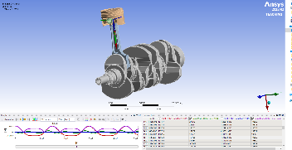 | 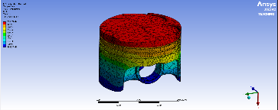 | 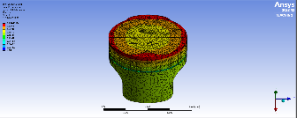 | 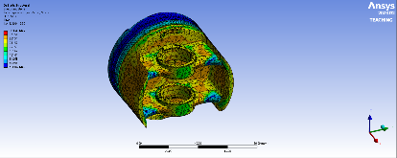
Figure 15- Aluminium piston -ridged dynamics | Figure 16-Aluminium piston - steady state thermal | Figure 17-Aluminium piston - static structural - Total deformation | Figure 18-Aluminium piston - Static structural - Equivalent stress
Aluminium alloy
stress (Mpa) | deformation (mm) | temp ©
361.49 | 0.292 | 308.79
1st | 3^{ed} | 1st
Table 4- Model output using Aluminium alloy piston and how it compares to the other materials

Cast Iron
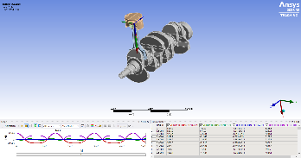  Figure 19-Cast Iron alloy piston -ridged dynamics | 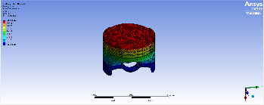  Figure 20- Cast Iron alloy piston - steady state thermal | 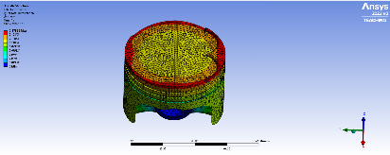  Figure 21-Cast Iron alloy piston - static structural - Total deformation | 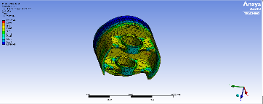  Figure 22-Cast Iron alloy piston - Static structural - Equivalent stress
Cast Iron alloy
stress (Mpa) | deformation (mm) | temp ©
473.42 | 0.178 | 440.94
2nd | 1st | 3^{ed}
Table 5- Model output using Cast Iron alloy piston and how it compares to the other materials

Temperature

Steel Aloy
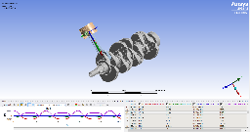  Figure 23-Steel alloy piston -ridged dynamics | 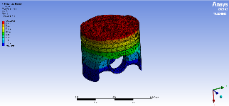  Figure 24-Steel alloy piston - steady state thermal | 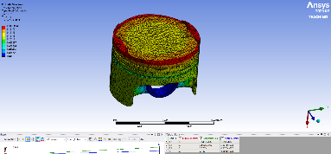  Figure 25-Steel alloy piston - static structural - Total deformation | 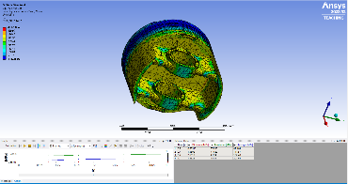  Figure 26- Steel alloy piston - Static structural - Equivalent stress
Steel alloy
stress (Mpa) | deformation (mm) | temp ©
483.5 | 0.182 | 423.04
3^{ed} | 2nd | 2nd
Table 6- Model output using Steel alloy piston and how it compares to the other materials

Analysis

Deformation
The aluminium piston sees the largest expansion, significantly greater than the other 2 materials.
Poisson’s ratio and Youngs modulus are the main material properties that have the greatest effect on Total deformation. Poisson’s ratio is the ratio that connects force acting vertically on the piston to the lateral deformation the piston experiences. it’s the amount of lateral deformation caused by vertical stress. young’s modulus is stress/strain or the force required for each unit of deflection. Aluminium has the lowest Youngs modulus and the highest thermal expansion coefficient. High deformation or piston expansion can create additional friction between the piston and the cylinder wall. This friction will resist the piston as it ascends and descends creating drag on crankshaft reducing the efficiency of the system and its power output. Peak deformation is seen at the top face of the piston. This is where the valve clearance cut outs are. High deformation in this area the valve will not have sufficient clearance and may be damaged.

Thermal
All temperature changes will cause expansion or deformation with is unwanted. This expansion can be measured and is commonly referred to as the thermal expansion coefficient. Whilst aluminium sees the lowest peak temperature, its thermal expansion coefficient is over double that of the two other materials and its increase in temperature is more than double so the expansion due to thermal loading will be the largest for the aluminium alloy piston.
Then main material properties that will affect the peak temperature are the thermal conductivity and specific heat capacity. A high specific heat capacity means more energy is needed to heat up a material. The order of peak temperatures is the same as the order of specific heat capacity.
The piston is connected to the conrod. The geometry of these two parts have been designed to fit together. If these two parts are made with different materials and have significantly different thermal expansion coefficients, there geometry will change at different rates. This could lead to a ‘baggie’ fit between the piston and conrod which will cause ‘rattling’ increasing wear on both parts.
(Li, 1982)

Stress
Stress is directly related to part failure. If a part is experiences high stress or repeated stress cycles it will eventually fail. The tensile strength of a material is the force required to pull a part to the point to which it breaks.
The Steel alloy piston sees the highest Equivalent stress. But this does not mean it will fail first. The steel alloy as a component has the highest tensile strength and the highest fatigue strength at 10^7 cycles. The steel alloy piston shows sees similar only 2.1% more stress than the iron piston whilst having 15.5% higher tensile strength and 31.8% increase in its fatigue strength at 10^7 cycles.

Future work
Topology work would be a verry interesting point of discussion for this project. I t would allow the heavy and strong Steel alloy piston reduce its volume whilst still having the ability withstand all the forces acting on it.

Conclusion and Recommendations

The steel alloy has the largest tensile strength and fatigue strength at 10^7 cycles. This means that a higher anomaly would be needed to cause familiar and it will have longer lifespan than the other 2 pistons. Whilst the steel piston experiences the most stress and is the heaviest, it would perform better in both these parameters after mass optimization / topology. The steel piston would see the most gain from something like this because of its strength and durability which would allow more material to be cut off whilst still being able to perform under the expected conditions.
The Cast Iron alloy piston sees the lowest amount of Total deformation. Because the piston will not deform as much the engineering team can make the cylinder diameter and piston diameter closer creating a more ‘snug fit’. The cast iron piston is the lightest by far.

The aluminium piston

The cast Iron alloy piston is the lightest by making it the more suitable for higher revving engines. He Steel alloy piston is the sturdiest and most reliable, its application would be in engines designed for machines such as tractors where a breakdown is more significant.

References
Asahi KASEI, n.d. Part10 Types of structural analysis and required material data. [Online]
Available at: https://www.asahi-kasei-plastics.com/en/knowledge-cae/plastics-cae10/#:~:text=CAE%20structural%20analysis%20%28stress%20analysis%29%20is%20an%20analysis,%28deformation%20behavior%2C%20internal%20deformation%20state%20of%20parts%2C%20safety%29.
[Accessed 14 12 2024].
BECU china rapid prototyping shop, n.d. BECU. [Online]
Available at: https://be-cu.com/blog/automotive-pistons/#:~:text=Material%20Selection%3A%20The%20choice%20of%20material%20for%20pistons,high%20strength%2C%20excellent%20thermal%20conductivity%2C%20and%20wear%20resistance.
[Accessed 12 12 2024].
Discover Engineering, n.d. Kinematic Analysis of Mechanisms: Principles and Methods. [Online]
Available at: https://www.discoverengineering.org/kinematic-analysis-of-mechanisms-principles-and-methods/
[Accessed 14 12 2024].
FEA tips, 2019. What is a Mesh Independance Study?. [Online]
Available at: https://featips.com/2019/03/31/what-is-a-mesh-independence-study/
[Accessed 11 12 2024].
Gardiner, J., 2017. xceed engineering and consulting. [Online]
Available at: https://www.xceed-eng.com/finite-element-analysis-convergence-and-mesh-independence/
[Accessed 11 12 2024].
Li, C.-H., 1982. Piston Thermal Deformation and Friction Considerations, s.l.: SEA.
Steel number , n.d. European steel and alloy grades / numbers. [Online]
Available at: https://www.steelnumber.com/en/steel_composition_eu.php?name_id=1522
[Accessed 15 12 2024].
Subramoniam, R., 2017. Slide Share. [Online]
Available at: https://www.slideshare.net/slideshow/piston-material-selection/83411332
[Accessed 12 12 2024].

Figure table
Figure 1-Piston 3
Figure 2-Gudgeon pin 3
Figure 3-Connecting Rod 3
Figure 4- Crank shaft 3
Figure 5-Assembly 3
Figure 6-The analytical solution for the axial force case 4
Figure 7-Boundary condition on the cantilever beam 4
Figure 8- Cantilever with uniform Load model result 5
Figure 9- analytical solution for the uniform load case 5
Figure 10-Bimetalic strip model results 5
Figure 11- analytical result from the bimetallic strip case 5
Figure 12-A graph showing Total deformation and Equivalent stress against mesh size 6
Figure 13-Localized peak stress 6
Figure 14- Bending cantilever case with incorrect boundary conditions 7
Figure 15- Aluminium piston -ridged dynamics 10
Figure 16-Aluminium piston - steady state thermal 10
Figure 17-Aluminium piston - static structural - Total deformation 10
Figure 18-Aluminium piston - Static structural - Equivalent stress 10
Figure 19-Cast Iron alloy piston -ridged dynamics 11
Figure 20- Cast Iron alloy piston - steady state thermal 11
Figure 21-Cast Iron alloy piston - static structural - Total deformation 11
Figure 22-Cast Iron alloy piston - Static structural - Equivalent stress 11
Figure 23-Steel alloy piston -ridged dynamics 11
Figure 24-Steel alloy piston - steady state thermal 11
Figure 25-Steel alloy piston - static structural - Total deformation 11
Figure 26- Steel alloy piston - Static structural - Equivalent stress 11

