Cover Page

Name : Shekhar Anant Naik.
Student Id : 2544915
Module : Software Solutions For Business
Module code : ACCA4026

Contents
Introduction 1
Task 1. e-Commerce Website builders/software solutions 1
1.1 Wix 1
1.2 Shopify 2
Task 2. Mind-map of contemporary software applications 2
2.1 Mind Mapping and Its Importance in Business Operations. 2
2.2 Create a mind map of contemporary software applications. 3
Task 3. Office Applications 4
3.1 Four office software solutions for business operations 5
Microsoft Word 5
Microsoft Excel 7
Microsoft PowerPoint 8
Microsoft Access 10
3.2 Test any two features 11
Mail Merge 11
IF Statement 14
Task 4. Communication and Collaboration applications 15
4.1 One contemporary Communication and one Online Collaboration 15
Gmail 15
Main Features. 15
Strengths and Weaknesses. 16
Zoom 16
Main Features. 16
Strengths and Weaknesses. 16
Comparative Analysis. 17
4.2 Test one feature of a freely available Communication (1) and one feature of a Collaboration (1) application 17
Gmail 17
Gmail Email and Attachment Feature 17
Zoom 18
Screen Sharing Feature in Zoom 18
Conclusion 20
References 20

Introduction
Computer programs have now become an essential component of modern-day business that assists in increasing the efficiency of a business, improving communications, making decisions, engaging customers and managing information. The right selection and implementation of software tools enable effective management of business processes and help in ensuring efficient performance of employees. This report discusses modern-day software tools and their usage in business operations. Two website developers used for e-commerce websites are reviewed, and the capabilities of mind-mapping and modern-day business software are considered. The report also considers the utilisation of Microsoft Office software in generating, analysing, storing and presenting information. The means of communication and collaboration, namely Gmail and Zoom, are also covered in this report. Practical activities are provided for application of the software capabilities in the simulated business environment.

Task 1. e-Commerce Website builders/software solutions
The e-commerce website builders refer to software programs that allow organisations to create and manage their virtual stores even without having any previous experience with programming. This is made possible by the variety of functions offered by the software programs, including site building, product management, payments and digital marketing, amongst others. With the rising number of online transactions, selecting the right e-commerce program is an important decision that an organisation has to make. There are many e-commerce programs currently available, and two of them include Shopify and Wix eCommerce.

1.1 Wix
 Wix website builder that is famous for its capabilities to sell online and construct a website at the same time is Wix eCommerce. It is suggested for small businesses, freelance entrepreneurs and start-ups due to its easy-to-use drag-and-drop editor. So, by using Wix, users are able to create visually appealing websites without having any technical skills.
The main advantages of Wix are its simplicity and flexibility. Therefore, users are able to create professional-looking websites utilising AI technology and numerous customising templates. In addition, Wix can provide SEO tools, email marketing and customer management services, which will help businesses to increase their online presence and customer interaction [2]. However, in comparison to Shopify, Wix does not have advanced e-commerce features.

1.2 Shopify
 Shopify is a cloud-based ecommerce platform designed specifically to help firms to set up and manage their professional web store. Shopify has an intuitive interface allowing users to design their website using pre-designed templates and drag-and-drop content items. The platform allows for conducting secure transactions, managing inventory, processing orders, executing customer relationship management operations and SEO-ing the website. As such, the platform is applicable not only for small companies but for big ones.
What sets Shopify apart from other platforms is its scalability. Businesses begin by creating a product line and gradually increase it without any transition to another platform. Moreover, Shopify offers various AI-powered tools, analytics and thousands of third-party applications through its App Store to optimise users' operations on the web. Nevertheless, additional expenses are incurred while purchasing premium themes and paid applications [1].
Comparison.
Overall, Shopify and Wix are good website builders for online businesses; nevertheless, the two have been developed to suit the needs of various organisations. Shopify has been developed with all the needed tools and capabilities for building an e-commerce store, including advanced inventory management, different payment options, a variety of applications and services, and scalability. Therefore, it will suit mid-size companies and enterprises that expect further development. Wix, however, is oriented towards a user-friendly interface and ease of use, lower cost, and the possibility of designing a website in a simple way through drag-and-drop features [3].

Task 2. Mind-map of contemporary software applications

2.1 Mind Mapping and Its Importance in Business Operations.
The mind map is a kind of organisation of information in which the main point is put in the middle, and other points related to it are added through branching. This approach brings some structure to the delivery of information and helps analyse and comprehend complicated things. Mind maps are not conventional notes; they consist of keywords, hierarchy, and visual connections of different ideas. It helps people understand information better and develop their creativity, and it makes the organisation of a great amount of information easier [4].
In a modern business environment, mind maps have become very useful tools for planning and making decisions. Businesses use mind maps for brainstorming, planning projects, analysing different processes, solving problems, and knowledge management. Through the visual connections of different ideas, employees will be able to define the priorities, see dependencies, and create a proper business strategy.
Another very important benefit that can be derived from using mind maps is that of fostering better collaboration and productivity. Ideas can be produced through teamwork, and this will help to foster innovations and make sure that everyone in the team has a clear picture of what the organisational goals are. Besides, the mind maps can help in better management of tasks by dividing the larger tasks into smaller ones.

2.2 Create a mind map of contemporary software applications.
The designed mind map enables carrying out the systematic analysis of the software applications that help to perform the business processes. The central concept "Contemporary Software Applications" is subdivided into fourteen categories. Each of them is represented by the most popular technologies in contemporary organisations [5].
The first one is connected with Operational and Financial Systems. They include ERP, Accounting and Finance, and Human Resource Management software that help to manage organisational resources, financial accounting, payroll, personnel documentation, and other processes.
The second category is the Team Productivity and Collaboration software, which includes such tools as Office Productivity software, Communication software, Collaboration and Project Management software, and Cloud Storage. They are used to create documents, communicate, manage projects, and exchange files regardless of their location in the world.
A next significant stream includes technologies for handling Data, Analytics, and Security, which encompass such systems as Database Management Systems, Business Intelligence & Analytics, Cybersecurity, and Artificial Intelligence. These technologies, organisations can work with business data, extract useful information from it, protect themselves from threats, and automate some processes in order to boost efficiency [6].
The last stream addresses Customer and Sales Management, which incorporates such applications as Customer Relationship Management, E-Commerce, and Marketing & Social Media. Such software solutions allow organisations to create relationships with customers, sell their goods/services online, promote their products and services, and communicate with customers.
Overall, mind maps clarify that nowadays businesses operate an integrated ecosystem of software applications. Each of them makes organisations more productive, more communicative, more efficient in terms of decision-making, and better in terms of customer service overall.
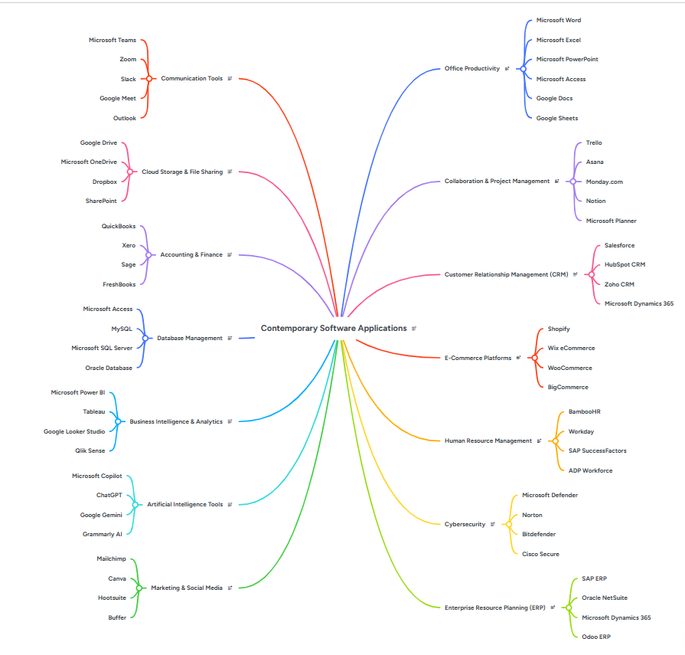
Figure 1: Mind map of contemporary software applications
(Source: Self)

Task 3. Office Applications
Office Applications for Creating, Storing, Presenting, and Analysing Business Information.
The applications used in Microsoft Office are essential tools that help in maintaining the functioning of organisations in daily routine. These tools help the employees to create professional documents, analyse data, communicate their ideas and information to others, as well as manage organisational information. As technological innovations have been increasingly utilised by organisations to improve the productivity and decision-making process, office software has become an extremely essential tool. Each of these applications is aimed at performing certain tasks but at the same time is integrated with other applications in order to improve the efficiency of the work. The report analyses four popular office applications such as Microsoft Word, Microsoft Excel, Microsoft PowerPoint, and Microsoft Access.

3.1 Four office software solutions for business operations

Microsoft Word
Microsoft Word is one of the most popular word processors in businesses. Microsoft Word enables creating, editing, formatting and managing professional documents. It is used to create reports, proposals, agreements, policies, letters, minutes of meetings, and other official documents. This software provides a user-friendly interface and good formatting options, which makes it ideal both for individual work and for team collaboration in a business environment.
This Photo by Unknown Author is licensed under CC BY-SA-NC

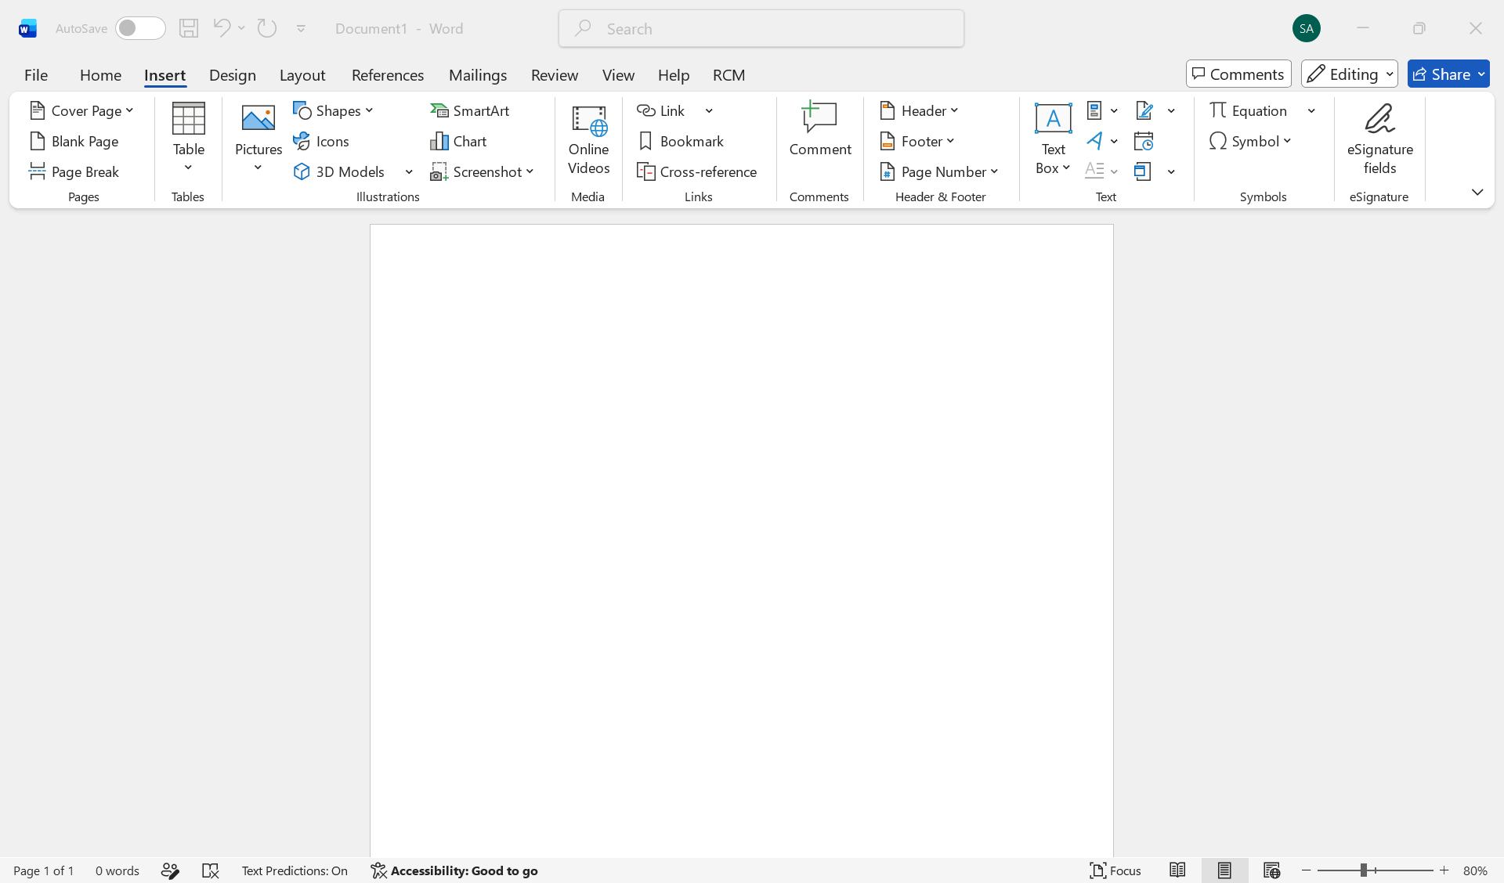
Figure 2: Microsoft word interface
(Source: Self)

Main Characteristics
There are many features available in the Microsoft Word software that enhance the effectiveness of working with documents. It is possible to create systematic and well-structured documents using such options as the usage of templates, styles, headings, tables, pictures, graphs, and SmartArt graphics. Also, such features as the spelling and grammar check, automatic formatting, page numbers, references, citations, and table of contents are available [7].
The Track Changes feature, which enables monitoring all changes made by different users and their acceptance or rejection, is a very useful feature. The Comments feature that enables collaborative document reviewing without making any changes is also very useful. Finally, Microsoft OneDrive integration enables collaborative work with documents anytime and anywhere.
Advantages of Business Processes
Microsoft Word enhances the productivity of the business processes thanks to the simplicity of document creation as well as using templates and formatting styles for the same purposes. The software provides efficient communication as it is possible to create professional documents with one company image. Integration with other Microsoft Office products enables to insert tables and charts from Excel for the creation of business reports [7].
Also, Microsoft Word enables the security of document sharing and version control and, thus, reduces duplication. The fact that many organisations operate in hybrid or remote Mode makes cloud collaboration of the application useful.
Disadvantages
Although the software has numerous advantages, there are some disadvantages of Microsoft Word. First of all, the application was developed for document creation but not for any calculations or databases. In addition, large documents containing pictures and complex formatting slow down on less powerful computers. Moreover, the collaborative feature of the application is available only for users with Microsoft 365 and an Internet connection [8].
In general, Microsoft Word is an indispensable business application due to its document creation and collaboration capabilities.

Microsoft Excel
 Microsoft Excel is one of the leading spreadsheet programmes which can be utilised for management and analysis of numerical data. This programme allows firms to organise and analyse numerical information, make calculations, create reports and base decisions on facts. Because of the great functionality and analytical opportunities of Microsoft Excel, the programme became important amongst the tools for business productivity [9].
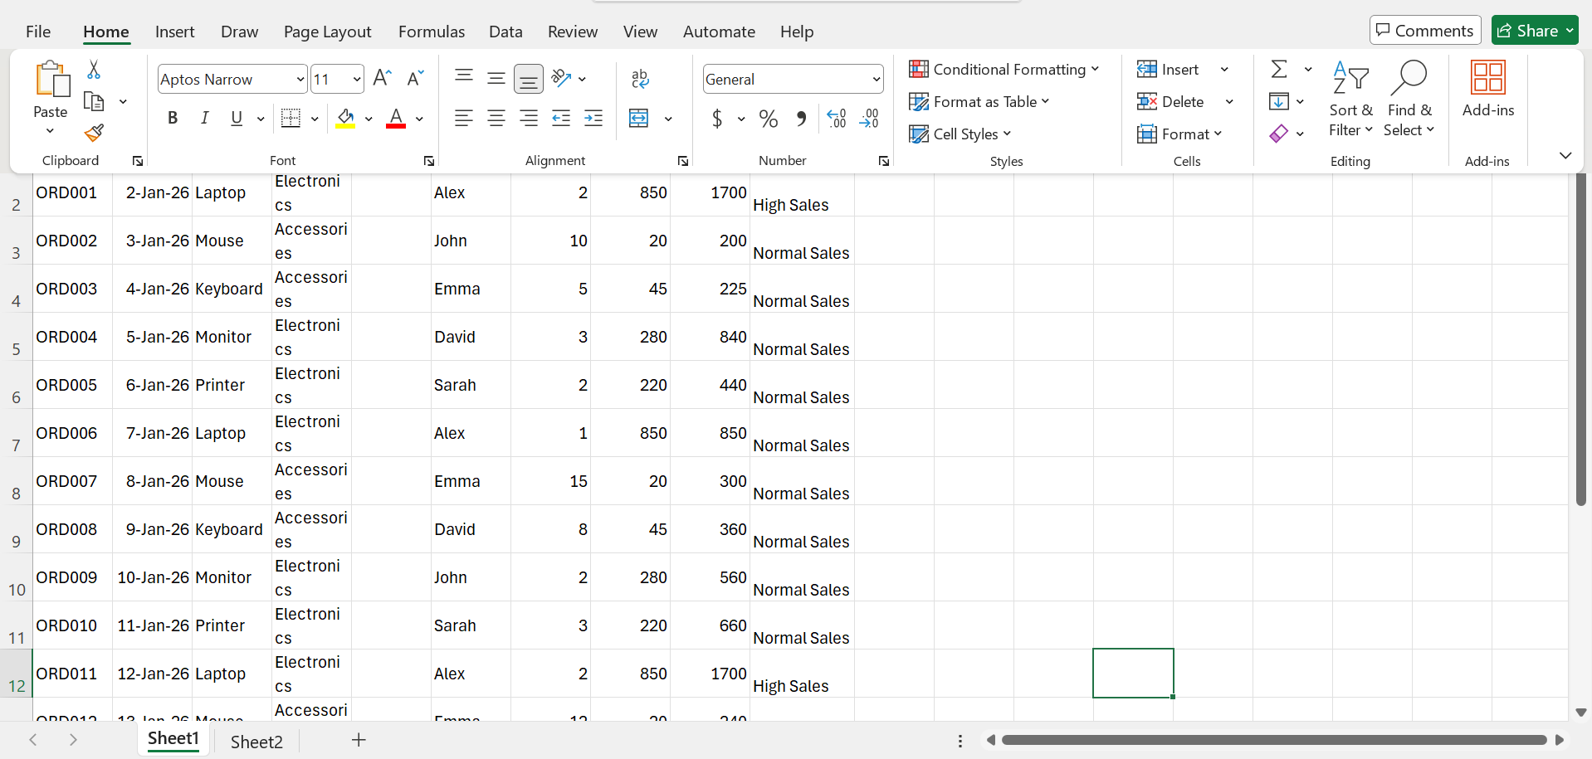
Figure 3: Microsoft Excel interface
(Source: Self)
Main Functions
The variety of tools offered by Microsoft Excel is of utter importance to multiple industries or sectors. There are several tools that can be applied for organisation and analysis of numerical data. Anyone can organise data in worksheets and tables and use formulas and functions for automation of calculations. Such functions as IF, SUM, AVERAGE, COUNT, and VLOOKUP assist companies in handling complicated sets of data.
Also, there are Pivot Tables, which help to sum up and analyse complicated sets of data; in such a way, managers will easily be able to identify trends and patterns. Moreover, graphs and charts can convert the numerical data into visual form. With the help of Conditional Formatting, the important numbers will be highlighted automatically [10].
Additionally, Microsoft Excel has data validation, sorting, filtering, and integration with Power Query and Power Pivot, which help businesses deal with increasingly complicated datasets. Cloud integration enables several users to access and edit the same spreadsheet while also controlling the versions.
Advantages for Business Operations
The productivity of businesses has increased overtime due to functions of Excel, which helps to remove manual calculations and increase the preciseness of the results of financial and operational reports. Excel is used for budgeting, expense tracking, sales analysis, forecasting, and key performance indicator evaluation [9]. Thus, this tool reduces the probability of making any mistakes and increases calculation speed for employees.
The flexibility of the program helps organisations to adjust the spreadsheet according to their needs. Therefore, Excel can be used by various companies of different sizes. Compatibility of Excel with other programs in the Microsoft Office package improves work efficiency.
Disadvantages
While Microsoft Excel is extremely flexible, it is designed not to be a substitute for database management software. Large amounts of data can slow down the performance and cause data inconsistencies when being edited by several people at once. Moreover, wrong formulas or data input can have a substantial impact on the analytical results.
Microsoft Excel can still be considered one of the most useful business programs due to its strong analytical capabilities, automation, and informed business decision-making.

Microsoft PowerPoint
 Microsoft PowerPoint is a tool that is used in the development of attractive slides to communicate information. In business, PowerPoint is used in meetings, training, project updates, marketing proposals, sales presentations, and strategic reports. PowerPoint provides information with text, pictures, graphs, animation, and other types of media.

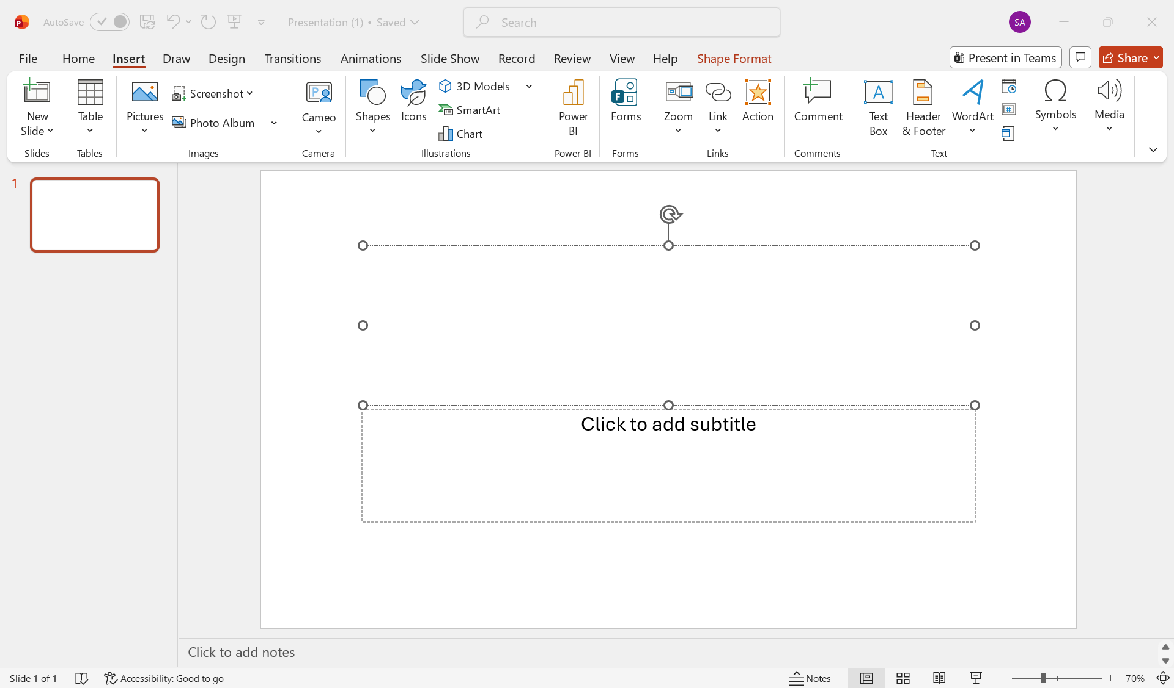
Figure 4: PowerPoint interface
(Source: Self)
Major Features
In PowerPoint, there are different templates and themes available to make it easier for the user to make a professional presentation. The user can use graphs, SmartArt graphics, tables, videos, icons and animations in their presentations to get the attention of the audience. An important feature of PowerPoint is the presenter mode, where the presenter can see notes while presenting slides [11].
An excellent feature of PowerPoint is that it allows collaboration in real-time with others through Microsoft 365 for developing a presentation. PowerPoint is integrated with Excel and Word, allowing the user to use charts, tables and documents from these programs in their presentations.
Advantages for Performing Business Processes
Business processes can be easily communicated through the presentations created in Microsoft PowerPoint. Presentations are used by companies for discussing the strategy, the status of projects, introducing new products and performing training. The presence of visual material helps to perceive the information better than only reading the text.
Additionally, the program allows creating both types of presentations, which are becoming more and more relevant due to the current hybrid work model. The integration with Microsoft Teams and cloud computing is making the software more accessible. [11]
Disadvantages
But there are some disadvantages of Microsoft PowerPoint as well. Excessive animation or amount of text may have a negative impact on the process of presentation and distract the audience from the main content. Additionally, this tool is not meant for performing data analysis or any other business processes except for presenting the information. Moreover, the effectiveness of the presentation process will depend on the skills of the presenter. Overall, Microsoft PowerPoint is an essential part of business processes.

Microsoft Access
 Access database from Microsoft is the tool of RDBMS to store, organise, retrieve, and manage information about business activities in a systematic way. Unlike spreadsheets, Access uses a database in which data is stored in the form of interconnected tables. This enables organisations to effectively manage their information in a more organised way. It is utilised by SMBs in inventory management systems, customers' records, employee databases, and business reports.
This Photo by Unknown Author is licensed under CC BY-NC
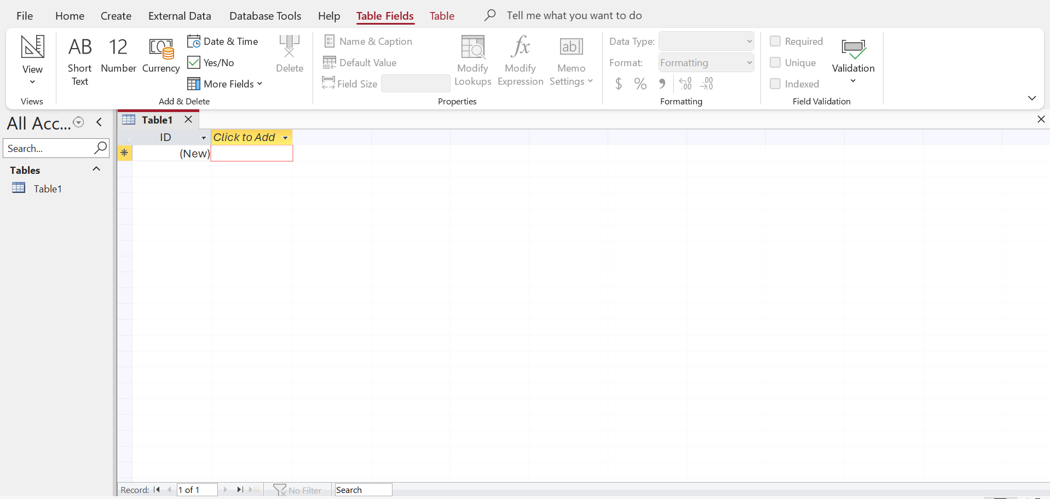
Figure 5: Microsoft Access interface
(Source: Self)

Key Features
Access software from Microsoft allows its users to design relational databases through the use of tables, queries, forms, reports, and relationships. Information regarding business activities is recorded in the table, whereas queries help users to get records as per the required conditions. Forms are utilised for entering data without any error and reports are designed for decision-making purposes.
Some other features of the software include primary keys, foreign keys, validation rules for data, indexing, and relationships to maintain the consistency of data. It also has the ability to import and export data from Microsoft Excel [12].
Advantages in Business Operations
It improves efficiency in business operations by offering a method of organisation and storing of information. The system prevents duplication in the storage of data through the relational database structure and allows employees to have access to the data through specific queries. The system makes it possible to automate repetitive actions using macros and the creation of reports without having to process the data manually [12].
This application is suitable in departments where there is a need for management of records but does not require the use of enterprise database management software.
Disadvantages
The software is not suited for large-scale applications because it may work slowly in enterprise-level applications where there are multiple simultaneous users. The users will require knowledge of the aspects of the database such as relationships, queries and normalisation. Moreover, organisations that require scalability will opt for enterprise database management software such as Microsoft SQL Server.
In summary, Microsoft Access is a good application for the management of data. It offers reliable data storage, information retrieval and improved report generation capabilities [12].

3.2 Test any two features

Mail Merge
Mail Merge is a feature in Microsoft Word that allows one document to be used to create several personalised documents. It can take information from a list, such as an Excel spreadsheet, and add different details to each copy. This can save time when a business needs to send similar letters or other documents to many people.
Microsoft says it is generating a collection of documents customized for each recipient, where the placeholders are filled in with data from an associated list, spreadsheet or database. It automates the process of sending a message out to each recipient that normally would have to be done individually - such as certificates, invoices, appointment letters [13].

Step : 1
Writing the main text. The letter was created initially in Word, and then the Mailings tab was opened and the merge started. It is important to do this prior to connecting a data source as the merge fields should be placed in the finished text, not the other way round. The final letter with the Mailings tab turned on and the merge fields placed in the salutation is seen in Figure 6.
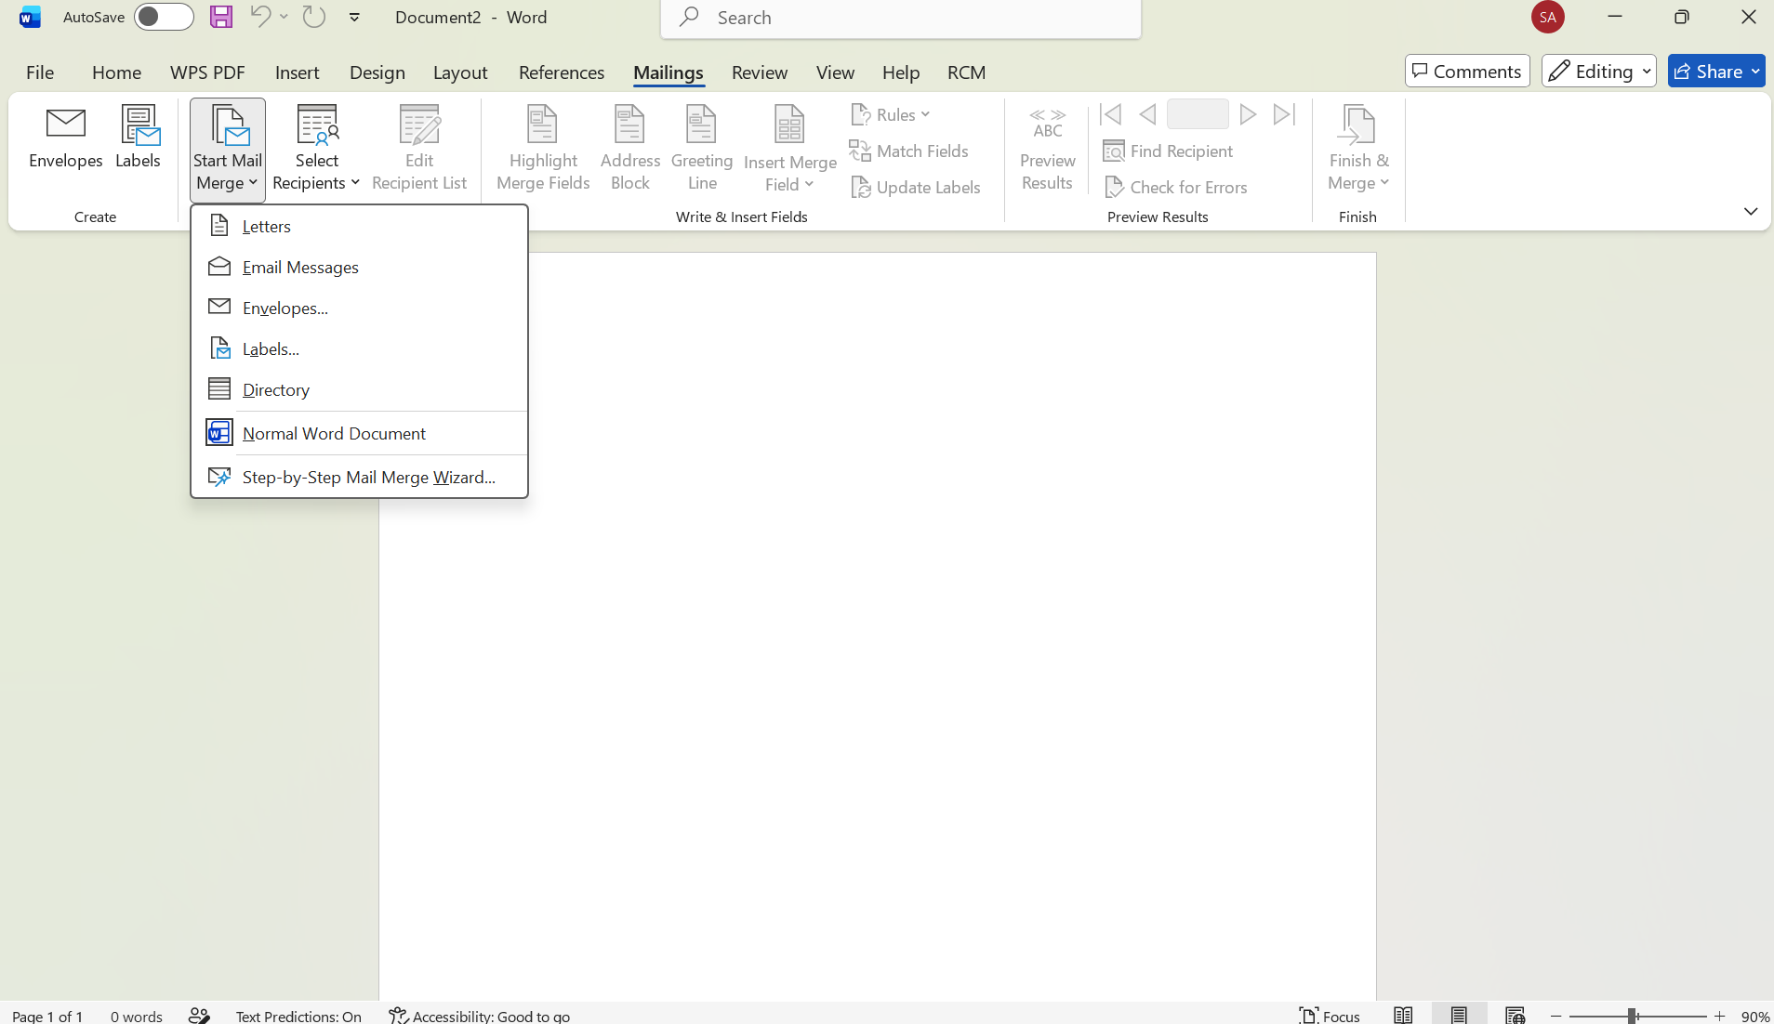
Figure 6 : Starting Mail merge process in Microsoft word
( Source : Self )
Step : 2
Building up the list of recipients. The data source was created by selecting Select Recipients, and Type a New List. Word displays the New Address List dialogue, which is a tabular editor that contains a variety of predefined columns, such as Title, First Name and Address. Four false records were made. The creation of the list in Word would usually be used for a small, one-off mailing, while with a recurring mailing an existing Excel worksheet would typically be connected, as Microsoft documents. The recipient list is displayed on entry, as indicated in figure 7.
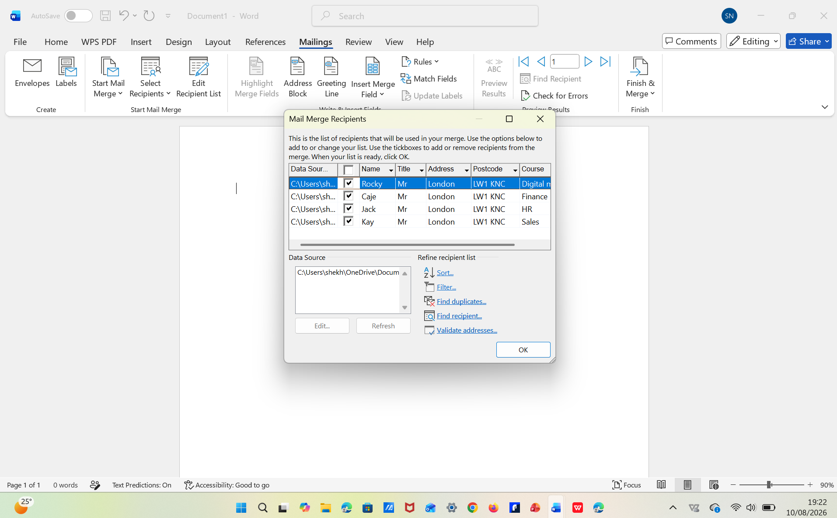
Figure 7: Creating the mail merge recipients list
( Source: Self )
Step : 3
Adding the merge fields. The placeholders were placed in the salutation with Insert Merge Field, which resulted in a salutation of: «First Name» «Last Name». The Merge Fields was then highlighted to show them from regular text, which helps verify that they have been properly typed as a merge field, since a field typed as regular text will not be highlighted and won't merge. As can be seen in figure 8. the merge fields are in place and highlighted.
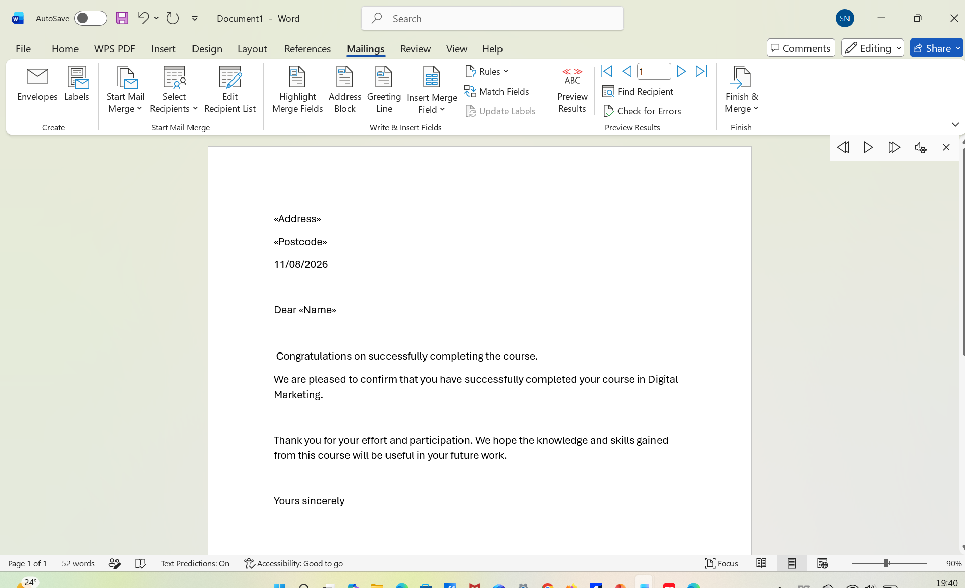
Figure 8: Inserting Merge Fields into the Letter
( Source: Self )

IF Statement
The use of the IF formula was demonstrated through the simulation of a sales data set, which had 15 sales records. A new column was introduced referred to as "Performance". The IF formula classified these records according to the sales volume. Any sales record having sales greater than or equal to $1,000 was labelled as "High Sales," and any sales record less than this amount was considered "Normal Sales." As shown in Figure 6, the function helped to identify the sales records with high performance, saving time from calculations [14].
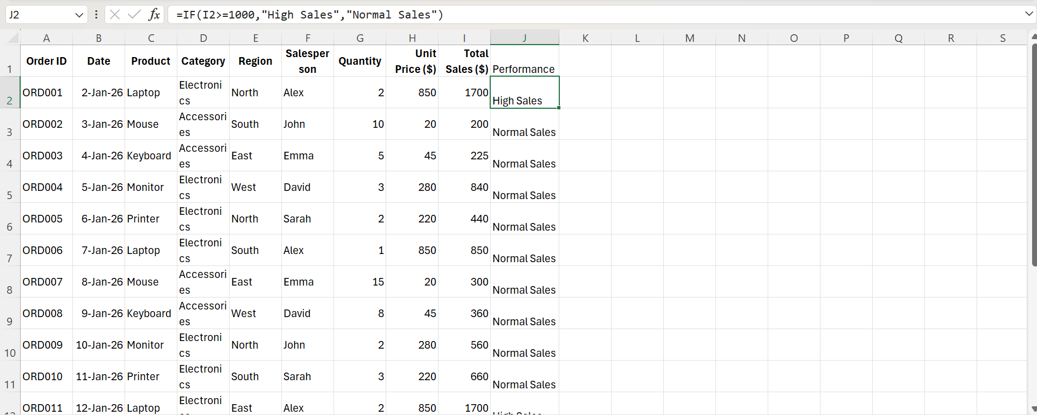
Figure 9 : Using IF formula for performance categorisation
(Source: Self)

Task 4. Communication and Collaboration applications
Excellent communication and collaboration are key in contemporary organisations in that they aid in increasing productivity, cooperation, decision making and information sharing. Considering the trend towards remote working, there arises a need to adopt digital platforms that will enable individuals in the organisation to communicate and collaborate regardless of where they are located. Whereas communication platforms facilitate information sharing, collaboration platforms allow for collaboration and interaction in real-time. The main objective of this chapter is to evaluate Google Mail as one of the contemporary communication platforms and Zoom as an online collaboration platform.

4.1 One contemporary Communication and one Online Collaboration

Gmail
Gmail is an online email provider created by Google and used for personal or business communication purposes. It helps in sending and receiving messages, storing and managing emails, sharing files, and communication with people. Being cloud-based, Gmail is available via computers, tablets, and smartphones and thus can be used by companies with flexible working policies.

Main Features.
The software offers several tools useful in conducting business communication. Firstly, there is an email tool allowing users to send emails and attach various documents, pictures and other files to them. Thus, it is convenient to communicate business information and coordinate different activities.
Another important tool of the software is the search tool that will help in finding previous emails based on keywords, the name of the sender, date of receipt, etc. It saves time for employees while looking for old emails. There are also labelling and filtering options helping to organise emails depending on project, department, customer, or importance of the emails [15]. In addition, Gmail is integrated with other Google services like Google Drive, Google Calendar, and Google Meet.

Strengths and Weaknesses.
The use of Gmail assists companies in improving their communication process through an efficient method of communicating. The use of cloud technology allows people to access emails irrespective of the geographical location or the computer being used. Search and filtering options make it easier to handle large amounts of emails.
However, sending a lot of emails increases the chances of creating information overload, making it difficult to filter the required information. Moreover, emails do not provide an efficient method of communicating in case of urgency since communication will not be instant. Companies should adopt appropriate security measures to guard their information.

Zoom
Zoom is an online video conferencing and collaboration tool that provides companies with the opportunity to conduct virtual meetings, training sessions, interviews, and project discussions. Zoom assists remote workers in ensuring communication among employees and external parties irrespective of their physical presence at one place.

Main Features.
Video conferencing is one of the key features provided by Zoom. It involves conducting live communication with participants using audio and video feeds. The screen sharing feature helps participants present presentations, documents, software applications or any other information which they wish to share with other participants of the meeting. This is particularly useful for training, demonstration, presentation and project discussion [16].
The other feature provided by Zoom includes the meeting chat feature through which participants can exchange messages and additional information. The other features available through Zoom include meeting recordings, participant management, virtual background and breakout rooms.

Strengths and Weaknesses.
Zoom makes it possible to collaborate as a team when there is need for meetings, and geographically remote employees can collaborate using the system. It not only saves time and money but also helps in arranging presentations, training, and online conversations.
Nevertheless, sometimes poor Internet connection causes issues and screen freezing hampering the quality of audio and video transfer. Also, extended virtual meetings sometimes get tiring, and there are paid functions in Zoom.

Comparative Analysis.
Both tools complement one another regarding the aspect of communication in business. As opposed to Gmail, which allows employees to engage in asynchronous communication, enabling them to exchange extensive details and documents not necessarily being online simultaneously, Zoom allows real-time interaction by means of which the participants discuss their work through audio and video.
As a result, Gmail is an appropriate tool for formal communication, making announcements, exchanging documents, and recording communication, while Zoom becomes the tool that is applicable in case of holding meetings, making presentations, giving training, demonstrating something, and having discussions with immediate interaction. If used together, both of the tools can create an effective communication process, for instance, organising a meeting via Gmail and then conducting it via Zoom [17].

4.2 Test one feature of a freely available Communication (1) and one feature of a Collaboration (1) application

Gmail

Gmail Email and Attachment Feature
Test on Email Composition and Attachment Facility in Gmail was done by simulating business communication. An email was composed using the test email account with the correct recipient, subject, and business message. A business document was attached to the email, and the email was then sent.
It is evident from Figure 8 that the Gmail Compose screen provides spaces for recipient, subject, message, and attachment. This facility helps in demonstrating the process by which business documents can be exchanged electronically among employees. Figure 10 demonstrates the received email, proving that Gmail can be used for business communication.
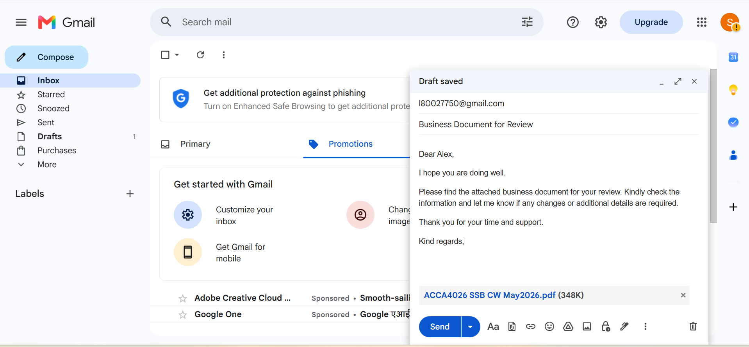
Figure 10: Composing a Business Email in Gmail
(Source: Self)

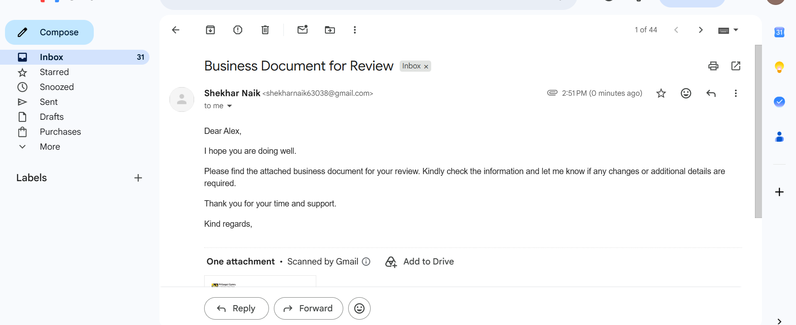
Figure 11: Successfully Received Email with Attachment
(Source: Self)

Zoom

Screen Sharing Feature in Zoom
To assess the usefulness of screen sharing in Zoom, a test virtual meeting was utilised for the purpose of a business meeting. During this meeting, the screen sharing function was activated, and a business document was shared with another participant of the meeting.
Step 1 : Figure 12 below shows that Zoom home page when signed in to zoom account. Zoom meeting is very simple to use. Information, and this shows how anyone can join, host, schedule the meeting and share their information online. This function is very effective in making business presentations and project discussions. [18].
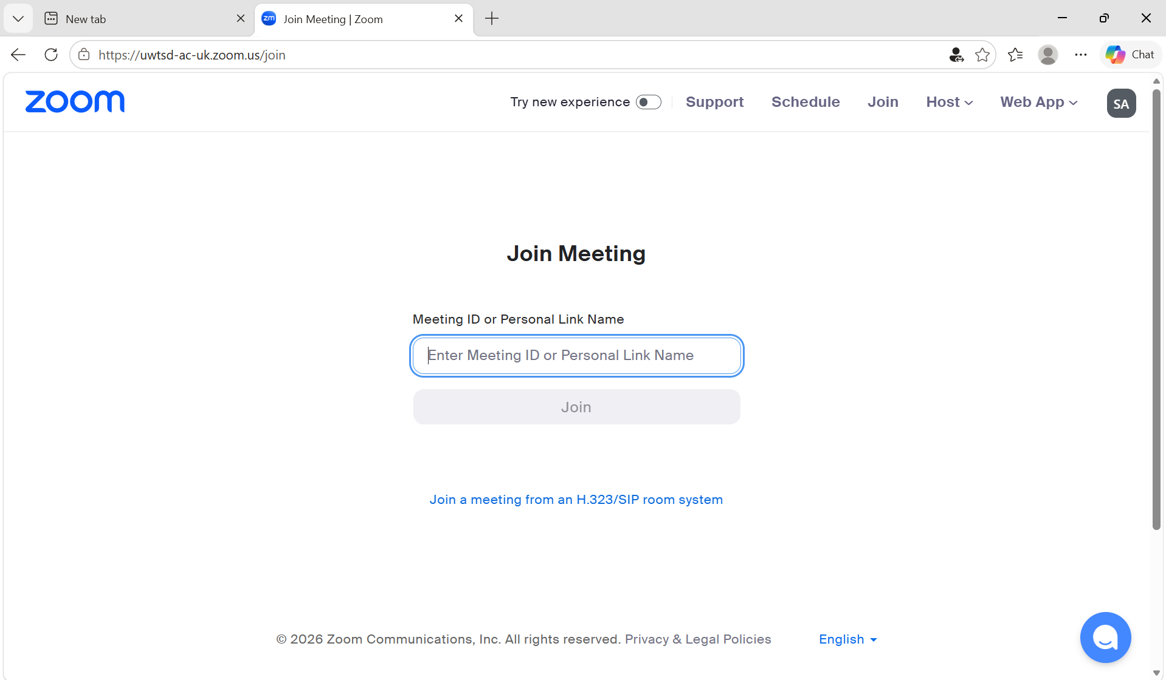
Figure 12: Creating a new meeting in Zoom
(Source: Self )


Figure 13: Zoom meeting link generated successfully
(Source: Self )

Conclusion
Through this report, the need for modern software applications to facilitate various business activities has been identified. The examples of software applications like Shopify and Wix concluded how easy it is to create a web presence. Also, the mind map has shown how various software applications help in facilitating various operational, financial, collaborative, analytic, security, and customer activities. The evaluation of software applications like Microsoft Word, Excel, PowerPoint, and Access has also shown how each software application has different functions in managing business information. Through the practical application of Excel, it has been seen how the Mail Merge and IF function help in automated classification and analysis of information.

References
[1] | S. Bang, ‘Top E-Commerce CMS Platforms (Shopify / WordPress / BigCommerce)’, 2023. Accessed: Aug. 08, 2026. [Online]. Available: https://www.theseus.fi/handle/10024/797028
[2] | M. Madiah, K. X. Ng, Y. W. Tan, Z. H. Tan, Z. T. Chong, and J. X. Chan, ‘Wix for Web Development and the Application of the Waterfall Model and Project Based Learning for Project Completion: A Case Study’, Journal of informatics and web engineering, vol. 3, no. 2, pp. 212–228, Jun. 2024, [Online]. Available: https://doi.org/10.33093/jiwe.2024.3.2.16
[3] | M. Rajeshree, R. Pawar, V. Arati, Mulay, and M. Arkatkar, ‘Application of TOPSIS for Selecting D2C Website Development Platform’, 2022. Accessed: Aug. 08, 2026. [Online]. Available: https://ieomsociety.org/proceedings/2022india/444.pdf
[4] | C. J. Fearnley, ‘Mind Mapping in Qualitative Data Analysis: Managing Interview Data in Interdisciplinary and Multi‐Sited Research Projects’, Geo: Geography and Environment, vol. 9, no. 1, Jan. 2022, Accessed: Aug. 08, 2026. [Online]. Available: https://rgs-ibg.onlinelibrary.wiley.com/doi/pdf/10.1002/geo2.109
[5] | C. H. C. Duarte, ‘Software Productivity in Practice: A Systematic Mapping Study’, Software, vol. 1, no. 2, pp. 164–214, May 2022, [Online]. Available: https://doi.org/10.3390/software1020008
[6] | R. Feng, H. N. Alsager, Z. Azizi, and L. Sarabani, ‘Impact of Mind-Mapping Technique on EFL Learners” Vocabulary Recall and Retention, Learning Motivation, and Willingness to Communicate’, Heliyon, vol. 9, no. 6, p. e16560, Jun. 2023, [Online]. Available: https://www.sciencedirect.com/science/article/pii/S2405844023037672
[7] | A. I. Akubos, ‘The Role of Word Processing Applications in Enhancing Administrative Efficiency in Business Education Departments in Tertiary Institutions in Bayelsa State’, Journal of Education Research and Library Practice, Apr. 2025, [Online]. Available: https://doi.org/10.70382/ajerlp.v7i8.027
[8] | O. Kruse and C. Rapp, ‘Word Processing Software: The Rise of MS Word’, Springer eBooks, pp. 15–32, Jan. 2023, [Online]. Available: https://link.springer.com/chapter/10.1007/978-3-031-36033-6_2
[9] | K. Ćosić and M. Imreh-Tóth, ‘Comparative Analysis of MS Excel and Power BI Tools for Business Reporting’, Applied Decision Analytics, vol. 2, no. 1, pp. 204–243, Mar. 2026, Available: https://ada-journal.org/index.php/ada/article/view/22/19
[10] | O. U. Ahumaraeze and C. E. Nlewedim, ‘Improving Students” Retention in Mathematics Using Excel Spreadsheet Software Package in Port Harcourt, Nigeria’, Journal of Instructional Mathematics, vol. 5, no. 2, pp. 121–135, Jan. 2025, [Online]. Available: https://doi.org/10.37640/jim.v5i2.2147
[11] | C. Zhang and Y. Zhao, ‘Design and Application of Multimedia Technology-Based Curriculum for Visual Communication Majors’, Advances in Multimedia, vol. 2023, pp. 1–11, Apr. 2023, [Online]. Available: https://doi.org/10.1155/2023/5061929
[12]  [13] | D. Hartini, M. Setiawardani, and M. Sutisna, ‘DEVELOPMENT of ELECTRONIC APPLICATIONS BASED on MICROSOFT ACCESS in KOPERASI INTI BANDUNG’, Records Management System Journal, vol. 1, no. 1, Oct. 2022, [Online]. Available: https://doi.org/10.62201/rmsj.v1i1.4  Microsoft Corporation, "Use mail merge for bulk email, letters, labels, and envelopes," Microsoft Support. [Online]. Available: https://support.microsoft.com/en-us/office/use-mail-merge-for-bulk-email-letters-labels-and-envelopes-f488ed5b-b849-4c11-9cff-932c49474705. [Accessed: 06-Aug-2026].
[14] | Jumshaidrz, ‘Excel for Beginners: Mastering IF-ELSE Statements’, Medium. [Online]. Available: https://medium.com/@jumshaidrz/excel-for-beginners-mastering-if-else-statements-decbfdd566af
[15] | M. Tarafdar, H. Wenninger, and J.-F. Stich, ‘Email Overload’, vol. 54, no. 2, pp. 77–96, Apr. 2023, [Online]. Available: https://doi.org/10.1145/3595863.3595869
[16] | G. Fauville, M. Luo, A. C. M. Queiroz, A. Lee, J. N. Bailenson, and J. Hancock, ‘Video-Conferencing Usage Dynamics and Nonverbal Mechanisms Exacerbate Zoom Fatigue, Particularly for Women’, Computers in Human Behavior Reports, vol. 10, p. 100271, May 2023, [Online]. Available: https://doi.org/10.1016/j.chbr.2023.100271
[17] | V. Malik and H. Azhar, ‘Enhancing Workforce Performance: Investigating the Impact of Gmail and Zoom Training in Organizational Settings’, International Journal of Islamic Education, Research and Multiculturalism (IJIERM), vol. 7, no. 3, pp. 1402–1420, Nov. 2025, [Online]. Available: https://doi.org/10.47006/ijierm.v7i3.549
[18] | Zoom Communications, Inc., “Zoom: One platform to connect,” Zoom, 2026. [Online]. Available: https://www.zoom.com/⁠



