Problem solving and decision making
Student name: Cristina Anton
Student ID: 2110293
Word count:2185
Tutor name: Nazmul Hasan

Abstract
Problem solving refer to the way how to solve a complex issue into organisations. For solve the problem decision making is a key, it is ability of choosing among more alternative solutions the better way for solve the problem. For analyse the problem can be used fishbone diagram and for decision making can be used GRIT tool. It is important to implement a plan for decision made and identify which are success indicators.
Table of Contents
Introduction 3
Complex problem and its impact for MCHT 3
PESTLE analysis for MCHT 4
Cause-and-effect analysis of the absenteeism 5
Choosing the right decision- GRID SCORE 6
Implementation plan for decision made 7
Success Indicators 8
Conclusion 8
References 8

Introduction
For ensure their success, organisation must take the right decision for solve problems efficiently and effectively. The aim of this report is to analyse staff absenteeism problem for MCHT in order to make the right decision to decrease people absenteeism. First will be analyse the nature and impact of staff absenteeism for MCHT. After that will be analysed external factors which can affect employee’s absenteeism using PESTEL framework. For analyse cause-and-effect of absenteeism will be used fishbone diagram and for analyse between more alternative solution will be used GRID- Decision making tool. After that will be explain decision making process and a plan for implement decision made for solve MCHT problem. At the end will be discussed success indicators to measure the effectiveness of decision made.
Mid Cheshire Hospitals NHS Foundation Trust (MCHT), is an NHS Trust, found in April 1991 and become a Foundation Trust in April 2008, they manage Leighton Hospital in Crewe, Victoria Infirmary in Northwich, and Elmhurst Intermediate Care Centre in Winsford. MCHT offer good quality, safe and efficient healthcare for people from Cheshire (NHS, Mid Cheshire Hospitals NHS Foundation Trust, 2017).

Complex problem and its impact for MCHT
Problem is “A matter or situation regarded as unwelcome or harmful and needing to be dealt with and overcome” (Oxford dictionaries, 2020). MCHT had a problem with staff absenteeism. Absenteeism is a failure of workers to report on the job when they are scheduled to work (Eajournals.org. 2022). Non-justified absences have a huge impact in organizations both economically and organizationally (Bill Cushard, 2022)
Some statistics show that from 1995 to 2020 absenteeism was always decreasing (Statistica.com, 2021). From 2020 and 2021 absenteeism increased again due to pandemic time. Rate of absenteeism in 2021 was 8.1 for Trust (NHS Sickness Absence Rates, 2021). From 2020, main reason of absenteeism was anxiety, depression, stress and the main factor which create this situation was Covid-19.
For MCHFT absenteeism was a long-term problem because from 2007 to 2012, absenteeism increased each year causing financial losses and decreases in term of productivity and quality of products. Decreasing quality of services increase customers will be disappointed. Financial losses were more than one million per year that means from 2007 to 2012 MCHT loss more than £5 million. Absenteeism also creates a bad work environment and affect relationship between employees increasing risk of conflicts.

PESTLE analysis for MCHT
It is crucial to understand the factors that can affect a company’s performance. The macro environment consists of variables that are beyond the control of an organization, but which require analysis to realign corporate and marketing strategy to shifting business environments. (Lim, 2020) This analysis is called PESTLE and it includes political, economic, social, technological, legal, and environmental factors that can affect an organization and make it adapt.
Political Factors
All political instability or changes can strongly influence business decisions. Political conditions are important on businesses for their effective operation (Frue, 2019).
- MCHT was affected by government strict restriction during pandemic time.
- Brexit- After Brexit many people decided to go back on their own country.
Economic Factors
There are different microeconomic and macroeconomic factors such as foreign exchange, taxes, interest rates etc. that can directly impact the business and its profitability (Rastogi and Trived, 2016).
- The COVID-19 also has impacted the economy negatively due to lockdowns.
- Increased of energy and gas with more than 50%
- Increase inflation
Social factors
The business is also affected by different social factors such as population, age, ethnicity, people choices and preferences etc. (Rastogi and Trived, 2016).
- The COVID-19 has also created a challenge for the businesses as many people are avoiding public jobs.
- Positive people must isolate
- Also, hight living standards affect MCHT because many people now prefer private clinics or hospitals.
Technological factors
The advancement in technology has changed the way business operate and compete. The businesses have to make themselves equipped with latest technological advancements in order to remain competitive (Frue, 2019).
- MCHT can benefit from different Systems for storage and analyse data
- MCHT can use technological advancement to track attendance and performance of employees.
- Technological advancement can help them to increase effectiveness of their business.
Environmental factors
The environmental awareness now demands that business carry out their operations in such a manner that they take care of the environment and people. Otherwise, they may have to face legal challenges and negative people response (Frue, 2019).
- Environmental regulations and standards
- responsible disposal of waste

Legal factors
Businesses must follow the laws and legislations of the country where operate to avoid legal troubles (Rastogi and Trived, 2016)
- must follow laws and regulations

Cause-and-effect analysis of the absenteeism
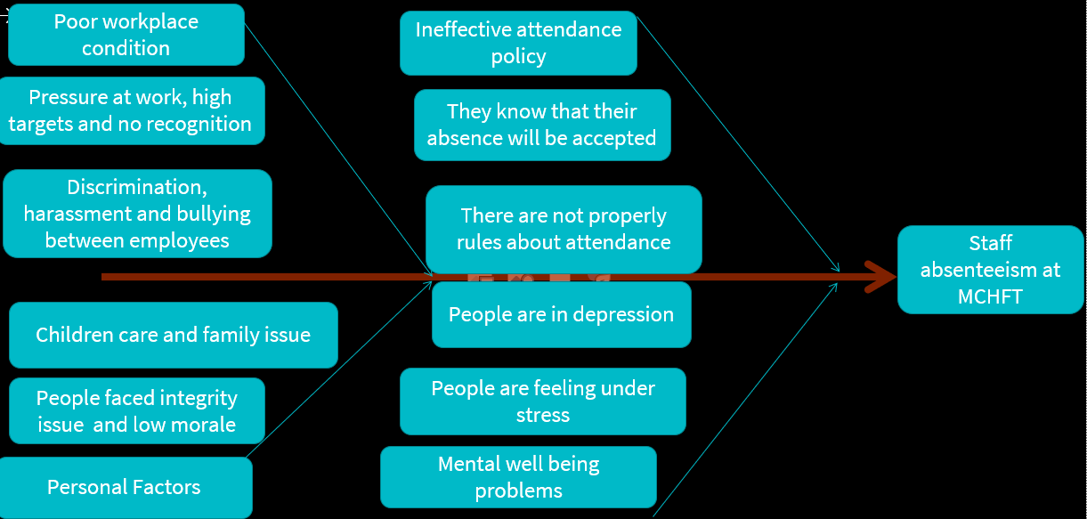
Cause-and-effect analysis is used to identify and resolve problems. There are many different causes that make people to make absence at MCHT. Can be condition at work, inside attendance policies, family issue or emergencies and health problems.
Poor working condition refer there might be pressure at work, hights targets and no recognition. Employees can be unmotivated if they work hard, and their work is not recognised. Managers must investigate if there is not discrimination, harassment, and bulling between employees.
Other point which can influence employees to do absence is ineffective attendance policy. If they know that their absence will be accepted, and nothing will happen if they continue to make absence then they will not change nothing. They will continue to take free time however when they want.
Health issue can be a reason for their work. Many people face mental wellbeing problems such as depression stress, anxiety. However, if they are not feeling good, they should bring fit note from their doctor, but manager should investigate if this stress is caused by internal factors in order to improve condition for increase efficiency in the organisation.
One other point which lead to absence at work is family emergency like children care or any family’s issue. But can be and personal factors such as adaptabilities at work or their low morale.
All this causes have as effect absenteeism for MCHT.

Choosing the right decision- GRID SCORE
“Decision making as the process of choosing between alternative courses of action” (CIM).
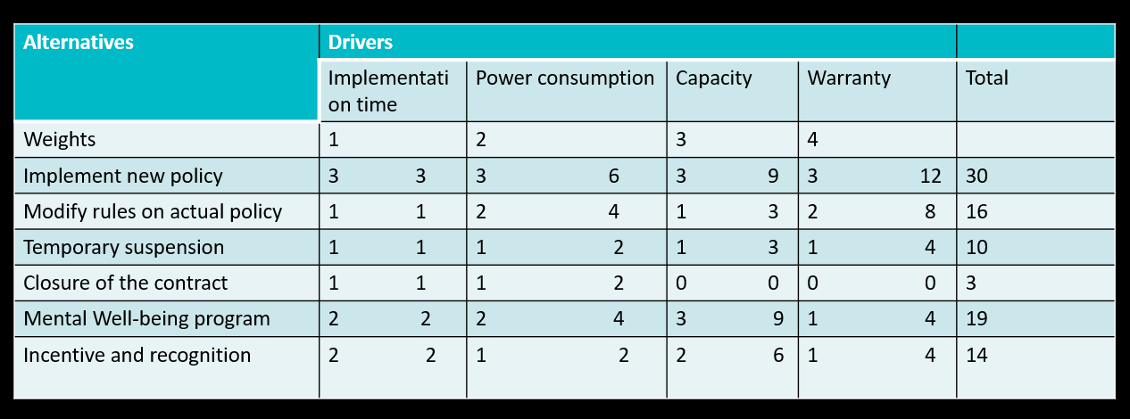

Grid score is a tool which is used for choosing between more alternative solution, which is the most suitable for the organisation. For choose the right solution among many alternatives it was used Grit Score planning tool.
For reduce absenteeism there are many alternative solutions such as:
- Creation of a new policy which each employee must sign agreement with sanction for absences can be helpful for organisation. HR manager can implement this policy in short time, have strong power because each employee must sign agreement. It has a strong capacity because will be implemented in order to cover specific problem, absenteeism.
- Modify rules on actual policies can also be helpful but can create confusion. It can require more time to change the rules, in the power, capacity and warranty are as well low because employees can misunderstand the changes and will continue to be missing at work.
- Temporary suspension of employees can be helpful. Some employees can understand the risk which they take when are missing from work but still is not adequate for MCHT because they are not replaced, and productivity will be not improved.
- Closure of contract also can make they realise the risk which they are taking and can help them to reflect at situation and stop to do it but is not powerful because MCHT need people to replace them and after that need time for new employees to take training and preparation on tasks so is long process and nothing will guarantee that the new employees will not do the same.
- Mental wellbeing program is a solution for people who have problem with stress or anxiety but not helpful for all of them. This is second appropriate decision which will be implemented if the new policy will not be enough powerful. Its capacity is very good because we have seen that most absences are due to stress and anxiety.
- Incentive and recognition can increase their motivation. Can be included on the decision of new policy of attendance. It is not enough powerful and do not guarantee that will make employees to be presents.
Factors which I have considered for weights the alternatives solutions are implementation on time, power capacity and warranty. The higher score is for creation of a new policy, that means the better decision is to create a new attendance policy but will be taken into consideration incentives and recognition for employees with good attendance. In case of failure of this decision, the next appropriate to consider is to create a wellbeing program to help employees to overcome their mental problems.

Implementation plan for selected solution
Action Planning
“Planning is deciding in the present what to do in future. It is the process whereby companies reconcile their resources with their objectives and opportunities” (Philip Kotler).
The MCHT must create a new attendance policy and keep track of employee absences. The new attendance policies will be Hr managers responsibilities and should be done in the next month. In the case of unscheduled absences, there must be specific rules in place to mitigate the negative results. Also, all employees must be aware of new attendance policy and must sign agreements for ensure that they understand which are the new rules and which are the risks if they fail to meet the standards requirements. The HR managers will always inform managers with the situation for contact people and to help them to reduce their absenteeism. For example, when someone is missing 40 hours, he receives the first meeting for investigations in which his manager will investigate the root cause of his absence. Depends on situation they can receive first letter of concern for next 6 months. If in the next 6 month they do another unauthorised absence, they can have another meeting of investigation. If there was not a strong reason with prove employees can receive a final warning due to failure to meet the standards requirements for its employment. After the final warning if they continue to have unauthorised absence then their contract of employment will finish.
A plan of how the new policy will be introduced in the system:
01-04-2022 | HR Managers must start to draw a plan of new attendance policies
08-04-2022 | HR Managers must present and discuss the new policy with managers
15-04-2022 | HR must update the policy after what have decided together with managers
21-04-2022 | The new policy must be ready for approbation
25-04-2022 | Must be released for be signed by employees
01-05-2022 | The new policy will be active
07/14/21/28-05-2022 | Monitor the action plan  On next mount weekly analysis of the situation
01/06/2022 | Evaluation of situation.

Monitoring
Hospital can monitor if the solution is working but they must monitor also monitor key performance indicator and action plan implementation.
HR managers at MCHT must analyse all information and rules from the action plan in order to ensure its success. Enacting the attendance policy consistently. Hr managers must close verify if employees understand the rules and follow them. In case of new absences, Hr must quickly inform managers to investigate what happen and take actions. In conclusion, Hr managers can monitor the new policy by weekly review and closely analysis of the situation. MCHT can offer rewards for good attendance in order to motivate employees to come at work.
Evaluation
HR Managers must evaluate the situation monthly for see if decision made is efficient and if there are improvements and make statements with results for keep managers informed. A continue evolution must be done for ensure that employees are coming back at work, and they are enough motivated to accomplish their requirements.
In case of failure of this plan with new attendance policy the HR managers will be ready to implement an alternative solution which will be a mental wellbeing program.

Success Indicators
Indicators of success are used to evaluate the outcome of the implementation.
KPIs- identify key performance is a critical measure of success. KPIs refer to the outcome after implementing the new attendance policy for absenteeism.
Planning and preparation of new attendance policies can be success indicators. For ensure success to reduce absenteeism MCHT must carefully integrate new rules which will be implemented with employee’s agreement.
Other success indicator is weekly review on monitoring.

Conclusion
In conclusion the problem of Mid Cheshire Hospitals NHS Foundation Trust is staff Absenteeism. Staff absenteeism is creating big financial losses and poor quality of services. Pestel is used for determining which are external factors that influence MCHT. Employees are missing from work from more reasons such as health problem, family issues, or because of poor working condition. There are different alternative solutions for solve MCHT’ absenteeism problem such as rewards, changes on policies, implementing feedback are analysed through GRIT decision making tool. Final decision is to create employee attendance policies and rewards for good behaviour and attendance which will be implemented by HR managers in one month. If the new attendance policy will not be successful, HR managers can implement an alternative solution which is a mental wellbeing program.

References
Cushard, B. (2022), The Impact of Absenteeism, ADP, (Online), Available at: https://www.adp.com/spark/articles/2017/01/the-impact-of-absenteeism.aspx (Accessed on 20 February 2022)
Eajournals.org. (2022), British Journal of Marketing Studies, (Online), Available at: https://www.eajournals.org/wp-content/uploads/Effect-of-Absenteeism-on-Corporate-Performance.pdf (Accessed 9 March 2022).
Frue, K., (2019). 6 Frustrating Disadvantages of PESTLE Analysis. (Online) PESTLE Analysis. Available at: https://pestleanalysis.com/disadvantages-of-pestle-analysis/ (Accessed 22 March 2021)
Lim, Y., 2020. The PESTEL model application to Ok Boomer and TikTok from a public relations perspective. Journal of Media Research-Revista de Studii Media, 13(37), pp. 94-110.
NHS (2017), Mid Cheshire Hospitals NHS Foundation Trust, Overview, NHS Trust, (Online), Available at https://www.nhs.uk/Services/Trusts/Overview/DefaultView.aspx?id=343 (Accessed on 20 March 2022)
Oxford Learner’s dictionary (2022), Problem, (Online), Available at https://www.oxfordlearnersdictionaries.com/definition/english/problem_1?q=problem (Accessed on 20 March 2022)
Rastogi, N. and Trived, D., (2016). PESTLE TECHNIQUE – A TOOL TO IDENTIFY EXTERNAL RISKS IN CONSTRUCTION PROJECTS. International Research Journal of Engineering and Technology (IRJET), [online] 03(01), p.385. Available at: https://www.irjet.net/archives/V3/i1/IRJET-V3I165.pdf (Accessed 22 March 2021).
Statista (2022), Percentage of working hours that were lost due to sickness absence in the United Kingdom from 1995 to 2020, (Online), Available at: https://www.statista.com/statistics/290196/uk-sickness-absence-rate/ (Accessed on 21 March 2022)
Mid Cheshire Hospitals, (2022), Annual Reports (Online), Available at : file:///C:/Users/lumin_oops26g/Downloads/Mid%20Cheshire%20Annual%20Report%20FINAL%20(3).pdf (Accessed on 21 March 2022)

