Fashioned from Nature, fashion activism and the fur industry.

Introduction
The title of my essay takes from the ‘Fashioned from Nature’ exhibition, curated by Edwina Ehrman in the Victoria and Albert Museum, South Kensington, London (in 2018-17) because this provides an opening introduction to thinking about how nature and animal has been used as part of clothing and fashion, in the past and how alternative resources are now being considered. (V&A, 2018/2019)
The essay will aim to consider fashion activism as a form of political protest against using natures finite resources, particularly in relation to protecting animal species which have been used for their fur, which has included red fox fur, marten fur, and beaver fur used for clothing. The mink coat, and rabbit collar, being two such artefacts.
Katherine Hamnett and Kate Fletcher are both pro - sustainable fashion and textile activists but in this essay, I will focus on those designers who have campaigned against the use of fur.
An emphasis on the designer Karl Lagerfeld who have used animal fur, with the supermodels as who have famously worn fur, including Cindy Crawford and Naomi Campbell will be featured alongside designers who have taken an anti - fur stance including Stella McCartney and with supermodel Gisele Bundchen who refused to wear fur. (PETA, 2002)
This considers the ethical implications of using such a resource for the sake of fashion and so ‘People for the ethical treatment of animals’ (PETA) become a significant reference here. PETA famously stated, ‘I’d rather go naked than wear fur”, (Industry, 1990), and I will look at this campaign in more detail. Another useful reference point is ‘Boss Models’, (PETA, 2011) who were the first modelling agency to go ‘fur free’.
Main body
The Fashioned from Nature show juxtaposed trendy garments with natural history exhibits and unprocessed plant and animal fabrics, allowing visitors to understand the materials of apparel and the roots of their clothing. It was in the V&A in South Kensington and it ran from 21st April 2018 to 27th January 2019. (V&A, 2018/2019) This show takes you on a trip through centuries of fashion that has both inspired and plunder the natural world. This V&A presentation will forever transform the way you think about fashion, as it is an exciting show determined to incite change. (Gallery, 2018/2019)
This was the first show in the United Kingdom to look at the dynamic relationship between fashion and nature from 1600 to the present day, and it is a brilliant example of fashion advocacy. (V&A, 2018/2019)

Some images from the exhibition (V&A, 2018/2019) (V&A, 2018/2019) (Gallery, 2018/2019)
This exhibition was the first UK exhibition to explore the complex relationship between fashion and nature from 1600 to the present day and is a solid representation of fashion activism.

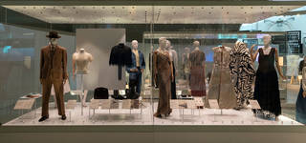
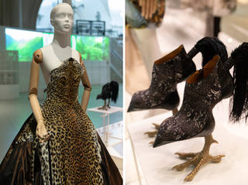
How has politics affected the fur industry? Has it been influenced by PETA and other related organisations' activism? Although there are no hard figures to back up the effect, it's obvious that PETA and other animal rights organisations' anti-fur efforts have affected the fur industry.
The governments of the United Kingdom and Austria have banned fur farming in their countries altogether, and although the U.S hasn’t taken any action against the industry, the number of mink farms in the U.S has plummeted from 1,027 in 1988 to less than 300 today. (American, 2009)
It is not just about the animals too, according to PETA, the amount of energy required to make a real fur coat from ranch-raised animal skins is roughly 15 times that required to make a fake fur garment. “Fur is therefore not biodegradable due to the chemical treatment used to keep it from rotting.” If not treated responsibly, these same chemicals contaminate groundwater near fur farms” (American, 2009) Meaning that it is not just the animals affected, there are a lot more consequences environmentally too.

Following on, there are a lot of famous anti-fur movements that have gained traction over the years, which has influenced a lot of famous names to finally go fur free. Brands from Gucci, Michael Kors to Calvin Klein. Calvin Klein being one of the first brands to go fur free way back in 1994. (Connor, 2018)
While in September 2018, London Fashion week became one of the first major fashion weeks to not show any fur on the catwalk. This is one huge milestone in itself, considering the amount of followers London Fashion Week has, it most probably influenced a lot of people to consider ditching the fur themselves.

For decades, the anti-fur campaign has ebbed and flowed. Calvin Klein stopped wearing fur in 1994, the same year that PETA launched a campaign with Naomi Campbell and Christy Turlington, saying that they would "rather go naked than wear fur." (PETA, 2011) Ralph Lauren, Tommy Hilfiger and Selfridges cut fur in the mid-2000s. More recently, in 2015, Hugo Boss joined the no-fur list, followed by Armani the next year. (Foley, 2018) These are all big names which have followed on, no doubt that the first designer to go fur free had a large influence, which has pushed all these other names to follow suit. This ripple gives hope that in the future eventually all the big brands and fashion designers will start to consider the movement and make changes in the right direction.

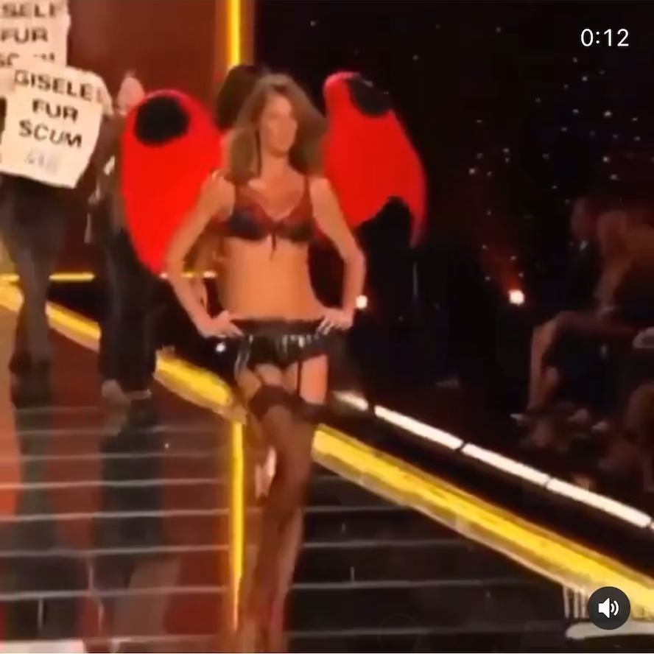
Gisele Bundchen is another example of an avid animal’s rights activist and also a supermodel, who chose to go fur free in 2002 after learning more about animal agriculture and how it effects the planet. It was actually protesters from PETA who stormed a Victoria’s Secret fashion show, that pushed her to make the change. They targeted Gisele Bundchen as she had recently signed a contact with Blackglama, which is a mink coat brand. Due to that protesting, she then became aware of what was happening in the fur industry and that changed her forever. She ditched the fur and has since become an environmental ambassador, an animal advocate and she’s even turned her and her family vegan. This one case highlights the impact of protests and campaigning, it’s easy to think if PETA hadn’t stormed her show, would she have made the change?
(PETA, 2002)

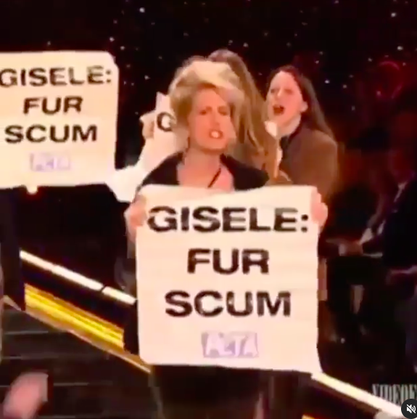

Video and image in question, showing PETA activists storming Gisele Bundchen’s catwalk show.

It is so positive to see so many famous designers following on and leading a fur free movement, but this begs the question of why are there still famous designers who are using fur? If there’s clearly an alternative that is up to standards for most, why is fur even still considered in the fashion world?

Following on, one counter argument came from Karl Lagerfeld, who says that “People who want to suppress the fur industry — if they have enough money to make an income for all the people who work in that industry, OK. I see it going nowhere.” “Fake fur pollutes the world more than anything else. Fur is an industry. It’s legal. The idea that people don’t like it — I understand. But as long as they use leather and eat meat, I don’t see that it’s a problem.” (Foley, 2018)

This can be outraging to read, as this can be seen as the reason that the fur industry is still going, when famous designers who have such a large influence are avidly supporting it. Fur is a luxury, and the burning question here is are the aesthetics and feeling of an animal’s fur worth a life? Is it worth possibly making these animals distinct in the future? Is it worth jeopardising the animal world for the sake of a runway? It seems absurd to sacrifice animals for the sake of fashion when there are perfect alternatives, where you can’t even tell the difference. Sustainability is a process and whilst there are a few designers who aren’t open to evolving and change, a lot are actively making that change to make their brands more conscious and environmentally friendly which is a huge step into the right direction.

Conclusion
By focusing on the fur industry I have been able to consider how we sustain and preserve our environment through fashion choices. I have considered fashion activism as a form of political protest and looked at famous anti-fur movements that have gained traction over the years. This I have done by focusing on key designers who have contributed to this cause. Delving into the political side of the fashion world, I have uncovered how powerful protests can be, and seen just how much one designer can influence a chain reaction. This essay has also touched on the other side, looking at why there are still designers using fur despite there being so many alternatives. This has proven an important point that the fashion industry is moving forward, the fur industry is slowly being filtered out through years of activism, campaigns and change and although it may never disappear in my time, there’s a lot of hope that it will eventually become something of the past in the fashion world.

Bibliography
American, S., 2009. What Impact Has Activism Had on the Fur Industry?. [Online]
Available at: https://www.scientificamerican.com/article/impact-activism-on-fur/
[Accessed 15 March 2021].
Connor, T. O., 2018. Why Fashion's Anti-Fur Movement Is Winning. [Online]
Available at: https://www.businessoffashion.com/articles/news-analysis/why-fashions-anti-fur-movement-is-winning
[Accessed 15 March 2021].
Foley, B., 2018. The Fur Debate; What designers say. [Online]
Available at: https://wwd.com/fashion-news/fashion-features/the-fur-debate-what-designers-say-1202648059/
[Accessed 15 March 2021].
Gallery, V., 2018/2019. Inside the Fashioned From Nature exhibition. [Online]
Available at: https://www.vam.ac.uk/articles/inside-the-fashioned-from-nature-exhibition
[Accessed March 2021].
Industry, T., 1990. PETA retires iconic "I'd rather go naked..." campaign. [Online]
Available at: https://www.theindustry.fashion/peta-retires-iconic-id-rather-go-naked-campaign/#:~:text=The%20%E2%80%9CI'd%20Rather%20Go,others%20have%20backed%20the%20campaign.
[Accessed 15 March 2021].
PETA, 2002. Gisele Bundchen Discusses How a PETA Protest Changed Her. [Online]
Available at: https://www.peta.org/blog/gisele-bundchen-discusses-peta-demonstration-transformed-her/#:~:text=B%C3%BCndchen%20stopped%20wearing%20fur.,a%20mostly%20plant%2Dbased%20diet.
[Accessed 18 March 2021].
PETA, 2011. Supermodels Strip for Animals. [Online]
Available at: https://www.peta.org/blog/supermodels-strip-animals-circa-1996/
[Accessed 15 March 2021].
V&A, 2018/2019. V&A Blog. [Online]
Available at: https://www.vam.ac.uk/blog/projects/fashioned-from-nature
[Accessed 15 MARCH 2021].
V&A, 2018/2019. V&A Gallery. [Online]
Available at: https://www.vam.ac.uk/exhibitions/fashioned-from-nature
[Accessed 15 march 2021].
(V&A, 2018/2019)

