University of Wales Trinity Saint David
Level 4

Student:
Florentina – Mariana Petre 1909658

Marketing Fundamentals – LCBB4004

Assessment 2
ANALYSIS AND EVALUATION - Costco

Lecturer: TUSHARA BALENDRAN

Table of Contents
Introduction 2
TASK 1A 2
TASK 1B 11
Conclusion 12
References 13

Introduction
Marketing is one of the most important functionalities that business operating in the modern era must undertake to ensure sustainability. Competition and saturation levels within market systems have increased tremendously, further increasing the significance over time. The current study highlights the implementation of the marketing function at Costco, one of the world’s most recognisable retailers.

TASK 1A
Processes and stages of marketing including the role of the marketing mix
Marketing may be defined as the cumulative set of activities and processes that brands that undertake to promote their products and services and increase the overall degree of their outreach. According to Keegan (2017), the marketing process in the modern era comprises of a number of different aspects including assessing the competition, planning the promotions and campaigns, developing target markets and utilising different channels and modes.
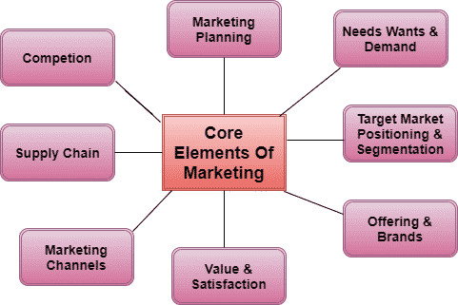
Figure 1: Elements of marketing
(Source: Moorman and Day, 2016)

The marketing function typically comprises of several stages, with the most prominent relating to establishing the mission statements, situational analysis, developing objectives, strategising, implementing and controlling. Establishing the mission statement and the objectives prior to the implementation process predominantly relates to outlining the key requirements that the marketing process seeks to achieve once the implementation is complete (De Mooij, 2018). An accurate and thorough analysis of the business environment within which an organisation operates in is extremely important to gauge the suitability of the promotional strategies and how they could benefit the business function in the long term.
Costco Wholesale Corporation, an American multinational retail organisation has consistently dominated the Western retail markets based on a sound and a holistic approach to the marketing function. Founded in 1976 by James Sinegal and Jeffrey Brotman, the company operates in over 780 plus locations and employs well over 250,000 individuals.
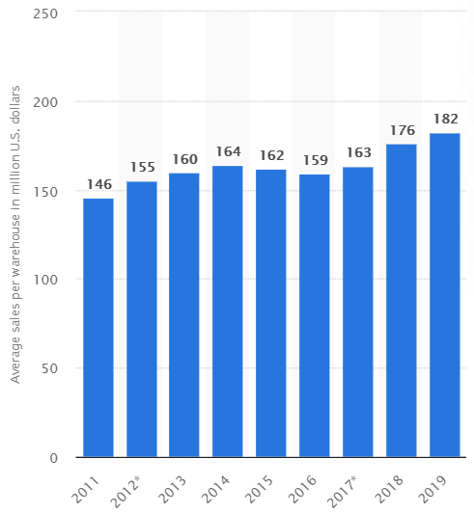
Figure 2: Average sales of Costco per warehouse
(Source: Statista.com, 2019)
Costco posted revenue figures exceeding the $150 billion mark as of 2019, comprising of an operating income of around$4.7 billion (Costco.com, 2020). The company has also mentioned of future expansion strategies to further develop their market position and compete with larger and more established organisations like Walmart to sustain their competitive advantage.
Porters Five Forces analysis
Porter’s five forces is one of the most acknowledged marketing tools in terms of analysing the competitive positioning of a market system and how organisations can improve their standing within the market. The analytical frameworks comprises of five major factors including the competitive rivalry, supplier power, buyer power, threat of substitution and the threat of new entry.
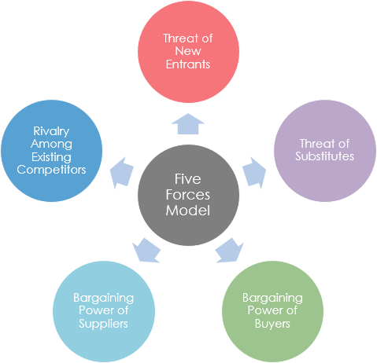
Figure 3: Porter’s five forces
(Source: Lewis, 2017)

Competitive rivalry: The competitive rivalry for Costco considering the specifics of the American retail market is relatively high. Large scale establishment like Walmart dominate the Western retail industry along with other highly agile competitors like Target and Sam’s Club (Gafar et al., 2017). The switching costs within the market are also pretty low since the market is well developed and the availability of information is immense. Naturally, it becomes imperative for Costco to optimise their marketing strategies and reach out to a larger consumer base over time to ensure that their competitive position is sustained and scaled up in a progressive manner.
Supplier power: The power of suppliers for Costco is low as the brand has significantly developed over the years, entailing a massive degree of awareness. Moreover, the developed nature of the Western economy, large presence of suppliers and the limited amount of forward integration further restricts the power that individual suppliers can exercise against Costco. Supplier power would not be a major concern for Costco’s marketing requirements in this regard.
Buyer power: The buyer power for Costco is extremely high given the large number of alternatives, availability of quality information and the low switching costs associated. Moreover, the competitors of Costco often rely on aggressive pricing strategies and predatory campaigns that further marginalise the company in terms of the customer pools. Focusing on retaining consumers would have to be a key area of consideration within the marketing strategies implemented by Costco.
Threat of substitution: Costco primarily offers generic products and services with a limited amount of differentiation. It inherently leads to a high threat of substitution as the western retail market is extremely developed and Costco’s competitors are brands that are very well established and diverse. In terms of the possible strategies, Costco would ideally have to focus on differentiating their products and offer a higher degree o value to their customers over time.
Threat of new entry: The threat of new entrants is low considering the economy of scale facilitated by Costco through its warehouse model and bulk pricing strategies. However, the ease of business formation in Western markets is very high, which could lead to the emergence of disruptive new entrants that may marginalise Costco in the coming years. Costco would have to focus on limiting the threat through a targeted emphasis on their customers and ensure that they are retained over prolonged periods of operation.
Despite the relevance of the five forces model to competitive analysis, the framework suffers from a number of limitations, with the most prominent relating to the static nature of the propositions. Moreover, the dynamism within the external forces and the fact that organisations typically operate across different business lines further limits the applicability of the model in a uniform and generalised manner.
SWOT analysis
The SWOT framework stands for the strengths, weaknesses, opportunities and threats that are pertinent to the business functions of an organisation. Developed by Albert Humphrey in the early 1970s, the model has been widely acknowledged across the world in terms of evaluating the internal competencies within an organisation (Gürel and Tat, 2017). While the model is extremely beneficial to assess internal competencies, the SWOT framework suffers from limitations like an absence of hierarchy and lack of objectivity among others.
Strengths  - Comparatively low pricing strategy (Gabler, 2016)  - Loyalty programs  - Loyal consumer base  - Organic advertising | Weaknesses  - Limited product diversification  - Limited territorial presence  - Poor emphasis on research and development
Opportunities  - Focus on the rising e-commerce and digital waves  - Expand into emerging economies (Bstrategyhub.com, 2020)  - International collaborations to compete with larger players | Threats  - Marginalisation by disruptive organisations  - Reduction in corporate brand image (Cdc.gov, 2015)  - Economic slowdowns  - Increase in competition levels
Table 1: SWOT analysis for Costco
Analysis
The key strengths for Costco include the extremely low price points that it offers its products at along with the extensive number of loyalty programs. Cumulatively, the company has been able to develop a consumer base that is very loyal over the years. Furthermore, Costco relies largely on organic advertising strategies such as word of mouth and personal recommendation, thus enhancing their position as a retail organisation that is inherently customer oriented. However, the weaknesses include a limited degree of diversification both in terms of the product offerings as well as the areas covered by the company. Sales within the American and Canadian markets account for roughly 80% of the revenue generated by Costco (Gabler, 2016). Furthermore, the emphasis on R&D has also been limited, especially when compared to competitors like Walmart who have gone on to invest millions to optimise their product delivery and value provision systems.
The major opportunities for Costco primarily relate to tapping into the digital economy along with expanding into emerging economies. Costco could also tap into collaboration with major players in international markets that improve their global competitive positioning as well. In terms of the threats, Costco could witness a significant degree of marginalisation by disruptive organisations in the recent future along with a reduction in their corporate brand image due to issues such as the E coli infection that took place in 2015 (Cdc.gov, 2015). Additionally, global economic slowdowns along with a steady rise in the levels of competition could further limit its growth potential over the coming years.
Segmentation, Targeting and Positioning
Determining the STP in terms of improving the competitive positioning is important to ensure a general sense of direction within the business objectives. The key segment for Costco includes consumer bases that seek to purchase daily household items and consumer goods, while the target markets include the lower and middle income groups along with certain sections of the affluent classes. In terms of positioning, Costco primarily markets itself as a retail wholesaler that offers quality products at affordable prices.

Marketing Mix 4P analysis
The marketing mix comprises of the core elements involved within the marketing function. Considering Costco primarily offers products as opposed to services, the 4P marketing mix would be highly appropriate including the elements of product, price, place and promotion.
Product: The products offered by Costco primarily include daily household items and essentials such as food items, beverages, appliances and several others. It also offers other items such as furniture, gifts and decoration, travel items and so on.
Price: The pricing strategy implemented by Costco is essentially aligned with a low price low margin model. Costco predominantly operates on the basis of an economy of scale, evident in the warehouse models of their stores along with the bulk discounts and group offers.

Figure 4: Elements of the 4P marketing mix
(Source: Thabit and Raewf, 2018)
Place: Costco offers its products both though physical retail and its online store and mobile application. However, a majority of the sales take place through physical means in their warehouse style stores.
Promotion: Promotional strategies implemented by Tesco are largely limited to organic methods such as word of mouth and direct functions like membership and loyalty programs. Additionally, the company also relies on strong public relations measures along with relationship and societal marketing campaigns to improve their brand image over time.
The role of marketing in creating value for customers
Costco relies on a number of marketing strategies including the development of a strong corporate brand, engaging in sustainable relationship based marketing and strategic societal marketing campaigns. Developing a strong corporate brand is extremely important in the modern era (Törmälä and Saraniemi, 2018). It allows organisation like Costco to reach out to prospective customers and ensuring that the scalability of the brand is driven upward. Additionally, societal marketing strategies are also implemented by Costco that include charitable contributions and cause based affiliations. Key areas of consideration for the company in this regard relate to needs aligned with supporting children and disadvantaged sections, facilitating education and health services and others (Costco.com, 2020). Relationship marketing functions are also implemented by the organisation in a holistic manner, which allows for an organic connect with their customers and allows Costco to compete with their alternatives more effectively.
Ansoff’s growth matrix
Costco could certainly emphasise on improving its growth potential through the maintenance of a strategic outlook towards the market systems. The Ansoff’s growth matrix could be beneficial in this regard, comprising of the four strategies as discussed below:
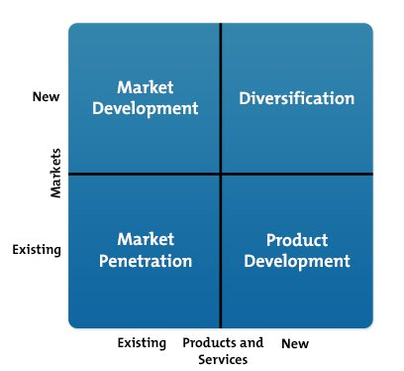
Figure 5: Ansoff’s growth matrix
(Source: Yin, 2016)
Market development: Market development relates to the introduction of existing products within new markets. While the scalability potential of the strategy is immense, the implementation could be a costly affair.
Diversification: Diversification relates to the introduction of complete new products in new markets and would not be recommend for Costco considering the massive investment associated therein.
Market penetration: Market penetration would be the most suitable strategy for Costco as it involves improving the presence of existing products in existing markets. Key strategies include an improved marketing function along with a sound understanding of the needs and demands of the consumers.
Product development: Product development could also be looked into by Costco, especially in terms of improving their competition with Walmart. Although new products are a requisite in the product development strategy, Costco could implement the same using highly targeted strategies that emphasise n R&D.

Stakeholder engagement and their impact on the marketing activities of an organisation
Engaging with the stakeholders in a regular manner and ensuring that their needs and demands are met comprehensively is of paramount importance to drive sustainability within the modern business environment. According to Nartey et al., (2018), stakeholders must be communicated with in a regular manner and ensure that their powers and interests are managed in a cumulative manner.
Considering the business functions of Costco, the internal stakeholders include the managers, employees and the investors. The managers and the employees are associated directly with the operations of the company along with the owners and the investors. Key responsibilities o the managers and employees include conducting the daily operations while owners manage and supervise them and the investors secure finances.
External stakeholders relate to the groups beyond the boundaries of the organisation and include the customers, government, creditors and the general community. The products offered by Costco are purchased by the customers, thus involving a direct line of communication. Creditors also need to be managed as they can influence the brand perception of companies. Additionally, the government exercises power through regulatory measures while the business operations of companies tend to affect the general community as a whole in most cases.

TASK 1B
Communication can be considered as a process of exchanging information among the individuals through using a common platform such as behaviour, symbols and sign. Information can be transmitted or conveyed through verbal or written form. On the other hand, people can express their ideas effectively with the help of different technological tools also. Several tactical tools were utilised to conduct and complete the project, the most prominent among which include the blog posts and verbal communication methods to interact with the end users. I believe that they were important aspects that led to a timely completion of the current study.
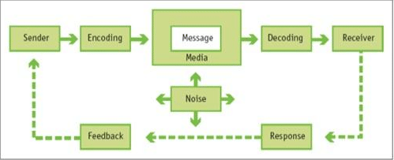
Figure 6: Kotler’s Model of communication
(Source: Hossain et al. 2017)
As per the communication model provided by Kotler, the process of communication can be considered as a dialogue between the customers and the company. This dialogue takes place at the time of preparing for sales, at the time of consume the product, and after consumption of them. There are some factors highlighted by Kotler such as encoding the messages as per their target audience’s intension and the process through which the customers will decode the message. The means of effective communication are needed to be selected by the emitters like Costco, as that is required for successful transmission of the message.
The integrated marketing communication or IMC is an idea where companies can deliver consistent and clear messages to the customers with the help of various communication channels by carefully coordinating and integrating the same. I firmly believe that developing a marketing communication process that integrates different channels is extremely important given the business dynamics in the current era.
Costco uses the tool of relational marketing and social marketing. Better customer loyalty and long-term engagement of the customers can be ensured through the relational marketing process. It includes membership programs that lead to create a harmonious relationship with the customers. Along with this, the organisation offers discounted materials t the customers that ensures repetitive visit to its warehouse stores. On the other hand, the Costco uses societal marketing strategy, where corporate social responsibilities are taken seriously in order to demonstrate environmental and societal concern to attract the customers. This organisation also makes donations, which is a way to enhance its social image. One of the major advantages of relationship marketing is companies can achieve a high return on investment, may get honest perspectives and may develop great reviews. However, it is a costly process of promotion, which may increase operational difficulties of the organisation. One disadvantage of societal marketing is, it may become difficult to measure its success though it creates a possibility to increase market share.

Conclusion
It can be concluded from the present discussion that communication is a process through which information can be exchanged between individuals and organisations. Kotler’s communication model suggests that the intention of the target audiences and effectiveness of the message are to elements that are important in successful transmission of message. Organisations like Costco also use two significant types of promotion such as relational marketing and societal marketing. Both the marketing tools are effective for gaining high return on investment.
It can be recommended to Costco to increase digital marketing and involve in e-commerce that may help it to develop huge customer base, increasing its profitability. On the other hand, improve customer services can also be a strategic approach to gain trust and develop effective relationship with the customers.

References
Bstrategyhub.com, 2020. Market penetration strategy. Available at: https://bstrategyhub.com/dominate-the-market-the-ansoff-matrix-way-market-penetration-strategy-explained/ [Accessed on: 13 April 2020].
Cdc.gov, 2015. Escherichia coli O157:H7 Infections Linked to Costco Rotisserie Chicken Salad (Final Update) | November 2015 | E. coli | CDC. Available at: https://www.cdc.gov/ecoli/2015/o157h7-11-15/index.html [Accessed on: 13 April 2020].
Costco.com, 2020. About us. Available at: https://www.costco.com/about.html [Accessed on: 13 April, 2020].
Costco.com, 2020. Charitable contributions. Available at: https://www.costco.com/charitable-giving.html [Accessed on: 13 April 2020].
De Mooij, M., 2018. Global marketing and advertising: Understanding cultural paradoxes. SAGE Publications Limited.
Gabler, N., 2016. Inside Costco: The Magic in the Warehouse. Available at: https://fortune.com/longform/costco-wholesale-shopping/ [Accessed on: 13 April 2020].
Gafar, M., Ali, N. and Abdullah, F., 2017. Determinants of Customer Experience Creation in Retail Industry. International Journal of Business, Economics and Law, 13(2), pp.11-19.
Gürel, E. and Tat, M., 2017. SWOT analysis: a theoretical review. Journal of International Social Research, 10(51).
Hossain, M., Kabir, S. and Rezvi, R.I., 2017. Influence of the integrated marketing communication on brand orientation and market orientation: a literature review. Australian Journal of Business Science Design & Literature, 10(1).
Keegan, W.J., 2017. Global marketing management. Pearson.
Lewis, R., 2017. Porter's Five Forces of competitive advantage.
Moorman, C. and Day, G.S., 2016. Organizing for marketing excellence. Journal of Marketing, 80(6), pp.6-35.
Nartey, L.J., Henisz, W.J. and Dorobantu, S., 2018. Status climbing vs. bridging: Multinational stakeholder engagement strategies. Strategy Science, 3(2), pp.367-392.
Statista.com, 2019. Costco's average sales per warehouse worldwide 2019. Available at: https://www.statista.com/statistics/269775/costcos-average-sales-per-warehouse-worldwide/ [Accessed on: 13 April 2020].
Thabit, T. and Raewf, M., 2018. The evaluation of marketing mix elements: A case study. International Journal of Social Sciences & Educational Studies, 4(4).
Törmälä, M. and Saraniemi, S., 2018. The roles of business partners in corporate brand image co-creation. Journal of Product & Brand Management.
Yin, N., 2016. Application of AHP-Ansoff matrix analysis in business diversification: The case of Evergrande Group. In MATEC Web of Conferences (Vol. 44, p. 01006). EDP Sciences.

