Developing Relationship and Workplace Achievement
Assignment code: BMSK5002
Student name: IFFAT ALAM
Student ID: 1707070
Lecture name: AFZAL MANNUA
Word count: 5232

Contents
Introduction: 3
LO1: The potential benefits of Siemens of developing individuals in the workplace 3
Maintaining product and service quality: 3
Continuous improvement in the quality of product and service 4
Achieving a high-performance culture 4
Flourishing the talent pool globally 4
Bolstering the careers of expert employees: 5
Engaging and motivating employees 5
Improving operational efficiency with updated knowledge and skill: 6
LO2: Management of expectation of an individual employee: 6
Examining the employees’ expectation and requirement: 6
Maslow’s hierarchy of need theory and employee expectation: 6
Herzberg’s Hygiene theory: 7
Expectancy theory of Victor Vroom: 9
Administration of people 9
Managing career development of individual employee: 10
LO3: Development vehicles available in Siemens and their ability to meet the need for individual development 10
On the job training program: 11
Mentor and consultant: 11
Job enrichment: 11
Job enlargement: 12
Job rotation: 12
Job crafting: 12
Off the job training program 12
Apprenticeship: 13
Temporary assignment and informal learning: 13
LO4: A detailed plan to meet the development need of the individual employee and performance management 14
Performance management and succession planning: 14
Support structure within the organization: 15
Techniques of supervision and appraisal: 16
Fair and objective assessment and appraisal: 17
Monitoring, evaluating, and recording individual feedback 18
Reporting performance appraisal 19
Mechanism of providing feedback 19
Career development strategies: 19
Conclusion: 20
References: 22

Introduction:
According to McKinsey’s 7s’ model, the skill of the employees is the part of hard competitive advantages of the organization that is mostly inimitable (Awasthi and Sharma, 2016). Developing individual at the workplace contributes to assuring continuous improvement in employee productivity as well as employee engagement. Therefore, the organization needs to motivate its employees with their personal development opportunities along with the intrinsic motivational factors. The following discussion is going to assess the potential benefits that Siemens is enjoying developing its work with a high-performance culture, the way this brand is managing the expectation of its employees, and the drivers Siemens has managed to improve the skills and competencies of its workforce. The discussion will finally prepare a detailed plan on meeting the individual need of the employees and managing their performance.

LO1: The potential benefits of Siemens of developing individuals in the workplace
Siemens is a German multinational conglomerate that was established 171 years ago headquartering in Munich and now serving worldwide. It is regarded as the largest industrial manufacturing company in Europe. The organization 379,000 employees around the world and 20,000 employees are engaged in their branches and operation in the UK. The organization has expanded its involvement in different industries like information and communication, automation and control, power, medical, transport, and some others like financial services. The organization has a unique organizational culture and human resource policy that helps their workforce to be recognized as one of the most efficient and enthusiastic workforces because of the strong commitment of the employer and the employees in response (siemens.com Global Website, 2019). The organization has assured the employee engagement that results in creating a high-performance culture. Their talent management strategy with the knowledge and skill development opportunity has benefitted the organization in managing performance and ensure optimum productivity.

Maintaining product and service quality:
Siemens is mainly a manufacturing-based conglomerate that has gained strong expertise in their upstream activities. This results in the consistent quality of the products that are directly connected to the skill and excellences of the employees engaged in manufacturing the products. While focusing on their downstream activities, the company has also become successful in attaining the customer satisfaction because of the dedicated set of employees who are highly customer-oriented and serve the customers of the organization both in B2B business activities and B2C business activities providing the customers with a personalized experience (Dong, et al. 2017). The effort of the organization in developing the employees and managing talents with an appropriate set of incentives and a flexible working environment actually bring it such success.

Continuous improvement in the quality of product and service
The work culture of Siemens with continuous development opportunities for the employees and flourishing their talent with the help of job crafting and adequate empowerment and equipment has been recognized as one of the most preferable employers. The organization assures the continuous improvement of the knowledge and skill of the employees and let the employees enrich their skill according to their career development plan with appropriate on-the-job training and development program (Davis and Amirbekova, 2017). The dedication of the organization in managing developed and knowledgeable workers results in the engagement of the employees to reach the vision of the organization. The organization has a belief that the employee engagement requires the commitment of the employees towards their responsibilities and the organizational citizenship and their success in achieving these have resulted in the continuous improvement in service and product quality.

Achieving a high-performance culture
It has to be mentioned that one of the significant parts of the business strategy of Siemens is to assure the excellence of its people and the organization has mentioned that the secret of their success is to define and clarify the role and responsibilities of the employee and let them know the extent to which the company trust them and rely on them. To ensure a high-performance culture, the organization has emphasized teamwork culture and it believes that the employees in a team are more productive than working individually (Dutille, et al. 2017). The team collaborates a variety of skills and helps the other member to improve and transfer their skills that contribute directly to the development of the people and resulted in a high-performance team along with developing individual employees contributing to their personal development process.

Flourishing the talent pool globally
Siemens has a leadership program that aims at improving the effectiveness and efficiency of the organization with an opportunity to develop their own specialism acquiring further expertise. This program works in an integrated way and leads to the global talent pool comprising the expert employees who are provided with the highest caliber leadership and management training by Siemens’ Leadership Excellence program. The talent pool of the organization assists the organization in attaining their goal of excellence in production and service extracting the optimum output of the resources in meeting the demand of the brand in the market (King, 2016). This talent pool also takes part in sensing the demand in the market, changes in the internal and external environment and with the empowerment facility, they can take decision subjectively and promptly that can contribute to the flourishment of the organization meeting their vision.

Bolstering the careers of expert employees:
Considering the individual aspects of the employee development efforts of Siemens, the company has prepared its organizational culture as an ideal strategy that assures the employee commitment to the organization and their organizational citizenship. With a view to improve the individual skill and nurture the talents, the organization has introduced the SLE program that is committed in the individual career development of the employees. When the employees found them to be cared by the organization, it contributes to their dedication to the vision of the organization and according to Herzberg’s two-factor theory, it is a part of the motivational factors with the highest effectiveness in making the employee living the goal of the organization (Noe, et al. 2017).

Engaging and motivating employees
The talent management program of the organization leads to delivering a set of committed and engaged employees that results in the superior performance of the employees along with their personal development. The organization’s intention is to assure the best of use of the talent of an individual employee with the talent management program that enables job enrichment and job enlargement. Job enrichment motivates the employees to take additional responsibilities and duties in the current job role to be met in order to attain reward promised by the organization, on the other hand, job enlargement contributes to the scope of the current job to stretch to a broader area of responsibilities with extra knowledge and skill development efforts by the organization (Sroufe and Gopalakrishna Remani, 2018). This strategy of developing the employees has enabled the organization to assure employee engagement and created a dedicated group of employees that enriches the productivity of the resources the company possesses.

Improving operational efficiency with updated knowledge and skill:
The organization has achieved operational excellence that leads to the continuous improvement of their profit margin and the excellence of quality in the end product has resulted in a set of brand community that has bolstered the revenue stream. The skills and knowledge of the employees are updated regularly to enhance the productivity of the performance management program and the organization considers the performance management process as the driver of their talent management that creates an integration between the organizational goal and personal goal of the individual employees (Moyle and Hackson, 2018). The teamwork and collaborative and integrated effort of the workforce have created a mark of successful improvement in operation management of Siemens.

LO2: Management of expectation of an individual employee:
To meet the expectation of the employees from their career and the involvement of the organization in developing the individual in the workplace, Siemens has ensured a concentrated program named Siemens Leadership Excellence program that provides the employees with the high caliber leadership and management training (Lapinote and Vandenberghe, 2017). Their people excellence management, talent management, and the performance management program aim at managing the expectation of the individual employees form the organization.

Examining the employees’ expectation and requirement:
The employee expectation can be explained with different motivational theories like Maslow’s hierarchy of need, Herzberg’s two factors theory, and Expectancy theory of Victor Vroom. With the structure provided by these theories, the major expectations of the employees from Siemens are noted below and explained accordingly.

Maslow’s hierarchy of need theory and employee expectation:
Maslow has defined the need of an individual in five consecutive stages and when the employer fulfills one of them, the employee need and expectation goes to the further stage. Siemens has a compact performance appraisal program that is dedicated to meeting the needs of eth employee according to their requirement and expectation.
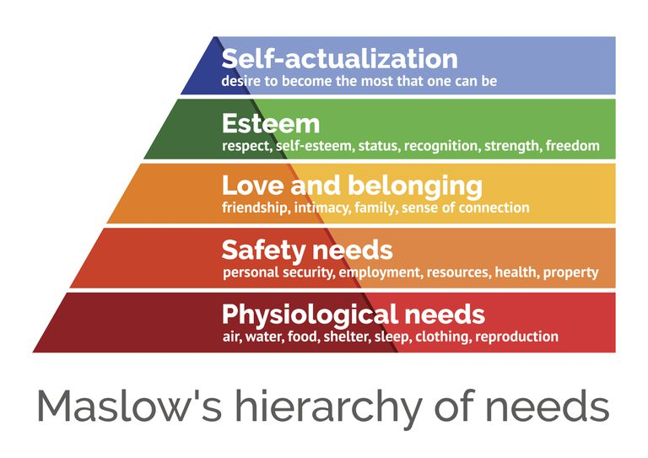
Figure 1: Maslow’s hierarchy of need
source: (Lpointe and Vandenberghe, 2017)
To meet the physiological need, Siemens has a performance appraisal team that assures the appropriate evaluation of the employees and ensure the fair payment to the employees at first. In order to meet the safety needs, the organization has a workplace safety program and additional payment for the vulnerable tasks obviously after mentioning the highest possible safety measures for the employees in such a situation. The fair assessment and judgment along with the adequate empowerment and congenial interrelationship among the employees contribute to meet the love and belonging needs of the employees (Punjaisri and Wilson, 2017). Especially in meeting the self-esteem need of the employees the organization has talent management program enabling job enrichment and job enlargement program with adequate empowerment. The company influences the top management and expert employee in their self-actualization stage collaborating their personal philosophy with the organizational target while assuring people excellence. It enables the employees in job crafting and provides flexibility to establish their strong mark in the achievement of the success of Siemens.

Herzberg’s Hygiene theory:
In this theory, the inventor has suggested that the motivational factors can be stratified into two groups, such as hygiene factors and motivational factors. Siemens believes that the highest productivity of the organization lies in the people excellence and thus it tries to meet both the motivational factors and hygiene factors to improve employee’s engagement (Dipboue and Dipboye, 2018).
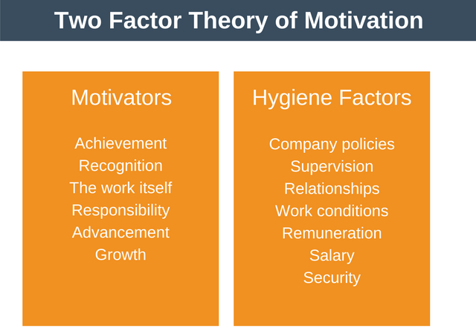
Figure 2: Two factor theory
source: (Mone, et al. 2018)
The human resource policy of the organization has been recognized as the most employee-friendly policy that focuses on the efficiency of the organizational resources with the improvement in employee productivity. The top management of the organization supervised their sub-ordinates through the teamwork. Their interrelationship is highly informal in nature to penetrate the interpersonal understanding and co-operative relationship. The employee safety program within the organization and the fair assessment policy along with the avoidance of negative politics within the organization, the company ensures the flexible and healthy working condition for the employees (Sharma, et al. 2016). Salary is the first consideration of an employee while engaging with the organization and Siemens has a compact performance assessment policy that assures the fair payment to the employees according to their effort and contribution to attaining the goal of the organization. The organization ensures the personal security of the employees, their privacy, and job security that also works as a significant factor in meeting employee expectation.
The performance management program implements the fair judgment and evaluation of the contribution and progress of the employees to meet their target set by the organization and arrange the recognition program accordingly (Tillotson, 2016). The company always rewards the effort of the employees and their commitment to the organization to encourage them to be committed and live the vision of the organization. The talent management program accelerates the job to be most interesting with the job enrichment and job enlargement process that improves the area of operation of an individual employee providing with an opportunity to further advancement. The performance management program of Siemens is responsible for the growth of the individual employee taking part in their personal development plan.

Expectancy theory of Victor Vroom:
This theory delineates that the individual employee considers that whether their effort is enough to hit the target and whether the promised reward is compatible to the effort and ultimately the product of the effort and instruments is the reward desired by the employees.
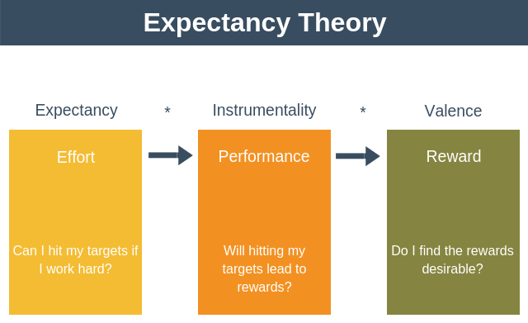
Figure 3: Expectancy theory
source: (Maroof, et al. 2017)
The performance management program of the organization assesses the expectation of the employees with the degree of their effort to attain the target and set the reward accordingly.

Administration of people
Siemens is a highly employee-oriented organization that believes that the employee satisfaction results in customer satisfaction according to service profit chain and ultimately it generates revenue and strengthen the brand community of the organization. The company cares about the individual development and success of the organization that reflects with their talent management program and the plan to improve the people excellence. The organization focuses on the development of the employees according to their career development plan and the personal development plan along with the company guidance of maintaining the organizational citizenship and assure the excellence of employee management (Haider, et al. 2015). The brand treats its employees as their customer while sensing their need and fulfill it as they actually encounter with the customers in the front end as well as in the back end. They reflect the brand personality and the consumers actually create a perception about the company in this modern age with the employee empathy and responsiveness while providing service and the fair trade activities of the organization.

Managing career development of individual employee:
Siemens contributes to the career development path of their employees with their people excellence program that aims at creating a global talent pool with the SLE program, achieving a high-performance culture, strengthening the career of the experts with the talent management program. The performance management program plays the role of the basement to manage the career development path of the experts as well as improving the skills and specialization of the employees in general. The SLE program contributes to the career development process of the individual with the highest caliber leadership and management training; the talent management program avails adequate empowerment with additional job responsibilities to flourish the personal skill and enrich the knowledge of the employees that results in superior performance. The performance management process contributes to matching the individual goal with the organizational goal where the completion of the individual goal ultimately contributes to the organizational goal (Anand and Yeung, 2018). With these programs, the organization tries to control the employee development process as well as the individual career development path.

LO3: Development vehicles available in Siemens and their ability to meet the need for individual development
As repeated uttered in the discussion previously that Siemens believes that the operational excellence of the organization is solely dependent on the people excellence that urges the brand to maintain essential training and development program as well as providing opportunities to improve talent with adequate empowerment and service equipment needed in this purpose. Moreover, the focus of the organization on teamwork instead of assigning tasks individually provides the evidence of the organization to be concerned about the interpersonal relationship among the employees and the process improving the knowledge and skills of the employees that are transferrable while working in a team (Moye, et al. 2017). However, to this purpose, the organization contributes to the individual development process with the following vehicles:

On the job training program:
Siemens generally arrange on the job training program in the probationary period of the employees under the concentrated supervision of the management and coach the employees at every step to standardize the outcome and letting the employee learn through work (Sing, et al. 2016). All the employees of the organization irrespective of their position have to take part in the training and development program and it helps to communicate the organizational culture with the new employees and the existing employees can improve their skill solving the errors and mitigating the skill gap they have.

Mentor and consultant:
The top management and expert employees play the role of mentorship and deliberately teach and coach the sub-ordinates with consultation and recommendation by directly involved in their decision making process within the organization while performing their responsibilities. It is a type of on the job training and development. It not only enriches the knowledge and expertise of the employees but also improves the interpersonal relationship across the layers of the organization with the help of informal communication. It is to mention that the SLE program of Siemens contributes to the employee’s development process initially with the mentorship and consultancy program to make the employee feel at home within the workplace and be the family member of the brand with a commitment to the welfare of the organization (Zakaria, et a. 2017).

Job enrichment:
When the employees add extra job responsibilities in their current job role in order to ve rewarded by the organization, it is called job enrichment. The additional job responsibility requires the improvement in the knowledge of the employee and as the employees voluntarily involved in extended job responsibility, the organization encourages them to be successful with additional training and development program to match the standard and motivate the employee to engage in such activities with an appropriate reward. Reward and recognition are the ultimate motivators to improve employee productivity and individual development (Zheng, et al. 2015).

Job enlargement:
It refers to the extension of responsibilities of the job to acquire additional knowledge and skill and in such case, the organization considers these employees more precious as they consider the personal development effort of the employees as the overall development effort of the operational efficiency. The individual that crossed the physiological need and safety needs are engaged in such activities (Khan and Beloch, 2017). This process is also another on-the-job training program where the employees gain further development in their skill being engaged in such voluntary activities. As the organization assesses the performance of the employees according to their contribution I reaching the organizational goal, these voluntary activities do not remain unpaid and the employees engaged in such activities gain further concentration of the employer.

Job rotation:
It refers to changing the job role and position temporarily to gain the knowledge and skills to be the all-rounder in every position in Siemens. The company avails job rotation for the purpose of removing the dullness of doing repetitive tasks and improving the knowledge of the employees with a new environment and new things to learn. Job rotation contributes to the employee development process with the knowledge of different jo responsibilities and boosts the employee efficiency in matching with the unknown situation and dealing with the unfavorable situation profitably (Swailes and Blackburn, 2016).

Job crafting:
It refers to the empowerment of the employees with the freedom of making a decision and redesigning the job structure according to his talent and interest. It contributes to improving employee engagement as the employees are empowered adequately in order to make the decision to meet the objectives set by the organization. However, it contributes to the flourishment of the personal skill as well as increase the productivity of the workforce as the allotted resources are limited but the employees structure and design their job according to their talent and assure the optimum utilization of the resources allotted (Mäkikangas, et al. 2016).

Off the job training program
The training and development program arranged by the organization that needs to attended externally out of the workplace is regarded as the off-the-job training program. In such a case, the SLE program of Siemens arranges off-the-job training and development for the employees assessing their need to be trained (Anstey, et a;. 2016). This cost higher for the organization in two ways, such as, the employees cannot attend their regular job responsibilities, on the other hand, the organization needs to pay for the arrangement. Instead of being expensive, Siemens invests in improving the skills and knowledge of the employees with the necessary skill development program.

Apprenticeship:
It refers to the period when the employees need both the theoretical and practical knowledge about the organization that requires both on the job and off the job training and development program. The company pays the employees in this period and also train them with the required knowledge and expertise. However, while commencing journey with the organization, Siemens used to offer the employees these programs and it helps to start a healthy relationship among the employees and the organization that becomes the basement of trust and dependence in the future (Asfaw, et al. 2015).

Temporary assignment and informal learning:
Another vehicle of learning available in Siemens is the temporary assignment that is a mode of informal learning. As the organization believes in team working, the employees as a team are provided with the temporary project or assignment that contributes to transfer their skills and knowledge to their fellows and colleagues and learn the ways to improve the personal skill. IT needs to mention that the effectiveness of the teamwork is far more than that of individual effort and the relationship created because of working as a group lasts longer and become more lucrative for the further project because of the understanding built among the employees in the team (Otoo, et al. 2019).
Siemens is considered as one of the most preferable company to be employed because of its ideal and unique employee management policy. The organization emphasizes on the employee expertize to assure a high-performance culture within the organization. The high-performance culture and the optimum utilization of the economic resources are ensured with the training and development vehicles available for the organization.

LO4: A detailed plan to meet the development need of the individual employee and performance management
The employee development process of Siemens starts with the performance management process that integrated the organizational goal and the individual goal according to the job responsibilities and individual talent. This process is regarded as the heart of the talent management program of the organization and considered as the cornerstone of the high-performance culture of the organization. Talent management program assures employee engagement with job enrichment and job enlargement that delivers the superior performance of the employee. The organization has a program of people excellence that aims at strengthening the career of the experts with the SLE program and achieve a high-performance culture and creating a global talent pool (Sheilds, et al. 2015). However, a further discussion ion the detailed plan is going to be illustrated in the following section.

Performance management and succession planning:
As mentioned previously performance process is the heart of employee development and maintaining the relationship with them in Siemens. The employees of the organization used to provide with a target to achieve based on their roles and responsibilities and they meet the target that ultimately contributes to meeting the organizational target.

The interrelationship between the individual target and organizational target
source: (Van De Voorde and Beijer, 2015)
The performance management process of Siemens helps their employees to enjoy the opportunities and choices in order to attain their full potential. However, their performance management process starts with defining the goal or target for the organization and allotting the resources accordingly.

Performance management process of Siemens
source: (Cloutier, et al. 2015)
After setting up the goal for the individuals that are the part of the organizational goal, it provides with all the necessary equipment, empowers the employees, and train them accordingly. The organization monitors the progress of the employees after providing all the necessary resources, power, and equipment. It creates an on-going dialogue between the team member and manager to evaluate the performance of the employees and that leads to further discussion on the performance improvement in the future (Lemmon, et al. 2016). This performance management process enables the organization to penetrate the effect of talent management as well as playing a significant role in creating a high-performance environment.

Support structure within the organization:
Siemens follows a divisional organizational structure because of their huge expansion of product line and the nature of the products require different team and policies. Therefore, the employee and top management maintains a clear distance and hardly can overtake each other.
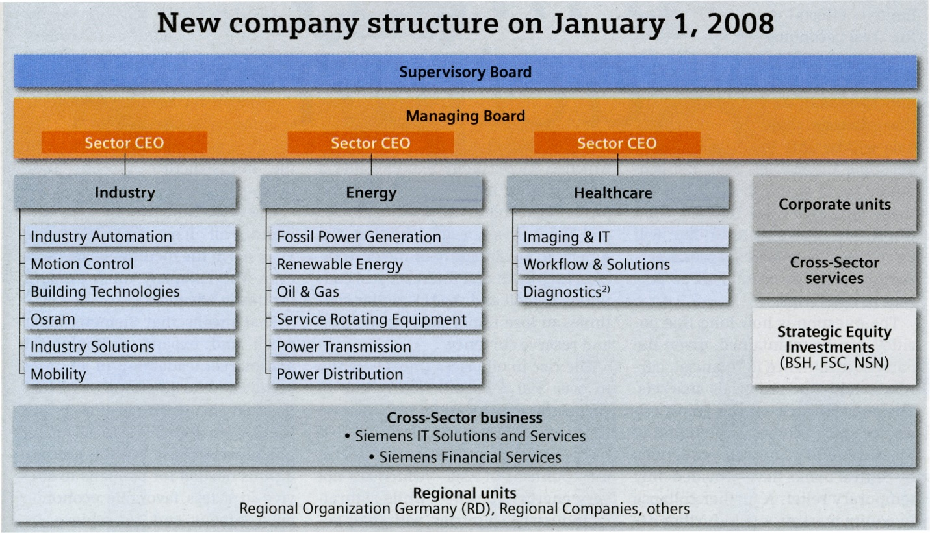
The organizational structure of the Siemens
source: (siemens.com Global Website, 2019)
The organizational structure shows that because of being a conglomerate with a number of SKUs the organization maintains a divisional organizational structure that enables their employees to achieve expertize in any of this division. At a limited position, the cross-sector business is available, with the job rotation facilities, the organization avails the employees to gather experience from a variety of industries. However, the organizational structure also encourages the employees to choose their interested area and industry and improve them accordingly designing their training and development process (Lukes and Stephan, 2017).

Techniques of supervision and appraisal:
In spite of creating a stiff organizational hierarchy and limited facility to change division, supervision is one of the most significant tools to control the standard of the productivity of the employee minimizing the error rate in operation and follow the set of standard of the organization irrespective of the position of the employees. The organization assures high caliber leadership and management training for the employees as well as the leader that leads to using the following techniques to supervise the sub-ordinate
Technical versus creative supervision
Cooperative versus authoritative supervision
Scientific versus intuitive techniques
Topes of supervision techniques
source: (Saks and Gurman, 2017)
The manager mostly followed the creative supervision within the organization while supervising the employees; it varies according to the characteristics of the employees and the job role. The managers of Siemens follow the co-operative strategy of supervision in order to create the high-performance work culture and ensure the effective talent management process that will contribute to the personal development process of the individual employees as well as the career development path. Siemens encourages its manager to follow a scientific and well-proven method of supervision to manage the talents (Hickey, 2018). The performance management process assuring people excellence, and talent management is the proven strategies to supervise the subordinates within the organization.

Fair and objective assessment and appraisal:
The performance management process of Siemens urges to ensure the appropriate assessment of the performance of the employees that motivates them as they found their effort has been recognized. The organization values their talents and tries to ensure the highest productivity of its global talent pool (Iqbal.et al. 2015). However, the following performance appraisal process helps the managers of the organization to assess the performance of the employee fairly-
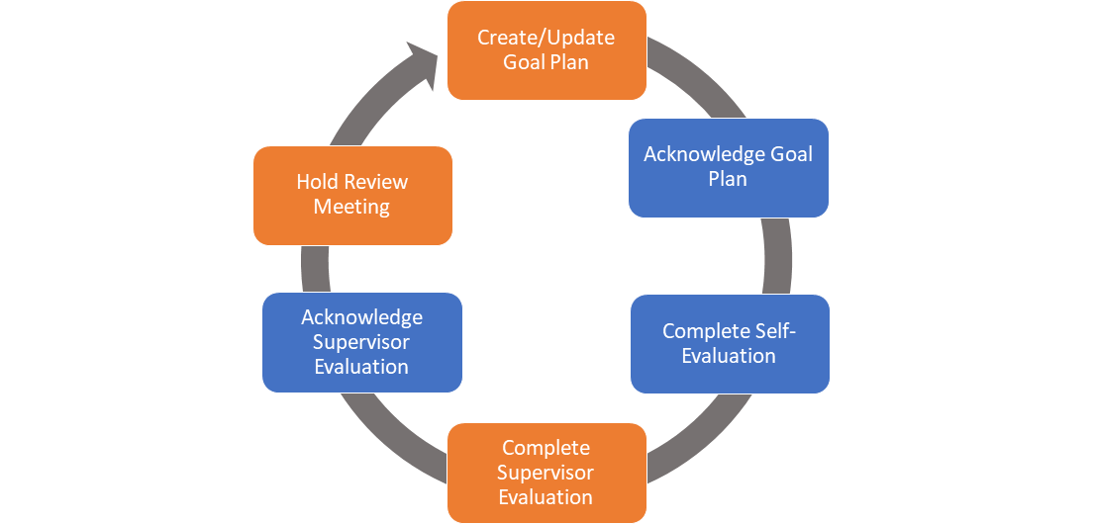
Performance appraisal process
source: (Suhalia, et al. 2018)
The process is designed to complying the process of performance management and starts with the creation of the goal plan set by the organization and acknowledge it and perform accordingly to reach the goal. However, the employees will evaluate their own performance according to the standard of the organization as well as the supervisor will assess the performance of the employees. The report of the supervisor will be acknowledged ultimately but if there is a significant mismatch, the top management will hold a meeting to review the report and ask reasoning. (Armstrong and Lander, 2018) If the report matches, the meeting will be called to set the next goal.

Monitoring, evaluating, and recording individual feedback
In order to monitor, evaluate, and record the performance of the individual, Siemens follows the scientific strategy with 360-degree feedback process and management by objectives process. In liaison with the performance management process, it is to mention that the employees are given target at the beginning of the year and the performance appraisal process assesses the degree to which a particular employee has reached the goal (Awasthi and Sharma, 2016). Depending on the performance, their remuneration, compensation, reward, and promotion decision are taken by the top management. To this purpose, the 360-degree evaluation method assesses the performance from every possible aspect and evaluate the actual performance of the employee as only the balance sheet cannot reflect the employee effort and performance.

Reporting performance appraisal
The unbiased and fair assessment of the performance requires a level of credibility by reducing the intentional fabrication and unintentional errors in reporting them. The organization goes for a two-step verification of the performance by the supervisors as well as the individual employee that assures the credibility and confidentiality of the personal information of an employee assessing the skill gap and the external factors that have resulted in the gap between the expected performance and actual performance (Dong, et al. 2017). The talent management process and the high-performance culture of Siemens is solely based on the trustworthy relationship between the organization and the employees, therefore the organization is highly concerned about the fair assessment of the employee performance and keeping the confidential information limited between the organization and the employees.

Mechanism of providing feedback
The fair assessment of the employee performance and the formulation of the remuneration and reward plan, the feedback process must be strategic and appropriate to reflect the actual contribution of the employees in attaining their individual and organizational goal. As mentioned above Siemens is highly concerned about the fair assessment of the employee performance. In order to meet this purpose, the company uses five different processes of collecting feedback such as collecting feedback anonymously from the peers, opening a platform for the employees to provide the feedback in an unbiased manner, collecting confidential feedback encouraging the employees with the assurance of reaching the feedback to the destination, acknowledging the feedback collected and responding to the collected feedback from these sources. It needs to understand that the feedback process must be maintained continuously over the years and continued to the next year even (Dutille, et al. 2018).

Career development strategies:
Siemens has managed the policy of people excellence, creating a high-performance culture in the organization, introduced talent management techniques, and performance management process to improve the individual knowledge and skill along with the individual interest and career development plant. Sustainable development of the career includes a consecutive and structured process that is shown below-

Career development strategies
source: (King, 2016)
The career development strategy of the employees of Siemens commences with the self-assessment that comprises the personal SWOT analysis and finding the strong zone and the zone of interest. According to the SWOT analysis, the individual employees need to assess the options he or she can avail and develop him or her according to the requirement of his expected career. The individual must communicate his skill, interest, and expertise to the target audience and let the employers understand his passion for the field. Then, after beginning the career or moving forward, he must assure meeting the promises or reflection he has shown in the self-marketing stage (Noe, et al, 2017). Siemens contributes to the self-development stages with their employee development vehicles and policies.

Conclusion:
The efficiency and engagement of the workforce assure the operational efficiency of the organization. Therefore, the skilled and knowledge workers are considered as the competitive advantages of the organization (Yang, et al. 2016). The developed and satisfied set of employees contributes to the organizational growth directly with their expertise in assuring the best service for the target market. Thus, each of the successful organization concentrates on their employee development and maintain a sustainable and congenial relationship with their employees treating them as customers.

References:
Anand, D. and Yeung, D., 2018. Employee development and its effect on employee performance at KFC Restaurant Brands.
Anstey, E., Fletcher, C. and Walker, J., 2017. Staff appraisal and development. Routledge.
Armstrong, M.B. and Landers, R.N., 2018. Gamification of employee training and development. International Journal of Training and Development, 22(2), pp.162-169.
Asfaw, A.M., Argaw, M.D. and Bayissa, L., 2015. The impact of training and development on employee performance and effectiveness: A case study of District Five Administration Office, Bole Sub-City, Addis Ababa, Ethiopia. Journal of Human Resource and Sustainability Studies, 3(04), p.188.
Awasthi, S. and Sharma, R.C., 2016. Employee Development through Competency Mapping: A way ahead for Organizational Growth. International Journal in Management & Social Science, 4(6), pp.260-270.
Cloutier, O., Felusiak, L., Hill, C. and Pemberton-Jones, E.J., 2015. The Importance of Developing Strategies for Employee Retention. Journal of Leadership, Accountability & Ethics, 12(2).
Davis, P. and Amirbekova, D., 2019. Assessing the challenges to employee training and development in Sub-Saharan Africa: a qualitative exploration. International Journal of Human Resources Development and Management, 19(3), pp.266-280.
Dipboye, R.L. and Dipboye, R.L., 2018. Employee Training and Development'. In The Emerald Review of Industrial and Organizational Psychology (pp. 581-624). Emerald Publishing Limited.
Dong, Y., Bartol, K.M., Zhang, Z.X. and Li, C., 2017. Enhancing employee creativity via individual skill development and team knowledge sharing: Influences of dual‐focused transformational leadership. Journal of Organizational Behavior, 38(3), pp.439-458.
Dutille, J., Dye, B., Krafton, C., Lee, C. and Pavesic, E., 2018. Student Employee Development and Why It Matters.
Haider, M., Rasli, A., Akhtar, C.S., Yusoff, R.B.M., Malik, O.M., Aamir, A., Arif, A., Naveed, S. and Tariq, F., 2015. The impact of human resource practices on employee retention in the telecom sector. International Journal of Economics and Financial Issues, 5(1S), pp.63-69.
Hickey, C., 2018. Building employee skills capacity-focusing on support staff. Independent Education, 48(1), p.22.
Iqbal, N., Anwar, S. and Haider, N., 2015. Effect of leadership style on employee performance. Arabian Journal of Business and Management Review, 5(5), pp.1-6.
Khan, K. and Baloch, N.A., 2017. Impact of Training on Employee Development and Other Behavioral Outcomes: A Case of Public Accountant Trainees in Khyber Pakhtunkhwa. Journal of Managerial Sciences, 11(1).
King, T.L., 2016. A tale of two theories: Human capital theory vs. social exchange theory and the impact of employee development on organizational outcomes (Doctoral dissertation, The Chicago School of Professional Psychology).
Lemmon, G., Glibkowski, B.C., Wayne, S.J., Chaudhry, A. and Marinova, S., 2016. Supervisor-provided resources: Development and validation of a measure of employee resources. Journal of Leadership & Organizational Studies, 23(3), pp.288-308.
Lukes, M. and Stephan, U., 2017. Measuring employee innovation: a review of existing scales and the development of the innovative behavior and innovation support inventories across cultures. International Journal of Entrepreneurial Behavior & Research, 23(1), pp.136-158.
Mäkikangas, A., Schaufeli, W., Leskinen, E., Kinnunen, U., Hyvönen, K. and Feldt, T., 2016. Long-term development of employee well-being: a latent transition approach. Journal of Happiness Studies, 17(6), pp.2325-2345.
Maroof, Z., Mabood, N., Mehmood, K. and Ahmad, B., 2017. Linking procedural justice and employee development: Investigating the mediating role of trust among primary and secondary Pakistani school teachers. Academic Research International, 8, pp.34-44.
Mone, E.M. and London, M., 2018. Employee engagement through effective performance management: A practical guide for managers. Routledge.
Moye, N., Mueller‐Hanson, R. and Langfred, C., 2017. Assessment for Leader Development. The Wiley Blackwell Handbook of the Psychology of Recruitment, Selection and Employee Retention, pp.353-375.
Moyle, P. and Hackston, J., 2018. Personality Assessment for Employee Development: Ivory Tower or Real World?. Journal of personality assessment, 100(5), pp.507-517.
Noe, R.A., Hollenbeck, J.R., Gerhart, B. and Wright, P.M., 2017. Human resource management: Gaining a competitive advantage. New York, NY: McGraw-Hill Education.
Otoo, F.N.K., Otoo, E.A., Abledu, G.K. and Bhardwaj, A., 2019. Impact of human resource development (HRD) practices on pharmaceutical industry’s performance: The mediating role of employee performance. European Journal of Training and Development, 43(1/2), pp.188-210.
Punjaisri, K. and Wilson, A., 2017. The role of internal branding in the delivery of employee brand promise. In Advances in corporate branding (pp. 91-108). Palgrave Macmillan, London.
Saks, A.M. and Gruman, J.A., 2017. Human resource management and employee engagement. In A Research Agenda for Human Resource Management. Edward Elgar Publishing.
Sharma, N.P., Sharma, T. and Agarwal, M.N., 2016. Measuring employee perception of performance management system effectiveness: Conceptualization and scale development. Employee Relations, 38(2), pp.224-247.
siemens.com Global Website. (2019). Siemens Website. [online] Available at: https://new.siemens.com/global/en.html [Accessed 7 Aug. 2019].
Sroufe, R. and Gopalakrishna Remani, V., 2018, July. The Mediating Effects of Social Sustainability on Employee Engagement Practices and Performance. In Academy of Management Proceedings (Vol. 2018, No. 1, p. 12155). Briarcliff Manor, NY 10510: Academy of Management.
Swailes, S. and Blackburn, M., 2016. Employee reactions to talent pool membership. Employee Relations, 38(1), pp.112-128.
Tillotson, K., 2016. An Exploratory Study of Factors Eliciting VA Employee No-Show Behavior In Veterans Affairs Employee Development Courses.
Van De Voorde, K. and Beijer, S., 2015. The role of employee HR attributions in the relationship between high‐performance work systems and employee outcomes. Human Resource Management Journal, 25(1), pp.62-78.
Yang, Y., Lee, P.K. and Cheng, T.C.E., 2016. Continuous improvement competence, employee creativity, and new service development performance: A frontline employee perspective. International Journal of Production Economics, 171, pp.275-288.
Zakaria, M.N., Yasoa, M.R., Ghazali, M.S., Ibrahim, M.A.H. and Ismail, M., 2017. Integration of employee development practices and organisational performance of local government. Institutions and Economies, pp.61-79.
Zheng, X., Zhu, W., Zhao, H. and Zhang, C., 2015. Employee well‐being in organizations: Theoretical model, scale development, and cross‐cultural validation. Journal of Organizational Behavior, 36(5), pp.621-644.

