https://www.frommers.com/slideshows/819303-best-and-worst-hotel-booking-sites-for-2020 (Accessed 18-10-20)

Best and Worst Hotel Booking Sites for 2020
By Reid Bramblett
Frommer’s regularly pits the top hotel room search engines and aggregators against each other to see which ones can find the lowest price. The new numbers are in—and we have a new winner.

The results were not what we expected.

Our former best site was toppled from its perch atop our list. Our new second-place winner wasn’t even on the list last time—and neither were two other sites that are now in our Top Ten. What’s more, the famous powerhouses like Expedia/Travelocity, Hotels.com, and Trip.com didn’t even make the cut this year.

Three types of hotel search engines
First, it helps to understand the playing field. There are basically three types of websites we use to find hotels: OTAs (online travel agencies); the hotels’ own websites, which may offer deals OTAs can’t match (and you should always double-check yourself before booking); and aggregators, or meta-search engines, which don’t actually handle reservations—they trawl both OTAs and hotel sites to return a compendium of results, then send you to your choice for booking.

We tested both OTAs and aggregators. Why include OTAs at all when there are aggregators that canvass them? Well, some aggregators aren’t nearly as good as they should be. In fact, one OTA on our ranking bested three aggregators even though all three supposedly included it among their results. You’d think aggregator results would find everything, but clearly they don’t, and our ranking proves it.

Advertisement

How We Determined our Ranking
We threw 60 room reservation scenarios at the major sites to determine which found the cheapest rates and the most options. To start, we tallied the number of choices each contender could rustle up in six major tourist cities: Orlando, Boston, Rome, London, Bangkok, and Buenos Aires.

Then we tested them on the same four or five specific hotels with varying price ranges, focusing on downtown locations since that’s where leisure travelers tend to want to stay.

To make it fair, when multiple sites found the same hotel, we awarded points for finding the lowest rates for it—and subtracted points for returning higher prices than its competition. With these stats in hand, we used a complicated weighting system designed to see which site saved the most money most consistently.

So who succeeded and who didn’t measure up? Read on...

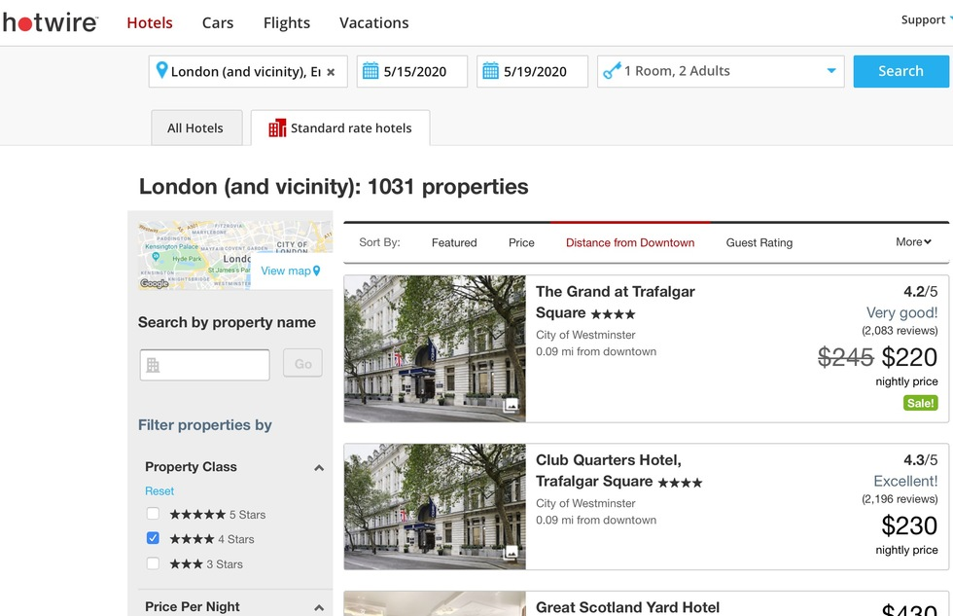
#10: Hotwire
OTA
In our previous test, Hotwire.com was at #5. This time, it plunged to the edge of our cutoff, barely besting its corporate parent, Expedia. The two often had identical results on price, but Hotwire’s ace in the hole remains its Hot Rate blind booking service, which can yield savings of up to 60% off a hotel that isn’t named until after you pay (although we figured out how to get around that mystery). Maybe Hotwire knows that’s where its strengths lie, because it now puts those anonymous offers up front; you have to click a tab opening a secondary window to see “standard rate” hotels with names. Once you look at those, though, the results are pretty poor. Hotwire only managed to find the best price one out of 26 times (and four other sites found it, too), whereas in five searches, it returned the worst or next-to-worst rates—and twice it told us a hotel was sold out when every other site on our list was able to rustle up a room.

Pros: Hot Rate blind bookings can find big savings; has filters for accessibile rooms
Cons: Mediocre performance by most measures; scored second-lowest on number of lodgings found; can only search factors such as neighborhood and guest rating one at a time, while competing sites allow the use of mutiple filters at once
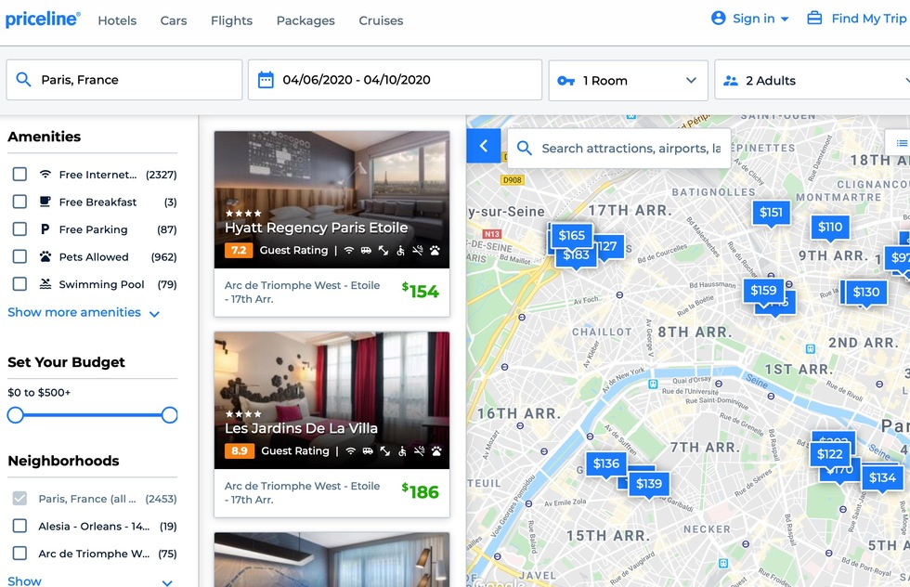
#9: Priceline
OTA
Priceline once ruled the middle-of-the-pack booking engines, but it nearly slipped off the charts since the last time we tested it. This time, it did find the best rate on our specific hotel twice, but so did most of the sites that outranked it. Although its performance is only average on finding the lowest prices, its patented blind booking Express Deals save anywhere from 18% to 60% as long as you are willing to learn the hotel’s name and address only after you’ve paid.
Pros: In addition to standard results (which we used for comparison purposes), Express Deals blind bookings and name-your-own-price reservations can yield savings of up to 60%
Cons: Map only shows the 30 hotels on that particular results page, not all the choices in the results; private rentals are on a separate results; sub-par filters; prices often jump up by a few dollars once you click to the hotel page; price quotes round down (a minor annoyance, but it feels sneaky)

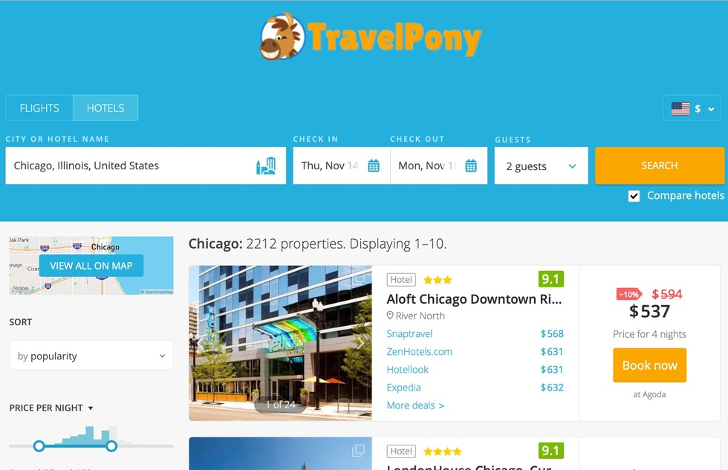
#8: TravelPony
Aggregator
TravelPony recently transitioned from a members-only, social media-oriented site into a standard aggregator, and the change has served it well, allowing it to break into the Top Ten for the first time. Its domestic results weren’t that good, but it fared better internationally, especially on the number of results it could find, if not always price. That said, it was the only site to notice that Hostelworld.com could shave 22% off a cheap stay in Buenos Aires. It seems to cast a wider net for OTA results—but we wondered if they’re properly vetted; some the lesser-known sites and apps it displays warrant a quick search for complaints and BBB.org ratings before you trust them with your booking.
Pros: Seems to include taxes whenever possible
Cons: Canvasses a few sites, services, and apps that have low rates but not always lofty reputations, so buyers beware

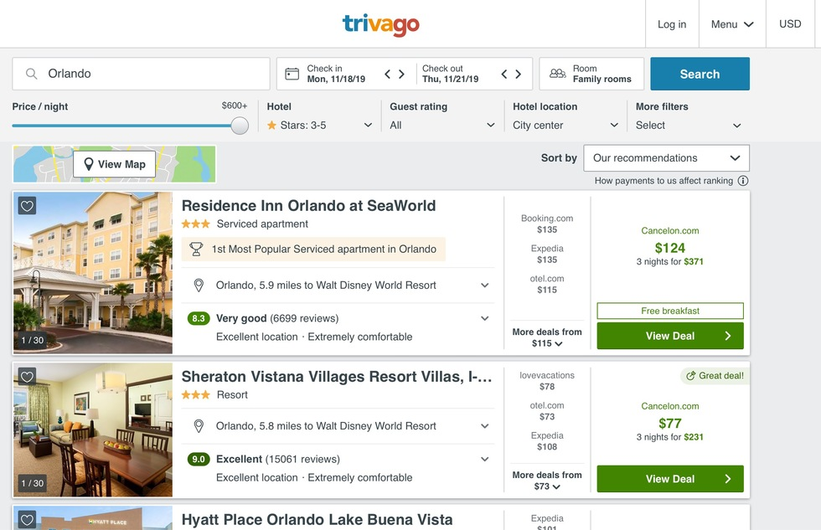
#7: Trivago
Aggregator
We barely know what to say. When Trivago launched several years ago, it came out of the gate strong, but it has only lost ground since. Yes, it has an intuitive interface, speedy refreshes, and a nice set of filters. However, beyond the cosmetics, it never beat the competition—and it also admits to favoring its partnerships in the placement of results, which means you have to hunt for its honest best. It did manage to find the same prices as most of the competitors ranked above it. Yet even though it claims that three of our top finishers are among the 250-plus sites it canvasses, it somehow found fewer hotels than each of them. Shouldn’t it return at least as many results as the sites it searches? The most hotels any site found in Orlando for our dates was 800; Trivago found only 125. London hotels under $75? Priceline returned 400. Trivago: 9. Trivago has perfected its incessant television commercials, but not its algorithms.
Pros: Lovely user interface; “distance from…” can look near any address; does direct searches on hotels’ own sites (warning: it favors direct rates even when they’re undercut by third-party sites)
Cons: Underperforms every other aggregator and OTA; never found lowest rates on cheaper hotels and tied for lowest price on a few expensive properties; formerly robust set of filters are now over-simplified; only shows the top 125 results based on any given criteria; sometimes features a “deal” that costs more than other results it found (the cheaper rate is sometimes displayed in smaller print beside the featured "deal," but may only be visible after clicking on the "More Deals" tab)
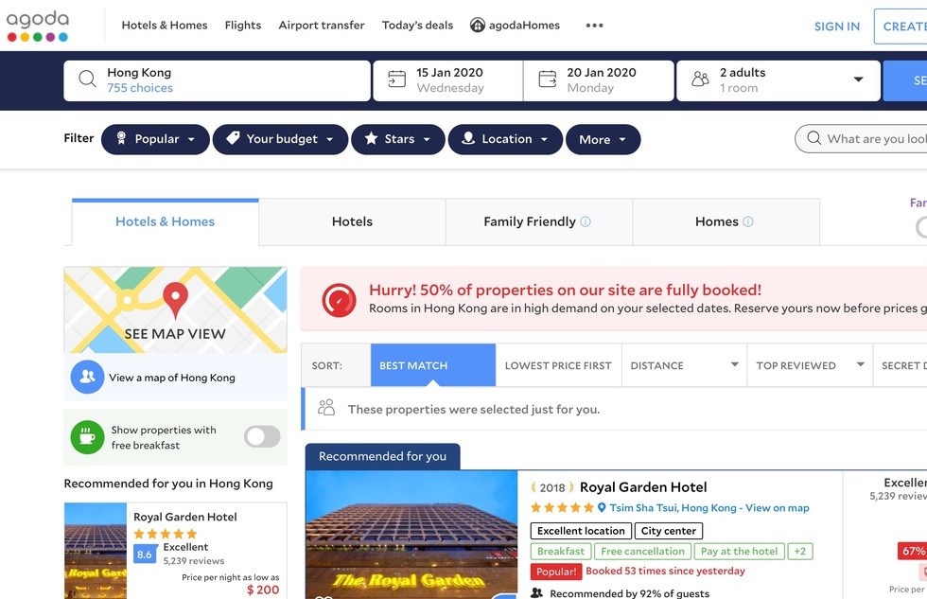
#6: Agoda
OTA
Agoda tumbled from the #2 slot it held last time because its test results haven't changed much while rival sites have improved. Treading water still serves it well in Asia, where it outperforms most (Agoda was founded in Thailand, though is now part of the Priceline/Booking.com family), but it hasn’t helped its poor domestic results—particularly in Orlando. It landed the “highest rate” anti-prize there a whopping three times, and on one search it was convinced that Orlando’s Marriott's Cypress Harbour Villas were sold out when every other site easily found space there for $207.
Pros: Consistently finds the most lodging options and lowest prices internationally, especially in Asia; good filters; “Member Rates” shave about 10% off select properties
Cons: Only fair-to-poor domestic results; only searches by city (most other sites allow searches by region or state as well); omits taxes and fees in Europe and Asia, which makes its results look lower cheaper than they are; cluttered with cheap marketing ploys that imply scarcity so you’ll book quickly (“36% off today!” “Only 3 Left!” “Early Bird Special!”) and sprinkles 4% of results with “Just missed it!” hotels not available on your dates

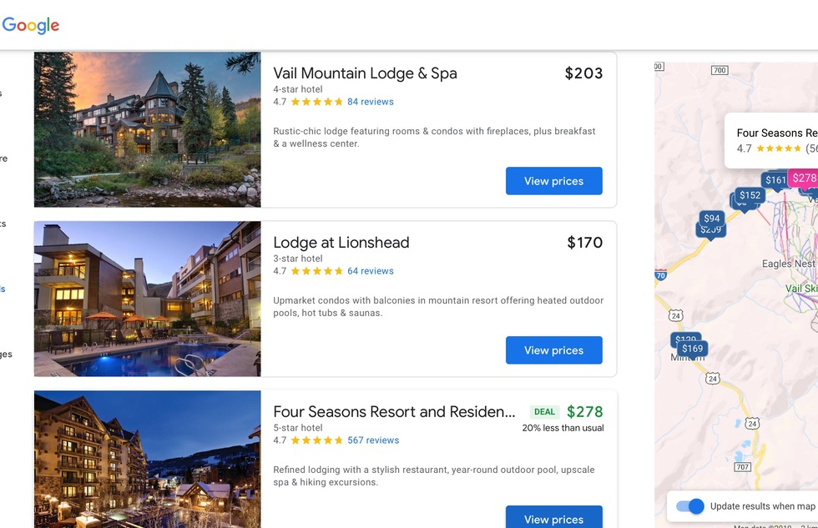
#5: Google.com/travel/hotels
Aggregator
In Google’s relentless campaign to rule every web search, it quietly built a potent aggregator for hotels. If you straight-up Google a hotel name, a box on the right of the results showcases, among reviews and other intel, the going prices from a bunch of booking engines. If you Google “hotels in X” with X being your destination, you get a little window showing some top results, a map, a few filters, and a “view all hotels” button. Or you can just go to Google.com/travel/hotels to get a full-fledged aggregator interface. Results and refreshes are lightning fast, and the interface is intuitive. As for the results of our tests? Well, there’s a reason even vaunted Google sits in the middle of the pack. It did find the best or near-best prices nine times—but it was never alone in finding those rates and it returned awful or the worst rates three times. It’s odd that Google, King of Search, never found the most options; it was among the three worst performers in our Top Ten.
Pros: Very fast; good filters; sometimes finds lower prices direct from the hotel site
Cons: Smaller set of results than most; best quotes are matched or improved upon by competitors

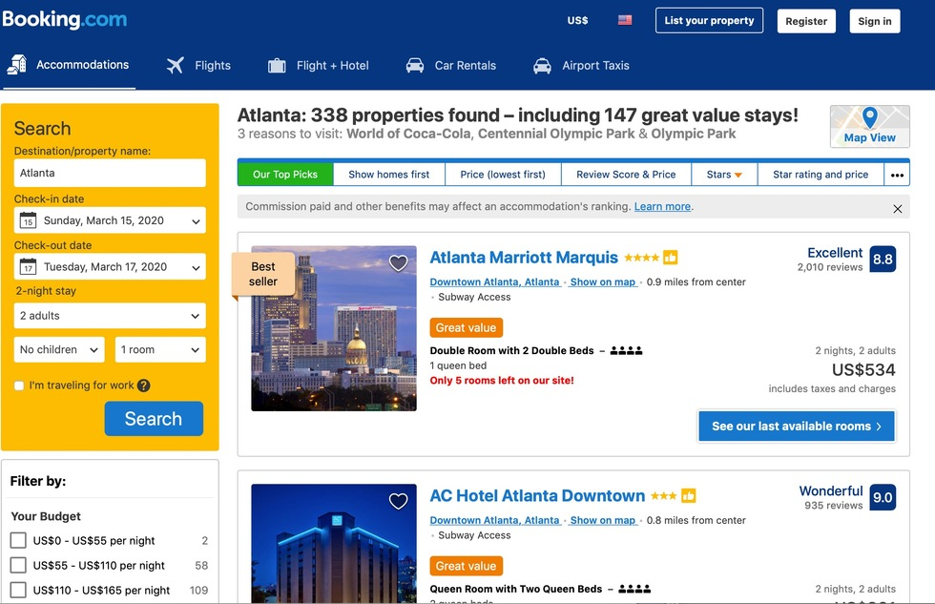
#4: Booking.com
OTA
Though a trio of aggregators has finally figured out how to do better than Booking.com, the venerable site still smokes the competition when it comes to the number of city-center lodgings it can find, especially for under $200. But it’s slipping on price. Booking.com used to be able to find the best or near-best rate about two-thirds of the time, if not more. But now it manages to take that ribbon only seven out of 26 times. On the other hand, it found a bad price only three times, and was one of only three sites that never returned a highest rate. We we also like to note that it includes taxes on the first rates you see, whereas the others bury fees in the fine print, behind hidden filter buttons, or on later screens. Finally, each listing includes user reviews that, unlike at crowdsourced sites, are guaranteed to be from actual guests (customers may only post a review after booking through the site).
Pros: Includes taxes from the start; usually finds at least twice the number of properties (if not more) than any other OTA, especially in the lower price brackets; consistently returns low rates (and rarely misses the lowest available price by more than a few dollars); great selection of filters and sorting options; has “Member Rates” that are about 10% off select properties
Cons: Occasionally returns a below-average price; like its corporate cousin Agoda, uses deceptive pressure-sales tactics that are banned in some countries—results may be tagged with alerts like “Only 3 rooms left on our site!,” and some results are “You missed it” hotels with no availability that are only included to give you a sense of anxiety and make you book faster

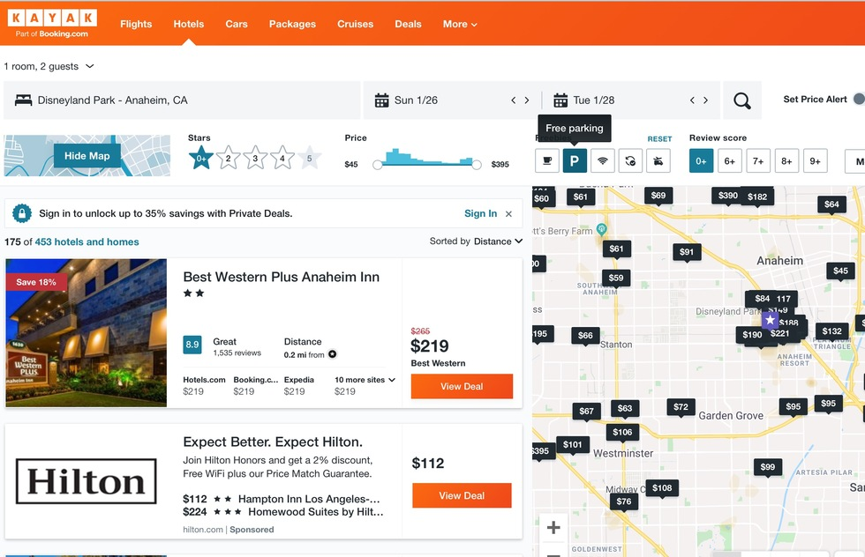
#3: Kayak
Aggregator
After years of underperforming, the most famous aggregator seems to have corrected its course. Kayak was one of only two established sites that actually moved up in our ranking, leaping from #7 to #3. It was the only site we tested (including the top two) that never returned a rate worse than average—and it did the best five times out of 26. (While the top two each stumbled on a bad rate here and there, they also found the best rate more often, giving them a points advantage.) Kayak also has a solid set of filters, including a fill-in window for “nearby” so you can name any landmark or address. Very nice. However, it somehow plants a cookie on your browser that apparently records searches performed on other sites—it auto-filled destinations and dates when we first logged on—which is creepy.

Pros: Offers option to include taxes and fees (but you have to select it); has “Member Rates” if you sign in (it’s free); searches direct on some hotel sites; nice filters
Cons: Doesn’t always lead with lowest price; somehow manages to include fewer lodgings than its corporate sister site, Booking.com, which it claims to search (this mystifies us)

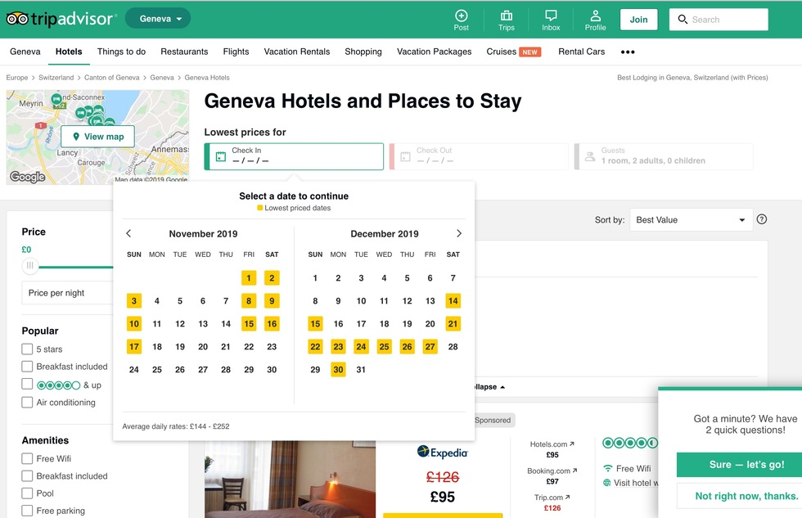
#2: TripAdvisor
Aggregator
Yes, alongside complaints about weird smells, rude clerks, and spotty Wi-Fi, the hotel listings on the mother of all crowdsourced travel review sites now aggregate prices so you can just click to book. Not only that, it’s doing a smashing job on finding low rates, just edging out Kayak.com. TripAdvisor has “user” reviews, but not necessarily “actually stayed in the hotel” reviews—experts estimate that between one-third and one-half of all crowdsourced reviews are false, paid for or written by friends, staff, or competitors, so you get both fake positives and fake negatives. Oddly, TripAdvisor fared abysmally—placing ninth overall—in the number of hotels it could find in each city, but its price performance on what it did find made up for that.
Pros: Great at finding low rates; good filters; handy user reviews; sometimes finds lower prices direct from a hotel’s own site
Cons: Fewer options than nearly all the competition

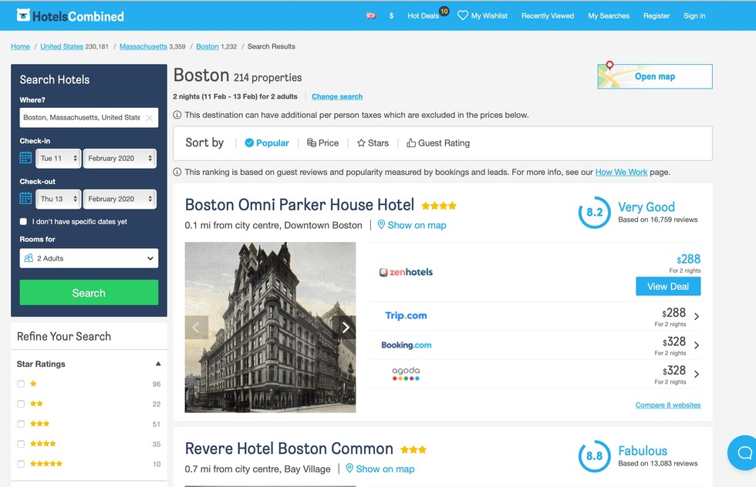
#1: HotelsCombined
Aggregator
The ontime king of aggregators has regained its throne! It slipped to #4 in our previous tests, but it once again clawed back atop the heap. It remains the top metasearch engine for ferreting out the best price on a specific hotel by name—so long as it is able to find that hotel. In our tests, HotelsCombined.com fared only modestly at producing lodgings in city centers. Though it claims to search 30 top sites, it often managed to find fewer options than the sites it plumbs—even those of its corporate siblings Booking, Agoda, and Priceline—which makes little sense. It also roped the worst price on one moderate Rome hotel, and claimed it couldn’t find any rooms at a moderate Bangkok inn when all the others did. In more than half the cases, prices it displayed from third-party sites were actually a bit higher once you clicked through—sometimes by just a dollar or two, sometimes by $10 or $20, and occasionally by as much as $60 or $100. We imagine this is a failing in its algorithms’ effectiveness at scraping timely results from its provider sites. Even considering that occasional accuracy glitch, however, HotelsCombined.com proved time and again its ability to bag the best rate, and that’s what counts—and wins the crown.
Pros: Searches up to 30 OTAs and booking engines at once; offers option to see price with or without taxes; sometimes shows lower rates than even the hotel itself quotes
Cons: Less choice than many competitors; when you click to book, the real price is consistently $1 more (or sometimes more than that); has inexplicably removed some small but handy features that once made it better, like the ability to eliminate individual hotels from results; lacks the handy location filters found at rival Trivago

