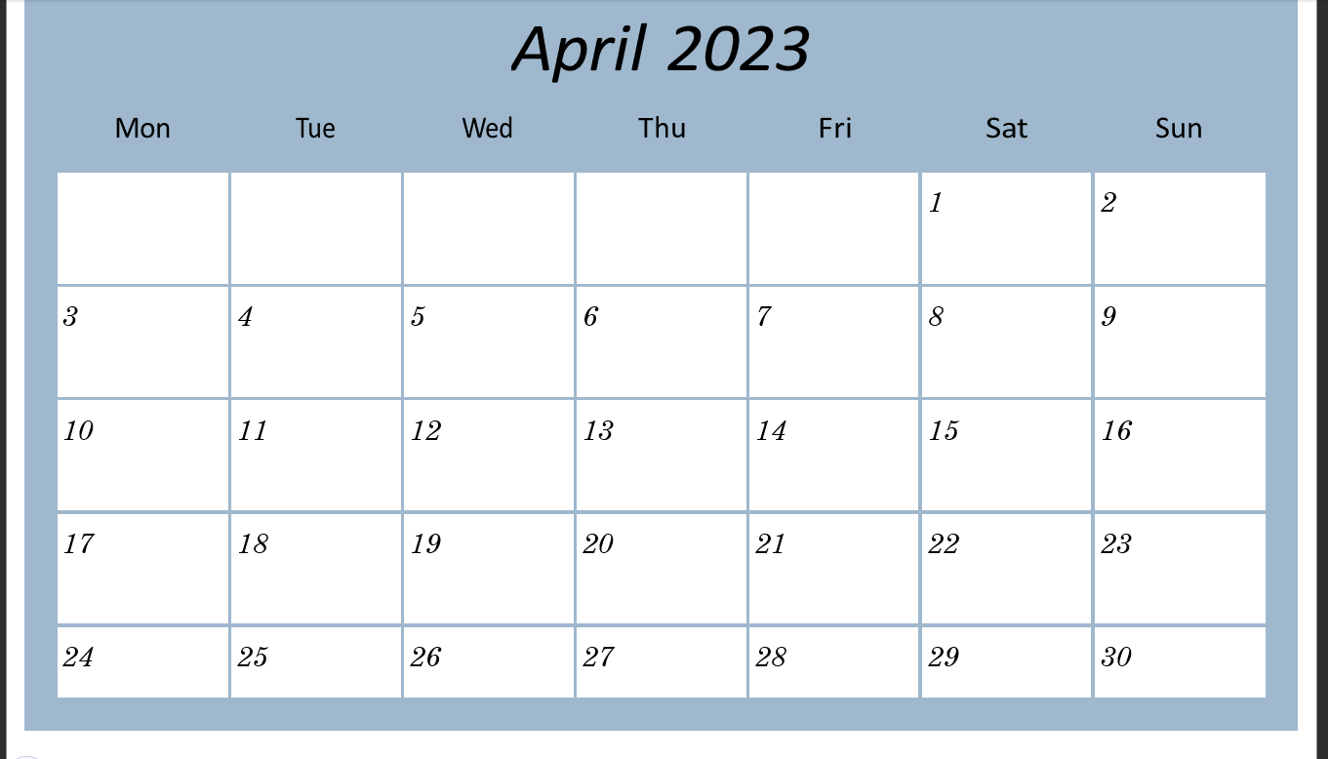
On the second day of my placement, it became apparent to me that Tom struggled with remembering important upcoming events, but he didn’t have a planner. I decided to sit down with Tom and design a schedule for him that was easy to read, used colours that were easy on his eyes, and something that wasn’t going to overwhelm him with a lot of text boxes and information. We enjoyed doing this together, and Tom indicated that it made him feel independent, knowing he had his own schedule that he created and was for his eyes only. It was apparent that having his own schedule made him feel independent, and creating it himself was very rewarding for him. He saw it all come together from start to finish, and I feel it’s important to have somewhere to physically write down upcoming events and important dates to ensure his mind didn’t become too overstimulated and result in a meltdown.

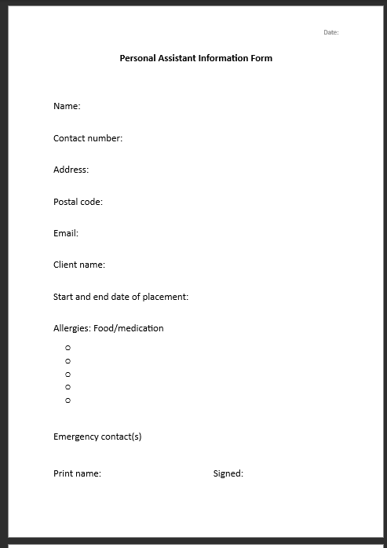

This piece of work was produced by me for Tom’s mother to simply ensure she knew how to get hold of me in case of an emergency.

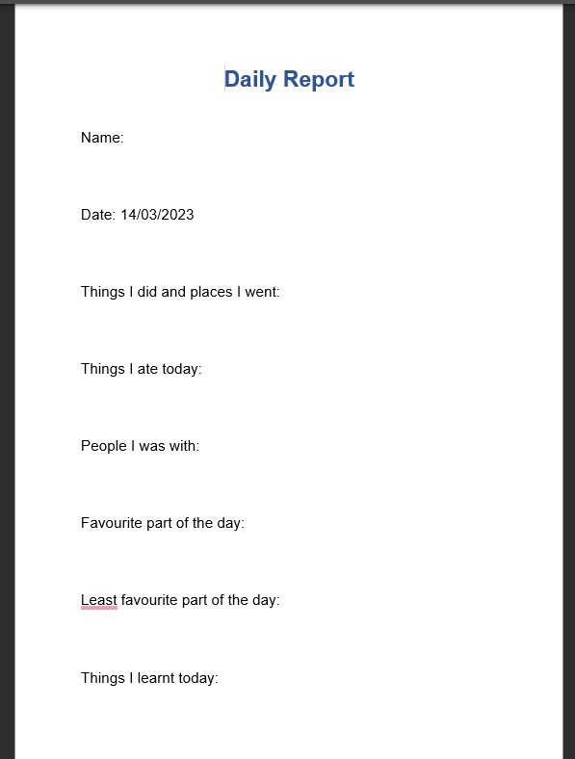
Tom’s mother asked me to produce and provide a reflective log for him and take 10-15 minutes at the end of each day to ask him about his day and the activities we did together, and I feel this was helpful when attempting to breakdown the day and provided me with some insight into how he felt during the day. This showed me that even though I may have thought one thing about the day, Tom may have felt another, and doing this with him every day, gave us a chance to dissect the day and allowed me to ask questions about why he may have felt a certain way and what he enjoyed, enabling me to implement these things into the following days and get to know his triggers a little bit better. This was especially useful after our outing to the Cawdor restaurant, it provided me with insight into how he actually felt this day.

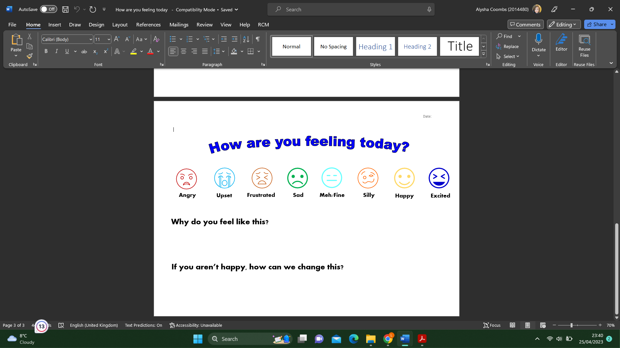
I decided to make a happiness scale for Tom in an attempt to get a feel for his emotions at the start of our sessions together, and then compare these to the end-of-day questionnaire that I made for his mother. I thought this would be a good idea because I could adjust the plans for the day according to how he was feeling. For example, if he indicated at the start of the day that he felt frustrated, I could switch the activities around and do something that wouldn’t involve stepping outside of his comfort zone. The reason for this is that as much as physical skills are essential to living an independent life, having the ability to express your feelings and talk about how you feel on the inside is just as important, and swapping plans around gave us the ability to lower the possibility of a meltdown. This did prove to be a success, however, upon reflection, I was lucky for most of the days because he does generally feel happy or excited. The only time he did express his frustration was after a phone call with a PC engineer. Tom’s whole life revolves around video games. Playing online is his escapism, and because his PC was in for repair and the engineer had given him a time estimate that wasn’t accurate this began to frustrate him. He expressed to me that he did not like being lied to, and he had his heart set on having his PC back within a few days, however,r this was not the case. Eventually, he did calm down and was able to express why he was feeling the way he was, and we discussed healthy coping mechanisms for when he does begin to feel frustrated. I reiterated to him that even though the PC engineer had told him it would only be a few days, some things are out of our control, and that although this doesn’t dismiss his feelings, he can’t let this cause a meltdown. After talking for a while, he began to see things a little differently and told me that he felt relieved that even though the PC was away for longer than expected, at least he was able to speak to the engineer and be reassured that nothing was broken, and he would eventually get it back. Reflecting on this, I do realise that in Tom’s case he sees things very ‘black and white’ and matter of fact. It is difficult for him to read between the lines.

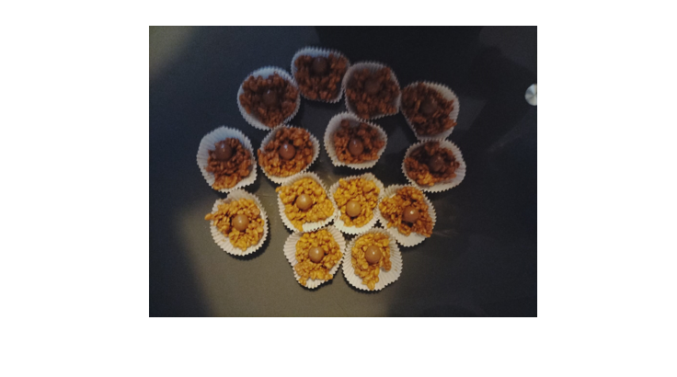
As I mentioned in my reflective piece, I chose to make rice krispie cakes with Tom as this combined two things that he liked and made him think of other ways to combine 2 foods that he wants to make something else. I learnt a lot in this session about the sensory issues he has. He does not like his hands feeling sticky or messy. However, I did explain to him that there are going to be many times in the future when he does go on to live independently that he will have to get his hands messy to cook for himself, and even though it feels uncomfortable in the moment for him, the sink is only a few steps away, and he could wash his hands whenever he felt necessary. I thought it was important not to brush off his sensory issues when it came to his hands because I did not want to dismiss his feelings, instead, I tried to find ways for him to cope with them in the moment and provide solutions to the problems that he was experiencing. He enjoyed this session and indicated that he found it relatively easy, and it was the mental block that would stop him from doing things like this before, but now that he knows how simple it was, he would be more confident to try new things like that in the future. I chose something easy to make because I didn’t want to jump straight into the deep end with something difficult, as I felt this would only negatively impact his confidence if he began to feel frustrated that he couldn’t do something.

A reflective piece on my work experience with a young adult with autism

Before I started my work placement, I didn’t think that I would learn so much about those diagnosed with autism or how this affects them and the people around them daily; it was only when I sat down to write this reflective piece that I realised how much I had learnt and how it has changed my outlook on the disorder. I used the reflection on action model more than the reflection in action model (Fallin, 2022). To protect the identity of the male I worked with, I will use the name Tom instead of his real name. Before, I wouldn’t pay too much attention when I was out in public; I didn’t consider how loud bangs may trigger someone living with autism or how I find it easy to walk into an unfamiliar building and know what to do or say, how a loud and open space may cause a sensory overload, or even how sticky hands can cause a sensory overload.
I completed my ten days of work experience with a young male with autism, specifically to teach him essential life skills such as taking him food shopping and making meals from the ingredients, going for lunch and showing him how to order and pay for his meal, how to properly conduct himself in a public setting, creating planners in an attempt to develop essential coping mechanisms concerning stress and anxiety and lessen the mental strain of having many things to remember but not having a physical reminder of what needs doing or something he could refer back to, encouraging independent behaviour such as paying for items in a shop or a bus ticket, how to effectively engage with shop assistants when attempting to communicate his needs, practising his phone manner when speaking to those that aren’t family, and how to problem solve at the moment when a potential roadblock is ahead.
Although my work placement with him aimed to teach him essential life skills, I came away with a new perspective, a more positive outlook on life, a different sense of compassion for others, and a newfound patience. What I mean by a positive outlook on life and compassion for others is that I now see the struggles that someone living with a disorder like autism must go through to try to fit into our society or even to meet what neurotypical people would consider easy everyday tasks. Watching Tom order his food and pay the bill showed me that talking to unfamiliar people took an immense amount of courage, and the anxiety that he went through dominated his mind; however, I communicated with him that if he wasn’t comfortable doing it, then I would take over, but also reminded him that living independently is an essential life skill that he needs. I gained more patience towards others and learnt how to deal with a situation that wasn’t going to plan or how to limit my frustration to limit Tom’s anxiety and frustration when he was dealing with sensory overloads, like during our cooking session. I considered myself in some ways a perfectionist; I like to take my time when preparing my food so it looks aesthetically pleasing on my plate, so to see Tom roughly preparing the food that needed to be cooked instead of carefully as I do was at times difficult for me but what I did reflect on during this was the fact that this wasn’t something he ever really did, and the fact that he was preparing everything from start to finish instead of someone else doing it for him satisfying because preparing and cooking food is such an essential life skill that he will need when he one day goes on to live an independent life in his own home, and saying anything remotely negative or trying to get him to do it the way I do could put him off doing this in the future because he may feel like he is doing it wrong. The following day we made rice krispies cakes. I chose this because it was relatively straightforward and followed on from what we did the previous day; it didn’t matter if they weren’t uniform in shape, and when cooking, there are going to be many times when your hands have to get messy, and it is okay to have chocolate on your fingers and avoiding a meltdown during this is essential to cooking independently. I reminded him during this that the kitchen tap was only a few steps away if he needed to wash his hands and that there are going to be times when you must get your hands messy. I also chose this because he likes rice kripies and chocolate, but he hadn’t considered combining the two to make something new, so this was interesting to watch his reaction and encourage him to try new things.
The most challenging part of the work placement was putting myself in his shoes in the sense of attempting to understand why he acts in or reacts to certain situations. It was easy for me to brush off something that I considered easy or not anxiety-inducing, but for Tom, something as small as entering a restaurant that he has never been to almost completely dominated his mind all morning until we left. As much as he enjoyed the meal, it was a huge step for him to do this; however, in the days after this, I did see a small increase in his behaviour in public, and at one point, he actually communicated that he wanted to order his own food during an outing to Carmarthen, and it made me happy that he actually wanted to do this independently instead of me encouraging him to do it. Since finishing my last day of work experience with him, I find myself being more thoughtful about the things I do and having more patience in situations where I used to get a little frustrated. As much as I helped him, he helped me in more ways than I even realised.

References

Fallin, L. (2022, October 26). LibGuides: Reflective writing: Schön. Libguides.hull.ac.uk. https://libguides.hull.ac.uk/reflectivewriting/schon

