University of Wales Trinity Saint David
SCHOOL OF HOSPITALITY & TOURISM MANAGEMENT
BA (Hons) International Hotel Management
Sustainable Hospitality & Tourism Management
Module Code: BMIH5006
Lecturer’s Name: Ruth Taylor-Davies
Student Name: Purna Lal Sapkota
Student Code: 2108557

Reports Topics: Destination Management
New York, USA

Table of Contents
Introduction 1
Principles of sustainable tourism 1
3 pillars of Sustainability 1
Practices, regulations, and responsibility of organizations for the implication of sustainable tourism 3
Traveling aspects of the New York industry 3
Butler’s life cycle model 4
Doxey’s Irridex model 6
Statistical chart 7
Recommendations 8
Conclusion 9
References 10

Introduction

New York City is the largest state in the USA, and it is well known for many things and one of them is easily artistic prowess and the talents at home. Because it has a great destination and around 66.6 million people visit the city (Mindge, 2022). A sustainable tourism destination means the place has a high number of benefits than a negative impact on the environment with its activity (Paddison and Walmsley, 2018). The report aims to evaluate sustainable tourism for the development of New York, USA’s destinations. The report will outline the principles of sustainable tourism in New York and the report will add practices, regulations, and responsibilities of the organization for the implication of sustainable tourism in New York. Therefore, the report will discuss Butler’s life cycle model and Doxey’s irridex model to highlight the stage of New York in the cycle. Finally, there will be some recommendations for New York for future development by obtaining sustainability.

Principles of sustainable tourism

3 pillars of Sustainability
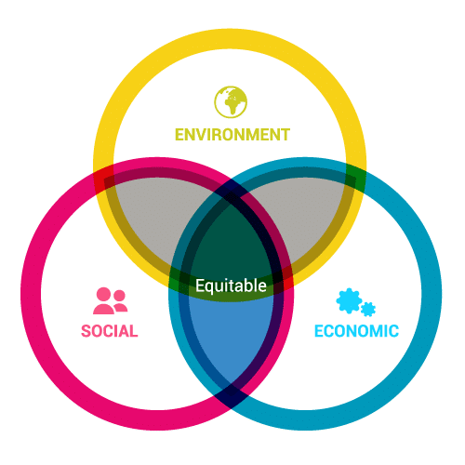
Figure 1: 3 Pilers of sustainability.
Source: (Husgafvel, 2021).
Environmental – The environmental pillar of sustainable development includes maintaining laws, and regulations to safeguard the environment and other resources (Husgafvel, 2021). The tourism industry of New York needs to use renewable energy in the rooms of the destination and manage waste by following a waste management plan. Using fresh water and making plans for reducing carbon emissions are also part of the environmental principles. For example – Cook Travel is ensuring the use of renewable energy in their rooms and using a proper waste management plan so that they can obtain customer satisfaction. Because customers are now environment conscious and select a hotel that has an accurate sustainable plan. It helped them to get 5% more customers than previous times (Thompson and Norris, 2021).
Socio-cultural – This paper focuses on initiative, community development, diversity, improving quality of living, and analyzing public policies. The tourism organization of New York needs to ensure peace, and security to contribute to the betterment of society (Janjusevic and Salama, 2018). Tourism organizations in New York need to avoid an unethical practice that harms employees and those organizations must ensure the offering of minimum wage and incentives to both genders who are dedicated to operating businesses for their organization. For instance, - New York Welcome agency contributes to society by recruiting ethnic people to their diverse destinations. The organization is searching for destinations in the forestall area and to secure their destination they are recruiting those native people at those destinations. It is helping them to reduce the unemployment rate and fight against poverty. This initiative of New York Welcome helped them to create value in society.
Economic – Economic pillar of sustainability is important for organizational existence, and it includes economic development, labor rights, and fair compensation. Tourism organizations in New York need to understand that stakeholders, employees, and society are an essential part of their contribution and response they are receiving profit. So, New York’s travel organization needs to share its profit with these figures. Trip Corner gives 2% of their profit to their employees as incentives and 1.5% of their profit goes to the community development program (Eiseman, 2018). It helps the organization to perform economic responsibility as well as fair play in the industry.

Practices, regulations, and responsibility of organizations for the implication of sustainable tourism

Practices – Tourism organizations need to practice staying in eco-friendly accommodations by using renewable energy at their buildings and tourism sites (Abd- Elkerim, 2019). Also, New York’s travel agency can collect foods, and vegetables from local small businesses to support them to expand their business. Also, New York’s travel arranger needs to offer local food to the tourists so that they get the test of the local food habit and culture. Fresh and nutritious local foods support the local economy and contribute to enhancing the income and employability of the community. So, tourism business needs to implement these practices in their organization for promoting sustainable tourism.
Regulations – To follow the regulation of the Break Free from Plastic Pollution Act of 2021, the tourism organizations of New York must say NO To Use Plastic because the use of plastic and throwing it in the ocean pollutes the ocean water and hampers the life of the ocean animals (Mamatzakis et al., 2022). As a result, it becomes difficult for these animals to live properly in the ocean. To reduce carbon emissions, tourism organizations need to use public transport instead of using individual cars. It also reduces the traffic on the road and safeguards the environment from the release of carbon dioxide (Dinica, 2022). So, the tourism organizations of New York need to implement these regulations into their organizations so that they can promote sustainable tourism in the USA.
Responsibilities – The tourism industry needs to give safety jackets, first aid kits, and walkie-talkies to the employees if they visit for touring the customers. moreover, the tourism industry needs to pay equal wages to both male and female employees to create a culture of equality and diversity in the organization (Simpson, 2021). Paying taxes accurately is also a responsibility of tourism organizations toward the government. The travel supporter needs to respect local norms and introduce those norms to tourism to make people aware of the local culture and region of New York’s people. Tourism organizations need to respect tradition and present it in front of tourist to create a sense of unity and acceptance toward culture among people. So, tourism organizations need to person these responsibilities to implement sustainable tourism into their organization.

Traveling aspects of the New York industry

In the time of traveling, people just do not travel, they also learn about different parts of the country. Traveling to different destinations helps a person to learn about geographical, demographical, and cultural differences (Schmidlin, 2017). It helps them to learn about the diversity of the world. Tourists need to select the correct travelers for themselves so that they generate great ideas for exploring diverse destinations. With the help of an agent, a client books flights, hotels, tours, and other things. Another aspect is accommodation, which is also related to the tourism organization, and they need to work on giving the best comfort in clients traveling times. Full-service, extended-service, and limited-service options must be available for customers. tourism organization needs to offer timeshare resorts, hotels, motels, and inns for clients as per their requirements and budget. The mode of transportation is also included with the tour to react to the destination on time. So, tourism organizations need to select flights, transport, and cars as per the time and budget of the client to fulfill their requirements. Tourism organizations also need to offer local foods to customers to introduce them to local eating habits. These aspects can help them to attract a high number of customers toward traveling.

Butler’s life cycle model

Butler’s model highlights a discussion about tourism carrying capacity and sustainability where the author highlighted that tourism destination requires to be managed carefully (JBB and SL, 2019). The butler’s model has six tourist areas of evolution which are discussed below -
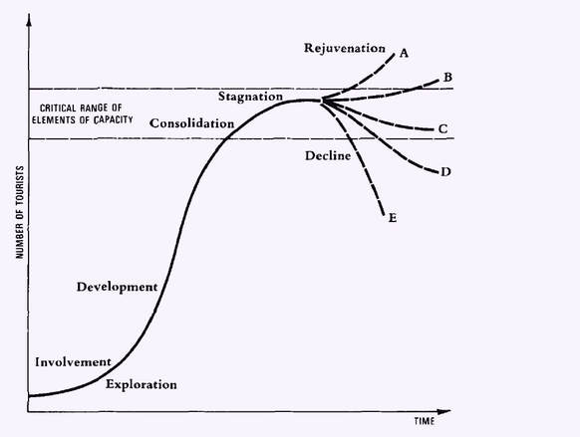
Figure 2: Butler’s life cycle model for the tourism industry.
Source: (Kusumah and Nurazizah, 2018).
- The exploration stage is the first stage which expresses the small number of tourist visits to the destination.
- The involvement stage outlines that residents become involved in tourism and pressures are increasing from previous years.
- The thirst stage is the development stage which refers that the high numbers of tourists visiting the destinations of the country.
- The fourth stage is the consolidation stage where the growth of tourism slows down and the country’s tourism industry re collaborating with franchises to improve the visit number.
- The stagnation is the fifth stage which shows that the visitor number reached its maximum capacity, and the organization established its image well.
- The final stage expresses the decline of possible alternatives as organizations failed to attract new visitors for tours and require a complete change in the tourism industry.
From the mentioned six stages, New York’s tourism industry is at 3rd stage which is the development stage because the industry received 66.6 billion visitors last year which was higher than previous times (Kusumah and Nurazizah, 2018). Tourism organizations like Trip Corner, Skylark Travel, Amnet New York, first in-Service Travel, Cook Travel, and New York Welcome accurately advertise their differentiated service for arranging tour for customers. Also, the travel organization activity is not controlled by the local people of the USA and so customers are attracted by their innovative travel arrangements. The government of the USA is also working to develop and improve USA’s natural and cultural attractions so that it can represent the country efficiently in front of the international tourism industry. So, New York is at the development stage in Butler's life cycle model.

Doxey’s Irridex model

Doxey’s irridex model was established in 1975 and is based on the understanding of the residents' attitude toward tourists in the different stages of a destination life cycle (Prentice, 2020). The irridex contains four stages which are Euphoria, Apathy, Annoyance, and Antagonistic.
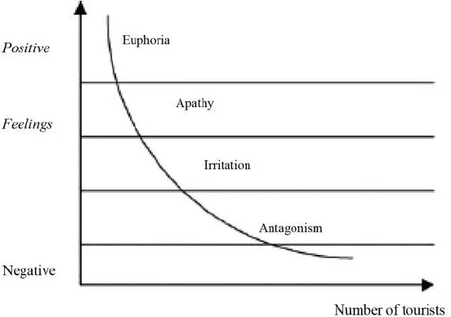
Figure 3: Doxey’s irridex model for the tourism industry.
Source: (Gass, 2017).
Here, New York City is at the 2nd stage of Doxey’s irridex which is Apathy. The New York destination has a neutral feeling and earrings on the side of positivity. But New York’s tourism industry needs some stakeholders who invest in the industry for adding more attractive destinations in the industry. At the same time, tourism organizations need to work more on improving service so that the customers are attracted by the innovative service of the industry's travel agency. It can drive the industry to get more tourists than the previous year (Gass, 2017). The tourism industry experts of the USA is attempting to control by increasing infrastructure so that they can obtain more success from the industry. Visitors notice a range of saturation points approaches of tourism organizations to make travel memorable for their customers. But local protest groups sometimes generate challenges to travel to New York for COVID-19 restrictions. So, the USA’s New York is at the apathy stage in Doxey’s irridex model.

Statistical chart

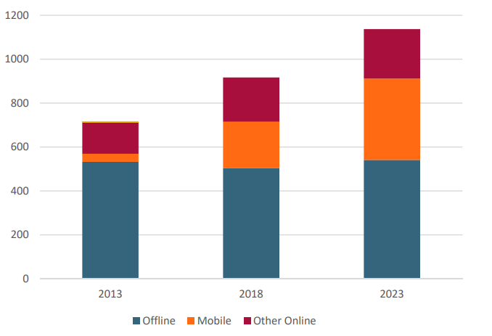
Figure 4: Booking of the customer for traveling to New York City.
Source: (Dinica, 2022).
The chart shows the number of bookings of the destination by travelers in New York from 2013 to 2023. In 2013, the city used to receive 750 bookings from customers for traveling the country. But in 2018, it increased by 200 bookings and the country received 950 bookings from customers for traveling. Finally, in 2023 New York received 1180 bookings from customers and it will increase gradually (Dinica, 2022). So, the increasing number of bookings of New York travel organizations for traveling highlights that customers are getting attracted more by the industry for traveling.
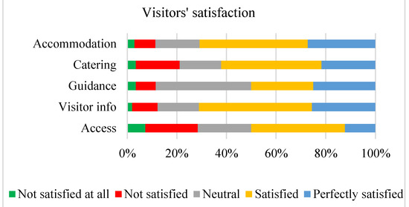
Figure 5: Satisfaction of customers for traveling to New York City.
Source: (Kusumah and Nurazizah, 2018).
The graph highlights that visitors are expressing that 20% of visitors are perfectly satisfied with the service of accommodation, catering, guidance, visitor information, and access. New York’s tourism organizations. Around 35% of visitors are satisfied with their service and 19% remain neutral after visiting the city. Therefore, 18% are not satisfied and 8% are not at all satisfied with their service (Kusumah and Nurazizah, 2018). Since the percentage of satisfied visitors is high it can be said that New York City, USA are in the development stage and apathy stage where they are getting positive response from customers.

Recommendations

- New York City should make regulations for the future development of the industry by not using plastic to avoid plastic pollution, ocean pollution, and landfills.
- New York City should arrange safety instruments for their employees when they go for sight visits to safeguard employees from any serious damage (Husgafvel, 2021).
- New York City should use the bus or public transport to take customers to their destinations to reduce carbon emissions and traffic from the environment.

Conclusion

The report is about sustainable tourism in New York USA where tourism organizations need to follow a waste management plan, profit sharing tendency, and recruit ethnic [people to secure their destination. Also, New York needs to avoid plastic use and separate cars for serving customers. Therefore, the industry is in the development of the butler’s model and getting 66.6 billion visitors to their destinations. Finally, the destination is getting huge booking and customer satisfaction which indicates that the industry is sustainably operating their business.

References
Abd- Elkerim, H. (2019) ‘The ethical practices in the tourism field and their impact on employees’ performance in official Tourism Organization’, Journal of Association of Arab Universities for Tourism and Hospitality, 16(1), pp. 156–172.
Dinica, V. (2022) ‘Spectra for tourism regulations in Protected Areas’, Protected Area Regulation and Tourism [Preprint].
Eiseman, D. (2018) ‘Chapter 6 Marketing Sustainable Tourism: Principles and practice’, Tourism Planning and Destination Marketing, pp. 121–140.
Gass, S.I. (2017) ‘Model world: A model is a model is a model is a model’, Interfaces, 19(3), pp. 58–60.
Husgafvel, R. (2021) ‘Exploring social sustainability handprint—part 2: Sustainable development and Sustainability’, Sustainability, 13(19), p. 11051.
Janjusevic, L. and Salama, M. (2018) ‘Sustainable tourism, towards Sustainable Development’, Principles of Sustainable Project Management [Preprint].
JBB, V. and SL, P. (2019) ‘Is Cancun dazed and confused with the Butler’s Life Cycle Model?’, Journal of Tourism and Hospitality, 5(3).
Kusumah, A.H.G. and Nurazizah, G.R. (2018) ‘Tourism Destination Development Model: A revisit to Butler’s area life cycle’, Heritage, Culture and Society, pp. 31–36.
Mamatzakis, E., Pegkas, P. and Staikouras, C. (2022) ‘Labour market regulations and efficiency in tourism industry’, Tourism Economics, p. 135481662210815.
Mindge (2022) ‘Effect of terrorism on the growth of the tourism in New York, USA’, Journal of Hospitality and Tourism Management, 5(2), pp. 11–20.
Paddison, B. and Walmsley, A. (2018) ‘New Public Management in Tourism: A case study of york’, Journal of Sustainable Tourism, 26(6), pp. 910–926.
Prentice, R. (2020) ‘The manx TT races and residents’ Views: A case assessment of Doxey’s “Irridex”’, Scottish Geographical Magazine, 104(3), pp. 155–160.
Schmidlin, F.W. (2017) ‘A new nonlevitated mode of traveling wave Toner Transport’, Conference Record of the 1988 IEEE Industry Applications Society Annual Meeting [Preprint].
Simpson, K. (2021) ‘Managing packaged tourism: Relationships, responsibilities and service quality in the inclusive holiday industry’, Tourism Management, 19(1), pp. 111–112.
Thompson, P.B. and Norris, P.E. (2021) Sustainability [Preprint].

