University of Wales Trinity Saint David
School of Engineering
Towards the Net Zero Logistics Sector
Lauren Lloyd
2315243
Degree Apprenticeship in Logistics and Supply Chain Management
20th November 2023
Study and Research Skills (ACMA4021)

Abstract
This report aims to provide an insight into the net zero movement, with a focus on achievability within the logistics sector. The Paris Agreement is discussed alongside the United Kingdom Government’s roadmap to industrial revolution plan regarding net zero. Within the report, a highlight of some of the incentives that are on offer to businesses and individuals to help aid in the transition to sustainability are discussed, aiming to raise awareness of the green incentive schemes. The benefits and challenges of undergoing a change to net zero is also a key point of discussion within this report, leading onto a conclusion that the benefits far outweigh any costs that may be incurred during this evolution. Achieving a net zero logistics sector is critical for the health of the planet and those who live on it. However, it will be a significant challenge to achieve in the current climate unless more support, resource, and guidance is provided.

Table of Figures
Figure 1: Map of Countries that have Adopted a Net Zero Target (Net-Zero Tracker, 2023) 6
Figure 2: UK Government's ten-point plan to achieve Net Zero (UK Government) 8

Table of Contents
Contents
1. Introduction 5
2. Achieving Net Zero in the logistics sector 6
2.1. The ‘Paris Agreement’ 6
2.2. Government incentives 7
2.3. Government plan to achieve Net Zero 7
3. Benefits of achieving Net Zero within the logistics sector 9
3.1. Economic impact 9
3.2. Societal impact 9
4. Challenges of achieving Net Zero within the logistics sector 10
4.1. Financial restraint 10
4.2. Lack of appropriate resources 10
4.3 Insufficient awareness 10
5. Conclusion 11
6. References 12
References 12

Introduction
The transition to net zero is a pressing challenge that is being faced in all corners of the world. Net zero is achieved when the amount of greenhouse gas emissions produced and the amount removed from the atmosphere is balanced (Shepheard, 2020), where greenhouse gases (GHG) refer to any gas that has the feature of absorbing infrared radiation emitted from the surface of the Earth and then reradiating it back into Earth’s surface (Mann, 2023).
The background behind the movement towards net zero is to limit global warming to a maximum of 1.5 degrees Celsius. If global warming rises higher than this level, then a range of dangerous impacts are expected to be experienced. These range from extreme and unpredictable weather such as floods and heatwaves to rising sea levels, all of which pose significant risks to both animal and human life.
A key milestone to deliver this target is for the logistics sector to become completely net zero. This is a significant challenge as on average, the manufacturing, transport, and storage sectors make up around 30% of all emissions released to the environment (Atmospheric emissions: greenhouse gases by industry and gas, 2023).
This report aims to explore the idea of moving towards a net zero logistics sector, the methodology behind achieving the goal, and the potential benefits and challenges associated with this.

Achieving Net Zero in the logistics sector

The ‘Paris Agreement’
The United Nations claims that The Paris Agreement is a legally binding international treaty on climate change, where the goal is to limit global warming by 1.5 degrees Celsius above pre-industrial levels (United Nations, 2020). This agreement requires parties to implement new challenging goals every five years for actions against climate change, at both economic and social levels. According to the net zero tracker produced and updated by Climate Watch, out of the 196 parties that adopted the Paris Agreement, only 97 parties have communicated a net zero target. Of those 97 parties, 26 have implemented a net zero target into law, 54 have implemented a target in policy document, and 17 have included a net zero target in their political pledge (ClimateWatch, 2023), highlighted in figure 1.
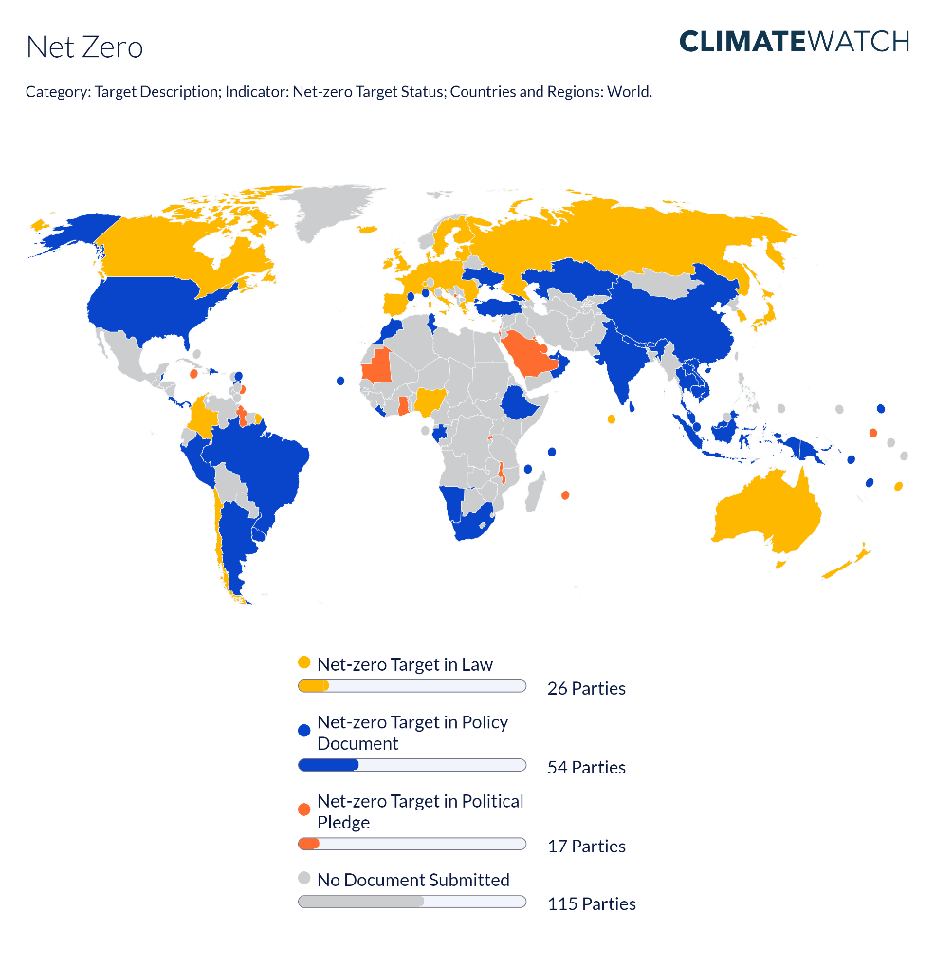
Figure 1: Map of Countries that have Adopted a Net Zero Target (ClimateWatch, 2023)
As less than 50% of the parties that signed the Paris Agreement have followed through and acted on their pledge, the timeline and feasibility of achieving the net zero agreement could be impacted.

Government incentives
To help businesses in the United Kingdom achieve the net zero target, the UK government has provided incentives that make it easier for businesses to operate sustainably. One of these incentives on offer to businesses is the ‘Industrial Energy Transformation Fund.’ This pledges £315 million of funding to businesses, available up until 2027, to help businesses with high energy usage reduce their carbon emissions by investing in energy-efficient and low-carbon technologies (Industrial Energy Transformation Fund, 2023). Another incentive on offer aimed at the transport sector is the ‘Plug-in’ grant. This scheme enables eligible applicants, which can be individuals or businesses, to receive money towards the purchase of an electric vehicle, assisting in the switch over to low emissions (Plug-in Vehicle Grant, 2022).

Government plan to achieve Net Zero
The UK government has established a ten-point plan on the methodology of achieving net zero emissions, illustrated in figure 2. The two points in this plan that this report will discuss are point four, “Accelerating the shift to Zero Emissions Vehicles”, and point six, “Jet Zero and Green Ships” (UK Government, 2020, p. 7). Point four of the ten-point plan refers to the target of ending the sale of petrol and diesel cars by 2030 (UK Government, 2020). This is a key milestone in achieving net zero within the logistics sector as by implementing a wide-scale transition to electric vehicles, the quantity of emissions released within this sector will reduce dramatically. Point six of the ten-point plan refers to the Government improving the aviation and maritime sectors to make the UK the “home of green ships and planes” (UK Government, 2020, p. 18). This will be done by investing in the production of sustainable aviation fuels and developing clean maritime technology in substitution of the current non-environmentally friendly technologies used (UK Government, 2020). If these goals are met, the emissions this sector releases will decrease, and the way the current logistics sector operates will change for the better. However, the feasibility of these targets is still doubtful, with many individuals claiming that these goals are not realistic (Haikal, 2023).
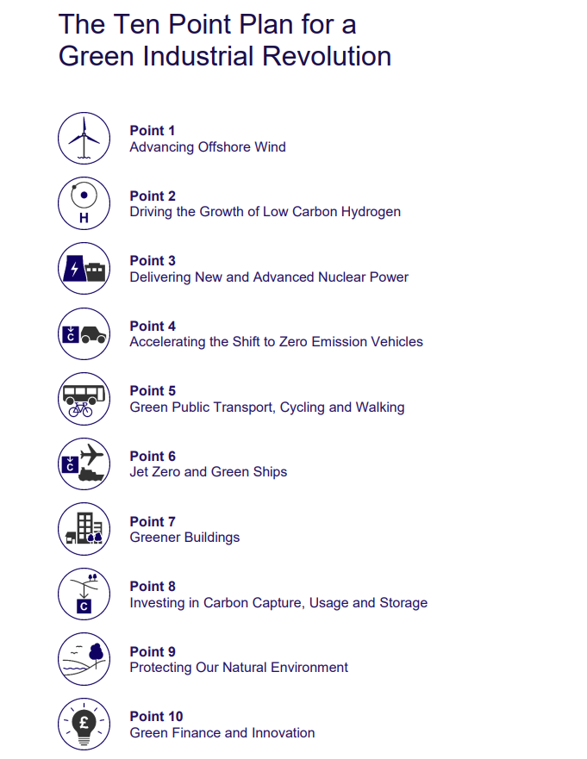
Figure 2: UK Government's ten-point plan to achieve Net Zero (UK Government)

Benefits of achieving Net Zero within the logistics sector

Economic impact
The McKinsey Institute produced a report that estimates that the transition to net zero could result in a gain of around 15 million jobs globally by 2050 (McKinsey & Company, 2022). There is a transition away from the fossil fuel sector towards the renewable energy sector, which is generally more labour-intensive, therefore increasing the number of jobs needed. The net effect of this is that an increased number of people are employed and will have more disposable income, therefore the economy is healthier and likely to grow. In addition, businesses that move towards sustainable practises within their operations could be more cost-effective as decarbonising processes can increase business efficiencies (McKinsey & Company, 2022), this enables businesses to reduce their costs and increase output. This benefits the economy as businesses can generate more output in the same amount of time which increases profitability. This leaves businesses with increased spending power to invest in local communities and employees, which aid in boosting the economy.

Societal impact
One of the main drivers behind the push for net zero is that it helps to avoid the worst effects of climate change, which can cause devastating impacts on both human health, and the health of the planet. By removing the danger of increased infections and diseases that are likely to occur due to climate change, the risk to human health will decrease, therefore by reaching net zero, society overall is healthier (Filippelli, et al., 2020). In addition to this, achieving net zero could help to protect the environment and its natural resources (DGB Group, 2023). This is an important benefit as it is necessary to reserve resources so that biodiversity can still take place, which is essential to all life itself. Additionally, it has been discovered through research that the protection of the environment and happiness levels are interlinked, therefore by protecting the environment, people are more likely to be happier (Bonasia, Simone, D'Uva, & Napolitano, 2022). This shows that avoiding climate change in turn promotes both physical and mental health benefits, which is a great advantage to society.

Challenges of achieving Net Zero within the logistics sector

Financial restraint
A challenge of reaching the net zero emissions target is the cost. This cost falls on individuals and businesses alike, who are each responsible for making the necessary changes to act more sustainably, but this may be a cost that many cannot afford in the current economic climate, even with Government support. The Committee on Climate Change estimates that the cost of delivering net zero by 2050 to the Government is between 1-2% of GDP per annum (Committee on Climate Change, 2019). Regarding this, the committee stated that “this level of cost is affordable” (Committee on Climate Change, 2019, p. 43). Though it may be affordable, whether the Government will pledge this cost to the cause annually is yet to be decided.

Lack of appropriate resources
A limiting factor on the path to net zero is a current lack of appropriate resources. In the logistics sector, there is a need to develop appropriate infrastructure so that businesses can rely solely on green technologies, without the need for support from less sustainable alternatives (Committee on Climate Change, 2019). However, this is a significant challenge as infrastructure development can be a time-consuming and expensive process, which could impact the timescale and achievability of the net zero goal.

Insufficient awareness
A main barrier affecting the achievability of net zero is a lack of awareness of the need for green supply chains (Saha, Raut, Yadav, & Majumdar, 2022). Due to this, a lot of people will not understand the reasoning behind the sustainability movement and so will not feel the need to act in an environmentally responsible manner. Unless actions are put in place to educate the population on the importance of reaching net zero, the likelihood of achieving it is significantly lower.

Conclusion
The transition to net zero within the logistics sector and wider sectors alike is one of the most complex challenges faced in this century so far, and to be able to achieve it, it is necessary to have objectives and plans in place. There is a target set by the government and incentive schemes to support the transition, however, many people are still questioning whether enough is being done to achieve the target set out in The Paris Agreement.
If net zero emissions are achieved within the logistics sector, there are many benefits associated with this outcome, such as economic growth and improved health. However, there are also many barriers to achieving this such as insufficient infrastructure and excessive costs which could make this target hard to achieve.
Even though the act of achieving net zero is substantial and requires significant work, the cost that climate change could have on the world is still much greater. Therefore, it is essential that these changes are made, and the Government does enough to support the transition, regardless of the cost and complexity involved.

References

References
Atmospheric emissions: greenhouse gases by industry and gas. (2023, October). Retrieved October 10, 2023, from Office for National Statistics: https://www.ons.gov.uk/economy/environmentalaccounts/datasets/ukenvironmentalaccountsatmosphericemissionsgreenhousegasemissionsbyeconomicsectorandgasunitedkingdom
Bonasia, M., Simone, E. D., D'Uva, M., & Napolitano, O. (2022). Environmental protection and happiness: A long-run relationship in Europe. Italy: Science Direct. Retrieved October 30, 2023
Committee on Climate Change. (2019, May). Retrieved October 23, 2023, from Net Zero - The UK's Contribution to Stopping Global Warming.
DGB Group. (2023, June). Net Zero: benefits, challenges, strategies, and the power of natural based solutions. Green Earth Blog. Retrieved October 30, 2023, from DGB Group.
Filippelli, G. M., Freeman, J. L., Gibson, J., Jay, S., Moreno-Madriñán, M. J., Ogashawara, I., . . . Wells, E. (2020). Climate change impacts on human health at an actionable scale: a state-level assessment of Indiana, USA. Indiana: Springer Nature B.V.
Haikal, D. (2023, August). The Positive Impact of Electric Vehicles in Logistics Companies. Retrieved October 29, 2023, from Linkedin.
Hobley, A., Waughray, D., Hadfield, M., Herhold, P., Humpert, H., Burchardt, J., . . . Weise, D. (2021). Net Zero Challenge: The Supply Chain Opportunity. World Economic Forum. Retrieved October 29, 2023
Industrial Energy Transformation Fund. (2023, September). Retrieved October 31, 2023, from GOV.UK: https://www.gov.uk/government/collections/industrial-energy-transformation-fund
Mann, M. E. (2023, October). Greenhouse Gas | Definition, Emissions, & Greenhouse Effect. Retrieved October 6, 2023, from Encyclopaedia Britannica: https://www.britannica.com/science/greenhouse-gas
McKinsey & Company. (2022). The Net Zero Transition. January. Retrieved October 31, 2023
Net-Zero Tracker. (2023, October). Retrieved October 27, 2023, from ClimateWatch: https://www.climatewatchdata.org/net-zero-tracker?showEUCountries=false
Plug-in Vehicle Grant. (2022, June). Retrieved October 31, 2023, from GOV.UK: https://www.gov.uk/government/publications/plug-in-vehicle-grant-portal-guidance/using-the-plug-in-vehicle-grant-portal
Saha, A. S., Raut, R. D., Yadav, V. S., & Majumdar, A. (2022). Blockchain Changing the Outlook of the Sustainable Food Supply Chain to Achieve Net Zero. Sustainability. Retrieved November 14, 2023
Shepheard, M. (2020, April). UK Net Zero Target. Retrieved October 6, 2023, from Institute For Government: https://www.instituteforgovernment.org.uk/article/explainer/uk-net-zero-target#:~:text=Net%20zero%20refers%20to%20achieving,amount%20removed%20from%20the%20atmosphere.
UK Government. (2020). The Ten Point Plan for a Green Industrial Revolution. London: UK Government. Retrieved November 1, 2023
United Nations. (2020). The Paris Agreement. Retrieved October 25, 2023, from United Nations: https://unfccc.int/process-and-meetings/the-paris-agreement
Wu, H.-H., Liu, W.-Y., & C. Huang, M. (2023). Moving Towards Net-Zero Carbon Society Challenges and Opportunities. Spring International Publishing. Retrieved October 27, 2023

