Assessing the effects of dry salt mummification on organic items

Abstract

This experiment sought to understand and test the few contemporary sources available on ancient Egyptian mummification. To do this, a frankfurter and tangerine were covered in salt and observed over a two-week period, replicating the natron desiccation referenced by classical scholars. This experiment confirmed the early sources to be feasible as signs of effective desiccation were found on both experiment items.

Mummification; Salt; Frankfurter; Tangerine; Desiccation; Ancient Egypt

  - Introduction

Mummification was the process by which the ancient Egyptians preserved their dead for the afterlife, generally by the rapid removal of water from the tissues. The archaeological evidence for this practice is abundant, but the sources that allows us to understand and replicate the process are very limited. Ancient Egyptian sources are remarkably reticent on the technical procedure of embalming and this is reflected both in the rare survival of the sources themselves, and in the details they contain. Diodorus implies that the professional knowledge of the embalming process was passed down through family tradition and therefore most likely this was oral. It is also probable that describing in any detail the process which involved the violation of the human body was not deemed appropriate for the ritually sensitive context of the tomb due to the belief that what was represented pictorially could, by magic, become eternal reality.

Egyptian textual sources provide some small details largely from the perspective of the ritual, as is the case in the Ritual of Embalming; the Rhind Magical Papyrus (200 BC) also contains some details of the embalming procedures relating to the evisceration. Fragmentary lists or receipts, mainly from the later periods of Egyptian history provide information on some of the materials used but in general our best sources are from classical foreign authors. Herodotus of Halicarnassus - writing in around 450BC - described three methods of mummification utilised in Egypt in incredible detail. He describes a process of evisceration, followed by desiccation in natron, the whole process occurring over a 70 day period. Later writers such as Diodorus and Athenaeus make an analogous link between the Egyptian method for the mummification and their method for the preservation of fish, by desiccation in dry natron salt. These sources are of incredible importance to the study of mummification; that said, they are not infallible. They are from the perspectives of outsiders and date only to very later periods of ancient Egyptian mummification, a burial process which was evidently already being practiced in some from during the 1st Dynasty. Questions remain over the extent to which these accounts are accurate or based on first hand knowledge. Such an evidently secretive group as the embalmers of ancient Egypt were unlikely to give these classical historians a complete picture. It is this void of understanding that experimental archaeology is best placed to fill.

There have been several exceptional projects attempting to replicate Egyptian mummification techniques. Thus far, there have been two successful and scientifically documented mummifications of human cadavers; these being the anonymous MUMAB mummy by Brier and Wade in 1994, and the more recent mummification of Alan Billis by Buckley in 2011. Salima Ikram has also been involved in several experiments involving mummified animals. Another notable study, particularly for this experiment, is the work of Öhrström et al. in their mummification project dealing with the organs of canopic jars. These experiments allow us to test the feasibility of the methods described by classical authors and push us toward an understanding of likelihood. It is in light of these experiments that this report was made, to test the effects of salt on specially chosen organic objects. This project attempted to replicate to a degree the Egyptian methods of desiccation described by classical authors to assess their usefulness and to gain a more detailed understanding of the process.

2.1 Methodology

For this experiment, two objects were chosen: a frankfurter ‘hot-dog’, and a tangerine. Both were selected for specific reasons. One of the best and closest biomedical models for humans is the pig. Given the conditions of the room permitted for the experiment, a raw item of pork was not possible to use, a frankfurter being 70% pork was a suitable candidate to monitor aspects of the desiccation process without creating issues. For the very reasons it was suitable however, its low water content and its contained preservatives, it was limited in its usefulness to the study. To better understand the effect of water on the mummification process, a tangerine was also chosen as a comparison.

On the 5th of March, both items were cut in two and divided into a ‘control’ and an ‘experiment’. The items were observed and measured by their weight, height, width, and length. This observation was to be repeated each week (see Appendix 1. for the complete set of observations). The items colour and texture was also specifically recorded. Colour was assessed by the Pantone Matching System (PMS) at a specific brightness on the same device each week. These observations were chosen to document aspects of the mummification process seen in the archaeological record. If the items were successfully desiccated it was expected that they would be substantially reduced in weight and size. Mummified objects also typically exhibit a hardened ‘leathery’ skin and a darker colour; the latter incidentally is what gives us the term mummy from the Persian ‘mummia’ (bitumen). The controls were also observed to compare the deliberate preservation to the natural decomposition of each object.

Natron was the naturally occurring compound of sodium salts used by the Egyptians in mummification and is chiefly found either in solution or as a deposit of the salt lakes of the Wadi Natrum of the Libyan desert. It is a very difficult substance to obtain today and a substitute needed to be synthesised. Natron is a mixture of sodium carbonate (Na2 CO3), sodium bicarbonate (NaHCO3 ), sodium chloride (NaCl),and sodium sulfate (Na 2SO 4). Unfortunately the only salts we were able to obtain for the experiment were sodium chloride and sodium bicarbonate. As an attempt to simulate the remaining qualities of natron a mixture of 70% sodium chloride and 20% sodium bicarbonate was added to a 10% quantity of Epsom salt (magnesium sulfate heptahydrate).

Each t item was added to a separate labelled bag. 100g of the salt mixture was added to the experiment items to evenly track the effects. The items were then left to be opened, cleaned of salt, and observed once a week for a period of a further two weeks on the 12th and the 19th of March before the experiment concluded on the latter date.

3.1 Results

As explained above, quantitative data was taken by measuring the items weight, height, width and length; qualitative data such as the colour, texture, and general descriptions were also assessed. For brevity and for ease of understanding, the length, width, and height, of these objects will be referred to by their approximate volume (LxWxH) unless otherwise stated. A full set of results is to be found in the appendices.

3.2 Week 2 Observations 12th March

The first set of observations were made on the 12th of March. This week saw the largest reduction in both items weight and volume for the experiment items (fig.1, and fig. 2). The tangerine experiment lost roughly 20% of both its weight and volume while the frankfurter lost roughly 40% of each. The texture contrast with the frankfurter between the control and the experiment was very clear. The control item had oozed a fatty residue that had coated the bag while the experiment frankfurter was already exhibiting the main traits of mummification and was visibly harder, drier, and darker in colour.

The tangerine – also having lost considerable volume and weight – was exhibiting dark areas of damp around the edges on both halves. Rather than becoming harder, the experiment was surprisingly softer than the control. It is likely that the salt drew moisture from inside the flesh into the skin leading to it becoming darker in colour than the control. An issue with the measurements of the volume was that the flesh shrunk inside of the skin, this higher density is also a sign of desiccation however was one we were unable to measure.

3.3 Week 3 Observations: 19th March

The observations made on the 19th of March, showed a higher reduction in the volume of the controls than the previous week whilst weight remained relatively similar. The frankfurter control had lost almost 7% of its volume, down from 98% the previous week to 91% on the 19th, the tangerine more steadily was down in volume from 93% to 84%.

Figure 1: Caradoc Ewing, Weight % Graph (2026).
The frankfurter control showed little to no difference in the weight, volume, texture, or appearance to the frankfurter experiment. It was 0.2g heavier than the previous week; this however is likely from excess salt that had stuck to the item. The control on the other hand showed signs of fungal growth in the form of two mold spots in the flesh. The tangerine experiment had saturated the salt in the bag and remained soft despite continuing to lose a comparable amount of weight and volume to the previous week. The control had continued decomposition in much the same way although an area of the skin not darkened by moisture had become hard.

Figure 2: Caradoc Ewing, Volume % Graph (2026).

4.1 Discussion

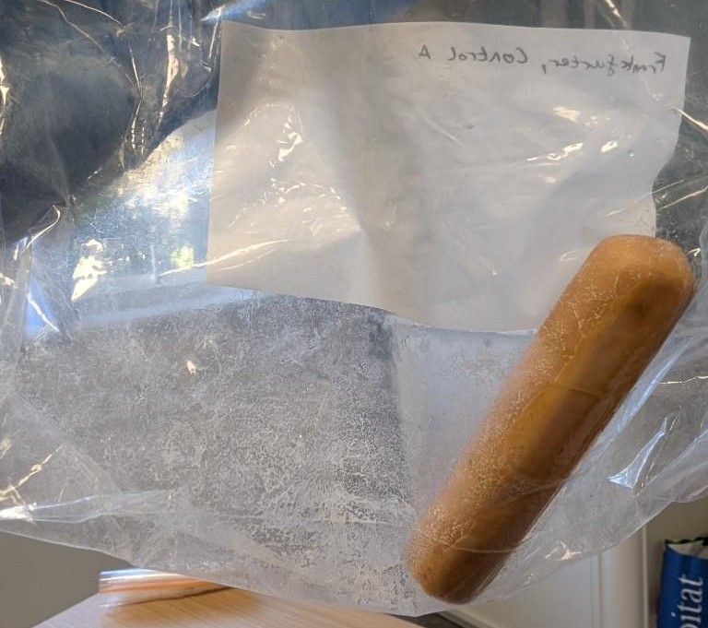
The results of the experiment were varied but in general showed either effective desiccation in the case of the frankfurter, or considerable dehydration in the case of the tangerine. What may appear to be a relatively simple experiment provided some worthwhile insights.

As expected, the most considerable volume and weight loss was seen in the first week. This correlates strongly with the findings of Öhrström et al.; in this experiment the first two weeks of their seven-week drying period saw by far the greatest loss in weight, and the greatest volume loss was seen in the first three weeks. This works effectively as a predictor of what may have happened if this experiment was continued for a similar period. While the frankfurter had already plateaued, the tangerine was still in the process of drying.
Figure 3: Caradoc Ewing, Fatty residue coating the bag (19th March 2026)

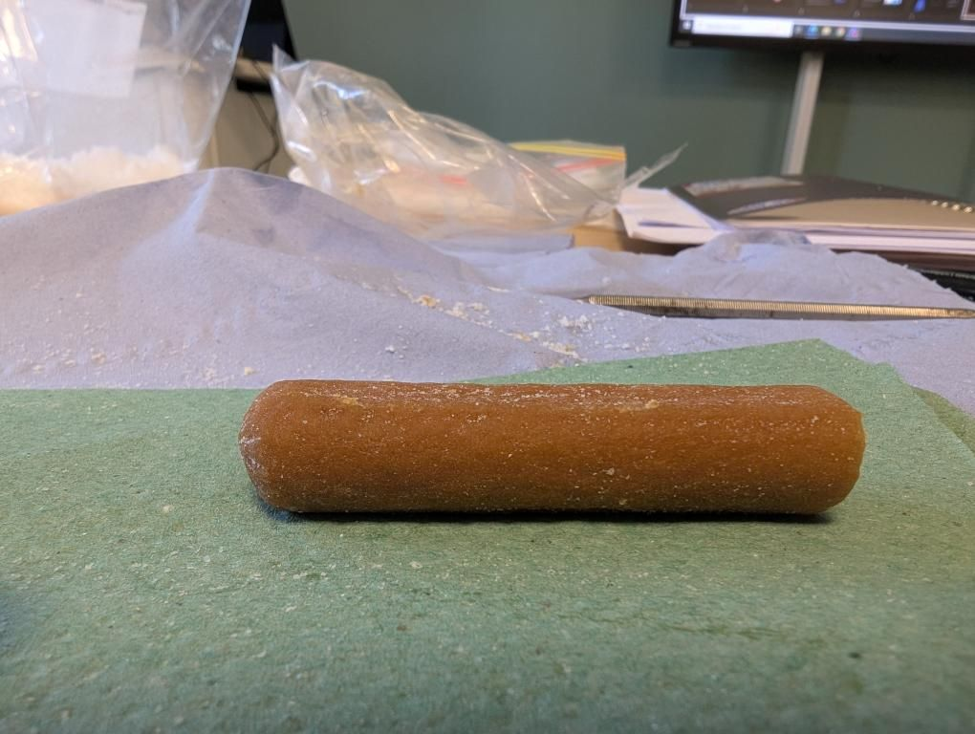
The failure of the tangerine to fully desiccate corroborates part of Herodotus’s account, that stage of evisceration and excerebation . Due to the high water content of the viscera and brain of the human body, it was important to remove it before effective mummification could occur. In Diodorus, the person responsible for the evisceration was known as the paraschistes, literally ‘ripper-upper’, who, once having removed the organs, suffered a ritual condemnation by the other embalmers for his violation of the corpse. The tangerines moisture stopped it from effectively desiccating in the prescribed time period, a longer experiment however and fresh salt being applied may have seen it continue to dry. In this way it can be analogised to the preservation of the organs themselves; once removed and isolated it was much easier to preserve these items.
Figure 4: Caradoc Ewing, Darkening of the skin shown on the frankfurter (19th March 2026).

The salt also proved effective at dealing with the fat content of the frankfurter. Natron salt was particularly effective at breaking down and stabilising the fatty tissues of the body. This was evidently also the case in the experiment. While from as early as the first observation, a viscous fatty residue had built up around the control (fig. 3), the experiment remained hard and dry with no such substance observable. This shows that the salt mixture was effective in stabilising the pork fat. The darkening of the skin seen on many mummies is largely a result of the resin used on them; however, our experiment showed some darkening of the skin also with just the use of salt desiccation (fig. 4).

There were however issues with the experiment, an understanding of the effects of dehydration on the items radiodensity would have been particularly useful as the flesh of the tangerine had shrunk inside the skin and therefore this shrinkage was not adequately represented by the volume measurements. It would also have been intriguing to understand if the mixture of salt used actually made a real difference to the end result of the experiment by means of another control.

4.1 Conclusion

Revisiting the evidence of Herodotus and Diodorus, this report has confirmed the feasibility of the method he describes of desiccation by layering the organic material in salt. Through this experiment it was also possible to see further into reasons why certain actions were described. The evisceration of the body described in the classical sources and also evident on the archaeological mummified bodies themselves, allowed the flesh and skin of the deceased to be desiccated far more effectively. It can be clearly seen in the tangerine experiment how important this was, as the moisture of the flesh was drawn through the skin and left the item soft and moist to the touch.

This experiment however leaves many questions unanswered. The nature of the items themselves meant that analogous links to human tissues had to be made that are not necessarily accurate. It is also not known how, once removed from the salt, these items would be preserved since there was no observation of this phase which is necessary to conclude the items were mummified. This means that the end set of results are far from perfect. As discussed however, they are also not without relevance or intrigue and can successfully be applied to an understanding of the technical process.

Reference List

Primary Source Material

Diodorus Siculus, Bibliotheca Historica, 91 (1st Century BC) in. The Library of History of Diodorus Siculus trans. C. H. Oldfather <http://penelope.uchicago.edu/Thayer/e/roman/texts/diodorus_siculus/1d*.html> [accessed: 28th March 2026].
Herodotus of Halicarnassus, Historíai, (450 BC) in. Livius.org, Herodotus on mumification (1995) <https://www.livius.org/sources/content/herodotus/mummification/> [accessed 22nd March 2026].

Secondary Source Material

Abdel-Maksoud, Gomaa; Eldin, Ezz Abed al-Sameh Al-Shazly; El-Amin, Abdel-Rahman; ‘Damage caused by insects during the mummification process: an experimental study’, Archaeol Anthropol Sci, 3 (2011), 291–308.
Ikram, Salima, ‘Experimental archaeology: from the meadow to the em-baa-lming table’, in. Egyptology in the Present: Experiential and Experimental Methods in Archaeology ed. Carolyn Graves-Brown (Swansea: Classical Press for Wales, 2015) pp. 53-74.
Lucas, Alfred (and J.R. Harris), Ancient Egyptian Materials and Industries, (London: Histories and Mysteries of Man, 1989).
Lunney, Joan K.; Van Goor, Angelica; Walker, Kristen E.; Hailstock, Taylor; Franklin, Jasmine; Dai, Chaohui; ‘Importance of the pig as a human biomedical model’, Science translational medicine, 13.621 (2021) 1-19.
Öhrström, Lena; Tekin, Ahmed; Bierdermann, Phillipp; Morozova, Irina; Habicht, Michaeol; Gascho, Dominic; Bode-Lesiewska, Beata; Imof, Alexander; Rühli, Frank; and Eppenberger, Patrick; ‘Experimental Mummification: In the tracks of the ancient Egyptians’, Clinical Anatomy, 33.6 (2020) 860-871.
Taylor, John H., Death and the afterlife in ancient Egypt (London: University of Chicago Press, 2001).
Wade, Andrew D.; Beckett Ronald G.; Conlogue, Gerald J.; Gonzalez, Ramon; Wade, Ronn; & Brier, Bob; ‘MUMAB: A Conversation With the Past’, Hoboken, 298.6 (2015) pp. 954-973.

Internet Source Material

Buckley, Stephen, ‘Revisiting the Armarna royals’, ESSA, 6th April 2012, https://www.egyptiansociety.co.za/revisiting-the-amarna-royals-part-2/ [accessed: 22nd March 2026].
PANTONE, ‘Colours’, <https://www.pantone-colours.com> [accessed: 29th March 2026].

Appendices

Week: | Week 1 |  |  |  | Week 2 |  |  |  |  | Week 3
Item: | Frankfurter Control (AC) | Frankfurter Experiment (AE) | Tangerine Control (BC) | Tangerine Experiment (BE) | Frankfurter Control (AC) | Frankfurter Experiment (AE) | Tangerine Control (BC) | Tangerine Experiment (BE) | Frankfurter Control (AC) |  | Frankfurter Experiment (AE) | Tangerine Control (BC) | Tangerine Experiment (BE)
Weight (g): | 19.3 | 18.2 | 40.7 | 46.1 | 18.8 | 10.6 | 40 | 38 | 18.0 |  | 10.8 | 39.3 | 32.1
Height (mm): | 16.64 | 16.74 | 42.81 | 43.22 | 16.54 | 13.71 | 40.18 | 39.23 | 15.68 |  | 13.78 | 39.71 | 37.37
Width (mm): | 17.35 | 17.46 | 29.16 | 29.74 | 17.2 | 14.14 | 28.53 | 27.03 | 17.02 |  | 14.44 | 27.18 | 25.60
Length (mm): | 76.12 | 73.65 | 59.49 | 59.45 | 75.6 | 66.9 | 60.05 | 56.28 | 74.73 |  | 67.16 | 58.46 | 57.08
Colour (PMS): | Outside: 472c  Inside: 698c | Outside: 472c  Inside: 698c | Peel: 2575c  Flesh: 2023c  Pith: 4201TCX | Peel: 2575c  Flesh: 2023c  Pith: 4201TCX | Outside: 472c  Inside: 698c  Slimy substance: 4201TCX | Outside: 4261c  Inside: 435c | Peel: 6018c  Flesh: 1485c  Pith: 134c | Peel: 1575c  Flesh: 2013c  Pith: 4201TCX | Outside: 472c  Inside: 698c  Mold: 18-5993TCX |  | Outside: 4261c  Inside: 435c | Peel: 18-1160TCX  Flesh: 2013c  Pith: 4201TXC | Peel: 6018c  Flesh: 1485c  Pith: 134c
Texture: | Soft and moist, inside is spongey. | Soft and moist, inside is spongey. | Soft with give; damp interior. | Soft with give; damp interior. | Considerably slimier. | Hard and dry. | Flesh slightly sticky; edges damp. | Softer than control. | Very slimy and sticky; soft; skin of hotdog at cut shrinking in on itself. |  | Harder but still not solid; skin leathery. | Moist area grown; non moist area was hard; sticky. | Skin is evenly soft.
Description: |  |  |  |  | White thick liquid | Stronger smell; visibly shrunken; darker in colour. | Flesh shrinking, pulling away from pith; darker spots appearing at cut; fermented smell. | Salt full of moisture; flesh in a better condition. |  |  | Salt was lumpy. | Pith separating from flesh; dark lumps particularly in the centre. | Further shrunken flesh; salt very saturated with moisture and has turned slightly orange; lumps in centre also but darker in pigment than control; less even dark spots; only small spot and slither of skin not darkened by moisture.
Appendix 1.

Gomaa Abdel-Maksoud, Ezz Eldin Abed al-Sameh Al-Shazly, Abdel-Rahman El-Amin, ‘Damage caused by insects during the mummification process: an experimental study’, Archaeol Anthropol Sci, 3 (2011), 291–308 (p. 291).
Salima Ikram, ‘Experimental archaeology: from the meadow to the em-baa-lming table’, in. Egyptology in the Present: Experiential and Experimental Methods in Archaeology ed. Carolyn Graves-Brown (Swansea: Classical Press for Wales, 2015) pp. 53-74 (p.53).
John H. Taylor, Death and the afterlife in ancient Egypt (London: University of Chicago Press, 2001) p. 48-49.
Diodorus Siculus, Bibliotheca Historica, 91 (1st Century BC) in. The Library of History of Diodorus Siculus trans. C. H. Oldfather <http://penelope.uchicago.edu/Thayer/e/roman/texts/diodorus_siculus/1d*.html> [accessed: 28th March 2026].
Taylor, Death and the afterlife in ancient Egypt, p. 48-49.
Ibid., p. 49-50.
Ikram, ‘Experimental archaeology: from the meadow to the em-baa-lming table’, p.54.
Herodotus of Halicarnassus, Historíai, (450 BC) in. Livius.org, Herodotus on mumification (1995) <https://www.livius.org/sources/content/herodotus/mummification/> [accessed 22nd March 2026].
Taylor, Death and the afterlife in ancient Egypt, p. 56.
Alfred Lucas (and J.R. Harris), Ancient Egyptian Materials and Industries, (London: Histories and Mysteries of Man, 1989) p. 283.
Abdel-Maksoud et al., ‘Damage caused by insects during the mummification process’, p. 291.
Andrew D. Wade, Ronald G. Beckett, Gerald J. Conlogue, Ramon Gonzalez, Ronn Wade, & Bob Brier, ‘MUMAB: A Conversation With the Past’, Hoboken, 298.6 (2015) pp. 954-973.; Stephen Buckley, ‘Revisiting the Armarna royals’, ESSA, 6th April 2012, https://www.egyptiansociety.co.za/revisiting-the-amarna-royals-part-2/ [accessed: 22nd March 2026].
Ikram, ‘Experimental archaeology: from the meadow to the em-baa-lming table’, p.56.
Lena Öhrström, Ahmed Tekin, Phillipp Bierdermann, Irina Morozova, Michaeol Habicht, Dominic Gascho, Beata Bode-Lesiewska, Alexander Imof, Frank Rühli, and Patrick Eppenberger, ‘Experimental Mummification: In the tracks of the ancient Egyptians’, Clinical Anatomy, 33.6 (2020) 860-871.
Wade, et al., ‘MUMAB: A Conversation With the Past’, p. 954.
Joan K. Lunney, Angelica Van Goor, Kristen E Walker, Taylor Hailstock, Jasmine Franklin, Chaohui Dai, ‘Importance of the pig as a human biomedical model’, Science translational medicine, 13.621 (2021) 1-19 (p.1).
PANTONE, ‘Colours’, <https://www.pantone-colours.com> [accessed: 29th March 2026].
Taylor, Death and the afterlife in ancient Egypt, p. 47.
Ibid., p.56.
Öhrström et al., ‘Experimental Mummification: In the tracks of the ancient Egyptians’, p. 862.
Öhrström et al., ‘Experimental Mummification: In the tracks of the ancient Egyptians’, p. 864.
Taylor, Death and the afterlife in ancient Egypt, p. 53.
Ibid., p.53.
Ibid., p. 56.
Ibid., p.47.

