AutoPark Management System Database Implementation Report.

Student name: Akacha Laidi
Student ID: 2531578
Module: Database Systems
Assignment: Data implementation using Microsoft Access

Content:

- Introduction.
- Scenario analysis.
- Database design.
- Query Development.
- Validation and Testing.
- Conclusion.
- References (IEEE Style).

- Introduction.
This project involved creating a Microsoft Access database for an AutoPark Management System. The purpose of the database is to store and manage information about customers, vehicles, parking sites, parking slots, bookings and payments in one organised system.
After analysing the assignment requirements, I created six related tables and licked them using primary and foreign keys. I then entered sample data and created queries to retrieve useful information, such as available parking spaces and payment records.
The aim of this project was to build a relational database the improves data organisation, reduces duplicate information and allows parking records to be managed efficiently.

- Scenario analysis.
The AutoPark Management System was designed to manage parking information in a simple and organised way. The database stores customer details, vehicle information, parking site details, parking slots availability, bookings and payment records.
The system consists of six tables. The customer table stores information such as name, phone number, email and address. The vehicle table stores vehicle registration numbers and vehicle types, with each vehicle linked to a customer.
The parking site table stores information about different parking locations, while the parking slot table stores the individual parking spaces and their current status. The booking table records when a vehicle enters and leaves the parking slot. Finally, the payment table stores payment details for each booking.
These tables are linked together using primary keys and foreign keys, allowing the database to retrieve accurate information while reducing duplicate data.

- Database design.
This section describes the tables created in Microsoft Access for the AutoPark management System. Each table was designed to store a specific type of information and is linked to other tables using primary and foreign keys.

  - Customer Table
The customer table stores information about customers who use the parking system. Each customer has a unique ID, together with their first name, last name, phone number, email address and home address.
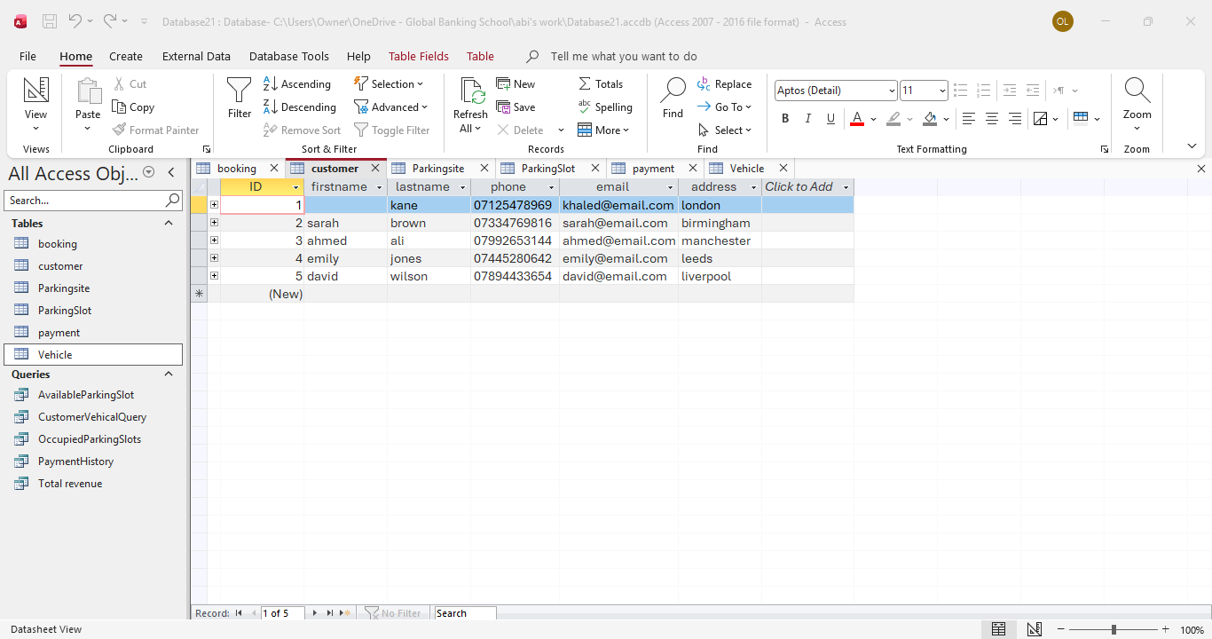

Figure 1: Customer Table

  - Vehicle Table
The vehicle table stores information about the vehicles registered by customers. Each vehicle has a unique vehicleID, a registration number and a vehicle type. The table also includes the CustomerID field, which links each vehicle to its owner.

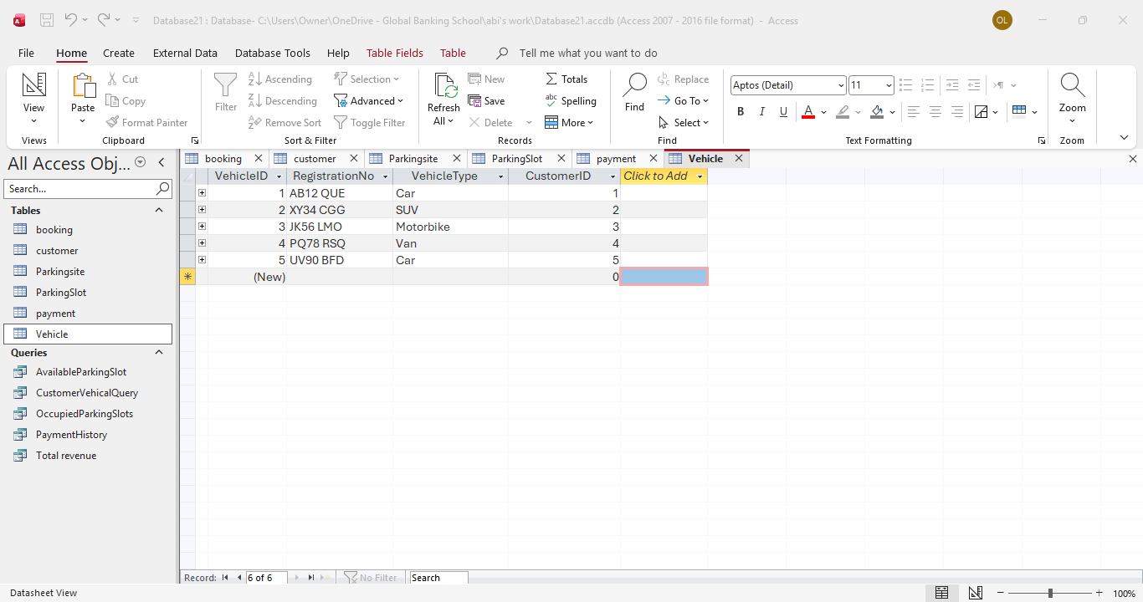

Figure 2: Vehicle Table

  - Parkingsite Table
The Parkingsite Table stores information about the different parking locations managed by the AutoPark Management System. Each parking site has a unique siteID, along with its site name, address and parking capacity. This table helps identify where parking slots are located.

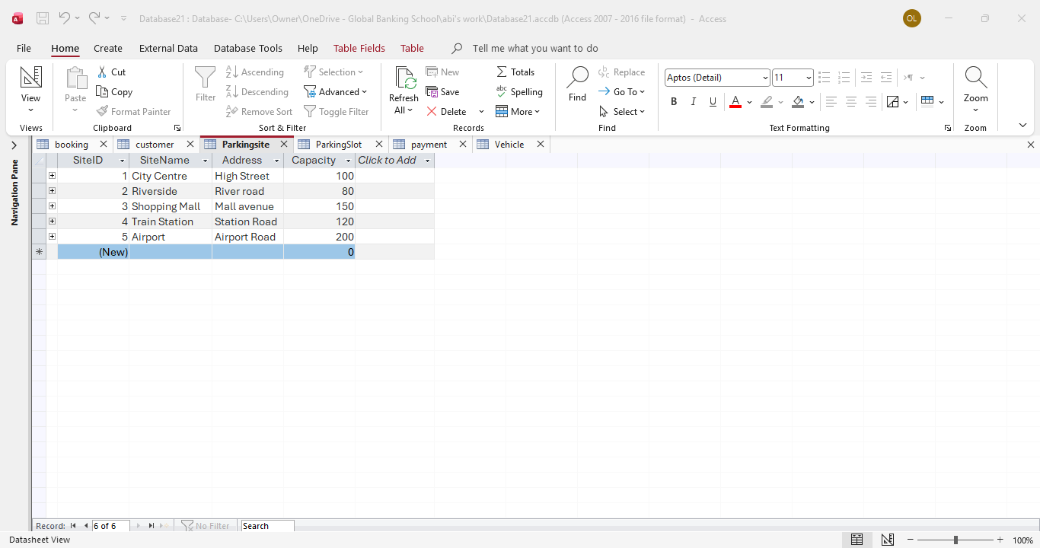

Figure 3: Parkingsite Table

  - Parkingslot Table
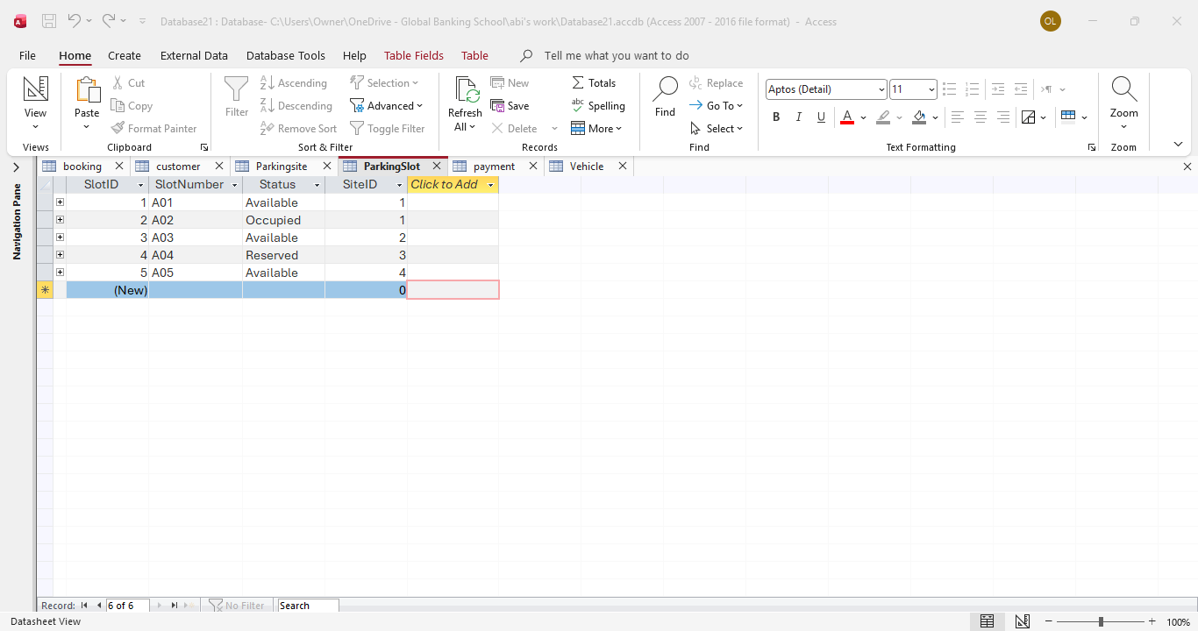
The parkingslot table stores details of all parking spaces available within each parking site. Every parking slot has a unique SlotID, a slot number, a status showing whether it is available or occupied, and a SiteID that links the slot to a parking site.

Figure 4: Parkingslot Table

  - Booking table

The booking table records every parking booking made in the system. It stores the vehicle being parked, the parking slot used, and the entry and exit times. This information allows the system to keep track of vehicle movements.

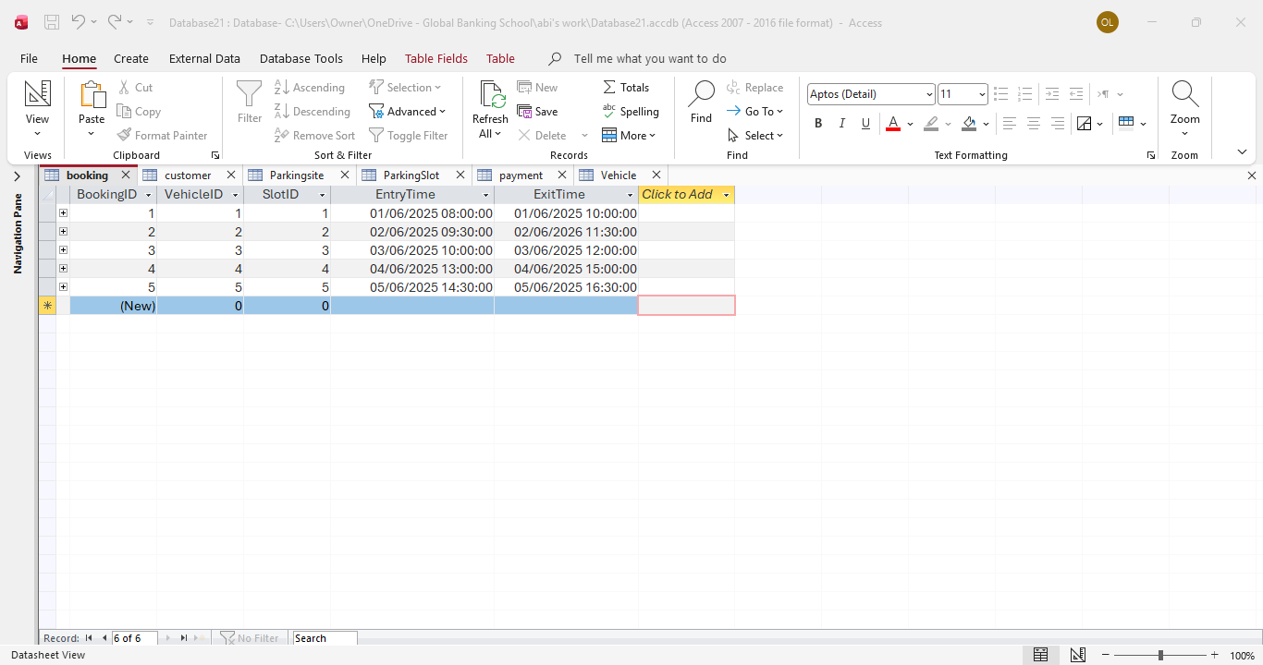

Figure 5: Booking Table

  - Payment Table
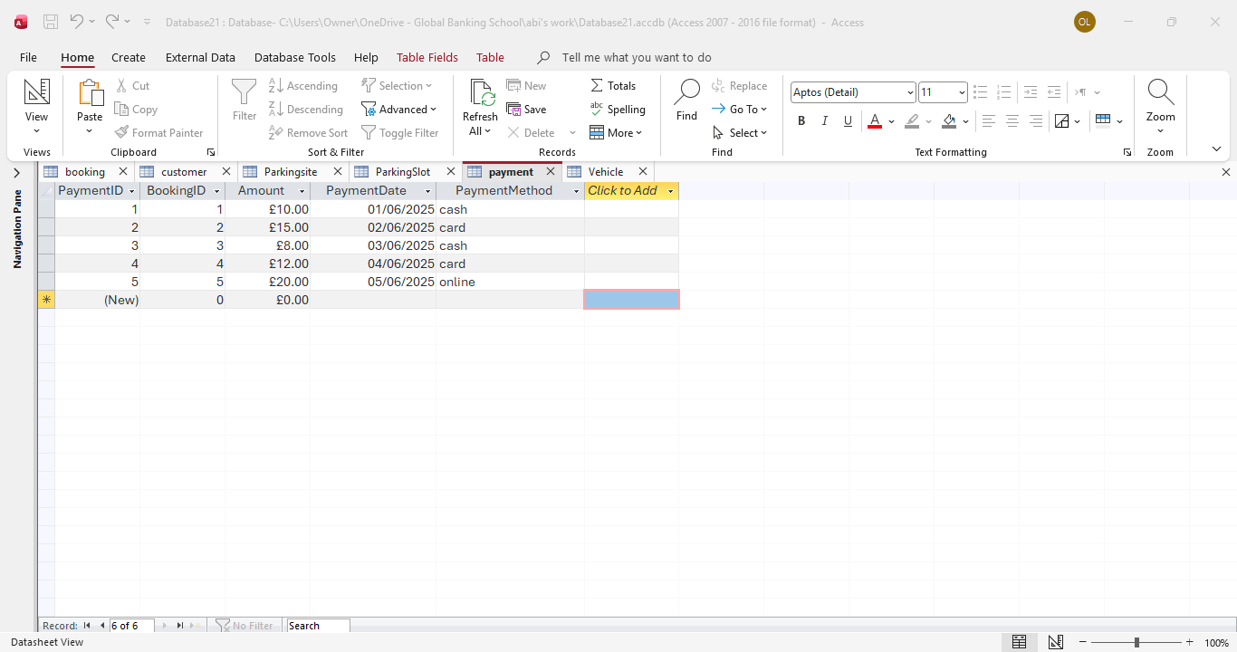
the payment table stores payment information for each booking. It includes the payment amount, payment date and payment method. Each payment is linked to a booking using bookingID.

Figure 6: Payment Table

- Query development.
This section explains the queries created in Microsoft Access to retrieve useful information from the AutoPark management System database. The queries help users search for information, monitor parking availability and view payment details.

  - Customer Vehicle Query
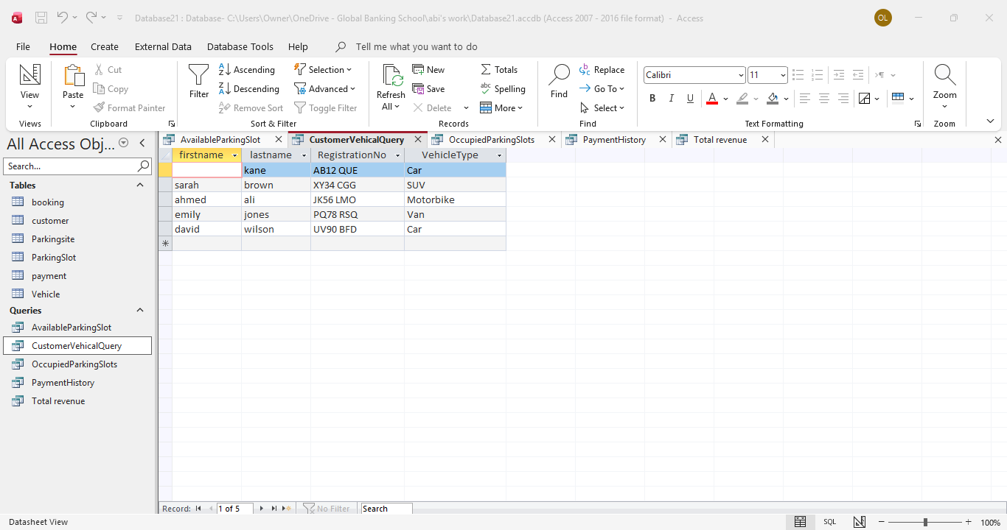
This query displays customer names together with their vehicle registration numbers and vehicle types. It is useful for identifying which vehicles belong to each customer.

Figure 7: Customer Vehicle Query

  - Available parking slot Query
This query displays parking slots whose status is marked as available. It helps staff identify free parking spaces.
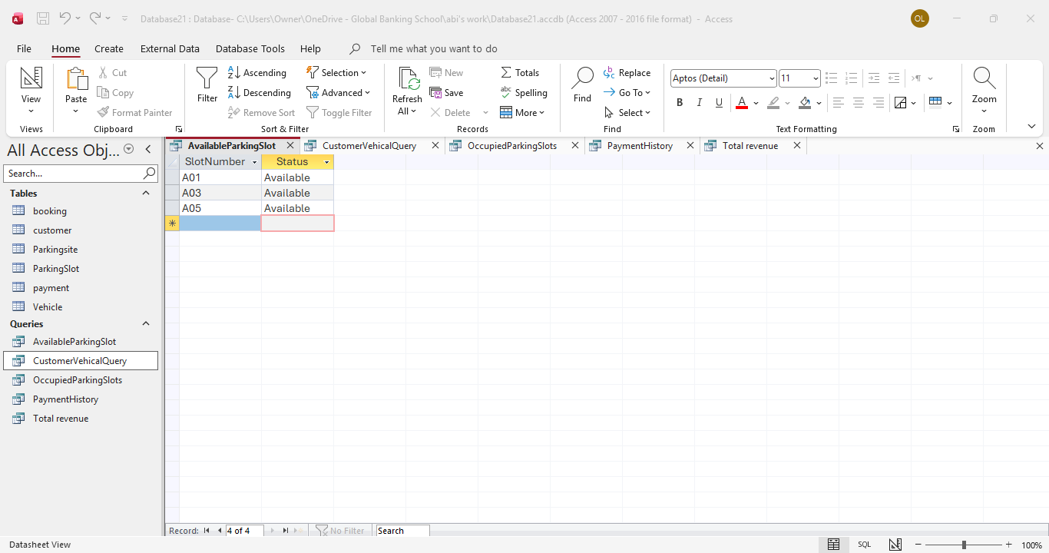

Figure 8: Available parking slot Query

  - occupied parking slot query
This query lists all parking slots that are currently occupied. It allows staff to monitor parking space usage.
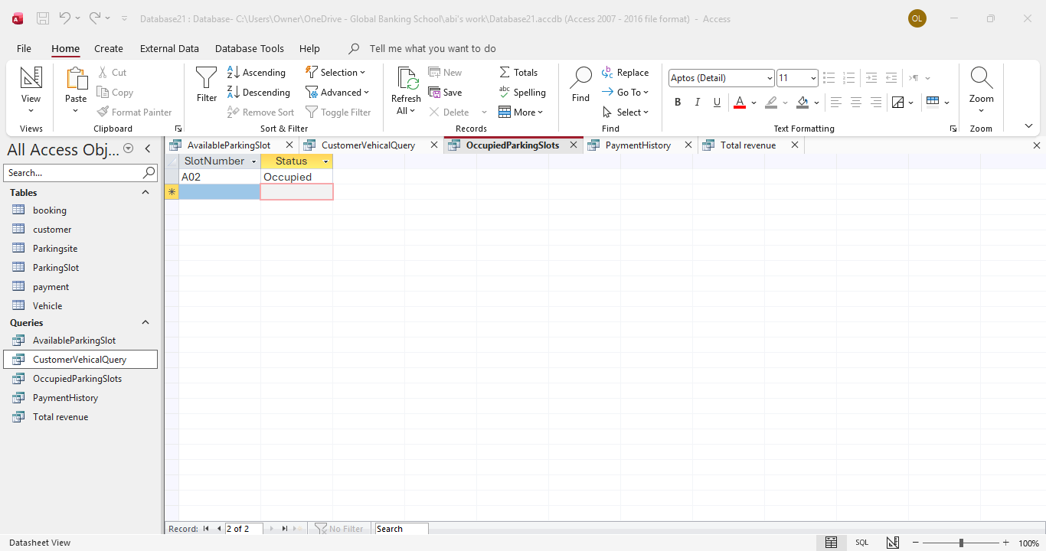
Figure 9: Occupied parking slot Query
  - Payment history query
This query displays payment records, including the booking ID, payment amount, payment date and payment method. It provides a history of all completed payments.
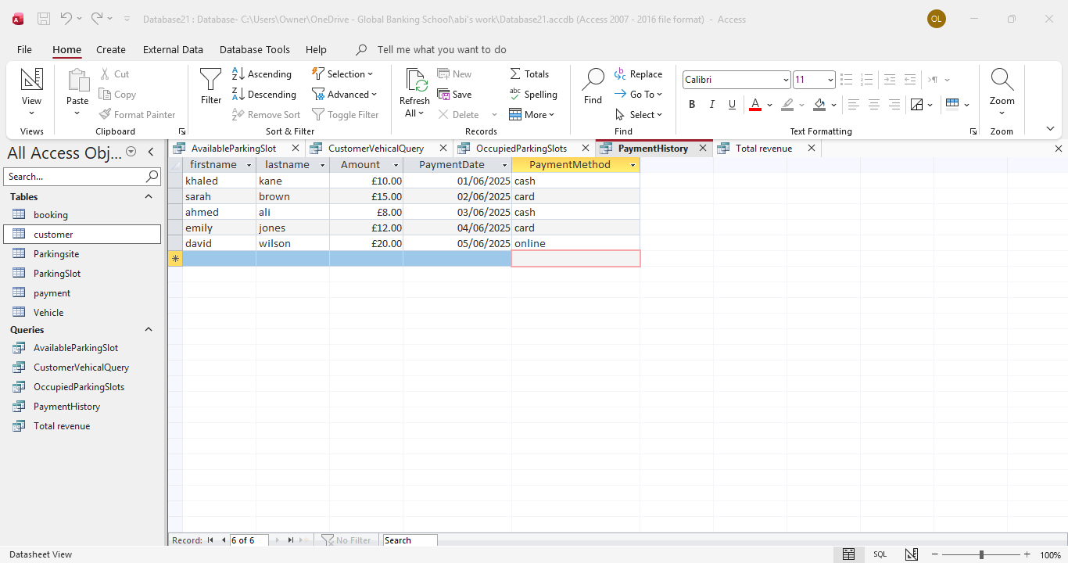
Figure 10: Payment History Query

  - Total revenue Query
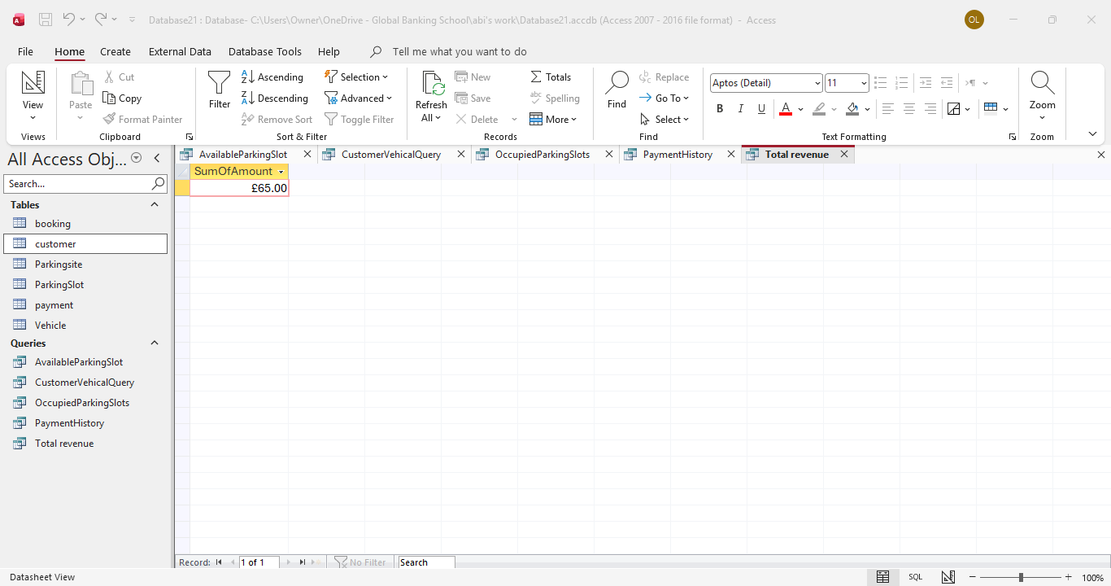
This query calculates the total amount of money received from all payments by using the Sum function on the amount field. It provides a quick overview of the revenue generated.
Figure 11: Total Revenue Query
- Validating and Testing
After creating the database, I tested all the tables, relationships and queries to make sure they worked correctly. Sample data was entered into each table, and the queries were run to check that they returned the expected results.
The tests showed that the database worked successfully. The relationships linked the tables correctly, and all queries displayed the required information without any errors.
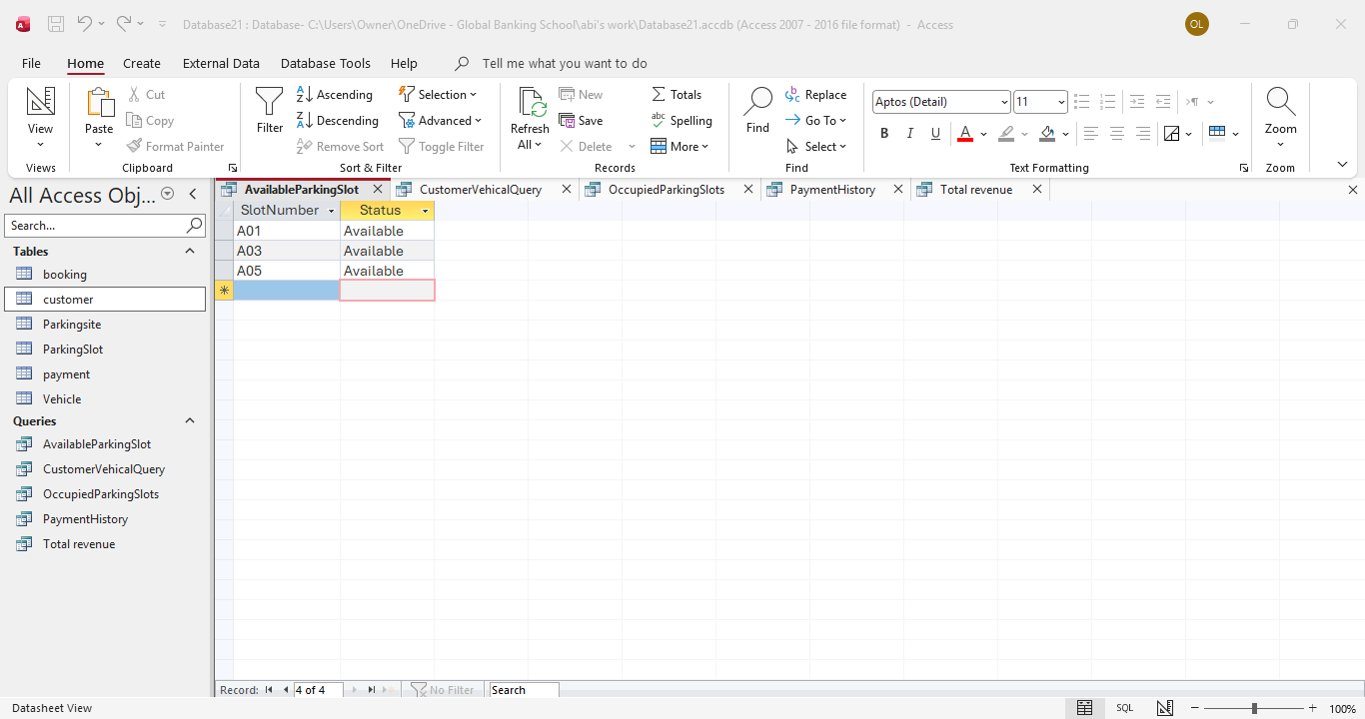
Figure 12: Database Testing Results

- Conclusion
This project successfully developed an AutoPark Management System using Microsoft access. The database was designed to store customer, vehicle, parking site, booking and payment information in an organised way. Relationships between the tables and the queries created allow data to be managed accurately and efficiently. Overall, the project met the assignment requirements and demonstrated the use of relational database design and implementation.
- References (IEEE Style)
[1] Microsoft, Microsoft Access documentation. Available: https://learn.microsoft.com/en-us/office/access/ (Accessed: 20 June 2025).
[2] R. Elmasri and S. B. Navathe, Fundamentals of Database Systems, 7th ed. Harlow, UK: Pearson, 2016.

