Daniel Collier
1908087@student.uwtsd.ac.uk
Abstract
In the following report, I will seek to substantiate my approach to the assignment.
Elemental Cost Plan
ACBA5003

Introduction
As part of Principles of Measurement and Estimating, we have been asked to carry out an elemental cost plan for our assignment portion of the 21/22 module. This was to be based on the UWTSD Swansea Campus Library Building, ‘Y Fforwm’.
Our lecturer Deborah Hughes provided us with a template elemental cost sheet that we were to populate as part of the exercise. She also provided drawings that we were to utilise to retrieve the relevant information about the building from.
The following report highlights my approach to this assignment and how I interpreted the brief to arrive at the conclusions I did.

Information Source
Lecturer Deborah Hughes submitted the initial information to us on February 22 2022, via Microsoft Teams. She also gave us a lecture relating to the information on the same day. As part of the information provided, we received the floor plans for the building, elevations, window & door schedules. The drawings provided on Feb 22 2022 were from Architects consultant Stride Treglown. We also received further drawings that were from Structural consultant JUBB, again via Microsoft Teams. These included various details about the buildings structural nature including the layouts of structural elements and specifications. We also received an elemental cost plan template. This was in an excel format and was populated with formulas which would carry figures through to a summary page.

Interpretation & Approach
Having initially read through the elemental cost plan, I had some queries about the information that was there. This led me to putting a queries list together for lecturer Deborah Hughes. This was sent on March 01 2022. The queries list was as follows:
 | Assignment Queries
1 | No facilitating works required?
2 | 1.1 Foundations - Do we have a make-up of slab? Or just price conc and DPM?
3 | 2.1 Frame - 2.1 states 'composite beam and slab floor', Is this PCC planks or Profiled Steel floor and steel columns encased in concrete? Or do we have a spec? No detail on drawings
4 | 2.2 Upper Floors - Is this separate to point 2.1?
5 | 2.3 Roof - Cost breakdown template states roofs to both 4th, 1st and 3rd floor? Are we to price just the roof to the Fforwm building, and shall we change the template to suit? Are we assuming a spec for this?
6 | 2.4 Stairs & Balustrading - States there is glazed balustrdaing to the roof deck? No roof deck to Fforwm building? Or can't spot on drawings. Does this refer to 1st floor terrace?
7 | 2.8 Internal Doors - Are we to include ironmongery? Door schedule has pack serial numbers… but are we to go into this depth?
8 | 3 Internal Finishes - Are we to assume spec for finishes and state our assumptions?
9 | 5.1 Sanitary Installations - No requirements for baths or panels & trims
10 | 5 Services - Generally - are we able to use information/quotes and pro rata to suit? Or would you rather we use spons?
11 | 8 External Works - Are we to include? No drawings to indicate areas and quantities

The information that was in the elemental cost plan didn’t appear to fit the nature of the building with various headings and items not suited.
I made the decision that I would attempt to stay true to the original template but alter items accordingly as I progressed through to suit.
As part of my Job with Green’s Construction, I have been given access and training with Causeway Estimating Technologies. This is an industry standard software that provides such capabilities as building and structuring Estimates and Bills of Quantities, and it has a measuring tool integrated. This allowed me to upload the drawings provided by Deborah Hughes in order to take off. The measuring tool allows you to calibrate the scale of the page to provide accurate measuring.
Once I had the drawings uploaded I proceeded to work my way through the headings and took off from the drawings the relevant areas. Please see below for example:
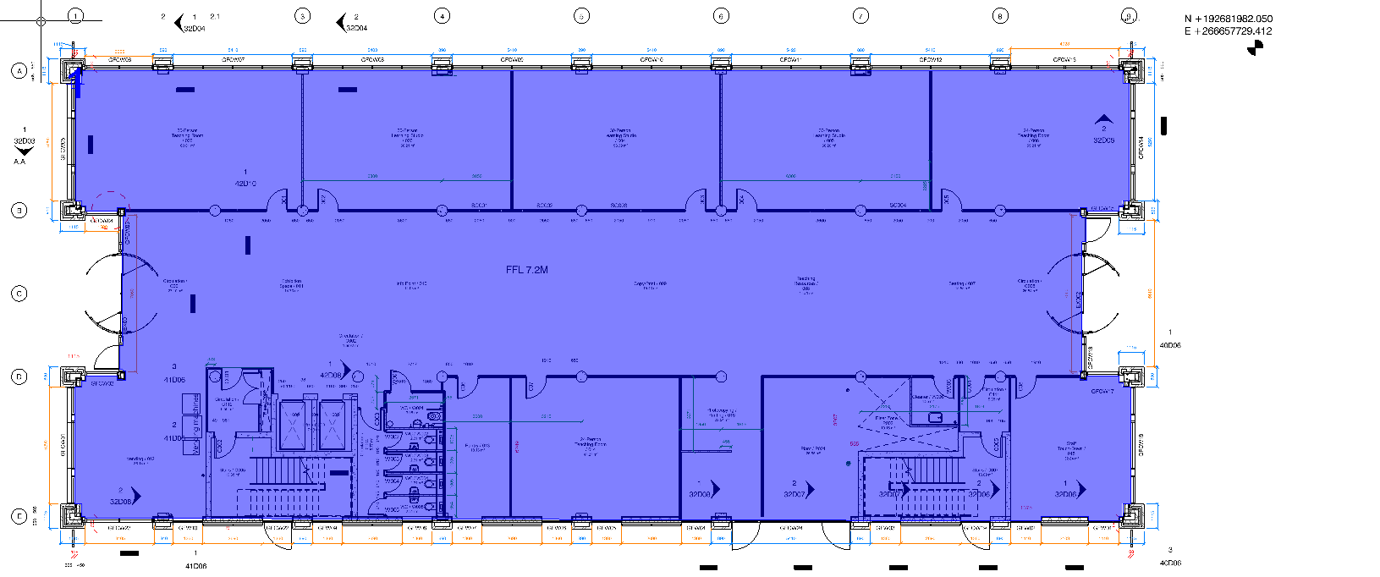
The area highlighted in blue is the area that has been measured. This example is for the GF gross internal floor area. I applied this principal across all measurements required. I was also able to use the information generated from the measuring tool to format a dimensions sheet. Please see example below:
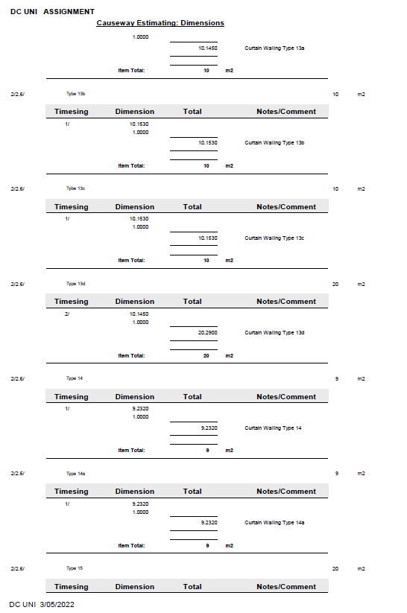

Once the quantities for each item were distinguished, I referred to the elemental cost template for the applicable unit of measurement for each item. Once I started to find applicable rates within Spons, I was able to determine whether the unit of measurement provided within the elemental cost template was suitable or needed to be altered. These were altered as I worked through the document.
The prices were built up by using the applicable rates found in Spons Architects 2020 for each item. Sometimes it was suitable to use the single rate specified. On other occasions it was necessary to build up what is called a ‘composite rate’. This refers to a series of rates for different (but applicable) items that are amalgamated to cover for all eventualities for the overarching item heading. I would take each individual composite item, add the Spons rate together and multiply it by the quantity attained for the item.
I am confident that I have well covered the items required with my approach and have demonstrated on the notes of every item where my information has been derived from.

Conclusion
Once I had entered the relevant quantities and rates into the elemental cost template, it self-populated the summary page which gave a final forecasted sum amount of £4,744,065.
For comparison, within Spons there are Building Cost Models which specify general cost for types of buildings. The most suitable model provided was for a ‘Secondary School Block’. This was based in the Southeast. Once I divided the overall footprint of that building back through its total cost, it gave a build cost of £2,276.50. My findings on the Fforwm cost exercise gave a total of £1,800.40. This is a cost difference of approx. £576/m2.
In my opinion, some of this can be attributed to the location factor and the expense difference that provides. Another portion could be attributed to economies of scale. The two buildings were vastly different in size, however it was the most suitable model I could find in Spons. The last portion that could be attributed to the difference is the fact that no facilitating works were carried out as part of our assignment.
I am confident that the two models would have been closer in comparison should the above points have been apart of the workings.

