TASK 2
PROFESSIONAL CAREER DEVELOOPMENT (REPORT)

STUDENT : ALESSIO MANIGRASSO

STUDENT ID : (2019791)

MODULE :PROFESSIONAL CAREER DEVELOPMENT

MODULE CODE : (BMSW4005_LON)

Table of contents

Introduction 2
Personal SWOT Analysis 2
Action Plan 3
Personal reflective model 4
Recruitment and selection 6
Conclusion 8
References 9

Introduction
The study was conducted to get an personal reflection based on the task 1 role play.

Personal SWOT Analysis
Strengths:
Experience: The first strength of mine can definitely be my experience in the related field. I have worked in a reputable company as a motor mechanic that has a well-established reputation for over three years. Hence, I have professional and practical experience regarding the job role.
Grasp of knowledge: As it is mentioned, I have been in the related field for some years. Thus, these practical experiences have helped me to obtain in-field knowledge throughout the years. In this regard, it is also worth mentioning that I have completed my higher school education. And after that, I took a learning session from a motor mechanic school that goes by the name Automotive Training Centre. Later, I completed my diploma in automotive academics from the reputed Newcastle College Automotive academy Helped me immensely to establish my operational goals. In addition to this, I have participated in a six months workshop at Tetbury Motor Centre as well. After that, I also joined Staffbase Recruitment in order to gain more enhanced knowledge related to the field.
Communication: Another strength of mine is my ability to communicate with others. I have always believed that communication and team play is the key to achieving the combined organizational and as well personal goals.
Weakness:
Decision making: My key weakness is my decision-making. Despite the fact that I have been in this field for a good three years span, I still have not been able to develop my decision-making skills which restrict me from taking action quickly.
Nervous: Due to my poor ability of decision making, I often cannot act quickly. Herein, this weakness of mine tends to get on my nerves, and I often get nervous in certain scenarios.
Opportunities:
Improving patience: I have been working on my patience in order to improve my decision-making and problem-solving skills. In this regard, it would be helpful to act more quickly and gain knowledge throughout the process of my professional career in order to become a better employee in the future.
Development in the operational output: The experiences in both professional and academic fields are helping me to gain professional development in order to produce better operational output.
Threats:
Multitasking: I have been working and exploring the same automotive field as a mechanic for years now. However, this practice did not allow me to explore any other criteria of the automotive industry, which affects my ability as a multitasked and threatens my versatility.
Areas of Improvement: In this regard, I have to work on my decision-making skills. It would help me to work fast in the given situations. In this regard, it is worth mentioning that it would help me to become better as a professional, and by doing this, I would reach the objectives that I want to accomplish. Another thing that I need to work on is my patience. I lose my patience whenever I cannot decide what to do, and thus it makes me incompetent in subtle scenarios. In this regard, I have to become more patient in order to study a situation and learn patiently from them.

Action Plan

Personal development goals | Milestones | Key activities | Resources | Target time
Improving decision making | I would feel accomplished if I could get better at decision-making. | I am learning and applying various effectiveness models. | Books and blogs from the internet. | Two months
Improving nervousness | I would feel accomplished if I could stay calm in difficult situations and solve them on my own. | I am doing meditation and exercises. | Books and vlogs from the internet. | Two months
Improving patience | I would feel accomplished if I could stay patient in the work field and appreciate the learning process. | I am doing meditation and exercises. | Books and vlogs from the internet. | Two months
Working on multitasking | I would feel accomplished if I could prove my abilities in different areas other than mechanical engineering. | I am taking courses from various online websites.  I am taking virtual internships in different fields. | Books and blogs from the internet.  Linkedin | Four months

Personal reflective model
Gibbs reflective cycle: Gibbs reflective cycle was first introduced by Graham Gibbs in 1988. It was developed in order to provide structured learning experiences for professional and personal effectiveness. Gibbs's reflective cycle is responsible for offering a framework in order to examine the experiences a person gains in personal and professional life (Adeani et al., 2020). In this regard, it is worth mentioning that the cyclic nature of the Gibbs reflective cycle tends to provide well-repeated experiences. In this regard, the cyclic nature of the Gibbs reflective models allows an individual to achieve learning and planning as per their experiences by evaluating what went right and what did not. Herein, Gibbs's reflective cycle would be an excellent self-reflective model in order to examine my personal strengths and areas of further improvement as per the SWOT analysis.
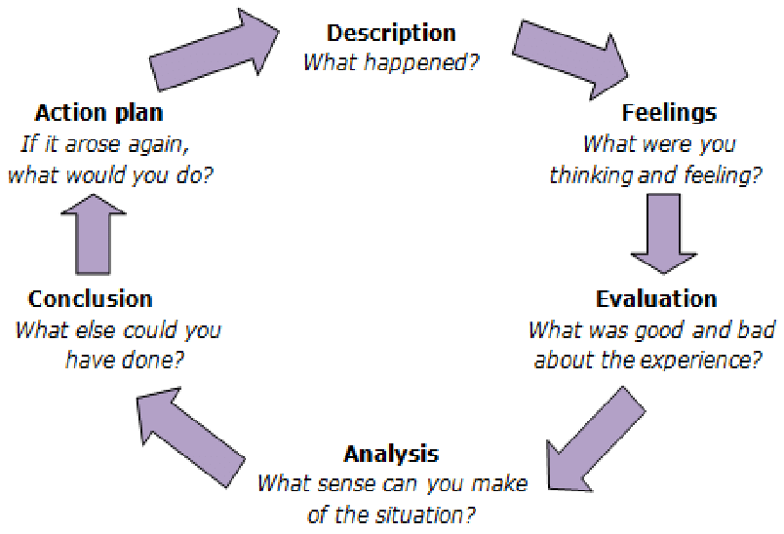
Figure: Gibbs Reflective Cycle Model
(Source: Akhter, 2015)
Gibbs reflective model consists of six fundamental components, i.e., description, feelings, evaluation, analysis, conclusion, action plan.
Description: The first component of Gibbs's reflective cycle is a description of the experience. This component focuses on the description of an individual's experience. I am a mechanic and have both professional and academic experience in the subject matter. However, I am not confident in my decision-making skills and tend to get nervous in certain scenarios.
Feelings: The second component of Gibbs's reflective cycle is feelings on the experience. In this regard, I have been in the mechanical field as a professional for a good three years and have enjoyed the experience thoroughly. I have worked full time after taking various diploma courses and participating in workshops. Due to these positive experiences, I am keen to work in this field further in my career.
Evaluation: The third component of the Gibbs reflective cycle is the evaluation of the experience. In this regard, this component derives both the good experiences and the bad experiences. The good experience is definitely regarding the job profile. I have always been keen on automobiles and wanted to become a mechanic. However, the bad exp[eirence regarding the previous job was the pressure of the job. However, if the job is appealing enough, the pressure of the job is completely bearable. However, the sourest part of the previous job was not getting paid on time.
Analysis: The fourth component of the Gibbs reflective cycle is an analysis of the experience. In this regard, the experience regarding the job was both good and bad, as it was evaluated in the previous segment. Although I have always felt enthusiastic about the job role that I was in the previous company, I had issues with my patience and decision-making. It was the reason which could have harmed my employability. In this regard, it is also worth mentioning that the work pressure and the fact of not getting paid on time was acting as a demotivating factor and was harming my professional career. However, I have been working on my weaknesses in order to become better professionally for my future prospects.
Conclusion: The fifth component of Gibbs's reflective cycle is the conclusion of the experience. On the basis of the experience, it can be concluded that the experience was still really great, and the main positive side was the learning lessons that I have gathered throughout the years. However, I could have performed better regarding my decision-making skills. Thus, I am always looking forward to learning further and looking forward to what the future opportunities bring for me.
Action plan: The sixth component of the Gibbs reflective cycle is the action plan as per the experience. Herein, I have developed an action plan in the previous segment in order to work on my weaknesses in order to become more proficient as a professional employee.

Recruitment and selection
My experience regarding recruitment and the selection process will be evaluated by Kolb's reflective model. It would be helpful to gain an effective idea of my own experience. The experiences will be reviewed, analyzed, and evaluated in three stages in a systematic order.
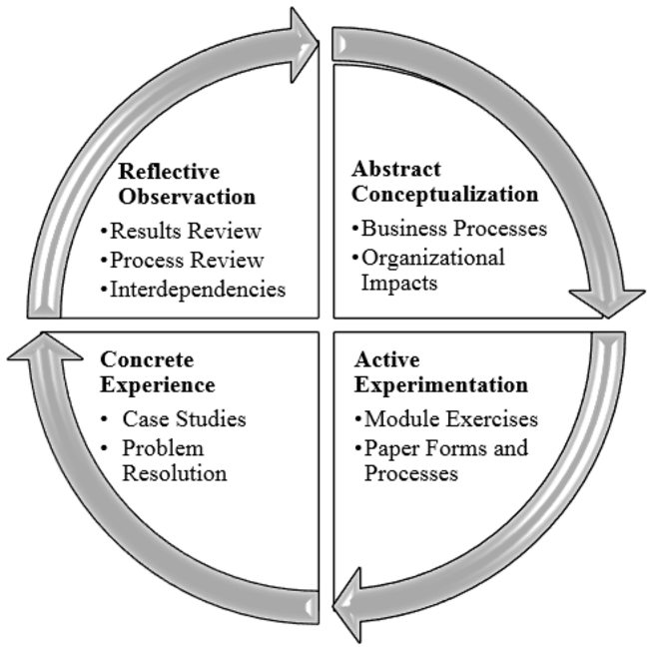
Figure: Kolb’s Reflective Cycle
(Source: Angolia and Pagliari, 2016)
There are four fundamental components of Kolb’s reflective cycle. These are reflective observation, abstract conceptualization, concrete experience, active experimentation.

Concrete experience: As per task 1, a role-play was arranged, and everyone had to perform in a pair. In this regard, I felt that I had no issues with working with another individual in the professional field, and I tried to learn from my fellow colleague throughout the process. I felt thrilled to learn what I possess as a professional in the mechanic field, and I was always keen to learn throughout the process. However, in this regard, it is worth mentioning that the process also helped me point out the key weaknesses that I felt regarding the job role. As I felt in the role play, that I have adequate knowledge regarding the job role due to my past experience in both academics and the professional field. I also observed that I have good communication skills as I felt no hesitation while discussing the topic with my partner, and I was eager to convey my knowledge on the related field with my partner.
Reflective observation: The second component of Kolb's reflective model is about Reflective observation. The first question I faced in task 1 was how I got to know about the job. I also have to describe why I feel that I am competent for the job role. I shared my strengths and weaknesses in the most honest way possible. However, the main hesitation I faced when they asked me was how I would react in a difficult decision-making scenario. In this regard, as was suggested in the SWOT analysis previously, I am not so good at decision-making, and I get nervous in harder situations. But I still tried to stay as composed as I could and gave them an honest answer. Fourthly I was asked how my skills can help the company in order to grow more. In this regard, it is worth mentioning that I felt confident about my existing skills as a mechanic, and I stated that due to my experience in the related field, I could provide the best output for the company.
Abstract conceptualization: In this regard, the experience I gathered throughout the tasks helped me to get a better idea about what I could have done better. I felt that my decision-making skills needed to be improved. It would help me to get better in managerial spots and climb the ladder of my professional career. However, my patience needs to be fixed first in order to get to that point.
Active experimentation: As per my weakness regarding my professionalism, I have developed an action plan in order to excel in the related field. In this regard, I have developed an action plan in order to improve my weaknesses, and I am working as per the action plan.

Conclusion
It can be concluded that the study has helped me to gather my key strengths and weaknesses. After evaluating the study, it has been assessed that although I have practical knowledge of the related field, I still have to improve my decision-making skills and patience related to the professional field. In this regard, the developed action plan will be helpful to address these issues and achieve the goals I seek as a professional.

References
Akhter, Nasreen. (2015). Development of a Semi Standardized Achievement Test of Education for Intermediate Level. Journal of educational research. 18. 1 to 19.
Adeani, I.S., Febriani, R.B. and Syafryadin, S., 2020. USING GIBBS’REFLECTIVE CYCLE IN MAKING REFLECTIONS OF LITERARY ANALYSIS. Indonesian EFL Journal, 6(2), pp.139-148.
Angolia, Mark & Pagliari, Leslie. (2016). Point-and-Click Pedagogy: Is it Effective for Teaching Information Technology?. Journal of Information Technology Education: Research. 15. 457-478. 10.28945/3546.

