DS 1 Template

My Screenshots/Photos

Screenshot/Photo 1
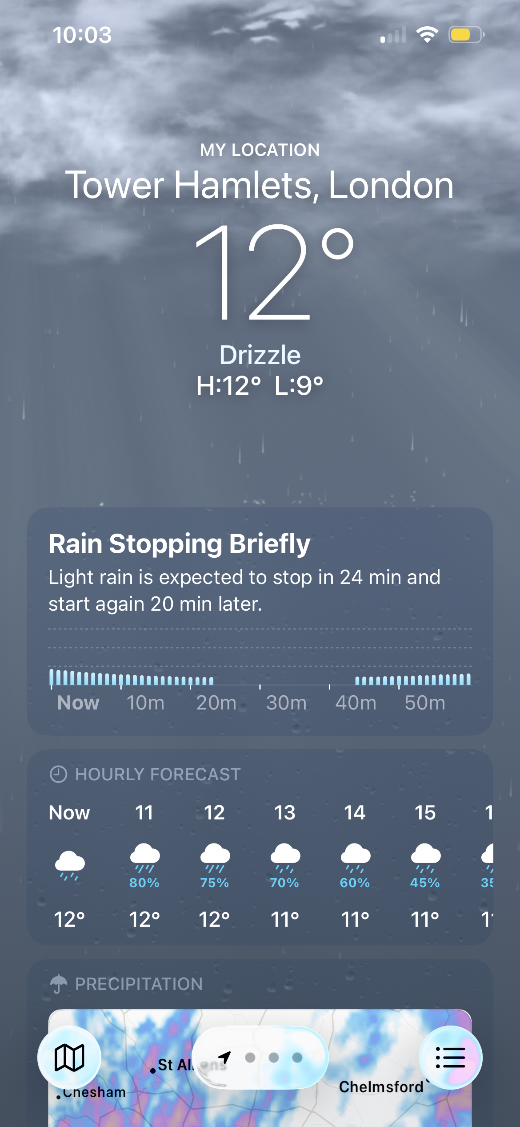
I quite often use the weather app on my iPhone to check the forecast to help me decide what appropriate outfit to wear for my day. This helps a lot with daily life schedules and feeling comfortable.

Screenshot/Photo 2
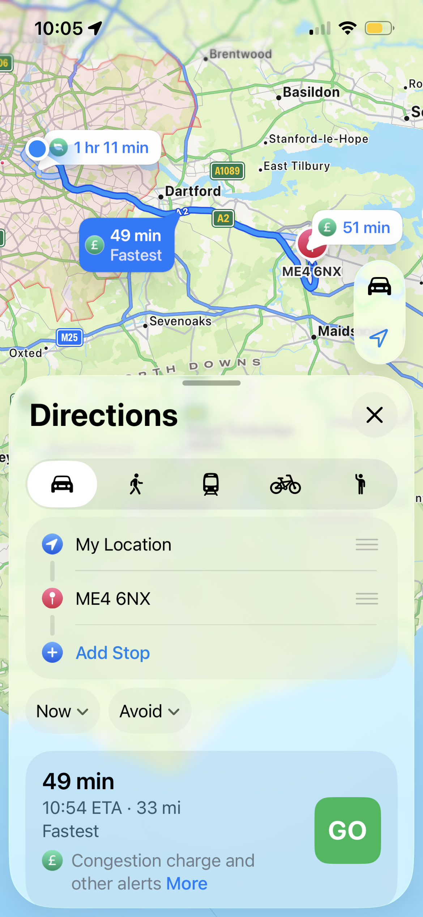
Maps on the iPhone, I find is a very popular and used app to help others and myself get from A to B. If we do not know where we are going or how to get somewhere we have never been before most people these days will not use a hand map, commonly everything is digital now and when travelling somewhere the ratio of people would use the maps app to do this.

Screenshot/Photo 3
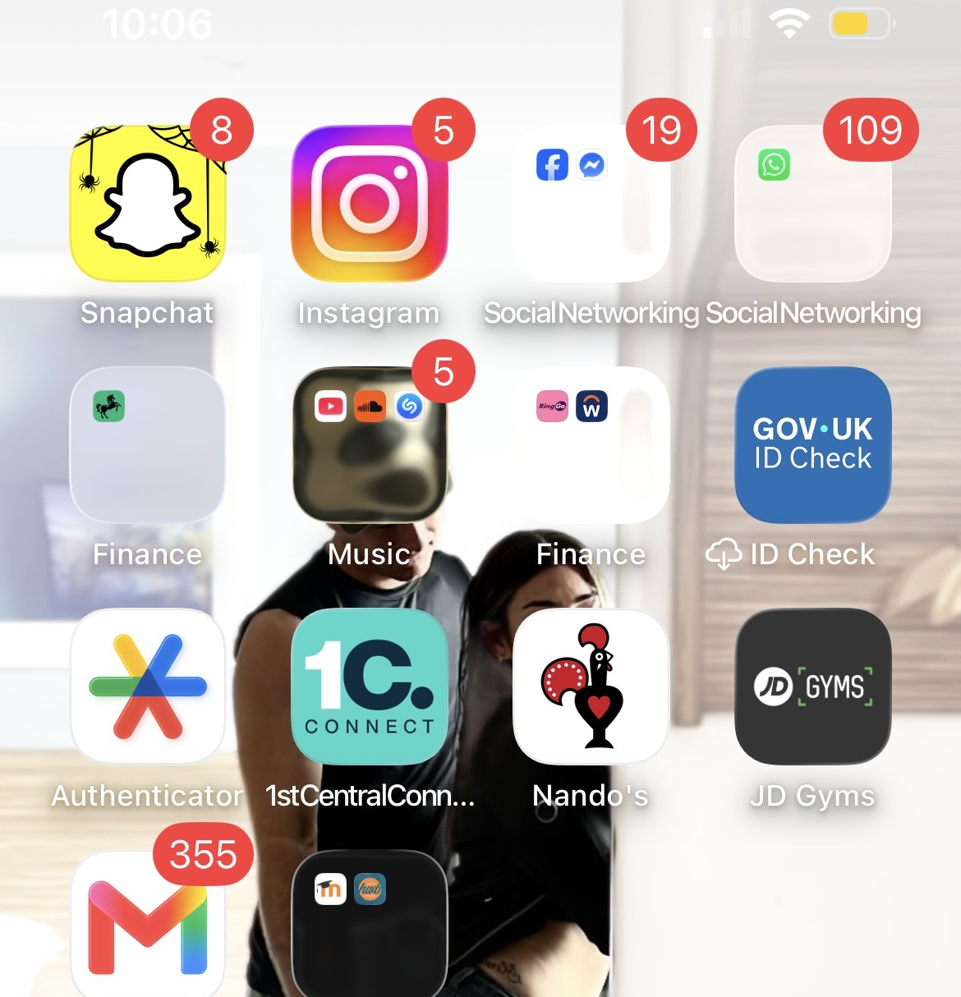
This screenshot particularly shows my used social media platforms, that shows my digital skills knowledge. How often does one use these apps? There are 4.8 billion social media users worldwide. I got these statistics from ‘The University of Maine’ website as a reliable source. These digital skills help people promote small businesses, communicate, finding contacts, updates, information and much more.

Screenshot/Photo 4
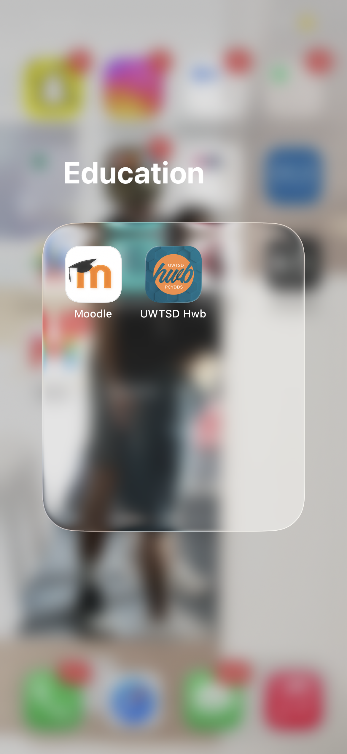
I use my digital skills when using the UWTSD app and Moodle for my University work. These are required apps that need to be used as its where we upload our assignments and find key information for example, our timetable, which tells me what time my lecture is and what classroom I am supposed to be in.

Screenshot/Photo 5
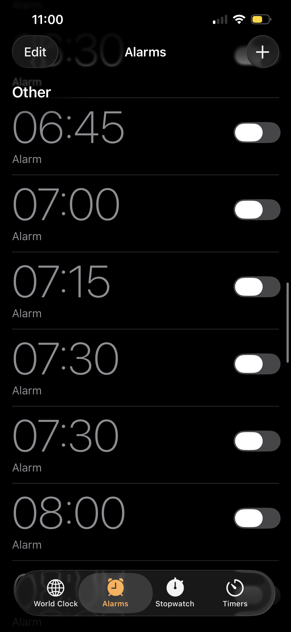
The alarm app is an important digital skill that I use because this is what helps me get up in the morning, helping me be punctual and not miss out anything in my lessons. This app is also used for other reasons other than being on time for university. For example, this could be for work life or appointments.

Screenshot/Photo 6
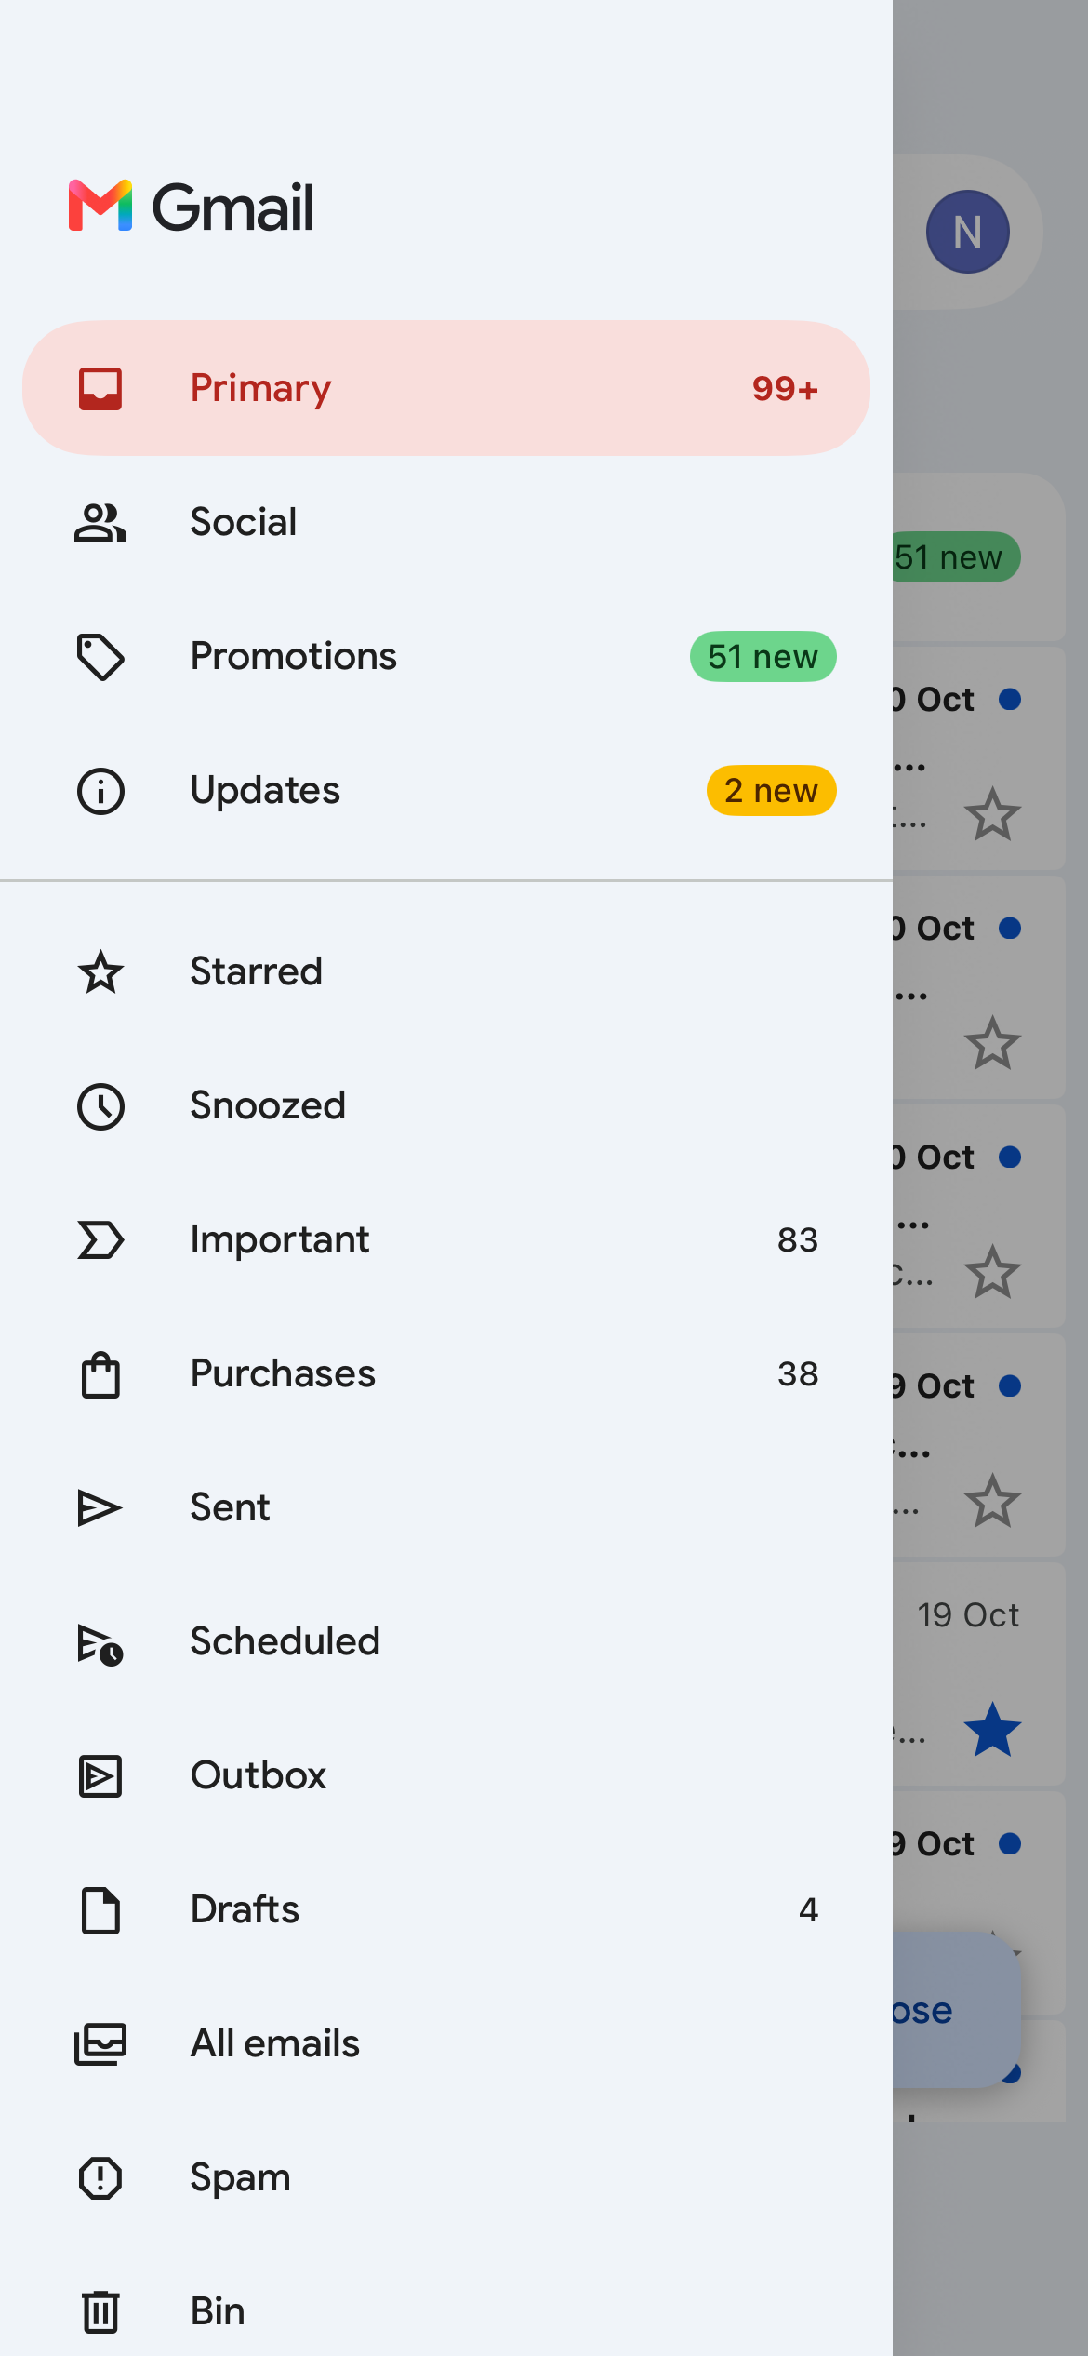
My Gmail account is another key digital skill I use in daily life because I use this to access important emails and private information. Aswell as your phone number, your email is a main source to use when keeping valuable information safe for example, a onetime verification code.

My Short Reflection
I use digital tools to help support me with day-to-day life, by accessing all the information and support I need. I feel confident when I need to find a specific source by using the correct digital media platforms. I would like to improve on using the ‘UWTSD app/website’ as this is a new media, as a student I am new to using however, I feel this won’t be hard for me to adapt to so I do feel confident about this overall. I often use these tools every day, when going to the gym, going to work, travelling and more. Digital skills are important for me because the way the generation is now and how much things have changed/developed, I would struggle a massive lot without these digital tools.

​​

