Marketing essentials
M4x01916
Genny Angelozzi
1815066
Lecturer: Dale Clark
Written Assignment Part 1

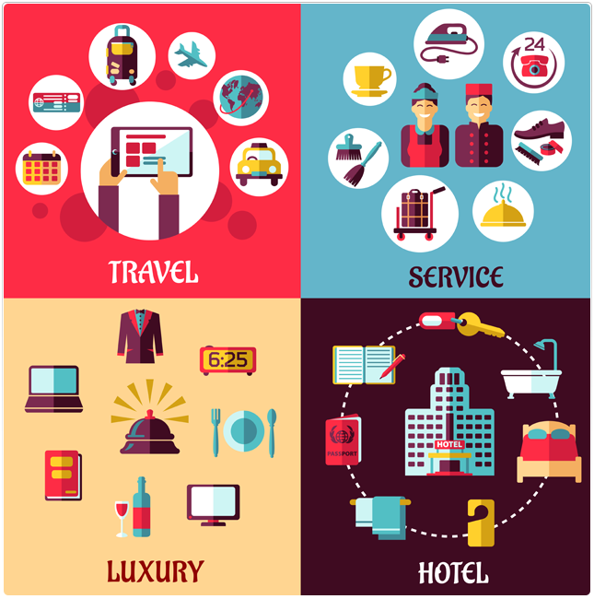

Content Page

Introduction ………………………………………………………………………………….p3

How the company is using MiS and its components as a tool for marketing,information gathering and communication……………………………………………………………..p4

Conclusion……………………………………………………………………………………p7

References…………………………………………………………………………………..p9

Introduction
A marketing information system (MIS) consists of people, equipment and procedures to collect, classify, analyze, evaluate and distribute in necessary, timely and accurate information to marketing decision makers. The MIS starts and ends with the marketing managers. The MIS interacts with managers to assess information needs, generate the necessary information through internal surveys, marketing intelligence and the marketing research process. Finally, MIS distributes information to managers in the correct form and at the right time, to help in planning, implementing and controlling marketing
Information systems are one of the important means used in marketing. Information systems can link the organizations’ policy and organize them for facilitate the marketing decision towards product and customer(Pride, 1989). The success of marketing administration is based highly on the availability of internal and external information. Every organization must organize and distribute the information for marketing managers and study their needs to provide them with the needed information.
In any business, marketing strategy is fundamental to building a brand, attracting new customers and maintaining loyalty. In The hospitality industry is the same. The key is the customer loyalty, marketing managers and executives spend a lot of time and resources to building brand and creating campaigns. These marketing include both print and digital collateral that target former guests while also attracting new clientele.
As already mentioned MIS is part of a data gathering process that imply data collection routine and systematic data collection procedures.For example a hotel manager may choose to collect data by means of a zip code analysis of guest registration information to determine the geographic profile of the guest of a hotels. This systematic information gathering is not just for one specific question but is part of an general system designed to monitor the degree of marketing success.
In this report we will talk about the marketing information system related to the hospitality industry, and more specifically we will talk about the Marriott International Hotel company that is an American multinational that manages and franchises numerous accommodation facilities.

How the company is using MIS as a tool for marketing,
information gathering and communication

"A marketing information system is a continuing structure of people, material and procedures to gather, sort, analyse, evaluate, and distribute ,timely and accurate information for use by marketing decision makers to improve their marketing planning, implementation, and control". Kotler, P., (1988)
The four main components of Marketing Information System (MIS) are:
• Internal Database: supplies reliable internal information of the company
• Marketing Intelligence System: gather the information from the external sources
• Marketing Research System: try to solve specific marketing problems of the company
• Marketing Decision Support System: are tools which helps marketing managers to analyze data and have better marketing decisions
Marriott operates hotels under fourteen different brands, so with a numerous accommodation facilities. For this reason, because of his vastness, it needs a support of information systems.
One of the most uses of information systems by Marriott International is its focus on technology initiatives to drive the company’s sales.
To achieve this goal the company has realized a customer-relationship management package and engaged in a plan to upgrade its central reservations, revenue and property management systems, allowing customers to view and book rooms online. An area where Marriott International uses information systems is through its many in house catering departments. The company started a system of the ChefTec recipe management, food costing and inventory system, a Windows-based platform. The operator has versions of software in different languages. Marriott also added its own glossary of culinary terms, optimum cooking times for off-used foods and a year-round planning feature, which helps chefs with seasonal menus; for example it informs them that March is the bestmonth for asparagus.
Taking advantage of ChefTec’s core and advanced features, Marriott International can organize inventories based on bids from multiple vendors; search for recipes by ingredients, categories and names; allege photographs and video files to recipes.
The information, including booking and reservation data, be shared quickly with all other properties, but it must also be accurate, and in line with the company’s overall strategy.
For the accounting, the company is trying to launch the Xcellenet system that allows executives to download software from the head office and digitally transmit accounting reports via telephone lines.
As regards human resources, the industry is making advanced technologies available for training and recruitment, such as the alexus system, which is a system that stores computers electronically, to which company staff can access via the internet.
When the company looks for staff, and must hold a position, the Alexus system automatically orders all the curricula to select the most qualified and deserving ones.
Another information systems on Marriotts business is the providing ‘free-to-guest’ internet access technology on the hoteliers’ revenue. The guests are taking advantage of the high-speed Internet access service for more than just electronic-mail. They are accessing digital music and other types of digital content, and Marriott is responsible for the costs of this.
In addition to field research and guest feedback, Marriott International also offers members of the free Marriott Rewards loyalty program a dynamic and personalized mobile experience. The hotel group the new version of the Marriott Mobile app in five languages, currently available for iOS and soon also for Android. Users will have new and expanded digital features, personalized travel content, a single navigation button and a login screen with scrolling content. The new Marriott Mobile app breaks the mold of the typical mobile applications of the hotel industry, which generally include a booking system and generalist content. The app adapts in a dynamic and personalized way to the user, who will have different contents and functions based on the stage of the trip in which he is: planning, departure, transit, arrival and stay at the hotel.
Marriott’s marketing in the last years has grown to consider technology as an investment rather than an expense.
Information Technology better understands and supports Marriott’s business strategy, and business executives have a better understanding of what technology can and can’t do. This provides Marriott with a sustainable competitive advantage.
In recent years, the Marriott Company has grown up a lot, and it is precisely in recent years that it has begun to invest heavily in information systems,
In fact, between 1999 and 2004, revenue grew by 44%, %, this means that for all Commercial companies investing in IT marketing systems is essential and it would help any company to grow up.

Conclusion

As already described, the marketing information systems are systems that aim to process information regarding the external environment. The information system is fed by data that is continuously updated and comes from different sources and in particular: from within the company itself From external sales forces From public and private institutional sources Market research. The fundamental objective that a company pursues with market research is to increase the knowledge of the market and its customers, this happens through marketing intelligence. Marketing intelligence consists of the ability to analyze, understand and evaluate what happens in the relationships between the business system and the environment in which it operates. The process is divided into four parts: Planning: consists in identifying which data can be useful for the purposes of the company choices to be made; Collection of data identified in the planning phase; Analysis of data collected and information processing; Dissemination of information Market research is a tool for collecting, analyzing and processing data to provide information for marketing decisions. There are numerous specific reasons for a company to undertake investigations: The analysis of consumer behavior; Determination of market share; The implementation of price policy; The forecast of future sales, the identification of new markets or new possibilities for using existing products; Analysis of competitors' behavior; The determination of the type of sales promotion to be implemented and the necessary financial resources. Market research can be divided into two types; Quantitative market researches are those researches that are based on the analysis of numerical data and can be divided into three phases: 1.predisposition of a research project that contains the analysis of the problem and the objectives and the identification of the necessary data; data collection and data analysis and interpretation.
The first phase consists in the preparation of a project that contains an adequate analysis of the problem and a careful observation of the starting situation in order to establish which data are necessary to solve it and achieve the objectives. It may be useful to know the trend of sales of competing products, the possible entry on the market of competing products or promotional initiatives carried out by competitors.
The second phase is that of data collection which can be carried out in four different ways: with the survey; direct observation; experimental method and panel method. The first method consists of carrying out interviews with a limited number of subjects that can be carried out through personal, telephone or postal interviews. The method of direct observation is instead the observation and description of the behavior of people and is an alternative to the survey. The experimental method is based on the simulation of a certain situation and on the study of behavioral changes related to the change of some variables. The panel method provides for the periodic detection of information on the buying habits of a consumer group that does not change over time.
The third and final phase develops in the analysis and interpretation of the collected data that are reported on diagrams and tables that favor their analysis and interpretation.
Last step is the preparation of the final report, a comment made by competent corporate bodies on the results of the research.
Qualitative research is used to identify the motivations of consumer choices. To do this the company that carries out this type of research asks itself these questions

- Who (who buys the product?)
- What (what is required by the consumer?)
- Where? (Where do you buy?)
- When? (when do you buy)
- Why?(do you buy)

References

- Kotler F,Keller K(2006). Marketing Management.
- Bader Al-deen Mohammed Bani Ismaeel(2015) The importance of using marketing information systems in five stars Hotels working in Jordan: an empirical study
- Sagar Pyakurel(2018) Marketing Information System –Definition, components and applications
- Kotler, P., (1988). Marketing Management. Planning and Control, Prentice-Hall
- Gaurav Akrani (2013) Components of marketing information systems
- UkEssays (2016) An overview of Marriott International-Information systems essay

