DriveWise Ltd
Business Plan
JUBED UDDIN AHMED
Student ID: [2518996]
Module: (Enterprise and Entrepreneurship)
Module Code: (LCLM4006_LON)
Lecturer:(Andry Rakotovololona)

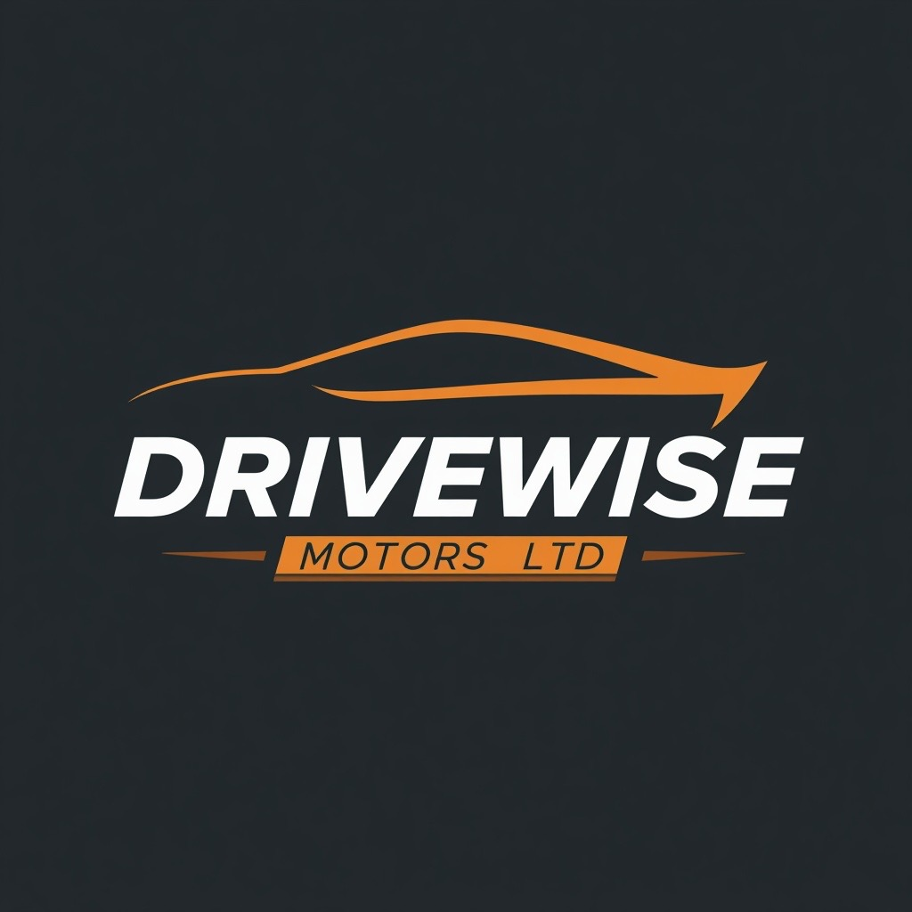

Executive Summary
DriveWise Ltd is a proposed private limited company that will specialise in the acquisition, refurbishment and sale of quality used and premium vehicles within London.
The business has been developed in response to increasing consumer demand for reliable, affordable alternatives to new vehicles, driven by higher living costs and rising new car prices (Society of Motor Manufacturers and Traders (SMMT), 2024).
Initially operating from a small forecourt accommodating approximately 15–20 vehicles, DriveWise Ltd will adopt a phased growth strategy, expanding into a medium-sized dealership within 6–12 months once financial performance and customer demand support expansion.
The company will differentiate itself through rigorous vehicle preparation, transparent pricing and exceptional customer service while embracing sustainable practices such as vehicle refurbishment, responsible recycling and digital documentation. Additional revenue will be generated through finance referrals, extended warranties and part-exchange services.
An initial investment of £120,000 will fund vehicle stock, premises, marketing and working capital. Financial forecasts indicate that the business can achieve profitability during its first year through careful inventory management, effective digital marketing and controlled operating costs. DriveWise Ltd therefore represents an attractive investment opportunity within the UK's resilient used vehicle market.

Executive Summary …………………………………………………………………… 2
Table of Contents……………………………………………………………………………………3
Introduction………………………………………………………………………….4
1. Business Concept……………………………………………………………………….……5
1.1 Business Description…………………………………………………...…….5
1.2 Products and Services…………………………………………………….…5
1.3 Mission Statement……………………………………………………………5
1.4 Vision Statement……………………………………………………………...5
1.5 Sustainability and Community Support…………………………………….5
1.6 Business Objectives (SMART)………………………………………………6
2. Market Analysis and Marketing Plan………………………………………….6
2.1 Market Analysis………………………………………………………...……...6
2.2 Target Market…………………………………………………………………...6
2.3 Competitor Analysis…………………………………………………...……….7
2.4 PESTLE Analysis………………………………………………………………7
2.5 SWOT Analysis………………………………………………………………...7
3. Marketing Communications……………………………………………………8
3.1 STP Model………………………………………………………………….….8
3.2 Marketing Mix (4Ps) ………………………………………………………….8
4. Operations and Management………………………………………………...8
4.1 Management Structure……………………………………………………...8
4.2 Operations…………………………………………………………………...8
5. Financial Plan…………………………………………………………………...9
5.1 Sources of Finance………………………………………………………...9
5.2 Start-up Costs………………………………………………………………9
5.3 Cash flow forecast ………………………………………………….……10
5.4 Sales Forecast …………………………………………………………...10
5.5 Break-even analysis …………………………………………………...…10
5.6 Operating Costs……………………………………………………………11
6. Conclusion…………………………………………………………….…….11
References……………………………………………………………………….12
Appendices……………………………………………………………………….14
Introduction
This business plan outlines the proposed establishment of DriveWise Ltd, an independent used vehicle dealership based in London. The report evaluates the business concept, market opportunity, marketing strategy, operational structure and financial viability of the business. It also examines the external environment and competitive landscape using recognised strategic planning tools, including PESTLE and SWOT analysis. Finally, realistic financial forecasts are presented to demonstrate the feasibility of the business and its potential for sustainable growth and future expansion across the UK (Burns, 2023; Johnson, Scholes and Whittington, 2020).

1.1 Business Description
DriveWise Ltd is a private limited company based in London, specialising in the purchase and sale of quality used and premium vehicles. The business aims to provide reliable vehicles at competitive prices, supported by transparent pricing and customer-focused service. Initially, DriveWise Ltd will operate from a small forecourt, with plans to expand to a medium-sized dealership as sales and profitability increase. The business will generate revenue through vehicle sales, finance referrals and value-added services such as warranties. By maintaining high-quality stock and building a strong reputation, DriveWise Ltd aims to establish itself as a trusted independent dealership before expanding to multiple locations across the UK.

1.2 Products and Services
DriveWise Ltd will specialise in the sale of professionally inspected used vehicles. Each vehicle will undergo mechanical inspections, servicing where required, professional valeting and vehicle history checks before sale to improve reliability and customer confidence. Additional income will be generated through finance referrals, warranty packages, part-exchange services and vehicle sourcing, reducing reliance on vehicle sales alone (Burns, 2023).
1.3 Mission Statement
“To provide reliable, professionally prepared used vehicles supported by transparent pricing, exceptional customer service and sustainable business practices”.
1.4 Vision Statement
“To become one of London's most trusted independent used vehicle dealerships before expanding into additional locations across the UK”.

1.5 Sustainability and Community Support
DriveWise Ltd will promote sustainability by extending vehicle life through refurbishment and resale. The business will recycle tyres, batteries and engine oil through licensed providers, increase its stock of hybrid and electric vehicles over time and reduce paper use through digital documentation.
1.6 Business Objectives (SMART)
Business Objectives
The business aims to sell approximately 120 vehicles during its first twelve months of trading, generating an estimated annual turnover of £1,056,000 and maintaining average monthly sales of between 10 and 11 vehicles.
DriveWise Ltd has established a series of SMART objectives to guide performance during its first year and support long-term growth. These objectives focus on sales growth, customer satisfaction, business expansion and sustainability, providing measurable targets against which performance can be evaluated (Burns, 2023). A full summary of the SMART objectives is provided in Appendix A.

2. Market Analysis and Marketing Plan
2.1 Market Analysis
The UK used car market continues to benefit from strong demand for affordable alternatives to new vehicles. Rising new car prices, increased living costs and continued consumer demand for used vehicles support market growth (SMMT, 2024; Statista, 2024). DriveWise Ltd will compete through quality inspected vehicles, transparent pricing and customer-focused service. A detailed competitor and PESTLE analysis is provided in the appendices.
2.2 Target Market
DriveWise Ltd will target first-time drivers, families, working professionals and individuals replacing existing vehicles who are seeking reliable used vehicles at competitive prices. Customer purchasing decisions are influenced by factors such as price, vehicle quality, finance availability, warranty provision and dealership reputation (Kotler and Keller, 2022). To meet these needs, DriveWise Ltd will provide quality inspected vehicles, transparent pricing and responsive customer service, creating a reliable and trustworthy buying experience.

2.3 Competitor Analysis
The London used vehicle market is highly competitive, with franchised dealerships, independent retailers and online marketplaces competing for customers. DriveWise Ltd will differentiate itself through quality inspected vehicles, transparent pricing, flexible finance options and customer-focused service. This strategy aims to build a strong local reputation, encourage repeat business and support sustainable growth. A detailed competitor analysis is provided in Appendix B.
2.4 PESTLE Analysis
A PESTLE analysis examines the external political, economic, social, technological, legal and environmental factors that may influence a business and its strategic decisions (Johnson, Scholes and Whittington, 2020). DriveWise Ltd must comply with UK consumer protection and vehicle sales legislation while adapting to economic conditions that influence customer spending. Economically, inflation, interest rates and changes in consumer confidence may affect demand for used vehicles, although increasing new car prices continue to encourage consumers towards the used vehicle market (ONS, 2025; SMMT, 2024). Socially, customers increasingly value reliability, affordability and excellent customer service. Technological developments, including online vehicle marketplaces and digital marketing, provide opportunities to improve sales and customer engagement (Chaffey and Ellis-Chadwick, 2022). Environmentally, increasing demand for hybrid and electric vehicles encourages the business to expand its stock while promoting sustainable vehicle reuse. A full PESTLE analysis is presented in Appendix C.
2.5 SWOT Analysis
A SWOT analysis was undertaken to evaluate DriveWise Ltd's internal capabilities and the external business environment. The analysis identified customer service and competitive pricing as key strengths, while limited brand recognition was recognised as the primary weakness. Market growth provides opportunities for expansion; however, increasing competition and economic uncertainty remain potential threats. The full SWOT analysis is presented in Appendix D.

3. Marketing Communications, STP Model and (4Ps)
An effective marketing communications strategy will build brand awareness and attract customers within London's competitive used vehicle market. DriveWise Ltd will apply the Segmentation, Targeting and Positioning (STP) model to target first-time drivers, families and working professionals (Kotler and Keller, 2022). Digital marketing, transparent pricing and customer reviews will strengthen the brand and support business growth. A detailed STP analysis is provided in Appendix E, while the Marketing Mix (4Ps) is presented in Appendix F.
4. Operations and Management Structure
4.1 Management Structure
DriveWise Ltd will operate with a lean management structure during its first year. The owner will manage strategic planning, vehicle sourcing and financial management, supported by a Sales Executive and an Administration and Finance Assistant. Vehicle servicing, preparation and MOT testing will be outsourced to trusted local garages to reduce fixed costs. As the business grows, additional staff will be recruited. The organisational structure is shown in Appendix G.

4.2 Operations
DriveWise Ltd will purchase used vehicles through trade auctions, dealerships and private sellers before completing inspections, preparation and professional valeting. Vehicles will be advertised through the company website, Auto Trader and social media. Finance referrals, warranty options and part-exchange services will enhance the customer experience while supporting profitability (Burns, 2023).

5. Financial Plan
5.1 Sources of Finance
DriveWise Ltd will be financed through a £100,000 investor contribution and £20,000 of the owner's savings, providing total start-up capital of £120,000. This funding will support vehicle purchases, premises, marketing and initial operating costs.
Table 1
Source of Finance | Amount (£)
Investor Funding | 100,000
Owner's Capital (Personal Savings) | 20,000
Total Funding | 120,000

Authors own work (2026)
5.2 Start-up Costs
The £120,000 investment has been allocated to vehicle stock, premises, marketing and working capital to support the business operations during the start-up phase.
Table 2
Item | Cost (£)
Vehicle Stock | 70,000
Premises Deposit & Initial Rent | 12,000
Equipment & Office Setup | 5,000
Insurance & Licences | 4,000
Website & Marketing | 5,000
Legal & Professional Fees | 3,000
Operating Cash Reserve | 21,000
Total | 120,000

Source: Author's own work (2026), based on estimated operating costs and projected sales using Atrill and McLaney (2022), SMMT (2024) and Auto Trader Retail Price Index (2024).
5.3 Sales Forecast
The sales forecast estimates DriveWise Ltd's expected vehicle sales during its first three years of operation. Forecast growth is based on increasing brand awareness, customer demand and expansion plans. The projected increase in sales supports the business's financial viability and future growth objectives.
Table 3
Period | Vehicles Sold | Average Selling Price (£) | Projected Revenue (£) | Estimated Gross Profit (£)
First 3 Months | 24 | 8,800 | 211,200 | 55,200
First 6 Months | 54 | 8,800 | 475,200 | 124,200
Year 1 | 120 | 8,800 | 1,056,000 | 276,000
Year 2 | 160 | 8,900 | 1,424,000 | 384,000
Year 3 | 210 | 9,000 | 1,890,000 | 525,000

Source: Author's own work (2026), based on UK used vehicle market data from the Society of Motor Manufacturers and Traders (SMMT, 2024) and Auto Trader Retail Price Index (2024).

5.4 Cashflow Forecast
A cash flow forecast has been prepared to assess the business's ability to generate sufficient cash to meet its financial obligations during growth. The forecast indicates that DriveWise Ltd is expected to maintain a positive cash position through consistent sales and controlled operating costs (Atrill and McLaney, 2022). See Appendix H for cash flow forecast.

5.5 Break-Even Analysis
A break-even analysis has been undertaken to determine the minimum number of vehicles DriveWise Ltd must sell to cover its annual fixed operating costs. The analysis indicates that the business is expected to reach break-even after selling approximately 75 vehicles, based on the forecast contribution per vehicle. As Year 1 sales are forecast to exceed this level, the business is expected to operate profitably. Detailed fixed costs, variable costs and break-even calculations are provided in Appendices I, J and K.

5.6 Fixed and Variable Monthly Costs
DriveWise Ltd's financial forecasts are based on estimated monthly operating costs, including both fixed overheads and variable costs associated with vehicle sales. Careful cost control and efficient stock management are expected to support positive cash flow and profitability during the first year of trading. A detailed breakdown of monthly operating costs is provided in Appendix J

6. Conclusion
DriveWise Ltd presents a viable opportunity to establish a successful used vehicle dealership in London. Supported by strong market demand, an effective marketing strategy and realistic financial planning, the business is well positioned for sustainable growth. Through reinvesting profits and expanding its operations, DriveWise Ltd aims to strengthen its market position and develop a network of dealerships across the UK.

References:
Auto Trader (2024) Retail Price Index. Available at: https://plc.autotrader.co.uk/news-views/press-releases/retail-price-index-december-2024/ (Accessed: 22 July 2026).
Atrill, P. and McLaney, E. (2022) Accounting and Finance for Non-Specialists. 12th edn. Harlow: Pearson.
Burns, P. (2023) Entrepreneurship and Small Business: Start-up, Growth and Maturity. 6th edn. London: Red Globe Press.
Chaffey, D. and Ellis-Chadwick, F. (2022) Digital Marketing: Strategy, Implementation and Practice. 8th edn. Harlow: Pearson.
Gürel, E. and Tat, M. (2017) 'SWOT analysis: A theoretical review', The Journal of International Social Research, 10(51), pp. 994–1006.
Johnson, G., Scholes, K. and Whittington, R. (2020) Exploring Strategy. 12th edn. Harlow: Pearson.
Kotler, P. and Keller, K.L. (2022) Marketing Management. 16th edn. Harlow: Pearson.
McCarthy, E.J. (1964) Basic Marketing: A Managerial Approach. Homewood, IL: Richard D. Irwin.
Office for National Statistics (2025) Economic indicators, UK. Available at: https://www.ons.gov.uk (Accessed: 21 July 2026).
Society of Motor Manufacturers and Traders (SMMT) (2024) UK Automotive Industry Statistics. Available at: https://www.smmt.co.uk (Accessed: 21 July 2026).
Statista (2024) Used Car Market in the United Kingdom. Available at: https://www.statista.com (Accessed: 21 July 2026).

Appendices
Appendix A - SMART Objectives
Source: Author's own work (2026), adapted from Burns (2023).

Appendix B – Competitor Analysis
Source: Author's own work (2026), based on market research and SMMT (2024).

Appendix C – PESTLE Analysis
Source: Adapted from Johnson, Scholes and Whittington (2020).

Appendix D- SWOT Analysis

Source: Adapted from Gürel and Tat (2017).

Appendix E – STP Model

Source: Adapted from Kotler and Keller (2022).

Appendix F: Marketing Mix (4Ps)
Source: Author’s own work, (2026).

Appendix G- Organisational Structure
Figure G1. Organisational Structure of DriveWise Ltd

Authors own work, (2026)

Appendix H – Cash flow Forecast
Table 4
Cash Flow
Month 1
(£)
Month 3
(£)
Year 1 (£)
Year 3 (£)
Opening Balance
120,000
135,000
120,000
260,000
Cash Inflows
88,000
88,000
1,056,000
1,848,000
Cash Outflows
80,500
80,500
966,000
1,625,000
Net Cash Flow
7,500
7,500
90,000
223,000
Closing Balance
127,500
142,500
210,000
483,000

Source: Author's own work (2026), based on projected vehicle sales and market assumptions.

Appendix I Fixed Operating Costs
Table 5
Authors own work (2026)

Appendix J – Variable Operating Cost
Table 6
Source: Author's own work (2026), based on estimated operating expenses

Appendix K – Monthly Break-even Analysis
Table 7
Source: Author’s own work (2026) calculated using the contribution approach described by Atrill and McLaney (2022).

