

Programme: BA International Hotel Management
Module: Management and Organisational Behaviour
Module code: BMIH5004
Assignment Title: Written report
Hotel: Hilton Hotel and Resort
Student name: Petru Piron
Student Id: 2233575
Dated: 07.02.2025

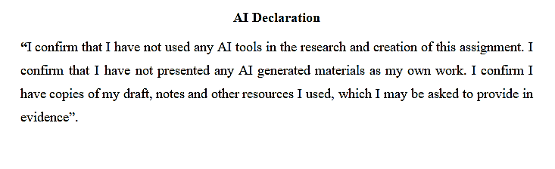
Executive Summary
This report critically discusses Hilton's recent initiatives, which include various aspects such as sustainably sourced food and beverages, luxury vacation rentals, and employee well-being programs, and explores how these will transform customer experience, brand perception, and workforce engagement in comparison with Marriott, IHG, Accor, Wyndham, and Hyatt. Hilton is successful in digital transformation and brand loyalty but lags behind its peers in achieving carbon neutrality and supporting employees. This report uses the ADKAR model to assess Hilton's approach to change management and identify potential implementation challenges. Although these programs fuel competitive advantage, they do so at a significant cost. Recommendations for the report include strengthening sustainability efforts, building on AI-based customer engagement, and leadership development to support future growth. A structured implementation plan is suggested, balancing short-term gains with long-term strategic positioning. Finally, Hilton has to continuously innovate and adapt to sustain its leadership position in the fiercely competitive global hospitality industry.

Table of Contents
1. Introduction 5
2. Organisation Structure, Culture, and Goals 6
2.1 Organisational Structure 6
2.2 Corporate Culture and Its Influence on Operations 7
2.3 Goals of Hilton Hotels and Resorts 9
3. Recent Change Initiatives 10
3.1 Identification of Recent Change Initiatives 10
3.2 Impact of These Initiatives 11
3.3 Change Management Analysis 12
4. Strategic Direction of Hilton Hotels and Resorts 12
4.1 Smart Objectives 12
4.2 Long-Term Objectives 13
5. Recommendations 14
5.1 Key Areas for Improvement 14
5.2 Implementation Plan 14
6. Conclusion 14
7. References 16

Introduction
This study aims to identify the Hilton hotel and its significance in terms of employment, the economy, and fulfilling customer needs. However, one of the most prominent hospitality brands is Hilton Hotels and Resorts, characterised by a century-long legacy of offering excellent services and luxury experiences. Moreover, the hotel was founded by Conrad Hilton in 1919; the company has grown into an international hotel industry leader, with more than 7,000 properties worldwide across 123 countries (Hilton, 2024). Additionally, it includes luxury brands such as Waldorf Astoria, full-service brands like Conrad Hotels, and budget-friendly options like Hilton Garden Inn (Hilton, 2024). Hilton Hotels and Resorts competes with other major hospitality brands around the world, including Marriott International, Hyatt Hotels, InterContinental Hotels Group (IHG), Accor, and Wyndham Hotels and Resorts, which provide the same luxury, mid-range, and budget accommodation services, taking advantage of digital innovations, sustainability initiatives, and loyalty programs to attract guests and expand their global market presence.
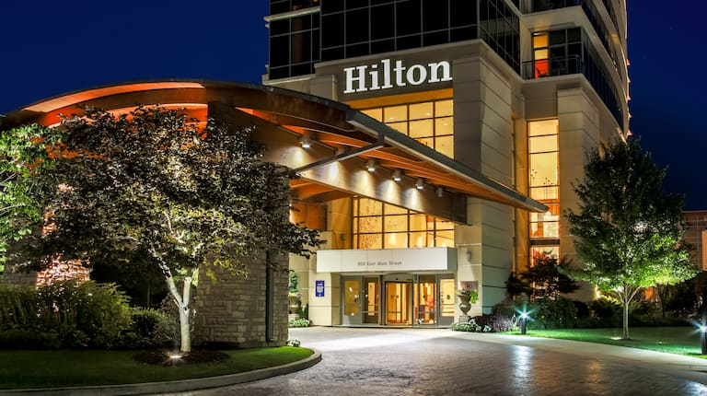
Figure 1: Hilton Hotel
(Source: Hilton, 2024)
This report evaluates and analyses Hilton Hotels and Resorts from the corporate to the individual hotel level. Key subjects covered are the organisational structure, corporate culture, goals, change initiatives over recent times, and strategic direction. The report concludes with recommendations for Hilton to strengthen its position in the hospitality industry globally.

Organisation Structure, Culture, and Goals

Organisational Structure
Hilton's organisational structure is a centralised corporate structure with flexibility at the individual hotel level, thus expanding globally while maintaining brand consistency (Hilton, 2024). The operational practices through franchised, managed, and owned properties enable geographical expansion while allowing for consistency in maintaining high brand quality (Alon et al., 2021). Subsequently, strategic issues are handled at the corporate level, but regional managers and hotel operators provide the localised delivery (Situmorang and Japutra, 2019). Moreover, compared with competitors such as Hyatt, and Marriott, Hilton strongly recommends standardisation and operational efficiency to support quality brands across diverse properties.
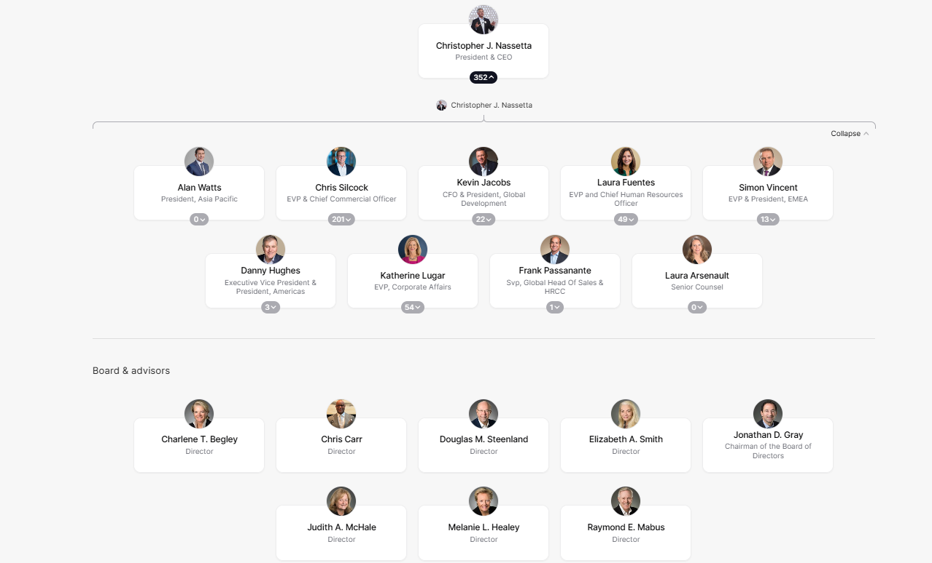
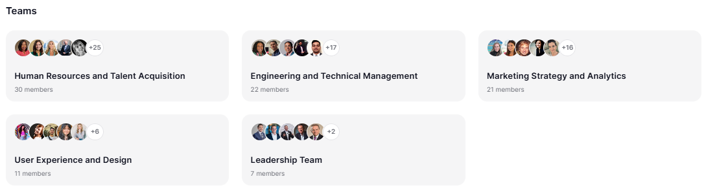
Figure 2: Organisational culture of Hilton
(Source: Hilton, 2024)

Corporate Culture and Its Influence on Operations
Hilton's company culture is founded on its HILTON values: Hospital Hospitality, Integrity, Leadership, Teamwork, and Ownership, and encourages brilliant service, innovation, diversity, and sustainability (Tworek et al., 2020). Moreover, a strong corporate culture will improve employee engagement, resulting in increased motivation, reduced turnover, and better services (Ababneh, 2021). Subsequently, a dedicated and well-equipped workforce can ensure that the quality of guest service is met and exceeded, thus building brand advocacy from clients (Ahmed and Omarein, 2024). However, it facilitates revenue growth, as repeat customers and premium experiences enhance the overall higher occupancy rates and profitability. As shown in (Figure 5), Hilton has demonstrated a steady and continuous increase from 2009 to 2023, with a notable increase after a corporate spin-off in 2016, and a steady recovery from the pandemic-related fall seen in 2020. The revenue in the year 2023 was the highest in the period observed. In Hilton, the culture of inclusivity, teamwork, and innovation provides a productive organisation and an effective workforce. Therefore, individuals are valued and empowered to contribute to quality services and efficiency in operations (Bandura, 2023). A positive environment encourages less turnover, better guest experiences, and greater performance, profitability, and long-term business success in Hilton.
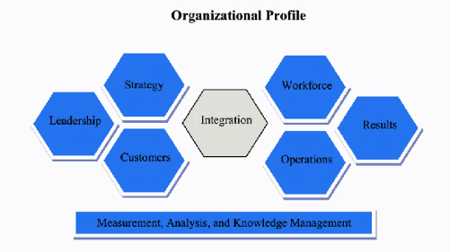
Figure 3: Baldrige Excellence Framework
(Source: Ghafoor et al., 2021)
Evaluating Hilton using the Baldrige Excellence Framework will be of great importance, this being about leadership, customers, and performance excellence, all of these are core components of Hilton's strategic view (Ghafoor et al., 2021) (Figure 3). This model points out continuous improvement and service, both aspects that contribute to Hilton's excellence. Therefore, by using such a framework, Hilton exhibits great attention to innovation, guest satisfaction, and operational excellence, so that Hilton hotels around the globe deliver services with excellence (Hilton, 2024). Moreover, through its adherence to these principles, Hilton emerged as a hospitality leader around the world, and this provides the company with the competitive advantage to maintain long-term growth despite industry changes (Ghafoor et al., 2021).
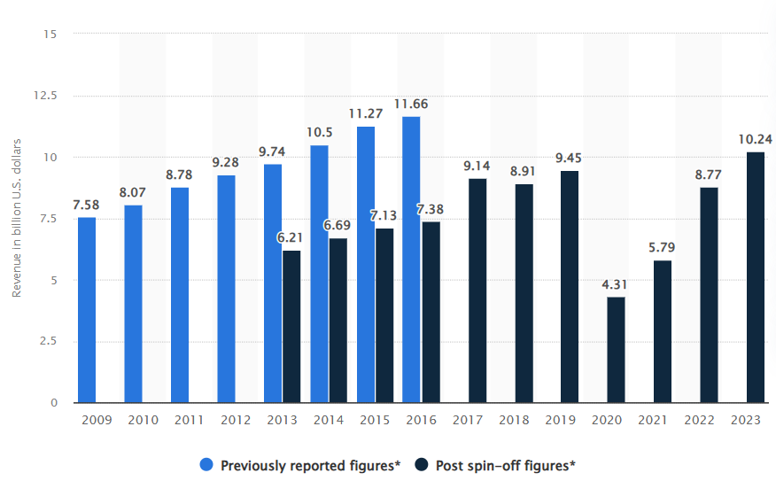
Figure 4: Revenue of Hilton from 2009 to 2023
(Source: Statista, 2023)

Goals of Hilton Hotels and Resorts
The corporate-level objectives of Hilton are revenue growth, market expansion, and customer loyalty through the Hilton Honors program (Hilton, 2024). Sustainability is also one of the main goals, where Hilton aims to cut carbon emissions and water usage by half by 2030. Moreover, Individual goals at the hotel level include service excellence, guest satisfaction, and operational efficiency (Ali et al., 2021). Each hotel operates according to the overall corporate strategy while fitting in with the local preferences and demands of the customers. This alignment also allows Hilton to ensure global consistency in operations while making those adaptations necessary on a local scale. As shown in (Figure 5), the employment rate in the hotel industry increased by 178 percent in 2023 compared to the previous year.
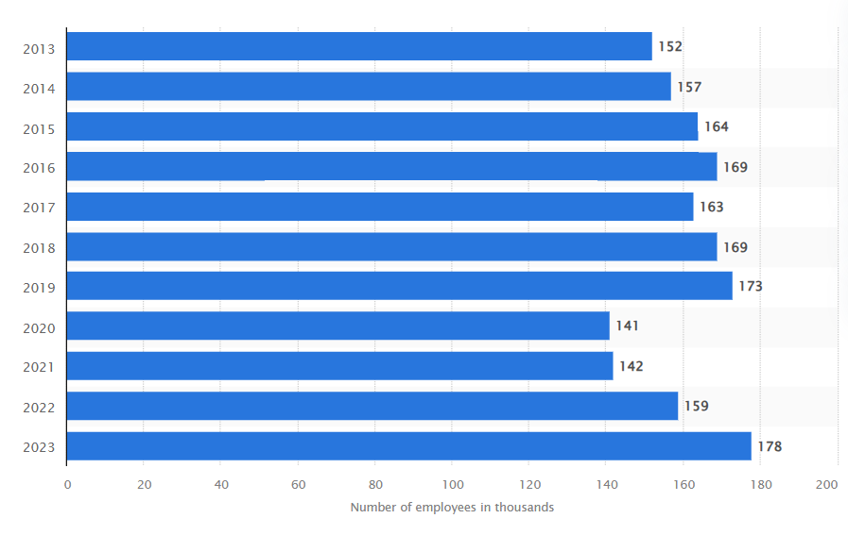
Figure 5: Employees of Hilton from 2013 to 2023
(Source: Statista, 2024)

Recent Change Initiatives

Identification of Recent Change Initiatives
Hilton Hotels has carried out several strategies for change (Zeng, 2021). This includes optimised operational efficiency and sustainability, improved employees’ welfare and well-being, and sustainable food and beverage practices, which include responsible sourcing; AI food waste tracking and sending zero food to landfill by 2030. To adapt to ever-changing market trends, Hilton went into luxury vacation rentals via the LXR Hotels and Resorts venture (Zeng, 2021). Moreover, now competing head-to-head with the giant Airbnb as well as luxurious boutique hotels. Additionally, employee wellbeing is in the framework of its highly broad Thrive@Hilton. By investing in workforce development, Hilton creates a more engaged and productive workforce that increases guest satisfaction (Zeng, 2021). Additionally, by taking measures to have greater diversity, equity, and inclusion in the workplace, Hilton retains employees and allows for innovation in the company (Bersin and Enderes, 2021).

Impact of These Initiatives
Customer experiences have evolved with seamless processes of check-in, mobile room controls, and AI-driven personalisation (Sabitha, 2024). Furthermore, guest satisfaction has improved in addition to streamlining operations to enhance efficiency while sustainability efforts promoted brand recognition for eco-travel and investing (Stafford and Graul, 2020). However, high implementation and technology dependency could be a big challenge. Moreover, workforce transformation through DEI initiatives and wellness programs has made employees feel good about working with the company (Javed, 2024).
Porter's Generic Strategies consist of three fundamental strategies in pursuing a competitive advantage, cost leadership, differentiation, and focus (Islami et al., 2020). The primary differentiation strategy used by Hilton includes premium services, digital innovations, and sustainability initiatives such as Thrive@Hilton and AI-driven personalisation (Stafford and Graul, 2020). Moreover, Hilton uses the focus strategy for luxury segments in LXR Hotels and Resorts catering to high-end travellers. The cost leadership that Hilton can make use of would be to position mid-range brands like Hilton Garden Inn with greater operational efficiency at reduced costs while maintaining a high-quality service (Islami et al., 2020).
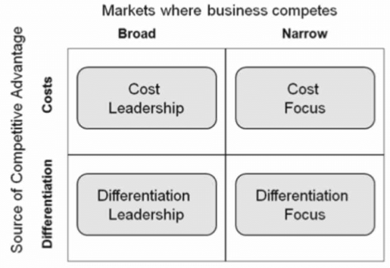
Figure 6: Porter Generic model
(Source: Islami et al., 2020)

Change Management Analysis
The ADKAR Model by Prosci is a framework for change management that centers around individual transitions when an organisation change (Paramitha et al., 2020). There are five stages involved: Awareness of the need to change, Desire to support the change, Knowledge about how to make the change, Ability to implement new skills to implement the change, and Reinforcement to sustain it over time (Tang, 2019). With the help of ADKAR, Hilton would successfully implement its new strategies to boost workforce engagement while maintaining a competitive advantage to uphold its continued improvement and excellence in operations (Paramitha et al., 2020).
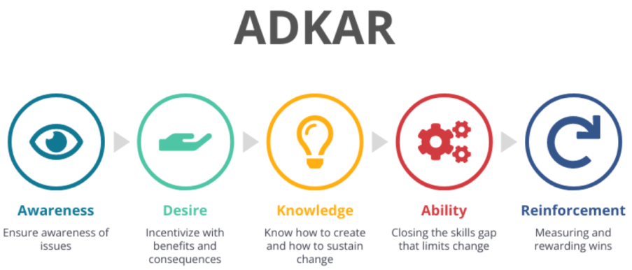
Figure 7: Adkar Model
(Source: Tang, 2019)

Strategic Direction of Hilton Hotels and Resorts

Smart Objectives
- Implement 15% of the DEI training programs across all global locations in two months (Javed, 2024).
- Reduce food wastage by 15% using AI tracking systems within two months (Sabitha, 2024).
- Reach 15% of the desired luxury vacation rentals under LXR Hotels and Resorts within two months.
- Engage 15% of Hilton's employees in Thrive@Hilton programs within two months.
- Reduce carbon footprint in all key properties by 15% through Travel with Purpose within two months (Stafford et al., 2020).

Long-Term Objectives
Hilton's long-term strategy focuses on sustainability, technological innovation, and workforce development to maintain its competitive edge (Zeng, 2021). Over the next five years, Hilton will focus on net-zero emissions, luxury vacation rentals, and digital customer experiences with AI and automation. The phased approach ensures high-impact properties transform sustainability in a phased rollout of innovative technologies across locations. The well-being of employees will continue to receive attention, from Thrive@Hilton programs to leadership development initiatives (Zeng, 2021). In contrast with the Resource Theory, this shows the strengths of Hilton to be ahead in competition; from its strength as a good brand to technological superiority in the service through AI (Freeman et al., 2021). The skills acquired by a human resource have added value toward developing a positive product, with such a view giving the corporation sustainability and profitability. However, an investment in a data-driven decision-making model means continuous evolution toward changing consumer expectations and across global standards in sustainability (Freeman et al., 2021).
Strategies Implemented to Achieve These Objectives
The new initiatives executed by Hilton, IHG, Marriott, and Accor help to improve the brand's reputation and customer loyalty to a great degree (Jindal and Kaur, 2024). Sustainability efforts, such as Hilton's Travel with Purpose and IHG's Green Engage, attract ecological travelers and stick to international environmental excellence benchmarks, automatically decreasing long-run operating costs (Stafford and Graul, 2020). Moreover, digital transformation has made it possible to improve customer experience through AI-driven personalisation, mobile check-ins, and smart room controls (Jindal and Kaur, 2024). Moreover, this will lead to more satisfied guests and improved operational efficiency. On the contrary, heavy reliance on automation may reduce the traditional human interaction that defines hospitality, thereby affecting customer engagement. Additionally, workforce well-being programs like Thrive@Hilton and Marriott's TakeCare have improved morale, reduced turnover, and improved service quality. However, the programs require investment in mental health support and financial literacy training that increases operational costs and impacts profitability in the short term (Jindal and Kaur, 2024).

Recommendations

Key Areas for Improvement
Areas for improvement will be on the aspect of broadening the 'better business' front, such as strengthening sustainability efforts, enhancing digital customer engagement, and enhancing employee training and development (Prakash et al., 2023). The expansion of eco-friendly hotel practices, such as carbon-neutral operations and reduction of water intake, can be in line with global sustainability trends (Prakash et al., 2023). AI-driven personalised services, such as predictive analytics to determine a guest's wants, can heighten customer engagement. Moreover, an investment in leadership programs will arm employees with skills to serve and retain them better (Brunner et al., 2023).

Implementation Plan
To ensure successful implementation, these initiatives need collaboration between senior leadership, hotel managers, and franchise owners with the alignment of Hilton's strategic goals (Jindal and Kaur, 2024). The short-term approach will be within 1-2 years with AI-driven personalised services and improvement in employee training programs, whereas long-term approaches (5+ years) would be sustainability improvements. This includes carbon-neutral operations. The initiatives should be implemented globally with a focus on key markets, where Hilton experiences significant customer demand (Jindal and Kaur, 2024). Sustainability, digital engagement, and workforce development are critical aspects that will support Hilton's sustainability advantage, boost guest satisfaction, and strengthen its brand reputation (Brunner et al., 2023).

Conclusion
Conclusively, this report was based on Hilton's strategic initiatives in the areas of sustainability, digital transformation, food waste, and employee well-being to support Hilton's competitive edge in the hospitality industry. The efforts in responsible sourcing, AI-driven personalisation, and workforce development are aimed at enhancing customer experience, brand loyalty, and operational efficiency. However, it challenges financial investment, such as reaching carbon neutrality and competitiveness gaps. The long-term sustainable success of Hilton will depend on continuous innovation and adaptation to emerging consumer expectations, as well as benchmarking with industry leaders.

References

Ababneh, O. M. A. (2021). The impact of organizational culture archetypes on quality performance and total quality management: the role of employee engagement and individual values. International Journal of Quality and Reliability Management, 38(6), 1387-1408.
Ahmed, R., and Omarein, J. (2024). Fostering Long-Term Customer Relationships by Enhancing Customer Experience A Case Study at Consultancy Inc.
Ali, B. J., Gardi, B., Othman, B. J., Ahmed, S. A., Ismael, N. B., Hamza, P. A., ... and Anwar, G. (2021). Hotel service quality: The impact of service quality on customer satisfaction in hospitality. International Journal of Engineering, Business and Management, 5(3), 14-28.
Alon, I., Apriliyanti, I. D., and Henríquez Parodi, M. C. (2021). A systematic review of international franchising. Multinational Business Review, 29(1), 43-69.
Bandura, A. (2023). Cultivate self‐efficacy for personal and organizational effectiveness. Principles of Organizational Behavior: The Handbook of Evidence‐Based Management 3rd Edition, 113-135.
Bersin, J., and Enderes, K. (2021). Elevating equity: The real story of diversity and inclusion.
Brunner, T. J., Schuster, T., and Lehmann, C. (2023). Leadership’s long arm: The positive influence of digital leadership on managing technology-driven change over a strengthened service innovation capacity. Frontiers in Psychology, 14, 988808.
Freeman, R. E., Dmytriyev, S. D., and Phillips, R. A. (2021). Stakeholder theory and the resource-based view of the firm. Journal of Management, 47(7), 1757-1770.
Ghafoor, S., Mann, R. S., and Grigg, N. (2021). The strengths and opportunities for improvement of the Baldrige Performance Excellence Program. Quality Management Journal, 28(3), 128-144.
Hilton (2024). “Hilton Brands | Global Hospitality Company.” Hilton.com, 2024, www.hilton.com/en/corporate/.
Hilton (2024). “Hotels by Hilton - Book the Best Rates across All Brands.” Hilton, 2024, www.hilton.com/en/.
Islami, X., Mustafa, N., and Topuzovska Latkovikj, M. (2020). Linking Porter’s generic strategies to firm performance. Future Business Journal, 6, 1-15.
Javed, H. (2024). Creating a positive workplace culture: diversity, equity, and inclusion initiatives. In Innovative Human Resource Management for SMEs (pp. 367-394). IGI Global.
Jindal, R., and Kaur, H. (2024). Managing Guest Expectations and Safety With AI and Smart Solutions. In Utilizing Smart Technology and AI in Hybrid Tourism and Hospitality (pp. 118-139). IGI Global.
Paramitha, T. A., Tobing, D. K., and Suroso, I. (2020). ADKAR Model to Manage Organizational Change. International Journal of Research Science and Management, 7(1), 141-149.
Prakash, S., Sharma, V. P., Singh, R., and Vijayvargy, L. (2023). Adopting green and sustainable practices in the hotel industry operations analysis of critical performance indicators for improved environmental quality. Management of Environmental Quality: An International Journal, 34(4), 1057-1076.
Sabitha, J. (2024). AI-Driven Customer Segmentation and Personalization. Zibaldone Estudios italianos, 11(2), 1-20.
Situmorang, R., and Japutra, A. (2019). Foreign versus local managers: finding the perfect leaders for multinational hotel subsidiaries. International Journal of Hospitality Management, 78, 68-77.
Stafford, E. R., and Graul, A. R. (2020). Turning consumers green: From green marketing myopia to our 2020 vision. Sustainability: The Journal of Record, 13(1), 10-21.
Statista (2023). “Revenue of Hilton from 2009 to 2023.” Statista, 2023, www.statista.com/statistics/297760/revenue-of-hilton-worldwide-holdings-inc/.
Statista (2024). “Hilton: Employee Numbers 2013-2018 | Statista.” Statista, Statista, 2024, www.statista.com/statistics/297758/number-of-hilton-worldwide-employees/.
Tang, K. N., and Tang, K. N. (2019). Change management. Leadership and change management, 47-55.
Tworek, K., Bieńkowska, A., and Zabłocka-Kluczka, A. (2020). Organizational reliability: Human resources, information technology and management. Routledge.
Zeng, L. (2021). Analysis of Hilton Worldwide Hotel Group’s Transnational Operation Strategy. Academic Journal of Business and Management, 3(11), 20-27.
Zeng, L. (2021). Analysis of Hilton Worldwide Hotel Group’s Transnational Operation Strategy. Academic Journal of Business and Management, 3(11), 20-27.

