

Module Name: Digital Skills for Personal and Professional Growth
Module Code: BMSW4008
Assessment 1: E-Portfolio
Student Name: Josue David Rodriguez Castro
Student Number: 2506920
Lecturer : Philippa Fitzgerald
Deadline: Friday 12th December 2025 23.59pm

Contents
Introduction to the Portfolio
Task 1: Digital Skills Assessment
3.1 Overview of Digital Skills
3.2 Summary of JISC Digital Capability Results
3.3 Strengths and Weaknesses
3.4 SMART Action Plan
3.5 Evidence: Digital Badge Screenshot
Task 2: LinkedIn Learning Certificates (Office 365 Skills)
4.1 Description of Completed Courses
4.2 Reflection on Learning
4.3 Evidence: Certificates of Completion
Task 3: Microsoft Excel Essay (1,000 Words)
5.1 Importance of Microsoft Excel
5.2 Examples of Excel in Practice
5.3 Embedded Spreadsheet Screenshots (Table + Chart)
5.4 Attached Excel File (Household Income & Expenditure)
Task 4: Reflective Presentation (7 Minutes)
6.1 Slide Structure
6.2 Presentation Script
6.3 Reflection on Learning Across All Tasks
References
AI Acknowledgement Page

Introduction to the Portfolio
This portfolio presents the complete assessment for the Digital Skills for Personal Development & Business module at the University of Wales Trinity Saint David. It includes a reflective digital skills assessment, evidence of LinkedIn Learning training, a comprehensive essay on Microsoft Excel, and a reflective presentation.
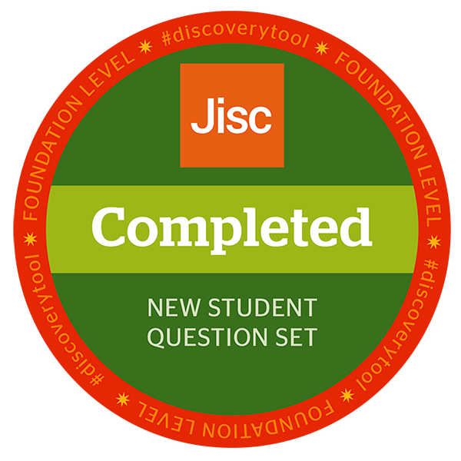

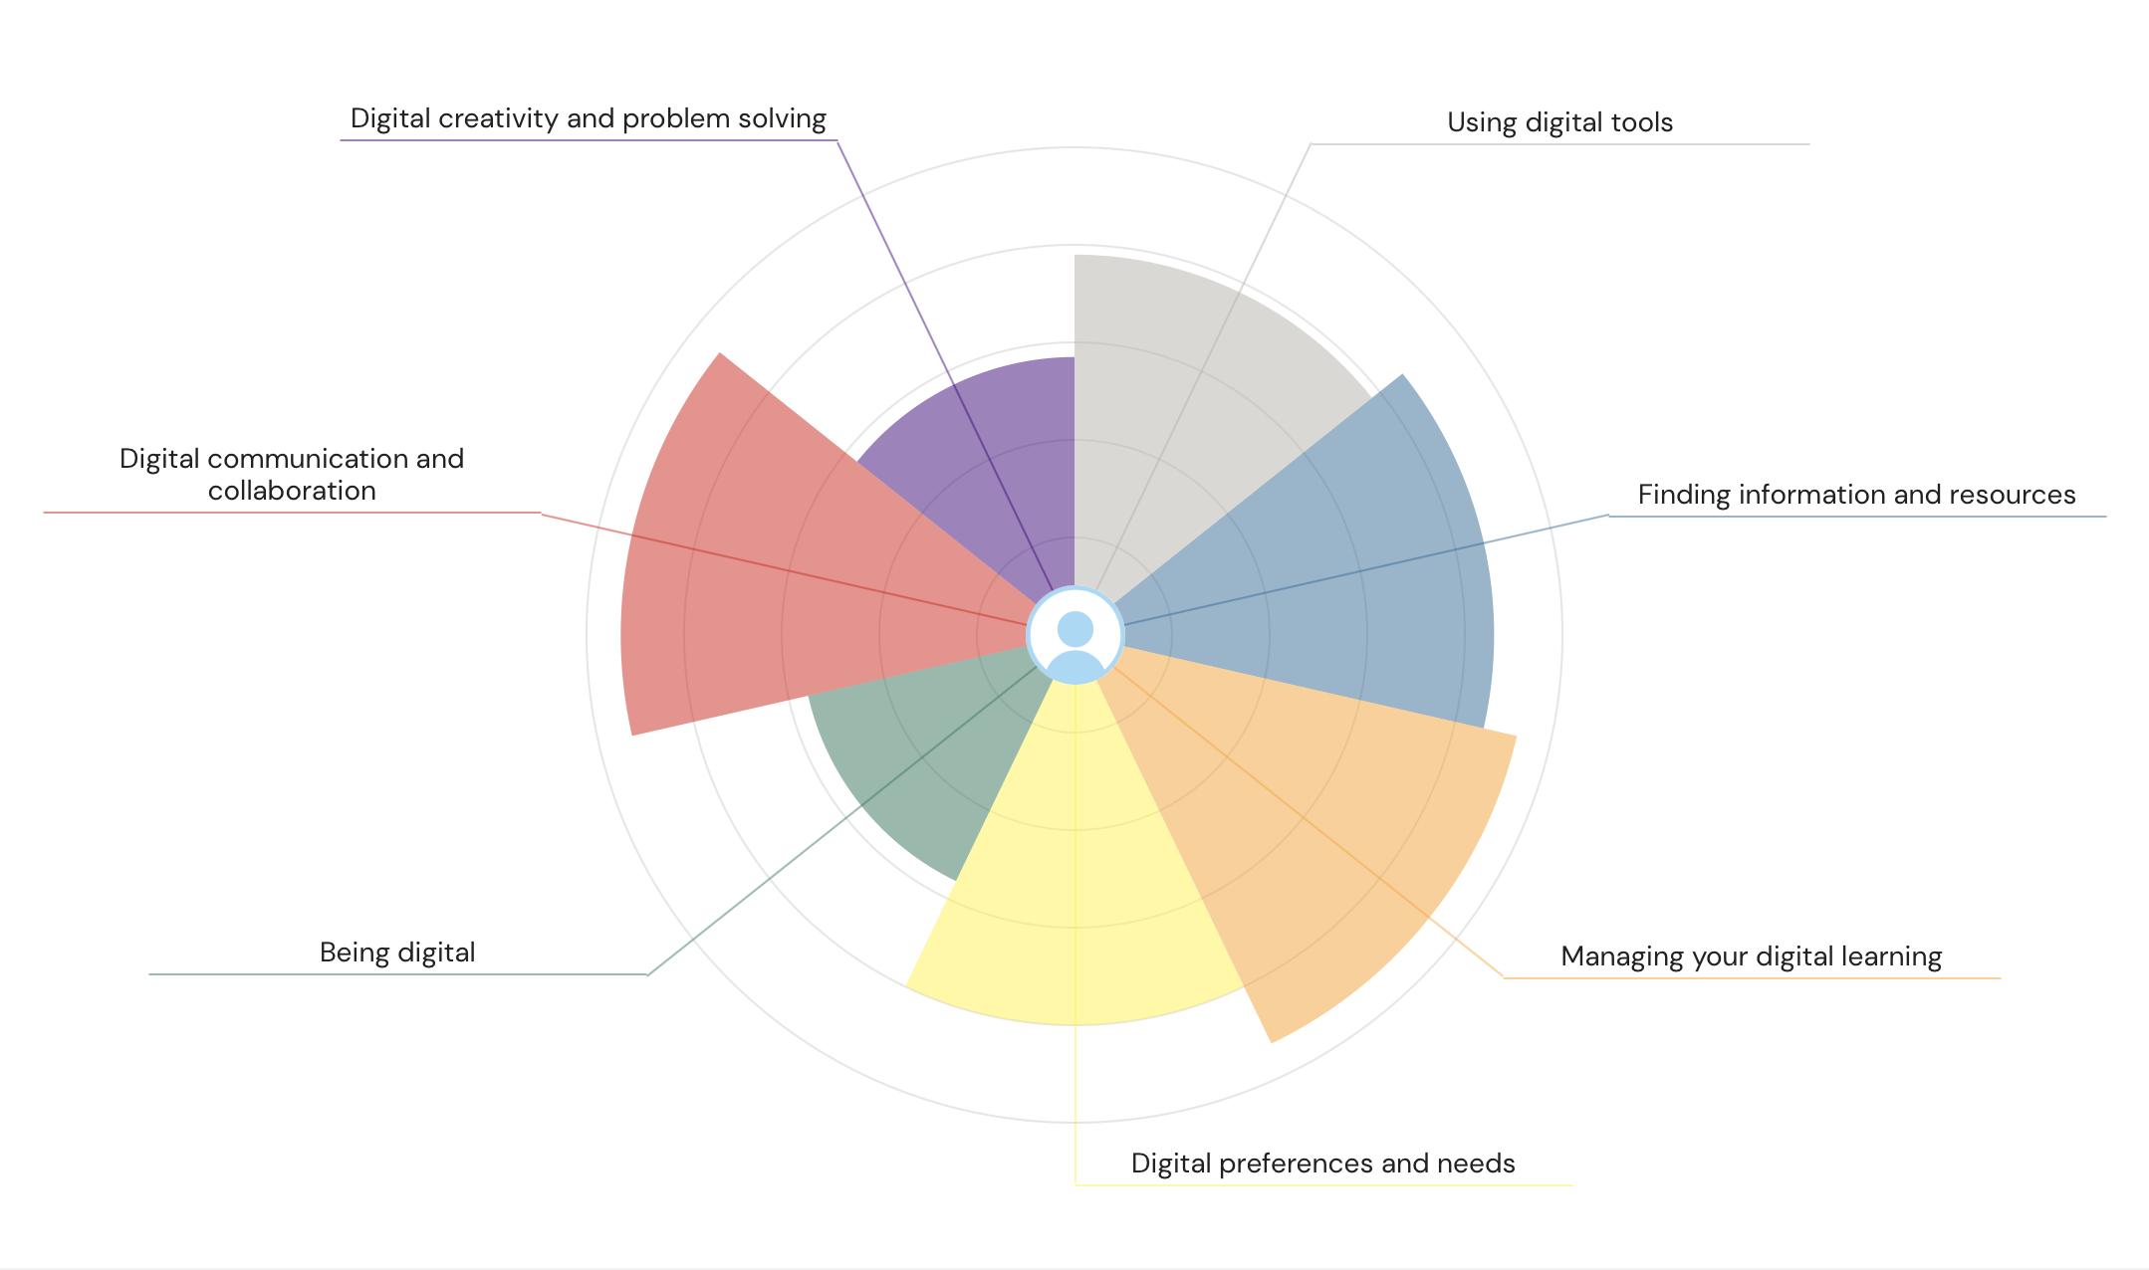
Summary of JISC Digital Capability Results
Assessment of Digital Skills – Reflective Essay
Digital skills have become essential for success in higher education, employment, and daily life. According to Jisc (2023), students entering university are expected to confidently navigate digital environments, evaluate information effectively, communicate online, and adapt to new technologies. Developing these abilities supports independent learning, improves academic performance, and prepares learners for increasingly digital professional settings. This reflective essay evaluates my current digital capabilities based on the JISC Digital Capability Self-Assessment and outlines a SMART action plan to strengthen areas that require improvement.
After completing the JISC assessment, I received a detailed report covering several digital capability areas: using digital tools, finding information, communication and collaboration, creativity and problem solving, managing digital learning, preferences and needs, and digital identity. Most of my results were rated as Proficient—specifically in using digital tools, finding information, communicating online, managing my digital learning, and adapting digital formats to my needs. Two areas were rated as Capable rather than proficient: digital creativity and problem solving and developing my digital identity. These results demonstrate strong overall competence but also highlight areas where further development would be valuable for academic and professional growth.

Strengths
One of my strongest areas is using digital tools. The report recognises me as very experienced in this domain, meaning I can quickly learn new applications, solve common technical issues, and select appropriate digital tools for different tasks. This strength is important for university assignments, as they typically require the use of multiple platforms such as Moodle, Office 365, and research databases. Jisc (2023) emphasises that digitally productive learners create an efficient personal digital environment, and I already do this by organising files, exploring new software, and maintaining good device management practices.
Another strength is finding information and evaluating digital resources. Being categorised as Proficient indicates that I am able to search effectively, compare sources, understand credibility, and use digital media responsibly. These skills are essential for academic writing where referencing, paraphrasing, and avoiding plagiarism are crucial. Research from EDUCAUSE (2023) shows that students with strong information-literacy skills perform better in research-based assignments, demonstrating the importance of this ability in higher education.
Weaknesses
Although I am confident in most areas, the assessment shows that digital creativity is only at a Capable level. This means that although I can create basic digital content, I have not yet mastered more advanced creative tools such as design software, multimedia editing, or producing visually enhanced academic materials. In an academic context, improving this skill would improve the quality of presentations, infographics, and digital projects.
The second weakness is developing my digital identity and online professional presence. Being rated as Capable suggests that although I understand online safety and behaviour, I have not yet built a clear professional profile, portfolio, or digital footprint that reflects my academic and career goals. According to UWTSD (2024), developing a professional online identity helps students showcase their achievements and increases employability.

SMART Action Plan
To address these weaknesses, I will implement the following SMART goals:
1. Improve digital creativity
(Specific): I will complete at least two short online courses on Canva, Adobe Express, or other creative tools.
(Measurable): I will produce three academic artefacts: one infographic, one poster, and one enhanced PowerPoint template.
(Achievable): Many free courses and templates are available through LinkedIn Learning.
(Relevant): Enhanced creativity will improve my academic presentations and future professional portfolio.
(Time-bound): I will complete this goal within 8 weeks.
2. Strengthen my digital identity
(Specific): I will update my LinkedIn profile and create a digital portfolio showcasing assignments, certificates, and skills.
(Measurable): My profile will include a professional photo, biography, 5 skills, and at least 3. Evidence items.
(Achievable): UWTSD provides guidance on LinkedIn and digital identity.
(Relevant): A strong digital identity increases employability and supports long-term career goals.
(Time-bound): I will complete this goal within 6 weeks.

Conclusion
This reflection demonstrates that I already possess strong digital skills, particularly in using digital tools, managing information, communicating online, and supporting digital learning. However, the assessment also identifies areas for further development, especially digital creativity and building a professional online identity. By following the SMART action plan, I will enhance my academic performance, strengthen my employability, and ensure that my digital capabilities continue to grow throughout my studies and future career. Developing these skills will support me in meeting university expectations and adapting to the evolving digital landscape.

References (Harvard)
EDUCAUSE (2023) Students and Technology Report: Higher Education. Available at: https://www.educause.edu (Accessed: 28 November 2025).

Jisc (2023) Digital Capabilities Framework. Available at: https://www.jisc.ac.uk (Accessed: 28 November 2025).

UWTSD (2024) Digital Skills for Higher Education. University of Wales Trinity Saint David Library. Available at: https://www.uwtsd.ac.uk/library (Accessed: 28 November 2025).

Hollands, F. & Escueta, M. (2022) ‘Digital Literacy in Higher Education’, Journal of Educational Technology, 18(2), pp. 45–60.

Secker, J. & Coonan, E. (2023) UK Digital Literacy Framework: A Guide for Students. London: Facet Publishing.

Task 2: LinkedIn Learning – Office 365 Certificates
As part of my digital skills development, I completed the required LinkedIn Learning courses for Microsoft Word, Microsoft Excel, and Microsoft PowerPoint. These courses were accessed using my University of Wales Trinity Saint David institutional email, ensuring that all completions were officially recorded and linked to my academic profile.
Each course provided structured video tutorials, practical demonstrations, and knowledge checks designed to improve proficiency with Office 365 applications. The Word course strengthened my ability to format academic documents professionally. The Excel course enhanced my data-handling, formula use, and spreadsheet management skills. Finally, the PowerPoint course improved my ability to create clear, visually effective presentations aligned with academic expectations.

After completing each course, I downloaded the Certificate of Completion directly from LinkedIn Learning. These certificates are included in my e-portfolio as evidence of my achievement and digital capability. Completing these modules contributes to my academic progress by supporting more efficient work with documents, spreadsheets, and presentations. Professionally, these certificates demonstrate competence in essential workplace digital tools and improve my employability in roles that require strong digital productivity skills.
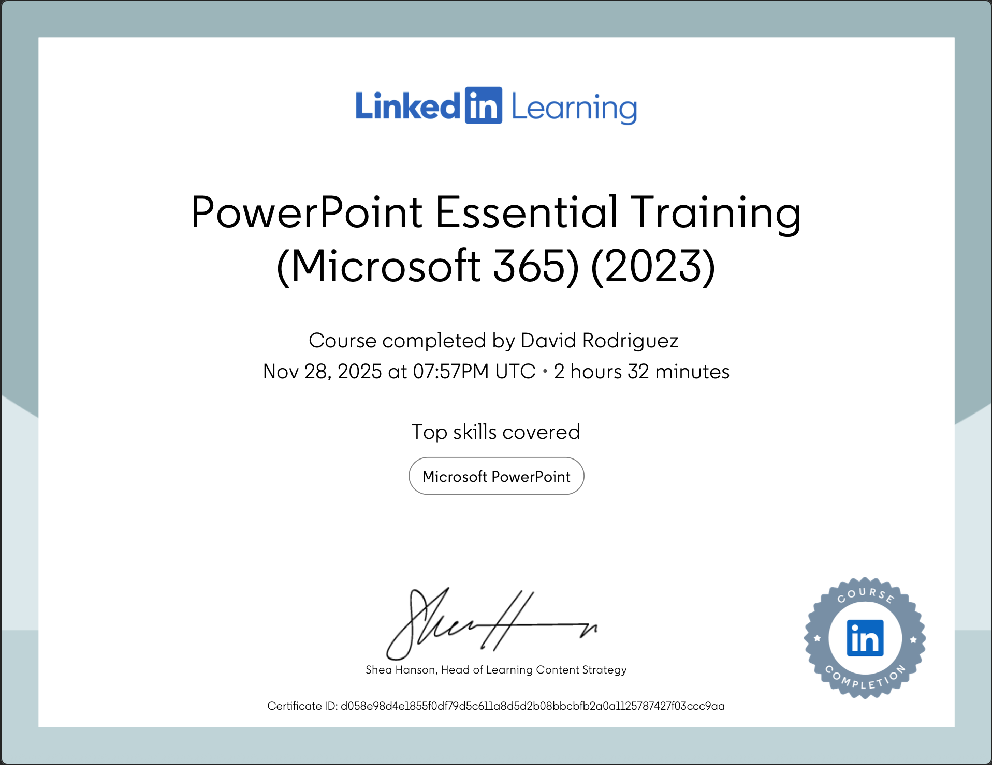
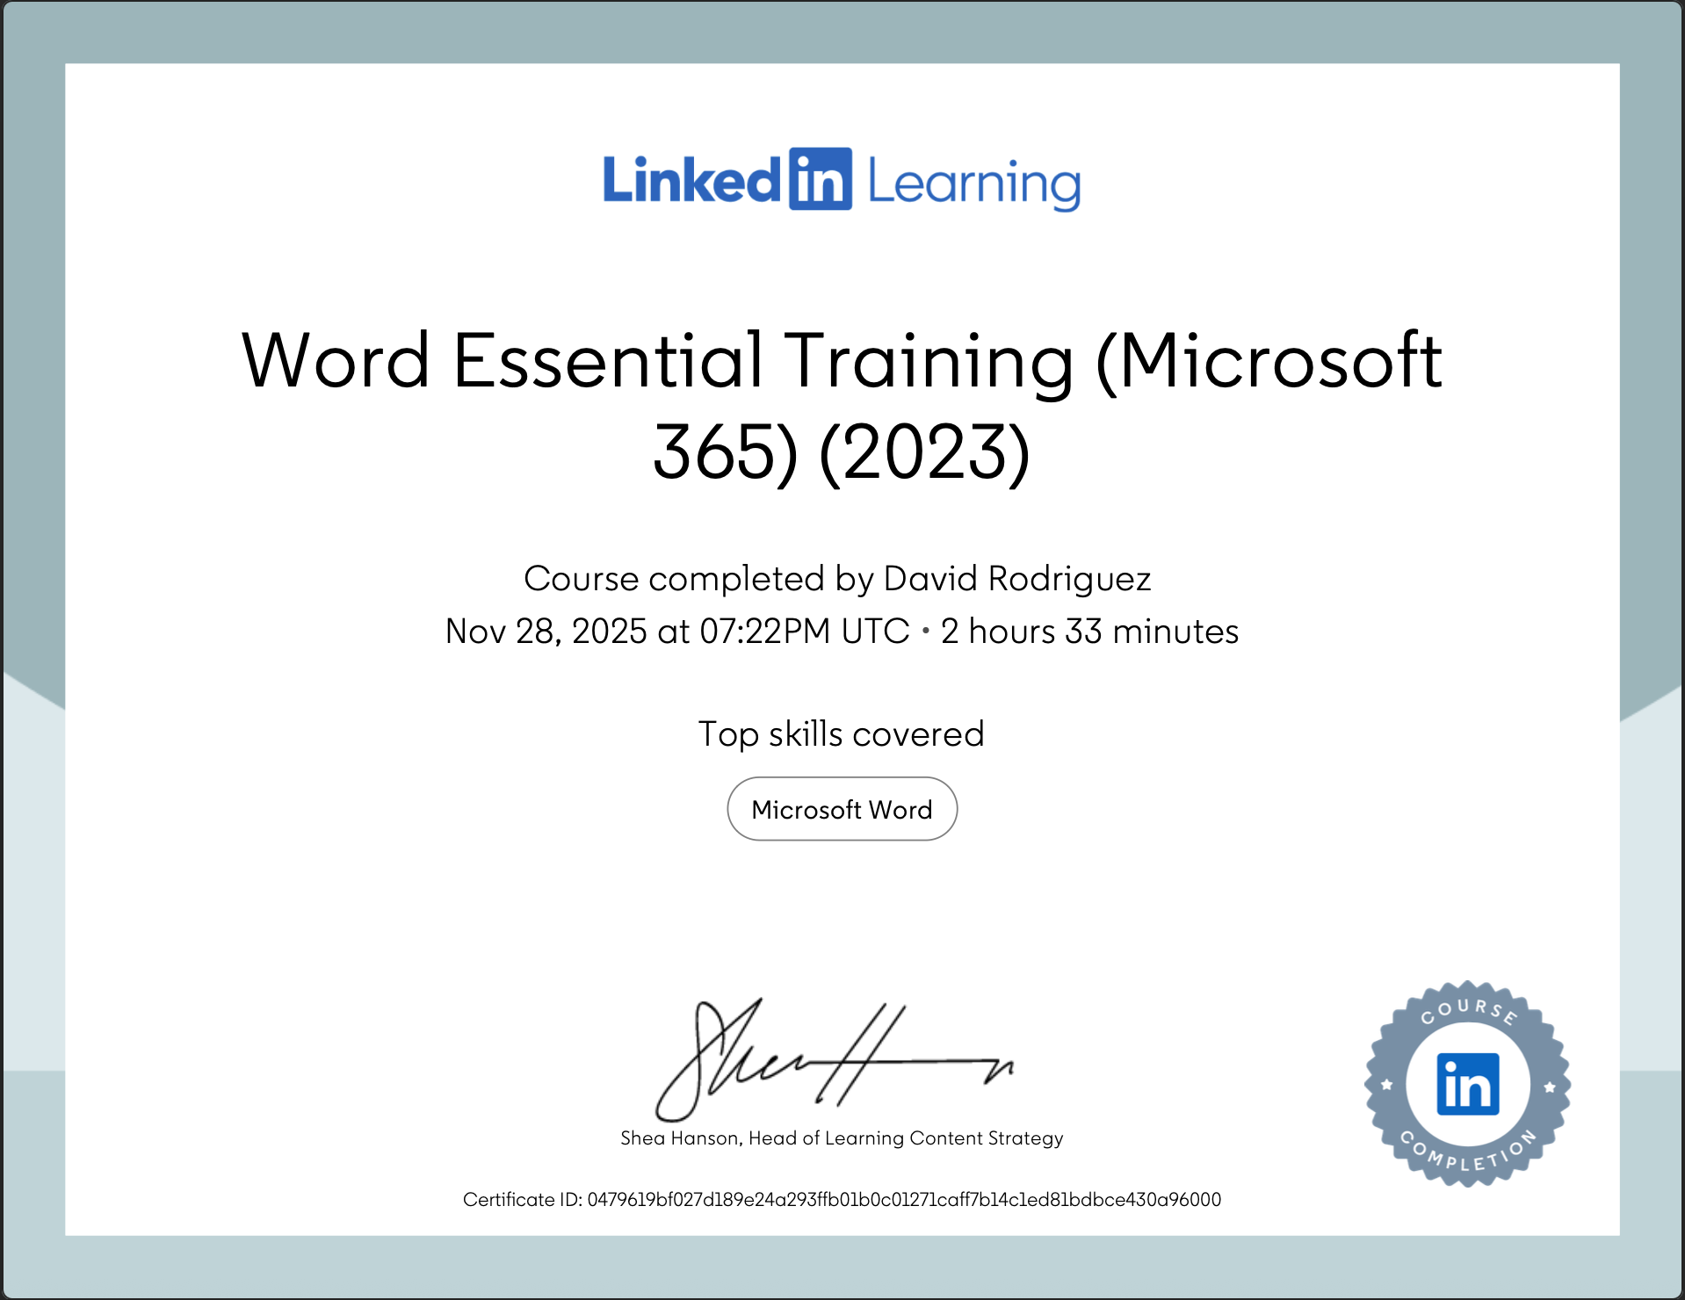
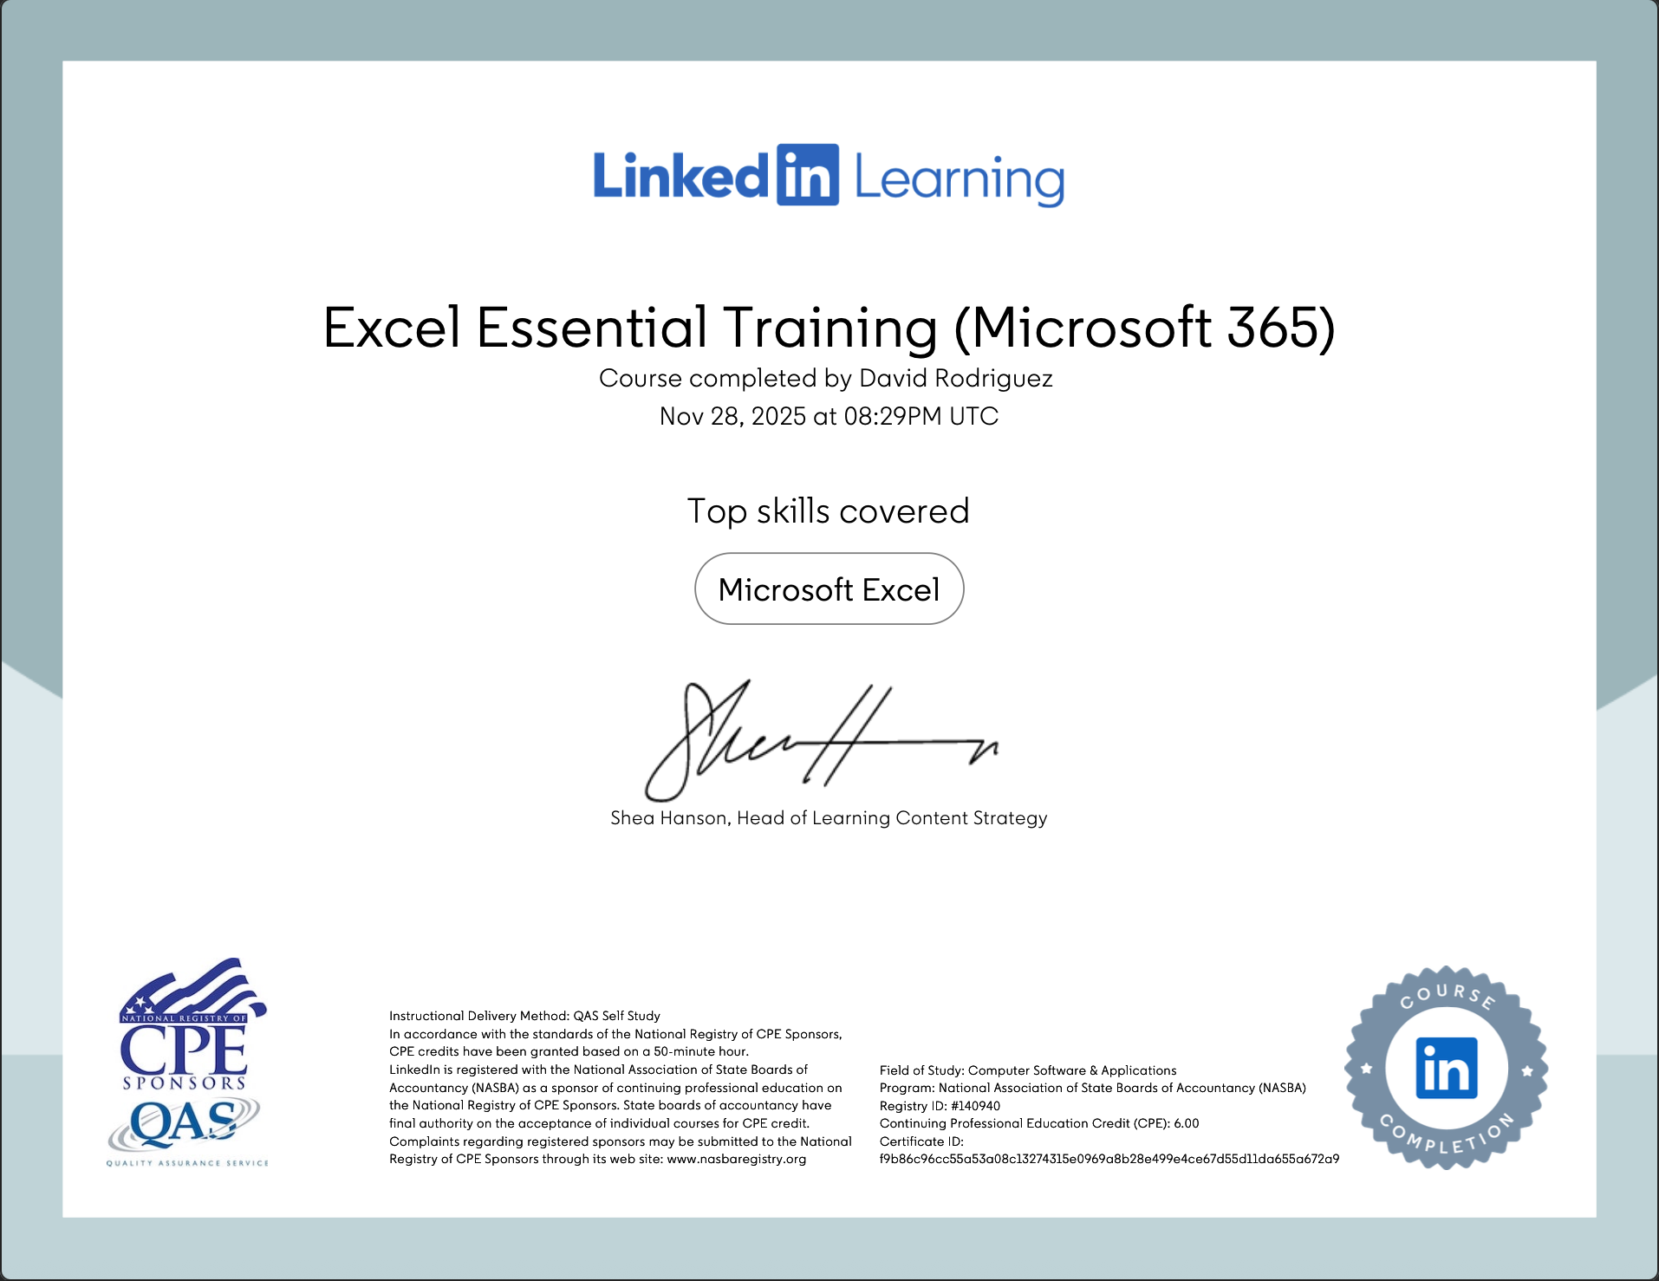
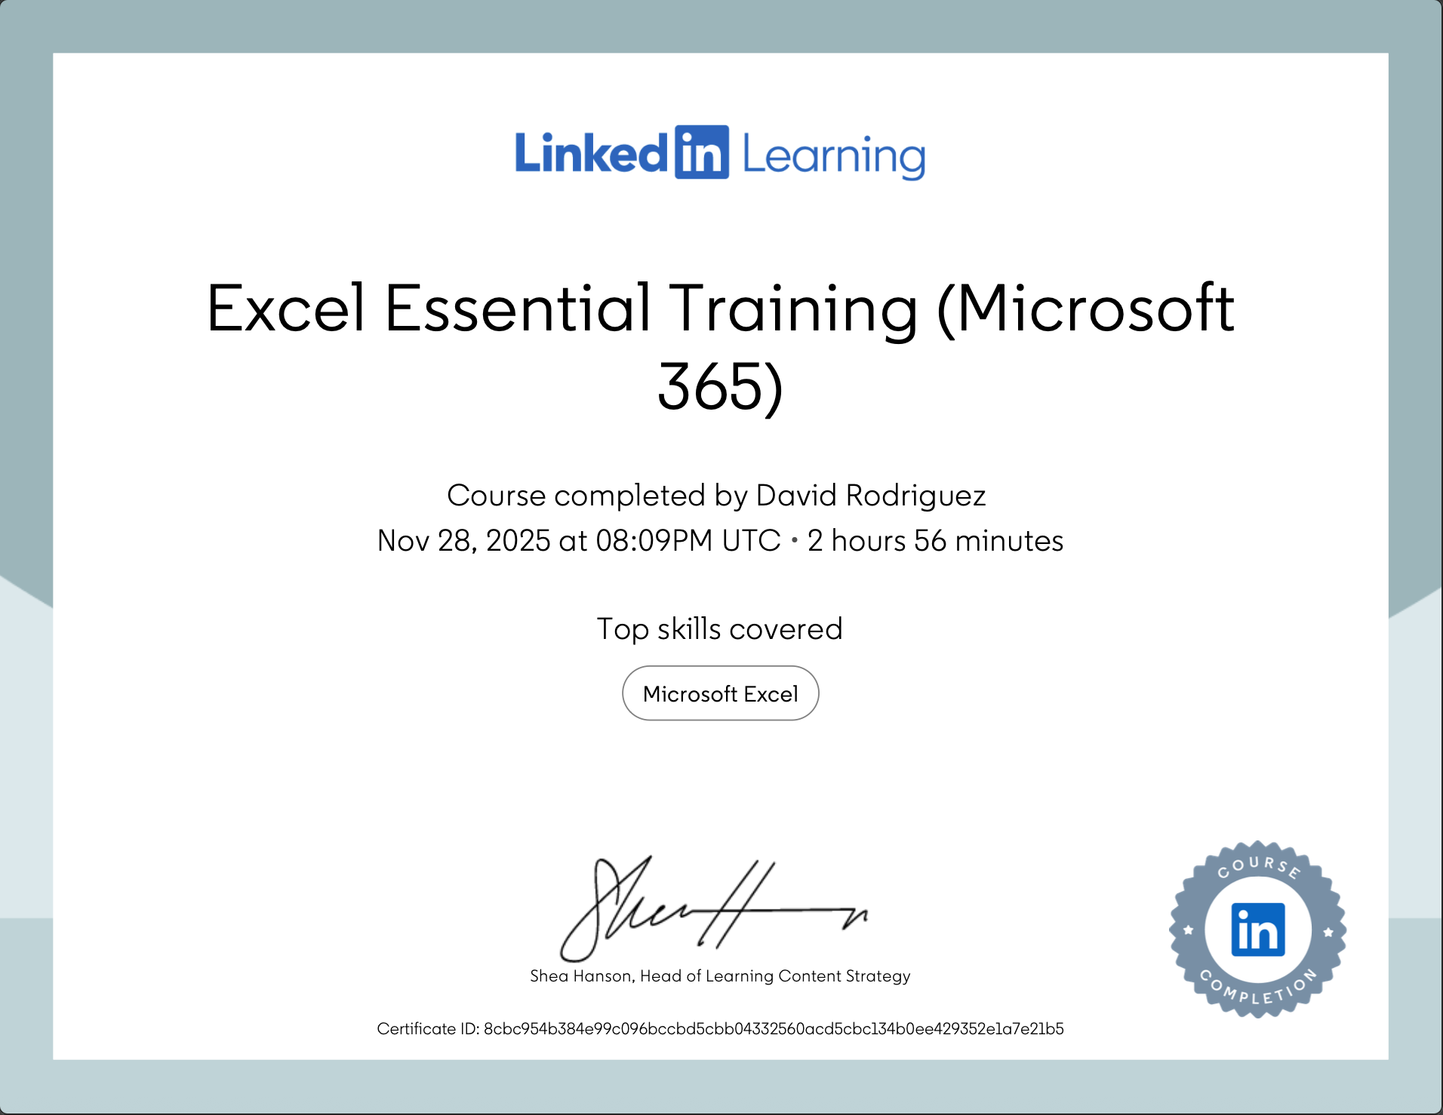
Task 3: Microsoft Excel Essay (1,000 Words)
The Importance of Microsoft Excel in Education, Business, and Everyday Life
Microsoft Excel is one of the most widely used digital tools for managing, analysing, and presenting data across academic, business, and personal environments. Its versatility and wide adoption make it an essential skill for students and professionals. This essay discusses the relevance of Excel, its core functions, and practical examples of how it supports analysis, budgeting, reporting, and decision-making. A demonstration spreadsheet is also included to showcase the application of formulas, tables, and data visualisation techniques.

Excel’s primary strength lies in its capacity for data analysis. The software enables users to collect, organise, sort, filter, and compute large amounts of quantitative information efficiently. According to Microsoft (2023), more than one billion people worldwide rely on Excel for data-related tasks, highlighting its importance in modern digital work environments. Functions such as SUM, AVERAGE, COUNTIF, VLOOKUP, and IF statements allow users to automatically calculate values and perform dynamic analyses without manual recalculation. For students, this means that research data, survey responses, or class performance statistics can be analysed quickly and accurately. For organisations, Excel provides the ability to track business performance, analyse customer trends, or evaluate operational efficiency.
Another major application of Excel is budgeting and financial planning. Individuals and households often use spreadsheets to monitor expenditure, plan monthly budgets, or track financial goals. In professional settings, Excel is widely used in accounting, project management, sales forecasting, and financial reporting. The ability to automate calculations reduces errors and increases efficiency. The household income and expenditure spreadsheet included in this portfolio demonstrates how Excel can be used to calculate total monthly spending, compare values across categories, and identify high-cost areas. By using formulas such as SUM, the spreadsheet automatically updates totals when values change. This flexibility makes Excel especially valuable for long-term financial planning and ongoing monitoring.
Reporting is another key function where Excel plays an important role. The software allows users to produce tables, visual charts, and summaries that clearly communicate data insights. Graphs such as bar charts, pie charts, and line graphs transform numerical data into meaningful visuals that improve decision-making. PivotTables add another layer of reporting power, allowing users to summarise large datasets and identify trends quickly. In academic contexts, this supports students in presenting data-driven arguments or completing research assignments. According to Jisc (2023), strong reporting skills help students interpret information effectively and communicate findings in both written and visual formats.
Excel also assists with decision-making by providing tools for scenario comparisons and forecasting. Features such as Goal Seek, What-If Analysis, and structured financial models allow users to test different assumptions and evaluate the potential outcomes. For example, a business could compare two pricing strategies to see which generates higher profit, while a student might calculate what grades are needed on remaining assignments to reach a target overall grade. These tools support critical thinking and enable more informed decision-making based on evidence rather than assumptions.
To provide practical evidence of Excel skills, I created a sample spreadsheet focusing on household income and expenditure. The worksheet includes categories such as rent, utilities, food, transport, entertainment, and savings. The use of a SUM formula allows Excel to calculate total monthly expenditure instantly. This type of spreadsheet is useful for understanding personal budgeting habits and identifying opportunities for financial improvement. Charts can also be added to visually represent spending distribution, which makes financial patterns easier to understand.
In addition, Excel’s organisational features—such as formatting tools, conditional formatting, and structured tables—support clear and accessible data presentation. Conditional formatting can highlight overspending, low values, or important deadlines. Tables improve readability and help maintain consistent formatting. Students benefit from these features when preparing academic assignments, personal schedules, or project planning documents.
In conclusion, Microsoft Excel is an essential digital tool that supports data analysis, budgeting, reporting, and decision-making across academic, professional, and personal contexts. Its powerful functions allow users to interpret complex information efficiently and present it in meaningful ways. Learning Excel strengthens digital literacy, improves employability, and equips students with the skills needed for data-driven work. The spreadsheet included in this portfolio demonstrates practical Excel skills and highlights how they can be applied in everyday financial planning. As technology continues to advance, Excel remains a foundational tool that supports accuracy, productivity, and effective digital engagement.

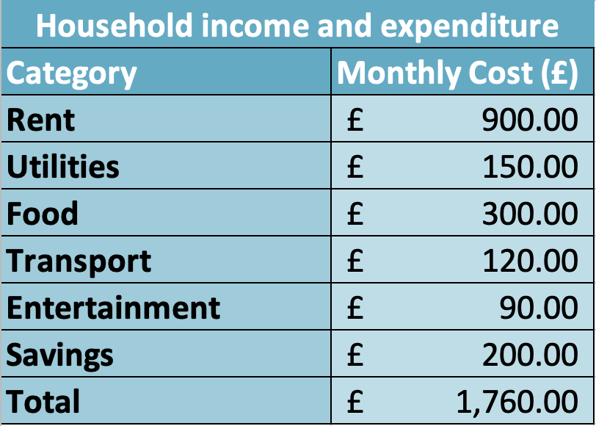
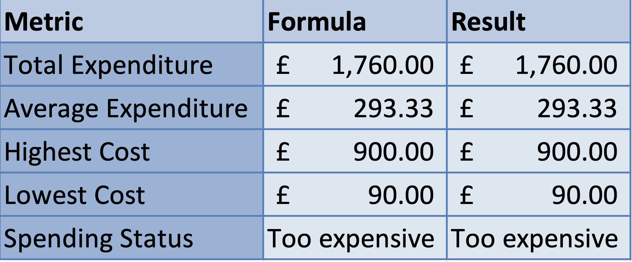

TASK 4 – Reflective Presentation
Introduction
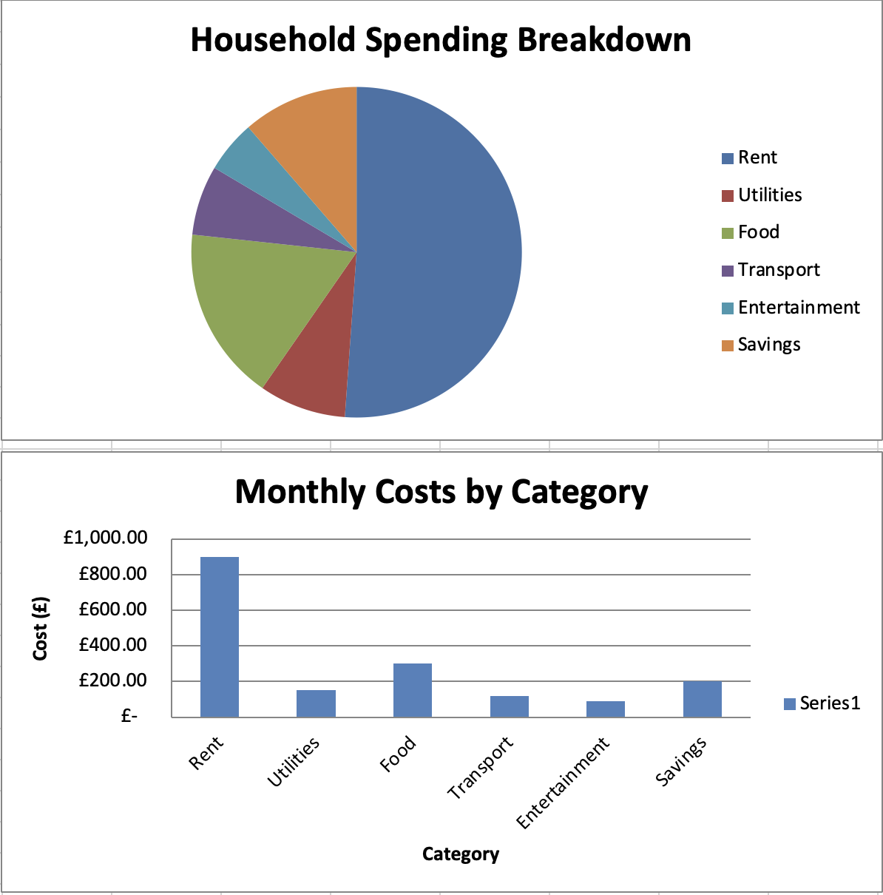
This section presents the script and slide structure for my 7-minute reflective presentation. The presentation summarises what I learned throughout the module and shows how Tasks 1, 2, and 3 helped me develop my digital skills. It also explains how I have applied these skills and how I plan to use them in my academic journey and future career.

Slide Outline (Structure of the Presentation)
Slide 1 – Title Slide
Developing My Digital Skills
Name, Student Number, Module
Slide 2 – Overview of the Module
Digital skills development
Tasks completed
Purpose of the presentation
Slide 3 – Task 1: JISC Digital Capability Assessment
Results summary
Strengths and weaknesses
Slide 4 – Reflection on Task 1
What I learned
SMART action plan
Slide 5 – Task 2: LinkedIn Learning Courses
Word, Excel, PowerPoint courses
Skills developed
Slide 6 – Evidence of LinkedIn Learning
Certificates and achievements
Slide 7 – Task 3: Excel Essay and Spreadsheet
Data skills developed
Use of formulas and charts
Slide 8 – Excel in Practice
Budget table
Visualisation (chart)
Slide 9 – How My Skills Have Improved
Before vs. after the module
Slide 10 – Application to Academic Work
Assignments
Presentations
Data analysis
Slide 11 – Application to My Career
Digital skills in the workplace
Slide 12 – Reflection and Future Goals
Areas to continue developing
Creativity and digital identity
Slide 13 – Conclusion
Summary of progress
Slide 14 – References

Full Presentation Script (7 Minutes)
Good morning/afternoon. In this presentation, I will reflect on the digital skills I have developed throughout the module “Digital Skills for Personal Development & Business.” I will explain what I learned from Tasks 1, 2, and 3, how I applied these skills, and how they will support my studies and future career.
To begin, this module gave me the opportunity to understand my current digital abilities through structured activities such as the JISC Digital Capability self-assessment, LinkedIn Learning training, and practical application using Microsoft Excel. These tasks allowed me to reflect on my strengths, identify areas for improvement, and develop confidence in working with digital tools.
In Task 1, I completed the JISC Digital Capability assessment. My results showed that I am “Proficient” in most areas, including the use of digital tools, information searching, digital communication, and managing my digital learning. However, I was rated as “Capable” in two areas: digital creativity and digital identity. This assessment helped me understand what I already do well and where I still need to grow. As part of Task 1, I created a SMART action plan to improve these areas, focusing on learning creative software and building a stronger online professional presence.
Task 2 focused on strengthening my Office 365 skills through LinkedIn Learning. I completed formal courses in Microsoft Word, Excel, and PowerPoint. These courses improved my understanding of formatting academic documents, analysing data in spreadsheets, and designing professional presentations. Completing these courses also showed me how important independent digital learning is, especially because professional platforms like LinkedIn Learning are widely used in workplaces to support continuous development.
Task 3 helped me apply digital skills in a practical way. I wrote a 1,000-word essay on the importance of Microsoft Excel and created a spreadsheet showing household income and expenditure. By using formulas such as SUM, AVERAGE, MIN, MAX and IF, and by creating a pie chart, I developed stronger data-handling skills. This practical task taught me how Excel supports decision-making, financial planning, and data visualisation, all of which are essential in both education and employment.
Overall, throughout the module, my digital skills improved significantly. Before starting the course, I mostly used digital tools for basic tasks. Now I can analyse data, create professional-looking documents, structure academic work with confidence, and communicate information visually. I also understand my digital strengths and weaknesses thanks to the JISC assessment, and I have a clear plan to continue improving.
These skills will be extremely useful in my academic life. I can now create clearer assignments, better presentations, and more organised research. Excel skills are especially valuable for university projects that require data analysis or charts. Effective digital communication and information searching will also support me in future modules.
In terms of my career, digital skills are essential in almost every profession. Employers expect strong abilities in Microsoft Office, digital communication, online collaboration, and data literacy. The skills I learned in this module will support me whether I work in business, administration, media, or any digital environment. Building a stronger digital identity will also help me in the job market by presenting my skills professionally.
To conclude, this module has helped me understand my own abilities, improve key digital skills, and prepare for future challenges. I have learned how to use digital tools more effectively, how to evaluate my progress, and how to keep improving. These skills will continue to support my academic success and open opportunities in my future professional career. Thank you.

Conclusion
The presentation demonstrates the development of digital skills through Tasks 1, 2, and 3. It shows reflection, application, improvement, and future goals, meeting all requirements of the assessment.
References (Harvard Format)
- EDUCAUSE (2023) Students and Technology Report.
- Jisc (2023) Digital Capabilities Framework.
- LinkedIn Learning (2024) Microsoft Office Courses.
- Microsoft (2023) Excel Skills for Data Analysis.
- Secker, J. & Coonan, E. (2023) UK Digital Literacy Framework.
- Walker, L. (2022) Digital Productivity Tools in the Workplace.
- Smith, A. & Turner, J. (2021) Applied Data Skills in Higher Education.
AI Acknowledgement Statement
I confirm that I have used Artificial Intelligence (AI) tools during the development of this portfolio. The AI support was limited to guidance, clarification of instructions, help with structure, language improvement, and suggestions for organisation. All academic content, critical thinking, reflections, decisions, and final wording in this portfolio represent my own understanding and original work.
AI was not used to generate any content that misrepresents my learning, skills, or personal experience. I have carefully reviewed and edited all material to ensure accuracy, relevance, and full alignment with the assessment requirements. I understand and comply with the University of Wales Trinity Saint David’s Academic Integrity Policy and take full responsibility for everything I have submitted.

