Caerau Primary School Community Garden Project

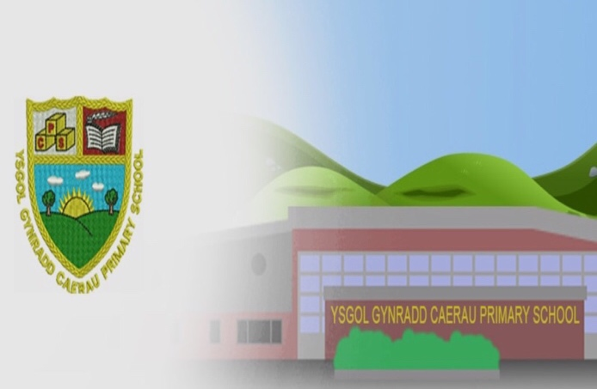
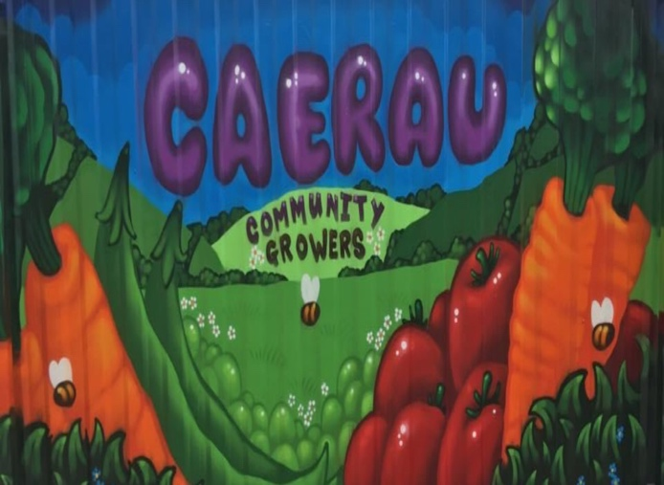

Caerau Primary School Community Garden Project
Index
1.0 Caerau Profile
1.1 Bridgend Local Authority Unitary Map
2.0 Needs Analysis
2.1 Income
2.2 Employment
2.3 Health
2.4 Education
2.5 Access to Services
2.6 Housing
2.7 Community Safety
2.8 Physical Environment
3.0 Conclusion
4.0 Caerau Primary School Community Garden Project Overview
5.0 Key Objectives
5.1 Health
5.2 Education
5.3 Poverty
6.0 Proposed Site Feasibility
6.1 Caerau Profile Following Regeneration
6.2 Proposed Redevelopment of Former Allotment Plots
7.0 Community Engagement
8.0 Collaboration of Services and Organisations
9.0 Creating the Garden
9.1 Embracing the Benefits of Community Gardening

Caerau Primary School Community Garden Project
Index continued
10.0 Funding
10.1 Charitable Trusts
10.2 Lottery Funding
10.3 Public Funding
10.4 Digital Income Generation
11.0 Sustainability
12.0 Conclusion

Caerau Primary School Community Garden Project
1.0 Caerau Profile
Caerau is demographically located two miles north of Maesteg, within the Llynfi Valley of Bridgend County Borough Council. Caerau is a former mining village, surrounded by forestry and mountainous terrain. Many of the houses within the area were purpose built in the early 1900s to house some of the 2,400 employees of North’s Navigation Company.
During World War 2, the miners of Caerau and their families were commended for continuously producing coal for the country and accepting evacuated children into their homes. The area was perceived as a close-knit community that was rich in employment. However, the closure of the coal mines during the late 1970s saw a long-term decline in the social and economic lives of residents, within the Caerau community and neighbouring valleys of South Wales (Richards, 1982), (Appendix 1) (Alden and Romaya, 1994).
During the 1980s, Caerau was engaged in a ten-year period of regeneration and growth via ‘The Programmes for Valleys’. The scheme was designed to combat the adverse social, physical, and economic effects, following the decline of the coal mining industry. Following the cessation of the scheme, the Welsh Index of Multiple Deprivation (WIMD) 1993 identified Caerau as one of the most deprived places in Wales to live, with a fifth-place ranking (Appendix 2). Subsequently, Caerau was identified as a community requiring the highest priority for the implementation of funding for regeneration, to improve the social, environmental, and economic outlook of the community (Alden and Romaya, 1994).

Caerau Primary School Community Garden Project
1.1 Bridgend Local Authority Unitary Map
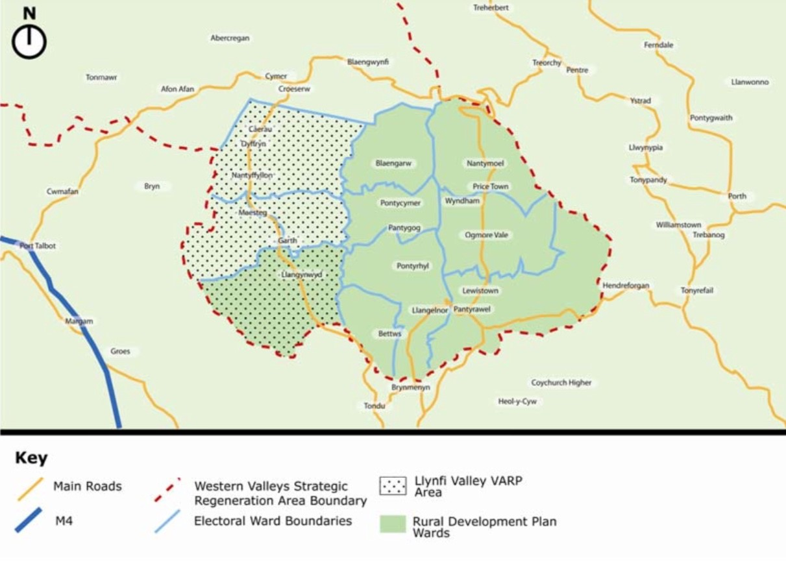
(Powell Dobson Urbanists, 2010).

Caerau Primary School Community Garden Project
2.0 Needs Analysis
Following WIMD rankings in 2014 and 2019, Caerau was recognized as one of the most deprived areas in Wales for employment, health, income, education, and community safety (Appendix 3). Statistical evidence from WIMD revealed that despite twenty-six years of priority funding, Caerau is still ranked in fifth place and described as an area with consistent ‘deep rooted’ deprivation (Appendix 4 and 5) (²Welsh Government, 2019). Within the Bridgend Local Authority, Caerau has been identified as the most deprived area of its county (¹Welsh Government, 2019).
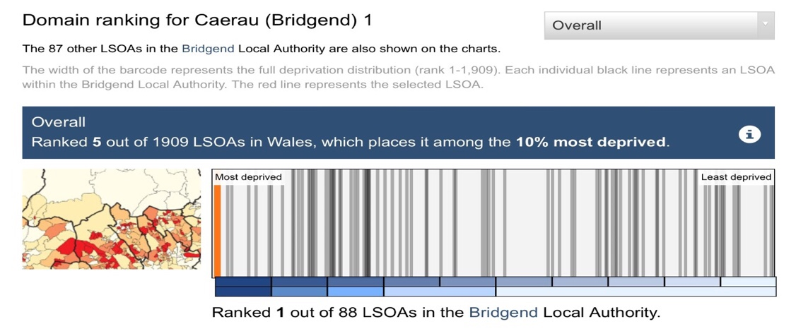
2.1 Income
Caerau is classified as one of the top 10% most deprived areas in Wales, with 46% of the population living in income deprivation. (¹Welsh Government, 2019).
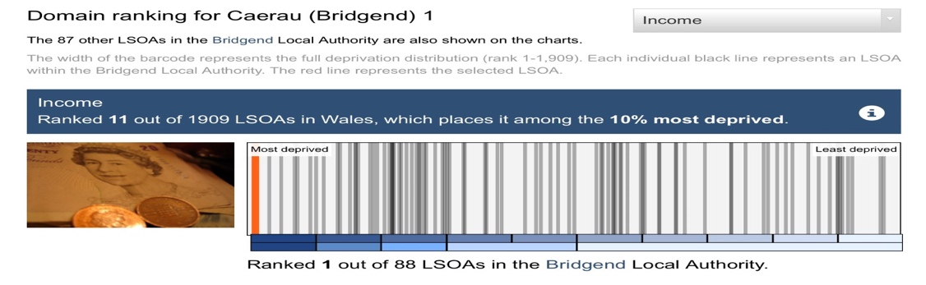
Caerau Primary School Community Garden Project
2.0 Needs Analysis continued
2.1 Income continued
The rate of income deprivation for WIMD 2019 indicated that there has been a further decrease, when compared to WIMD 2014 figures (²Welsh Government, 2019). Economic inactivity rates in Caerau are 14% higher than the Welsh average (³nomis, 2020). In addition, Caerau identifies as being the worst hit area for economic inactivity at 36.8% within Bridgend Local Authority (Appendix 6).
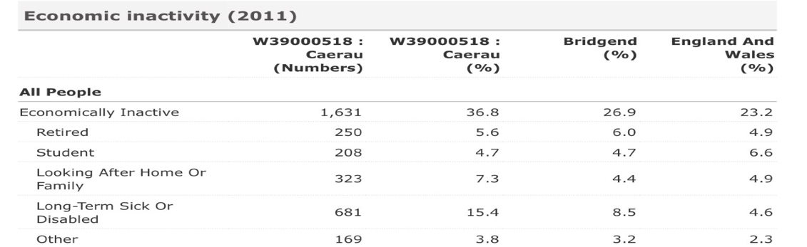
⁽²nomis, 2020).
According to the Joseph Rowntree Foundation (JRF), a household is defined as living in relative poverty if they receive less than 60% of the average United Kingdom household income, and only able to sustain the purchase of household basics (²Welsh Government, 2020). According to the ³Welsh Government (2020), 23% of the Welsh population during 2018-19 lived in relative income poverty. Furthermore, children were most at risk, with 28% subjected to relative income poverty (³Welsh Government, 2020).
Households with below average income are highly likely to endure material deprivation from not having sufficient access to goods and services. Latest figures from the Welsh Government 2018-19, show that 11% of children and 8% of pensioners in Wales were in material deprivation and at risk of food poverty (⁴Welsh Government, 2020).
Caerau Primary School Community Garden Project
2.0 Needs Analysis continued
2.2 Employment
The 2019 edition of the WIMD profile identifies Caerau as one of the most deprived areas in Wales for employment. Across all categories it has the highest rate of unemployment, naming it a ‘hard pressed community’ (²Welsh Government, 2019).
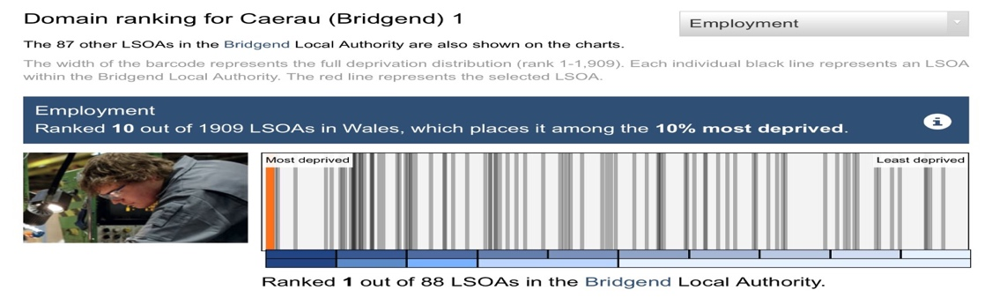
Unemployment rates in Caerau are 5% higher than the Welsh average (²nomis, 2020). In addition, Caerau identifies as being the second worst hit area for unemployment at 12.8% within the Bridgend Local Authority (Appendix 7).
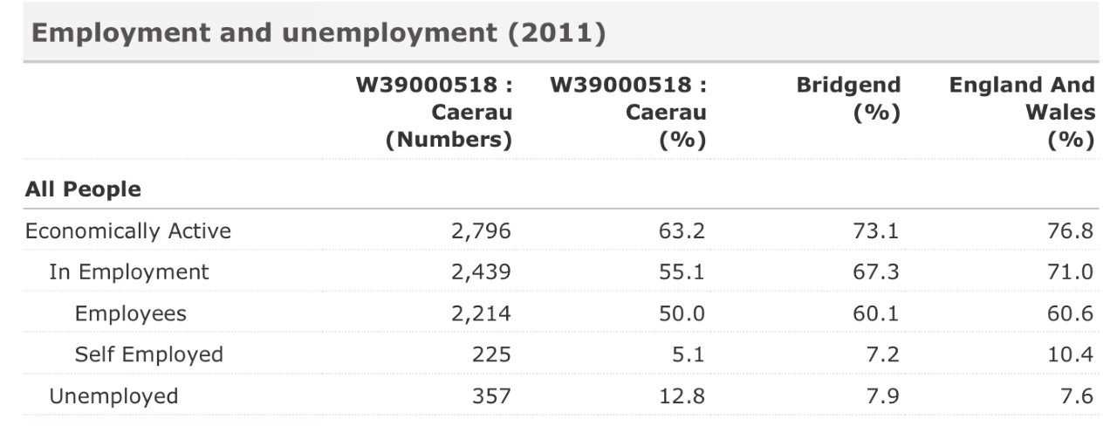
Furthermore, Caerau saw an increase in the WIMD 2019 rate of employment deprivation, when compared to WIMD 2014 figures (Appendix 1.2). The rate of employment deprivation is calculated by measuring the amount of working age persons in receipt of employment related benefits. According to WIMD 2019, the valleys of South Wales displayed elevated levels of employment deprivation (Appendix 8) (²Welsh Government, 2019).
Caerau Primary School Community Garden Project
2.0 Needs Analysis continued
2.3 Health
The 2019 edition of the WIMD profile identifies Caerau as one of the most deprived areas in Wales for health. Key health domain results for WIMD 2019 indicated that there has been a further decrease, when compared to WIMD 2014 figures (²Welsh Government, 2019).
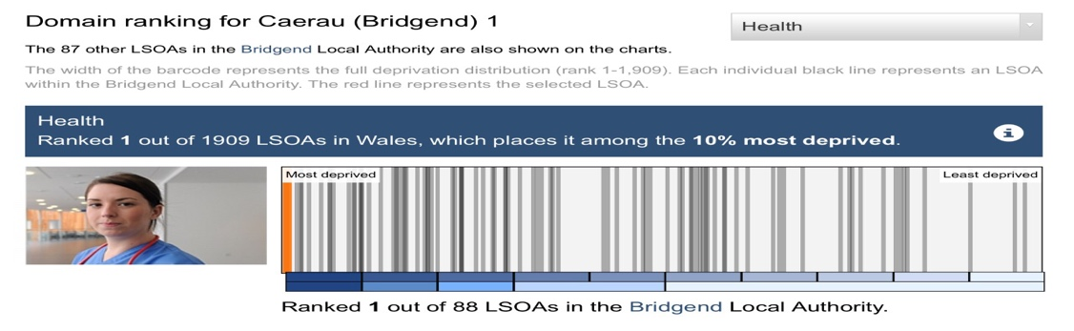
People registered as long-term sick or disabled in Caerau are four times greater than that of the Welsh average. In addition, Caerau is recognized as one of the worst areas for the domain of health within the Bridgend Local Authority (²nomis, 2020).
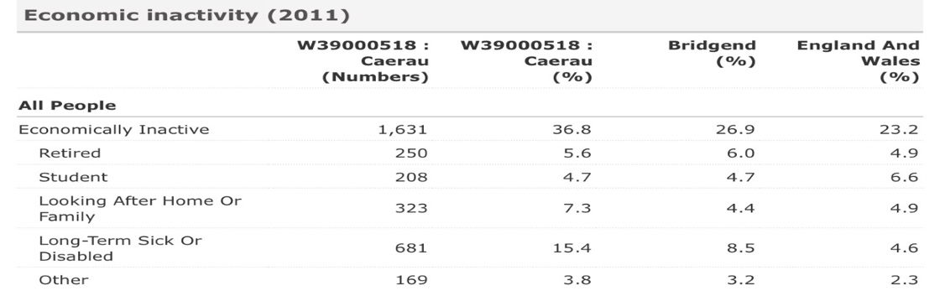
Furthermore, the South Wales valleys displayed high pockets of health deprivation when compared to other areas in Wales (Appendix 9). The health domain measures seven key indicators that capture the status of Caerau’s population. Caerau has a resident population of 4289, of which a quarter are retired, long-term sick or disabled (³nomis, 2020).

Caerau Primary School Community Garden Project
2.0 Needs Analysis continued
2.4 Education
Caerau is classified as one of the top 10% most deprived areas in Wales for the domain of education. Within the Bridgend Local Authority, Caerau is ranked first place for deprivation relating to education (¹Welsh Government, 2019).
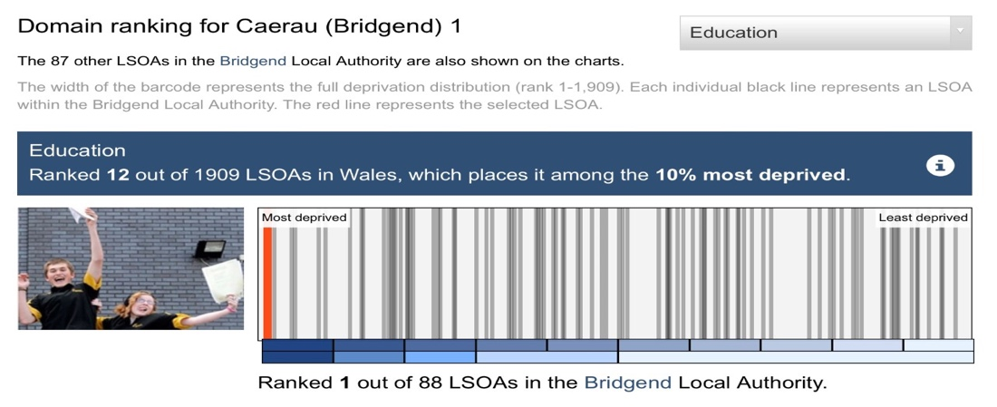
Statistical evidence shows that the number of people in Caerau with no qualifications is more than double the Welsh average at 37.1%. In addition, Caerau is recognized as the second worst place for the domain of education with no qualifications in the Bridgend Local Authority (Appendix 10) (²nomis, 2020). Furthermore, the South Wales valleys displayed high pockets of education deprivation when compared to other areas in Wales (Appendix 11).
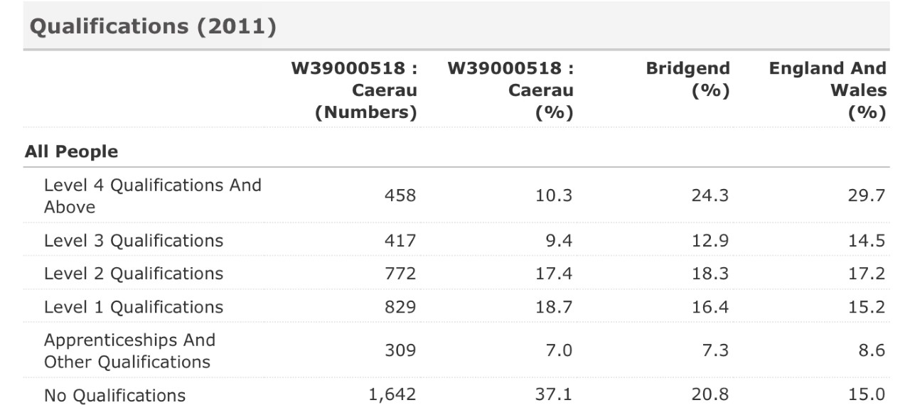
Caerau Primary School Community Garden Project
2.0 Needs Analysis
2.4 Education continued
According to WIMD (2019), 26% of Caerau’s population is under the age of 16 and in attendance of full-time education. Furthermore, 32% of Caerau’s population has dependent children, compared to 28% for Wales. However, engaging children in education is foreseen as a priority in accordance with the Well-being of Future Generations (Wales) Act 2015 (²Welsh Government, 2015).
2.5 Access to Services
The 2019 edition of the WIMD profile places Caerau amongst the top 10-20% most deprived areas in Wales for the domain of Access to Services. Within the Bridgend Local Authority, Caerau is ranked fourth place for deprivation relating to Access of Services (¹Welsh Government, 2019).
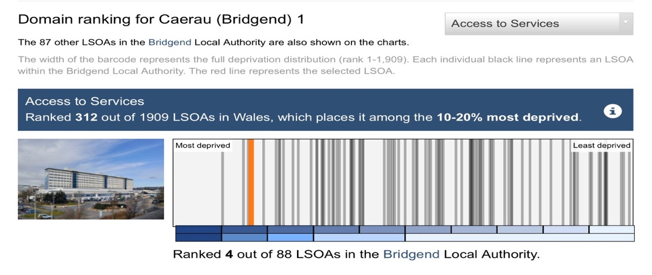
According to the ¹Welsh Government (2019), deprivation linked to Access of Services negatively affects the day-to-day living for households in the affected community. This directly correlates to material and social deprivation. Material deprivation affects a person’s ability to access food shopping and is therefore a need which is considered essential. Whereas aspects of social deprivation can include a person’s desire to attend after school clubs and is considered more of a want in preference of a need.
Caerau Primary School Community Garden Project
2.0 Needs Analysis continued
2.6 Housing
The 2019 edition of the WIMD profile places Caerau among the 50% least deprived areas in Wales for the domain of Housing. Within the Bridgend Local Authority, Caerau is ranked in thirty third place for deprivation relating to Housing. However, within the community of Caerau 49% of housing is rented. Furthermore, of the houses occupying the rental market, 39% of it is socially rented compared to the Welsh average of 16% (Appendix 12) (¹Welsh Government, 2019).
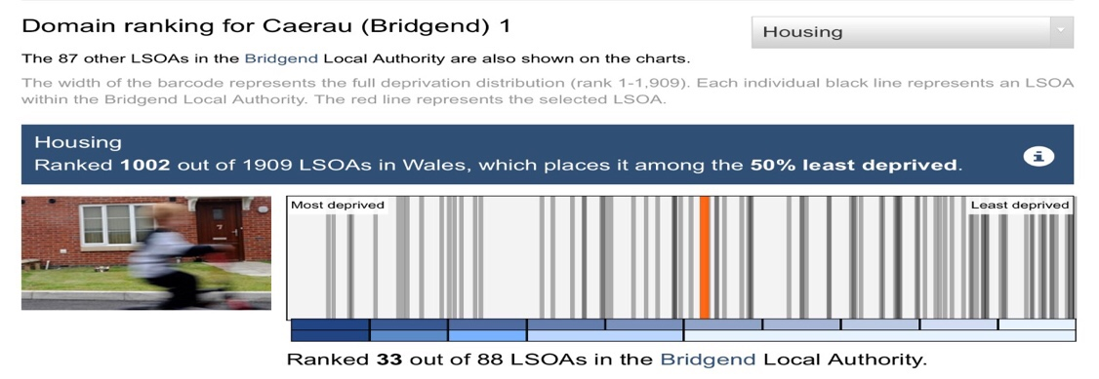
2.7 Community Safety
The 2019 edition of the WIMD profile places Caerau among the top 10% most deprived areas, for the domain of Community Safety. Within the Bridgend Local Authority, Caerau is ranked in second place for deprivation relating to community safety (¹Welsh Government, 2019).
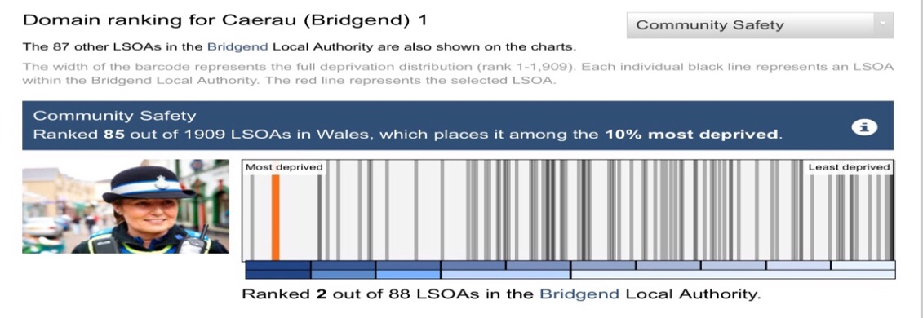

Caerau Primary School Community Garden Project
2.0 Needs Analysis continued
2.7 Community Safety continued
According to WIMD 2019, Community Safety results for Caerau were consistent with other key results showing high pockets of deprivation in the South Wales valleys (Appendix 13). In addition, patterns of deprivation relating to community safety were consistent with figures obtained for WIMD 2014 (¹Welsh Government, 2019).
According to UKCrimeStats (2020), there were 757 crimes reported in the Caerau area between November 2019 – October 2020, of which:
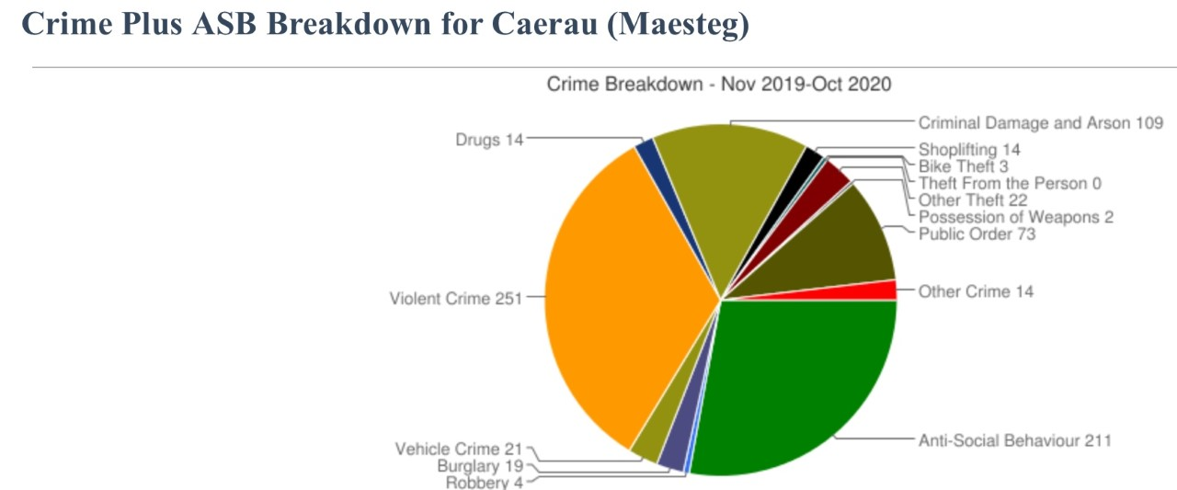
Caerau was further identified as having the highest numbers of crime within its five-mile radius for October 2020 (Appendix 14) (UKCrimeStats, 2020).
2.8 Physical Environment
The 2019 edition of the WIMD profile places Caerau among the 50% least deprived areas for the domain of Physical Environment. Within the Bridgend Local Authority, Caerau is ranked in fiftieth place for deprivation relating to physical environment (¹Welsh Government, 2019).

Caerau Primary School Community Garden Project
2.0 Needs Analysis continued
2.8 Physical Environment continued
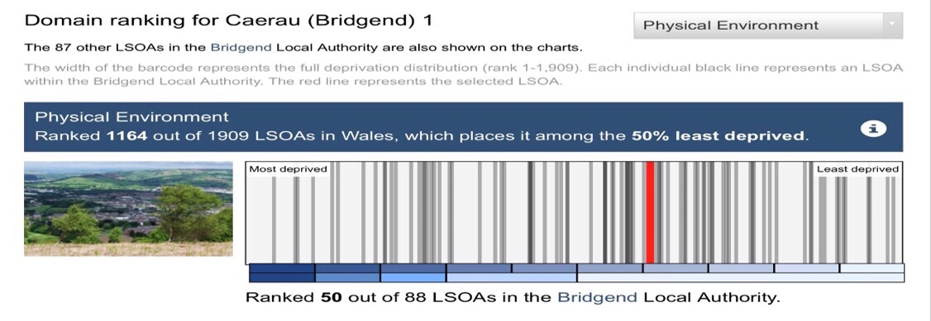
The WIMD 2019 profile identified the South Wales valleys as having the least deprivation relating to physical environment (Appendix 15) (¹Welsh Government, 2019).
3.0 Conclusion
Closer analysis of the WIMD 2019 deprivation profile has revealed pockets of domain deprivation for Caerau. Within the domain of Health, Caerau has been identified as the most deprived area in Wales. Within its population, the number of people registered as long-term sick or disabled is four times higher than the national Wales average (²Welsh Government, 2019).
Improvements to access of services and housing can help to reduce health inequalities between individuals. According to the ¹Welsh Government (2015), health inequalities experienced in areas of deprivation include low birth weight, healthy life expectancy, dental health, physical activity, mental health.
Furthermore, Caerau is amongst the top ten most deprived areas for the domain of Employment, with the highest rate of unemployment across all categories in Wales, identifying it as a ‘hard-pressed community’ (²Welsh Government, 2019). In the absence of employment opportunities, residents in the community are more likely to identify as economically inactive (²Welsh Government, 2020).
Caerau Primary School Community Garden Project
3.0 Conclusion continued
During 2016-17, 46% of Caerau’s population endured income poverty and material deprivation, which can increase the risk of food poverty. To reduce the impact of poverty, employment training and support programmes, are perceived as an essential strategy to engage persons from workless households in sustainable employment opportunities (¹Welsh Government, 2015)
In addition, the WIMD 2019 profile placed Caerau within the top 10% most deprived areas for the domains of Education, and Community Safety, whilst Access to Services was identified as one of the most deprived areas in Wales. Within the community, the number of people registered with no qualifications was double that of the national Wales average. A lack of educational qualifications coupled with difficulties in accessing services, could inadvertently explain the consistently elevated levels of crime relating to the domain of Community Safety.
Furthermore, Caerau has elevated levels of households with dependent children of which 26% are registered as under 16 years of age - 8% higher than the Welsh average. In addition, a further 25% of the population are registered as retired.
To improve the prospects of the community, it is proposed to initiate a community school garden scheme to tackle areas of domain deprivation. Children, parents, and members of the community will work together to create an area which will promote the educational and well-being benefits of community gardening whilst creating a sense of respect and pride for the community. Working in collaboration with key partnerships is an effective strategy to tackle poverty premium and is therefore perceived as an essential need for the regeneration of the community.

Caerau Primary School Community Garden Project
4.0 Overview
According to Local Government Improvement and Development (2010), the health of a community is determined by a range of social, economic, and environmental factors. However, the elements within each, are not always easy to influence or control due to limiting factors. A lack of income, poor access to healthcare and inappropriate housing can affect the health of not only individuals but also communities.
Strategies which contribute to improving the health of a community, include providing support to improve social bonds and establish positive health patterns, which can lead to a healthier lifestyle. In addition, raising the educational outcomes of the community helps to improve well-being and reduce health inequalities (Local Government Improvement and Development, 2010).
Tackling health inequalities is foreseen as a priority in narrowing the gaps in health for communities which are perceived as disadvantaged, in accordance with the Well-being of Future Generations (Wales) Act 2015. The Act is designed to address challenges which affect the economic, social, cultural, and environmental well-being of Wales, via its seven well-being goals (²Welsh Government (2015).
The Act is legislatively responsible for creating and sustaining a healthier Wales by providing opportunities for people to make good choices regarding their mental and physical health, irrespective of their socio-economic circumstances and background. Adopting this approach helps to reduce health inequalities in areas of deprivation in accordance with the Inverse Care Law (Akbari et al., 2018). According to StatsWales (2020) the average life expectancy for residents of Bridgend borough is on average seventeen months less than that of the national average for Wales (Appendix 16).

Caerau Primary School Community Garden Project
4.0 Overview continued
In addition, the general health of Caerau residents is perceived as poor with 15.4% of the population registered as long term sick or disabled, which is negatively impacting the economic health of the area as residents are less likely to be economically active. According to ¹Welsh Government (2015), persons enduring economic inactivity are more likely to suffer with poor mental and physical health thus increasing the likelihood of living in poverty.
According to the ¹Welsh Government (2015), a strong economy which offers sustainable, well-paid employment to all persons is the most positive approach to tackle poverty. However, access to well paid, sustainable jobs is often dependent on a person’s educational attainment and level of skills. Early intervention is key to addressing the gap between poverty and educational attainment.
Raising attainment levels amongst pupils from deprived backgrounds is key to narrowing the gap in educational attainment and poverty. According to the ¹Welsh Government (2015), barriers to education can be addressed through early intervention and working in collaboration with key partnerships, including Families First and Flying Start.
However, Caerau is ranked in fourth place for deprivation relating to Access of Services. Deprivation in this domain could be a limiting factor in narrowing the gap in health, educational attainment, and poverty. Households subjected to this domain of deprivation are subjected to material and social deprivation leading to inequalities in health.
To address deprivation relating to the domain of Access to Services, it is hereby proposed to initiate a community school garden project at Caerau Primary School. In addition, the project will encompass issues of deprivation relating to health, education, and poverty.

Caerau Primary School Community Garden Project
5.0 Key Objectives
5.1 Health
Reduce the impact of social, economic and environment determinants of health by:
- Ensuring children are given the best start in life by reducing the impact of poverty and deprivation
- Promoting positive mental and physical well-being
- Promoting the benefits of a healthy diet
- Promoting the positive benefits of physical exercise (Public Health Wales (PHW), 2016).
According to the British Medical Association (2017), poverty in early childhood is associated with low birth weight, chronic diseases, obesity, and reduced life expectancy (Appendix 17). Furthermore, poverty can affect children's cognitive development and mental health, leading to implications in later life. People from lower socio-economic groups and communities are more likely to suffer with long-term health conditions which include diabetes, hypertension, and chronic obstructive pulmonary disease. In addition, children exposed to poverty are more likely to engage in unhealthy behaviours as they develop (Appendix 18).
In accordance with ‘Prosperity for All: the national strategy,’ the Welsh Government implemented strategies to address good health, recognizing the key role schools play in encouraging healthy lifestyles amongst children. Embedding the importance of a healthy lifestyle is key to ensuring good health in later years. In areas of deprivation, to ensure all children endure a good start in life, access to the provision of Flying Start and Families First is recommended. Furthermore, innovative approaches should be provided to communities to encourage active lifestyles, which promote good physical and mental health (²Welsh Government, 2017).

Caerau Primary School Community Garden Project
5.0 Key Objectives
5.1 Health continued
According to Thompson (2018), exposure to green spaces and gardening benefits our physical and mental health as advocated in The Guardian (2020) (Appendix 19). Research studies by Beyer et al., (2014) found that daily interaction with the natural environment, had long-term benefits on health. Recommendations from the study, included utilizing exposure to the natural environment as a form of preventative medicine to address areas of physical and mental health concerns. This notion is fully supported by PHW (2016) and the World Health Organisation, as a strategy to build better environments and healthier communities.
5.2 Education
Reduce the impact of social, economic and environment determinants of education by:
- Advocating early years intervention
- Encouraging children to develop their full potential in life
- Encouraging life-long learning.
- Improving residents' skills and employability (PHW), 2016).
According to the ²Welsh Government (2017), early childhood experiences are critical in ensuring children lead a healthy, fulfilling, and prosperous life. Strategies to advocate this notion, include early engagement with Flying Start and Families First to address the long-term needs of the community.
Encompassing early intervention strategies, this project will endorse educational activities to support all six Areas of Learning of the Curriculum for Wales, to create learners who are:
- Ambitious and capable
- Enterprising and creative contributors to society
- Healthy and confident individuals
- Informed and ethical citizens (¹Welsh Government, 2020).
Caerau Primary School Community Garden Project
5.0 Key Objectives
5.2 Education continued
In addition, it is anticipated that the school will become a community hub, offering opportunities for the acquirement of new skills and community educational via the community garden. Encompassing this approach long-term will encourage life-long learning to improve the skills of resident, thus increasing employment opportunities. This notion is endorsed by ‘Prosperity for All: the national strategy’ (²Welsh Government, 2017) and PHW (2016) as a strategy to reduce social, health and economic inequalities.
5.3 Poverty
Reduce the impact of social, economic and environment determinants of poverty by:
- Ensuring children are given the best start in life
- Providing support to the community to improve key skills and employment opportunities
- Enhance the well-being of the community by reducing the prevalence of alcohol and smoking (PHW, 2016).
According to the British Medical Association (2017), living in poverty affects a person’s life chances. Reducing the prevalence of food poverty amongst households is perceived as a strategy to ensuring children are given the best start in life. Food poverty amongst low-income households is rising due to varying factors, including affordability and availability of consumables, education and cooking skills.
Strategic action recommended to tackle food poverty, includes the development of key skills for families utilizing Families First programmes. Working in collaboration with key partnerships is an effective strategy to tackle poverty premium and regenerate the well-being of the community ¹Welsh Government (2015).

Caerau Primary School Community Garden Project
6.0 Proposed Site Feasibility
Adjacent to Caerau Primary School is a derelict area of land that was formerly utilized as public allotments. However, the plot of land has fallen into disrepair over the years and is projecting an unsightly view to members of the community. In addition, it is negatively impacting upon the benefits of recent regeneration work carried out in the area, intended to improve the rural projection of the valley.
Indigenous land to the rear of the proposed plot was reclaimed by Bridgend County Borough Council and reprofiled to create areas of broadleaf deciduous woodland, walking trails and a cycle path (Figure 6.1). The rural profile of the area significantly improved and is projected to positively impact upon the community’s health. However, adjacent to the walking trail and cycle path is the former allotment site which, in its current state is unsightly. Consequently, this could be foreseen as a barrier to engaging in the health benefits of the previous regeneration work.
Access to the plot of land is via a public footpath and footbridge which runs adjacent to Caerau Primary School. Children from the primary school can access the land via a school gate positioned directly adjacent to the footbridge. However, the proposed site for redevelopment is currently closed to members of the public and is only accessible via Bridgend County Borough Council upon request.
Upon inspection of the plot, it is evident that the land was effectively utilized as a community area, to reap the benefits of growing local foodstuffs. However, the land is currently overgrown with vegetation and brambles and is in much need of regeneration. There appear to be eight areas of designated growing areas, which are complimented with redundant sheds which do not appear to be strong in structure. The plot has permanent access to running water via a stream that runs under the footbridge.

Caerau Primary School Community Garden Project
6.0 Proposed Site Feasibility continued
Analysis of HM Land Registry has identified that the land is owned by Bridgend County Borough Council. Furthermore, the land has been designated as unsuitable for urban development due to the proximity of the stream and former usage of land. Therefore, in conjunction with the long-term regeneration development plans for Caerau, redevelopment of this incongruous area of land would positively impact the pupils of Caerau Primary School and the community.
Figure 6.1 Caerau Profile Following Regeneration
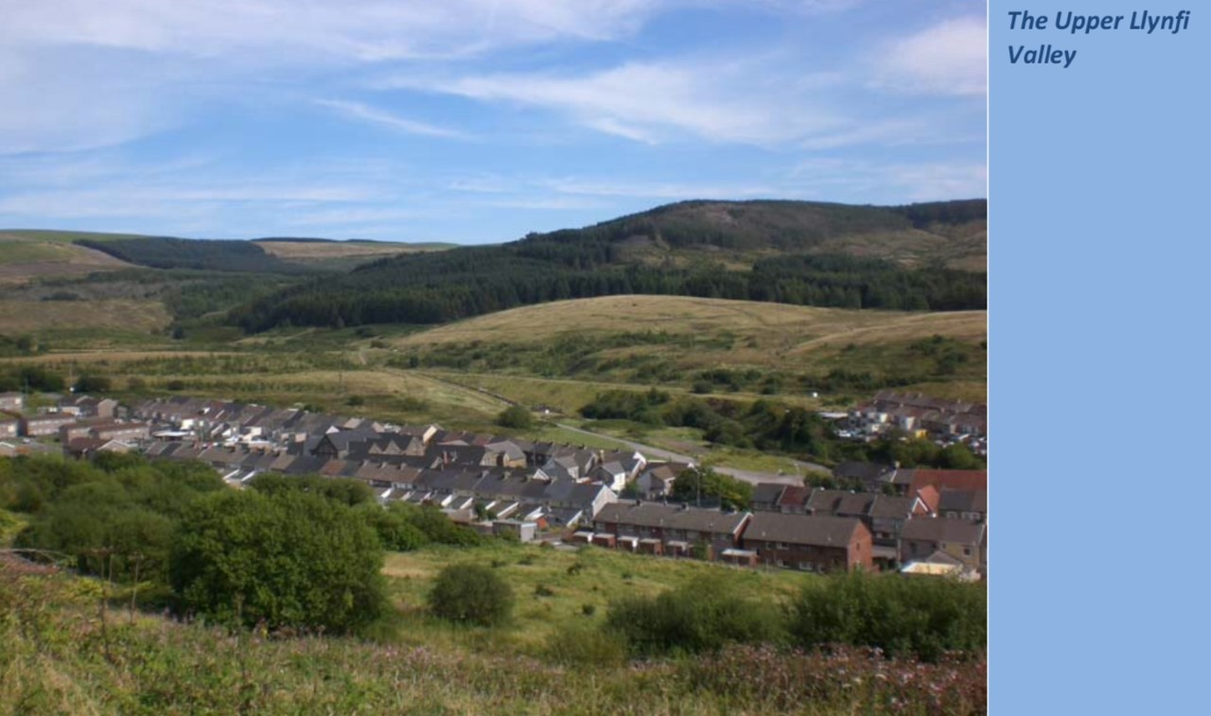
Figure 6.2 Proposed Redevelopment of Former Allotment Plots
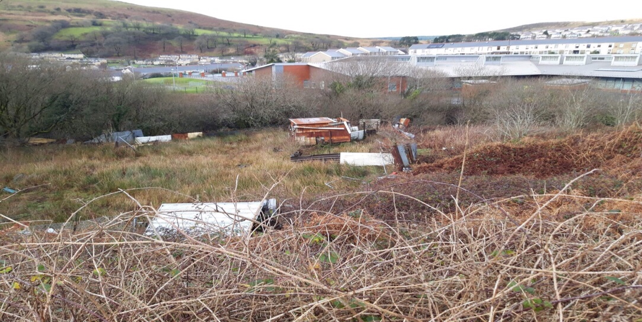
Caerau Primary School Community Garden Project
7.0 Community Engagement
According to the Federation of CITY FARMS & COMMUNITY GARDENS (2021), there is increasing evidence which supports the benefits of communal growing, outdoor education and green spaces for mental and physical health. Given the proximity of Caerau Primary School to the proposed site for regeneration, this will be the initial point of reference for engagement of the community.
In accordance with the requirements of the Foundation Phase, school children aged 3 to 7 years are actively engaging in experiential learning, utilizing the outdoor environment (Welsh Government, 2009). Furthermore, the Curriculum for Wales supports outdoor learning for all children, advocating the provision of Forest Schools (¹Welsh Government, 2020).
According to the Welsh Government (2009), outdoor play supports the holistic development of children. To ensure children effectively partake in outdoor learning, effective partnerships are recommended between parents, carers, practitioners and the whole community. Engaging families via their children is an effective strategy to involving the wider community and the sharing of good practice.
Children from across all Key Stages of the school were initially engaged in classroom activities linked to the promotion of the project. The activities included home/school tasks, in a bid to further engage the wider family network. In addition, the school’s Parents Teacher Association promoted a competition aimed at each Key Stage, to create a poster promoting the next stage of engagement ‘The Wishing Tree.’
The ‘Wishing Tree’ was created in the school grounds with children from the school’s Eco Committee and Healthy Schools. Members of the community alongside parents, children and practitioners were asked to share their ideas on the vision for the project. The ‘Wishing Tree’ was a valued asset in engaging persons and sharing ideas.

Caerau Primary School Community Garden Project
7.0 Community Engagement continued
To promote the next stage of the project, it is the intention to share ideas and visions during the half time interval of the next school performance, which is aptly themed. Details of interested personnel will be recorded and later invited to partake in a meeting after school, where it will be the intention to work towards the formation of a primary stakeholder committee, to include interested members of the community, children, parents, and grandparents.
To ensure the project profile is continually raised within the community, it is the intention to create various social media platforms to share news of forthcoming events in relation to the project. However, a lack of access to internet facilities could be foreseen as a barrier to engagement. Subsequently, letterbox posting will be undertaken to all residents in the form of a newsletter with details of advancements and forthcoming events in relation to the project. This form of engagement is undertaken to attract and widen the participation of secondary stakeholders.
8.0 Collaboration of Services and Organizations
According to the Welsh Government (2009), outdoor learning is most effective when partnerships are established between the whole community, parents/carers, and practitioners. Collaborative working is considered a valued asset when planning and creating an outdoor provision. Therefore, it is projected that primary stakeholders will engage with tertiary stakeholders to heighten the chances of success.
Caerau is recognized as one of the most deprived areas in Wales in terms of employment, health, income, education, and community safety (²Welsh Government, 2019). In accordance with the Well-being of Future Generations (Wales) Act 2015, legislation was placed upon neighbouring public bodies to address the social, environmental, economic, and cultural well-being concerns of Caerau (²Welsh Government, 2015).

Caerau Primary School Community Garden Project
8.0 Collaboration of Service and Organizations continued
To encompass the intentions of the Act, the ²Welsh Government (2017) established a national strategy to address five priority areas of concern: Early Years, Social Care, Housing, Skills and Employability and Mental Health. Furthermore, the strategy identified a need for collaboration between public services and voluntary sector partnerships. Working together is considered essential in delivering long-term objectives for the community encompassing early intervention and a people centred approach.
Consequently, Caerau is rich in all aspects of early intervention encompassing public services and voluntary organizations. Early childhood public service intervention is provided to the residents of Caerau via Flying Start, Families First and PHW in accordance with the Well-being of Future Generations (Wales) Act 2015.
Flying Start provision is offered to all families in Caerau with children under the age of four. Free childcare, parenting support and help with early language development is available (Bridgend County Borough Council, 2021). In addition, Flying Start collaborates with PHW to ensure early childhood health issues are addressed (PHW, 2021).
Similarly, Families First provides support to whole families focusing on early intervention and prevention. Support is appropriate to the needs of each family and aimed at building and developing resilience in a bid to improve the longer-term objectives for families. Early intervention is adopted as a strategy to avoid future costly, remedial care (¹Welsh Government, 2017).
According to Community Insights (2016), Caerau has a high success rate of engaging residents with community and voluntary organizations. As a result, there is a plethora of available community groups. Following the success of the ‘Wishing Tree,’ several groups were identified as potential candidates for engagement, including Caerau Market Garden, Caerau Men’s Shed Caerau Development Trust and Creative Learning Through the Arts.

Caerau Primary School Community Garden Project
8.0 Collaboration of Service and Organizations continued
Engaging in partnerships which encompasses population and cultural differences, facilitates a sense of change via social mobilization. In addition, partnership group members possess beneficial skills which can be utilized to enhance the development of this project.
Consequently, it is the intention to collaborate with all available services and personnel, to provide opportunities for members of the community to share good practices and exchange knowledge, maximizing the potential benefits of this project.
9.0 Creating the Garden
Establishing a community school garden will provide a safe, harmonious environment for the residents of Caerau. The proposed area for re-development will be transformed into practical, easy-to-maintain growing spaces for fruit and vegetables, attracting wildlife. The garden will encapsulate tranquility, providing sensory experiences and interaction with nature and the environment.
The garden will be segregated into areas of raised beds following collaboration with Caerau Men’s Shed and Caerau Development Trust. Children from Key Stage 2 will assist in the design of the raised beds, incorporating all six Areas of Learning in accordance with the Curriculum for Wales. Members of the community will be provided with opportunities to engage in activities which support the acquisition of new skills. The raised beds will provide plot boundaries and create easy access to the following gardens, in association with Caerau Market Garden:
- The Kitchen Garden – vegetables and salad crops will be established, encouraging all associated members to try new foodstuffs in accordance with healthy eating.
- The Herb Garden - an array of herbs will be grown for sensory and culinary usage.
- A Dry Garden – ornamental grasses, Mediterranean herbs, and bamboo will be grown to illustrate diverse cultural environments and promote the effects of climate change.

Caerau Primary School Community Garden Project
9.0 Creating the Garden continued
- A Wildflower Meadow – utilizing a variety of seed mixes, the garden will provide mini meadow ‘pockets’ that are beneficial to wildlife.
- The Woodland Garden – native hedgerows will border the grounds of the garden to create safe habits for wildlife.
- The Fruit Garden – thornless varieties of raspberry, blackcurrant, and gooseberry plants will be grown to attract wildlife and produce fruit
- The Rainbow Garden – a rainbow spectrum effect will be created by planting rows of assorted colours in a bid to promote the benefits of healthy eating. The rows will encompass varied species of edible flowers and vegetables.
- The Bog Garden – adaptation of the current designated pond area to create a safer, standalone feature encapsulating moisture-loving plants, to attract an array of insects and wildlife
Each of the designated raised plot areas will be established by the primary school children, with support from Caerau Market Garden, Caerau Men’s Shed, Caerau Development Trust and members of the community. Opportunities will be provided for all members to acquire new skills through the planting and nurturing of all associated garden paraphernalia. In addition, opportunities to create associated artwork in association with Creative Learning Through the Arts will be provided throughout the expanse of the project.
9.1 Embracing the Benefits of Community Gardening
The garden will be utilized to support all aspects of green spaces, outdoor education, and community growing. Horticultural tasks involved in community growing will support the health and well-being of all associated members. It is anticipated that associated members of the project will engage in regular exercise and adopt a healthier eating pattern, thus improving their overall lifestyle.
Caerau Primary School Community Garden Project
9.1 Embracing the Benefits of Community Gardening continued
According to Elmagd (2016), engaging in regular physical activity supports a healthy lifestyle which is pivotal to preventing long-term health disease and stroke. Exercise and physical activity can help to alleviate feelings of anxiety and stress, through the production of endorphins leading to increased self-confidence. Preventative benefits to health include reducing the prevalence of heart disease, diabetes, cardiovascular disease, obesity, smoking and alcohol consumption. Furthermore, engagement in regular exercise increases levels of a brain-deprived protein, which supports learning and education.
Developing key skills and encouraging life-long learning is essential for personal development, life chances and future resilience (²Welsh Government (2017). According to, Roy (2020), education is key to the development of personal economic growth. This project will provide opportunities for engagement in:
- Creative and expressive arts - opportunities to explore expressive arts
- Health and Well-Being – opportunities will be provided to gain an understanding on the fundamental principles of healthy eating and physical exercise, to promote positive health and mental well-being
- Humanities – encompassing various disciplines, members will embrace the heritage and culture of their locality, interrelating it with worldwide issues to create a sense of connectedness with their community
- Languages, literacy, and communication – associated members will engage in effective communication with their peers, promoting the use of the Welsh language
- Mathematics and numeracy – members will engage in logistical activities using problem solving techniques, to make authentic numerical connections to real-life situations
- Science and Technology – several forms of technology will be utilized throughout the project. Opportunities for engagement in science related activities will be vast, due to the nature of the project.
Caerau Primary School Community Garden Project
9.1 Embracing the Benefits of Community Gardening continued
Embracing a lifestyle which embodies education and the surrounding ecosystem, enhances the adoption of a positive lifestyle, thus reducing the impact of poverty. In addition, the acquisition of key skills via support programmes, enhances the community’s sustainable employment opportunities (¹Welsh Government, 2015).
Embracing horticultural activities via community gardening provides opportunities to engage in food production, whilst acquiring new skills leads to improved life chances. Case studies highlighting the effectiveness of community gardening can be found in Appendix 20 and 21.
10.0 Funding
To ensure project viability and sustainability, three financial options are to be considered:
- Limit the need for financial assistance - accepting in-kind donations of materials and resources, whilst adopting the principles of 5Rs – reduce, re-use, repair, recycle and regularly review. In addition, members will share Disclosure and Barring certificates via Update Service to lower costs.
- Generate and sustain our own personal income – accepting donations-in-kind, sales of goods and participation in local fundraising events and activities
- Secure external funding via charitable trusts, lottery funding, public funds, and digital income generation
10.1 Charitable Trusts
Liaise with charitable trusts to access funding opportunities:
- Bridgend Association of Voluntary Organizations (BAVO)
- Funding Wales
- Joseph Rowntree Charitable Trust – Sustainable Future
- Community Chest Fund
Caerau Primary School Community Garden Project
10.0 Funding
10.1 Charitable Trusts continued
- Comic Relief
- Children in Need
10.2 Lottery Funding
Access small capital grants offered by:
- Peas Please
- Heritage Lottery Fund
- Coalfields Regeneration Trust
- Communities’ Own Food Project
10.3 Public Funding
Access capital grants via:
- Bridgend County Borough Council – Town and Community Council Fund
- European Structural Funds
- Wrap Cymru – Circular Economy Fund
- Community Facilities Programme
- Creative Learning through the Arts
10.4 Digital Income Generation
- Access social media sites and incorporate a PayPal donation button
- Utilize JustGiving as an online fundraising service.

Caerau Primary School Community Garden Project
11.0 Sustainability
Essential to the long-term viability of the project, is retaining public interest. Stakeholders will receive regular newsletters informing them of key developments and events. The wider community will be invited to partake in quarterly celebration days ‘Season Days.’ Each season day will accordingly focus on the showcasing of seasonal produce grown at the garden, with opportunities to purchase the seasons pickings. In addition, local restauranteurs will be invited to participate in showcasing their culinary talents, utilizing local produce.
In addition, community fun days will involve all members of the community to celebrate local traditions and customs. During the Spring season, the garden will hold an Easter Egg Hunt and May Day gathering to celebrate the arrival of new beginnings. During the Summer season, the garden will partake in a Summer Fair to sell local produce and plants. Autumn Harvest will be celebrated with the garden offering free pickings of fruit and vegetable in exchange for a small donation. In addition, the results of the annual ‘Sunflower’ competition will also be revealed with a child from each year group receiving a small prize for the tallest plant. Finally, the winter season will be celebrated with the gathering of foliage to create wreaths, which will be offered for sale amongst other seasonal produce.
According to the Welsh Government (2009), to support all areas of community development, outdoor environmental projects must be developed over continuous years, to support the acquisition of new skills. Subsequently and over the expanse of time, further calendar events will be created to correspond with cultural traditions creating opportunities to explore the benefits of community gardening.

Caerau Primary School Community Garden Project
12.0 Conclusion
Following the breakdown of the mining industry during the 1970s, Caerau was identified as one of the most deprived places in Wales to live. During the last forty years, regeneration schemes have provided funding to alleviate economic, environmental, and social deprivation. However, Caerau is still perceived as area suffering from great deprivation, with health, education, unemployment, and income at the forefront of domain deprivation.
To embrace change, this project will utilize early intervention and collaborative working with key partnerships, to address areas of domain deprivation. Regenerating the designated area will support training and educational initiatives, stimulate enterprise, and help to alleviate social problems resulting from underlying economic change. Collaborative working on the community garden will improve the visible environment and foster empathetic feelings to create a sense of pride, respect, and togetherness. Improving social bonds can help to establish positive patterns of health, leading to a healthier lifestyle.
Engaging in horticultural activities, actively promotes the benefits of positive physical and mental well-being. In addition, the community garden will target the long-term educational outcomes of the community by promoting the development of new skills to increase employment opportunities. Embracing all strategies, the community garden will positively impact the general well-being of residents and help to reduce health inequalities.
Regeneration of land in economically deprived areas, creates opportunities to support sustainable community initiatives, to bring the land back into effective use. Creating attractive environments, encourages people to live and work within the area, stimulating enterprise and better paid jobs, reducing the impact of poverty deprivation. Furthermore, community gardening provides opportunities for community cohesion and social capita.

Appendix 1
Location of the 50 most deprived wards in Wales 1993

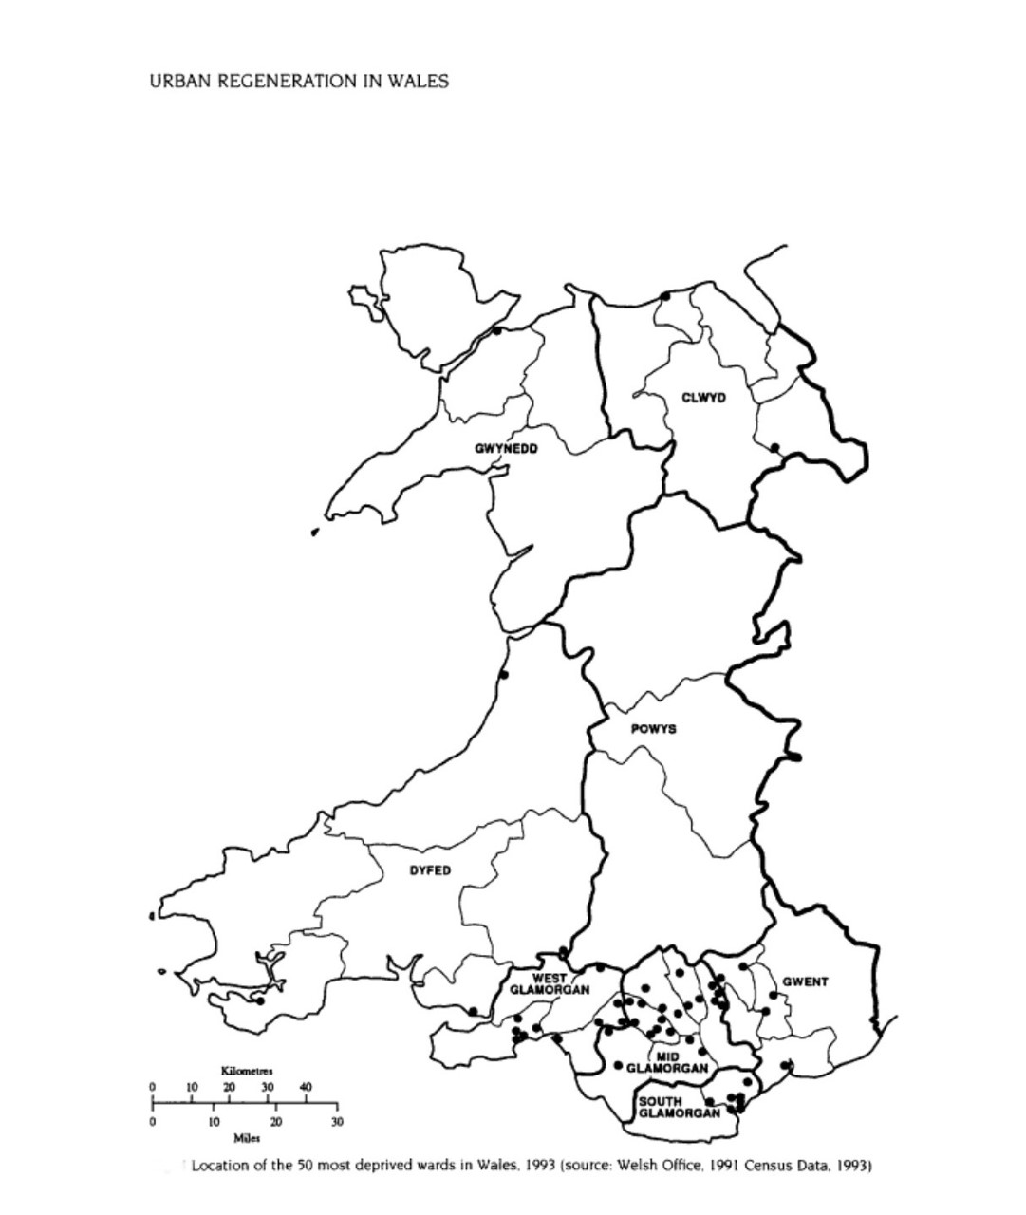
(Alden and Romaya, 1994).
Appendix 2
1993 Ward Index of Deprivation

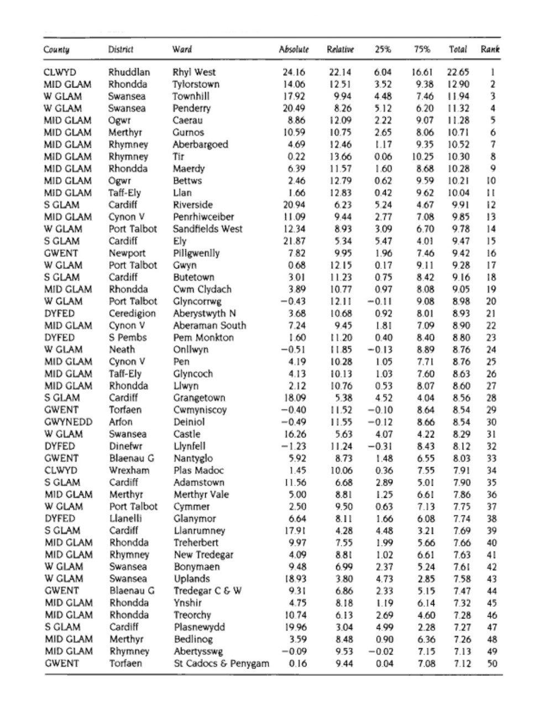
(Alden and Romaya, 1994).
Appendix 3
Most Deprived Areas (WIMD 2019)

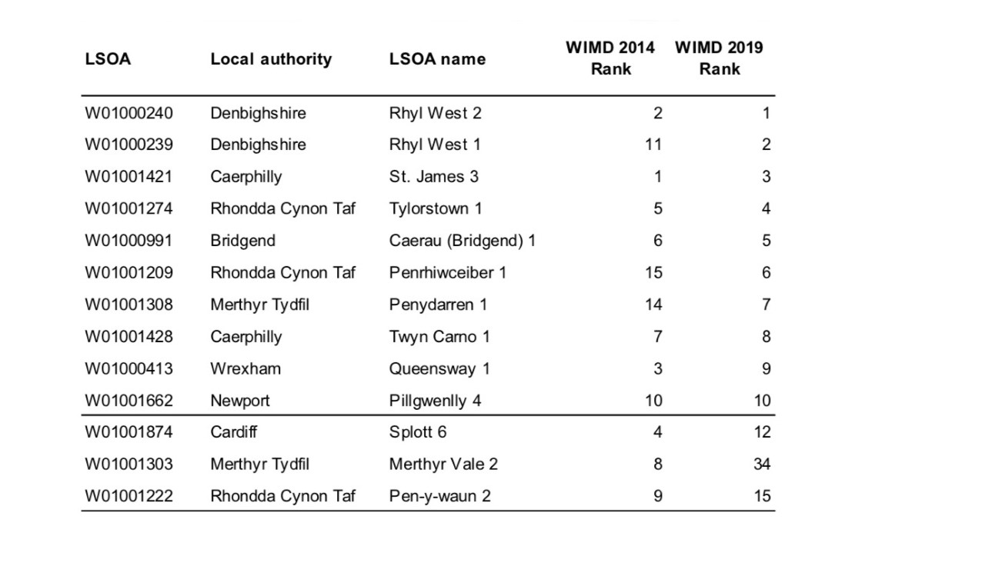
(²Welsh Government, 2019)
Appendix 4
Small areas of Deep-Rooted Deprivation (WIMD) 2019

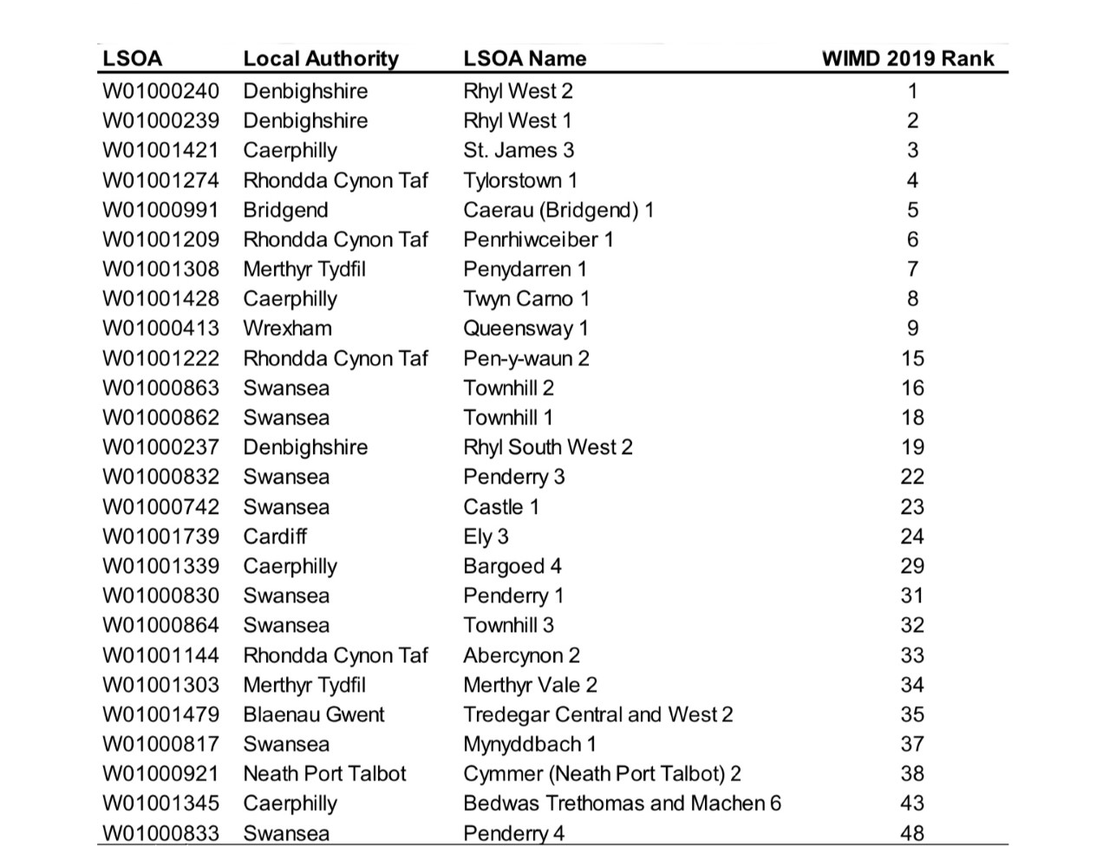
(²Welsh Government, 2019).
Appendix 5
Deep Rooted Deprivation (WIMD) 2019

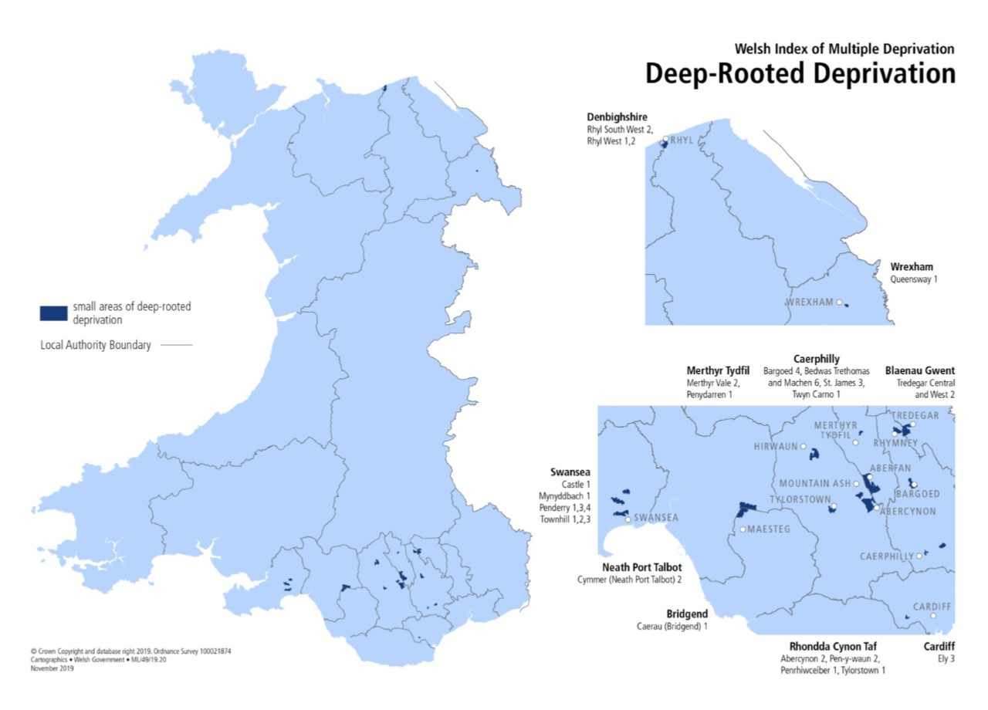
(²Welsh Government, 2019).
Appendix 6
Economically Inactive – Area Comparison

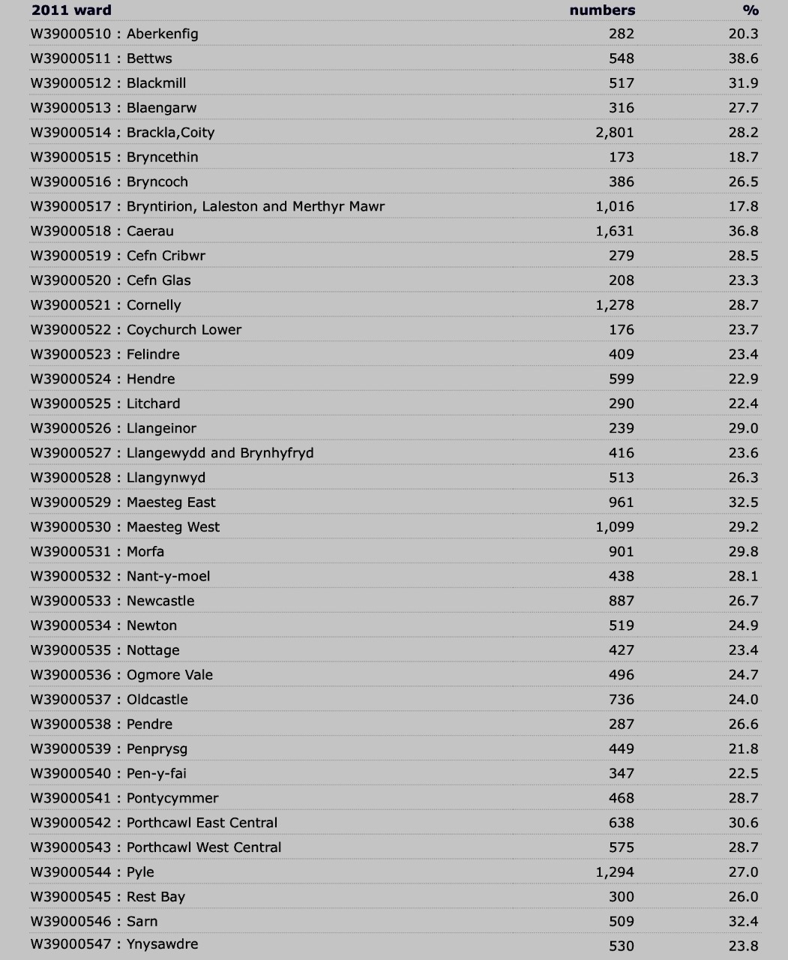
(¹nomis, 2020).
Appendix 7
Economically active – Unemployed - Area Comparison

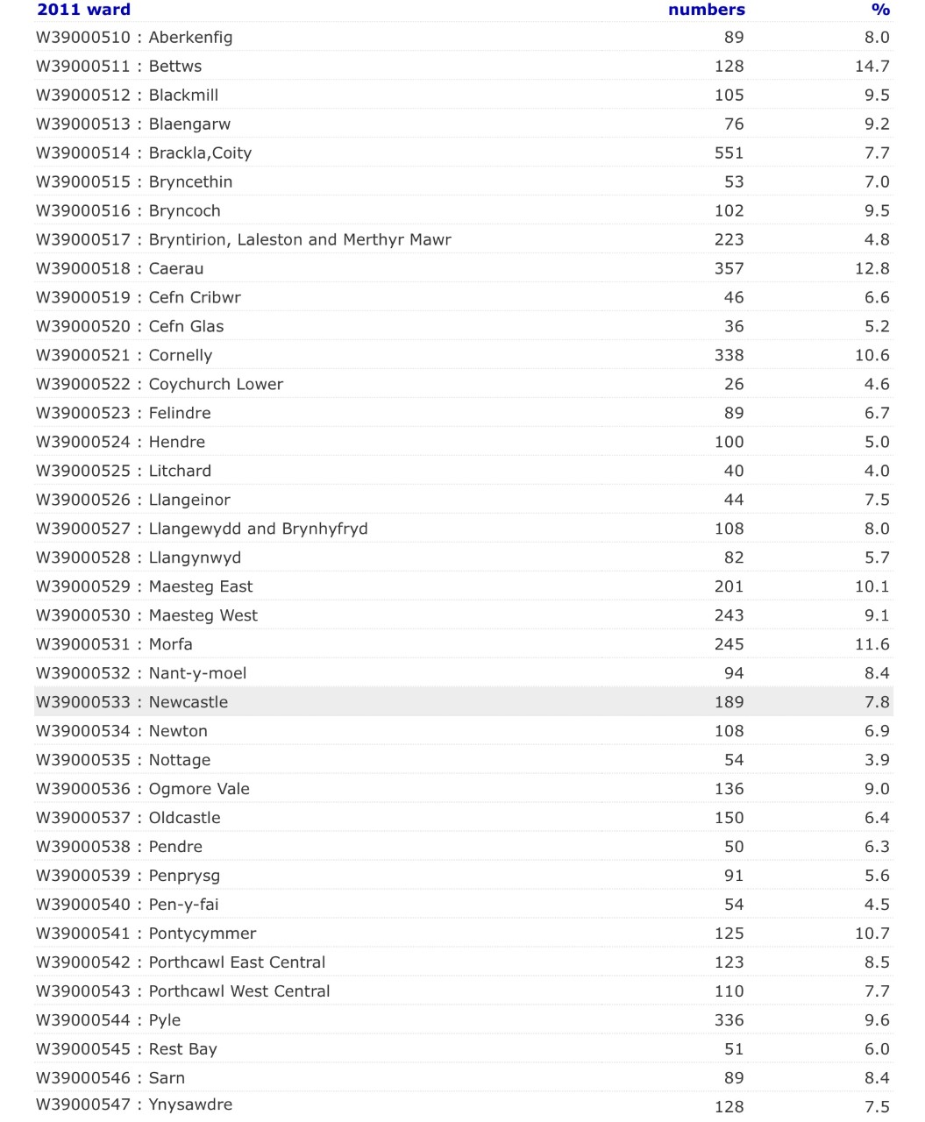
(²nomis, 2020).
Appendix 8
WIMD 2019 – Employment Domain

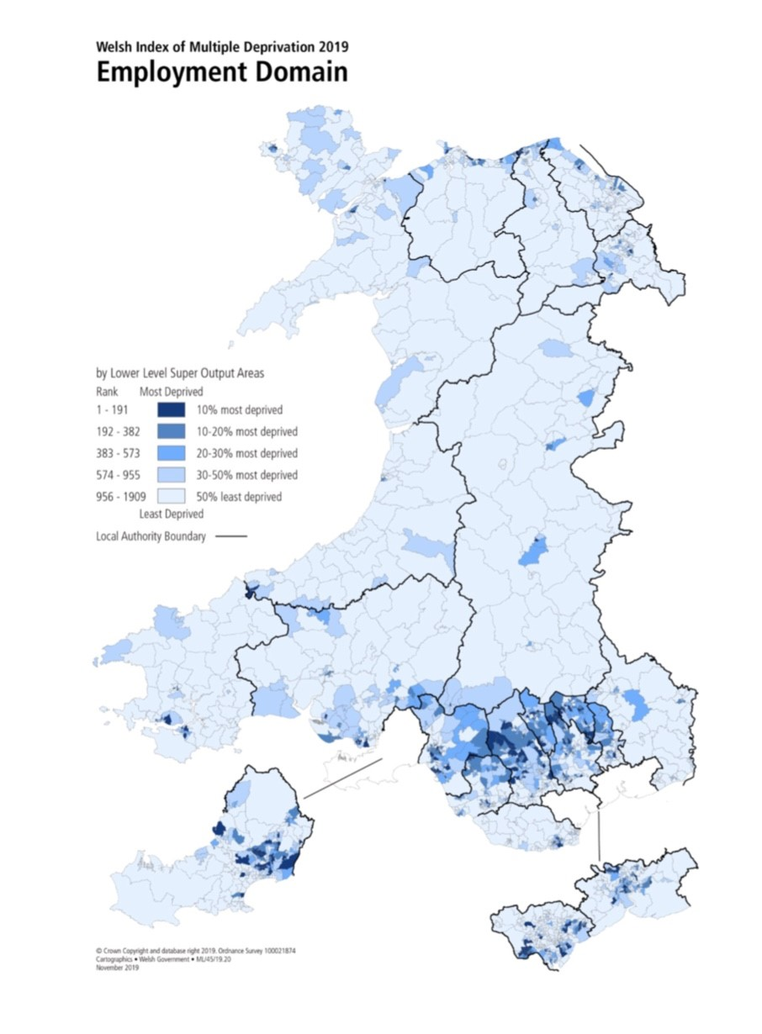
(²Welsh Government, 2019).
Appendix 9
WIMD 2019 – Health Domain

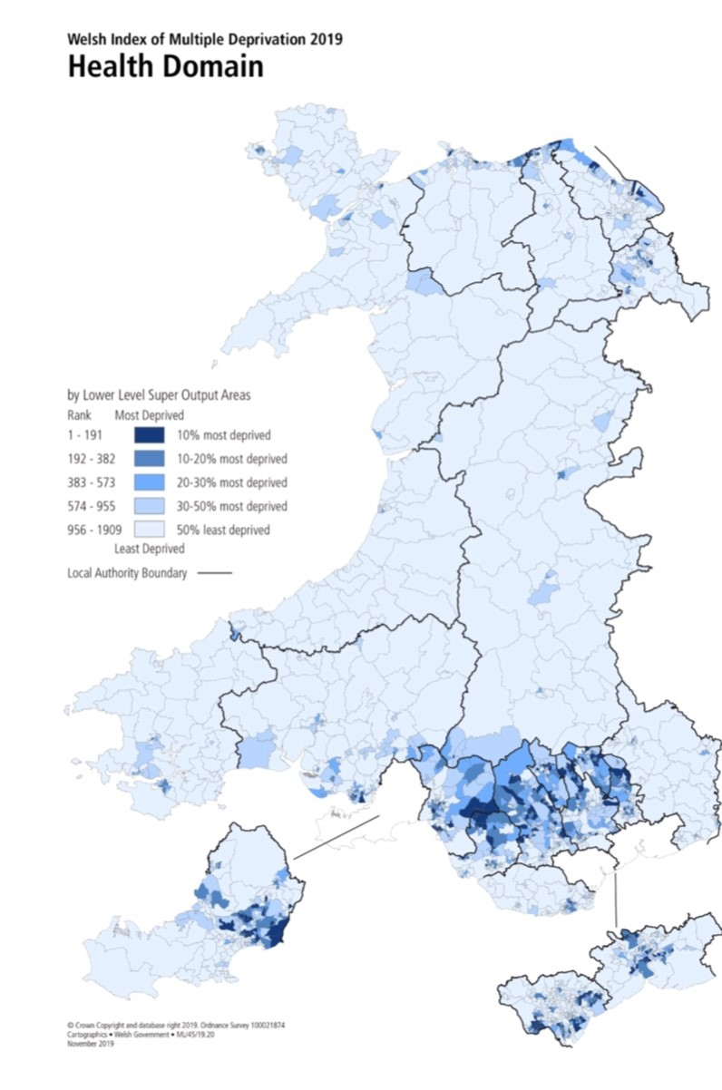
(²Welsh Government, 2019).
Appendix 10
No Qualifications - Area Comparison

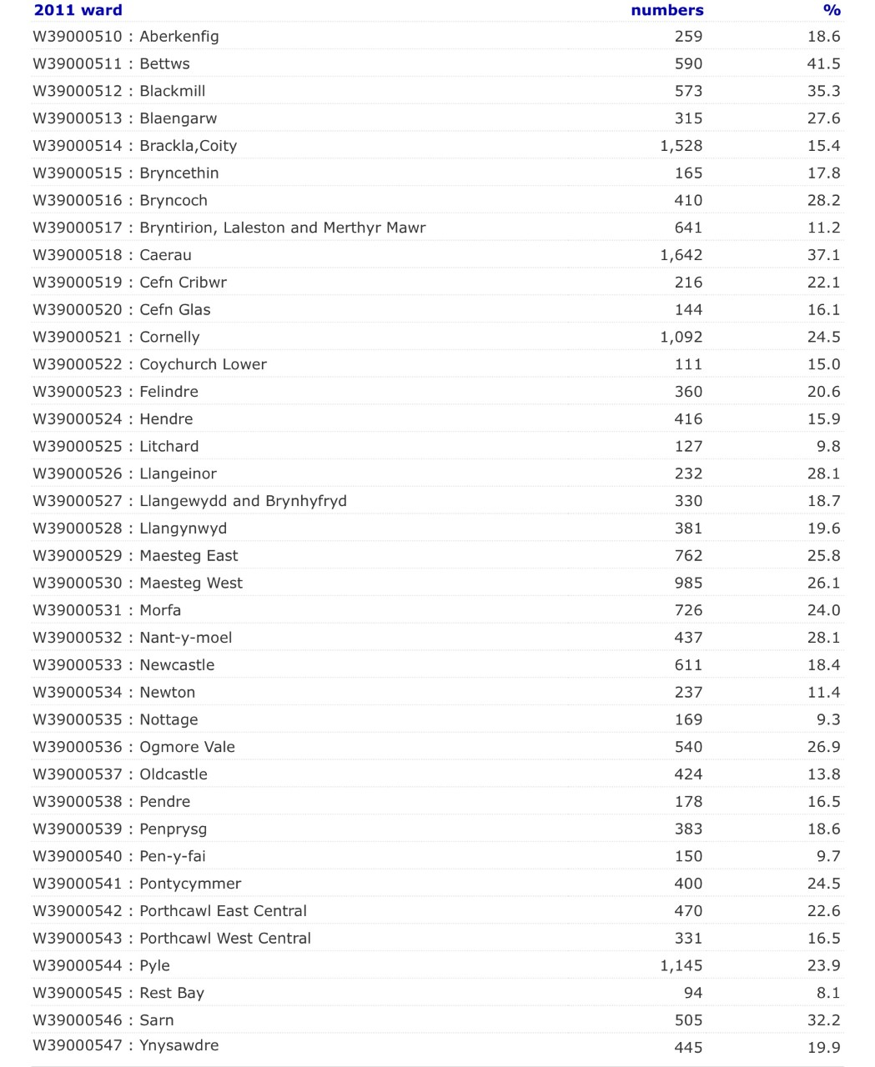
(²nomis, 2020).
Appendix 11
WIMD 2019 – Education Domain

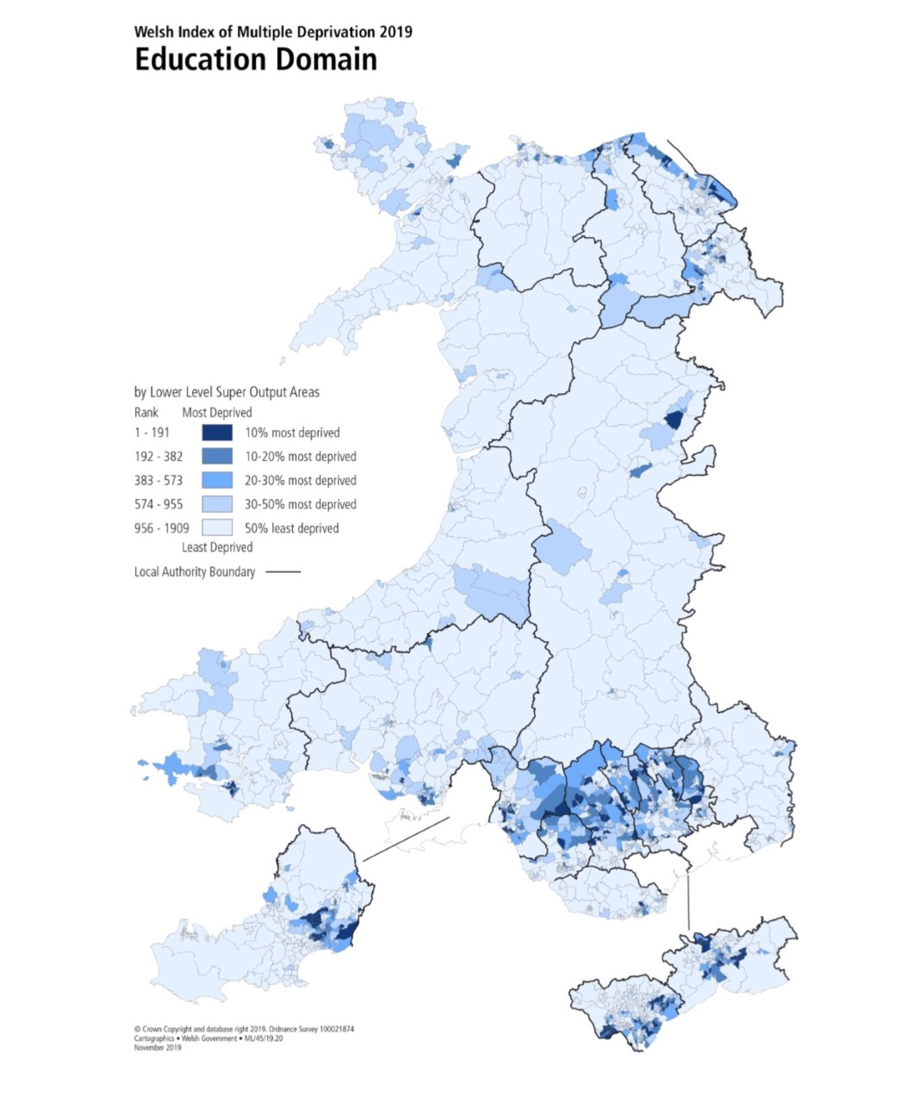
(²Welsh Government, 2019)
Appendix 12
WIMD 2019 – Housing Domain

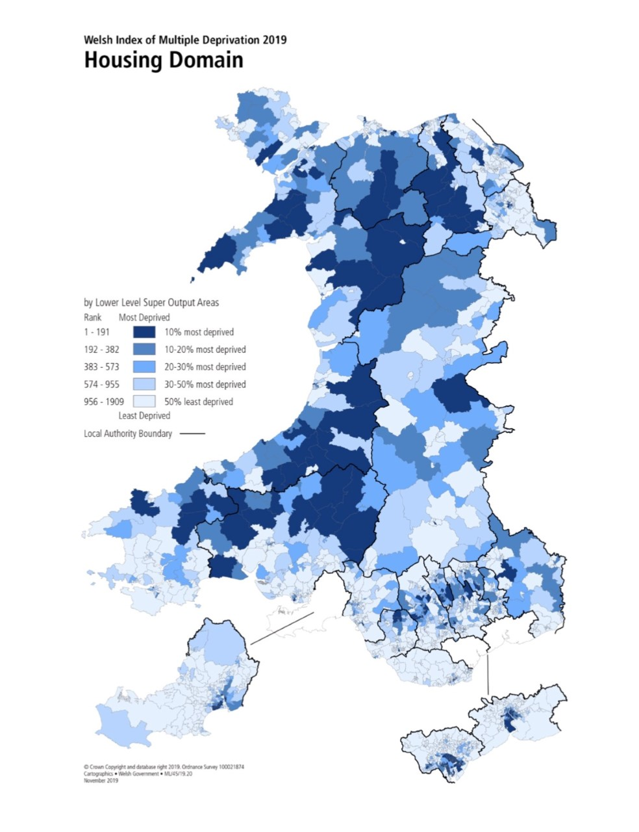
(²Welsh Government, 2019).
Appendix 13
WIMD 2019 – Community Safety Domain

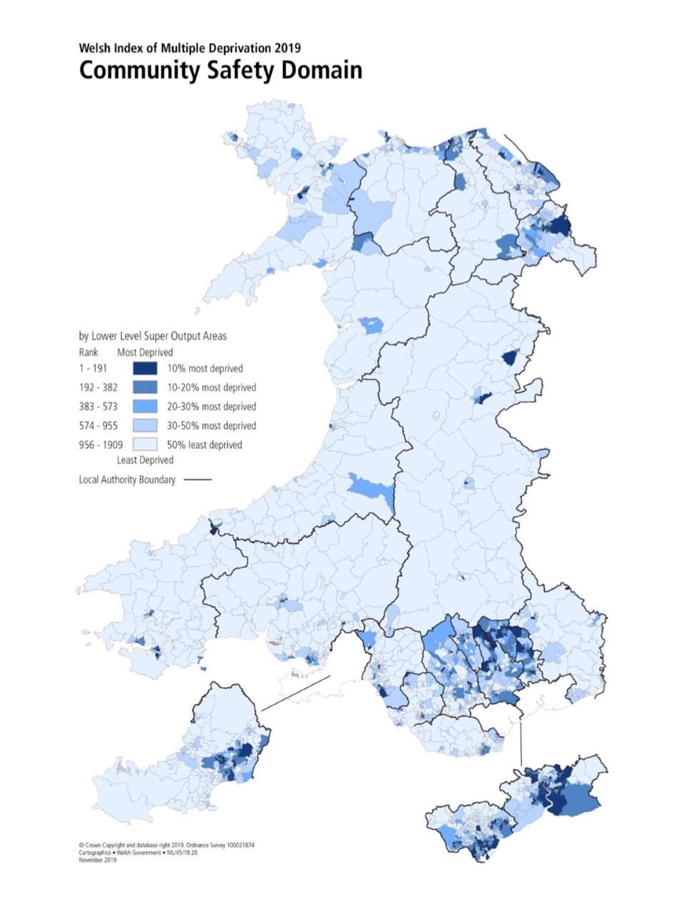
(²Welsh Government, 2019).
Appendix 14
Neighbourhood crime league table for October 2020

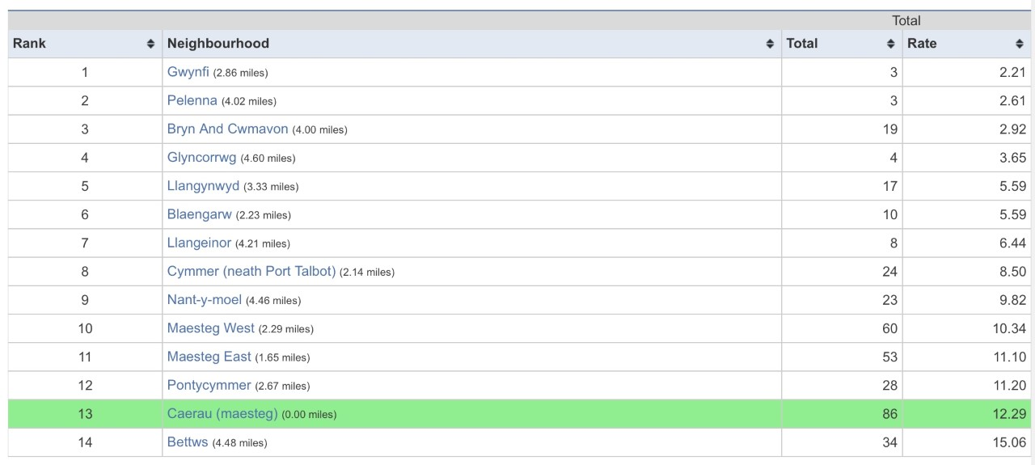

(UKCrimeStats, 2020)

Appendix 15
WIMD 2019 – Physical Environment Domain

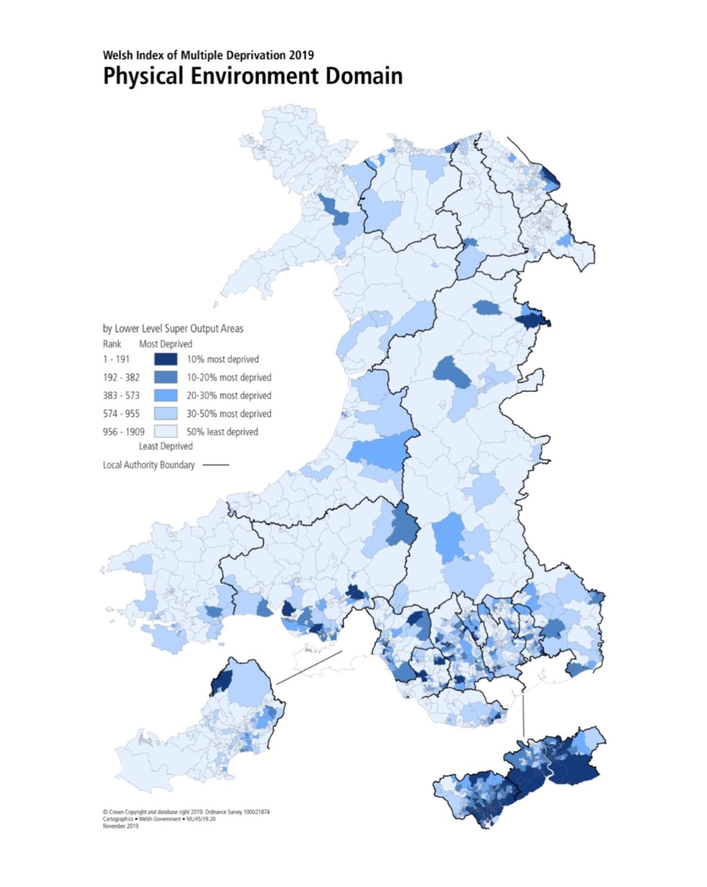
(²Welsh Government, 2019).
Appendix 16
Life expectancy by local authority and gender
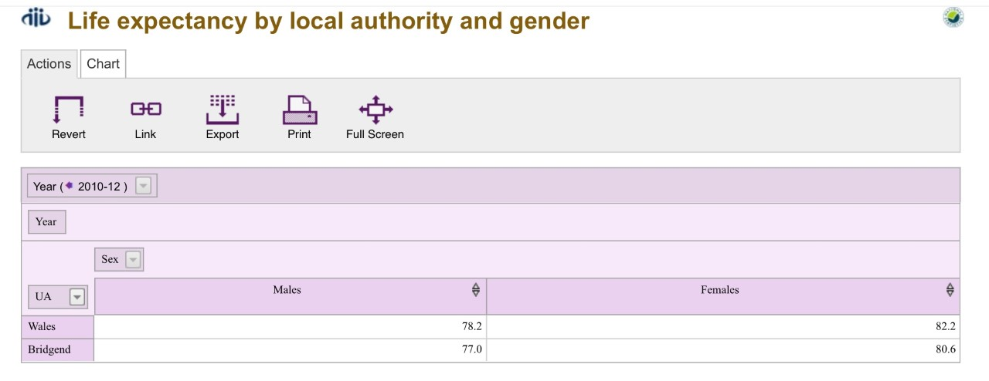

(StatsWales, 2020).
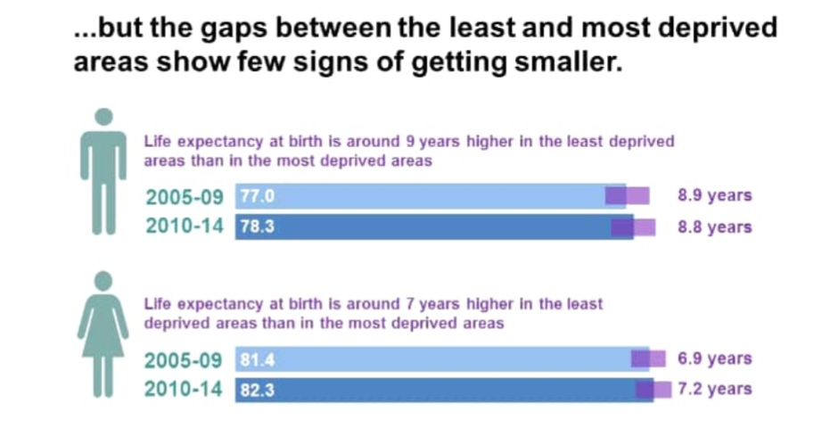
(PHW, 2020)

Appendix 17
Percentage of live single births with a low birth weight
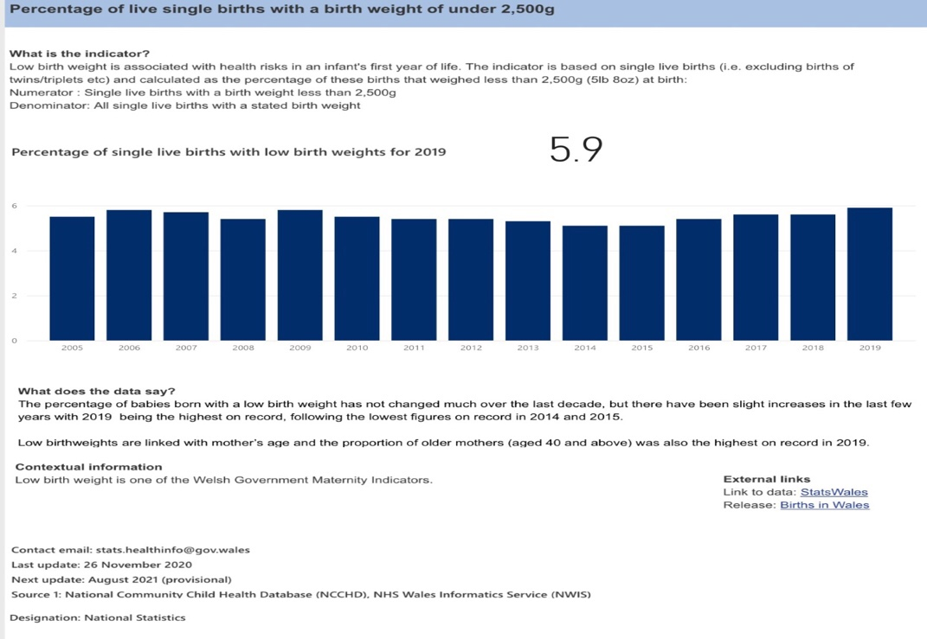
Healthy life expectancy at birth from the most and least deprived areas
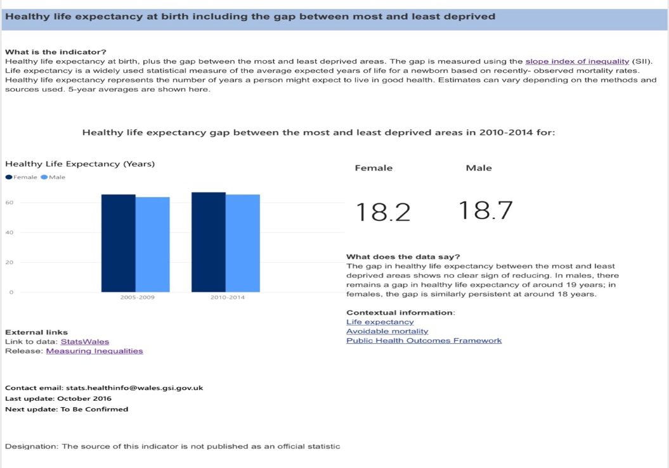
(Welsh Government, 2021).
Appendix 18
Percentage of children aged 11 – 16 engaged in unhealthy behaviours.
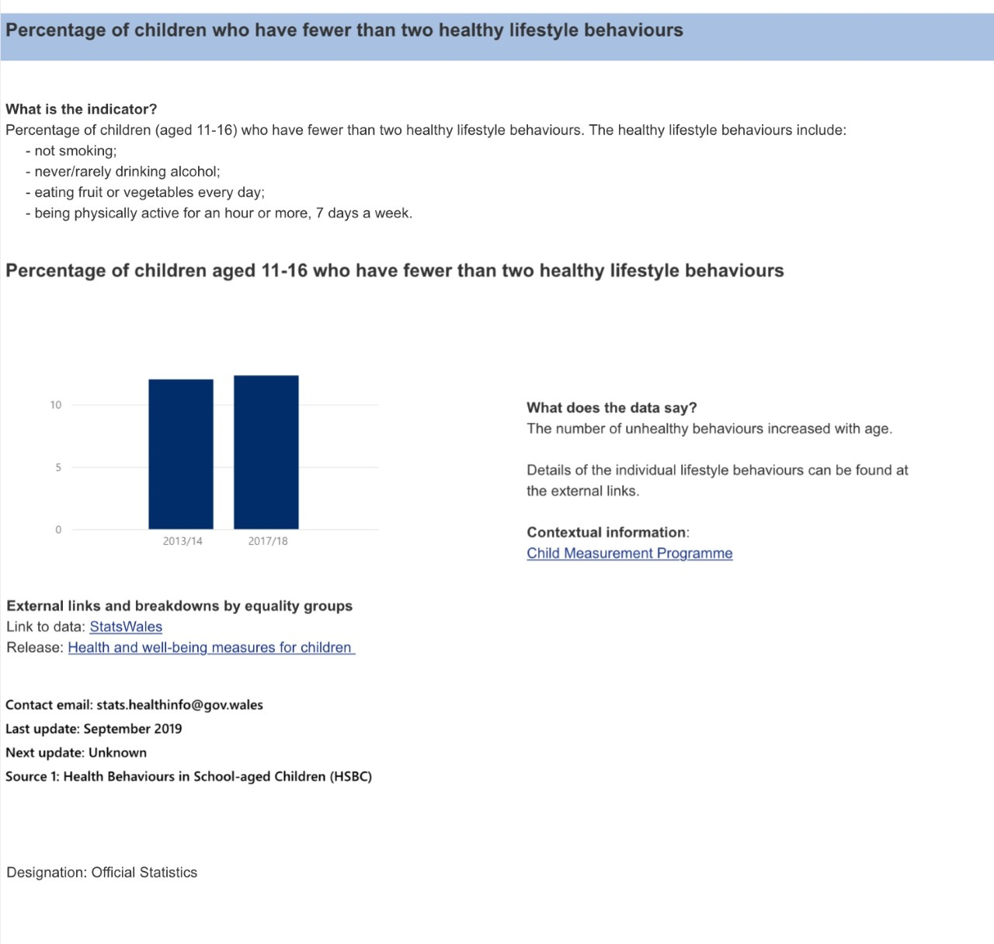
(Welsh Government, 2021).

Appendix 19
It’s official: allotments are good for you – and for your mental health

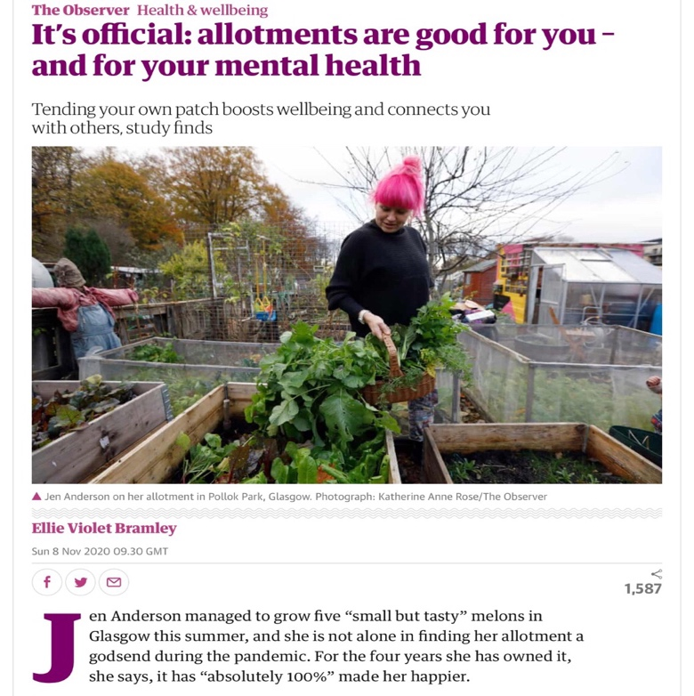
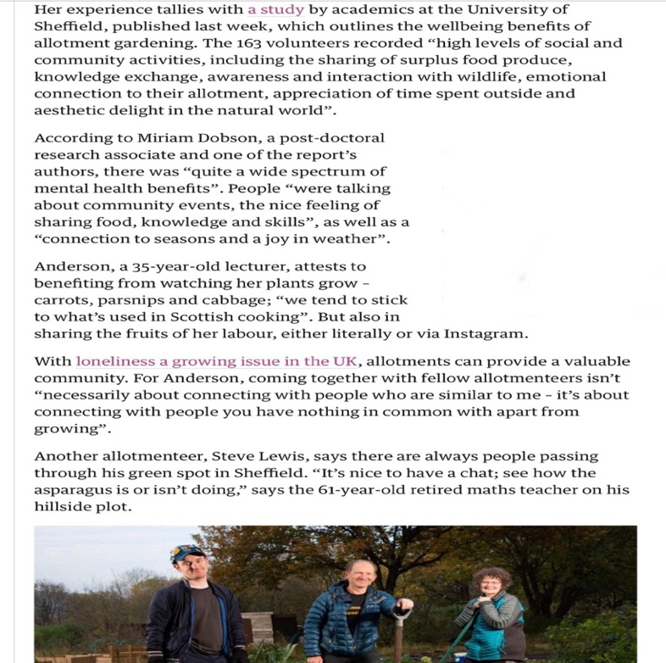
(The Guardian, 2020).
Appendix 19
It’s official: allotments are good for you – and for your mental health
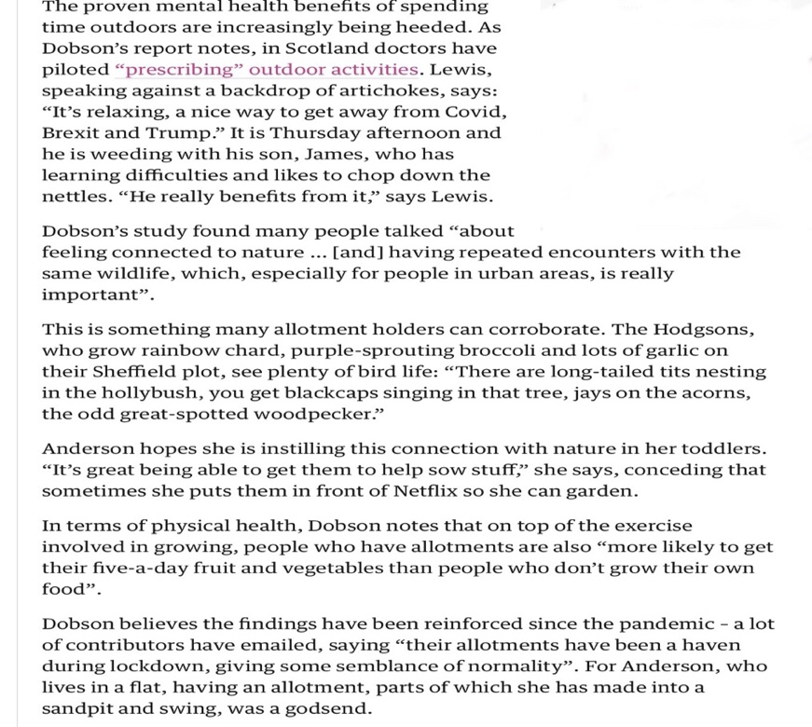
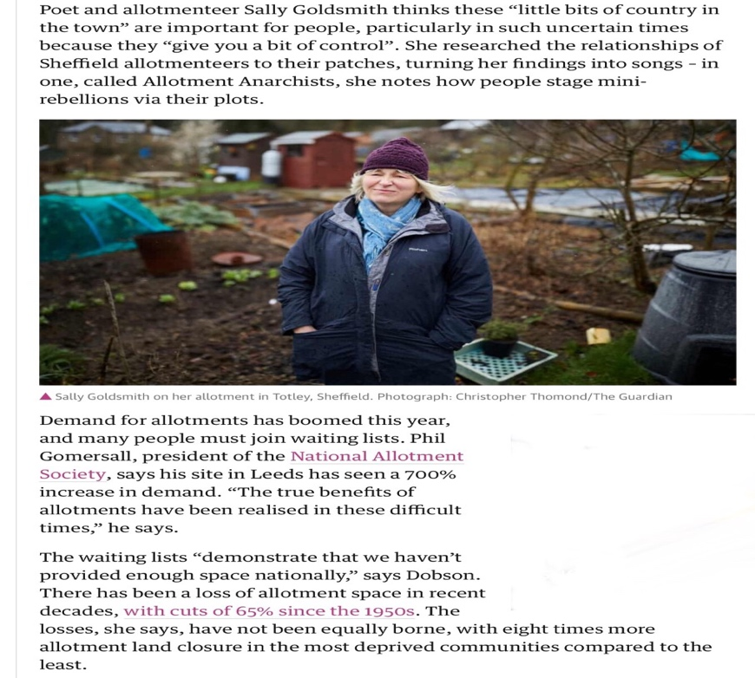
(The Guardian, 2020).
Appendix 19
It’s official: allotments are good for you – and for your mental health
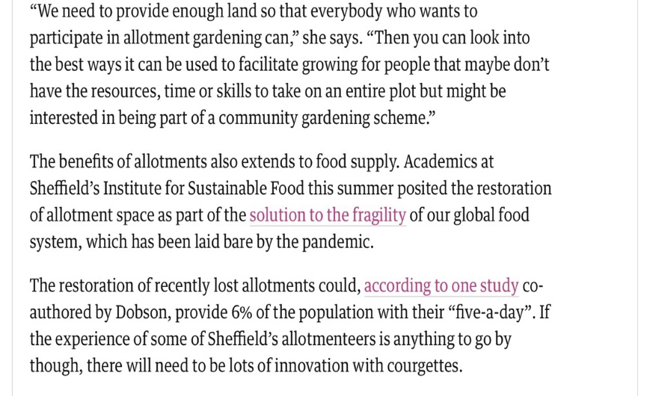
(The Guardian, 2020).

Appendix 20
Case Study – Badgers Brook Allotment, South Wales
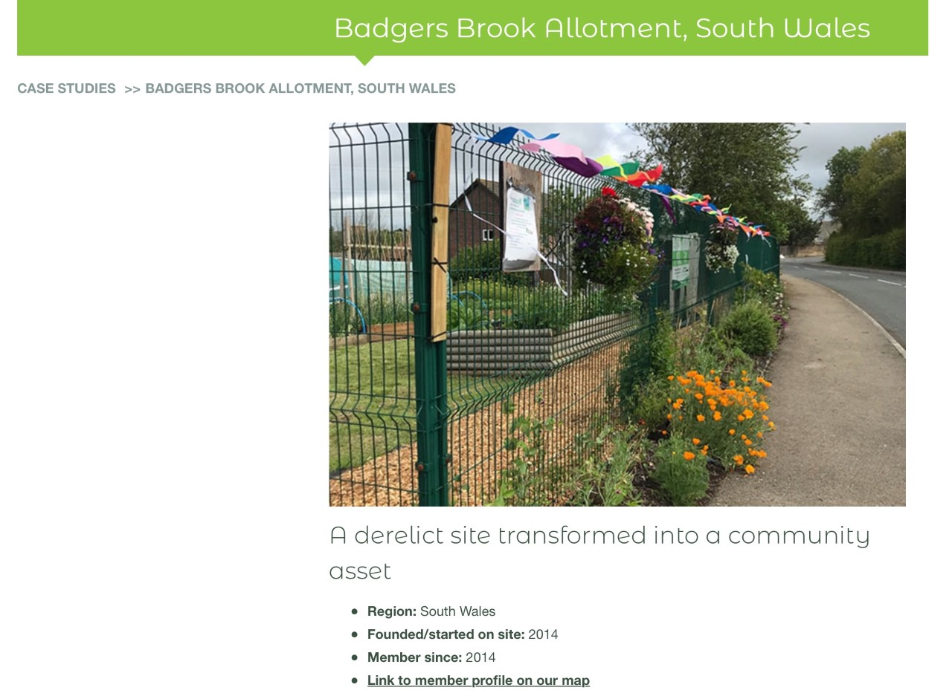
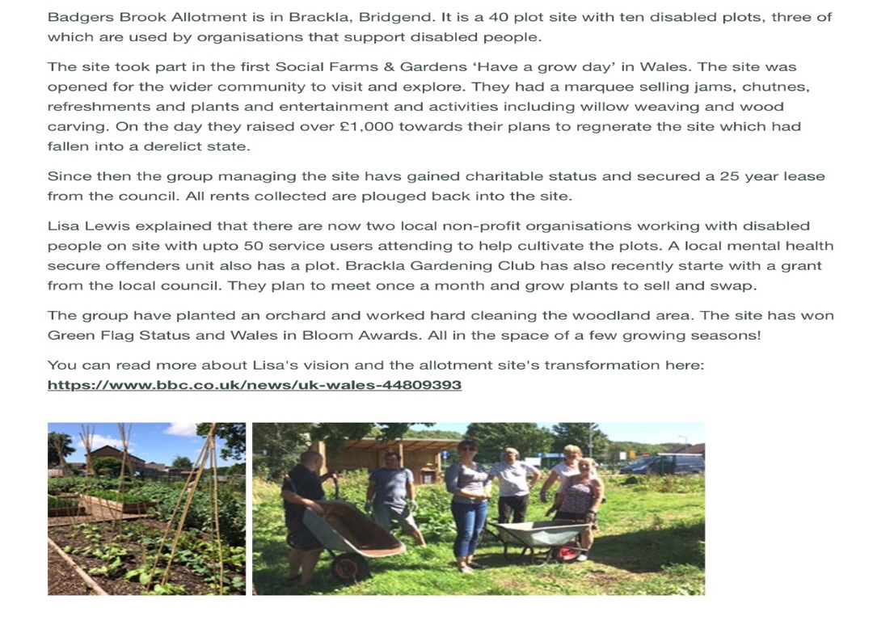
(Farmgarden, 2021).
Appendix 21
Teach children about berries – they engage with nature, connect with others
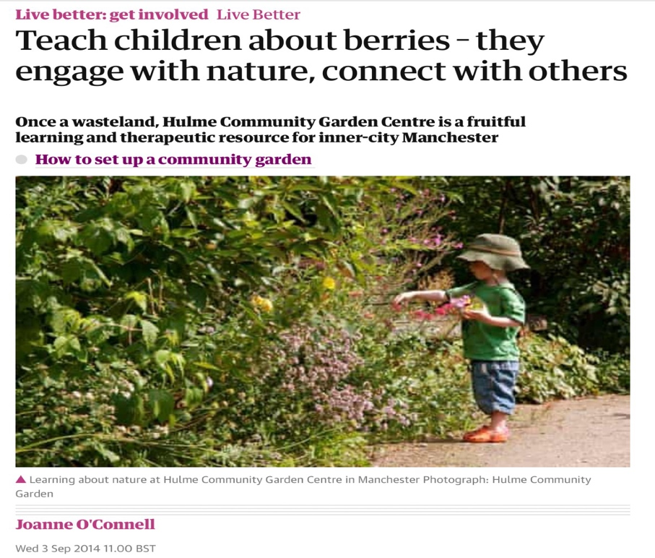
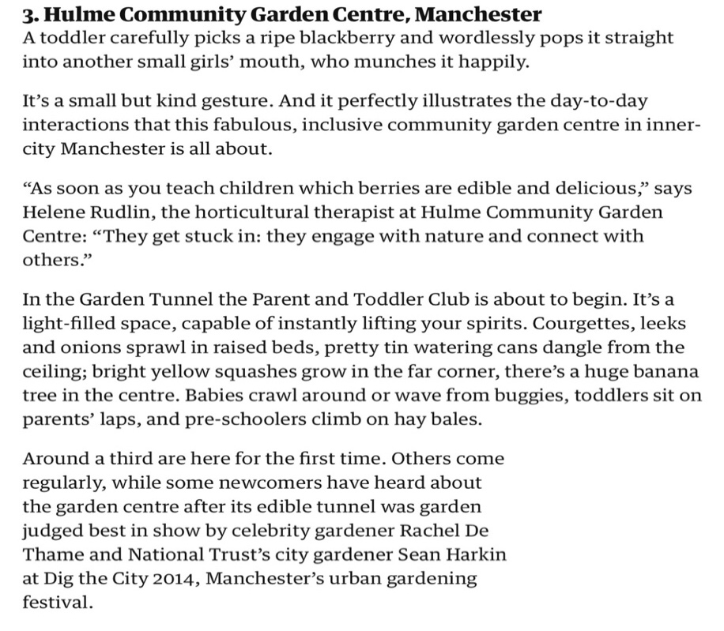
(The Guardian, 2014).
Appendix 21
Teach children about berries – they engage with nature, connect with others
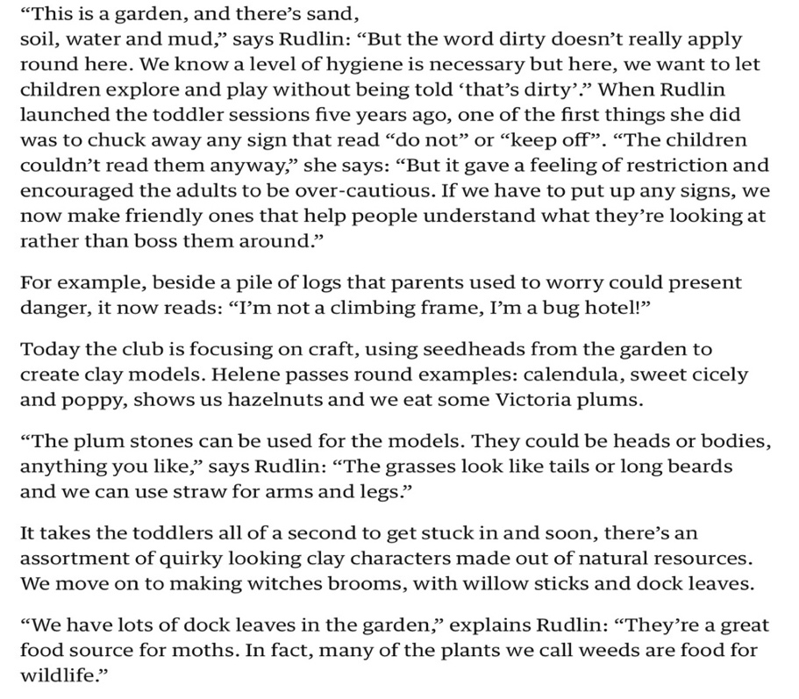
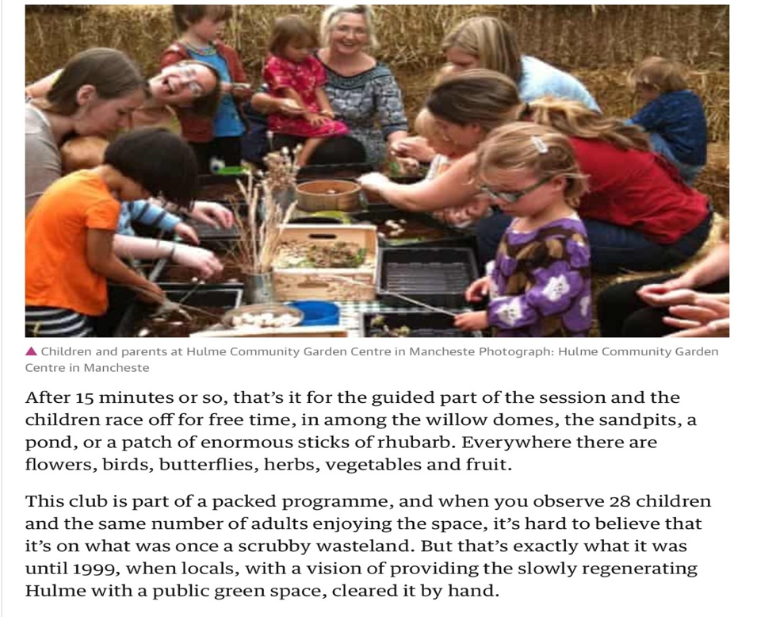
(The Guardian, 2014).
Appendix 21
Teach children about berries – they engage with nature, connect with others
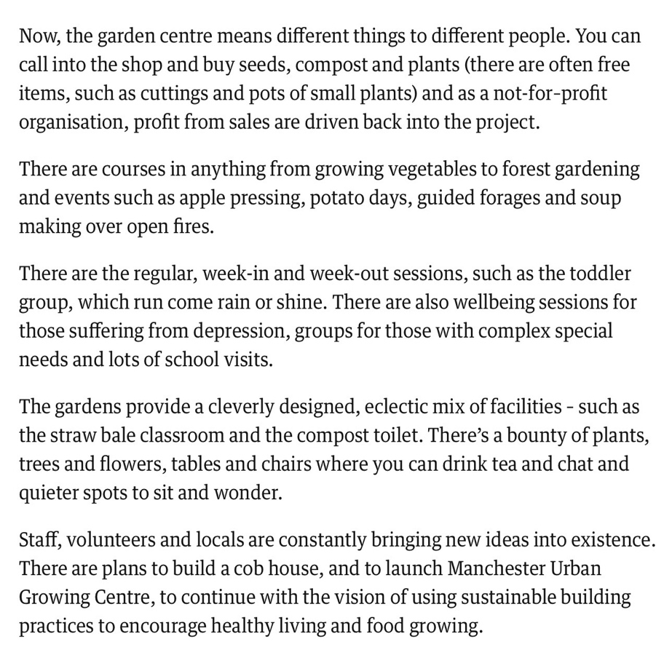
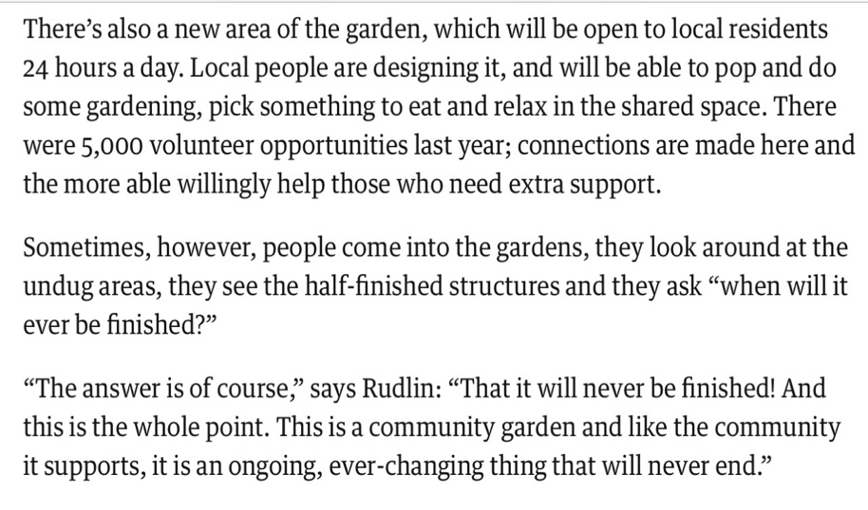
(The Guardian, 2014).

References
Akbari, A. et al. (2018) ‘The Inverse Care Law programme: evaluating a population based intervention in primary care within deprived communities in Wales’, International Journal of Population Data Science, 3(2). Available at: https://ijpds.org/article/view/521 (Accessed: 5th January 2021).
Alden, J. and Romaya, S. (1994) ‘The Challenge of Urban Regeneration in Wales: Principles, Policies and Practice’, The Town Planning Review, 65(4), pp. 435 – 461. Available at: https://www-jstor-org.ezproxy.uwtsd.ac.uk/stable/40113316?seq=15#metadata_info_tab_contents (Accessed: 15th December 2020).
Beyer, K.M. et al. (2014) ‘Exposure to neighbourhood green space and mental health: evidence from the survey of the health in Winconsin’, Int. J. Environ. Res. Public Health, 11(3), pp. 3453-3472. Available at: https://www.mdpi.com/1660-4601/11/3/3453 (Accessed: 15th January 2021).
Bridgend County Borough Council (2021) Flying Start. Available at: https://www.bridgend.gov.uk/residents/children-and-young-people/flying-start/ (Accessed: 10th January 2021).
British Medical Association (2017) Health at a price: Reducing the impact of poverty. Available at: https://www.bma.org.uk/media/2084/health-at-a-price-2017.pdf (Accessed: 14th January 2021).
Community Insights (2016) Driving Change Plan – Caerau. Available at: http://www.bct.wales/uploads/resources/2019-11-06-56-1-first-caerau-driving-change-pl.pdf (Accessed: 12th January 2021).
Elmagd, M.A. (2016) ‘Benefits, need and importance of daily exercise’, International Journal of Physical Education, Sports and Health, 3(5), pp. 22-27. Available at: https://www.researchgate.net/publication/306118434_Benefits_need_and_importance_of_daily_exercise/citations (Accessed: 16th January 2021).
Farmgarden (2021) Badgers Brook Allotment, South Wales. Available at: https://www.farmgarden.org.uk/badgers-brook-allotment-south-wales (Accessed: 16th January 2021).
¹Federation of CITY FARMS & COMMUNITY GARDENS (2021) Benefits of community growing, green spaces and outdoor education. Available at: https://www.farmgarden.org.uk/sites/farmgarden.org.uk/files/benefits-community-growing-research-and-evidence.pdf (Accessed: 9th January 2021).
²Federation of CITY FARMS & COMMUNITY GARDENS (2021) Growing with families, groups and schools. Available at: https:// https://www.farmgarden.org.uk/system/files/engaging_schools_children_and_families_0.pdf (Accessed: 9th January 2021).
Joseph Rowntree Foundation (2020) Households below a Minimum Income Standard: 2008/09 - 2017/18: Summary. Available at: https://www.jrf.org.uk/file/53276/download?token=IBIZOW3o&filetype=findings (Accessed: 21st December 2020).
References continued
Local Government Improvement and Development (2010) Not another consultation! Making community engagement informal and fun. Available at: https://www.involve.org.uk/sites/default/files/field/attachemnt/Not_Another_Consultation.pdf (Accessed: 5th January 2021).
¹nomis (2020) Economically Inactive – Area Comparison. Available at: https://nomisweb.co.uk/reports/Imp/ward2011/1140858884/subreports/ward2011einact_compared/report.aspx (Accessed: 21st December 2020).
²nomis (2020) Economically Active – Area Comparison. Available at: https://www.nomisweb.co.uk/reports/lmp/ward2011/1140858884/subreports/ward2011eact_compared/report.aspx (Accessed: 22nd December 2020).
³nomis (2020) 2011 Ward Labour Market Profile W39000518: Caerau. Available at: https://www.nomisweb.co.uk/reports/Imp/ward2011/1140858884/report.aspx (Accessed: 21st December 2020).
Powell Dobson Urbanists (2010) Llynfi Valley VARP Baseline Report. Available at: https://www.bridgend.goc.uk/media/1995/sd63.pdf (Accessed: 9th January 2021).
Public Health Wales (2016) Making a Difference: Investing in Sustainable Health and Well-being for the People of Wales. Available at: https://www.wales.nhs.uk/sitesplus/documents/888/PHW%20Making%20a%20difference%20ES%28Web%5F2%29.pdf (Accessed: 7th January 2021).
Public Health Wales (2020) Measuring inequalities: Overview. Available at: https://www,publichealthwalesobservatory.wales.nhs.uk/measuring-inequalities-2016-overview (Accessed: 22nd December 2020).
Public Health Wales (2021) Flying Start infographic. Available at: https://phw.nhs.wales/topics/immunisation-and-vaccines/flying-start-infographic-final-eng-png1/ (Accessed: 10th January 2021).
Richards, B. (1982) History of the Llynfi Valley. Mid Glamorgan: D. Brown & Sons Ltd.
Roy, P. (2020) ‘Development as Improved Life Chance: Education for Improved Life Chances’, Kardan Journal of Social Sciences and Humanities, 2(2), pp. 1-12. Available at: https://www.researchgate.net/profile/Parveen_Roy/publication/340677307_Development_as_Improved_Life_Chances (Accessed: 16th January 2021).
The Guardian (2014) Teach children about berries – they engage with nature, connect with others. Available at: Teach children about berries – they engage with nature, connect with others | Live Better | The Guardian (Accessed: 17th January 2021).
The Guardian (2020) It’s official: allotments are good for you – and for your mental health. Available at: It’s official: allotments are good for you – and for your mental health | Health & wellbeing | The Guardian (Accessed: 10th January 2021).
References continued
Thompson, R. (2018)’Gardening for health: a regular dose of gardening’, Clinical Medicine, 18(3), pp. 201-205. Available at: https://www.ncbi.nlm.nih.gov/pmc/articles/PMC6334070 (Accessed: 15th January 2021).
UKCrimeStats (2020) Caerau (Maesteg). Available at: https://ukcrimestata.com/Neighbourhood/9229 (Accessed: 30th December 2020).
Welsh Government (2009) Foundation Phase: Outdoor Learning Handbook. Available at: https://hwb.gov.wales/storage/fcb8539c-9be7-4883-8542-35d7b54b56f2/foundation-phase-outdoor-learning-handbook.pdf (Accessed: 9th January 2021).
Welsh Government (2012) Tackling Poverty Action Plan 2012-2016. Available at: https://business.senedd.wales/documents/s500001880/CELG4-20-14%20Paper%205.pdf (Accessed: 7th January 2021).
¹Welsh Government (2015) Building Resilient Communities. Available at: https://dera.ioe.ac.uk/24506/2/150701-tackling-poverty-action-plan-2015-en_Redacted.pdf (Accessed: 16th December 2020).
²Welsh Government (2015) Well-being of Future Generations (Wales) Act 2015. Available at: https://www.futuregenerations.wales/wp-content/uploads/2017/02/150623-guide-to-the-fg-act-en.pdf (Accessed: 21st December 2020).
¹Welsh Government (2017) Families First: Programme Guidance. Available at: https:// https://gov.wales/sites/default/files/publications/2019-07/families-first-guidance-for-local-authorities_0.pdf (Accessed: 12th January 2021).
²Welsh Government (2017) Prosperity for All: the national strategy: Taking Wales Forward. Available at: https://gov.wales/sites/default/files/publications/2017-10/prosperity-for-all-the-national-startegy.pdf (Accessed: 10th January 2021).
¹Welsh Government (2019) Welsh Index of Multiple Deprivation (WIMD) 2019: The official measure of relative deprivation for small areas in Wales. Available at: https://wimd.gov.wales/Isoa/w01000991?lang=en# (Accessed: 21st December 2020).
²Welsh Government (2019) Welsh Index of Multiple Deprivation (WIMD) 2019: Results report. Available at: https://gov.wales/sites/default/statistics-and-research/2019-11/welsh-index-multiple-deprivation-2019-results-report-024.pdf (Accessed: 17th December 2020).
¹Welsh Government (2020) Curriculum for Wales. Available at: https://hwb.gov.wales/curriculum-for-wales (Accessed: 21st December 2020).
²Welsh Government (2020) Material deprivation and low income: April 2018 to March 2019. Available at: https://gov.wales/material-deprivation-and-low-income-april-2018-march-2019 (Accessed: 21st December 2020).
³Welsh Government (2020) Relative income poverty. Available at: https://gov.wales/relative-income-poverty (Accessed: 21st December 2020).
References continued
⁴Welsh Government (2020) Relative Income Poverty: April 2018 to March 2019. Available at: https://gov.wales/relative-income-poverty-april-2018-march-2019 (Accessed: 22nd December 2020).
Welsh Government (2021) National Indicators: mapping to Well-being and UN Sustainable Development Goals: interactive tool. Available at: https://gov.wales/national-indicators-mapping-well-being-and-un-sustainable-development-goals-interactive-tool (Accessed: 14th January 2021).

