

An Exemplar of Modern Architecture- The Schröder House

School of Architecture, Built and Natural Environment

Course: BSc Architecture

Name: Mari Emyr
Student Number: 2303850
Module code: ACAA4003
Word count: 1,053
Date: 13/03/202
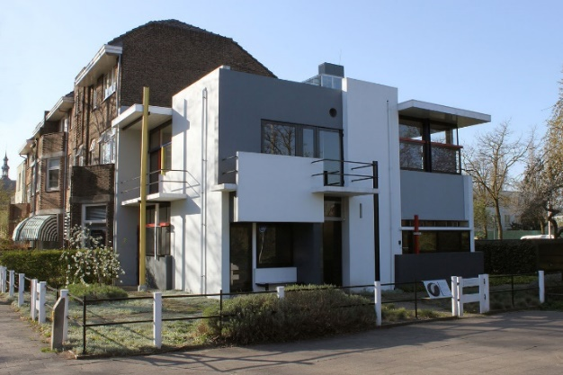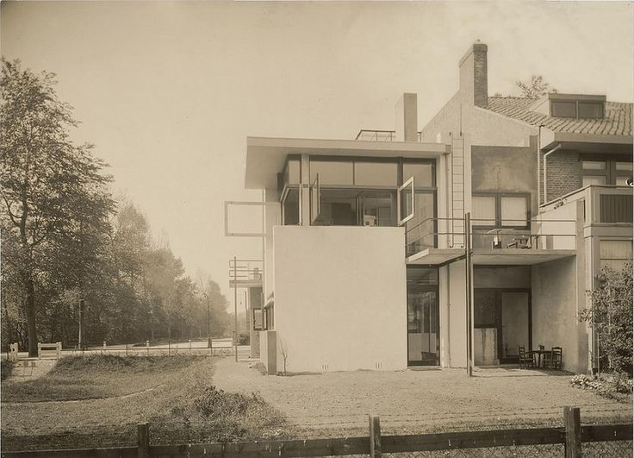
2
1

The design of this revolutionary house began with two visionary minds. Truus Schröder was a Dutch socialite and trained pharmacist who was unhappy in her marriage. After the death of her husband, Frits Schröder, Truus searched for a smaller home for herself and three children to live. In her previous home, a Dutch architect and furniture designer named Gerrit Rietveld designed the “room with the beautiful greys” (Van Zijl, 2010) to keep her marriage situation bearable, which she greatly appreciated. They had been in contact over the years, so when she needed a new home, she asked for his assistance. Rietveld had never designed a house before. She initially wanted “a house without walls”. Truus also had a passion for avant-garde design, while Rietveld was a part of the de Stijl movement, so the house took inspiration from Piet Mondrian’s artwork. While Truus did reject the first design of the Schröder house, eventually Rietveld realized an opportunity to design a house based on the principles of the Red-Blue Chair, his first exploration of the de Stijl movement. The house was built in 1924 in Prins Hendriklaan, Utrecht, the Netherlands. Today, the house is a museum, still in its original location and has been refurbished to excellent condition and allows 12 visitors per hour (schroderhouse.com, n. d.).

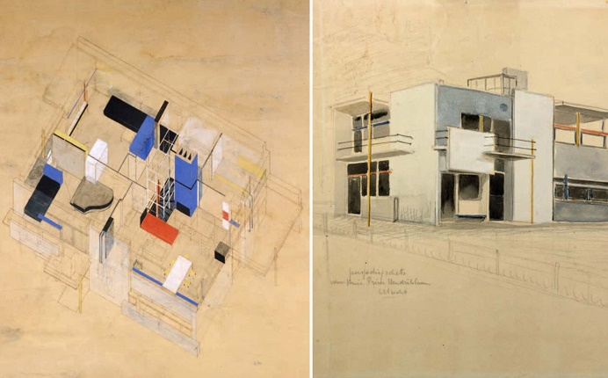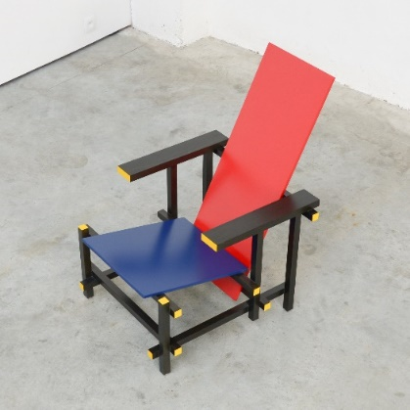
4
3

The plan of the Schröder house is based on a grid system, inspired by the de Stijl’s style of vertical and horizontal lines. The building is very consistent with using square and rectangular shapes throughout the whole design, giving it a modern look. The ground floor has six main areas. The studio room and the servant’s bedroom have windows allowing a lot of natural light and a visual landscape from outside. On the other hand, the reading and the working room are designed to be more private and quieter to give a focused atmosphere when working or studying. The layout of the ground floor could have turned out differently. This is because their design needed approval by the building codes at the time in Utrecht. This makes the ground floor more conservative in comparison to the upper floor. The stairs are placed in the centre of the building, spiralling to the first floor. Also, each room on the ground floor, except for the WC, has access to the outdoors and a water and gas supply. The first floor of the Schröder house is unique and very experimental. This is because the interior walls are movable, allowing the area to be customisable. There are also three balconies facing all directions except the Northwest. On this floor, the largest bedroom was for Truus’s two daughters, the other large bedroom for her son, and the smallest, private bedroom for herself. When the walls are moved, it all becomes one large space, apart from the bathroom which remains hidden. The living-dining area almost has its full exterior wall as windows, making the space merge with the landscape and expanding the feel of the inside space. Its whole structure has many different variations of routes to walk around the house, especially on the upper level, which makes the house a lot more interesting and easier to live in.
7
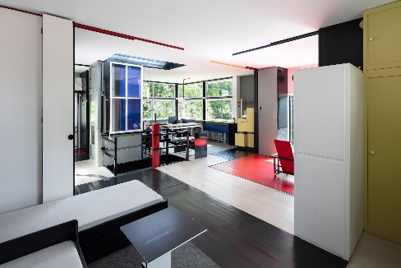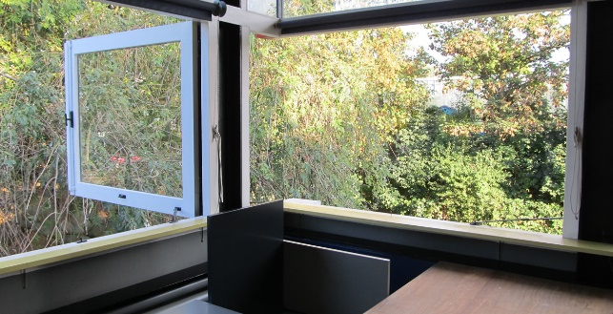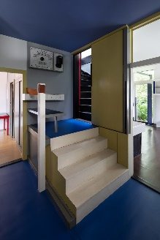
6
5

Rietveld went with the choice of traditional Dutch brick, wood construction, iron, and glass (rietveldschroderhouse.com, 2012). He had many reasons for staying with traditional methods, one being that he was not experienced with concrete. At the time, it was a new material and very expensive. He considered that it was best to avoid it as the main building material. However, the horizontal and vertical balcony slabs and the foundation were constructed out of concrete. The main aesthetic choice of the Schröder house is that it is in the style of a de Stijl painting. These artworks are square geometric shapes in bright primary colours, white, and shades of grey, framed with bold black lines. These features are shown in the Schröder house, with its colour choices, horizontal and vertical lines, and black framed windows. The cubism of the building also reflects de Stijl and omits the use of curves or triangular forms on this structure as would be seen on a traditional house.

The Schröder house has many new ideas that were not seen in other buildings before. One is the sliding partition walls on the upper floor. Rietveld originally wanted the walls to be transparent, which would have been another new idea. He also didn’t like the idea of moving walls, but this was Truus’s request. The windows in the living-dining area upstairs also have a different feature, in that the windows could swing open perpendicularly. This would make the corners vanish to make the room feel larger and also a part of the outdoors. Truus’s favourite spot in the Schröder house was the first floor, where she would spend a lot of time. Because of this, Rietveld added a speaking tube that allowed her to talk to visitors by the front door without moving from her spot. Also, the colours of the house have meanings. Spaces coded yellow signify circulation spaces, for example, the corridor, stairwell etc. Rooms with a blue colour represent that they can be accessed from multiple entrances. The kitchen/dining room has this. Finally, the red colour indicates that the rooms are private. The bathroom, Truus’s room, and the studio which belonged to Rietveld have red inside (medium.com, 2018).

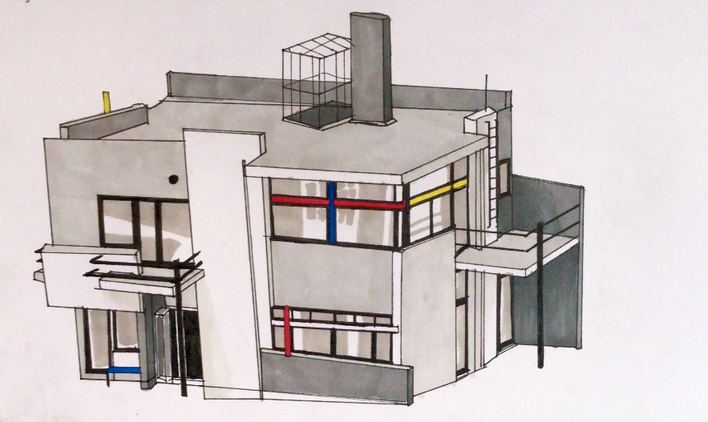

Even though this was the first house Rietveld designed, it is by far his most famous. The Schröder house also reflects de Stijl and Mondrian’s work very well, especially since Rietveld turned the 2D art into a 3D structure, and how this type of building style had never been seen before. The idea of sliding and rotating panels showed how a living space can adapt to the needs of its inhabitants. This as well as the combination of openness and transparency breaks down traditional barriers between indoor and outdoor spaces. The Schröder house has become a mark on the landscape of modern architecture. By creating this unique house that was both very open and had private spaces, he succeeded in designing the perfect house for his client. Truus bought the Schröder house the day after it’s construction, because she liked it so much, and continued to live in the house for 60 years until her death, in 1985 (revitveldschroderhuis, 2011).

Floor plans, sections, and elevations
8
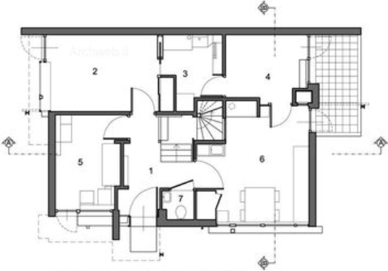  Ground floor plans | 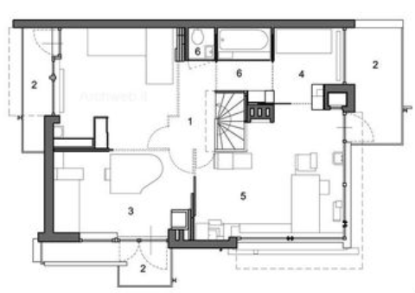  First floor plans
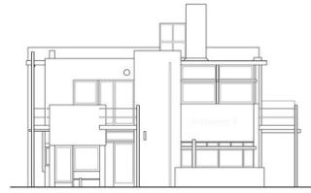  Front elevation | 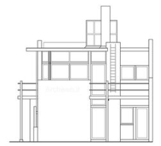  Right side elevation
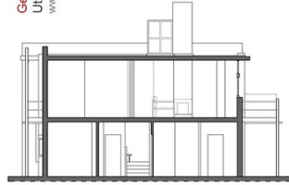  Front section | 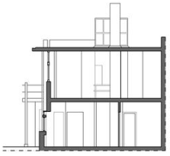  Right side section

References
Bibliographies
Van Zijl, I. (2010) Gerrit Rietveld. New York: Phaidon

Websites
Merchant, S., Shi, J., Ru, S. and Ratajczak, N. (2012). THE RIETVELD-SCHRODER HOUSE: DIAGRAMS: AN IN-DEPTH ANALYSIS OF THE DESIGN OF THE RIETVELD-SCHRODER HOUSE. [online] Available at: https://rietveldschroderhouse.blogspot.com/2012/12/diagrams-in-depth-analysis-of-design-of.html (Accessed: 12/03/2024)
MockeryofaSham (2011) The Schroder House (1924), Utrecht, Netherlands. 28 August. Available at: https://www.youtube.com/watch?v=kf8WdLNuTj0 (Accessed: 12/03/2024)
Rietveld Schröder House. (2019). Rietveld Schröder House – Unesco World Heritage in Utrecht. [online] Available at: https://www.rietveldschroderhuis.nl/en (Accessed: 13/03/2024)
www.schroderhouse.com. (n.d.). Rietveld Schröder Schroder House. [online] Available at: https://www.schroderhouse.com/. (Accessed: 12/03/2024)
Zhang, F. (2018). Analyzing The Rietveld Schroder House Through Original Diagrams. [online] Available at: https://medium.com/@arcaesthetics/analyzing-the-rietveld-schroder-house-through-original-diagrams-b06b357a7000 (Accessed: 13/03/2024)

Images
Figure 1- 20th century architecture (n. d.) photos and plans. Available at: http://architecture-history.org/architects/architects/RIETVELD/PIC/SH01.jpg (Accessed: 14/03/2024)
Figure 2- 20th century architecture (n. d.) photos and plans. Available at: http://architecture-history.org/architects/architects/RIETVELD/PIC/SH51.jpg (Accessed: 14/03/2024)
Figure 3- 20th century architecture (n. d.) photos and plans. Available at: http://architecture-history.org/architects/architects/RIETVELD/PIC/SH002.jpg (Accessed: 14/03/2024)
Figure 4- 1stdibs (n. d.) Red and Blue Chair by Gerrit Rietveld for Cassina. Available at: https://a.1stdibscdn.com/red-blue-chair-by-gerrit-rietveld-for-cassina-for-sale-picture-9/f_10470/1559891760093/Red_and_Blue_Chair_by_Gerrit_Rietveld_for_Cassina_4145_2_master.jpg?disable=upscale&auto=webp&quality=60&width=700 (Accessed: 14/03/2024)
Figure 5- 20th century architecture (n. d.) photos and plans. Available at: http://architecture-history.org/architects/architects/RIETVELD/PIC/SH21.jpg (Accessed: 14/03/2024)
Figure 6- 20th century architecture (n. d.) photos and plans. Available at: http://architecture-history.org/architects/architects/RIETVELD/PIC/SH33.jpg (Accessed: 14/03/2024)
Figure 7- 20th century architecture (n. d.) photos and plans. Available at: http://architecture-history.org/architects/architects/RIETVELD/PIC/SH27.jpeg (Accessed: 14/03/2024)
Figure 8- Archweb (n. d.) Schröder House. Available at: https://i.pinimg.com/736x/f9/a6/f2/f9a6f2f81b68c8acd75f562cecebf301.jpg (Accessed: 14/03/2024)

