

Assessment 1 – Reading Task Template
PART 1: Upload your photo of your A3 in-class notes here:
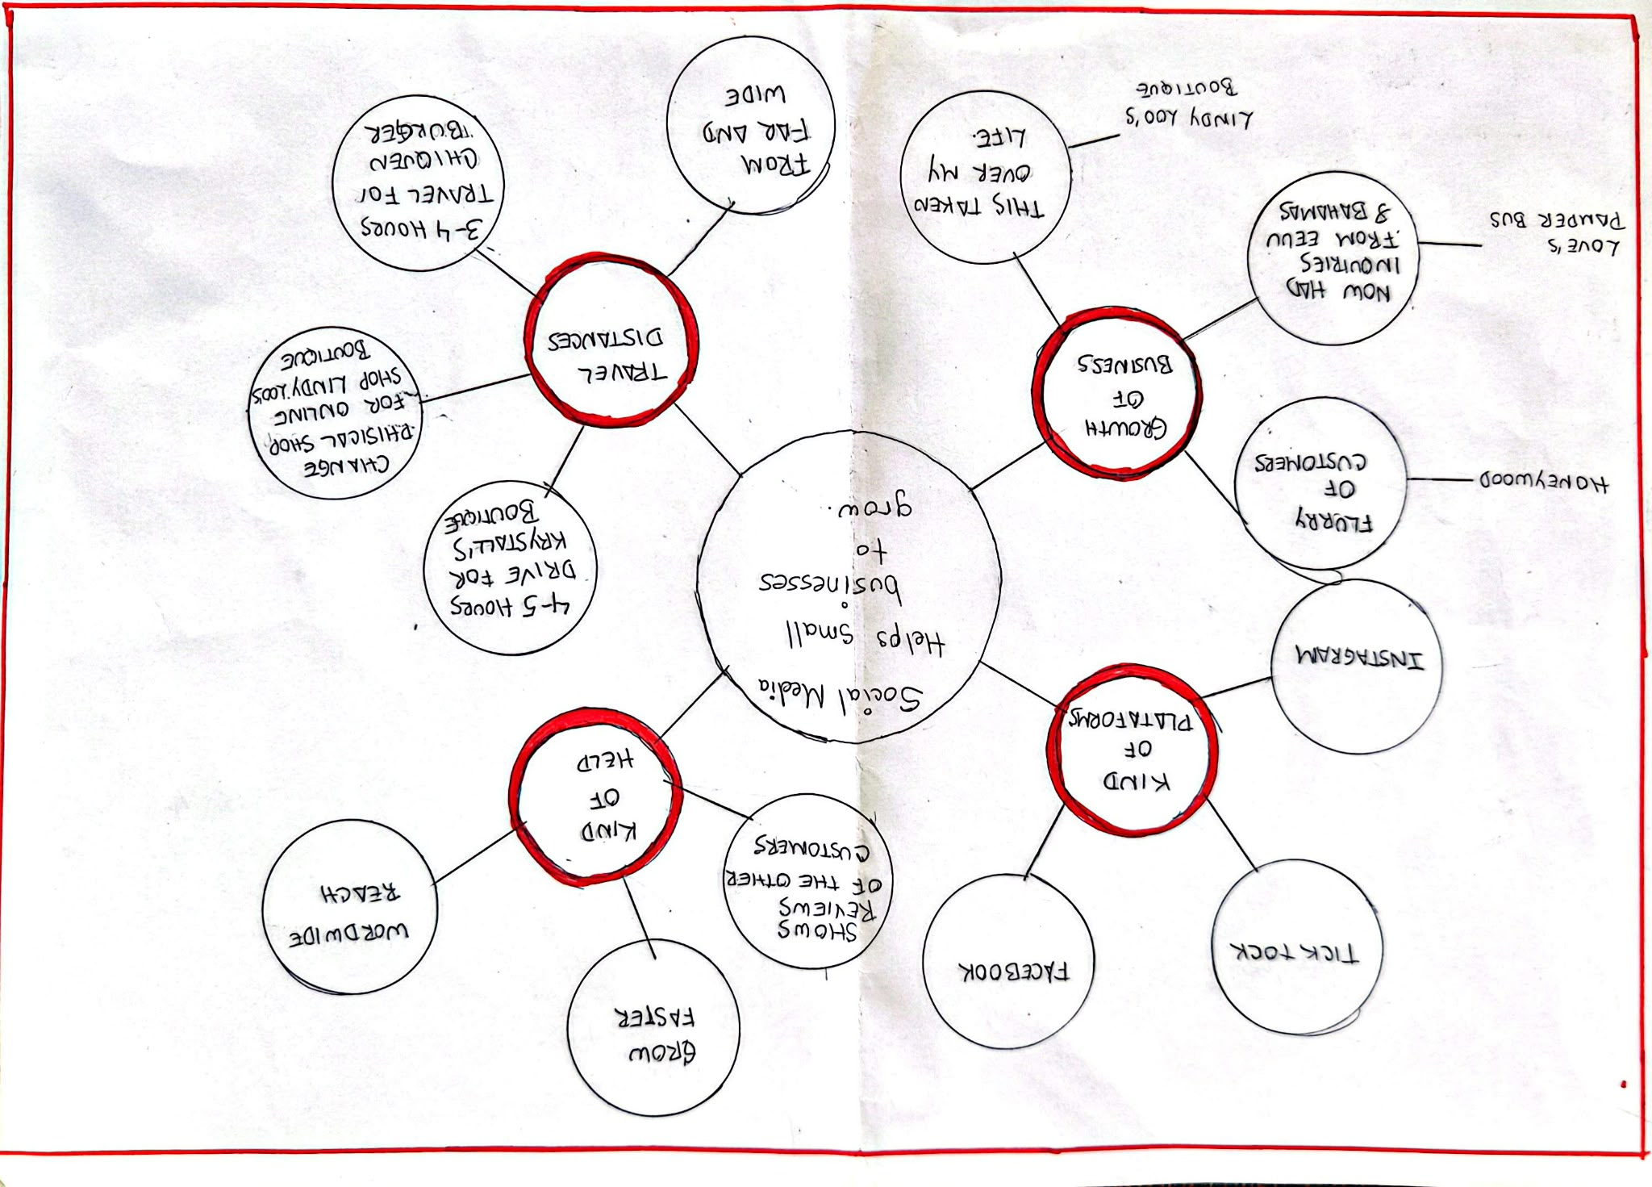

PART 2:
- Answer every question below in 1-3 full sentences.
- Use your own words. Do not use generative AI to answer these questions.
- Include a specific detail from the text when asked.
REMINDER
- The main idea is the overall message of the whole text.
- A key point helps to explain the main idea.
- A specific detail or example from the text shows that the key point is true.

- What is the main idea of the whole text?
How social media helps to small businesses to growth

- What is one key point that supports the main idea, and which specific example from the text shows this?
Kind of Plataforms.
The text talk about Tick Tock, Facebook an Instagram
- What is a different key point that supports the main idea, and which specific example from the text shows this?
- Travel distances Examples: “ The people drive 4 or 5 hour for come here”
- Gtowth of businesses Example: “Flurry of customers”
- Which part of the text do you think is most important, and why?
For me is the more important part is the main Idea because if you identify the main idea you could find the important part of the other parts that support your Diagram or map.
Reflection:
- What did you find difficult in this task (including in-class components), and why was it difficult?
Was difficult for me identify the difference between details and general idea that support the main idea.
- What helped you with this difficulty, and how did it help you?
The explanation of the teacher about what was the detail and global idea,

