DS 1 Submission

My Screenshots/Photos

Screenshot/Photo 1
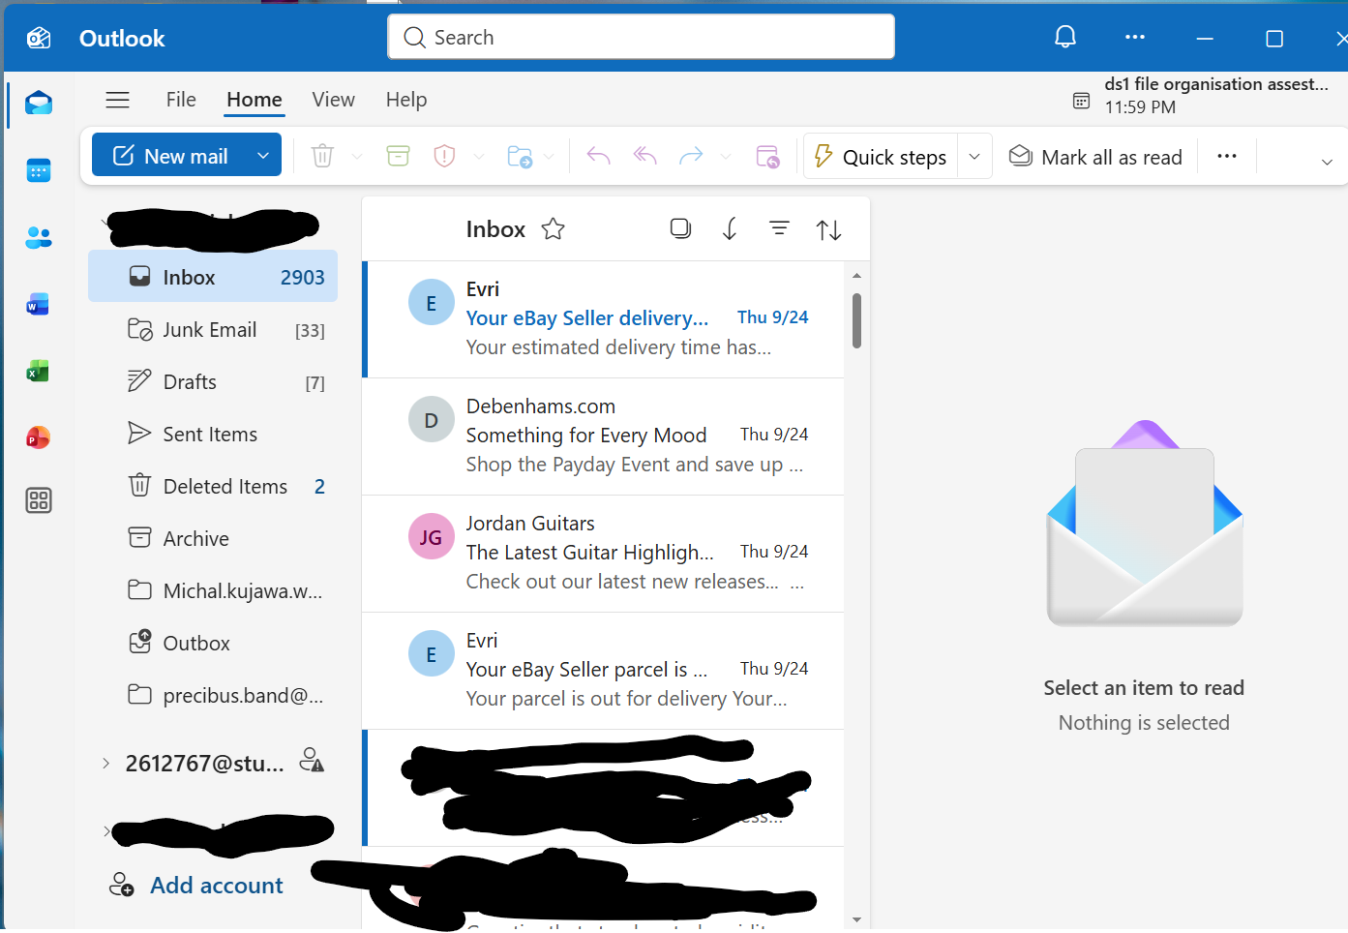
MS Outlook
Helps me to manage all of my e-mail addresses (work ,personal, school) nice and tidy.

Screenshot/Photo 2
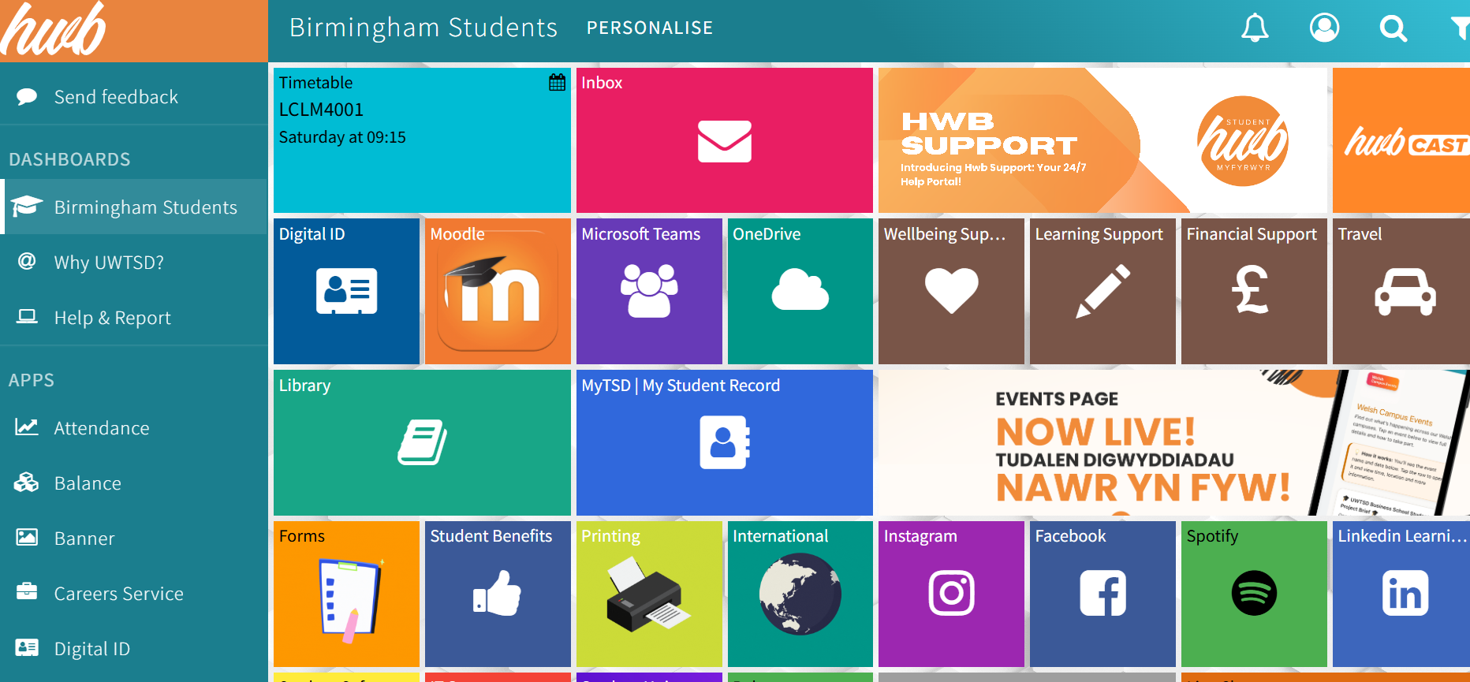

HwB
Gives me an access to everything that I need for my studies.

Screenshot/Photo 3
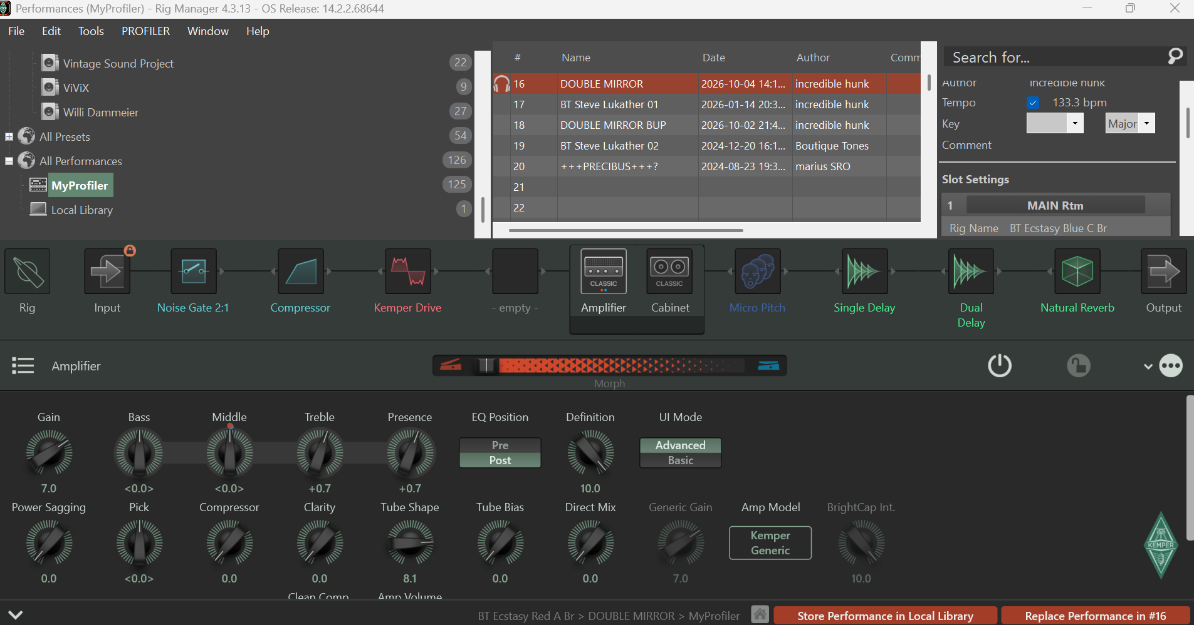
Kemper Rig Manager
This is an app that I use to edit the sounds of my musical instrument. It allows me to avoid diving for hours in the hardware interface of my equipment. Makes every change in the settings super straight forward.

Screenshot/Photo 4
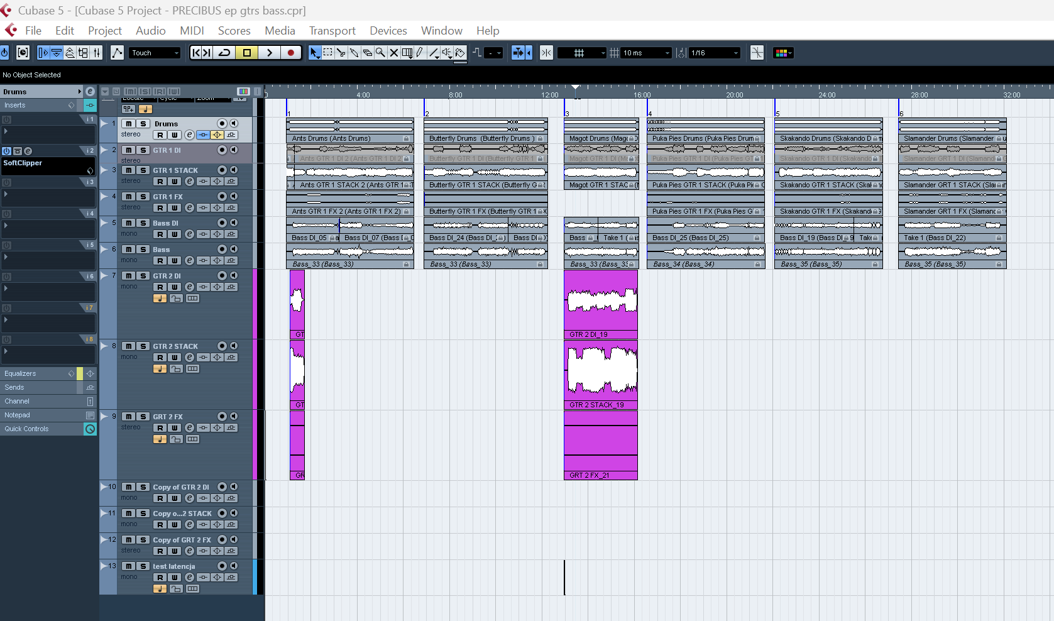
Steinberg Cubase 5
This app is a DAW (digital audio workstation). It’s like a virtual recording machine.

Screenshot/Photo 5
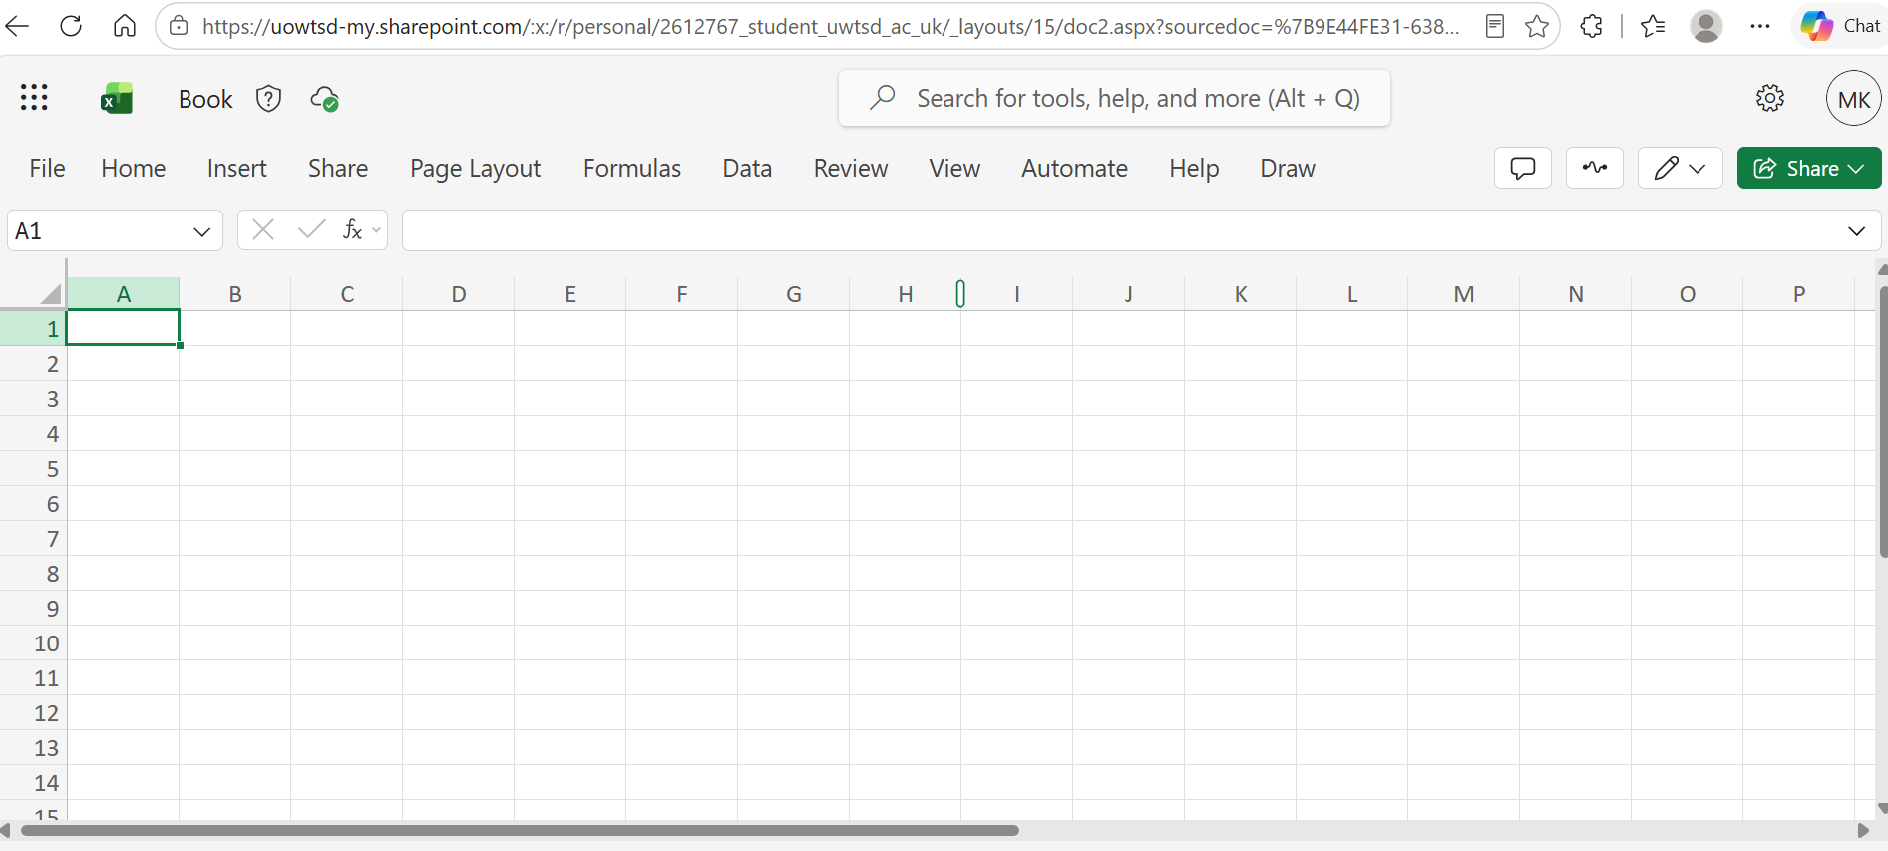MS Excel
This is the app on which today’s world is based.
In a nutshell – a fancy calculator

Screenshot/Photo 6
 Just Eat
A handy app that makes my life easy when I’m hungry.

My Short Reflection
I use digital tools as my everyday apps which show a mix of study, work, hobby and routine life. I feel confident when it comes to use the ones linked directly to my hobbies. I would love to improve my skills in professional use of MS excel. Sometimes I struggle while use MS excel. I hope this module will allow me to move more confidently in this area. Digital skills are important for me because they let me study, work and live effectively in a world where almost everything runs through technology.

Submission Checklist
Before you submit, please check:
​ ☒ I added 4–6 screenshots
☒ I wrote short sentences for each screenshot
☒ I wrote my short reflection
☒ My work is my own
☒ My file opens correctly
​​

