University of Wales Trinity Saint David
Wales Institute of Science & Art


Energy in a Flywheel
Further Science for Engineers (ACHA4007)

Noah Kenneford
2400270
03/2025
Contents
1. Introduction 1
2. Experimental Procedure 2
3. Results 5
4. Analysis 6
5. Conclusion 8
6. Evaluation 9
7. Further Work 11
8. References 12

Introduction
The purpose of this experiment is to observe the behaviour of a flywheel, calculate its characteristics from given & observed values and compare them against theoretical figures.
Flywheels are a means to store energy through a rotating mass, a wheel. The faster they spin the more energy they hold, and the more mass for a given speed also provides a greater storage of energy. The energy stored is most often reclaimed for use through an electrical motor and generator set, producing a current and converting the kinetic energy to electrical energy. Energy can be added back to the flywheel by applying current to the motor, spinning the flywheel faster. Modern flywheel setups will usually contain the flywheel in a vacuum to mitigate friction losses within atmosphere and rotate the flywheel around a set of bearings to minimise friction losses. (Bolund, Bernhoff et al. 2007)
In the context of the motorsport world, flywheel technology is used in Kinetic Energy Recovery Systems (KERS). In his book Alberto Boretti (2013) writes about ‘Flybrid Mechanical KERS’ used in both Formula 1 and LMP1 cars. These are systems using high speed flywheels up to around 60,000rpm that store around 400kJ of energy that can be used to accelerate the vehicle at the driver or engineer’s choosing.

Experimental Procedure
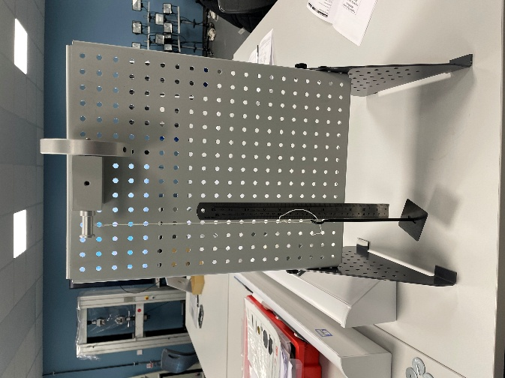
In order to observe the properties of our flywheel the experiment was set up as follows.
Figure 1 - experiment set up with no weight
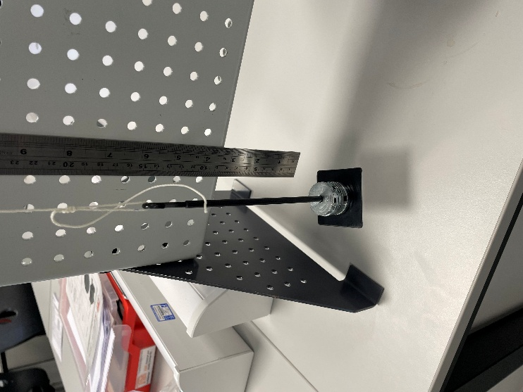

On the supplied metal stand the flywheel, bearing and pulley were attached. A magnetic ruler was attached to the stand and aligned with the zero mark with the weight carrier at its bottom, resting position. This is shown in Figure 1.
Figure 3 – Weights attached to pulley system
Figure 2 – Weights counted out
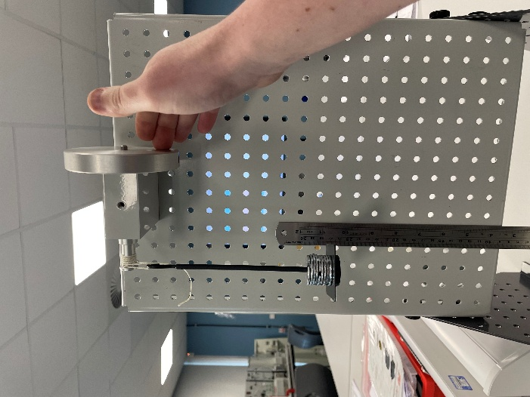
Figures 2 and 3 show the addition the first weights to the carrier which is on the end of the string and attached to the pulley. As the nominal weight for string and carrier is 10g, 90g of weights is added the first time to make the total mass attached to the flywheel 100g.
Figure 4 – Weights raised on flywheel
The flywheel is then rotated by hand until the weight carrier is aligned with the 280mm mark on the rule, gaining the weights 280mm above their bottom position. This is shown in Figure 4.
The flywheel is then released, allowing the weights to return to their bottom position and then ‘bounce’ back up, with the flywheel spinning rewinding the string in the opposite direction. The distance back up the ruler is measured, as well as the time taken to reach this point.
This was repeated for a total of three times and the results recorded to obtain an average reading.

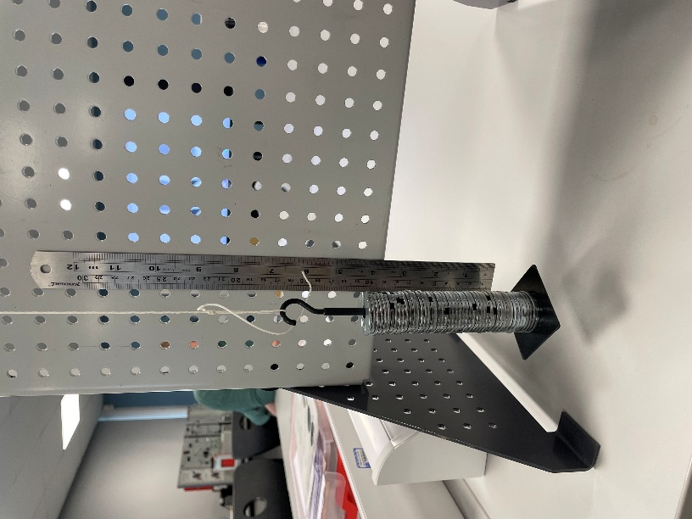
The experiment was then repeated with an extra 100g added each time, until three results were obtained for each weight 100g, 200g, 300g, 400g and 500g.
Figure 5 – the maximum weight for the experiment
Figure 5 shows the maximum amount of weight added to the carrier.

Results
The results from the experiment are shown below.
Test | Mass (g) | Time (s) | Height (mm)
1 | 100 | 4.34 | 236
2 | 100 | 4.21 | 237
3 | 100 | 3.93 | 237
4 | 200 | 3.02 | 251
5 | 200 | 2.72 | 250
6 | 200 | 2.97 | 251
7 | 300 | 2.34 | 251
8 | 300 | 2.48 | 253
9 | 300 | 2.57 | 254
10 | 400 | 2.29 | 250
11 | 400 | 2.01 | 251
12 | 400 | 2.2 | 249
13 | 500 | 2.01 | 240
14 | 500 | 1.86 | 245
15 | 500 | 2.11 | 235

Analysis
Using the raw data set above I calculated this spreadsheet and graph.
The spreadsheets use given values shown at the bottom left and the results from the experiment to calculate several characteristics, such as the Potential Energy Loss, Linear and Angular Acceleration and Velocities, and the maximum Kinetic Energy stored in the flywheel in the experiment.
Below is the formula used for the adjusted loss in Potential Energy between the start and finish positions in the experiment.
$${PE}_{loss}(adjusted)=(mg\left(h_{1}-h_{2}\right))×\frac{h_{1}}{(h_{1}+h_{2})}$$
To work out the torque present at the flywheel, the following formulae were used.
$$F=mg-ma$$
$$τ=Fr$$
Therefore.
$$τ=\left(mg-ma\right)r$$
The values for Angular Acceleration use the following formula.
$$α=\frac{a}{r}$$
To work out the Kinetic Energy present in the flywheel the following was used.
$$KE=0.5×I_{t}×ω^{2}$$
The spreadsheet has two values for Kinetic Energy. One of these uses the given values for Inertia by the manufacturers of the flywheel, and the other one uses the value of Inertia that is calculated by the graph.
The graph plots the calculated values of Torque against the values of angular acceleration of the flywheel. The graph shows a positive linear correlation, and the trendline given by Microsoft Excel gives the equation
$$y=0.00038x-0.00057$$
The first value here alongside x is the gradient and gives us the calculated value for Inertia in the system, being 0.00038kgm².

Conclusion
The data gathered shows what would be expected of a flywheel. As the force applied to the flywheel increases, so do the Velocities and Acceleration values, as well as the Torque and Kinetic Energy that is stored.
In theory, the Kinetic Energy stored in the flywheel should calculate to be the same as the Potential Energy at the start of the experiment added to the Potential Energy loss.
$$KE=PE+{PE}_{loss}$$
When these values are added and compared to the figures for Kinetic Energy calculated, there are some differences. Most results were within 7% of expected, although the 500g weighted experiments had a value ~12% higher than the calculated Kinetic Energy. The potential reasons for this will be discussed in the next section.

Evaluation
While the values that have been calculated make sense, they are not especially close to the expected values from the experiment.
Through the course of the experiment some measures were taken to ensure the accuracy of result taking, however not everything was ideal.
One thing that was noted early on was that when weight was applied to the weight hanger, the string attaching it to the pulley would stretch. This would make the bottom position of the weights to be below the 0mm mark on the rule and would skew any results to be below what they should be. To account for this every time new weight was added the rule was re-positioned so that the weights sat at 0mm again.
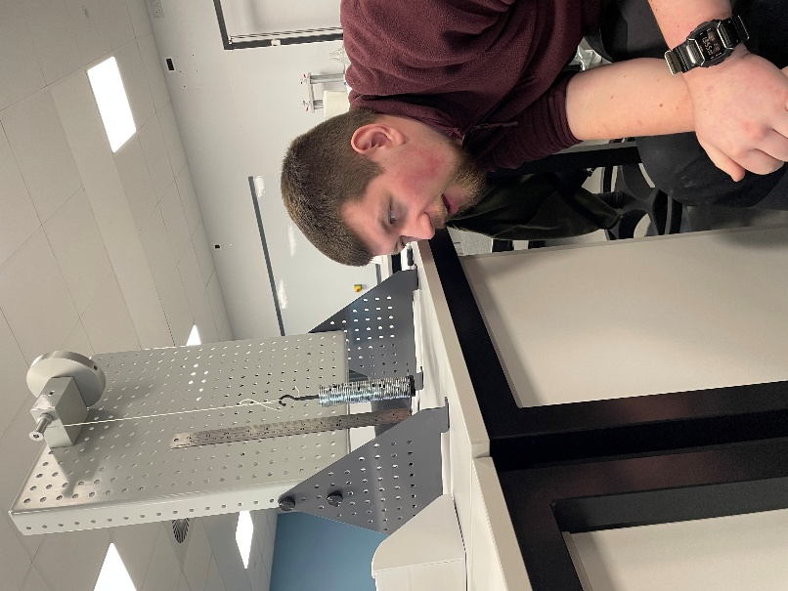
It should be noted that all measurement taking was done by eye. The final height of the weights at the end of their travel as well as the setting of the weight stack at 0mm was done by eye, with no way of telling how accurate this was.
Figure 6 – observation of settings
This is shown in figure 6, and there could be discrepancies of possibly up to a few millimetres in each result.
Similarly, near the end of experiment taking this problem was made worse. As the weight increased so did the speed, which made the height difficult to read with a short window of time where it was at the top of its travel. The stopwatch was activated by hand, and this could also have been inaccurate.
However, some effort was made to mitigate these factors. One example of this is that the same two people were employed each time to read both the height of the weights at end of travel and to record the time taken for the experiment. This ensured that it was not a case of differing opinion on when buttons would be pressed or the measurements taken, however if the persons employed were making mistakes, then this would probably be repeated.

Further Work
In an ideal world, there could be some changes made to the methodology of this experiment to increase its accuracy and reliability.
One such change could be the employment of electronic switches and sensors to record times and distances instead of the human eye and judgement. A computer would be more accurate than a human at recording the time by many magnitudes, and this could eliminate a lot of error from the results, bringing the expected and actual results closer together.
As a redundancy for this, multiple sensors could measure each result. While they provide for a lot of accuracy there can be differences from manufacturing processes, and having multiple and creating an average would increase accuracy further.
Another factor that could be improved upon was sample size. For each weight there were only three repeats, and any erroneous result could skew the figures by a large amount. If the experiment was repeated more times, then it would be more accurate, and again bring the measured results closer to their expected values.

References
BOLUND, B., BERNHOFF, H. and LEIJON, M., 2007. Flywheel energy and power storage systems. Renewable & sustainable energy reviews, 11(2), pp. 235–258.
BORETTI, A.A., 2013. Kinetic energy recovery systems for racing cars. 1 edn. Warrendale, Pa. (400 Commonwealth Dr., Warrendale PA USA): Society of Automotive Engineers.

