I confirm that I have not used any AI tools in the research and creation of this assignment. I confirm that I have not presented any AI generated materials as my own work. I can confirm that I have copies of my drafts, notes, and other resources I used, which I may be asked to provide in evidence.

Sway Link: https://sway.cloud.microsoft/l2FtcWsPVv4CsS8q?ref=Link

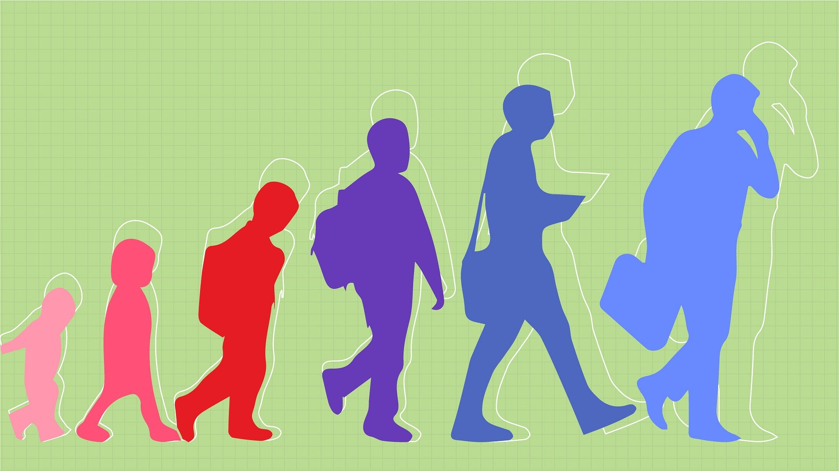

Development Across the Lifespan.

How has COVID-19 had an Impact on Children's Emotional Development?
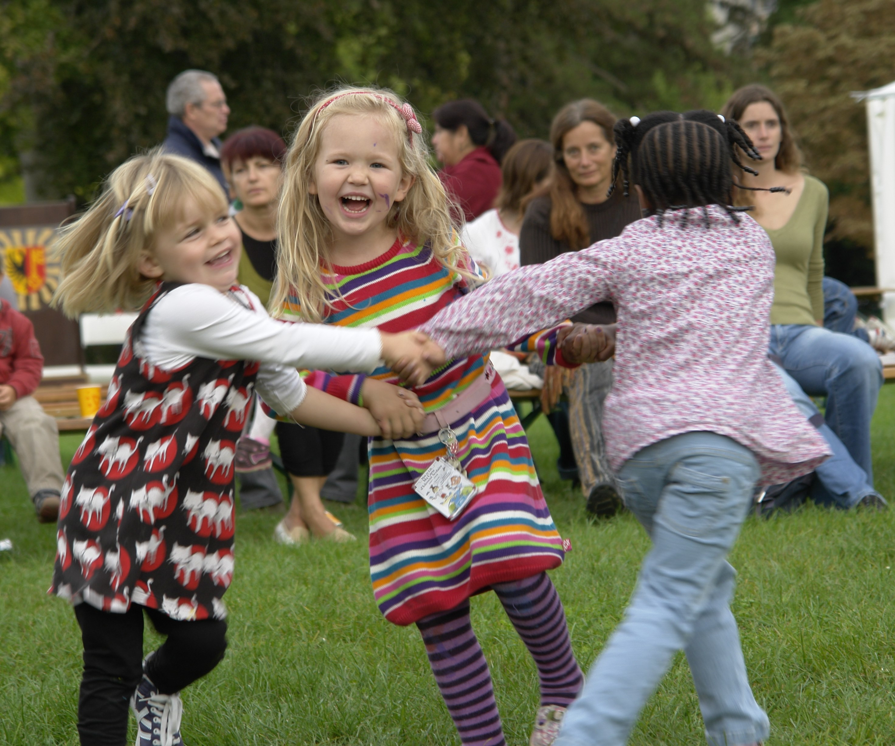
Did you know there were a total of three lockdowns during the COVID-19 pandemic? According to BBC News, 2021, the first lockdown started on 23rd March 2020, the second on 5th November 2020 and the third on 5th January 2021. From this, you must wonder how this must have impacted children’s emotional development during this time and how that has evolved over the years. In this blog, I will be covering the basic statistics from the pandemic, as well as looking into the emotional development of children and how COVID-19 has influenced that. Furthermore, I will consider theorists' points of view when discussing my research.
COVID-19 and Bereavement
UK Parliament (2021) states that COVID has had an unsettling disruption in children’s lives, with it having a complete backlash on their emotional development. UK Parliament (2021) says this has resulted in an increase in child mental health from a lack of social contact and possible bereavement due to the effects of the pandemic. GOV.UK (2020) talks about how children’s well-being was impacted by COVID-19, stating that there were worries about family members or friends becoming ill. The Office of National Statistics (2022) shows a rough idea of just how many people lost their lives to COVID-19. In 2021, England received a total of 63,555 deaths and a total of 3,650 deaths in Wales. This brings the overall total to 67,205 deaths in England and Wales due to the pandemic in 2021. BBC Children in Need (no date) has also stated that due to social distancing, an impact from the pandemic, children were unable to attend the funerals of their loved ones in person.

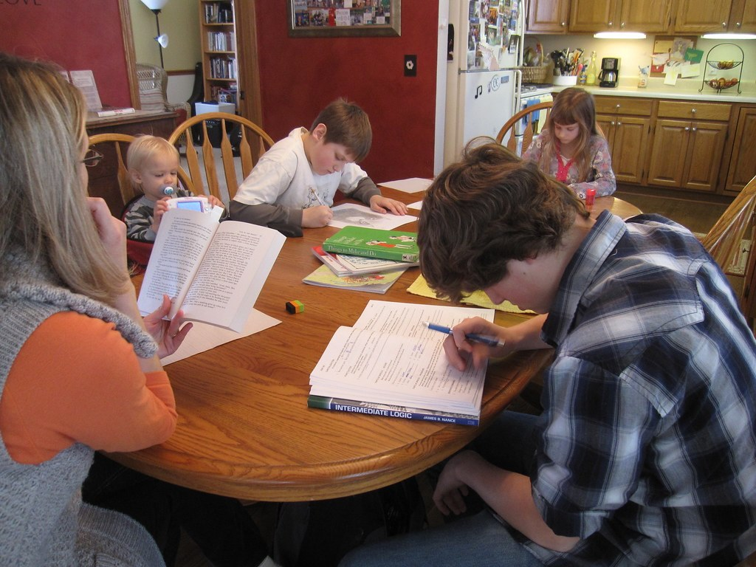
Home Schooling during the Pandemic
As a result of the lockdowns, schools closed, sending children home to learn their materials. This reduced children’s ability to have a consistent relationship with their classmates. (Anders, Blaurock, Oppermann and Zanders, 2024, pg. 1433). From this, emotional struggles brewed, and there was a struggle for children to stay positive throughout this process. (Anders, Blaurock, Oppermann and Zanders, 2024, pg. 1433). Simply Psychology (2024) talks about a theorist called Erik Erikson. He came up with eight stages of psychological development: aging from infancy to adulthood. These include:

- Trust vs. Mindset
- Anatomy vs Shame and Doubt
- Initiative vs. Guilt
- Industry vs. Inferiority
- Identity vs. Role Confusion
- Intimacy vs Isolation
- Generativity vs. Stagnation
- Ego Integrity vs. Despair
When researching, I found that Industry vs. Inferiority is well linked to children's emotional development. Neuro Launch (2024) states that Industry is about children developing new skills and tackling challenges.

What Other Challenges Were Faced during the Pandemic?
Children faced many challenges during the pandemic, some of which have already been mentioned, including social distancing, as stated by Children in Need (no date). Another primary challenge children faced during the COVID period was getting back into a routine. BBC News (2021) explains how parents were concerned about their children’s behaviour going back to school, saying how they became ‘irritable’ as well as their tempers increasing. GOV.UK (2020) explains this, saying that the lack of physical activity children were receiving during the pandemic likely affected their behaviour. Furthermore, GOV.UK (2020) also describes how this then leads to mental health issues and how children are unsure of how to cope with it. As a result of the growing increase in mental health problems, GOV.UK (2020) says schools started to provide pastoral care and support for children upon returning to school to help their emotional well-being and development.

Maslow and What He Believed.
Maslow’s Theory of Hierarchy of needs talks about what people desire in their life. However, due to the pandemic, these needs were difficult to meet. For example, physiological needs are probably the most important needs as Change Therapy (2022) states that people crave air, food, water, shelter, sleep and clothing. According to The Office for National Statistics (2020), due to COVID-19, shops and businesses closed, making it hard to get hold of these needs. Furthermore, safety is another factor to include. Change Therapy (2022) suggests that the environment in which people feel the safest in becomes impacted when there are emergency factors included. A clear example of this is COVID-19 when everyone had to stay indoors.
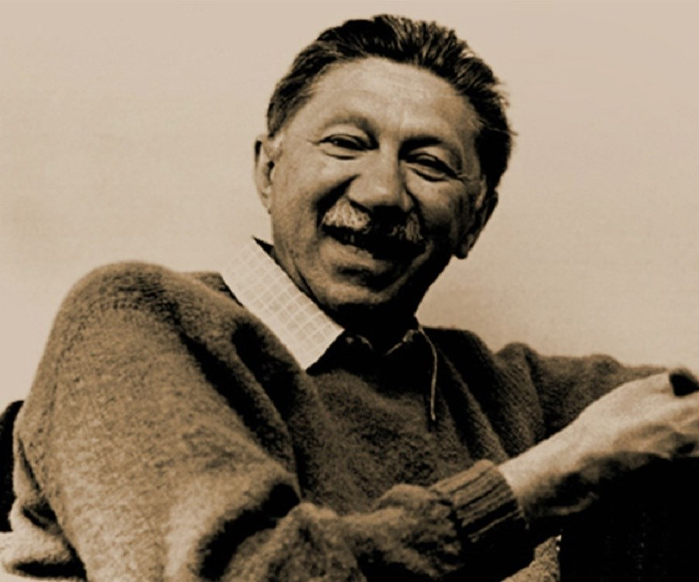
1 - Abraham Maslow (Source: Famous People, no date).

Erik Erikson.
According to Very Well Mind (2023), Erik Erikson’s Identity vs Role Confusion stage in his Psychosocial development talks about children being unable to explore who they are and being unsure of where they fit in life. This stage is mainly used to describe children aged 12 to 18 years old. According to the National Library of Medicine (2023) social media and internet played a huge part in this. While some adolescents used the internet sensibly to communicate with friends and family, the National Library of Medicine (2023) states that some also witnessed unhelpful content. This explains why many teens went through an identity crisis during the pandemic. An identity crisis can begin at any given time. For example, many teens are influenced by the people they see online, leading to teens not liking how they look. This can then lead to eating disorders and body image concerns. (Jaoude, Naylor and Pignatiello, 2020, pg. 2). Moreover, cyberbullying is a significant aspect of social media. The constant bullying can lead a person to have thoughts of suicide and lead to possible attempts. (Jaoude, Naylor and Pignatiello, 2020, pg. 2). These are just some pre-COVID examples. Just imagine how this increased during the pandemic.
According to Young Minds (2021), one in six children aged between 5 and 16 were noted to have a mental health problem in 2020. Young Minds (2021) suggests that this is a massive increase from the previous one in nine back in 2017. Furthermore, 83% of young people said to have had a mental health problem only became worse due to the pandemic. Taking these statistics into consideration, the National Library of Medicine (2023) explains how the pandemic allowed more time for internet access, allowing an increase in damaging their emotional development.
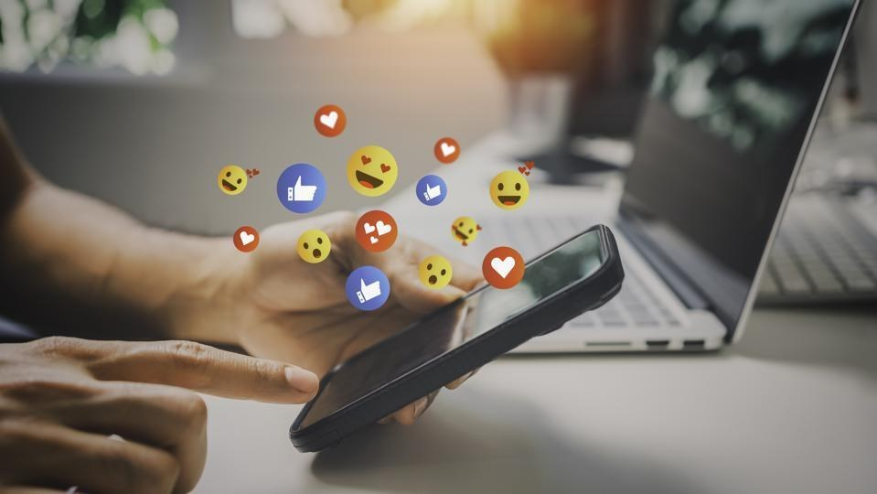
2 - (Source: Forbes, 2023).

My own Experience from my Research
From researching, I have found that I have had experiences relating to what I have spoken about. For example, I struggled with my mental health during covid. This affected my emotional development when returning to school, as I was afraid to be open about my feelings. As a result, I had pastoral help, which helped me gather precisely how I was feeling. This links to Erikson's theory as I and everyone my age had the challenge of tackling GCSEs after having little to no social or face to face contact with our school teachers during the lockdown period. This shows precisely how much COVID-19 has impacted children's emotional development and how actions were implemented to help fix it.

The Impact Play has on a Child's Physical Development.
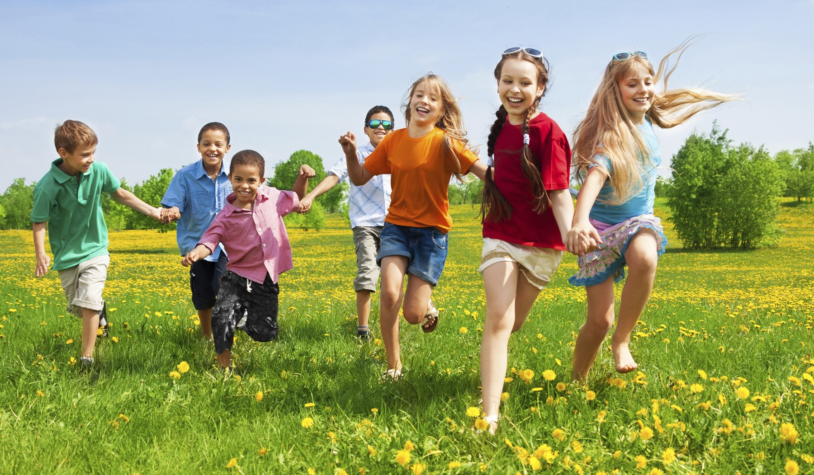
According to BBC Tiny Happy People (2025), play is essential for children because it increases their attention span and allows their physical skills to develop. I don’t know about you, but from my own experience, I think play is the most critical aspect of a child’s life as they can learn so much. With this in mind, how does play help develop a child’s physical ability? In this blog, I will discuss how a child can grow physically through playing and investigate theorists' points of view and what they believe play means for a child’s physical development.

Different Types of Play.
(Doherty and Hughes, 2024, p.182) states that physical development is how a child is able to form physically, from their height and weight. Play plays a big part of this. There are known to be six different types of play children experience. These are known as:
- Unoccupied Play
- Solitary Play
- Onlooker Play
- Parallel Play
- Associative Play
- Cooperative Play
(BluBerry Edu, 2019).
BBC Tiny Happy People (2025) talks about these different types of play in more detail. Associative Play and Cooperative Play links into this topic more as children become more interactive and play more with each other. For example, BBC Tiny Happy People (2025) says that during Associative Play, children interact and chat with each other, as well as share their toys. These include play dough and climbing outside. According to NAEYC (2019), playdough plays a big part in a child’s physical development. For example, when children poke, role and squish the dough it allows for dexterity to improve in a child’s hands and fingers. NAEYC (2019) explains that this is because little muscles are being used in their fingers, helping their fine motor skills. BBC Tiny Happy People (2025) says that Cooperative Play is all about children working together and having more imaginary play, such as role playing. An example used by BBC Tiny Happy People (2025) is playing house. A book by (Haymer, 2022) indicates that this learning style is known as Kinaesthetic as children use their bodies to navigate their play and prefer to act out or be hands on with their learning. This links to role play and how children can develop their physical skills through this.

Maria Montessori
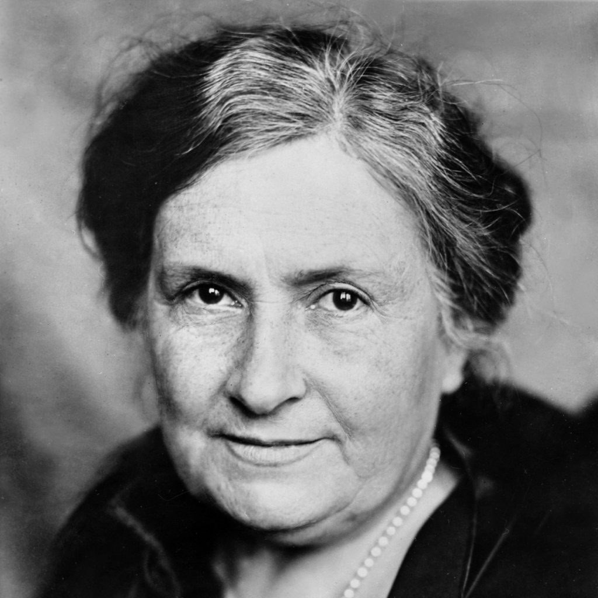
3 - Maria Montessori, (Source: English Teacher Resources, no date).
There are many theorists that talk about play. One of these theorists is Maria Montessori. According to Simply Psychology (2024), Montessori says that hands-on experience is extremely important for a child’s physical development. For example, using fine-motor skills by using scissors is a great way to develop physically. Furthermore, Berg (2024) explains that Montessori believed children thrived on indoor and outdoor play experiences to develop their physical skills.

Physical Play Activities for Children.
Physical play activities differ depending on a child’s age. (Haymer, 2022, p.15) states that by the time a child is 12 months old, they will be able to crawl and pull themselves upright. These skills would have developed from birth gradually by children moving their heads, sitting up unsupported, sucking, and rolling their eyes. (Haymer, 2022, p.15). NHS (2022) suggests that children aged from 0-2 years should follow specific guidelines to stay physically active. Babies up until the age of 1 should be allowed at least 30 minutes of tummy time, and parents should allow them to be as active as possible. For children aged 1-2 years old, NHS (2022) suggests that they receive a total of 180 minutes of physical activity a day to help their physical development. That’s 3 hours in total. NHS (2022) says the best playful way for this is for children to contribute to skipping, hopping, running and jumping. (Haymer, 2022, p.15) states that children of this age group are more than likely able to throw a ball, walk, crawl and jump.
These activities can be made into fun games for children. For example, BBC Tiny Little People (2025), says children can use baskets to throw a ball into them as a ‘target.’ Furthermore, BBC Tiny Little People (2025) also gives more examples of physical activities children can do to improve on their physical development. One example suggested that is good for 4-year-olds is an obstacle course. According to Montessori Lessons (2023), obstacle courses help to build endurance, strength and co-ordination. Children aged 3 to 5 years old can develop physically as most of them are able to walk, run, climb, hop and stand on 1 foot. (Haymer, 2022, p.15). CDC, (2024) states that it is recommended that children aged 3 to 5 years old should be encouraged daily by their parent or guardian to do some form of physical activity to improve their physical development. Moreover, children aged 6 to 17 should engage in at least 60 minutes of physical activity a day if they are to develop their physical skills.

SKIP Cymru
Children can create their own fun, but adults should also take responsibility for children wanting to stay active. A way to ensure that children do engage in the correct amount of physical activity a day is SKIP Cymru. This is a system set up for adults to learn how children can develop physically, using fun games and challenges. An article discussing SKIP Cymru explains that early childhood is the most important time for children to develop physically. However, teachers have a lack of knowledge and guidance to help with that. SKIP Cymru trains teachers on how they can promote physical development through PE and teach children the importance of staying fit. (Goodway, John, Wainwright and Williams, 2024). I have used SKIP Cymru in the past when preparing lessons, and I found it extremely helpful for gaining knowledge on fun games children can play to ensure they are developing physically.

What has been learnt?
From this research, children undoubtedly can develop their physical skills through play. This can be any type of play, such as outdoor or indoor play and it can be done in many ways. Examples used in this blog include fine motor skills, and fun physical activities, such as SKIP Cymru.

How does ACEs have an Impact on a Child's Moral Development?
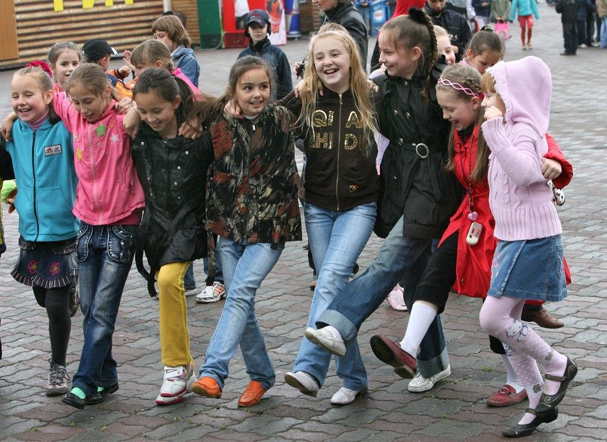
Have you ever had to experience ACEs? The term ACEs is a shortened form of the phrase ‘Adverse Childhood Experiences’. In the UK, NHS (2021) recognises that 47% of the population have experienced at least 1 ACE in their lifetime. That is almost half the population. Furthermore, 9% of the population, according to NHS (2021) have experienced 4 or more ACEs. NHS (2025) explains the different type of ACEs a child may experience in their life. Some of these examples include:
- Verbal Abuse
- Household Domestic Abuse
- Parental Separation
- Household Alcohol Abuse
- Household Drug Abuse
NHS (2025) states that a child who experiences ACEs in their childhood is more likely to show a problematic side to them later in their life. Furthermore, NHS (2025) also says that children are more likely to develop a mental health illness with them having experiences with ACEs. In this blog I will be discussing how ACEs can have an impact on a child’s moral development, and the relevant tactics to prevent this from happening. Moreover, I will be discussing different theorists and their thoughts on moral development, and how the environments a child lives and is surrounded by can also have an impact.

What is Moral Development?
According to Simply Psychology (2024), Moral development is the process where children learn to understand what is right and wrong. (Doherty and Hughes, 2023, p.393) explains moral development is about the way children learn from their parents regarding views, standards and how they should behave.
In a video by (Sprouts, 2019) they go into depth on the theorist Lawrence Kohlberg and how he set up 6 stages of moral development, that are split into three groups. Pre-conventional, conventional, and post-conventional. (Sprouts, 2019) suggests that stage 1 and 2 in Kohlberg's Moral development are part of the pre-conventional layer, stage 3 and 4 are part of the conventional layer and stage 5 and 6 are part of the post-conventional layer. This is because these stages link with each other on how a child may perceive a certain situation.
According to Simply Psychology (2024), Lawrence Kohlberg’s 6 Stages of Moral Development are:
- Avoiding Punishment
- Self Interest
- Good Boy Attitude
- Law and Order Morality
- Social Contract
- Principle
Stage 1 and Stage 2 can be found in the pre-conventional level and are known for children aged 3-7 years old. Simply Psychology (2024) suggests that these stages are all about following the rules and understanding that punishment is for those who obey them. Stage 3 and 4 can be found in the conventional level and are aged 8-13 years old. Simply Psychology (2024) explains that these stages believe that people should not live up to other’s expectations or goals. Finally, the post conventional level describes stages 5 and 6 for children aged 14 to adulthood. Simply Psychology (2024) makes it known that children in this stage believe that justice should be served for ‘bad’ behaviour.

4 - Lawrence Kohlberg (Source: Owlcation, 2023).

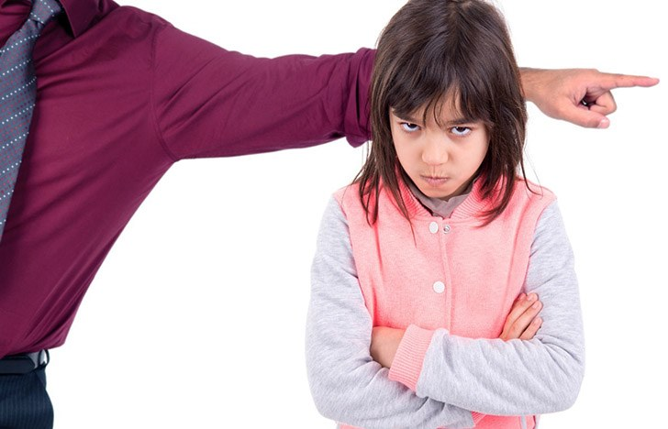
How do ACEs influence a child’s behaviour?
Help Children Live Better (2024) suggests that children with ACEs will struggle developing their mind. This can cause harmful levels of stress, which later effects their behaviour. According to NHS (2021), children who have experienced ACEs are more likely to struggle managing their behaviour in school settings, form healthy relationships and friendships, and manage their emotions. (Doherty and Hughes, 2023, p.392) states that moral development is best described by the theorist Urie Bronfenbrenner. Bronfenbrenner focused on the environments children are brought up in. This may give an understanding as to why different environments have different outcomes for children. One of the stages in Bronfenbrenner’s system is the Microsystem. (Hayes, Lyons and Smith, 2017). This system links in more to why ACEs can impact moral development.
Simply Psychology (2024) states that the Microsystem is possibly the most important stage of a child’s life. During this stage, a child experiences its first immediate environment, including parents, carers, siblings, classmates, teachers and neighbours. In this stage, Simply Psychology (2024) explains that a child can be made to believe whatever they see or hear based on what they experience. This links into Albert Banduras social learning theory. (Haymer, 2022) says Bandura set out an experiment where children were placed in a room and witnessed an adult attacking a bobo doll. Later, (Haymer, 2022) explains that the same children were left in the room and copied the adult by attacking the bobo doll. This theory proves that children learn from what they see, and that Bronfenbrenner’s theory can back this up with systems of the levels children can progress at. Moreover, Bandura believed that children learn from their environment, which results in their behaviour. (Haymer, 2022).

What support is out there to help with ACEs?
From the evidence conducted, you must wonder what services are available to children with ACEs? I personally believe it is important to understand and be aware of the different services available to those who have ACEs, so that we know how to support them. NHS (2021) advises that children with ACEs can access CAHMS support as they can complete assessments to determine the best outcome for children. Not only that, NHS (2021) states that CAHMS also work alongside parents and carers and support them throughout the process. Mind (2022) says that CAHMS is a mental health service that supports children and young people with difficult experiences. National Institute for Health and Care Research (2023) suggests that children with ACEs should receive support to help them as it can lead to mental health problems later in life. They say that children should try and seek support through positive relationships, such as foster carers, teachers and therapists as these are people who children can trust.
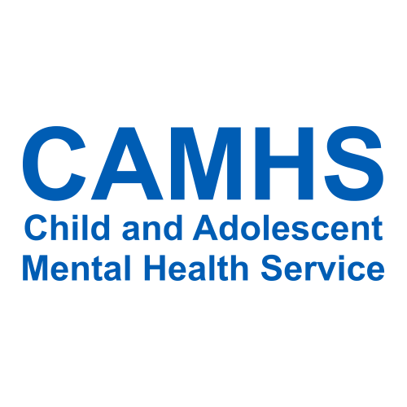
5 - (Source: Victim Advice Line, 2019).

What outcome can be concluded?
From looking at this evidence, it is valid to assume that children with ACEs can witness and copy the behaviour they see from their prime environment and use it in their life. As stated by NHS (2021), children are more likely to pass on their ACEs to the next generation of children. This is because they grow up believing what they have been taught in their household by watching and observing, proving Bandura’s theory. Kohlberg’s 6 stages of development can also confirm this as children learn from the environment around them. However, the right support and guidance can have a massive impact on how a child controls their life after the long-lasting effects of ACEs. This includes seeking medical help from CAHMS or just talking to a trusted adult if that is easier for the child.

Word Count: 3,277 words.

Reference List
Abi-Jaoude, Naylor and Pignatiello (2020). Smartphones, Social Media Use and Youth Mental Health. Canadian Medical Association Journal, 192 (6). p.2. Available at: Smartphones, social media use and youth mental health. (Accessed: 09/02/2025).

Anders, Blaurock, Oppermann and Zander (2024). Children’s Social-Emotional Development During the COVID-19 Pandemic: Protective Effects of the Quality of Children’s Home and Preschool Learning Environments. Early education and development, 35 (7). p.1433. Available at: Children’s Social-Emotional Development During the COVID-19 Pandemic: Protective Effects of the Quality of Children’s Home and Preschool Learning Environments. (Accessed: 07/02/2025).

BBC Children in Need. (No date). The Impact of the Pandemic on Childhood Bereavement. Available at: The Impact of the Pandemic on Childhood Bereavement - BBC Children in Need. (Accessed: 07/02/2025).

BBC News. (2021). Lockdown: Are people breaking COVID rules? Available at: Lockdown: Are people breaking Covid rules? - BBC News. (Accessed: 03/02/2025).

BBC News. (2021). Years to get children back on track after COVID. Available at: 'Years to get children back on track after Covid' - BBC News. (Accessed: 08/02/2025).

BBC Tiny Happy People. (2025). How do children play? 6 styles of play in early childhood. Available at: Stages of Play: 6 different ways your child will play - BBC Tiny Happy People. (Accessed: 15/02/2025).

BBC Tiny Happy People. (2025). Throwing games with socks. Available at: Throwing games for kids' hand-eye coordination - Bean bag or sock throwing game - BBC Tiny Happy People. (Accessed: 16/02/2025).

Berg. (2024). The Montessori method of education: A child-led approach. Available at: What is a Montessori nursery? | The child-led approach. (Accessed: 17/02/2025).

BluBerry Edu. (2019). 6 Types of Play. Available at: 6 Types of Play - YouTube. (Accessed: 15/02/2025).
CDC. (2024). Child Activity: An Overview. Available at: Child Activity: An Overview | Physical Activity Basics | CDC. (Accessed: 16/02/2025).

Change Therapy. (2022). Understanding Maslow’s Hierarchy of needs. Available at: Understanding Maslow’s Hierarchy of Needs – Change Therapy. (Accessed: 22/02/2025).

Doherty and Hughes. (2023). Child Development Theory and Practise 0-11. 2nd edn. Harlow: Pearson Education, Limited.

English Teacher Resources. (No Date). Maria Montessori. Available at: Maria Montessori - English Teacher Resources. (Accessed: 17/02/2025).

Famous People. (No date). Abraham Maslow Biography. Available at: Abraham Maslow Biography - Facts, Childhood, Family Life & Achievements. (Accessed: 22/02/2025).

Forbes. (2023). Top Social Media Statistics and Trends of 2024. Available at: https://www.forbes.com/advisor/business/social-media-statistics/. (Accessed 17/)2/2025)

Goodway, John, Wainwright and Williams (2024). Examining the fidelity of implementation of SKIP Cymru (Successful kinaesthetic instruction for pre-schoolers- Wales) by early childhood teachers in Wales following a programme of professional development. Physical Education and Sport Pedagogy, p.3. Available at: Examining the fidelity of implementation of SKIP Cymru (Successful kinaesthetic instruction for pre-. (Accessed: 17/02/2025).

GOV.UK. (2020). Effects of pandemic on children’s wellbeing reviewed in new report. Available at: Effect of pandemic on children's wellbeing revealed in new report - GOV.UK. (Accessed: 06/02/2025).

Hayes, Lyons and Smith (2017). Journal of Mathematical Behaviour. The ecology of instructional teacher leadership, p.270. Available at: The ecology of instructional teacher leadership. (Accessed 20/02/2025).

Haymer. (2022) Children’s Care, Play, Learning and Development: Theory. Cardiff: WJEC.

Help Children Live Better. (2024). Adverse Childhood Experiences. Available at:What are ACEs? - Help Children Live Better. (Accessed: 19/02/2025).

Helpful Professor. (2024). 5 Types of Development (Physical, Cognitive, Social Etc). Available at: 5 Types of Development (Physical, Cognitive, Social, etc) (2025). (Accessed: 15/02/1015).

Mind. (2022). Understanding CAHMS - for 11–18-year olds. Available at: What is CAMHS? - for 11-18 year olds | Mind - Mind. (Accessed: 20/02/2025).

Montessori Lessons. (2023). The Benefits of an Obstacle Course for Children. Available at: The Benefits of an Obstacle Course for Children. (Accessed: 16/02/2025).

NAEYC. (2019). Playdough Power. Available at: Playdough Power | NAEYC. (Accessed: 15/02/2025).

National Institute for Health and Care Research. (2023). What support do young people affected by adverse childhood experiences need? Available at: Support needs following adverse childhood experiences - NIHR Evidence. (Accessed: 22/02/2025).

National Library of Medicine. (2023). Impacts of COVID-19 quarantine and isolation on adolescent social functioning. Available at: Impacts of COVID-19 quarantine and isolation on adolescent social functioning - PMC. (Accessed: 09/02/2025).

Neuro Launch. (2024). Industry vs Inferiority: A Psychological Explanation of Erikson’s Fourth Stage. Available at: Industry vs. Inferiority: Erikson's Fourth Developmental Stage. (Accessed: 05/02/2025).

NHS. (2021). Adverse Childhood Experiences (ACEs) and Attachment. Available at: Adverse Childhood Experiences (ACEs) and Attachment - Royal Manchester Children's Hospital. (Accessed: 18/02/2025).

NHS. (2022). Physical activity guidelines for children (under 5 years). Available at: Physical activity guidelines for children (under 5 years) - NHS. (Accessed: 16/02/2025).

NHS. (2025). Adverse childhood experiences and the lasting impact. Available at: Adverse childhood experiences and the lasting impact - NHS Safeguarding. (Accessed: 18/02/2025).

Northern Life. (2025). Margret McMillan – school dinner pioneer. Available at: Margaret McMillan - School Dinner Pioneer • Northern Life. (Accessed: 17/02/2025).

Office for National Statistics. (2022). Deaths due to COVID-19, registered in England and Wales: 2021. Available at: Deaths due to COVID-19, registered in England and Wales - Office for National Statistics. (Accessed: 06/02/2025).

Office for National Statistics. (2020). The impact of the coronavirus so far: the industries that struggled or recovered. Available at: The impact of the coronavirus so far: the industries that struggled or recovered - Office for National Statistics. (Accessed: 22/02/2025).

Owlcation. (2023). Lawrence Kohlberg’s 6 Stages of Moral Development. Available at: Lawrence Kohlberg’s 6 Stages of Moral Development - Owlcation. (Accessed: 22/02/2025).

Simply Psychology. (2024). Bronfenbrenner's Ecological Systems Theory. Available at: Bronfenbrenner's Ecological Systems Theory. (Accessed: 20/02/2025).

Simply Psychology. (2024). Erik Erikson’s Stages of Psychosocial Development. Available at: Erikson's Stages of Development. (Accessed: 05/02/2025).

Simply Psychology. (2024). Montessori’s Theory of Education. Available at: What Is Maria Montessori Theory Of Education. (Accessed: 16/02/2025).

Simply Psychology. (2024). Piaget’s Theory of Moral Development. Available at: Piaget's Theory of Moral Development: Heteronomous vs. Autonomous. (Accessed: 18/02/2025).

Simply Psychology. (2024). Kohlberg’s Stages of Moral Development. Available at: Kohlberg's Stages of Moral Development. (Accessed: 18/02/2025).

Sprouts. (2019). Kohlberg’s 6 Stages of Moral Development. Available at: Kohlberg’s 6 Stages of Moral Development - YouTube. (Accessed: 18/02/2025).

UK Parliament. (2021). Children’s Mental Health and the COVID-19 Pandemic. Available at: Children's Mental Health and the COVID-19 Pandemic. (Accessed: 03/02/2025).

Very Well Mind. (2023). Identity vs Role Confusion in Psychosocial Development. Available at: Identity vs. Role Confusion in Psychosocial Development. (Accessed: 06/02/2025).

Victim Advice Line. (2019). Children and Adolescents Mental Health Line (CAHMS). Available at: Children and Adolescent Mental Health Service (CAMHS) - Victim Advice Line. (Accessed: 22/02/2025).

Young Minds. (2021). Mental Health is a big issue for young people. Available at: Mental Health Statistics UK | Young People | YoungMinds. (Accessed: 09/02/2025).

