Problem
Analysis and Solution
Development

Module Name: Analysing and Solving Problems
Module Code: ACCA 4019
Student Name: Hebun AY
Student ID: 2529281
Group:2
Lecturer’s Name: Dr Redhwan Al-amri

Table of Contents
Table of Contents 1
1. Introduction 2
2. Deconstruct the Problem 2
2.1 MoSCoW Technique Requirement 2
2.2 Variables Identification 2
3. Proposed Solution 2
3.1 Flowchart 2
3.2 Flowchart Explanation 2
4. Reflection and Justification 2
4.1 Abstract thinking 2
4.2 Sub-dividing 2
4.3 Justification of solution 2
4.4 Limitation 2
4.5 Assumption 2
5. Conclusion 2
References 2

Introduction
Group work in computing helps students develop technical, communication and problem-solving skills. However, meetings can be difficult to organise when students have different timetables, part-time jobs and personal commitments. In this scenario, incompatible schedules can delay tasks, cause missed weekly deadlines and create uneven workloads.
This report analyses the scheduling problem and proposes a structured solution for group project meetings. The problem is divided into smaller components, requirements are prioritised using MoSCoW, and the main variables and constraints are defined. A flowchart is then used to show how schedules are filtered, compared and checked against meeting-duration and deadline requirements. The solution is finally evaluated through abstraction, decomposition, systems thinking and scheduling optimisation.

Deconstruct the Problem
The problem involves several constraints that must be satisfied together. A meeting is useful only when the selected time is available to the group, long enough for discussion and early enough to support the weekly deadline. The problem was therefore divided into three connected areas: temporal availability, deadline control, and communication/confirmation. This follows computational thinking, where a larger problem is decomposed before a solution is designed [2]. A systems perspective is also relevant because schedules, deadlines and member responses affect one another [3].
Temporal availability includes lectures, tutorials, work shifts, personal commitments and the weekly scheduling window. These periods act as constraints because meetings cannot be placed when a member is unavailable. Deadline control includes the weekly project deadline and minimum meeting duration. Communication covers invitations, confirmations, reminders and unexpected changes. Scheduling research shows that preferences such as preferred days and spacing between meetings can also affect choices [4]. Therefore, feasible slots should be ranked rather than selected randomly.
MoSCoW was used to separate essential requirements from optional features. It classifies requirements as Must Have, Should Have, Could Have and Won’t Have [1]. In this scenario, Must Have requirements ensure that fixed commitments are respected, a feasible time is found and the meeting occurs before the weekly deadline. Should Have and Could Have items improve usability, while Won’t Have items define the system boundary and prevent unnecessary scope.

MoSCoW Technique Requirement
Priority | Requirements
Must Have | Identify a meeting time when all group members are available.  Treat lectures, work shifts and other fixed commitments as unavailable.  Schedule the meeting before the relevant weekly project deadline.  Require confirmation of the selected meeting time.
Should Have | Send invitations through a calendar platform such as Google Calendar or Outlook.  Provide an online meeting option when a physical meeting is unsuitable.  Allow unexpected conflicts to be reported and another slot to be requested.
Could Have | Recommend a meeting location or online platform.  Record attendance and assigned tasks.  Send an automatic reminder before the meeting.
Won’t Have | Generate or complete academic work for students.  Continuously track students’ physical locations.  Guarantee attendance after a meeting has been confirmed.
Table 1. MoSCoW prioritisation of the scheduling requirements.
The Must Have items define the minimum scheduling solution. Should Have and Could Have items add flexibility and convenience, while Won’t Have items exclude functions that do not contribute directly to the scheduling problem. This keeps the design focused on the assignment objectives [1].

Variables Identification
Variable | Type | Description
Available Time Period (T) | Input | The total weekly period in which group meetings may be considered.
Academic Schedule (Ai) | Constraint | The fixed lectures, tutorials and laboratory sessions of student i.
Work Shift (Wi) | Constraint | The fixed part-time employment schedule of student i.
Personal Commitments (Pi) | Constraint | Periods when student i is unavailable because of personal responsibilities or other commitments.
Individual Free-Time Set (Si) | Derived variable | The remaining free periods for student i after fixed commitments are removed: Si = T \ (Ai ∪ Wi ∪ Pi).
Project Deadline (Dk) | Constraint | The submission time for weekly project milestone k.
Minimum Meeting Duration (Md) | Parameter | The minimum continuous period required for the meeting, for example 60 minutes.
Common Availability Set (O) | Derived variable | The periods in which all members are free: O = S1 ∩ S2 ∩ ... ∩ Sn.
Optimal Meeting Slot (Topt) | Output | The selected feasible meeting time that satisfies duration and deadline constraints and is preferred among valid alternatives.
Table 2. Key variables and constraints used by the scheduling solution.

Proposed Solution
A rule-based scheduling process is proposed so the same logic can be reused for different groups and timetables. Each member’s unavailable periods are removed from the overall scheduling window to create an individual free-time set. These sets are intersected to find common availability. Constraints are then applied until feasible choices remain, reflecting the general logic of optimisation [6]. Academic scheduling research also shows that meeting allocation can be represented using availability and time constraints [5].

Flowchart
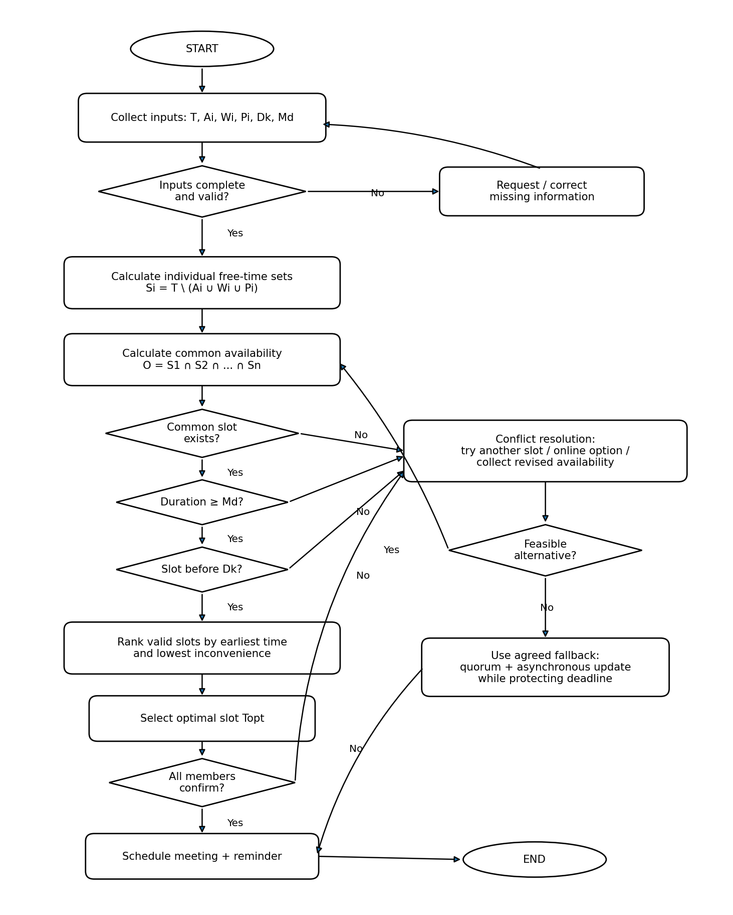
Figure 1. Logical flowchart for optimising group project meeting allocation.

Flowchart Explanation
The flowchart in Figure 1 begins by collecting the scheduling period T, academic schedules Ai, work shifts Wi, personal commitments Pi, project deadline Dk and minimum meeting duration Md. Inputs are checked before calculation. Missing or inconsistent information is corrected first so that an invalid schedule is not created from incomplete data.
For each member, fixed commitments are removed from T using Si = T \ (Ai ∪ Wi ∪ Pi). This converts different reasons for unavailability into a simple available/unavailable representation. The same logic can therefore be applied to students with different combinations of lectures, work and personal commitments.
The free-time sets are intersected as O = S1 ∩ S2 ∩ ... ∩ Sn to identify periods when all members are available. If no common period exists, conflict resolution is used instead of ending the process. Revised availability, another candidate slot or an online option can be considered. This reflects the fact that real scheduling depends on context as well as calendar availability [4].
If common availability exists, each candidate is checked against Md and Dk. Slots shorter than the agreed meeting duration are rejected, and any slot occurring too late to support the weekly milestone is also removed. These checks ensure that a technically free period is not accepted unless it can support a useful meeting before the project deadline.
When several valid slots remain, they are ranked rather than selected randomly. The earliest feasible time can be preferred because it leaves more time for project work before the deadline. A simple inconvenience measure may also favour slots that avoid work shifts or repeatedly disadvantaging the same member. This follows the optimisation principle of choosing the best option after all required constraints have been satisfied [6]. Ranking is useful because two slots may both be feasible while one creates less disruption for the group. More advanced systems could use integer or constraint programming, as academic scheduling models demonstrate [5], but the simpler rule-based method is sufficient for the logical design required here.
The highest-ranked slot is stored as Topt and sent to the group for confirmation. If all members confirm, the meeting is scheduled and a reminder can be issued. If a member rejects the slot, the next feasible alternative is tested. This avoids unnecessarily restarting the complete process.
If no common alternative remains, revised availability or an online meeting is considered. If full attendance is still impossible before the deadline, an agreed fallback such as a quorum plus an asynchronous written update may be used. This is an exception because full attendance remains the preferred objective, but it prevents the scheduling process from causing a missed project deadline.
Overall, the flowchart meets the scenario objectives by finding common free time, filtering conflicts and rejecting unsuitable or late slots. Because the logic uses variables and constraints rather than personal identities, it can be reused for different student groups.

Reflection and Justification

Abstract thinking
Abstract thinking was used to remove unnecessary personal detail. Students are represented through general variables such as Ai, Wi, Pi and Si rather than as separate cases. Abstraction and decomposition are recognised computational-thinking techniques [2]. This makes different commitments easier to process consistently and allows the method to be reused.

Sub-dividing
Sub-dividing separates the scheduling problem into manageable stages. Availability is calculated first, duration and deadline requirements are checked next, and confirmation is handled afterwards. This reduces complexity and makes the logic easier to test. The stages remain connected as parts of one scheduling system, which is consistent with systems thinking [3].

Justification of solution
The approach is appropriate because required constraints are satisfied before preferences are considered. A slot cannot be chosen only because it is convenient; the Must Have requirements must first be met. This is consistent with MoSCoW prioritisation [1]. The intersection method is transparent, easy to verify and suitable for a Level 4 logical design. It also provides a clear explanation of why a slot has been accepted or rejected. Compared with an informal group discussion, the proposed method applies the same checks consistently. Later implementations could use constraint-solving or integer-programming methods for larger groups, rooms, repeated meetings or more complex preferences [5], [6].

Limitation
The solution has several limitations. Its output depends on students providing accurate schedules, and new commitments can invalidate a previously suitable slot. Requiring full attendance may also leave no feasible option for groups with restricted availability. The ranking rule does not fully model fairness, travel time or individual working preferences, which can vary substantially [4]. It also assumes that preferences can be reduced to simple ranking criteria, although real decisions may involve negotiation. Finally, the flowchart is a logical design rather than an implemented application, so performance, usability and scalability with large datasets have not been tested.

Assumption
The solution assumes that students provide accurate, current schedules, that Dk is known and that Md has been agreed. Calendar times are assumed to use the same time zone, and all members are assumed to be able to access the chosen physical or online meeting. It is also assumed that students respond to confirmation requests within a reasonable time. If full attendance is impossible, the group is assumed to have agreed a fallback such as a quorum and asynchronous update. These assumptions are important because the reliability of the model depends on its input conditions and on members keeping their availability information up to date.

Conclusion
The scheduling problem was treated as a constrained allocation problem. MoSCoW was used to prioritise requirements, the main variables were defined, and a logical flow was developed using availability, duration and deadline checks. The solution reduces timetable conflicts and helps ensure that meetings occur before weekly deadlines. Abstraction and decomposition make the method reusable, while the stated assumptions and limitations identify areas for future improvement.

References
[1] Agile Business Consortium, “What is MoSCoW Prioritization?,” May 28, 2026. [Online]. Available: https://www.agilebusiness.org/resource/what-is-moscow-prioritization/. [Accessed: Aug. 8, 2026].
[2] R. Pelánek and T. Effenberger, “The Landscape of Computational Thinking Problems for Practice and Assessment,” ACM Transactions on Computing Education, vol. 23, no. 2, Art. no. 22, pp. 1–29, 2023, doi: 10.1145/3578269.
[3] N. Voulvoulis, T. Giakoumis, C. Hunt, V. Kioupi, N. Petrou, I. Souliotis, C. Vaghela, and W. I. H. binti Wan Rosely, “Systems thinking as a paradigm shift for sustainability transformation,” Global Environmental Change, vol. 75, Art. no. 102544, 2022, doi: 10.1016/j.gloenvcha.2022.102544.
[4] L. Sun, L. Mok, S. Sen, and B. Sarrafzadeh, “Rhythm of Work: Mixed-methods Characterization of Information Workers Scheduling Preferences and Practices,” Proceedings of the ACM on Human-Computer Interaction, vol. 8, CSCW2, Art. no. 356, pp. 1–38, Nov. 2024, doi: 10.1145/3686895.
[5] S. Moradi, “An Integer Linear Program for Periodic Scheduling in Universities,” arXiv:2412.11941, Dec. 2024, doi: 10.48550/arXiv.2412.11941.
[6] Google, “About OR-Tools,” Google for Developers, Aug. 28, 2024. [Online]. Available: https://developers.google.com/optimization/introduction. [Accessed: Aug. 8, 2026].

