Business Issues and the contexts of Human Resources

Report Title: The Evolving role of HR in the contemporary business world

Name: Jayne O’Sullivan

CIPD Membership Number: 53321739

Date: 9/1/2019

Word count (max: 3900 words)

I declare that this assignment is my own work and that any information obtained from books and other sources have been appropriately referenced.

Signed Jayne O’Sullivan Date 9th January 2019

Introduction

The report will show how HR has evolved from Personnel to /HRM/SHRM. The Transformation of HR is now more strategic and business focussed. Reasons for this is related to globalisation, competition, change in product markets etc. The emphasis now on managing financial performance. HR’s role is to get the best out of people, they are needed to add value themselves. The realisation that people are assets and make the difference. Factors other than wages motivate people, more companies are having to up-skill their workforce because of staff working longer due to the rise in the pension age. The report highlights the need for companies to change and reevaluate the role of their HR departments. They need to look at how to attract the best people to wont to work for them, pay and the geographical position of the where the company is located can have an impact on recruitment. HR has had to grow and show that they do add value and are worth having. There uncertain times ahead, and companies to change with it.

Table of Contents
Contents 1
An Analysis of key forces that shape HR 2
Fig 1 Ulrich Model of HR roles. 3
Table 1 personnel management 4
Advantages and Disadvantages of using SWAT Analysis, PESTEL and PRIMO f. 4
Fig 2: Porter's five forces model. 5
factors which impact on an organisation’s business and its HR function 6
key stages in strategy formulation and implementation and the role of HR. 7
Figure 1. David’s Model of the Strategic Management’s Process 7
business performance and the role of HR 8
different sources of business and contextual data can be assessed
and utilised for planning purposes. 9-10
Conclusion 11
Bibliography 12-13

An analysis of some of the key forces which shape the HR agenda:

Human Resource Management is a business arm that many businesses cannot function without. The concept of Dave Ulrich or the “Ulrich Model” serves as a benchmark for many HR professionals today in their attempt to adapt to the changing roles in HR, and business partnership. Up until now, many companies still lack an HR integrated system to keep records organised and so as for payroll, recruitment, talent or skills management, education, and training. Shingal, T (2018)
According to Dave Ulrich, there are different models of HR, and how it is structured, as can be seen in Figure 1 below.

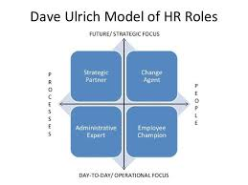
Fig 1 Ulrich Model of HR roles.

The human resources professional is at a crossroads. Over the last 30 years, HR organisations have gone through several changes, moving from an operational role (the ‘personnel department’) to one of ‘HR as a service centre’ to one focused on ‘driving talent outcomes’. CIPD (2018)
Long gone are the days when the Human Resources department focused solely on recruiting employees. HR has become an invaluable resource itself, working hand in hand with top-level management. The strategic importance of HR cannot be underestimated. It’s the role as the liaison between employees and the company is a vital one, especially given the highly competitive nature of the workplace today. Each company has a different strategic plan. The tools available to HR departments when developing their Plan can be seen below. IC Matters. (2018)
HR has changed over the years from the personnel department to HR Director, Business Partner, Advisor, and HR Assistant. Some work at board level and others work at management level, while others play a part in supporting. All roles can add value to any company if used in the correct way. It is important that HR professionals learn and develop to bring added value to the company they are working for. HR needs to make themselves available and work with managers and staff.
The table below shows how HR has evolved, as businesses needs have changed. HR has had to continually adapt.

Table 1 personnel management, HRM and contextual HRM
The Personnel Management | The HR Management | The contextual HRM
Driven by employer needs to treat people fairly in the organisation | Driven by employer needs, an advantage in the market place | Driven by factors such as legislation, and union
Operates in stable market conditions | Operates within competitive markets. | Operates within the regulated market condition
Managing people with a strong administrative purpose | Managing people with a strong strategic purpose | Understanding the factors influencing HR decisions in firms
Incorporates people management | The unitary frame of reference to organisation and people management | Incorporates a pluralist frame of reference to organisation and people management
Source: adapted from Farnham (2015)

Advantages and Disadvantages of using SWAT Analysis, PESTEL and PRIMO f.

Advantages & Disadvantages of PESTLE & SWOT Analysis
Both SWOT & PESTLE analyses are simple and easy to list but hard to implement fully. It takes time and research to completely analyse the situation. SWOT analysis might not be able to provide results for each factor plus for the analysis to be successful, it requires expertise which would analyse all possible threats and weaknesses and turn them into strength and opportunity. It requires resources and capital to perform and a positive outcome cannot be guaranteed, PESTLE analysis is to be used if the SWOT analysis of a company fails and they need to study markets. It focuses on external factors and not on the firm’s internal factors which can cause conflict. PESTLE analysis works on a macro scale as it includes economic factors. These factors are uncertain and change constantly depending on the state of the country.
SWOT and PESTLE are both resourceful and beneficial to companies if they are in weak positions. In order to determine which one to use and implement, it is important to judge the stance of the company and internal factors more than external factors. SWOT and PESTLE analysis should be used together for better results and a complete analysis. Due to the advantages and the disadvantages of either, it is a good idea to combine the two to help provide you with the best analysis. It is good practice to perform the PESTLE and then use the results as the opportunities and threat section of the SWOT. (pestle analysis. 2016)

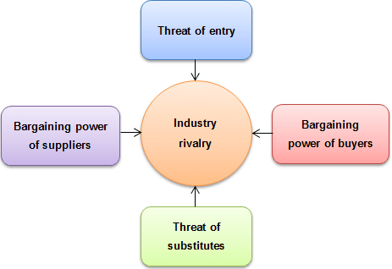

Fig 2: Porter's five forces model.

Porter's five forces model above (Jurevicius, 2013), gives a systematic way for the company to figure out what's going on in their industry, and what to do next. It does this by getting you to ask the right questions When more organisations compete for the same market share, profits start to fall. Strong bargaining power allows suppliers to sell higher priced or low-quality raw materials to their buyers. This directly affects the buying firms’ profits because it has to pay more for materials. Suppliers have strong bargaining power when There are few suppliers but many buyers. Buyers have the power to demand a lower price or higher product quality from industry producers when their bargaining power is strong. Lower price means lower revenues for the producer, while higher quality products usually raise production costs. The threat of substitutes. This force is especially threatening when buyers can easily find substitute products with attractive prices or better quality and when buyers can switch from one product or service to another with little cost. (Jurevicius, 2013). Often when you are in the thick of things, it’s difficult to see the wood from the trees. Porter's 5 forces framework and questions are an excellent start to figuring out what to do next. It forces (no pun intended) to think in a structured and logical manner. So that you are less likely to act on subjective whims. Master, D (2018)

4 different factors which impact on an organisation’s business and its HR function

Technology
The advent of new technology is a major cause and a driver of increased competitiveness in its own right, Taylor, S. Woodhams, C. (2016). ICT can make processes and communication within a business quicker and more efficient. Firms also need to keep their software and hardware up to date. If they don’t, they risk being seen as old-fashioned by customers and in danger of becoming obsolete. Automation refers to the introduction of machines to do work that was previously done by people. For example, a growth area of the future is expected to be nanotechnology. BBC. (2018). AI technology is viewed as being there to take jobs away from people. Working with AI can also help HR with recruitment by taking on the time-consuming tasks, such as online applications.
Environmental
Environmental factors could include where your business is located in relation to finding sufficient appropriate staff or changes to the environment that mean a need for more or fewer employees. A simple example of environmental factors affecting human resource planning is the consideration of how your employees get to work safely during extreme weather; your plan may need to include the possibility of telecommuting in order to keep everything going. Dillon, S. (2018)
Social Trends
Several social factors can have an influence on the HR planning, but we need to take into account equalities and diversity in particular. Where there is a clear discrepancy of one social group, it’s a good idea to build in ways of opening up new opportunities. Companies could benefit by holding a recruitment event in the area or conducting a survey of locals, asking if they would consider a job at your company and if not, why not. Dillon, S. (2018). Recruiting and advertising online has become more popular, as more people have access to computers. Companies have had to make improvements and update their systems.
Law
Changes in the Law can also have an impact on HR, and businesses the new GDPR policy was a massive headache for HR Professionals. Brexit has also brought its challenges, as. The workforce is the most vital part of any business, and companies in the UK have benefited enormously from the migration of workers from Europe. EU nationals play a significant role in UK businesses, with recent figures from the Office for National Statistics showing that there are currently 2.28 million EU citizens working in the UK, representing 7% of the UK’s total workforce. Following the Brexit vote and the possibility of a no-deal scenario, businesses should be mindful that employees could be concerned about their future in the UK and may decide to relocate and seek work elsewhere. It would be up to the HR department to make sure the correct information is available to employees, “It is crucial that companies take action and devise internal HR policies to help their EU workers” Haycock, L. (September 2018).

key stages in strategy formulation and implementation and the role of HR.

Figure 1. David’s Model of the Strategic Management’s Process
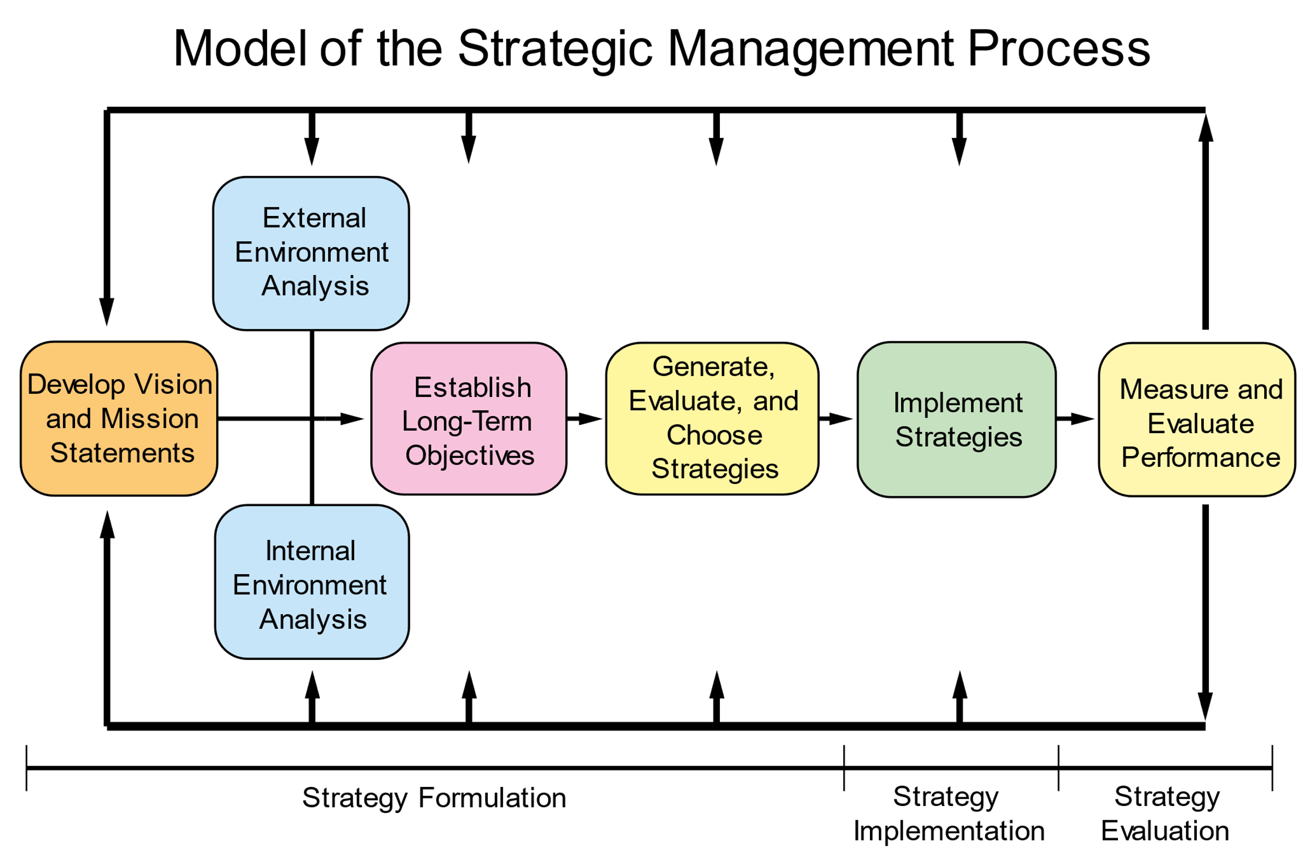Source: David (p. 46)
HR can contribute to organisation Strategy.

HR can have a Participation at different levels (board member, facilitator, adviser), the more HR is involved the more they will be valued.
Provision of organisational insights and hard information.
Analysing and interpreting business and performance data.
Identifying obstacles and risks.
Preparing position and policy papers
Communicating with senior, middle managers and staff
Working closely with line management, the HR professionals identified the culture that the increas­ingly competitive environment demanded. The HR team provided a powerful agenda for integrating staffing, performance management, training, and development.

The Institute of Business Ethics has examined why business ethics is important to a company. HR has a responsibility for delivering a company’s ethics message. HR plays a vital role in facilitating an ethical culture.
CIPD references, we believe that work can and should be a force for good, for everyone involved in the world of work. When work is good, people are more likely to be happy and fulfilled, businesses are more likely to be productive and profitable employees will want to work for you. The problem is, work isn’t always a force for good. Corporate scandals involving workplace harassment and poor treatment of workers have shone a spotlight on what can happen when ethics aren’t integral to the way organisations operate, raising difficult but necessary questions. Ethical practice in organisations includes the application of ethical values (such as fairness, honesty, openness, and integrity) to organisational behaviour. Are colleagues treated with dignity and respect? Are customers treated fairly? Are suppliers paid on time? Does the organisation acknowledge its responsibilities to wider society? CIPD, (2018)
Developing a strong sense of purpose and identification with the HR professional can equip a company to challenge the unethical practice. Core values exist in most companies. HR professionals are the main contact for staff and have unique access to staff during their career. HR may not have responsibility for the ethics program, however, they will be involved in implementing it. HR is responsible for the key systems processes underpinning the ethics message. CIPD, (2018)

Evaluate business performance and the role of HR

Turnover
HR Needs to have an understanding of the company's labor supply. Turnover can affect HR planning and has costs associated with it. The turnover rate of total employees within departments and seasonal basis informs recruiting decisions and budgets. managers may want to compare their company’s turnover rate to other similar companies in their industry as part of improvement processes.
Employee Engagement
Employee engagement is a good way of assessing how the workforce is feeling. Surveys can help HR understand where improvements need too made. Research has proven that employee engagement contributes to increased profitability, yet most organisations still have no formal engagement strategy in place and two-thirds of employees are disengaged, HR can play a vital role with support to managers and employees. Having an engaged workforce is clearly good for business, but there's no one-size-fits-all strategy to make it happen. So, gaining a better understanding of what your unique employees need is the surest path to success. Jaramillo, S. (2018).
Performance
HR performance metrics may be used to measure human resource management or in key areas of the business such as sales performance, manufacturing production or customer service productivity. Performance metrics aligned with corporate goals highlight areas of excellence or those in need of improvement. Metrics are used to understand what areas customer service is having to spend most of the time, what type of queries they are having and why.
Measurement Plans
HR metrics, create a measurement plan that outlines key components of metrics and how they’ll be used. The business questions need to be answered by measurement, defining the metrics or how the measurements will take place if a new report is required then HR department would need to submit accurate information when required, this is usually done at month end, these reports are an essential part of planning for any company. Budgeting for staff, recruitment and any new equipment that is needed to keep the organisation functioning many HR professionals would be responsible for this as they tend to be the gatekeepers for this information
Cardenas, H

different sources of business and contextual data can be assessed and utilised for planning purposes.

Economic inactivity rate, as stated on the Gov. wales website, shows how economic inactivity can affect an organisation. This would have an impact on HR as this would have effect staff, by a slowdown in sales, which could also have an impact on levels of the workforce needed. HR would need to deal with short term layoffs or even redundancies.
Wales: The economic inactivity rate in Wales was 21.3 percent. This is 0.9 percentage points down on the quarter and 2.3 percentage points down on the year.
UK: The UK economic inactivity rate was 21.0 percent. This is 0.2 percentage points down on the quarter and 0.5 percentage points down on the year. Welsh Government. (2018)
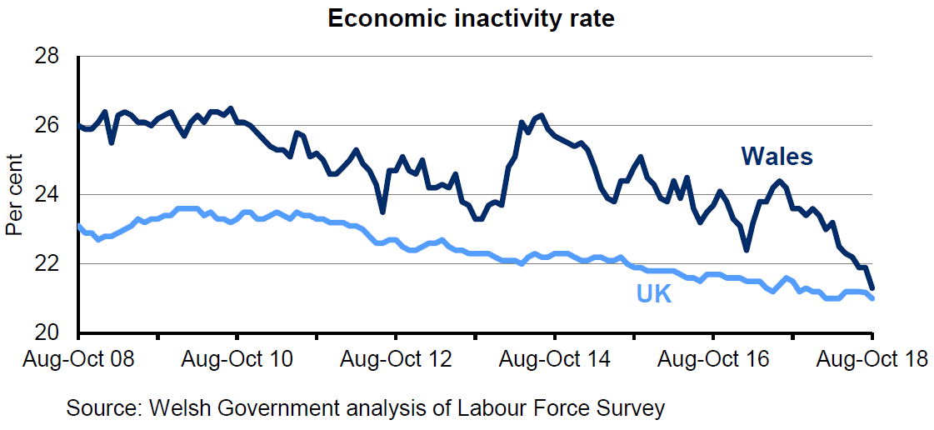

Targets and budgets have an influence on planning purposes, department, employees are fed a rich diet of reports, metrics and key performance indicators (KPIs). Without the clear insight, these provide into company performance. In a 2012 Economist Intelligence Unit survey of 418 global executives, an overwhelming 85% said their HR team didn’t excel at providing insightful metrics. In HR’s defence, the function faces considerable challenges when it comes to assembling and presenting meaningful workforce analytics. Relevant data is often spread across a number of different HR systems, each of which might define the same information differently. And some of that data may be downright inaccurate or woefully out of date. Twentyman, J. (2014)

Four out of five UK businesses have seen costs rise because of changes in employment legislation, the British Chambers of Commerce (BCC) reports. The apprenticeship levy, pensions auto-enrolment, and a new higher minimum wage have increased business costs. The changes to employment legislation were designed to help improve wages and prospects for workers, but the BCC is concerned that high employment costs will have a negative impact on employees, as this could put a financial strain on companies, who could ultimately have to make the decision to reduce their workforce. "Higher employment costs impact on the bottom line and reduce the resources available to invest in the business and its people," said Jane Gratton, the BCC's head of business environment and skills.
The survey found that:
75% of respondents report an increase in costs as a result of pensions auto-enrolment
50% of businesses report an increase in costs due to the National Living Wage
20% of businesses report an increase in costs as a result of the Apprenticeship Levy
To deal with minimum wage increases: BBC. (2017).

38% of respondents plan to raise prices of products and services
25% of businesses intend to reduce pay growth for staff
21% of companies plan to reduce staff benefits
20% of respondents are likely to scale back on recruitment
"It is the cumulative impact of all of these changes, and the pace at which they are being introduced, that causes the greatest concern and poses the biggest risk. This is when companies will need to rely on their HR departments, to help with the legal side of things, and to provide support for staff.

Conclusion

HR will need to continue to evolve as businesses evolve. Ulrich has refered to the fact HR from the outside in will need to develop and show that are effective in an organisatioin. It shown that technology will affect the function and its role, but can also be a good tool have, HR will always find ways to evolve and strive to add value to companies.

Bibliography

BBC. (2017). Most UK businesses hit by rising employment costs. Available: https://www.bbc.co.uk/news/business-41047890. Last accessed 9th January 2018.
BBC. (2018). External factors. Available: https://www.bbc.com/bitesize/guides/zgfrpbk/revision/5. Last accessed 28th December 2018.
Cardenas, Heidi. "HR Metrics and Their Impact on Business." Small Business - Chron.com, http://smallbusiness.chron.com/hr-metrics-impact-business-62267.html. Accessed 09 January 2019.
CIPD. 2018. Ethical practice and the role of HR. [ONLINE] Available at https://www.cipd.co.uk/knowledge/culture/ethics/role-hr-factsheet#23796. [Accessed 27 December 2018].
CIPD. 2015. A collection of thought pieces. [ONLINE] Available at https://www.cipd.co.uk/Images/changing-operating-models_tcm18-10976.pdf. [Accessed 27 December 2018].
https://www2.deloitte.com/uk/en/pages/human-capital/articles/introduction-human-capital-trends.html
Deloitte. (2018). 2018 Global Human Capital Trends. Available: https://www2.deloitte.com/uk/en/pages/human-capital/articles/introduction-human-capital-trends.html#. Last accessed 9th January 2018.
Dhiren Master. 2018. What are the advantages of Porter's five forces? [ONLINE] Available at https://www.quora.com/What-are-the-advantages-of-Porters-five-forces. [Accessed 28 December 2018].
Dillon, S. (2018). Factors Affecting Human Resource Plans. Available: https://smallbusiness.chron.com/factors-affecting-human-resource-plans-61165.html. Last accessed 7th January 2019.
Farnham, D, 2015. Human Resource Management its External context. In: Human Resource Management in context. 1st ed. London: CIPD, pp. 6-7.
Jaramillo, S. (2018). Four Lessons From Companies That Get Employee Engagement Right. Available: https://www.forbes.com/sites/forbeshumanresourcescouncil/2018/06/22/four-lessons-from-companies-that-get-employee-engagement-right/. Last accessed 9 January 2018.
Jurevicius, O. 2013. Strategic management insight. [Online]. [6 January 2019]. Available from: https://www.strategicmanagementinsight.com/tools/porters-five-forces.html
pestle analysis. 2016. SWOT vs. PEST, and How to Decide Which One to Use. [ONLINE] Available at https://pestleanalysis.com/swot-vs-pest-analysis. [Accessed 28 December 2018].
poppulo. 2018. HR strategy examples – What makes a successful HR strategy? [ONLINE] Available at
https://www.poppulo.com/blog/hr-strategy-examples-what-makes-a-successful-hr-strategy/. [Accessed 27 December 2018].
https://storage.ning.com/topology/rest/1.0/file/get/382932?profile=original
Taylor, S. Woodhams, c. (2016). Developments in the external environment. In: Taylor, S. Woodhams, C Studying Human Resources Management. 2nd ed. London: cipd.co.uk. 49-51.
Tonmoy Shingal. 2018. Managing HR Roles: David Ulrich’s Model. [ONLINE] Available at https://blog.mettl.com/talent-hub/managing-hr-roles-david-ulrich-model. [Accessed 27 December 2018].
Twentyman, J. (2014). Your guide to HR analytics. Available: https://www.hrmagazine.co.uk/article-details/your-guide-to-hr-analytics. Last accessed 9th January 2018.
Welsh Government. (2018). Key economic statistics. Available: https://gov.wales/statistics-and-research/key-economic-statistics/?lang=en. Last accessed 9th January 2018.

