Academic and Employability skills – BMSW4001
Mohamed Wasim Samsudeen
Student ID: 1908197
01 May 2020

Table of Content
- Executive summary…………………………………………3
- Instructions……………………………………………………. 4
- Methodology…………………………………………………..5
- Findings…………………………………………………………...6
  - Personal development plan……………………………6
  - Resume Writing……………………………………………………7
  - Time management: Eisenhower Method……………..8
  - Summarising…………………………………………….9
- Discussions………………………………………….10
  - Personal development plan…………………10
  - Time management: Eisenhower Method……11
  - Resume Writing………………………………………..12
  - Summarising……………………………………….13
- Conclusion…………………………………………………..13
- Recommendations…………………………………………14
- Reference………………………………………………….15
- Appendices………………………………………………….16
9.1 Personal development plan…………………..16
9.2 Time management: Eisenhower Method…………17
9.3 Resume Writing……………………………………….18
9.4 Summarising……………………………………19

- Executive Summary

The main aim of this report is to reflect on the topics that I have learned in term one and term two. I have discussed about four different topics which I found very useful to both of my academic and employability. How they have helped me to achieve my short-term goals and guiding me thoroughly in my education field.

Introduction

Academic and employability skills include several skills which can be applied to both areas. I will be talking about 4 different useful academic and employability skills which I found useful to me and I also be reflecting on what I have learned in-class exercises. Which I’m currently implementing to both academic and employability. I have learned to use these unique skills in my daily working life. The topics I will be covering is Personal development plan, Time management, Resume writing and Summarising. I will be reflecting on how useful these skills are to me in my current situation.

- Methodology
I have used my notebook, internet, published literature and in-class exercises to collect the relevant information that is refereeing to academic and employability skills which I must include in the report.

- Findings
4.1 Personal Development Plan
Personal Development Plan in-class exercise covered in term one.
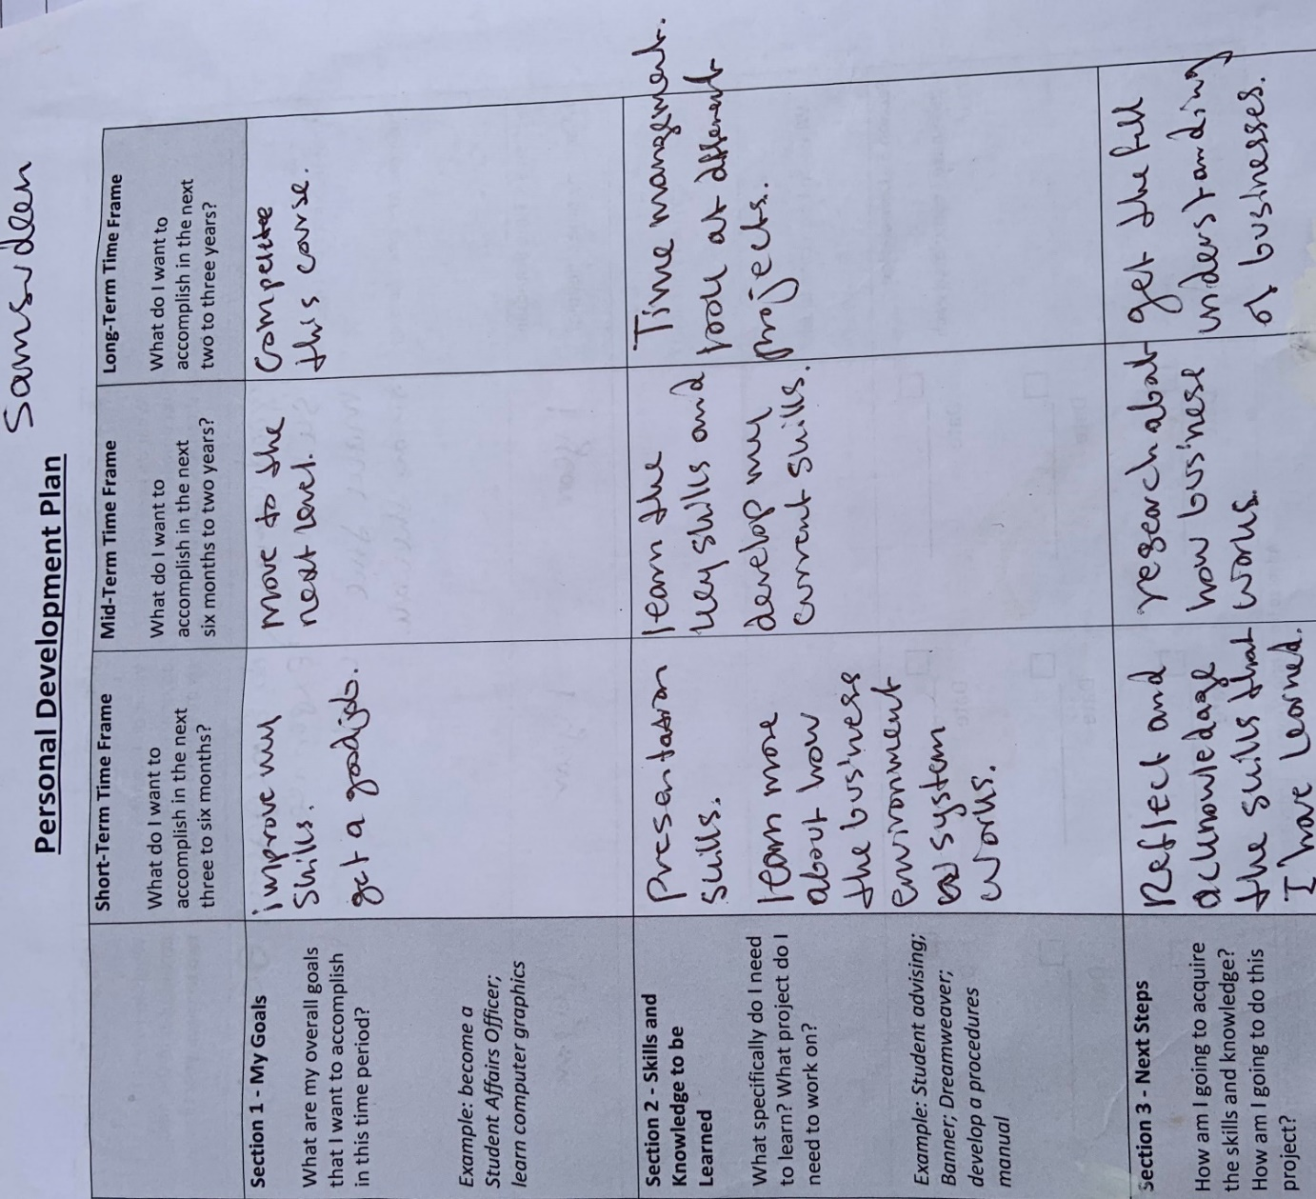

4.2 Resume Writing
In term two I have reviewed a poor looking CV in-class exercise.
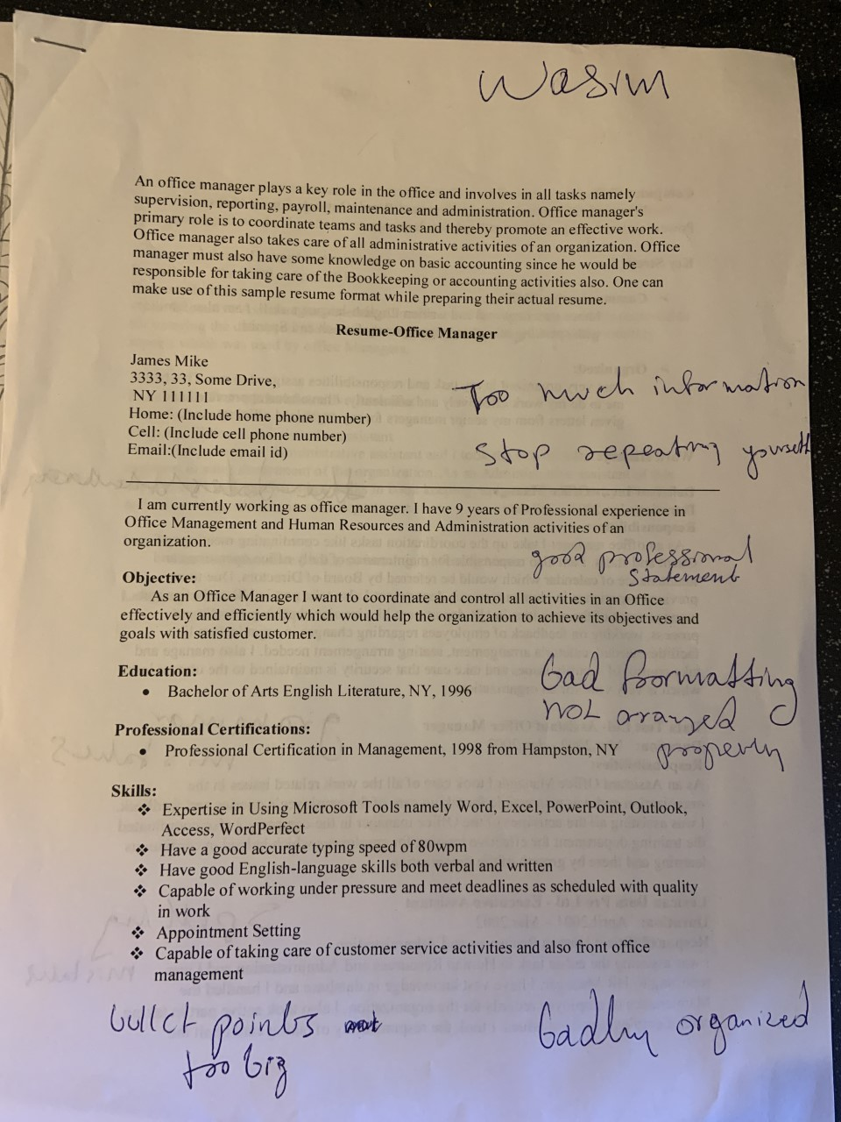
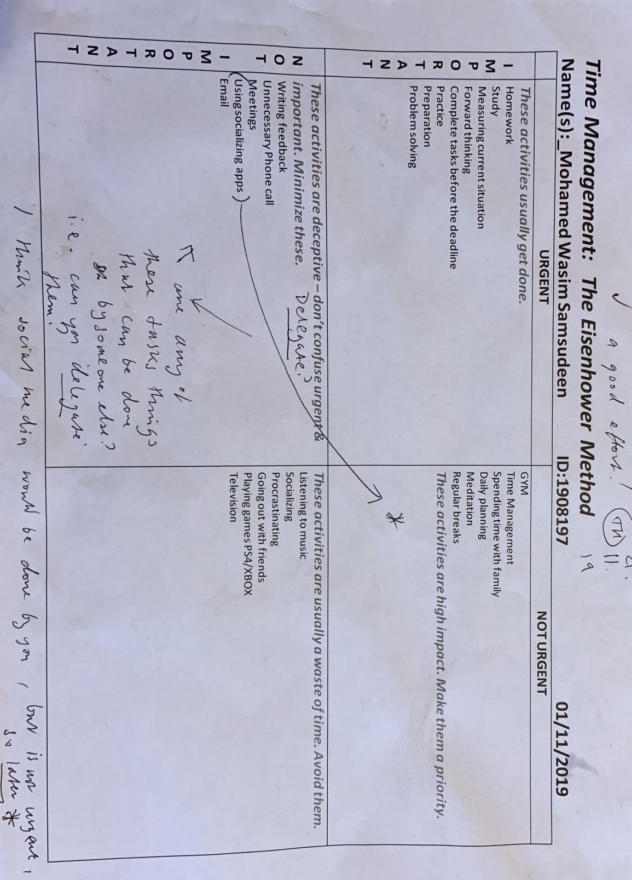
4.3 Time management: The Eisenhower Method
In term one Time management: The Eisenhower Method in-class exercise.

  - Summarising
Term one: I have practised summarising in-class exercise.
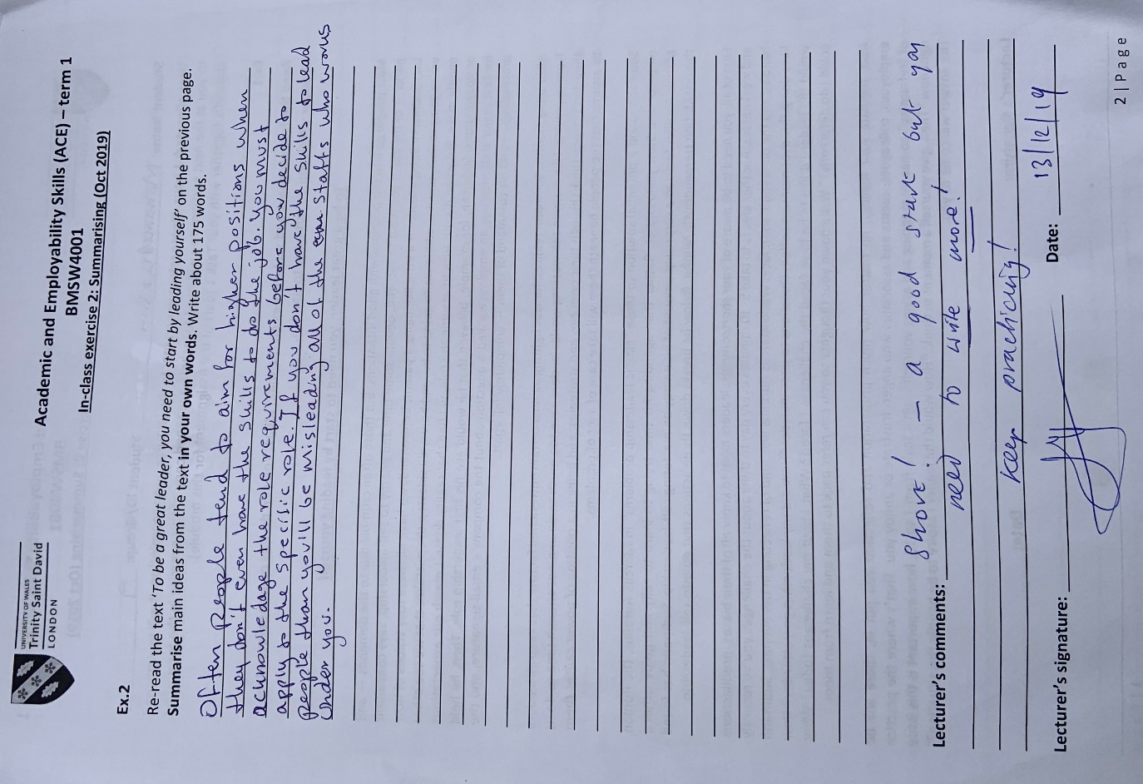

- Discussion

  - Personal development plan

It is used to improve on yourself and plan clearly where you are headed in your career. Listing the key aims and goal that I want to accomplish.
Personal development plan is the process of setting a specific goal to achieve in some time period. This was one of the useful topics for me because at the beginning of learning this topic I did not know anything about personal development plan. After learning this topic, I was able to set a specific personal goal for myself to achieve in few months’ time. For example, my goal is to find a part time job in in few months’ time.

Setting my own personal short-term, mid-term and long-term goals in my professional career and academic studies helped me to know what I need to complete and achieve in the time period. I have Carefully, organised my ideas and being proactive to accomplish each objective has enabled me to know what I must do to achieve the goals. The steps I should make to achieve these goals. For example, making measurements and setting a time frame and checking whether I have accomplished the goal or not.

The interesting thing to me is that the Personal development plan is guiding me to achieve my future aims and goals. I am now setting important goals to myself to achieve in the next year. For example, after finishing this course I would like to move to a level 5 business course.

  - Time management: Eisenhower Method

Time management: Eisenhower method is very useful skill which gave me a clear view to spend my time wisely. The time management Eisenhower method is divided into four sections, Urgent. Not urgent, not important and important. Good time management enabled me to accomplish more in a shorter time period. So that I will have more free time to spend on other tasks that requires my attention.
By Learning the Eisenhower’s method, it has enabled me to use the time wisely. I use the Eisenhower’s method to plan my everyday routine. Time management is one of the basic skills it comes before any other skills because if you don’t use the time wisely, you’ll get withdrawn from the university and at work you’ll be asked to leave. For example, I always leave early to get the train and arrive at university on time without being late for the lessons. Also, for work time management is vital. For example, if I don’t arrive on time to my own workplace than I will put others in risk to complete they’re on task which will lead to cause even more occurring problems as the company is still running. Everyone needs to take their work seriously and arrive on time as they are scheduled on the timetable. If I decide to progress to the next level in my current workplace than I need to show them that I will be the good candidate for that role. If I’m bad at time management than I’ll not get the role to lead the team in the future.
Before learning this time management topic, I was not managing my time wisely and I always used to allow things to the last minute. Nowadays, I use time management method to plan my time very wisely. For example, I break the big tasks into smaller chunks. I focus on the most important tasks which needs to be done first.

  - Resume Writing
I learned about how to write a good-looking resume for employability. After learning about how to write an interesting resume for employability. I made some changes to my own original resume. For example, I got rid of few unnecessary information which I have used in my own resume. I have also learned that Resume is the first and only direct communication you make with your employer. It must be very straight forward, and it should only contain information which are relevant to the job role that I’m applying for.
CV is your first presentation to your potential employer. I implemented what I learned in-class exercise on my original CV. I carefully thought about designing my original CV very clearly and input only the essential information. After, I made changes to my resume I was able to get job interviews fast. Now I know how to write a good-looking CV for myself and to be able to interview.
The CV which I used to have was not helpful as the one I have now because it looks more professional and very clear.

  - Summarising

Summarising technique is very useful it enabled me to pick out the key points in a larger text and it enabled me to leave out the unnecessary information in the text. It helped me to organise and write a text in its purposeful and much shorter way. Summarising method can be used in various subjects it enables you to understand the text easily in your own way.
Summarising exercise was useful now I can summarise a big information to a smaller text. It enabled me to focus on the key words and phrases of a given information that are worth to keep in mind and to remember. It also taught me to the ways to ignore unnecessary text in an information. Summarizing exercise improves my memory power.

Conclusion
In conclusion, I have discussed about four important topics which I found interesting and useful to me. For example, I have discussed about, personal development plan, time management, Resume writing and summarising. And how they have been useful in my both academic and employability.
Learning these four skills is very useful and it has helped me to develop myself and enabled me to achieve my short- term goals without any delays. The Topic that I have discussed and discovered in my findings are vital for both academic and employability skills. I have also discussed how important they are to your career.

Recommendations

The four topics that I have mention in this report has been very interesting and useful to me. In the future, these skills will worth more value and by fully understanding each of the skills and knowing their purpose and what they are used for will provide you with a clear understanding of your own career path. It will also help you to assess yourself to know where you are at the current situation. And what you need to do to improve on the negative skills that are holding you back from achieving what you want to accomplish. I recommend, academic and employability skills are very important, and they should be implemented in every aspect of your career.

References
Resume Writing
Available at: https://www.dayjob.com/what-is-a-cv-622/(accessed: 04/05/2020).

Time management
Available at: https://www.mindtools.com/pages/article/newHTE_00.htm(accessed: 04/05/2020).

Summarising exercise
Available at: https://www.readingrockets.org/strategies/summarizing(accessed: 04/05/2020).

Appendices
Personal Development Plan
In term one Personal Development Plan in-class exercise.

CV
In term two I have reviewed a poor looking CV in-class exercise.

Time management
In term one Time management: The Eisenhower Method in-class exercise.

Summarising
Term one Summarising in-class exercise.

