Strees analysis and Computer aided engineering
Motion Simulation

Michael Cheeseman (1707473)

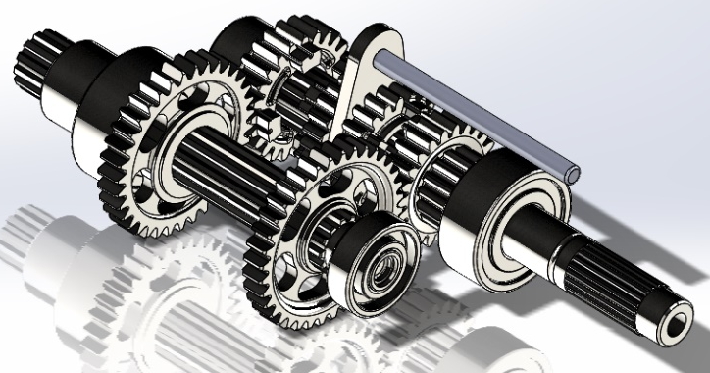
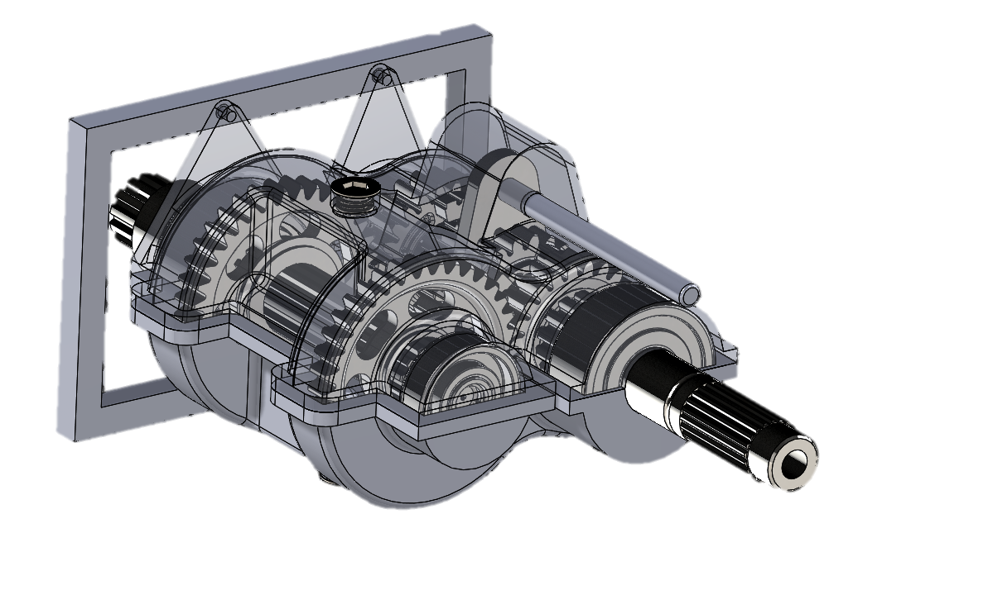

Executive Summary

This report is in conjunction with a Computer Aided Engineering (CAE), Computer Aided Drawing (CAD) file which a link can be found in section 3.6. This report explains the authors actions taken for the CAD file with the objective to use a set of components and create a gear box housing for these components, the second objective is to be able to run a motion analysis on the full assembly and check the angular velocity of the output shaft of the gear box. The Author will start with an introduction on Motion Simulation and FEA, before moving on the main body. The Main body will go through both Parts of the housing the Top and Lower Housing of the gear box assembly, how it was modelled and why it was modelled in such a way. After the modelling the author explains how they assembled and the created a motion simulation, as well as what methods they used to reduce the redundant mates in the simulation. The redundant mates went from 48 down to 7 by swapping basic mates to advanced mates as well as the use of rigid body groups. The author will then explain the results attained by the software and explain the graph shown. Before concluding the report and giving a recommendation for further development.
Table of Contents
1 Executive Summary 1
2 Introduction 3
2.1 Motion Simulation 3
2.2 FEA 3
3 Gear Box Housing and Motion Analysis Study 5
3.1 Gear Box Housing 5
3.1.1 Lower Gear Box Housing 5
3.1.2 Top Casing 7
3.2 Gear Box Assembly 8
3.3 Motion Simulation 9
3.4 Analysis of the Simulation 11
3.5 Simulation Properties 13
3.6 Link to Cad Files 13
4 Conclusion 14
5 Recommendation 14
6 References 15
7 Table of Figures 16

Introduction

Motion Simulation
Computer-Aided Engineering or CAE methods was available for the use of designing in the 1980s, the next tool to be wildly used by designers is Finite Element Analysis or FEA. Motion simulation and motion analysis is a tool that any designer can use to be able to take a CAD model whether it is a single part or assembly from a CAD environment and be able to set actions that will take it into a simulated physical operation. This is used to calculate the forces and motions of an assembly as it would move under Load in a real world application (Solid Solutions Management, 2019) (Nudelhi & Steffen, 2017). Most motion simulation packages can calculate the effect of the following on an assembly as told by (Autodesk, 2019), (Siemens, 2019), (Solid Solutions Management, 2019) and (Solidworks, 2010):
- Forces
- Springs
- Dampers
- Gravity
- Contact between components
- Bushings
With the motion of the assembly has been determined, the analysis of the individual components in the assembly can be evaluated in the motion study or the data could be exported from the study in the one software and then imported into another analysis study package (Solid Solutions Management, 2019). Since when Motion Simulations have been introduced as a tool for designers it has reduced the need to use numerous prototypes revisions to physically test components. (Machine Design, 2008).
Companies are now trying to reduce time to market for their products for many factors including competition and to be able to sell product to make profit faster by streamlining R&D. Design engineers have significantly lost the time to be able to perform research to develop the product so instead use Motion Analysis to preform test to their designs as well as preforming FEA on the designs (Koutromanos, 2018) (Machine Design, 2008).

FEA

Finite Element Analysis (FEA) is a method used by Designers to show whether a product will work as it is intended or if it will break, and wear out (Bathe, 2014) (Ross, 1998). FEA works by breaking down a deigned object into a large number of finite elements. A computer software uses different “mathematical equations” (Autodesk, 2019) in the aid to predict the behavior of each element. This software then uses the equations and can then predict the behavior of the design in real world. (Kurowski, 2018) (Ross, 1998)
According to (Autodesk, 2019) FEA is helps predict the behavior of products affected by many physical effects, including:
- Mechanical stress
- Mechanical vibration
- Fatigue
- Motion
- Heat transfer
- Fluid flow
- Electrostatics
- Plastic injection molding
FEA software can be utilized in a wide range of industries, but is most commonly used in the aeronautical, biomechanical and automotive industries. A Finite Element model comprises a system of points, called “nodes” (Siemens, 2019), which form the shape of the design. Connected to these nodes are the finite elements themselves which form the finite element mesh and contain the material and structural properties of the model, defining how it will react to certain conditions (Ross, 1998) (Siemens, 2019). “The density of the finite element mesh may vary throughout the material, depending on the anticipated change in stress levels of a particular area” (Siemens, 2019).
For a Designer to simulate the effects of real-world working environments in FEA, various load types can be applied to the FE model, including forces, moments, displacements, velocities, accelerations, temperature and heat flux, elemental forces such as distributed loads, pressure, and temperature as well as applying gravity to the model (Autodesk, 2019) (Bathe, 2014).
According to (Siemens, 2019) FEA is beneficial to be used in new product design, or to redesign and improve an existing product, to ensure that the design will be able to perform to specifications prior to manufacturing. FEA allows a designer to be able to do the following:
- “Predict and improve product performance and reliability” (Siemens, 2019)
- “Reduce physical prototyping and testing” (Siemens, 2019)
- “Evaluate different designs and materials” (Siemens, 2019)
- “Optimize designs and reduce material usage” (Siemens, 2019)

Gear Box Housing and Motion Analysis Study

Gear Box Housing

The Gear box housing as shown in figure 1 is the completed design carried out by the author. This design has incorporated the use of numerous features to be able to create the housing of the gear box. Solidworks CAD Package gives a large range of modelling tools to be able to create a model as told by (Solidworks, 2019). The CAD models for the components of the gear box by (Harrison, 2019) as shown in table 1. The author was tasked to model the housing of the gear box as well as to run a motion study on the housing using the Solidworks cad package.

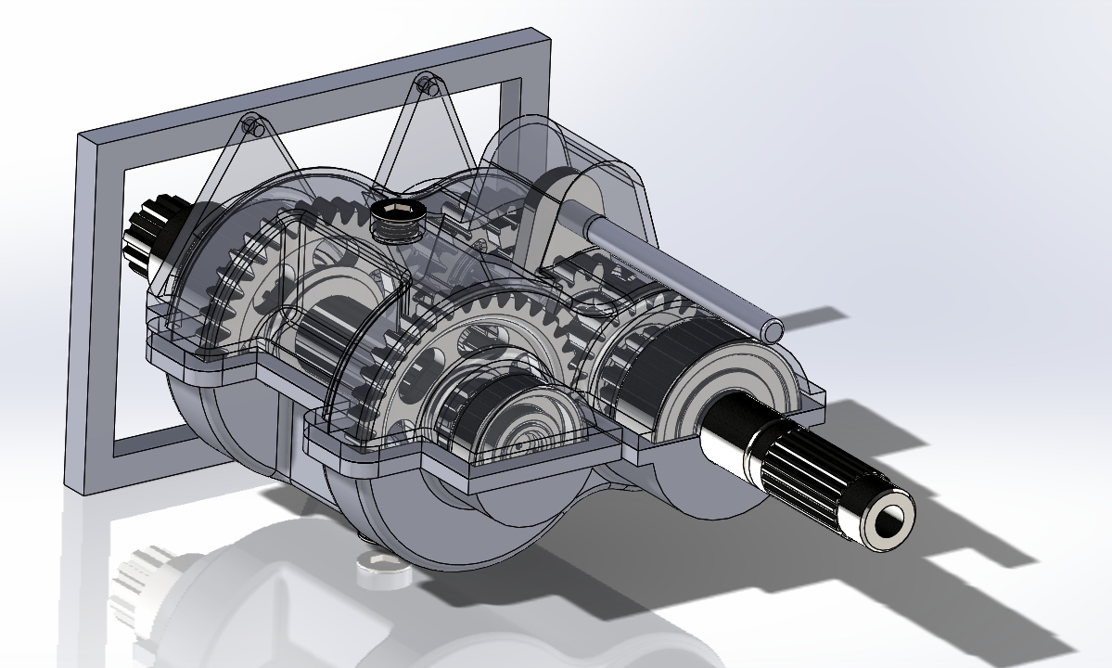
Figure 1: Image of the completed gear box with the top casing transparent (Cheeseman, 2019)

Lower Gear Box Housing

For the Author to be able to finish with the Lower Gear Box Housing as shown in Figure 2, the Author started with a simple sketch that would cover the gears to be able to extrude the housing the entire length of the gears. Once the body of the housing was formed the author used the cut tool both “cut extrude” and “cut revolve” (Solidworks, 2019) to form the outer shape of the housing as shown in Figure 3. When completed the sketches for each of the cuts the Author projected the geometry from the first sketch to be able to link the sketches together without using equations for the dimensions. The Author attempted to use equations on the sketches but could not understand how to link an equation from one part to another, the author did not pursue the equations as the brief does not state to make the design future proof. The between centers of the input shaft was worked out to be ≈61mm as C=(Ng+Np)/2P as found on (Engineers Edge, 2019).
Where C is Center
Ng is Number of Teeth on gear
Np is Number of Teeth on Pinion
P is Diametral Pitch
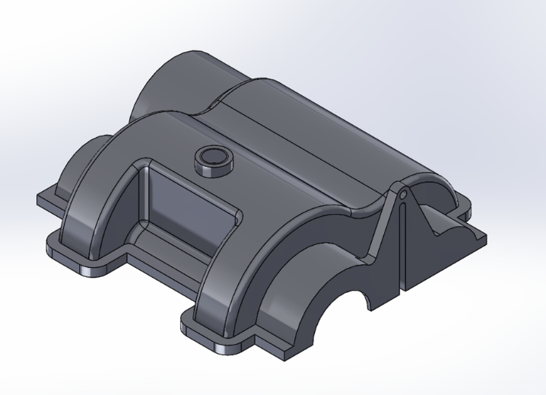
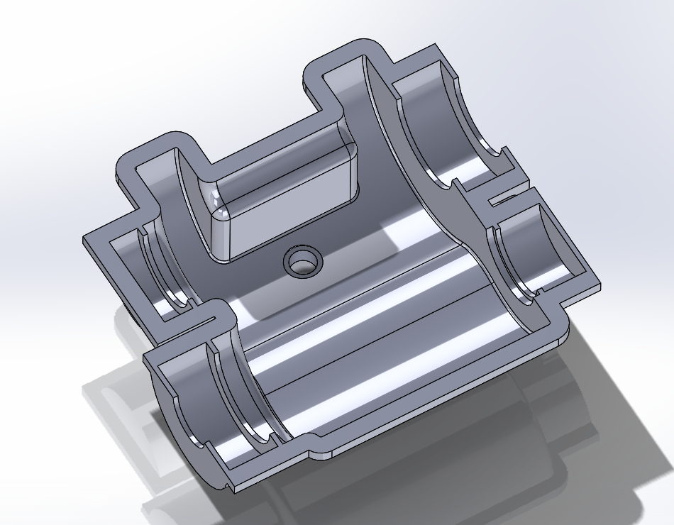
Figure 2: Image of the bottom gear box casing (Cheeseman, 2019)

Figure 3: Image of the lower gear box casing under side (Cheeseman, 2019)

To ensure that the Gear Box would work in real world applications the author added a sump plug to be able to change any lubrication oil if the design where to be made. The Author created this feature on the Lower Gear Box Housing by creating a new datum plane and creating a boss with a threaded hole through the boss for a sump plug to be screwed into the boss. With the boss complete the author then shelled out the top face. The Author had to create new bosses to be able to hold the bearings in place and to create cut out for both the input shaft and the output shaft to go through the frame. The Author choose to add a plate that can be used to attach the Lower Gear Box Housing to the Top Gear Box Housing this feature has been called the Casting Edge this feature can be further developed to add threaded holes for fasteners to be able to secure the two parts together as shown in figure 2, 3 and 5. The design tree for the Lower Gear Box Casing can be found in figure 4. The Author could have used loft, swept, and rib features but the Author felt that with the size of the gear box that these features were not needed. If the gear box had more than just two gears the rib features especially, would have been used to ensure the casing could withstand a larger force across the body than that over the short distance that is the current body is.
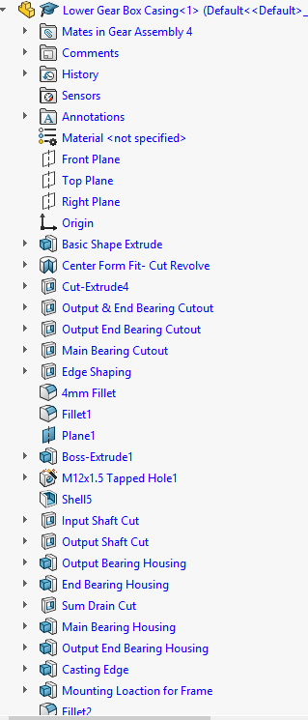

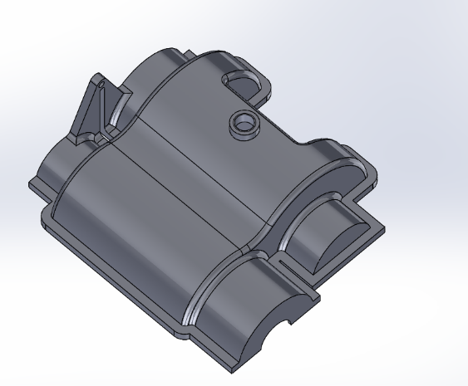
Figure 4: Image of the Lower Gear Box Casing (Cheeseman, 2019)

Figure 5: Image of the Design Tree for the Lower Gear Box Casing (Cheeseman, 2019)

Top Casing

The Top Casing as shown in Figure 6, 7, 8 and 9, has been designed exactly the same as the lower gear box housing. To achieve this the author took the lower gear box housing and mirrored all the features from this part. The reason why the author chose to do this was to ensure that the two parts would it fit perfectly together. The next step was to split the gear box to form the top gear box housing to ensure that it will fit the lower gear box housing exactly. The design was then rolled back to a point before the shell was added so that the boss for the shifter as well as the cut-out to reduce any wasted space to ensure the design would be light if it was actually planned to be made. The Design Tree for the Top Gear Box Housing can be found in figure 10.
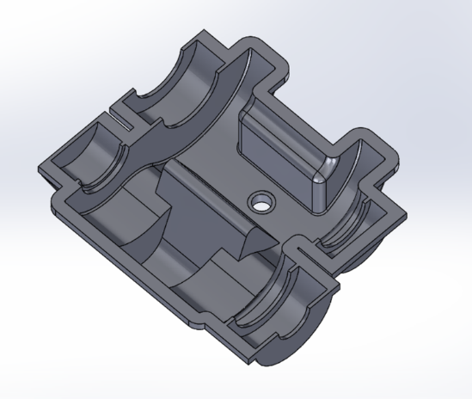
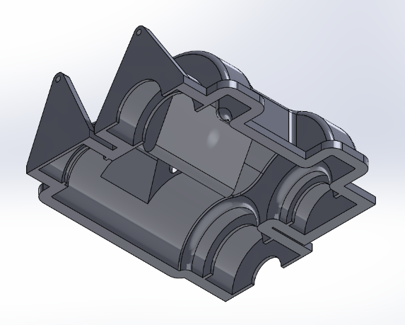

Figure 6: Image of the Top Gear Box Casing (Cheeseman, 2019)

Figure 7: Image of the Top Gear Box Casing (Cheeseman, 2019)
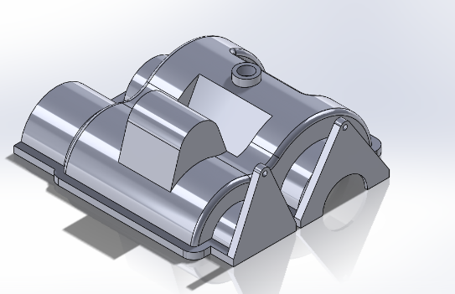
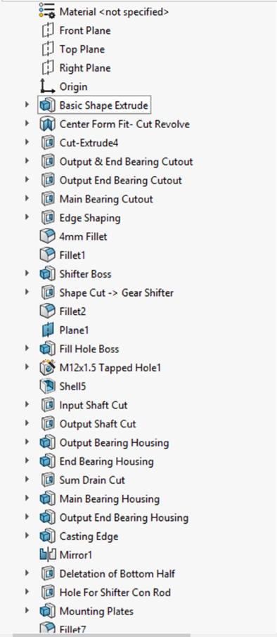

Figure 8: Image of the Top Gear Box Casing (Cheeseman, 2019)

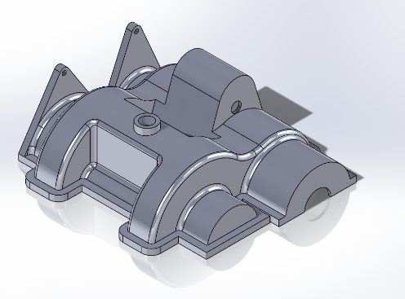
Figure 9: Image of the Top Gear Box Casing (Cheeseman, 2019)

Figure 10: Image of the design tree for the Top Gear Box Casing (Cheeseman, 2019)

Gear Box Assembly

The Bill of Materials for the Full Gear box assembly can be found in Table 1 as well as the author for each of the parts. An image of the full assembly can be found in Figure 11 and Figure 12.
Part | Quantity | Author Of Model
Gear Box Assembly | 1 | (Cheeseman, 2019)
Top Gear Box Housing | 1 | (Cheeseman, 2019)
Lower Gear Box Housing | 1 | (Cheeseman, 2019)
Input Shaft | 1 | (Harrison, 2019)
Main Input Bearing | 1 | (Harrison, 2019)
Input Gear 1 | 1 | (Harrison, 2019)
Combined Gear | 1 | (Harrison, 2019)
Gear Shifter Fork | 1 | (Harrison, 2019)
Gear Shifter Rod | 1 | (Harrison, 2019)
Input Gear 2 | 1 | (Harrison, 2019)
End Input Bearing | 1 | (Harrison, 2019)
End Output Bearing | 1 | (Harrison, 2019)
Output Gear 1 | 1 | (Harrison, 2019)
Output Gear 2 | 1 | (Harrison, 2019)
Main Output Gear Bearing | 1 | (Harrison, 2019)
Output Shaft | 1 | (Harrison, 2019)
Frame | 1 | (Harrison, 2019)
Table 1: Bill of Materials for Gear Box Assembly

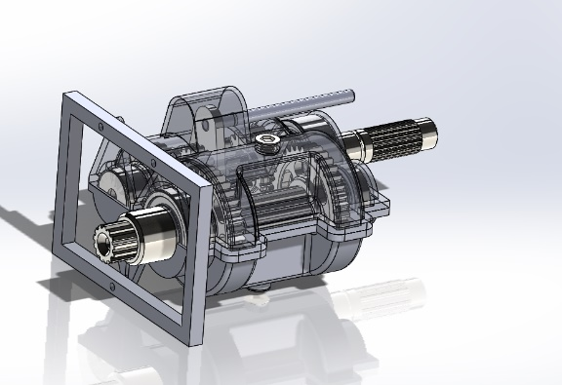
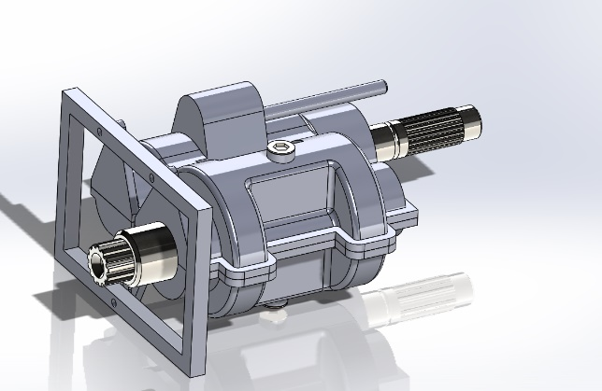

Figure 11: Image of full assembly (Cheeseman, 2019)

Figure 12: Image of full assembly from output side (Cheeseman, 2019)

To ensure that the assembly stays together the author started to use concentric and coincident mates for numerous parts within the assembly to start to form the finished product. The author then used distance mates for the positioning of the gears to the housing. As the assembly should be constrained to a fixed point the author used the frame supplied by (Harrison, 2019) to mate the housing to as shown in figure 13.

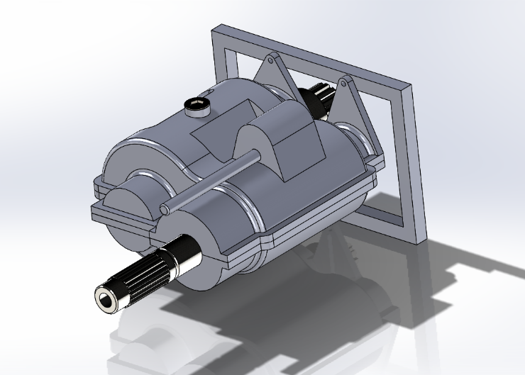
Figure 13: Image of the full assembly from input shaft (Cheeseman, 2019)

Motion Simulation

The Motion simulation analysis has been set up by the author to last 3 seconds. The author placed a motor with a constant speed of 100 rpm on the input shaft as shown by figure 14, this is to simulate a motor attached to the input shaft. The next step was to put a force to selector rod the applied force was set at 1Nm this is to pull the combined gear into the first gear for 1.4 seconds starting at 0 seconds. The next step the author tool was to set a second force to push the gear from the first gear to the second gear, the value is set at 1Nm to start acting at 1.6 seconds lasting for the full simulation this will push the combined gear from gear one over to the second gear.
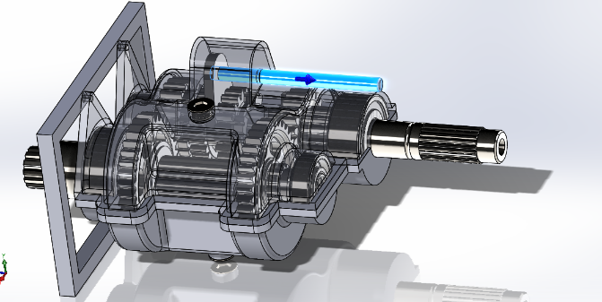
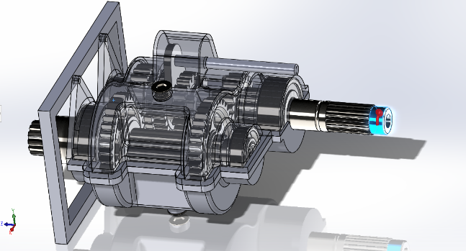
Figure 14: Image of applying force to Sector Rod (Cheeseman, 2019)
Figure 15: Image of setting motor to Input Shaft (Cheeseman, 2019)

Motor set as 100 rmp
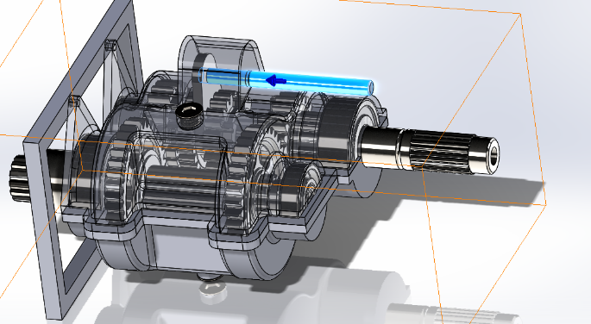
Figure 16: Image of applying force to Sector Rod (Cheeseman, 2019)

To Ensure that the gears make contact with each other when the study is running, contact mate have been set up by the author between the following parts:
- Gear 1 on both input and output shaft as shown in figure 17.
- Gear 2 on both input and output shaft as shown in figure 18.
- Primary gear 1 and the combined gear as shown in figure 19.
- Primary gear 2 and the combined gear as shown in figure 20.
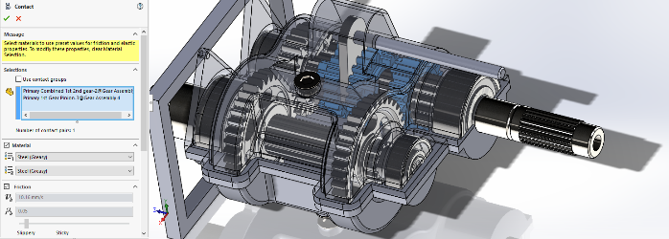
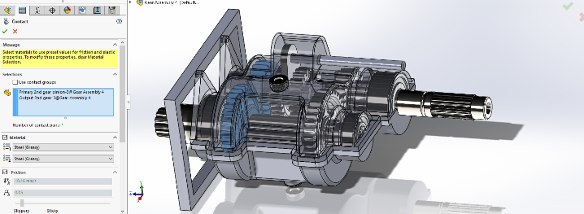
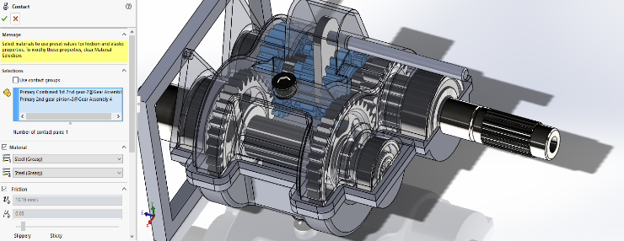
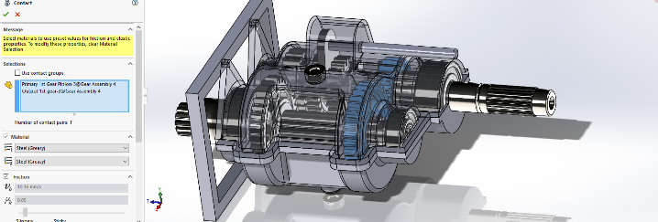
Figure 17: Image of assembly setting up contact mates (Cheeseman, 2019)

Figure 18: Image of assembly setting up contact mates (Cheeseman, 2019)

Figure 19: Image of assembly setting up contact mates (Cheeseman, 2019)
)

Figure 20: Image of assembly setting up contact mates (Cheeseman, 2019)

All of the contact mates have all the materials have been set to steel greasy so that the simulation would emulate a real-life scenario as the gears would be running in lubrication oil from the sump of the gear box. The penultimate item to place onto the gear box is a rotary damper on the output shaft to simulate a load on the gearbox. The Author then placed a graph to show the angular velocity of the output shaft, the resultant graph is shown in figure 24.

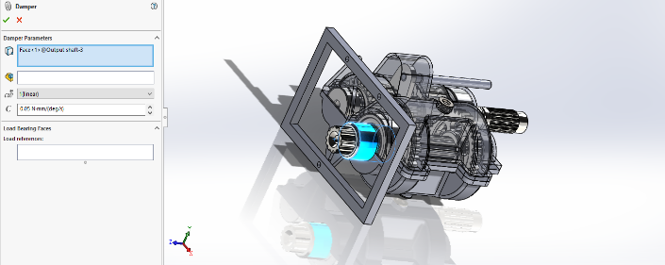
Figure 21: Image of setting up a damper on output shaft (Cheeseman, 2019)
)

In an attempt to reduce the number of redundancies for the motion study. When the author first started the study the redundancies where 48 they have now been reduced down to only 7 as shown in Figure 22. The way the author was able to reduce the redundancies down was to change the standard mates used to hinge mates this reduced the mates from 48 down to 28. To reduce the redundant mates further the author grouped the parts into the three rigid body groups as shown in Figure 23, this step reduced the mates from 28 down to 18. The author then removed two mates that where repeated by accident, this then reduced the redundancies from 18 down to 7.

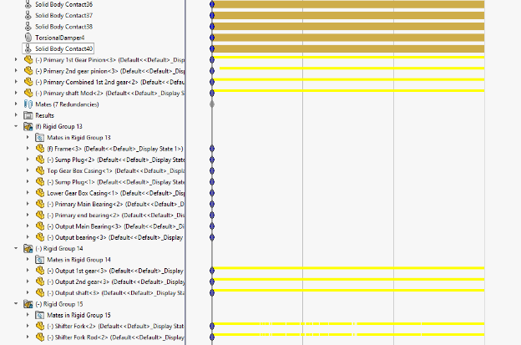
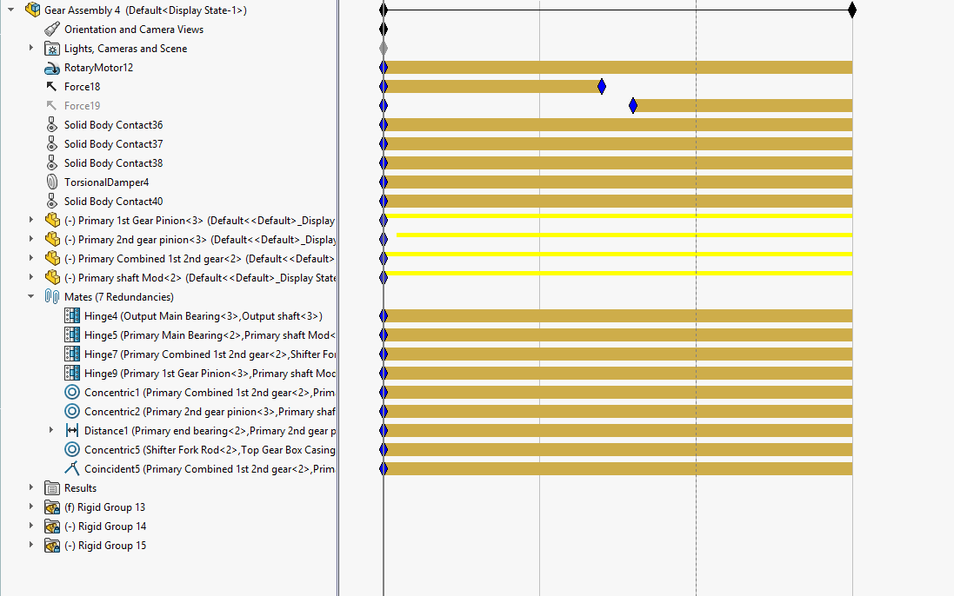
Figure 22: Image of motion study showing Rigid Groups (Cheeseman,2019)

Figure 23: Image of motion analysis tree (Cheeseman, 2019)

Analysis of the Simulation

The Graph in Figure 25 shows the magnitude of the angular velocity on the output shaft. The initial spike between the time of 0.00 and 0.15 seconds at the start of the simulation, this can be explained as the gears are starting the mesh and sit correctly with each other from where they were in the model space to the simulation. The immediate spike after the gears has meshed at ≈ 0.2 seconds is wear the first contact of the combined gear to the Primary Gear 1 before the gears engaged properly. Between 1.35 and 1.5 seconds the graph show a drop in velocity this is due to the force holding the gear in place was removed ready for the combined gear to be moved across to the primary gear 2. The larger drop between 1.6 and 1.80 seconds is where the force to move the combined gear actually moved positions on the output shaft. The Graph shows backlash off the motor kept freezing as the software was taken the points, this was made more prominent by having a damper on the output shaft which puts a higher resistance on the output shaft slowing the shaft down as shown in figure 24. Figure 24 is the same simulation as used for the creation of figure 25 without the use of a damper on the output shaft. Even though the issues with the simulation both graphs shows a clear change in speed as the combined gear moves from gear 1 to gear 2.

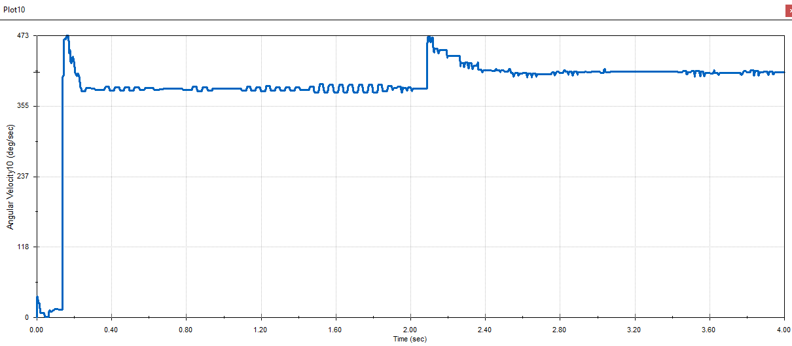
Figure 24: Image of angular velocity on the output shaft without a damper (Cheeseman, 2019)

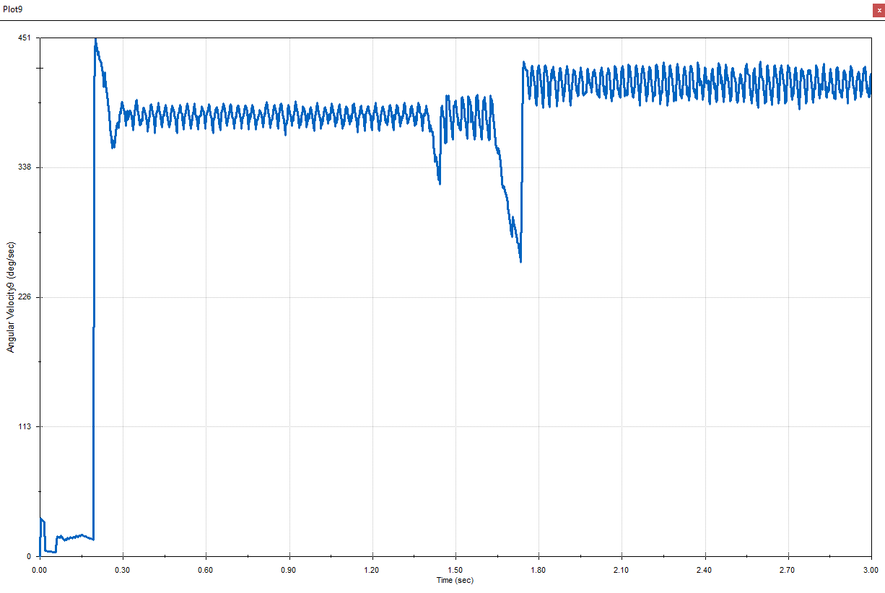
Figure 25: Image of angular velocity on the Output Shaft (Cheeseman, 2019)

Simulation Properties

The motion study can be altered to adjust the simulating environment or the amount of data points taken to plot a graph. The standard “Frames per second” (Solidworks, 2019) that is set to when starting a new motion study is 25 "frames per second” (Solidworks, 2019). But this setting is unsuitable for the purpose of the simulation. To ensure that the simulation takes a point every degree that the output shaft turns the equation that the author used is below. An image of the Motion Study Properties showing the Frames per second used is in figure25.

$$Speed of Input Shaft (rps)=\frac{Speed of Input Shaft (rpm)}{60 seconds}$$

$$1.66666 (rps)=\frac{100 (rpm)}{60 seconds}$$

$$Frames Per Second=Speed of Input Shaft \left(rps\right) ×Degrees of movement$$
$$600=1.666667 \left(rps\right) ×360°$$
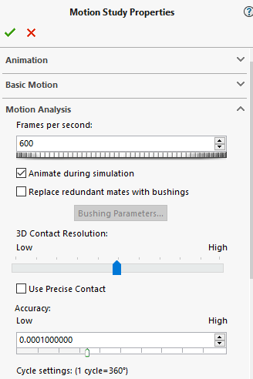

Figure 26: Image of the Motion Study Properties (Cheeseman, 2019)

Link to Cad Files
Below is the link to the CAD files found on the Author’s OneDrive.
https://uowtsd-my.sharepoint.com/:f:/g/personal/1707473_student_uwtsd_ac_uk/EtUYkzjhUfNAjkesgaucIRMB6v0KUIrk0GLelCxtxc-lRA?e=uWcw7I

Conclusion
To Conclude this report, the author has intended to use as many of the features that Solidworks has to offer as needed for the creation of both the Lower Gear Box Housing and the Top Gear Box Housing. Due to the size of the gear box, the author wasn’t able to use some features such as lofts and sweeps as they deemed it unnecessary. The author also tried to used equations to link geometry of the housing together but unfortunately did not understand how this operation could have been completed. The geometry of the first sketch has been projected throughout the design tree to enable the first sketch to be changed and most of the other features will be changed due to the link to that particular sketch. The author started to use standard mates in while assembling the housings together but then switched to advanced mates such as hinges to reduce the number of redundancies down on the motion simulation. The Motion simulation had 48 redundancies starting but after the author changed from standard mates to advanced mates and made 3 different sets of rigid groups the author was able to reduce that down to 7 redundant mates. The output graph shown in figure 24 and 25, shows a definitive change in angular velocity from when the Combined Gear switches over from first gear into second gear.

Recommendation
To Develop the Author’s design further, the deign could have a system of cooling the lubrication oil that would be inside the gear box. Depending on the application that the gear box will be used for the improvement could be as simple as adding a set of cooling fins to the gear box, or it could be adding a complete cooling system of a pump a filter and an intercooler for the gear box. Another way to further the design would be to add fasteners to the assembly that would hold the two parts together.

References
Autodesk, 2019. Finite element analysis software. [Online]
Available at: https://www.autodesk.com/solutions/finite-element-analysis
[Accessed 08 06 2019].
Balfour, J., 2005. Computer Analysis of Structural Frame Work. London: Collins.
Bathe, K.-J., 2014. Finite Element Procedures. 2nd ed. Watertown: Pearson Education.
Cheeseman, M., 2019. Gear Box Motion Analysis. [Art] (UWTSD).
Engineers Edge, 2019. Gear Design. [Online]
Available at: https://www.engineersedge.com/gear_formula.htm
[Accessed 14 06 2019].
Harrison, A., 2019. Gear Box Assembly Parts. [Art] (UWTSD).
Kim, N.-H., 2015. Introduction to Non Lionear Finite Element Analysis. London: Springer.
Koutromanos, I., 2018. Fundamentals of Finite Element Analysis. Chichester: Wiley.
Kurowski, P., 2018. Engineering. Mission: SDC Publication.
Machine Design, 2008. Understanding Motion Simulation. [Online]
Available at: https://www.machinedesign.com/archive/understanding-motion-simulation
[Accessed 08 06 2019].
Moritz, F., 2014. Electromechanical Motion Systems - Design and Simulation. Chichester: Wiley.
Nudelhi, S. & Steffen, J., 2017. Analysis of Machine Element Using SOLIDWORKS Simulation. Mission: SDC Publication.
Ross, C., 1998. Advanced Applied Finite Element Methods. Chichester: Horwood Publishing Limited.
Siemens, 2019. Finite Element Analysis. [Online]
Available at: https://www.plm.automation.siemens.com/global/en/our-story/glossary/finite-element-analysis-fea/13173
[Accessed 08 06 2019].
Solid Solutions Management, 2019. Kinematic Motion Analysis. [Online]
Available at: https://www.solidsolutions.co.uk/solidworks/simulation/features/motion.aspx
[Accessed 08 06 2019].
Solidworks, 2010. Understanding Motion Simulation. [Online]
Available at: https://www.solidworks.com/sw/images/content/Training/SIM_Motion_UnderstandingMotion_WP_ENG.pdf
[Accessed 08 06 2019].
Solidworks, 2019. Solidworks. [Online]
Available at: https://www.solidworks.com/
[Accessed 14 06 20119].
Thompson, M. & Thompson, J., 2017. ANYSY Mechanical APDL for Finite Element Analysis. Oxford: Butterworth-Heinemann.
Zienkiewicz, O., 1977. The Finite Element Method. 3rd ed. London: McGraw-Hill.

Table of Figures

Figure 1: Image of the completed gear box with the top casing transparent (Cheeseman, 2019) 5
Figure 2: Image of the bottom gear box casing (Cheeseman, 2019) 6
Figure 3: Image of the lower gear box casing under side (Cheeseman, 2019) 6
Figure 4: Image of the Lower Gear Box Casing (Cheeseman, 2019) 6
Figure 5: Image of the Design Tree for the Lower Gear Box Casing (Cheeseman, 2019) 6
Figure 6: Image of the Top Gear Box Casing (Cheeseman, 2019) 7
Figure 7: Image of the Top Gear Box Casing (Cheeseman, 2019) 7
Figure 8: Image of the Top Gear Box Casing (Cheeseman, 2019) 7
Figure 9: Image of the Top Gear Box Casing (Cheeseman, 2019) 7
Figure 10: Image of the design tree for the Top Gear Box Casing (Cheeseman, 2019) 7
Figure 11: Image of full assembly (Cheeseman, 2019) 8
Figure 12: Image of full assembly from output side (Cheeseman, 2019) 8
Figure 13: Image of the full assembly from input shaft (Cheeseman, 2019) 9
Figure 14: Image of applying force to Sector Rod (Cheeseman, 2019) 9
Figure 15: Image of setting motor to Input Shaft (Cheeseman, 2019) 9
Figure 16: Image of applying force to Sector Rod (Cheeseman, 2019) 9
Figure 17: Image of assembly setting up contact mates (Cheeseman, 2019) 10
Figure 18: Image of assembly setting up contact mates (Cheeseman, 2019) 10
Figure 19: Image of assembly setting up contact mates (Cheeseman, 2019) 10
Figure 20: Image of assembly setting up contact mates (Cheeseman, 2019) 10
Figure 21: Image of setting up a damper on output shaft (Cheeseman, 2019) 10
Figure 22: Image of motion study showing Rigid Groups (Cheeseman,2019) 11
Figure 23: Image of motion analysis tree (Cheeseman, 2019) 11
Figure 24: Image of angular velocity on the output shaft without a damper (Cheeseman, 2019) 12
Figure 25: Image of angular velocity on the Output Shaft (Cheeseman, 2019) 12
Figure 26: Image of the Motion Study Properties (Cheeseman, 2019) 13

