Zefang Lin
1905062 | Developing Professional Practice
Professional development report

Table of Contents
Executive summary 2
Introduction 2
Activity 1 2
1. Data analysis 2
2. Effective communication 3
3. Skill acquisition 3
Activity 2 4
Definition of Group dynamics 4
What group dynamics can be affected 4
Importance of teamwork skills 4
Tuckman model 5
Belbin’s 9 Team Roles 5
Activity 3 7
Activity 4 8
References 9

Professional development report

Executive summary
This professional development report aims to describes four activities related to the career development of an accountant. The first activity is about an evaluation of being a professional accountant. The second activity is to describe what parts form the team dynamics. The third activity is to describe a project and evaluate its influence and own experience. And finally, it will generate a professional development plan.

Introduction
Due to the rapid development of society and the economy, the accounting industry is gradually being integrated with other professions and has begun to create many new jobs, which provides an opportunity for the development of future accountants. Accounting is a very special job for work experience and expertise. The entry threshold is relatively low. The hardest part is future developments. Professional people need to gain professional experience and continually improve professional quality and expertise to develop their knowledge for better development. There are many benefits to develop an accounting career. The most important thing is to understand how a business operates.

Activity 1
An accountant is one who has passed one accounting test for a certified public accountant and completed the required work experience (A Dictionary of Accounting, 2010). Accountants who have proven their strength through professional association certification exams are certified to use their duties. These laws and regulations give professionals responsibilities, such as demonstrating their ability to compose financial statements, and can assume responsibility for professional misconduct (Kagan, 2020). Accountants are integral to the operation of every company. Analyze and provide reliable information on financial records. Can play a major role in financial information, auditing, forensic accounting, corporate finance, tax, business recovery, and other areas (Insidecareers.co.uk, 2019). Accountants' general duties include preparing accounting and tax filings, managing payroll, managing income and expenditure, auditing financial information, preparing and presenting reports, budgets, business plans, reviews, and financial statements, accounts, and Provides business plan analysis, tax planning, financial forecasting, risk analysis, and bankruptcy case management (TARGETjobs, 2019).
The skills required for a professional accountant are:

1. Data analysis
For finance functions, historical data is sufficient for leaders. However, with the development of the times, the demand for data analysis of large companies is increasing. Today, accountants are required to understand how to shape big data into ideas based on simple decisions.

2. Effective communication
Without the effective communication skills of an accountant, useful information cannot be transferred. A good accountant not only needs to know the results of the analysis, but also informs the employer (who really needs this information). Therefore, accountants need to enhance better written communication abilities (Arnold, 2019).

3. Skill acquisition
Technology is constantly changing, and so is the technology needed at other times. A truly wonderful accountant needs to continuously learn new skills and knowledge to maintain his leadership in this job. This requires not only the accountant to have a basic knowledge of the technology itself, but also the continuous cultivation of flexibility and adaptability to meet various needs.
ACCA is a UK Certified Public Accountant and Certified Public Accountant. More than 7,300 employees are allowed to work in 180 countries and regions around the world. The ACCA course was developed and designed according to the actual requirements of the current business community finance and accounting staff. In complex conditions, pay special attention to students' analytical and decision-making skills and training for judgment. Through systematic quality education, students can gain practical talents, students can adapt to different environments after learning, members have comprehensive management, senior financial management with quality May become an expert. ACCA members are engaged in treasury and financial management operations in the industrial, commercial and corporate finance departments, four major audit and accounting firms, financial institutions, and finance and tax departments. Many members have senior positions (financial management, treasurer, treasurer and even chairman) in large companies around the world. CEO). In the UK today, there is a shortage of financial talent and the market requires many ACCA-qualified talents. After completing the second part of PART2, you can easily find accounting related tasks in the UK. After earning the ACCA qualification, the average salary of the employees is also very high and is very suitable for people who want to be an accountant taking the exam (Chinaacc.com, 2019).
The three conditions required to become an ACCA member are:
1. Exams: Pass the exams in the ACCA Professional Qualification Program 14 process (9 of these can claim different levels of waiver depending on the student's education and professional background).
2. Ethics: Complete research and testing of the online ethics curriculum.
3. Experience: Over 3 years working experience (Accaglobal.com, 2019).
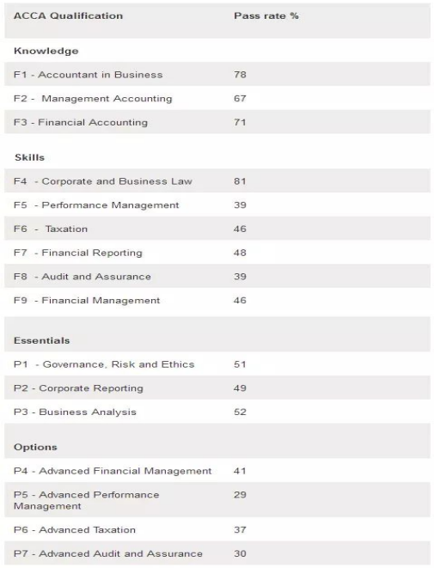
Figure 1 ACCA exam subjects 1

Activity 2

Definition of Group dynamics
Group Dynamic was first proposed by Lewin in 1939 (Backstrom, 2006).

What group dynamics can be affected
The success or failure of a group depends on many factors. Interaction between group members' resources, structure (group size, group, role, norm and group cohesion), group, process (communication, group decision-making process, power dynamics, interaction, etc.) and group work (complex) Dependency) (library of his article, 2019). The nature of the individuals in the group, leadership, the structure of the group or team, issues of power and state, the structure and processes of communication can also influence the dynamics of the group (X-Culture.org, 2020).

Importance of teamwork skills
Teamwork creates a work atmosphere and encourages each team member to have a sense of belonging, increasing the intent and efficiency of team members. It also helps members learn and motivate the overall potential of the team (Wehbe, 2017). Teamwork can achieve great projects that people cannot achieve independently. Teamwork can help generate more innovative ideas because other members' opinions can conflict. The diversity of team members can help generate a variety of ideas, so you can generate ideas and make better plans when making decisions. Teamwork can limit member behavior. Members will unknowingly accompany the masses and agree with most people on the team with conscious decisions and actions to achieve the goals of limiting rules and controlling individual actions. Regulation and control of individual behavior can help standardize group behavior and increase team efficiency (Salas, Sims and Burke, 2005).

Tuckman model
One of the best-known theories of team development is the "team development phase" proposed by psychologist Bruce Tuckman in 1965. The five stages of the team cando are described: training, attack, normalization, execution, and pausing.
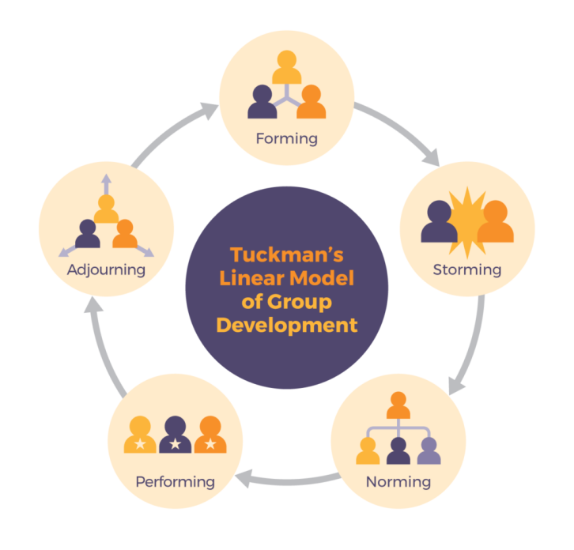
Figure 2 The Stages of the Tuckman Model
Tuckman's team and group development model help people understand the stages of development that are underway in their work, so they can plan and decide on the next steps and guide them to gain the results. Team leaders can ask team members to determine the location of this model and the work required to complete each step and achieve better performance. Also, if teams are regularly checked in this model, we can get rewards for team members to see their progress (Elsey, 2019).

Belbin’s 9 Team Roles
Studies show that the most successful teams consist of multiple actions. Dr. Meredith Belvin and her team have identified nine action groups called "team roles." Each team is exposed to each of the nine "team role" actions and becomes a high performance team (Belbin.com, 2019). People can have a few team roles that are best suited for them, so there is no problem if the team size is less than nine. The roles of the nine teams are coordinator, implementer, plant, monitor, resource researcher, teammate, modeler, expert and finisher (Belbin.com, 2019).

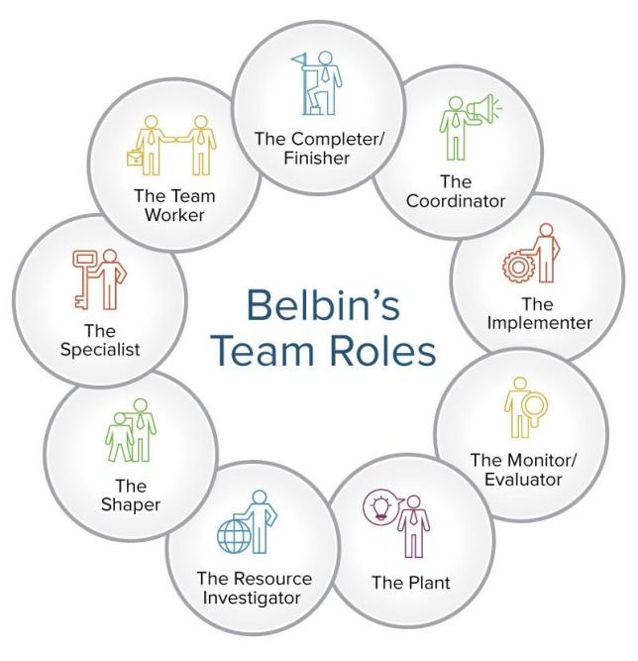
Figure 3 Belbin Team Roles
Each team role has its strengths and weaknesses, and each role is equally important. Using Belbin to understand their role in a particular team has increased their contribution to the team. People can better understand and take advantage of their strengths and manage their team's weaknesses. Effective team leaders and team development professionals can often use the Belvin model to create a more balanced team. If all team members have similar styles and roles, team balance may be compromised. If the weaknesses of the team members are similar, you can amplify the weaknesses of the whole team. If team members have similar benefits in teamwork, team members can compete (rather than together) with team work and responsibilities that best suit their style. Natural (Mindtools. Com, 2019). Leaders who know this can use this model in teams to play the required team role and resolve conflicts and weaknesses between team members.

The Thomas and Kilmann model for dealing with team conflicts describe five major approaches to team conflict management (competition, acceptance, participation, avoidance, and collaboration) (Thomas and Kilmann, 2019).
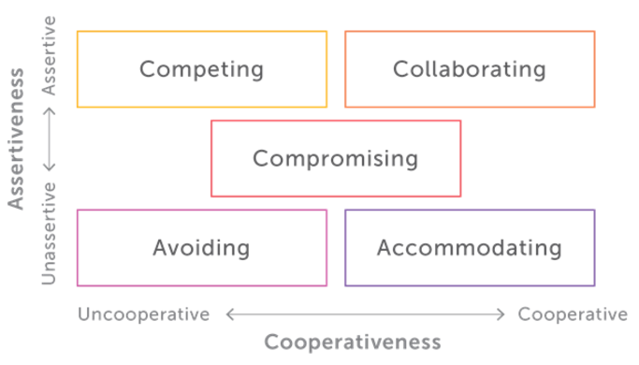
Figure 4 Thomas and Kilmann's model 1
Based on the class table, I measured that I tended to work to resolve the dispute. A specific example of life was when I was in China, deputy of our college student association culture and entertainment department. At last year's department overview meeting, our department secretary gave me a task belonging to him because he was busy. I was dissatisfied at the time, but if I didn't do the job there would be no representative of the department and I promised that the professor would blame me. Therefore, I still finished work.

Win-win also known as confronting the problem or problem solving (Hrpersonality.com, 2019). A symbiotic situation is more of a concern than the parties. The mutually beneficial approach views dispute resolution as an opportunity to achieve mutually beneficial results. This involves identifying the basic interests of employees and finding options that meet the needs of all parties.
In real life, for example, the minister and I needed to prepare a travel plan for the entire student council. Our journey took only three days, but we wanted to go to the location shown. Obviously, we could not go to all picturesque places in this short time. Eventually we achieved a win-win situation where all the people in the discussion chose the pictorial location they wanted to go to and abandoned the pictorial location they wanted to go to. Finally, student union members are very happy with their travel plans.

Activity 3
Last semester I participated in an accounting simulation and experiment project that lasted for almost five weeks. The project was mainly based on manual simulation. In the experiments I actually experienced the basic procedures and methods of corporate accounting, and strengthened my understanding of theoretical knowledge in practice. In the course experiment, I encountered many problems that I have not encountered in theoretical study, and the process of solving this problem was the process that I really improved in the study of this course. At the same time, after this period of manual accounting processing, I fully realized the difficulty of being a qualified accountant, and fully realized the invaluable importance of computerized accounting. The main content of this project is to improve our ability to handle actual accounts.
Through this project, we realized that we must have diligent determination and a rigorous work attitude. Accounting is a very accurate activity and accountants need to explain each problem correctly and use each formula correctly. Accounting is not an innovative profession. Based on exact figures that can reflect the problem, people who want to become a professional accountant need to increase their sensitivity to numbers and check your calculations and approvals several times to find and resolve issues with time and close gaps.
During this period, my partner and I used “brainstorming” many times. During the meeting, we spoke freely and gave our own views and opinions. Everyone is equal. Through this method, we reasonably assigned everyone's tasks and completed the tasks assigned by our superiors. We all feel that our ability has been greatly improved.
In the process of the project, we also use Gantt chart to make plans, which helps us to accurately determine the implementation of the project. When various tasks start and end is also clearly shown in the picture. Let's have a clearer understanding of everyone's work.

Activity 4
CPD effectively achieves personal objectives, sustains technical development, is professionally accredited, is well positioned to compete for talent, develops leadership skills and influences others. Helps prove ability to give. As needed (continuation of professional development in 2019).
The value of continuous professional development cannot be underestimated. This is the professional duty of the professional. Sometimes required by specialized organizations. For example, ACCA requires members to submit a CPD statement each year. If an ACCA member has not submitted a CPD within two years, it will be removed (Cn.accaglobal.com, 2019). But basically, the personal responsibility of the professional is to update the knowledge and skills to be able to provide high quality service to meet customer expectations and professional requirements.
CPD is based on the reflex practice base (CIPD, 2019). Reflex practice is closely related to the concept of learning through experience, because people have to think about what they are doing and then decide to do it differently. CPD is a lot of help to get into the habit of using reflexes. The practice of reflexes has great benefits for improving one's perception and increasing understanding of others (CIPD, 2019). Reflex exercises can also help people develop creative thinking skills. Maintaining a learning diary and using reflex practices regularly at work can support more meaningful discussions for professional and personal development. Learning logs need not only a diary or list of activities, but also a systematic way to record and analyze learning events. Reflexes can be used to improve students' learning levels and life experiences with work. Adopting reflex practice takes time, but it will eventually help others (Skillsyouneed.com, 2019).
After I decided to choose ACCA, I knew that I must choose an advanced program with two options that have passed 12 exams in order to qualify. For advanced projects, choose advanced financial management and advanced taxes. In order to be a good accountant, learning deeper financial management and knowing taxes can be very useful for my job. I am interested in tax accountants. Tax accountants use their skills and knowledge to understand tax laws and regulations in the most effective way for customers and employers (Allbusinessschools.com, 2019). I should advise on how to minimize the impact of company and customer taxes on the company (Neuvoo.ca, 2019). What is more, another thing attracting me most is that taxpayers' salaries are also relatively high.

References
Accaglobal.com. (2019). Home | ACCA Global. [online] Available at: https://www.accaglobal.com/uk/en.html [Accessed 15 Dec. 2019].
Allbusinessschools.com. (2019). Accounting is More than Crunching Numbers: Read an Accountant Job Description [online] Available at:
Anon, 2010. accountant. A Dictionary of Accounting, pp.A Dictionary of Accounting.
Arnold, S. (2019). 6 Skills Accountants Need to Survive the Robot Uprising | BlackLine Magazine. [online] BlackLine Magazine. Available at: https://www.blackline.com/blog/exceptional-accountants/6-skills-exceptional-accountant/ [Accessed 15 Dec. 2019].
B. Tuckman, "Developmental sequence in small groups," Psychological Bulletin, vol. 63, no. 6, pp. 384-399. Available: http://dx.doi.org/10.1037/h0022100
Backstrom, L.; Huttenlocher, D.; Kleinberg, J.; Lan, X. (2006). "Group formation in large social networks". Proceedings of the 12th ACM SIGKDD international conference on Knowledge discovery and data mining - KDD '06. p. 44. doi:10.1145/1150402.1150412. ISBN 978-1595933393.
Belbin.com. (2019). The Nine Belbin Team Roles. [online] Available at: https://www.belbin.com/about/belbin-team-roles/ [Accessed 16 Dec. 2019].
Belbin.com. (2019). Why use Belbin. [online] Available at: https://www.belbin.com/about/why-use-belbin/ [Accessed 07 Jan. 2020].
Chinaacc.com. (2019). On the career development prospect of ACCA members. [online] Available at: http://www.chinaacc.com/acca/hyxw/ji20190422142940.shtml [Accessed 15 Dec. 2019].
CIPD. (2019). CPD Cycle Stages | CIPD. [online] Available at: https://www.cipd.co.uk/learn/cpd/cycle [Accessed 16 Dec. 2019].
Cn.accaglobal.com. (2019). CPD Room - ACCA China. [online] Available at: https://cn.accaglobal.com/member/c28/cpdroom.html [Accessed 16 Dec. 2019].
Continuing Professional Development. (2019). The importance of continuing professional development (CPD). [online] Available at: https://continuingprofessionaldevelopment.org/why-is-cpd-important/ [Accessed 16 Dec. 2019].
Elsey, E. (2019). Tuckman's Team and Group Development Model | by Emma-Louise Elsey | The Launchpad - The Coaching Tools Company Blog. [online] The Coaching Tools Company. Available at: https://www.thecoachingtoolscompany.com/get-your-team-performing-beautifully-with-this-powerful-group-development-model/ [Accessed 16 Dec. 2019].
Hrpersonality.com. (2019). Conflict Management Techniques. [online] Available at: https://www.hrpersonality.com/resources/conflict-management-techniques [Accessed 16 Dec. 2019].
https://www.allbusinessschools.com/accounting/job-description/ [Accessed 16 Dec. 2019].
Insidecareers.co.uk. (2019). What is accounting? | Graduate Jobs, Internships & Careers Advice - Inside Careers. [online] Available at: https://www.insidecareers.co.uk/career-advice/what-is-accounting/ [Accessed 15 Dec. 2019].
Kagan, J. (2020). Accountant. [online] Investopedia. Available at: https://www.investopedia.com/terms/a/accountant.asp [Accessed 7 Jan. 2020].
Mindtools.com. (2019). Belbin's Team Roles: How Understanding Team Roles Can Improve Team Performance. [online] Available at: https://www.mindtools.com/pages/article/newLDR_83.htm [Accessed 16 Dec. 2019].
Neuvoo.ca. (2019). What does a Tax Accountant do [online] Available at: https://neuvoo.ca/neuvooPedia/en/tax-accountant/ [Accessed 16 Dec. 2019].
Salas, E., Sims, D. E., & Burke, C. S. (2005). Is there a “big five” in teamwork. Small group research, 36(5), 555-599.
Skillsyouneed.com. (2019). Reflective Practice | SkillsYouNeed. [online] Available at: https://www.skillsyouneed.com/ps/reflective-practice.html [Accessed 16 Dec. 2019].
TARGETjobs. (2019). Accountant: job description. [online] Available at: https://targetjobs.co.uk/careers-advice/job-descriptions/276909-accountant-job-description [Accessed 15 Dec. 2019].
Thomas and Kilmann (2019). An Overview of the Thomas-Kilmann Conflict Mode Instrument (TKI) A long-term collaboration by Dr. Kenneth W. Thomas and Dr. Ralph H. Kilmann - Kilmann Diagnostics. [online] Kilmann Diagnostics. Available at: https://kilmanndiagnostics.com/overview-thomas-kilmann-conflict-mode-instrument-tki/ [Accessed 16 Dec. 2019].
Wehbe, S. (2017). 5 Important Reasons Why Teamwork Matters - Potential.com. [online] The Online Learning Platform. Available at: https://www.potential.com/articles/5-important-reasons-why-teamwork-matters/ [Accessed 16 Dec. 2019].
X-Culture.org. (2020). The Effects of the Team Leadership Structure on Team Dynamics and Performance in GVT Context. [online] Available at: https://x-culture.org/for-researchers/research-projects/the-effects-of-the-team-leadership-structure-on-team-dynamics-and-performance-in-gvt-context/ [Accessed 7 Jan. 2020].
Your Article Library. (2019). Group Dynamics: it's characteristics, stages, types and other Details | Management. [online] Available at: http://www.yourarticlelibrary.com/management/group-dynamics-its-characteristics-stages-types-and-other-details-management/5363 [Accessed 16 Dec. 2019].

Appendix

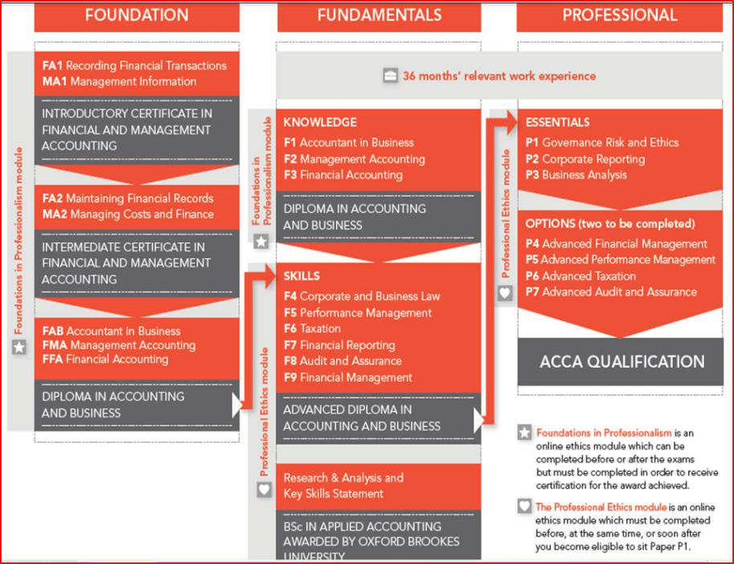
Activity1:
Ev1: ACCA form

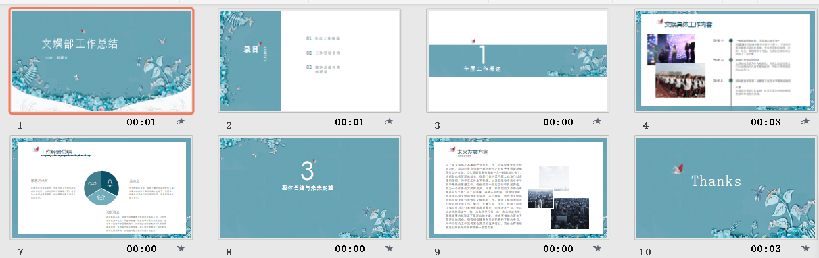
Activity2:
Ev1: PowerPoint I used to solve problems in meetings last year (Compromising in Thomas Kilmann)

Ev2: Activity was successful

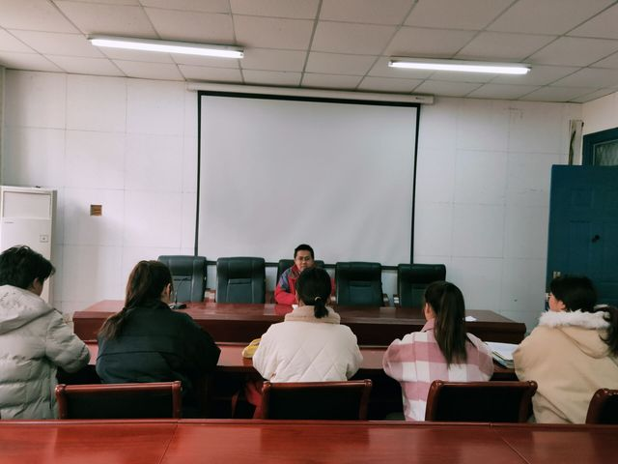
Activity3:
Ev1: Brainstorming Meeting
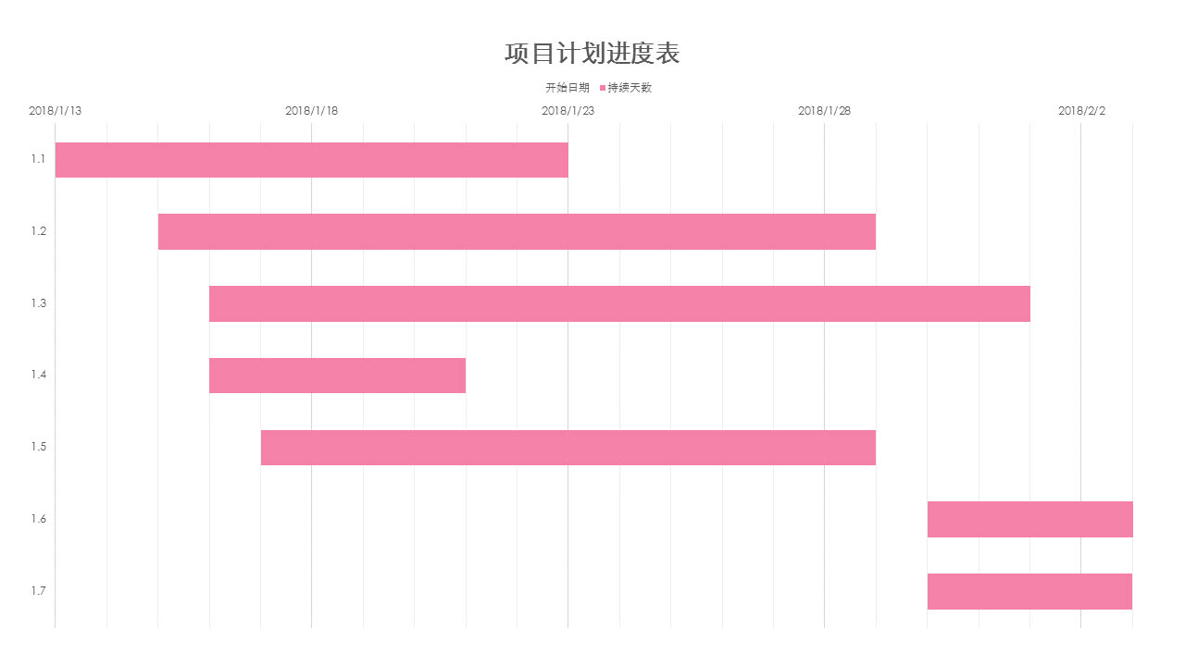
Ev2: Gantt Chart we used in the project

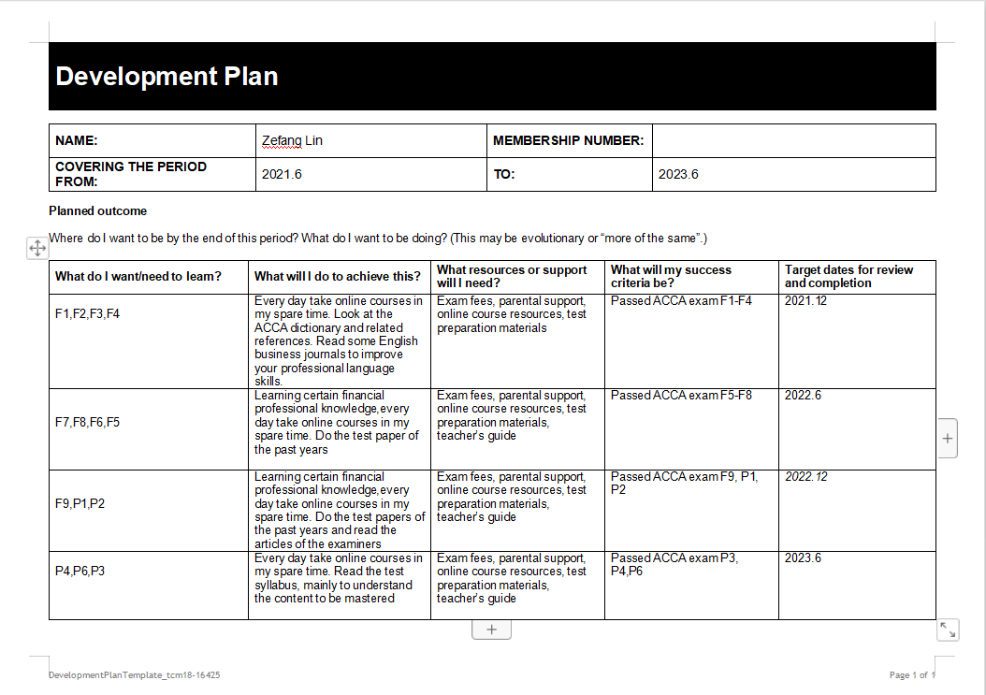
Activity4:
Ev1: Development Plan

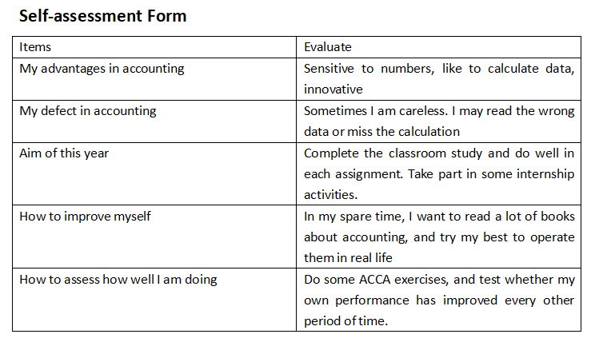
Ev2: Self-assessment form

