e-PORTOFOLIO REPORT
Evidence Based Policing & Applications
BMPL4001

Dumitru Vasile Gomoescu
Student number: 2223227

Table of contents

Core ideas of evidence-based policing………………………………………………….2
Criminological theories which use Evidence based-policing …………………………3
Body-worn cameras……………………………………………………………………….4
Strengths and weakness of Police Body Worn Cameras …………………………....5
Ethical Consideration ...............................................................................................6
Use of Body Worn Cameras on street crime ............................................................7
References................................................................................................................8

Core ideas of evidence-based policing

Many things has been done over the years to improve police decision making. As a result, evidence-based policing came into existence. The use of the best available research on the outcomes of police work to implement guidelines and evaluate agencies, units, and officers is defined as evidence-based policing (EBP) . This means that police procedures are being studied for officers to better understand what they are doing right and wrong, resulting in more effective police work. In other words, evidence-based policing utilises research into routine police procedures to assess the current practises and guide police in future decision making . Evidence-Based Policing it is used to make evaluations simpler to see for individuals researching police interventions and law enforcement ("Evidence-Based Policing Matrix,") and to assist them decide what would be helpful. The target's characteristics, the degree to which the approach is proactive or reactive, and the specificity or generality of the plan are three common crime prevention features that are classified and visualised by this matrix . So, the matrix provides details on police tactics and what can be done to assist police officers in making the best judgements for their communities. Police officers can use the evidence-based policing matrix described to direct them in creating upcoming tactics and strategies. The Kansas City Experiment was significant research that was conducted on law enforcement procedures. This experiment, which was funded by the Police Foundation and focused on the use of preventive patrol, was the first major scientific investigation of police enforcement operations . Areas of Kansas City were divided into three parts for this experiment. In the first section, there was no change to the patrol, in the second, the patrol was doubled, and in the third, an entirely different strategy for patrolling was tested, which involved no patrolling at all . The outcomes of this experiment surprised us. All three of the under-investigation areas remained unchanged (Schmalleger, 2015).

Criminological theories which use Evidence based-policing

Evidence based-policing is a method of making decision about ,, what works’’ in policing.(Lawrence W. Sherman).
Triple T strategy is a method that help police on their decision . Targeting: Ranks and compare the level of harm associated with various places , times, and people . Identifying a high priority policing problem. Testing: Using scientific strategies tests to show if crime increase or decrease. Tracking: For desired outcome it should be tracked by using GPS records questioning witnesses or using body-worn video cameras.
Crime Opportunity Theory :suggests that when an individual wants to commit a crime, they look for an opportunity or a practical target. For example, if a city neighbourhood offers no off-street parking, it may be a prime target for vehicle thefts.
Crime Pattern Theory: integrates crime within a geographic context that demonstrates how the environments people live in and pass through influence criminality. The theory specifically focuses on places and the lack of social control or other measures of guardianship that are informally needed to control crime. For example, a suburban neighbourhood can become a hot spot for burglaries because some homes have inadequate protection and nobody home to guard the property.
Broken Windows Theory: explains how lesser crimes, untended areas, blight, graffiti, and signs of disorder decrease neighbourhood residents' willingness to enforce social order, which in turn leads to more serious crime. If police target minor transgressions, they may prevent serious crime from developing in those places.
Social Disorganization Theory suggests that crime occurs when community relationships and local institutions fail or are absent. For example, a neighbourhood with high residential turnover might have more crime than a neighbourhood with a stable residential community.
Situational Crime Prevention Theory suggests that crime and public disorder can be prevented by reducing opportunities for crime. For example, if crime occurs regularly in a dimly lit alley, public works could improve lighting and increase police presence in the area.

Routine Activity Theory suggests that crime occurs when a motivated person, a suitable target and the lack of capable guardian converge in the same place at the same time . Criminals choose or find their targets within context of their routine activities, such as traveling to and from work, or other activities such as shopping, and tend not to go too far out of their way to commit crimes.

Body-worn cameras

Police body‐worn cameras (BWCs) have gained popularity in recent years. However, many minimize the complexity of this transparency initiative and elevate the potential benefits. While BWCs can promote police accountability, they may also reduce citizen trust in police organizations. For BWCs to achieve win‐win solutions, police organizations should determine the level of citizen support for specific BWC practices. However, measuring citizen support presents several challenges. Social desirability may impact polling results, as participants underreport responses they perceive to be outside the norm. The authors employ a list experiment design to measure true citizen support for BWC practices. They find statistically significant levels of social desirability for police discretion in the activation of BWCs and for restriction of footage accessibility regarding suspects with mental illness. Decision makers should not rely on public opinion polls as a gauge of true citizen support for BWC use.
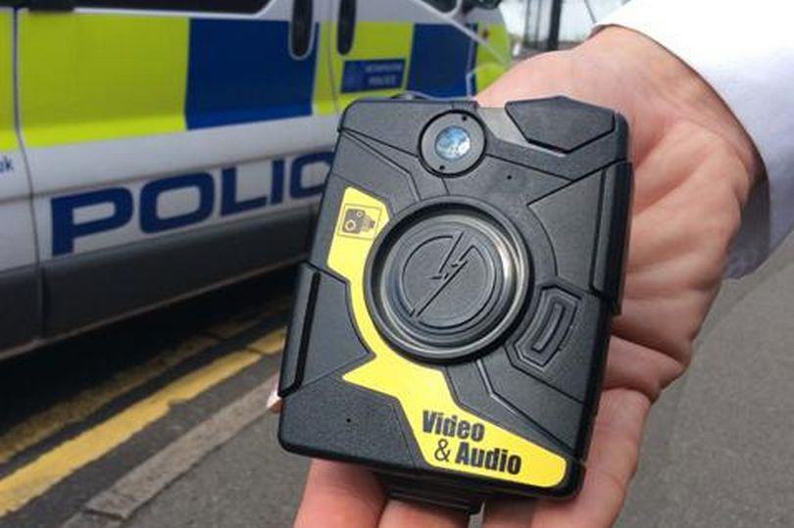
Body-worn camera
Strengths and weakness of Police Body Worn Cameras

When it comes to body worn cameras for police, many people think they’re a great way to encourage and enforce better practices in the police force in addition to increasing accountability. These systems require significant up front and on-going budgetary investment as well as the integration of multi-faceted technology which includes, hardware, software, security, and the allocation of support staff. In addition, there are ethical considerations such as the privacy of victims, officers, and by standards which must be carefully considered and brought into the decision-making process. A recent Pew Research Centre survey revealed that 66% of officers and 93% of the public favour the use of body cameras by officers to record interactions with citizens. Modern Policing is difficult at the best of times, however, over the past two decades we have seen a steady rise in tensions between law enforcement agencies and the communities they serve. With this trend have come increased calls for greater police transparency, accountability, and oversight. Since the early 2000s Body Worn Camera technology has sought to address these issues by providing a clear and unbiased video record of police interactions with the community. However, many officers have serious reservations about the use of police body cams. Here are some pros and cons of body worn cameras for police.
PRO: Footage can be used as evidence
This is probably one of the biggest benefits of body cameras for law enforcement — the ability to use the footage later in a court of law if necessary. Without this footage, your case may be severely lacking, depending on what the case is about. But the fact is, footage from both police body cameras and police dash cameras can be incredibly useful in a court of law.
CON: Restricted privacy
There’s no secret that police body cameras can limit the privacy of both law enforcement and civilians. These cameras are usually on and running for nearly the full duration of an officer’s shift, and they will most likely capture short snippets of random bystanders. Additionally, all footage is owned by the state, so footage of any arrests made can damage the reputation of defendants. So, in large, police body cams can inhibit privacy, but it’s a small price to pay if it means better protocol enforcement by police.

PRO: Violence prevention
A study conducted in 2013 by the University of Cambridge discovered that both police and respondents become less likely to use violence when police wear body cameras, citing a drop in force rate by a whopping 50%. This serves as very strong evidence that more cameras ultimately mean less violence.
CON: Video quality
Another concern some people have about police body cams is the actual quality of the footage. While it isn’t possible for it to be perfect due to officers’ movements, lighting, and other factors, it’s likely that there could be blurs or lags in the footage, which can make it hard to properly interpret. However, this is quickly being remedied, as camera technology is consistently evolving.

Ethical Consideration

Every technological advancement has brought about moral and ethical consideration and questions that must be addressed . Although the recording of individuals in a public space is not illegal as there is no expectation of privacy , if that recording is perpetrated by a government agency that has the authority to detain an individual of liberty or property , should the individual(s) have the option to consent or decline? If no consent is required for the subject of a police, contact what about passers-by or bystanders who happen to be in the proximity of the incident but not directly involved ?
Furthermore, what if the parties involved are not suspects but victims of crime or minor children , should special consideration be given to those individuals ? The decision to adopt or abandon Body Worn Camera technology must include Police Body Worn Cameras.
In response with this issue in 2023, the latest body worn cameras can process faces within three-meter distance and compare then to those in a pre-configured database with any matches triggering alerts or additional camera activity such as recording and streaming .
Faces that are not matched against the data base are not recorded or saved by the camera.

Use of Body Worn Cameras on street crime

When it comes to street crime, BWCs have been shown to be particularly effective in reducing the incidence of use of force by police officers. Studies have found that the use of BWCs leads to a decrease in the number of incidents where police officers use force, as well as a decrease in the number of citizen complaints about use of force. In addition, BWC footage can be used as evidence in court, leading to higher conviction rates and more successful prosecutions. However, it's important to note that the effectiveness of BWCs depends on a number of factors, including how they are implemented and the policies surrounding their use. For example, it's important to have clear guidelines around when BWCs should be turned on and off, how footage is stored and accessed, and how officers are trained to use them. There is a risk that BWCs could perpetuate bias if they are used selectively or if officers selectively release footage that supports their narrative. Additionally, there is a risk that officers may be more likely to use force or escalate a situation if they know they are being recorded. Overall, while BWCs may not be the best solution to street crime but they can be an effective tool for reducing the incidence of use of force by police officers and improving transparency and accountability in policing.

References

Lawrence W. Sherman. Crime and Justice, Vol. 42, No. 1, Crime and Justice in America 1975–2025 (August 2013), pp. 377-451.
Schmalleger , 2015. ,,Evidence-Based Policing Matrix’’.
Cohen, Lawrence E., and Marcus Felson, "Social Change and Crime Rate Trends: A Routine Activity Approach," American Sociological Review 44 (August 1979).
National Institute of Justice, "Why Crimes Occur in Hot Spots," October 13, 2009.
https://nij.ojp.gov/topics/articles/why-crimes-occur-hot-spots .(last accessed 30.03.2023.
Bromberg, Daniel E. Charbonneau, Étienne . Smith, Andrew. Hoboken, Body‐Worn Cameras, and Policing: A List Experiment of Citizen Overt and True Support USA: Public administration review, 2018, Vol.78 (6), p.883-891 .
https://www.mylondon.news/news/local-news/police-body-worn-video-cameras-now-7498059 (last accessed 30.03.2023).
Richard Lin, 2016. Police Body Worn Cameras and Privacy: Retaining Benefits While Reducing Public Concerns, 14 Duke Law & Technology Review 346-365.
Security Journal United Kingdom , Video management systems . March 2023 . Issue 26 ,p.39.

