Slide 1

Slide 2

Slide 3

Slide 4

Person Role Description Continued
- Administration support providing letters for grading of posts
- Probation administration
- Maternity and Paternity administration
- Recruitment and selection
- Equality and Diversity
- Staff achievement payments
- Administration of performance management and improvement systems
- Termination of employment
- User acceptance testing
- Upkeep of electronically stored personal records
- Carry out regular Human Resource Audit checks to ensure integrity of data is maintained.
- Ensure Compliance with Data Protection Legislation

Slide 5

Slide 6

KNOWLEDGE
Personnel and Human Resources - Knowledge of principles and procedures for personnel recruitment, selection, training, compensation and benefits, labor relations and negotiation, and personnel information systems.

Administration and Management - Knowledge of business and management principles involved in strategic planning, resource allocation, human resources modeling, leadership technique, production methods, and coordination of people and resources.

Customer and Personal Service - Knowledge of principles and processes for providing customer and personal services. This includes customer needs assessment, meeting quality standards for services, and evaluation of customer satisfaction.

Law and Government - Knowledge of laws, legal codes, court procedures, precedents, government regulations, executive orders, agency rules, and the democratic political process.

SKILLS
Speaking Ability
To be able to make a presentation or speech clearly and effectively with confidence minus all the “ums” and “likes” and “ers”.

Reading people
The ability to sense if someone is lying or trying to hoodwink.

Backbone
The ability to stand firm and not be intimidated. A “backbone” comes from the strength of your convictions and knowledge of your “craft.” The more knowledgeable you are the more confident you will be in your encounters with managers.

Empathy
Without the ability to see another point of view or to understand the nuances of a situation you will be robbed of the ability to make the appropriate decisions at the appropriate time.

Listening
The ability to put aside your agenda and listen and “hear” what someone is saying and how they are saying it.

BEHAVIOUR
Integrity - Job requires being honest and ethical.

Stress Tolerance - Job requires accepting criticism and dealing calmly and effectively with high stress situations.

Leadership - Job requires a willingness to lead, take charge, and offer opinions and direction.
Initiative - Job requires a willingness to take on responsibilities and challenges.

Dependability - Job requires being reliable, responsible, and dependable, and fulfilling obligations.

Self-Control - Job requires maintaining composure, keeping emotions in check, controlling anger, and avoiding aggressive behavior, even in very difficult situations.

Cooperation - Job requires being pleasant with others on the job and displaying a good-natured, cooperative attitude.

Concern for Others - Job requires being sensitive to others' needs and feelings and being understanding and helpful on the job.

Human Resource Officer’s Current Knowledge, Skills and Competencies (Refer to table in the slide)

Human Resource Officer’s Career Plan (Refer to table in the slide)

Human Resource Personnel Career Development Plan (Refer to table in the slide)

Human Resource Officer Training and development needs (Refer to table in the slide)

Slide 7

Human Resource Officer’s Current Knowledge, Skills and Competencies
 | Strong | Weak
Leadership | $$√$$
Systems Applications and Products in Data Processing(SAP)knowledge |  | $$√$$
Initiative and Creativity | $$√$$
Communication | $$√$$
Team Work | $$√$$
Language skills | $$√$$
Positive Attitude | $$√$$
Financial Management |  | $$√$$
Ethics | $$√$$
Presentation Skills |  | $$√$$
Honesty | $$√$$
Critical Thinking | $$√$$
Commitment to Ongoing Human Resource learning | $$√$$
Human Resource Organisational skills |  | $$√$$

Human Resource Officer’s Career Plan
The diagram below show the Human Resource Career progress chart at TPS UK
Human Resource Assistant
Chief Human Resource Officer
Training and Development Coordinator
Payroll Specialist
Human Resource Manager
Human Resource Clark
Human Resource Director

The Human Resource officer’s Career Plan shows the highest possible position in TPS UK that a Human Resource Personnel can reach.

Slide 8

Further benefits

- Improvement in worker performance.
- Consistency in duty performance.
- Ensuring worker satisfaction.
- Reduction in supervision.

Slide 9

Training and development
Refers to educational activities within a company created to enhance the knowledge and skills of employees while providing information and instruction on how to better perform specific tasks.

It is also conducted to Designs, coordinate, organize, and facilitate learning and development of solutions to needs of an organisation.
It supports the workforce in acquiring knowledge, skills, and abilities required for effective job performance.

Performance Assessments
- Is conducted to review the performance of employees for a period of time.
- To assess the gap between the current and desired performance.
- To assist the manager in conducting the control/audit.
- To help in improving relationships and communication between managers and employees

Performance Appraisal
Helps to keep a record of each employee’s job performance, including what efforts they have made as well as what they achieved.

Slide 10

CONCLUSION
Human Resource Management as performed by the Human Resource Personnel constitutes a vital role in the organisation’s life.

Performance management system such Appraisals, Skills Gap analysis, Training and development needs analysis etcetera, are more less life support systems of an organisation.

They play an important role that constitutes the psychological contract between managers and colleagues.

It gives them an opportunity to derive the colleague’s performance and behaviour toward organisational goal in terms of developing colleagues while keeping a good relationship with them.

Comparable organisations use more or less the same financial and material resources for their business but reach different performance levels in efficiency and effectiveness it becomes clear that the driving factor for these differences is in how company´s management understands and implements its role in human resource management.

Therefore, the managerial influence on employee is essential for constant improvement of human resource management processes in an organisation. Human resource management is on the one hand used as a generic wording for every arrangement of personnel management.

On the other hand it is seen as denotation of a specific approach within the human resource management which is identified by different characteristics. According to a narrow understanding companies try to gain competitive advantage by acquiring engaged and capable employees.

For their acquisition a set of cultural, structural and personnel oriented techniques is used.

From doing this assignment, I have come to appreciate the importance of Career planning, Knowledge, Skills and behaviour analysis by Human Resource personnel as well as the organisation. I have learnt how to design a training program for a Human Resource Officer.

Slide 11

REFERNCES
Collings, D. G. and Wood, G. (2009) Human Resource Management: A critical approach. London: Routledge.
Darwish, T.K. (2013) Strategic HRM and Performance: Theory and Practice. London: Cambridge Scholars Publishing.

Evans, S. and Tourish, D.(2016) ‘Agency theory and performance appraisal: How bad theory damages learning and contributes to bad management practice’, Management Learning. Available at: https://doi.org/10.1177%2F1350507616672736 (Accessed: 25th April 2021).

Hirsh, W. et al(1996) ‘Strategies for career development: Promise, Practice and Pretence’, Available at: https://www.employment-studies.co.uk/system/files/resources/files/305.pdf (Accessed: 29th April 2021).
Johnason, P.(2009) ‘HRM in changing organisational contexts. In Collings, G. and Wood, G. (Eds.), Human resource management: A critical approach’, pp. 19-37. London: Routledge.
Marler, J. et al(2016) Making HR Technology Decisions: A Strategic Perspective. New York: Business Expert Press.
Mullins, L.J. (2016) Management and Organisational Behaviour, 11th edn. London: Pearson.
Mullins, L.J.(2019) Organisational Behaviour in the Workplace, 12th edn. London: Pearson.
Ulrich, D. (1996) Human Resource Champions. The next agenda for adding value and delivering results. New York: Harvard Business Review Press.

Welbourne, T. M. and Cyr, L. A. (1996) ‘Agency Theory Implications for Strategic Human Resource Management: Effects of CEO Ownership, Administrative HRM, and Incentive Alignment on Firm Performance’, Center for Advanced Human Resource Studies (Working Paper, 96- 17), Available at: https://ecommons.cornell.edu/bitstream/handle/1813/77043/Agency_Theory__Organisational_ControlWP96_17.pdf?sequence=1&isAllowed=y (Accessed: 28th April 2021).

Williamson, O.(1994) Transaction cost economics and organisation theory. In Smelser, R. and Swedberg, R. (Eds.), Handbook of Economic Sociology: pp.77-107. Princeton, NJ: Princeton University Press.

Wright, P. M. and McMahan, G. C.(1992) ‘Theoretical Perspective for Strategic Human Resource Management’, A Journal of Management, 18(2), pp.295- 320. Available at: https://www.researchgate.net/publication/322538234_Strategic_Human_Resource_Management_and_Theoretical_Background_A_Critical_Review_Perspective (Accessed: 17th April 2021).

APPENDICES
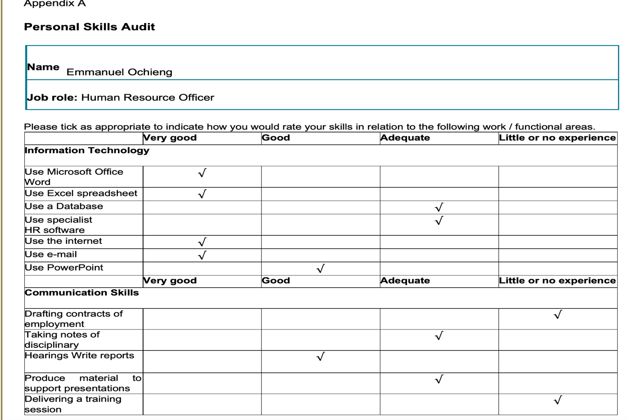
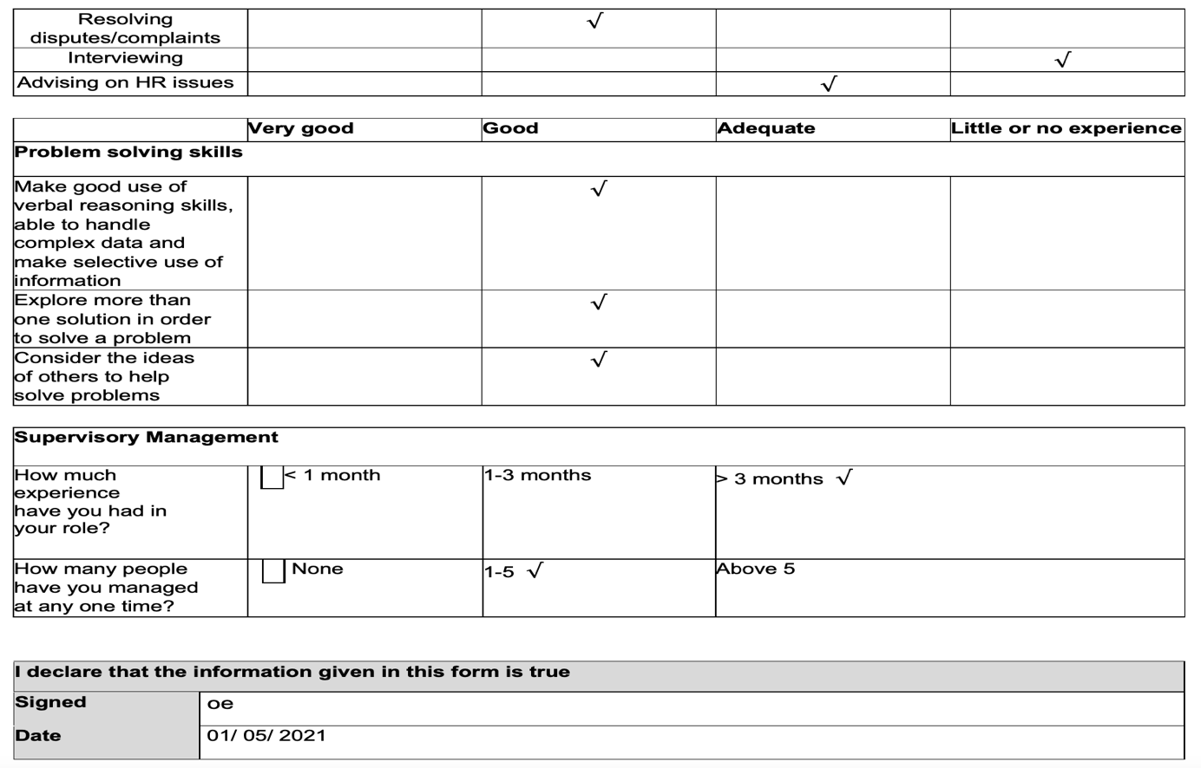

Appendix B:
Appraisal Form


