

IOT SMART Beehive

By
Charlie Wilkins

Supervisor: Simon Thomas
Second Marker: Gaynor Thomas

Project submitted as part of the requirements for the award of BSc (Hons) Computing (Computer Networks and Cybersecurity)

April 2024

Declaration Form and Form of Consent
DECLARATION

I, Charles Michael Wilkins, declare that I am the sole author of this Project; that all references cited have been consulted; that I have conducted all work of which this is a record, and that the finished work lies within the prescribed word limits. I have used dictation software and a scribe to assist my report submission.
This work has not previously been accepted as part of any other degree submission.

FORM OF CONSENT
I, Charles Michael Wilkins hereby consent that my Project, submitted in candidature for the B.Sc. (Hons) Computing (Computer Networks and Cybersecurity) degree, if successful, may be made available for inter-library loan or photocopying (subject to the law of copyright), and that the title and abstract may be made available to outside organisations.
Date: 24 April 2024

Abstract
Beekeeping is the ancient art of managing bees.
For hundreds of years humans have valued the products from the hive; honey, beeswax, propolis and Royal Jelly and in return have managed bee colonies, providing the bees with a straw skep or modern wooden/synthetic hives. The bees are semi-domesticated in this symbiotic relationship, so it is the responsibility of the beekeeper to ensure that the bees are healthy and able to maintain the homeostasis of the colony in the hive. This means ensuring that they are not overheating in the summer or too cold and damp in the winter, that they have sufficient stores and are not endangered by animals. It is impossible for the beekeeper to do this unless they are able to monitor the hives and measure parameters such as the humidity and temperature within the hive.
The aim of this project was to evaluate systems which record these parameters within a beehive – the concept of the ‘smart beehive’.
Methods used: the project used a pre-production smart beehive system from a small start-up company called HiveBeat. This is not yet in production, so the research project provided an opportunity to Beta-test their equipment consisting of tags and controllers in conjunction with controller configuration software to connect the tag through home Wi-Fi.
Key Findings: The HiveBeat system worked well but there was a problem with the range achieved with radio wave technology. This was fine for the very close home apiary but not sufficient to reach the apiary next door. This defeats the object of remote hive monitoring and illustrates the requirement to select the correct technology for the job. Data from 8 sensors every 30 minutes between January and April 2024 allowed for more effective temperature and humidity management, allowing for significantly improved hive population health.
Recommendations include the need to identify an alternative technology for recording hive parameters which increases the range between controllers and tags so that the monitoring is truly remote. There are small changes in the HiveBeat system which would improve the data processing and user interface which would exponentially improve the utility of the system. Overall, this project has demonstrated that there is a very useful role for smart hive monitoring, but this is reliant on choosing suitable technology which meets the requirements of the beekeeper in their responsibility to support homeostasis within the bee hive.

Table of Contents
IOT SMART Beehive 0
Declaration Form and Form of Consent 1
Abstract 2
Table of Contents 3
Table of Figures 6
Chapter 1 – Introduction 7
1.1 Background to Project Choice 7
1.2 Aims 8
1.3 Objectives 8
Chapter 2 – Research and Review of Literature 9
2.1 Background Research 9
Data Analytics 10
Data Sharing 12
Real-World Applications 12
2.2 Beekeeping 12
2.3 Issues within Beekeeping 13
American Foulbrood (AFB) 14
European foulbrood (EFB) 14
Chalkbrood 14
Sacbrood 14
Varroa 14
Wax moth. 15
Other pests 15
Poisoning 15
2.4 IoT sensors and equipment 15
Sensors/Devices 16
Connectivity 16
Data Processing 18
User Interface 18
2.5 The concept of smart beehives 18
Chapter 3 – Research and Development Methodology 20
3.1 Research Methodology 20
3.1.1 Philosophy 20
3.1.2 Approach 20
3.1.3 Strategies 20
3.1.4 Risks & Limitations 21
3.1 5 Ethical Issues 21
3.1.6 Validity, Reliability & Generalisability 22
3.1.7 Data Evaluation Methods 22
3.2 Development Methodology 23
3.2.1 Software Development Methodology or Other Relevant Major Methodology 23
3.2.2 Any Other Relevant Subsidiary Methodologies 23
3.3 Resources and Planning 24
3.3.1 Hardware Resources 24
3.3.2 Software Resources 24
3.3.3 Information Resources 24
3.3.4 Human Resources 24
3.3.5 Project Plan 24
Chapter 4 - Design and Implementation 26
Results and Discussions 26
Sensors 26
Connectivity 28
Data Processing 30
User interface 30
Chapter 5 – Analysis Practical application and deployment 34
Sensors 34
Connectivity 37
Data Processing 38
User interface 38
Chapter 6 – Evaluation 39
Chapter 7 - Conclusions and Recommendations 40
Conclusions 40
Recommendations. 40
Sensors 40
Connectivity 41
Data Processing 42
User interface 42
Chapter 8 – Reflection 43
Chapter 9 – References 44

Table of Figures

Figure 1. Long Range (LoRa) data link capabilities. 17
Figure 2. Project timeline. 25
Figure 3. Breakdown of project phases. 25
Figure 4. Sensor and plastic guard showing some wax and propolis after removing from the hive. 27
Figure 5. Sensor in position attached to the wooden frame using the glue strip and pressed into the wax of the honeycomb. 28
Figure 6. Controller set up with power cable, connected to the home internet and line of sight to the home apiary. 29
Figure 7. Website interface showing options for graphical representation of data. 31
Figure 8. This data shows that the small nucleus colony in a small box was able to maintain a very steady internal hive temperature and humidity. 32
Figure 9. Variable data showing the diurnal variation in temperature reflecting the ambient temperature changes. 33
Figure 10. Sensor showing shape and glue strip (with removable glue-strip protection still in place). 34
Figure 11. Sensor position in the hive (moved to the side) showing how the bees have modified the honeycomb around it. 35
Figure 12. Sensor set up at the out apiary with controller attached to power source and laptop attached to Wi-Fi by phone hot spot. 36
Figure 13. Data from 2 hives which superficially looks similar because the graphs optimise the data representation. 39

Chapter 1 – Introduction
The context for this project is that I am a beekeeper and a cyber security student, and I am looking to develop both areas of my life within this project.
I have no industrial partner and do not intend to have one. However, the equipment I am using for the hive monitoring is purchased from a start-up company called HiveBeat and not yet commercially available, but I have been allowed to use it whilst still in its developmental phase. I have explained this in the ethics section.

1.1 Background to Project Choice
The background reason for doing this project is to develop my understanding of the Internet of Things (IoT) and how that relates to computer networks and cybersecurity.
I have been keeping bees for 11 years with my family as a company called “Wild Close Bees” (our house is called Wild Close) and we recognise that having smart beehive technology could assist us to improve our management of the business. Using technology in our apiaries would allow us to see data for the individual hives so that we could monitor the well-being of the colonies and compare their health status and performance. This would allow us to oversee them from a distance and reduce the requirement to visit the multiple apiary locations and open the hives, therefore reducing the stress on the bees.
I am the right person to do this project because I have developed IT skills from doing IT courses at school and university, including my HND in cybersecurity and computer networks.
I have been a beekeeper for 11 years and understand the lifecycle of the bee and the annual cycle of the colony. I am interested in learning more about bees and am supported in this hobby by my mother who has completed academic modules for the British Beekeepers Association (BBKA) exams and is training to be a Master Beekeeper. She is my beekeeping mentor and is continuing to teach me about bees; I am teaching her IT.
Beekeeping is an ancient skill with evidence of bees being kept by the Egyptians as early as 3500 BC. They attached great religious and spiritual significance to the honey bee, which was associated with royalty, and the bee was the symbol of the king of Lower Egypt.
Over my years as a beekeeper, I have recognised the contribution of technology to this craft but also learned to adapt to the times when you have to do everything without mechanisation or technology. For example, when processing honey, you could use a manual crank to spin the frames or buy an electric motor that can spin the frames at 60 revs per minute. This is not just about the extra time and effort it takes to spin frames by hand, but the efficiency of the faster and smoother electric motor which means that more of the honey is extracted and there is less risk of the delicate wax comb breaking during the process. This is a mechanical advantage, and the purpose of this project was to explore what further advantages we would achieve by applying technology.

1.2 Aims
1. Create a system which will record parameters within a beehive – a ‘smart beehive’.
2. Learn about software integration through IOT to hardware sensors.

1.3 Objectives
1. Research the use of remote monitors, hardware and software integration.
2. Identify a timescale for the project.
3. Install and set up the software integration and hardware sensors.
4. Trial the equipment and record data.
The practical application I have used for the project is the use of HiveBeat radiofrequency sensors, connecting to a central controller which then transmits data by Wi-Fi to a secure server managed by the company. They then process the data and present it on the interface which is a secure access website. The project gives me the opportunity to understand the technology, how the system is practically set up, the limitations of both the physical equipment and the application and the utility for the beekeepers and the bees.

Chapter 2 – Research and Review of Literature

2.1 Background Research
Introduction: The reason why honey bees are important in world economics and the role of technology in making beehives ‘smart’.
It has been estimated that insect pollinated crops contribute 1/3rd of the total volume of food eaten by humans [1], and 2/3rd of all types of crops require insect pollination [2]. Honey bees are one of the main pollinators for crops and trees and in addition to providing pollination services the beekeeping industry produces honey and hive products such as wax, pollen, propolis and Royal Jelly. Statistics for the USA in 2023 recorded 16,814 employees working in the beekeeping industry [3] managing over 3 million honey bee colonies [4] with a turnover of $624 million. Using technology to reduce the number of man-hours needed would reduce costs and improve efficiency in tasks such as checking hive health, assessing productivity and the requirement for interventions. Using AI to analyse bee behaviour [5], [6] and colony trends could help the beekeeper to be more efficient and improve their management of the bees.
The type of data which could be collected from smart beehives includes monitoring temperature sensors [7], [8] on the inside and outside of the hive. This would show if the hive is at the correct temperature, if the hive is properly insulated and how much work the bees are having to do to heat or ventilate the hive [9] to regulate low or high ambient temperatures, in order to maintain the brood at a steady 35’C. Humidity sensors would demonstrate the correct humidity for the brood and the ripening of the honey where the water content of nectar is reduced from 80% to 20%, so the honey has a low enough water percentage (ideally below 17.6%) to be stored without fermenting.
There are several different reasons why the weight of a beehive should change over the course of the year. Weight sensors [10] would measure the weight of increasing numbers of bees as the brood nest increases in springtime and diminishes in the autumn. As the bees collect nectar, the hive gets heavier, and sharp increases could indicate a ‘nectar flow’ when certain plants are in bloom. This would alert the beekeeper that they might need more space to store these resources. If they have insufficient space, this can trigger a swarming response when half the bees are lost from the colony, which then drastically reduces the number of bees to gather the honey crop for that year. As they go into the winter period the hive weight would indicate whether enough nectar has been stored as honey which is essential for their survival in the colder months. At any time, a sudden reduction in weight might indicate that the hive has ‘swarmed’ and that a proportion of the bees, led by the queen, have left to start a new colony. It could also indicate that the hive was no longer on the sensor, which could be because it had been knocked over by animals or strong winds, or stolen. Rapid alerting of the beekeeper could save the bees from dying of cold if the hive was on the ground and the lid had been knocked off.
In addition to nectar, bees collect pollen for feeding the brood and the amount of pollen coming into the hive could be independently assessed using hive entrance recordings.
Sound sensors indicate whether the bees are alive and the amount of activity in the hive. Bees communicate through sounds and vibrations of the wax comb which will indicate activities such as when they are regulating the internal temperature by evaporative cooling using water and flapping their wings to create convection currents. In the days before a swarm issues there is a change in vibrations as they communicate with each other and prepare to leave the hive [11], and this could be detected so that the beekeeper can take action to prevent losing the swarm.

Data Analytics
Importance of Data: the more information you have access to, the better your understanding of how to manage the bee colony. When you can collect a significant quantity of data, it can be analysed to gain insights that inform decision-making. Technology can be used to assist this process.
The following is a list of automated hive control monitoring and data analysis from the literature research [12], [13], [14], [15] which could include:
Decision-making support: Using AI or machine learning over multiple years could start to pick up trends in colony development, which would be useful for a number of practical tasks and optimising the genetics of the bee stock.
Alerts and Notifications: Customisable notifications and alerts could allow a real-time response to situations in the hive, rather than turning up too late, i.e. after the hive has swarmed or the colony has starved from lack of resources.
Temperature Alerts: It is essential to know the temperature within the hive so that you are aware if the bees are overheating due to lack of water or too much sunlight, or if it is too cold and the hive needs additional insulation.
Humidity Alerts: These are useful so you know if the bees are struggling to find enough water to maintain the humidity inside of the hive or are if they are actively ripening honey and producing water vapour as a waste product which must be expelled from the hive.
Environmental monitoring: Understanding the environment in which the bees are flying provides data for their management and includes ambient temperature, humidity, wind speed, solar radiation, and pollen count. Weather data [16] will help predict foraging behaviour and enable optimal placement of the hive.
Security: The security options include cameras on hives to provide threat detection. Vandalism protection could be done by using cages over the hives which are difficult to remove and have sensors that trigger remote detection. The main animals which attack hives within the UK are badgers, although other livestock, such as cows, could accidentally knock the hive over. Bees are at risk of other bees robbing their hive if they are weak or diseased; this is possible to detect with video recording software [17] which records both the amount of activity and the nature of the activity at the hive entrance.
Sound Anomalies: These can indicate many different situations including external threats from an animal attacking the hive to a person trying to vandalise the hive. Internal sound recordings would indicate the activity within the hive ranging from almost stillness when the bees form a cluster in the winter, to frenzied excitement as a swarm is about to leave.
Hive Connectivity: With hive networking is would be useful to link data from all the hives in various locations to send data to the website or storage location for the data.
Central Control Hub: A central control hub would be useful to be able to see all the data from the smart hive technology in one location.
Remote Communication: Remote communication is necessary to integrate software and hardware.
Remote Hive Management: This could include remote food release that opened a mechanical gate and allowed access to additional food for the bees (sucrose or fondant) if the hive weight had dropped to a dangerous level. The width of the entrance could be reduced in adverse weather, or if the colony was under threat from wasps or hornets, or closed in the evening if the hive was to be moved the next day. All these tasks would normally require the beekeeper to travel to the apiary, put on a bee suit, just to complete do a task that only takes a few moments.
Remote Hive Inspection: Remote cameras can be used to look at the frames and assess the health of the bees [18], for example, looking for bacterial disease and varroa mite infection [19] and from there you can decide if you need to inspect the hive in person. This reduces the number of physical inspections required and saves time.
Pest Control Activation: Honey bees are susceptible to several diseases and require routine treatments. These are in different forms: medicated syrups that the bees walk through or vaporised crystals. Depending on the type of medicine the pest control activation will be different but could be remotely delivered in each hive as required. Automation would save time and increase the accuracy of dosage, and potentially facilitate a more frequent low-dose regime, which would reduce adverse effects.

Data Sharing
Collaborative Beekeeping: The contribution from each beekeeper could be 20 to 30 hives, but if 10 beekeepers collaborated that would be 300 hives sending data. Collecting collaborative data increases the accuracy of analysis.
Research Contribution: Collaboration increases the data for research, which would improve understanding and enable better health awareness and increased productivity.
Data-Driven Decisions: Data-driven decisions consist of informed high management, predictive analysis, and improved productivity. A combination of these things enables the beekeeper to be time and resource efficient [20].

Real-World Applications
Commercial Beekeeping: On large-scale operations for commercial beekeeping to enhance productivity, a couple of smart hives could be used within a large apiary. For example, a one-acre farm field with 100 hives in a grid formation could have a smart hive in each corner, allowing assessment of the field quality for commercial farming. A few smart hives would reduce costs in physical labour and fuel.
Hobby Beekeeper: Accessibility is important to hobby beekeepers who may be working during the week and unable to check their bees apart from weekends when the weather may not be suitable. Smart hives would augment the physical inspections, allow regular virtual inspections despite the weather or availability of the beekeeper, and provide a learning tool hive for hive management.

2.2 Beekeeping
Beekeeping is the process of looking after bees, but this can be done in various ways depending on the type of person you are, your motivation for keeping bees and the level of financial, time and emotional investment. In my opinion, the options are:
Laid-back / hands-off / ‘natural’ beekeeping where you purchase the equipment (hive, smoker, hive tool, frames) join a bee club to complete basic training, acquire or purchase your first colony of bees and then after you have put them in the hive, you basically leave them alone and only check them once or twice a year.
The enthusiast beekeeper who invests significantly into their new hobby so that they can fully look after their hives, which may range from 2 to 10 colonies, noting that it can become an obsession and without intention, the number of colonies can easily increase over the years. This is about the interest of keeping the bees rather than making a living from the hive products.
Significant/ full-time, small business (family) beekeeper or beekeeping partnership. This type of person may have sufficient equipment to be able to extract honey and process wax and other hive products on their own premises. They may have 15 to 30 hives depending on the time of year and may have gone through the academic and legislative processes, so they will have certificates demonstrating beekeeping proficiency and food hygiene so that they can sell honey and other bee products in local shops.
The last category is commercial enterprise bee farmers who will have hundreds of beehives. The commercial drivers, by definition, reduce the time that can be spent just enjoying watching the bees and emotional investment in the process of beekeeping, and requires efficiency if the business is to be successful. Commercial beekeepers may manage the bees in a different way, for example when harvesting honey, they would not wait for every frame to be sealed i.e. for all the honey to be perfect and ready but would take the supers off the hive and synthetically ripen the honey in a shed using warmth and dehumidifiers. They would also mix all of the honey in a blended batch as compared to artisan beekeepers who might have 5 different mono-floral honey harvests throughout the year. Sadly, some commercial beekeepers, particularly those from outside the UK, increase their yield by adding corn syrup or other substitutes to make the honey go further and increase sales. Honey adulteration is a threat to the commercial bee farmer as it reduces the value of their crop and to the artisan beekeeper.

2.3 Issues within Beekeeping
The principal focus for the beekeeper is the health of the colony and there are several threats, diseases and pests of which the beekeeper needs to be aware. A combination of IoT-connected data sensors/devices and alerting would allow continuous monitoring and early detection to enable timely intervention. Further details of the threats are available from the National Bee Unit website [21]; the text below just provides a brief overview of the threat and what could be detected.

American Foulbrood (AFB)
Causative agent: Paenibacillus larvae. This highly contagious spore-forming bacterium kills late-stage (sealed) larvae and pre-pupae, which then decompose into a foul-smelling fluid which can be drawn out in the ‘rope test’. In the initial stages, the cappings look sunken and greasy. Finally, the dead larvae dry out to a dark, hard scale. The disease is a Statutory Notifiable Disease and colonies in which AFB is confirmed will be destroyed.

European foulbrood (EFB)
Causative agent: Melissococcus plutonius. The non-spore-forming bacterium affects younger larvae before they are capped, causing them to starve, die, turn yellow and finally form a rubbery brown scale. The foul smell is from secondary bacterial infection. The disease is a Statutory Notifiable Disease. Affected colonies are either destroyed and burnt if the infection is severe or treated using the "shook swarm technique.
The foulbrood diseases could be detected by chemical signalling from the decomposing larvae. It is possible that there would be other reasons for larva death, such as chilled brood (when the colony is too weak to keep the brood warm), which would give a false positive.

Chalkbrood
Causative agent: Ascosphaera apis. The fungus infects the sealed brood, causing larvae to die and dry out to a hard white/ grey chalky ‘mummy’. Common in spring but may cause the death of a significant proportion of the brood and weaken the colony. No treatment available, but requeening with less susceptible strain may work.

Sacbrood
Causative agent: Sacbrood virus. The sealed brood larvae die and dry out to a black scale with a “Chinese slipper” appearance. No treatment available.

Varroa
Causative agent: Varroa destructor. The mated ectoparasitic female mite feeds on the fat body of larvae, entering the cell just before capping and reproducing within the cell. The weakened bee may emerge, releasing the next generation of mated female mites to repeat the cycle. They are transported between colonies on adult bees on whom they feed. The mite is a vector for Deformed Wing Virus and others (Kashmir bee virus, and slow paralysis virus). This is now the most serious pest of honey bees worldwide and is controlled but not eliminated by a combination of synthetic pyrethroid chemicals, natural oils and acids such as thymol and oxalic or formic acid. Research is looking into alternative treatments and breeding for natural resistance. Chemical signalling may be possible to detect the pheromones emitted by dying brood or from the mites themselves. Camera detection of mites may be possible and as with all of the pests and diseases, the discrepancy between thriving and struggling hives would alert the beekeeper to the problem.

Wax moth.
Causative agent: There are two species of wax moth found in Britain. The lesser wax moth (Achroia grisella) and greater wax moth (Galleria mellonella). The greater wax moth can be a serious pest destroying stored comb and damaging the fabric of the hives. Treatment involves good hygiene and freezing of stored supers or honey comb. Video surveillance could be taught to recognise the pest through AI algorithms.

Other pests
Hives may be knocked over by livestock such as cows, wild animals such as deer or attacked by badgers or vandals. In winter, when the bees cannot protect themselves, hives can be attacked by field mice (Apodemus sylvaticus) and green woodpeckers (Picus viridis). The IoT sensors in the form of CCTV with animal recognition algorithms could be used to detect intrusion at the entrance or radar detection of large objects moving near the hive, similar to self-driving car technology. Weight sensors would detect if the hive was no longer on the stand.

Poisoning
Poisoning by agrochemicals in particular insecticides such as the neo-nicotinoids is a significant risk for bee colonies. Detection would be by sudden deterioration in the health of the colony, abnormal behaviour at the hive entrance. In this case, the IoT systems could be used to coordinate with local farmers, monitor when spraying is happening and shut the bees within the hive for these periods.

2.4 IoT sensors and equipment
There is a vast range of different equipment available in the Internet of Things category such as Sensors/Devices and Connectivity Data Processing User Interfaces. These are the core of any IOT system [22] and the cost ranges from cheap with limited capability to extremely expensive with high capability.

Sensors/Devices
Sensors and devices to collect the data from the environment, such as the weight of the hive, temperature, humidity, CO2 level, movement, activity sensors, vibration monitors and video recording. These can include laser or light detection systems, AI interpretation and machine learning systems. The terminology of ‘sensors/devices’ is used to describe the range of equipment from a single sensor measuring one parameter, to a complex device which integrates multiple readings of different modalities and may before some analysis and interpretation. The best devices have simple user interfaces, but when working in an environment with nature, it is important to recognise that living organisms do not follow algorithms, so a degree of caution should be exercised when interpreting data. An example of this is a reduction in colony weight in the Autumn could be interpreted as the number of bees naturally reducing in preparation for the winter. The reality could be a thriving colony which has unexpectedly swarmed outside the normal swarm season (May-July). The significance is that at this stage, it would be too late for the left-behind bees to raise a new queen, and this colony would be doomed unless the beekeeper rapidly intervenes and provides another queen or combines them with another colony.

Connectivity
The method by which the information is transmitted from the sensor/device to the internet depends on the hardware used and the access available. Methods range from direct physical connection to the internet via ethernet cable via a gateway/router, to Wi-Fi, Bluetooth or cellular. Other options include low-power wide-area networks (LPWAN) or even satellite communications. Using the example of beehive monitoring, the solution must consider power consumption, range, and bandwidth, noting that it would also need to be weatherproof and not harmful to the bees in any way. “Choosing which connectivity option is best comes down to the specific IoT application, but they all accomplish the same task: getting data to the cloud.”
Long Range data links (LoRa). LoRa is an RF modulation technology for low-power, wide area networks (LPWANs) [23]. I believe that LoRa capabilities would be suitable to increase the range for HiveBeat or other smart hive companies. The list of capabilities is illustrated in Figure 1.
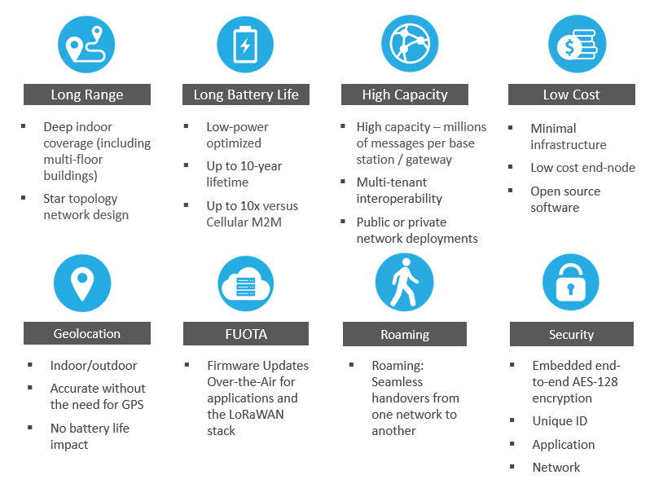
Figure 1. Long Range (LoRa) data link capabilities.

Sigfox 0G Technology is another low power wide area network (LPWAN) “dedicated to Massive IoT. It is designed to connect devices securely at low cost in the most energy-efficient way”[24]. The OG technology boasts “autonomy with extremely low-energy consumption, allowing years of battery life; Simplicity, with no configuration, connection request or signalling, so the device is up and running in minutes; Cost efficiency, from the hardware to the network, every step is optimised to be as cost-effective as possible; Small messages, no large assets or media allowed on the network, only small notifications, up to 12 bytes; Complementarity, Sigfox 0G technology can be used together with any other type of network, e.g.: Wi-Fi, Bluetooth, GPRS, NB-IoT, LoRaWAN.”
An alternative would be Zigbee [25] which provides all the same capabilities, which has Mesh networking but with opened Standard.

Data Processing
Data processing describes the reception, storage and analysis of the data received. At the simplest level, the data processing simply represents the data, i.e. a graph of hive internal temperatures. A more complex processor would be able to correlate internal hive temperature with external ambient temperature and interpret the humidity index as a measure of hive cooling whilst video recording the amount of activity of the bees to ventilate the hive.

User Interface
The importance of designing a user interface is that it must be suitable for the situation. Many beekeepers wear sting-proof gloves, and when dealing with the hives, it is very easy to get sticky from the honey, wax and propolis, which is not compatible with delicate electronic equipment. “Depending on the IoT application, the user may also be able to perform an action and affect the system.” For example, if the video motion detector at the hive entrance detects frenetic activity from robbing or wasp attack, and sends an alert notification, the user might be able to remotely adjust the size of the hive entrance, making it smaller and easier for the resident colony to defend themselves. Being able to do this remotely, without having to travel to the apiary is time efficient and could make the difference between rescuing a colony or not. The next level would be AI interpretation of the scenario using predictive algorithms and automated closing of the entrance space via predefined rules without involving the beekeeper to make that decision.

2.5 The concept of smart beehives
The core concept of smart beehives is taking 21st-century devices and putting them in a historical craft so that you can reach the efficiency level for optimised bee welfare and produce enough honey for economic success. With technology, and as mentioned above, the different components of IoT devices, you can create a complex system for collecting and processing the data, saving time and money.
There are many smart beehive systems on the market and the following list is a good overview with summary of features [26].
The Bee Corp uses LTE-M-connected sensors that provide data on temperature and hive movement and even stream infrared camera images of the inside of the hive to help estimate colony health and size.
Hivemind uses satellite hubs to send a wide variety of hive data long distance.
Arnia tracks temperature, humidity, hive weight, bee counts, and weather conditions.
The Bee Corp uses LTE-M-connected sensors that provide data on temperature and hive movement and even stream infrared camera images of the inside of the hive to help estimate colony health and size.
HiveGenie measures bee trips, bee counts, hive location, temperature, humidity, CO2, weather, and weight, making it fairly comprehensive.
Broodminder is a fairly inexpensive solution usable via smartphone and Bluetooth.
ModuSense can track bee activity down to knowing what time of day they leave and what time of day they return.
EyesOnHives uses cameras and machine learning to track colony health and provide alerts if it notices anything unusual.
IoBee is working to install hive monitors across Europe in conjunction with governments and partners.

Chapter 3 – Research and Development Methodology

3.1 Research Methodology
The steps that have been taken in this process are as follows:
- Research the background.
- Review what other systems are available on the market.
- Build the prototype connecting the hardware sensors to the software.
- Collect data.
- Analyse results.
- Conclude efficacy, adjust, and make recommendations for future development.

3.1.1 Philosophy
Use of positivist philosophy, deductive approach (testing a theory), using precise and highly specific data and generalising from the sample to the population.
Methods are software development and experiments, using a highly structured approach, collecting qualitative data in large amounts to allow generalisation of the sample size to the population and the researcher is independent of the results.

3.1.2 Approach
Deductive.
This is a practical project where data can be collected and analysed.

3.1.3 Strategies
- Literature review
- Experiment
- Software development
The literature review is necessary to see what information is already known, what problems need to be solved and what other solutions have been proposed.
The Experiment will show whether the equipment can be used to detect the data required.
The software development will enable this to become a system which can be used by beekeepers and is user-friendly. It will also show if the system actually serves a useful purpose in making the beekeeper more efficient and looking after the bees.

3.1.4 Risks & Limitations
External factors which could prevent the project from being a success include:
- The availability of suitable equipment such as sensors (cost, environmental suitability, availability).
- Incompatible software.
- Factors in the beehive which prevent the recording of accurate data.
to prevent this from happening by:
- Careful planning and thorough research.
- Initial pilot experiments with the equipment.
If things do go wrong, it is planned to work around this by beginning with simple measurements which will test the validity of the proposal and then make incremental changes to add complexity as each element is proved.
Limitations on the project:
- Cost and availability of equipment.
- The activities of the bees are seasonal, so some behaviours are limited to specific times of the year.
These will be handled by careful planning and timeline analysis.

3.1 5 Ethical Issues
There are no ethical issues related to this research. The bees will be handled by experienced beekeepers and will not come to any harm.
Potential of physical, mental, or reputational harm to the researcher, any industrial partners, any participants, or to the university: The normal risks of handling bees will be mitigated by careful planning, and supervision from an experienced beekeeping mentor. Full beekeeping protective clothing will be worn when handling the bees.

3.1.6 Validity, Reliability & Generalisability

3.1.6.1 Validity
This is a good way to investigate this problem because research [27] has demonstrated that the use of technology to monitor the bees through a smart beehive is efficient for the beekeeper and improves the care of the bees.

3.1.6.2 Reliability
Once the equipment has been set up, the results should be reproducible by a different researcher. The aim is that the smart equipment can be used by non-technical beekeepers. The IOT element should enable the usability and repeatability.

3.1.6.3 Generalisability
The pathway will be proven with a simple measurement such as the weight of the hive, but other parameters could be added in in due course. Over the course of a year, the bees will exhibit all the different behaviours and the data would reflect these changes over time.
Once proven, the pathway can be applied to other bees in other locations at other times.

3.1.7 Data Evaluation Methods

3.1.7.1 Data Collection
The types of data I will collect are initially measurements of hive movement humidity and temperature.
These require sensors to monitor the hive and feed back to an information hub.
The data will then be analysed and interpreted with my knowledge of beekeeping, assisted by my beekeeping mentor if required.
No survey is required.
The minimum amount of data will depend on the accuracy of the sensors which will be determined in the next stage of the project.
The data from a single hive may be inaccurate so it would be sensible to monitor several hives at the same time. This would exponentially increase the amount of data that could be collected in the timeline of the research project.

3.1.7.2 Data Evaluation
The data will be evaluated by comparing the results from the sensors with visual data from the hives. This is time consuming and may be inaccurate but is the only way at this stage to confirm what the sensors are showing. This may be first order data, ie the motion sensor indicates the hive has been knocked and I can see that hive is moved, or it may be second order data; the temperature and humidity are perfectly maintained, and visual inspection shows a thriving colony. This is qualitative rather than quantitative data and there is no statistical analysis.
The data will be presented by graphical representation of weight and temperature with observational interpretation of the activity of the bees at that time.

3.2 Development Methodology

3.2.1 Software Development Methodology or Other Relevant Major Methodology
The software development used is remote sensors and monitoring using IOT software because this is most suitable for an IOT project.

3.2.2 Any Other Relevant Subsidiary Methodologies
At this point, there are no other methodologies needed for this project.

3.3 Resources and Planning
The resources needed are access to beehives, access to suitable monitoring and measuring equipment, and suitable hardware and software equipment.

3.3.1 Hardware Resources
The hardware required is monitoring equipment: initially weight, humidity and temperature sensors.
This will need to connect through the IOT to a normal PC.
Technical Issues to consider include sensor reliability, connectivity problems and power supply.

3.3.2 Software Resources
Software required is the measuring devices that can function and communicate, and then send the data over the network to storage location or website.

3.3.3 Information Resources
At this point, I do not need any external data to which I don’t have access.

3.3.4 Human Resources
In this research project, the use of human resources is limited to the requirement for an experienced beekeeper mentor who has access to the beehives and will collaborate in the monitoring.

3.3.5 Project Plan
The timeline for the major project is as shown in the chart below.
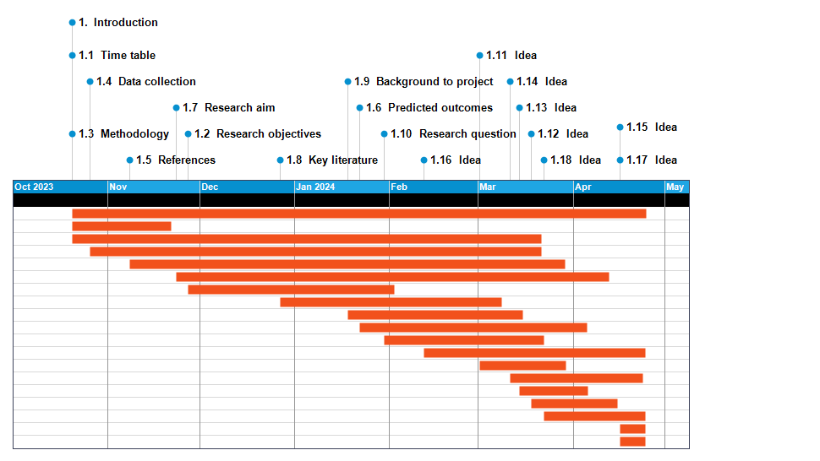

Figure 2. Project timeline.

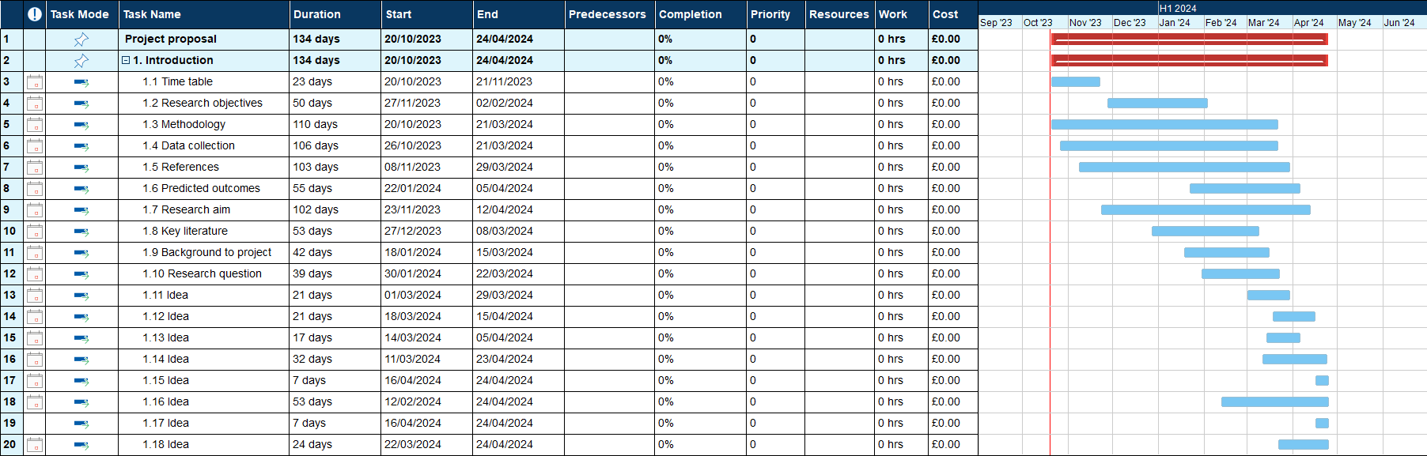

Figure 3. Breakdown of project phases.

The next section in my project will be to read a lot of literature reviews and increase my understanding of the internet of things, smart beehives, and the networking between them. I will start my dissertation and once I have enough knowledge of the equipment, I will need to buy the hardware and the necessary software to connect with it. Once I have built the smart beehive, I will record the successes and difficulties creating the product and then record data to prove the processes and provide enough evidence to achieve my aims and objectives.

Chapter 4 - Design and Implementation
The sensors, connectors and software were purchased from a company called HiveBeat. This is a start-up company which has only recently begun trading although they have been developing their product for some time. Their strapline is “affordable remote beehive monitoring” which indicates the market share that they are pursuing. Most of the smart hive monitors reviewed in the literature are extremely expensive and beyond the resources of most hobby beekeepers and not viable at scale for many commercial bee farmers.
The company was extremely helpful, allowing the purchase of the sensors and controllers at cost before the official launch as ‘early adopters’ and provided real-time support throughout the project.
The short study period restricted the scope of what could be achieved but most the interesting phase is probably the initial set-up and understanding limitations of the various systems. This company has only just started trading and is still in the development phase which enabled discussion with the founder and his technical team. They were very receptive to comments, recognised the issues that were faced and have already incorporated many of the suggestions in their next stage of development.

Results and Discussions

Sensors
The sensors were high quality, robust, custom made and designed to measure humidity, temperature, and hive movement.
They were small enough to slip into the hive easily and designed with careful consideration of the shape of the wooden top bar of the honeycomb frame and the wax comb as shown in Figure 4.
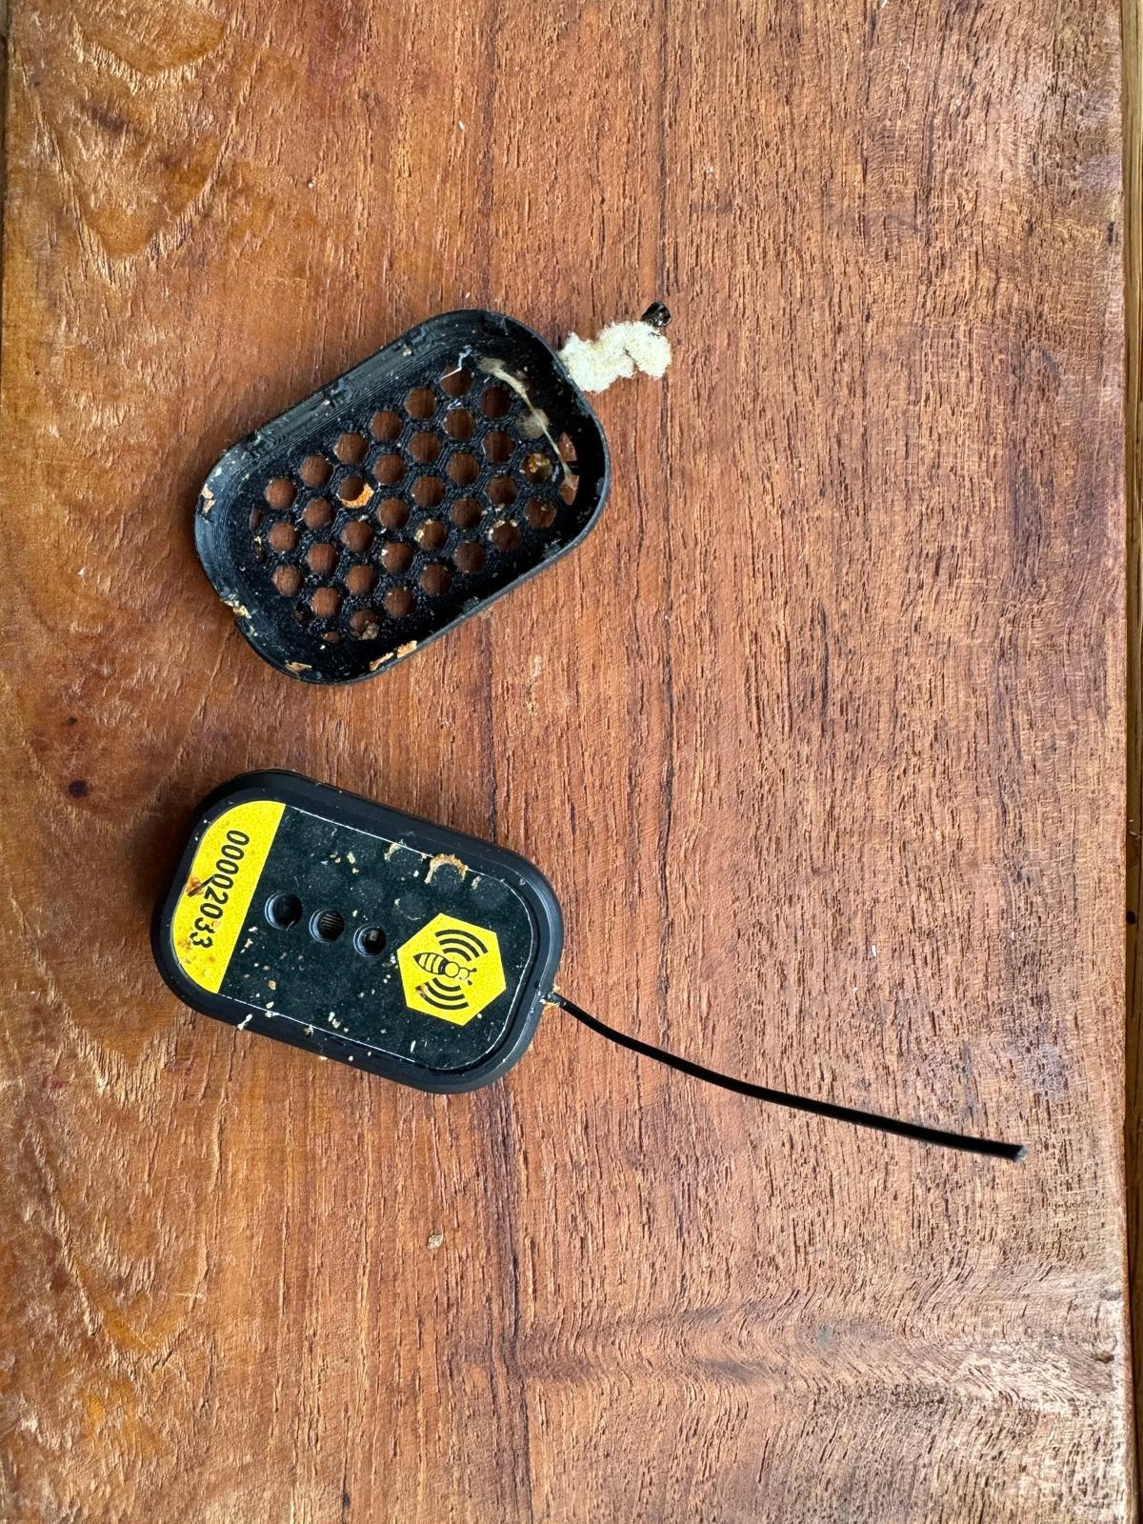

Figure 4. Sensor and plastic guard showing some wax and propolis after removing from the hive.

The sensors came with a plastic cover which clipped on the outside to protect them from wax, propolis and honey. This had a cut-out at one end so that the arial could protrude.
The method of attaching the sensor is designed with a glue strip, and the recommendation was to remove the protective plastic and stick the glue strip onto the top bar of the frame. This would be a single-use method and required the frame to be clean and taken out of the hive to perform this task. Because of the timing of the project, I was putting the sensors in during the winter and did not want to lift out the frame and disturb the cluster of bees as this risked both ‘rolling the bees’, potentially injuring the queen, and chilling the bees during the manipulation. I therefore chose to attach a piece of string to the sensor covers and fix this to a nail in the top bar. This was helpful as did not require me to lift the frame out, allowed me to lower the sensors under control, and made it easy to reposition so that I could move the sensor if the readings indicated that it was not in the centre of the cluster.
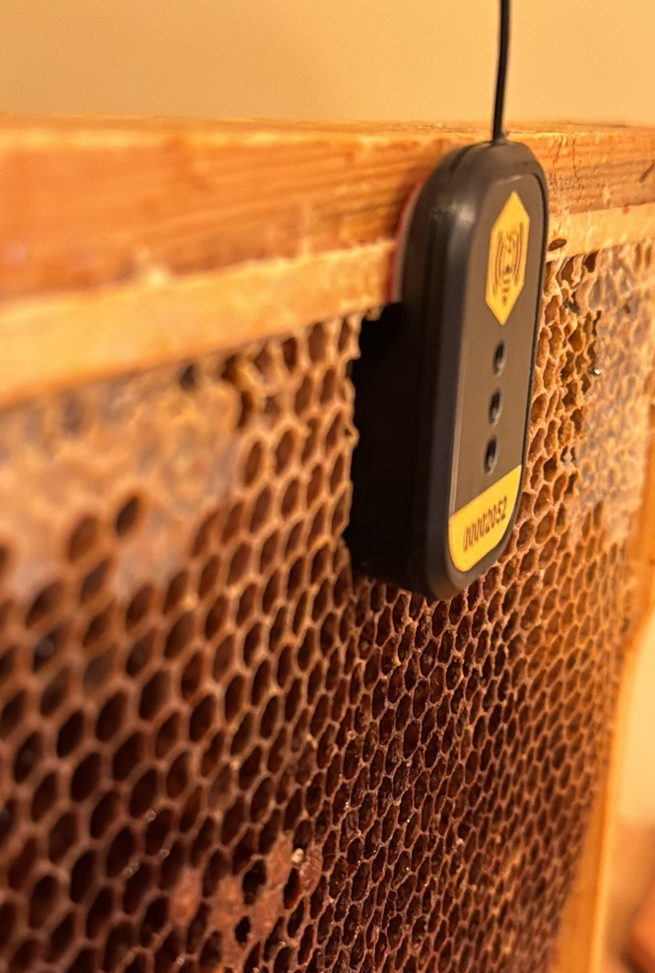

Figure 5. Sensor in position attached to the wooden frame using the glue strip and pressed into the wax of the honeycomb.

Connectivity
The connectivity of the HiveBeat sensors is radio wave at 2.4GZ to the controllers which connect to the secure server by Wi-Fi.
The controller software is downloaded from the HiveBeat website onto a computer. This only runs on a Windows computer.
Each sensor is identified by an 8 digit number and during the set up process each sensor was registered with the name of the hive, location (postcode/latitude & longitude), environment (rural/urban/main forage), experience of the beekeeper, characteristics of the bees (strain, heritage, genetics), management (disease treatment), hive type (Langstroth, British National, other) and a final section of the productivity of the colony.
The sensor connects to the controller with Lower power radio frequency - 2.4Ghz wavelength. This proved to be the most difficult part of the implementation because radio wave technology has a relatively short range and can be blocked by physical obstructions such as trees. The range of radio waves determined by the wireless frequencies which are government controlled and restricted. The primary differences are the range (coverage) and bandwidth (speed) that the bands provide. The 2.4 GHz band provides the most coverage but transmits data at slower speeds. The 5 GHz band provides less coverage but transmits data at faster speeds. This prevents interference with other equipment but requires the controller to be close to the sensor, and the controller had to be within Wi-Fi range and attached to a power source.
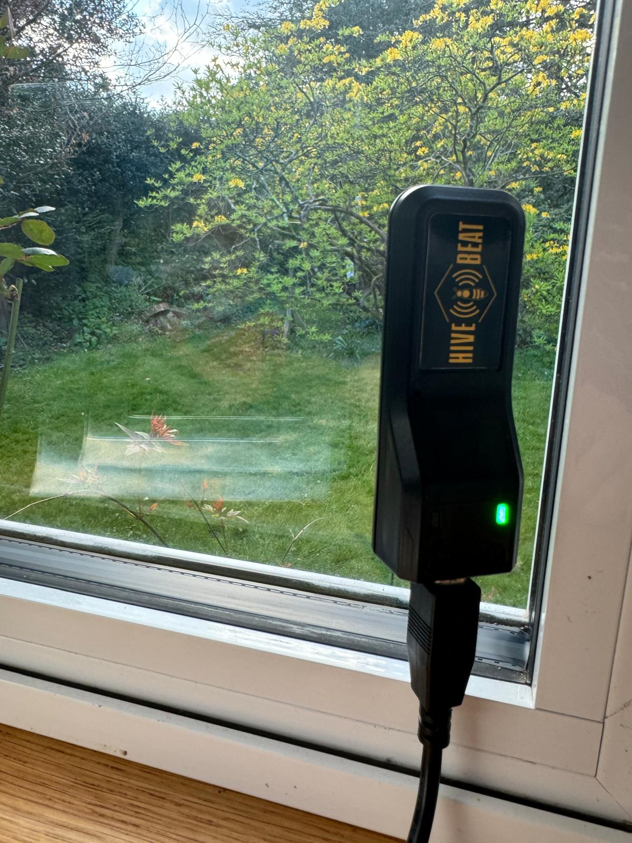

Figure 6. Controller set up with power cable, connected to the home internet and line of sight to the home apiary.

Data Processing
The data received from the sensors was sent directly from the controller and then to the HiveBeat server. This ensured that the system was secure, and the information was encrypted. I was then able to log into the HiveBeat website and see the data from our controllers and their paired sensors.
The data was presented graphically and in near real-time so we could see if there were any changes within the hives.
The alerts feature was excellent, allowing a quick response if for example the hive was knocked over, or a sudden drop in temperature might indicate that the lid had been blown off. This feature could literally save the colony.

User interface
The graphical data had a number of pre-set options:
The time data could be shown for 10 or 30 minutes, 1, 6, 24 hours, 3 days, or all time.
The chart types were scatter or lines.
Data resolution was low-high or all points, with data being sent from the sensor every 30 minutes.
The screen shot below illustrates these options.
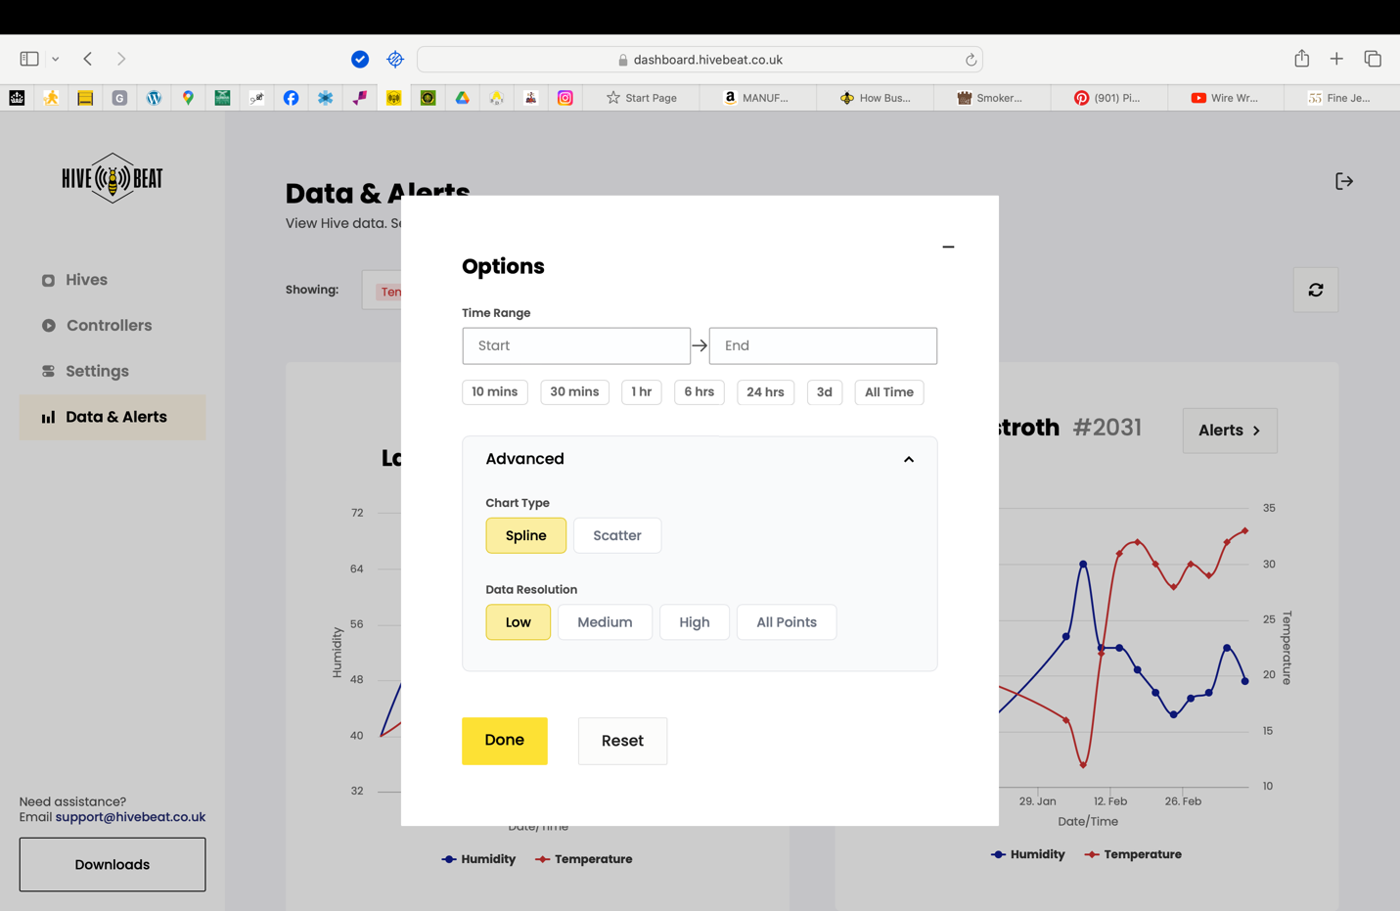

Figure 7. Website interface showing options for graphical representation of data.

The time frames were only available for selected pre-set. At times it would have been useful to have, for example, 2 weeks because 3 days did not give enough data to see the trend, but all points showed when the tags were being set up a month before we received them, followed by a lengthy period of no transmissions and then the data we wanted was compressed. It would be helpful if it was possible to set the time frame in terms of both the length of the period and the start date of the data represented.

The two different chart types were useful when looking at the trends and the full data on scatter. For example, one of the hives was a small ‘nucleus colony’ which was able to maintain an almost perfect temperature and humidity with very small fluctuations (Figure 7). The lines were useful when looking at consolidated data over longer periods of time.
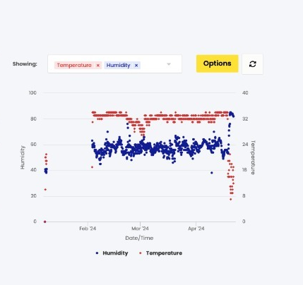

Figure 8. This data shows that the small nucleus colony in a small box was able to maintain a very steady internal hive temperature and humidity.

Other hives showed more variability, and this may have been related to genuine fluctuations in the temperature of cluster, the tag being misplaced outside the cluster, or the tag slipping which happened in a few hives.
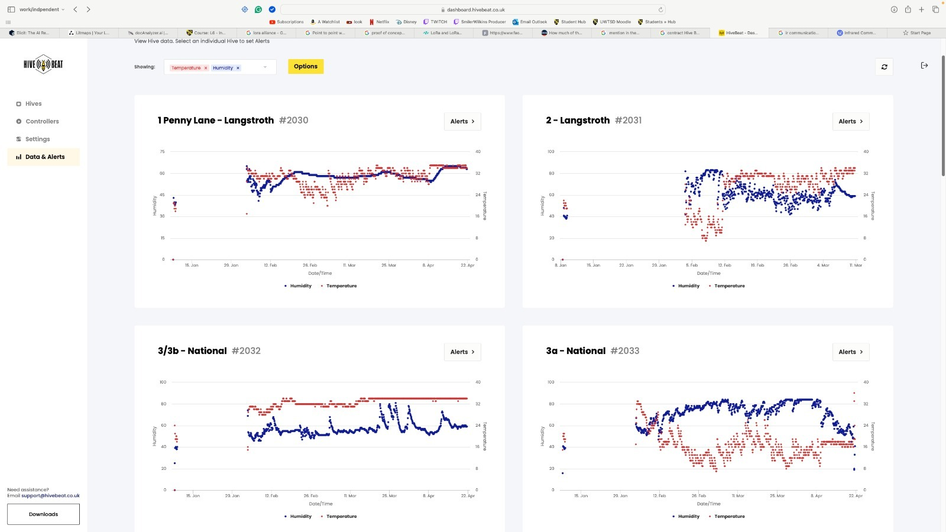

Figure 9. Variable data showing the diurnal variation in temperature reflecting the ambient temperature changes.

The alert feature, set for significant changes in temperature would therefore alert the beekeeper that the tag had slipped, or that the temperature had genuinely fallen because the bees were unable to maintain the temperature. This could happen in the winter because they had insufficient stores, because a woodpecker had made a hole in the hive through which cold air was entering, or in the summer, if the hive was overheating because it was in direct sunlight, or the bees did not have access to water to provide evaporative cooling, or because the beekeeper had left the entrance shut by mistake and the bees were ‘cooking’ inside the hive.
As previously discussed, the alert feature could make the difference between a colony surviving or not and provides reassurance for the beekeeper at a distance, without having to disturb the bees.

Chapter 5 – Analysis Practical application and deployment

Sensors
The sensors were very good at collecting the data and reliably recorded a data point every 30 minutes.
They were small, easily placed in the hive, noting the adaptation to use string rather than single-use glue strip.
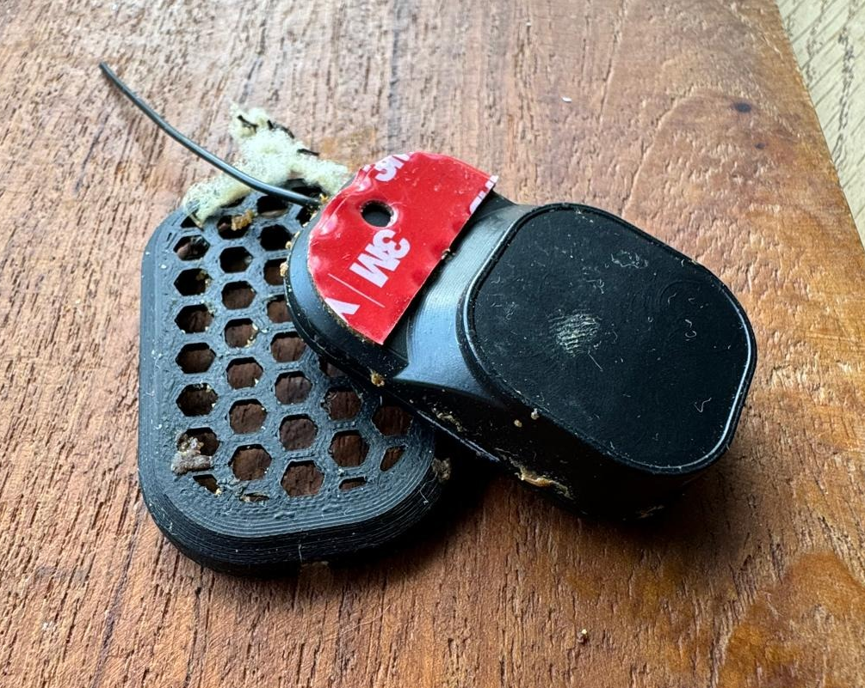

Figure 10. Sensor showing shape and glue strip (with removable glue-strip protection still in place).

The arial was at the top of the sensor and therefore stuck up above the level of the top bar. If the roof was place on top of this, there was no space for the arial, and it bent horizontally. The use of string to lower it further into the hive prevented damage to the arial.
The cut-out at one end of the plastic cover had to be positioned the right way up so that the arial could protrude, if placed the wrong way up, the end without a cut out could damage the arial.
The bees will always build comb around objects in the hive, and they modified the wax in the frame around the sensors. This helped to hold the sensors in position.
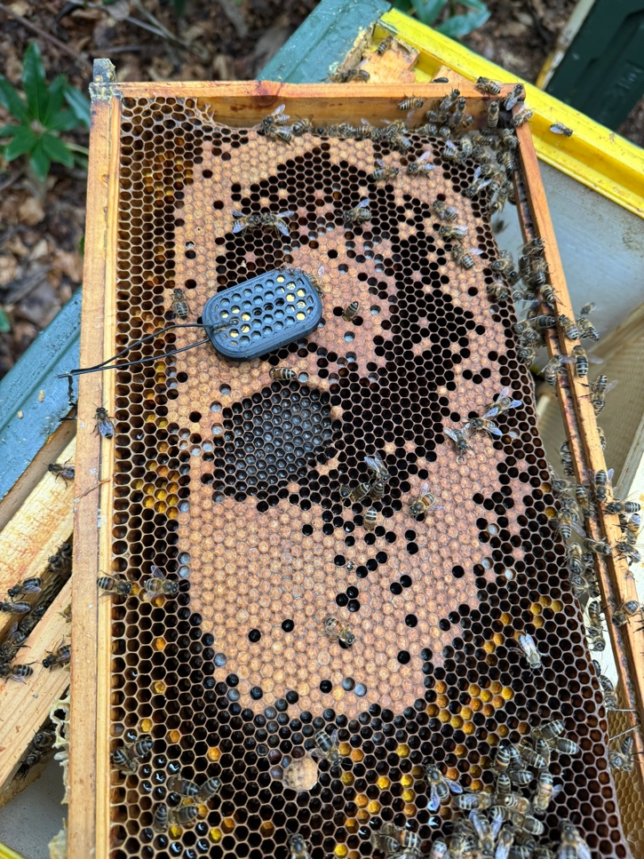

Figure 11. Sensor position in the hive (moved to the side) showing how the bees have modified the honeycomb around it.

During the initial set up the controllers ping every 30 seconds for 30 minutes. This is an excellent feature as it ensures that you have put the sensor in the correct position, and it is activated. However, this can only be used once and not repeated, the information provided with the kit explains this and tells you to have the computer available during the set-up process.
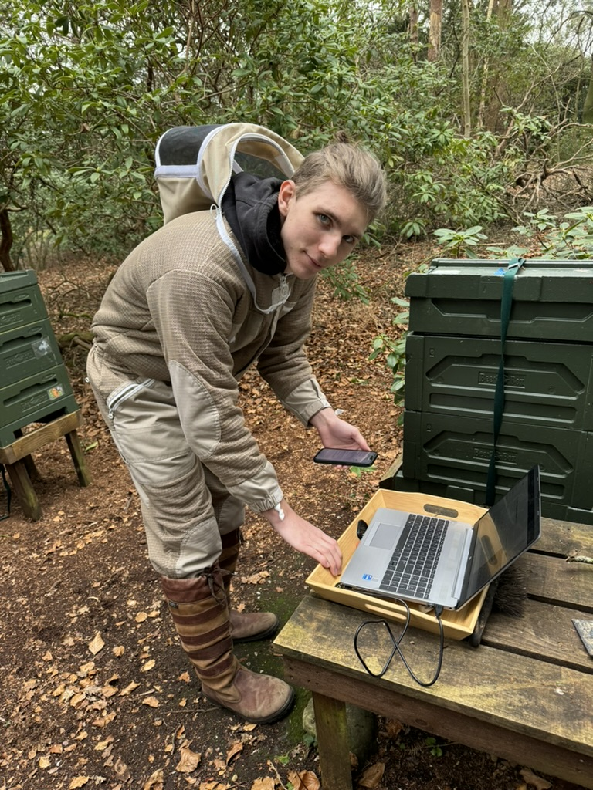

Figure 12. Sensor set up at the out apiary with controller attached to power source and laptop attached to Wi-Fi by phone hot spot.

This worked perfectly in the home apiary which is only 20m from the house where the controller was connected to the power source and the internet.
Because the out-apiary was out of Wi-Fi range, this meant taking the computer to the apiary and hot-spotting to a phone. After I had activated the tags, I realised that this was not connecting, but I had set it off and only had the 30 minutes of regular transmission. With hind sight, I should have activated just one controller at a time so that I did not make this mistake for the rest of the tags.

Connectivity
The connectivity of the HiveBeat sensors is currently Radio Frequency with Wi-Fi based controller connection.
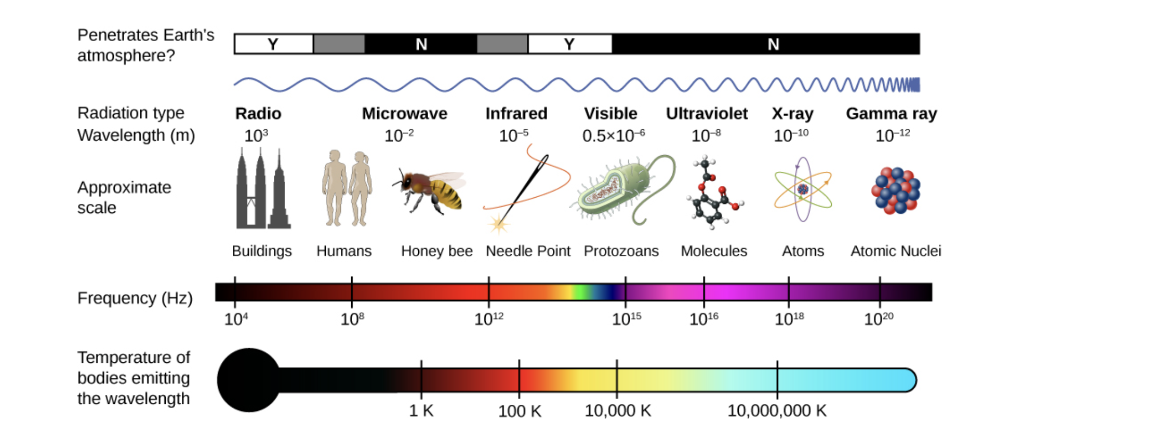

Figure 12. The electromagnetic spectrum, showing the major categories of electromagnetic waves.

The radio frequency range is too short to be able to monitor hives at a distance but was useful to remotely monitor the close hives in the home apiary. This requires the controller to be close to the sensor, but the controller had to be within Wi-Fi range and attached to a power source. During the set up for the out apiary (in our next-door neighbours’ garden) I tried all options to increase the range, using a 4m power cable, using a Wi-Fi extender in the garage and mounting the controller on a 6ft pole. Unfortunately, the line-of-sight for low frequency radio waves is easily obstructed by vegetation and the neighbour’s garden has a wooded area and other vegetation. There was intermittent contact with two of the sensors but no reliable data transmission, so efforts were concentrated on the home apiary and the other out apiary tags were removed at the next inspection.

The HiveBeat website suggests the ranges are local WI-FI within a 100m range for HiveBeat Hobby, or 1000m range for HiveBeat Professional. Realistically, few beekeepers have apiaries within 100m of their power/Wi-Fi range and remote sensors are most useful when they are able to monitor remote hives.
The controller software is downloaded from the HiveBeat website onto a computer. This only runs on a Windows computer. I have a Mac computer so had to access a Windows computer for the set-up, this was an added complication.

Data Processing
The data received from the sensors was sent directly from the controller and then to the HiveBeat server. This ensured that the system was secure, and the information was encrypted. I was then able to log into the HiveBeat website and see the data from our controllers.
The data was presented graphically and in near real-time so we could see if there were any changes with the hives.
The alerts feature was excellent, allowing a quick response if for example the hive was knocked over, or a sudden drop in temperature might indicate that the lid had been blown off. This feature could literally save the colony.

User interface
During the initial set-up of controllers and tags on the website there were some problems with importing the data for each hive which I had to type in multiple times. This is an understandable glitch in early development and a member of the team helped and got a support engineer. This is to be expected during Beta testing for the company and as an experienced beekeeper I am hopefully able to give them good feedback.
The graphical data had pre-set options. The chart types were scatter or lines and these were useful for assessing trends or looking at specific data points. The obvious flaw in lines on graphs is when they join unrelated data, for example indicating that the humidity was gradually rising when we set the system up. The reality was that we had taken the sensor from one environment to another, so it was a completely different environment, not a gradual change which the graph appears to illustrate.
As above, the time frames were only available for selected pre-set ranges, and it would have been useful to be able to customise the ranges when looking at different aspects. For example, seeing how the hives coped with a particularly cold week or measuring over a 6-week period but excluding the data from before we received them.
The other modification required is to be able to fix the data range to allow comparison of hives.
Figure 13 below shows two hives side by side who look to be performing roughly the same in terms of the amplitude of the temperature and humidity variation. When you look closely at the temperature data (red line) you can see that Hive 6 – Langstroth Nuc is generally fluctuating by less than 2ºC, maintaining between 32ºC and 34ºC with a drop to just 26ºC. Hive 5 - Langstroth is fluctuating by 24ºC, varying from 11ºC to 35ºC in the day time. This is drastically different and either indicates that the sensor is not in the middle of the cluster, or, that they are not managing to maintain the 35º C because they either have insufficient stores to fuel heat generation or do not have brood to keep this warm, which might indicate the queen is absent or failing. All of this is information that the beekeeper needs to know and interpret. The current data management optimises the graphical representation so that it fills the graph on the screen, but this is misleading and makes it more difficult to compare how the hives are performing which is essential to see if one hive is struggling and might require an intervention.
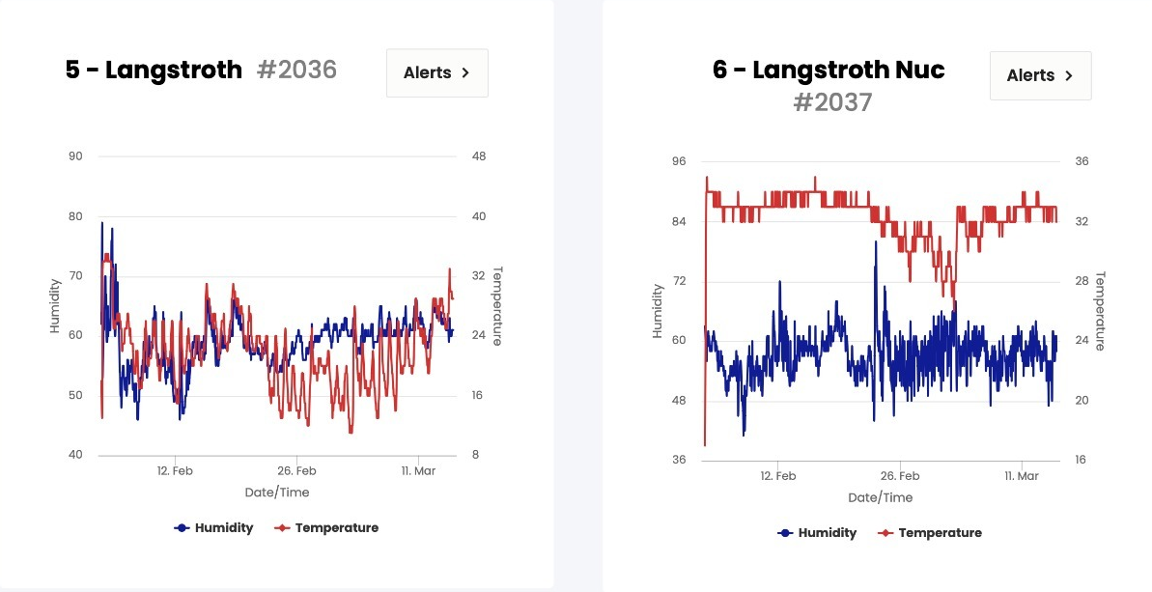

Figure 13. Data from 2 hives which superficially looks similar because the graphs optimise the data representation.

Chapter 6 – Evaluation
HiveBeat are a fledgling company who have created a product to support the management of bees and the work of the beekeeper. Beekeepers need all the resources available to them to optimise their activities for the benefit of the bees and their business. Whilst honey is a saleable commodity, the profit margins have been eroded by cheap imported honey which is not subject to EU regulations and is often adulterated with sugar syrups.
Overall, the Hivebeat sensors performed well regarding the measurement of humidity and temperature allowing monitoring and insight into the performance of the hive. The main disadvantage of this study was the distance between the tags and controllers which greatly limit their practicality. Also, there were restricted manual optimisations and controls for the graphs on the website.

Chapter 7 - Conclusions and Recommendations

Conclusions
The aim of the study was to evaluate a system to record parameters within a beehive – a ‘smart beehive’.
During this process I have learnt about software integration through IOT to hardware sensors.
The objectives were to research the use of remote monitors, hardware, and software integration, install and set up the software integration and hardware sensors, trial the equipment and record data.
This project has demonstrated that smart hives provide a step-change in the ability of the beekeeper to monitor hives at a distance and increase efficiency.
The key learning points have been:
The hardware equipment must be reliable and able to perform the task.
The more features within the hardware, connectivity, and data, the more the complexity of the system and the higher the cost. This system was designed to be affordable but there is always a trade-off with functionality.

Recommendations.

Sensors
The glue strip fixation method has been discussed above from our experience, a system that allows them to be attached to the top bar and lowered between the frames would be preferable. This could be a simple as a plastic strip with a flange that hooks over the frame. This could have a keyhole cut out which would then slip over a nail hammered into the top bar of the frame. For most beekeepers this would be within normal practice as the frames are held together with panel pins, but there are few beekeepers who use plastic foundation which would presumably be harder to nail into. Realistically, a flanged strip would be quickly propolised by the bees and held securely in place. As discussed, this would also protect the ariel if it was slightly deeper in the hive and not bent by the roof above it. Apparently one of the previous prototypes had the arial along the side of the sensor, rather than protruding, but this reduced the range.
The sensors measured humidity, temperature, and hive movement. As discussed in the research section of this project, there are many other parameters which could be measured, in particular, vibrations (including sound) although this would require AI level interpretation. This is a good use for machine learning in AI. Hive entrance sensors with insect recognition AI would be very useful for spotting pests such as the Asian Hornet. The spread of the non-native Asian Hornet throughout Europe in the last few years has had a serious impact on beekeepers in France and the UK National Bee Unit and British Beekeeping Association are recognise that 2024 is a critical year for British wildlife. There have been 13 Asian Hornets detected in the UK since 2016 but last year there were 72 nests found in 56 locations. There are two teams looking at AI recognition of Asian Hornets at bait stations, Exeter University VespAI [28]and HornetAI from Pollenize [29]. Once this technology is perfected it would be ideal for hive entrance recording for all beekeepers.
The size was small enough not interfere with the colony but not too small to be able to manipulate wearing beekeeping gloves.
The cut-out for the arial at one end plastic cover for the sensors has been mentioned as a risk for damaging the arial if placed the wrong way. It would be very simple to have a cut-out at both ends which would eliminate this risk.

Connectivity
A remote sensor needs to be able to monitor at a distance. This realistically requires it to have an integral power source, which can be recharged easily.
The connectivity should be cellular rather than Wi-Fi. Wi-Fi was the limiting factor on this hardware as it was impossible to provide a source close enough to the apiary, even using Wi-Fi extenders.
The range for the HiveBeat hobby sensors that I was using is only 100m and as discussed, few beekeepers have apiaries within 100m of their power/Wi-Fi range. Realistically hobby beekeepers, who are keeping bees in ends of gardens or fields need a greater connectivity than a bee farmer who might have access to these resources in premises close to their larger apiaries. SIM based technology with integral power source is essential for this task and I believe this is what is available in the HiveBeat Professional sensors which are advertised as having a 1000m range. These are not released yet so it is not clear whether they will meet the brief of ‘affordable hive monitoring’.

Data Processing
The radio wave data from the sensors is received by the controller and transmitted to the HiveBeat server by Wi-Fi. The information is encrypted, and I used 2 factor authentication to log into the HiveBeat website and see the data form my controllers. HiveBeat takes the cybersecurity of the data very seriously and is developing 3 factor authentication for their platform which will be used in the future. The cyber security of the actual hive data may not appear to be a pressing issue, but this could provide a portal for cyber-attack on the end user or indicating the activities of the beekeeper which could make them vulnerable to phishing attacks. Data breaches could compromise the physical security of the beekeeping enterprise, for example, indicating where the hives are placed could result in theft.

User interface
The controller software only runs on a Windows computer, and it would be helpful if it was available for Apple Mac iOS too. It would be helpful to be browser based and used on a smart phone or iPad, not just a computer.
In the initial set up there are drop-down menus for strain of bee. There was not a category to match most of mine which are 'locally adapted hybrids'. With the hive types there was only Langstroth and National but not Langstroth Nuc and National Nuc (a nucleus is a small version of these hives). Although there was a section for hive insulation, i.e. adding extra insulation in the winter, there was no differentiation between polystyrene and wooden hives which affects the thermal properties all year.
There is only one option for feeding, which needs two or more boxes as they might be given syrup in the autumn and Bakers Fondant in the late winter. This has been fed back to the company.
As discussed in the results section, the time frames were only available for selected pre-set ranges, and it would have been useful to be able to customise the ranges when looking at different aspects. For example, seeing how the hives coped with a particularly cold week or measuring over a 6-week period but excluding the data from before we received them.
The other modification required is to be able to fix the data range to allow easy comparison of hives as discussed in the results section. There are so many variables in living systems within the natural environment, so comparison of relative performance is the best metric.

Chapter 8 – Reflection
This has been a really interesting project to conduct, I have learnt a lot and gained new skills and it has been more interesting because I was able to research a topic that interests me. I believe that being a beekeeper for 10+ years has given me a great insight and appreciation for this project.
Although there are quite a lot of smart beehive sensors on the market there are not many which are affordable for hobby beekeepers. My family part-funded the purchase of the HiveBeat system so that I could complete this research project, but it was a considerable cost for me.
The HiveBeat system is not yet in production and unsurprisingly had some issues, with the radio wave technology of the sensors limiting distance as the main problem. However smart hives is an interesting area of research as bees are an essential element of the world ecosystem and facing difficulties with climate change and the impact of modern practices such as monoculture and the use of pesticides.
The use of smart monitoring and being able to rapidly respond to situations aids the management of the bees and improves efficiency. I have learnt about the practical application of the Internet of Things and how broad this application can be, IoT is useful in so many situations.
Doing this project has made me realise how much of the world is connected, beyond the obvious connections that we see. It has also made me realise the complexity of technology, how easily it can fail because of power supply, Wi-Fi access, trees in the way, aerials that can break and be bent by lids placed carelessly. Technical design of physical equipment is extremely difficult, and the developer has to be aware of all the variations (different type of hives) and environment (trees in the 100m between sensor and controller) otherwise the end user will not be satisfied with their product. This is why R&D costs so much, long before anything going into production. I am not sure that most people realise this amount of work when they buy the next level of gadget.
This dissertation was the longest and most detailed report I have done. It has been very helpful to have the structure as a framework for my gradual completion of the project. I had not previously done any methodology and resource planning and this structure helped me to organise my thoughts and learn from the process. I believe that I have chosen reasonable aims and objectives. I have relied on dictation software and a scribe to organise and produce the written work and would like to acknowledge this support from Clare Rees, University of Wales Learning Support Specialist and my beekeeping mentor and scribe, Dr Ali Everest.

Chapter 9 – References

[1] | H. Ritchie, “How much of the world’s food production is dependent on pollinators?,” Our World in Data, 2021. [Online]. Available: https://ourworldindata.org/pollinator-dependence#article-citation. [Accessed 14 January 2024].
[2] | Food and Agriculture Organization of the United Nations, “Why bees matter: the importance of bees and other pollinators for food and agriculture,” 2018. [Online]. Available: https://www.fao.org/3/i9527en/i9527en.pdf. [Accessed 15 January 2024].
[3] | Ibis World, “Beekeeping in the US - Employment Statistics 2005–2029,” 2024. [Online]. Available: https://www.ibisworld.com/industry-statistics/employment/beekeeping-united-states/. [Accessed 16 January 2024].
[4] | preliminary-results-from-the-bee-informed, “[4] https://beeinformed.org/2023/06/22/united-states-honey-bee-colony-losses-2022-23-preliminary-results-from-the-bee-informed-partnership/”.
[5] | T. [10] Sledevič, “ [10] Sledevič, Tomyslav and Darius Plonis. “Toward Bee Behavioral Pattern Recognition on Hive Entrance using YOLOv8.” 2023 IEEE 10th Jubilee Workshop on Advances in Information, Electronic and Electrical Engineering (AIEEE) (2023): 1-4.”.
[6] | P. e. a. [11] Siefert, “ [11] Siefert, Paul et al. “Honey bee behaviours within the hive: Insights from long-term video analysis.” PLoS ONE 16 (2021): n. pag.”.
[7] | Imoize, “ [1c] Imoize, Agbotiname Lucky et al. “Development of a Low-Cost Wireless Bee-Hive Temperature and Sound Monitoring System.” Indonesian Journal of Electrical Engineering and Informatics 8 (2020): 476-485.c”.
[8] | Oskin, “ [5a] Oskin, Sergei et al. “Automatic Temperature Control System for a Bee Hive.” (2019).”.
[9] | Meikle, “ [4.5] Meikle, William G. et al. “Honey bee colonies maintain CO2 and temperature regimes in spite of change in hive ventilation characteristics.” Apidologie 53 (2022): n. pag.”.
[10] | Meikle, “ [3] Meikle, William G. et al. “Using within-day hive weight changes to measure environmental effects on honey bee colonies.” PLoS ONE 13 (2018): n. pag.”.
[11] | G. e. a. Voudiotis, “ [6] Voudiotis, George et al. “Proposed Smart Monitoring System for the Detection of Bee Swarming.” Inventions (2021): n. pag.”.
[12] | Mahamud, “ [1a] Mahamud, Md. Sadad et al. “Mouchak - An IoT Basted Smart Beekeeping System Using MQTT.” 2019 4th International Conference on Robotics and Automation Engineering (ICRAE) (2019): 84-88.”.
[13] | Zabasta, “ [1b] Zabasta, Anatolijs et al. “IoT Approach Application for Development of Autonomous Beekeeping System.” 2019 International Conference in Engineering Applications (ICEA) (2019): 1-6.”.
[14] | Cecchi, “[2] Cecchi, Stefania et al. “A Smart Sensor-Based Measurement System for Advanced Bee Hive Monitoring †.” Sensors (Basel, Switzerland) 20 (2020): n. pag.”.
[15] | Cecchi, “[4] Cecchi, Stefania et al. “Multi-sensor platform for real time measurements of honey bee hive parameters.” IOP Conference Series: Earth and Environmental Science 275 (2019): n. pag.”.
[16] | Braga, “[1] Braga, Antonio Rafael et al. “A method for mining combined data from in-hive sensors, weather and apiary inspections to forecast the health status of honey bee colonies.” Comput. Electron. Agric. 169 (2020): 105161.”.
[17] | Tashakkori, “Tashakkori, Rahman Mitchel et al. “Analyses of Audio and Video Recordings for Detecting a Honey Bee Hive Robbery.” 2020 SoutheastCon (2020): 1-6.”.
[18] | Braga, “Braga, Diogo et al. “An Intelligent Monitoring System for Assessing Bee Hive Health.” IEEE Access9 (2021): 89009-89019.”.
[19] | Var-Gor, “[x] “Detection of Varroa mites from honey bee hives by smart technology Var-Gor: a hive monitoring and image processing device.” TURKISH JOURNAL OF VETERINARY AND ANIMAL SCIENCES(2021): n. pag.”.
[20] | Susanto, “[5] Susanto, Ferry et al. “Addressing RFID Misreadings to Better Infer Bee Hive Activity.” IEEE”.
[21] | “nationalbeeunit.com.beebase,” [Online]. Available: https://www.nationalbeeunit.com/diseases-and-pests/. [Accessed 22 12 2023].
[22] | “www.leverege.com,” [Online]. Available: https://www.leverege.com/iot-ebook/how-iot-systems-work#:~:text=However%2C%20all%20complete%20IoT%20systems,processing%2C%20and%20a%20user%20interface.. [Accessed 22 12 2023].
[23] | https://lora-developers.semtech.com/documentation/tech-papers-and-guides/lora-and-lorawan/#:~:text=LoRa%20Modulation%20Characteristics&text=There%20are%20eight%20500%20kHz, “https://lora-developers.semtech.com/documentation/tech-papers-and-guides/lora-and-lorawan/#:~:text=LoRa%20Modulation%20Characteristics&text=There%20are%20eight%20500%20kHz,kHz%20uplink%20and%20downlink%20channels.,” [Online]. Available: https://lora-developers.semtech.com/documentation/tech-papers-and-guides/lora-and-lorawan/#:~:text=LoRa%20Modulation%20Characteristics&text=There%20are%20eight%20500%20kHz,kHz%20uplink%20and%20downlink%20channels..
[24] | https://www.sigfox.com. [Online].
[25] | a. https://www.techtarget.com/iotagenda/definition/ZigBee#:~:text=Zigbee%20is%20a%20standards%2Dbased. [Online].
[26] | A. W. Y. N. t. K. A. t. I. o. B. [. M. 1. 2. h.-o.-b. Braun, “Braun, Andrew. What You Need to Know About the Internet of Bees. [Online]. March 16, 2020. https://www.iottechtrends.com/internet-of-bees/,” [Online]. Available: Braun, Andrew. What You Need to Know About the Internet of Bees. [Online]. March 16, 2020. https://www.iottechtrends.com/internet-of-bees/.
[27] | Shaout, “[1.1] Shaout, Adnan K. and Nathan Schmidt. “Bee Hive Monitor.” 2019 International Arab Conference on Information Technology (ACIT) (2019): 52-57.”.
[28] | T. C. A. O. J. e. a. V. a. d. l.-b. s. f. t. d. o. i. h. C. B. 7. 3. (. h.-0.-0.-z. O’Shea-Wheller. [Online].
[29] | P. H. A. t. https://www.pollenize.org.uk/hornet-ai. [Online].
[30] | T. Sledevič, “ [10] Sledevič, Tomyslav and Darius Plonis. “Toward Bee Behavioral Pattern Recognition on Hive Entrance using YOLOv8.” 2023 IEEE 10th Jubilee Workshop on Advances in Information, Electronic and Electrical Engineering (AIEEE) (2023): 1-4.”.
[31] | P. e. a. ] Siefert, “ [11] Siefert, Paul et al. “Honey bee behaviours within the hive: Insights from long-term video analysis.” PLoS ONE 16 (2021): n. pag.”.

