Security Analysis Report
Steel Form Manufacturing



Prepared by:
Fatema Bandali -Student ID 2514792

Table of Contents

- Introduction ---------------------------------------------------------------------- Page No.

- Task -----------------------------------------------------------------------------------

2.1 Identification of Modern Threats ---------------------------------------------

2.2 Modern Security Policies ------------------------------------------------------

2.3 Technical Mitigation Measures ------------------------------------------------

2.4 Proactive Monitoring and Incident Response -------------------------------

2.5 Continuous Training and Awareness ------------------------------------------

- Conclusion ---------------------------------------------------------------------------

References ------------------------------------------------------------------------------------

Appendix (Presentation Slides) ------------- --------------------------------------------

- Introduction

Cybersecurity faces many challenges such as AI powered attacks ransomware and human errors. Artificial intelligence automates attacks and develops malware and phishing emails. Ransomware is a software that a company encrypts making is unusable until a ransom is paid. Phishing emails and texts are there to deceive the user to use sensitive passwords or financial information. Human errors when a company has no skilled professionals to deal with these challenges too(Hussain et al. 2020)

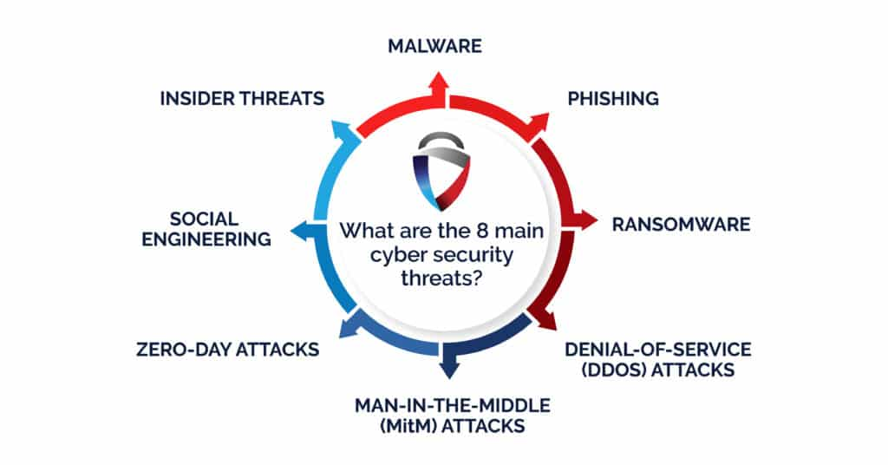

Figure 1. Security Challenges in Computers [1]

Ensure recommendations are grounded in specific standards like NIST CSF and the CISA Known Exploited Vulnerabilities catalogue.

  - Identification of Modern Threats

Identifying Modern Cybersecurity Threats

External Threats

Ransomware-as-a-Service (RaaS)
Ransomware-as-a-Service (RaaS) is a business model where cybercriminal groups create ransomware and lease it to affiliates for a share of the ransom payments. This model makes it easier for people to engage in cybercrime, resulting in a significant rise in ransomware attacks against businesses, healthcare providers, educational institutions, and government agencies. Modern ransomware attacks often involve double or triple extortion. Attackers not only encrypt data but also steal sensitive information and threaten to publish it unless a ransom is paid. [2]

AI-Powered Social Engineering (Vishing)
Artificial intelligence has greatly improved social engineering attacks, especially voice phishing (vishing). Attackers use AI voice cloning, natural language processing, and automated conversation systems to impersonate trusted figures like executives, IT support, or financial institutions. These convincing attacks make it more likely that victims will reveal sensitive information, approve fraudulent transactions, or grant unauthorized access to systems.

Supply Chain Compromises
Supply chain attacks focus on trusted third-party vendors, software providers, or service partners to indirectly access an organization’s systems. By compromising software updates, cloud services, or vendor credentials, attackers can infiltrate multiple organizations at once. As businesses increasingly rely on connected digital systems, supply chain security has become a crucial part of managing cyber risks.

Internal Threats

Insider Threats
Insider threats come from employees, contractors, or business partners who intentionally or unintentionally compromise an organization's security. Malicious insiders might steal confidential information or sabotage systems. Negligent users may leak sensitive data due to poor security practices, weak passwords, phishing attacks, or accidental data sharing.

Cloud Adoption Risks
As organizations shift workloads to the cloud, new security challenges arise. Common risks include misconfigured cloud storage, insecure APIs, too many user permissions, poor identity and access management, and limited visibility into cloud resources. Without proper governance and constant monitoring, these weaknesses can put sensitive data and critical business applications at risk.

Hybrid Work Security Risks
Hybrid work models expand the attack surface by allowing employees to access corporate systems from remote locations using personal or unmanaged devices and home networks. This creates added risks like insecure Wi-Fi connections, device theft, credential compromise, and less oversight of endpoint security. Organizations must implement strong security measures.

Clearly identify current and emerging internal and external threats, including Ransomware-as-a-Service (RaaS), AI-powered social engineering (vishing), supply chain compromises, and risks associated with cloud adoption and hybrid work. (You can refer Lecture notes or use google to research on this task. Make sure you cite the text and add the reference in the list of references).

  - Modern Security Policies

Policy Statement
Authentication must be completed for all users, devices, and applications prior to the granting of access to resources within the organization. Access shall be granted using the principle of least privilege. [3]

Controls
Multi-Factor Authentication (MFA) is mandatory for all users.
Permissions shall be granted based on RBAC and users’ job roles.
Privileged accounts shall be maintained separately.
Quarterly access reviews shall be conducted for users.
Account disabling shall take place as soon as employees leave the organization.
Framework Alignment

Zero Trust

Verify explicitly
Least privilege access

NIST CSF

Protect (PR.AA – Identity Management and Access Control)

ISO 27001

Annex A.5 – Identity Management
Annex A.8 – Access Control
CIA Triad

Confidentiality

Protection from access by unauthorized parties.

Integrity

Only authorized parties shall have the ability to alter information.

Availability

Decreases risk of account compromise and disruption of services.

Develop a set of security policies that align with the Zero Trust model and best practices from frameworks like NIST CSF and ISO 27001. Try to discuss if your proposed security policies are clear, relevant, and practical?

- Utilize industry standards such as ISO 27001, NIST, or GDPR compliance guidelines when developing your security policies.
- Engage with frameworks like the CIA Triad (Confidentiality, Integrity, Availability) to assess the implications of your proposed measures.

Are the proposed security policies clear, practical, and explicitly aligned with Zero Trust principles and frameworks like NIST or ISO 27001?

  - Technical Mitigation Measures
- Specific Technical Measures (Essential) Example: Multi-Factor Authentication (MFA): VTAM should enforce phishing-resistant MFA, such as Microsoft Authenticator or FIDO2 security keys, for all remote access, Microsoft 365 accounts, VPN connections, privileged accounts, and cloud services. This reduces the risk of credential theft and phishing attacks, which remain major tactics used by ransomware groups (Microsoft, 2024). Other practical measures include: - Multi-Factor Authentication (MFA) - Endpoint Detection and Response (EDR) - Security Information and Event Management (SIEM) - Cloud Security Posture Management (CSPM) - Email Security Gateway - Data Loss Prevention (DLP) - Network Segmentation - Zero Trust Network Access (ZTNA) - Immutable Backups - Vulnerability Scanning - Patch Management using CISA Known Exploited Vulnerabilities (KEV) - Privileged Access Management (PAM) - Encryption (AES-256, TLS 1.3) - Security Awareness Training.

Other practical measures include: - Multi-Factor Authentication (MFA) - Endpoint Detection and Response (EDR) - Security Information and Event Management (SIEM) - Cloud Security Posture Management (CSPM) - Email Security Gateway - Data Loss Prevention (DLP) - Network Segmentation - Zero Trust Network Access (ZTNA) - Immutable Backups - Vulnerability Scanning - Patch Management using CISA Known Exploited Vulnerabilities (KEV) - Privileged Access Management (PAM) - Encryption (AES-256, TLS 1.3) - Security Awareness Training.

2. Administrative Measures

Administrative Control | Implementation
Security Awareness Training | Quarterly phishing simulations and annual cyber training
Incident Response Plan | Develop playbooks for ransomware, phishing and data breach scenarios
Access Control Policy | Role-Based Access Control (RBAC) and least privilege
Vendor Risk Management | Yearly third-party security assessments
Business Continuity Planning | Annual disaster recovery testing
Asset Inventory | Maintain updated inventory using automated discovery tools

3:Explain Implementation
A SIEM tool, like Microsoft Sentinel or Splunk, should be used to collect log data from Microsoft 365, AzureAD, firewalls, gateway and endpoint. Correlation rules can automate detection of unusual login activity, privilege elevation and lateral movements, allowing a quick response from the security team.

4: Link measures to identify threat

Threat Mitigation
Phishing MFA + Email Filtering + Awareness Training
Ransomware Backup + EDR + Patching
Insider Threat RBAC + DLP + SIEM
Cloud Misconfiguration CSPM
Credential Theft PAM + MFA

5:Are they realistic for VTAM

Microsoft Defender XDR
Microsoft Sentinel
Microsoft Intune
Azure AD Conditional Access
Veeam Immutable Backup
All of the above are commonly used commercially available and implementable by all organizations like VATM.

6:Current Threats

- Ransomware
- Phishing
- Insider threats
- Supply chain attacks
- Social engineering
- AI-Assisted phishing

Proactive Monitoring and Incident Response

- 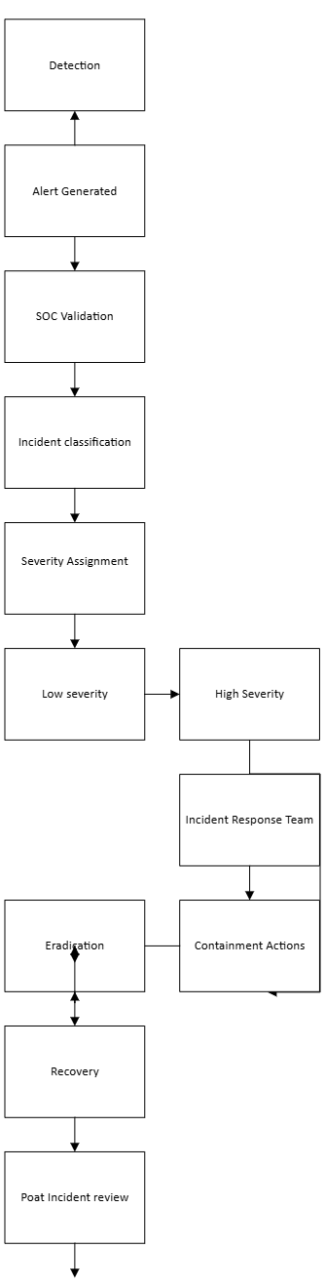

  - Continuous Training and Awareness

The Continuous Security Awareness Program is designed to create a culture of security in which all employees are aware of their responsibilities regarding securing organisational information assets. The program provides consistent, relevant, and engaging training for different roles through phishing and vishing testing, exercises, and performance metrics, instead of waiting for yearly compliance-based training programs.(Manifavas et al. 2014)

- Conclusion

The results clearly show that the use of an effective cybersecurity approach involving the combination of Zero Trust model, continuous monitoring by means of SIEM/SOAR technology, as well as the implementation of continuous security awareness training improves organizational resistance to contemporary cybersecurity risks. It is suggested that organizations implement continuous phishing and vishing testing, role-specific training, automated incident response, as well as regular review of policies based on ISO/IEC 27001 standards and NIST Cybersecurity Framework. Further research will involve the use of artificial intelligence for threat detection, expansion of UEBA analytics, cyber threat intelligence exchange, and regular red team exercises.

Bibliography

[1] | A. a. M. A. a. R. S. {Hussain, {Proceedings of the 3rd international conference on networking, information systems \& security},, 2020}.
[2] | O. Akinsuli, The rise of AI-enhanced Ransomware-as-a-Service (RaaS): A new threat frontier}, 2021.
[3] | B. S. Haney, Applied artificial intelligence in modern warfare and national security policy, HeinOnline, 202.

Annexures/ Appendix (If any)


