Name: Tia Willock

Student Number: 2514120
__________________________________________________________

WORKSHEET 1 – TESTING (Using Variables)

- Original code:
Surname = str (input ("What is your Surname?"))
NatInsuranceNum = str(input ("What is your national insurance number?"))
Age = str(input ("What is your age?"))
workHoursPerWeek = float (input("How many hours do you work per week?"))

print ("You inputted: ",Surname,",",NatInsuranceNum,",",Age,",",workHoursPerWeek)

- Code Testing

For each test below, run your code and enter the values provided. Present a screenshot of the programme running. Did the programme behave correctly or did it do something unexpected, and if so, why?

Surname:
- Enter JONES
- Leave blank
- Enter A
- Enter 123

National Insurance Number:
- Enter PE534121B
- Leave blank
- Enter AB11223344556677 (ie too long for National Insurance number format)
- Enter 22PE4088A (ie wrong format)

Age
- Enter 34
- Enter 150
- Enter -4
- Enter a letter

Number of working hours per week:
- Enter 37.5
- Enter 150
- Enter 0
- Enter -2

Fill in a box for each test above. You should present 16 separate boxes, 1 for each test. (Note: the first two boxes are provided as a template)

Test:
Surname
i. Enter JONES
Screenshot(s) of output:

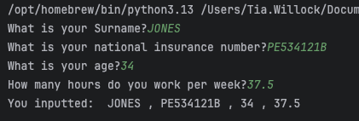
Result: Did the programme behave as expected ie syntactically and logically correct?

Pre Fix Comments
Yes, it asked the user for their input, the user inputted their surname, and it outputted the name without any errors.
However, to improve I would use ‘.capitalize()’ to force the first letter to be capitalised and forces the rest of the word to be lowercase. This makes the format consistent, so that every entry looks the same in the database.

Post Fix Comments:
This was my end solution for this issue. I then tested the code afterward and the test outputted the expected result of Jones.

Test:
Surname
ii Leave blank
Screenshot(s) of output:

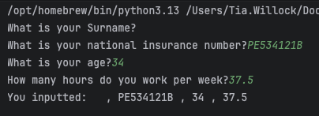

Result: Did the programme behave as expected ie syntactically and logically correct?

Pre Fix Comments
Yes, syntactically the programme behaved as expected, as I didn’t put any validation to stop it from having a blank entry.

However, it is not logically correct, as surname should not be empty. Originally, to fix this I thought about adding a null checker, but if the user input is a string, it can never be null. Even if the user presses enter, it will just be an empty string. So, validating, using a minimum length check would ensure that the surname couldn’t be left blank.

Post Fix Comments
When fixing this, I decided against having a minimum length check, as upon researching, one letter surnames do exist. So, I decided to just do an empty string check and maximum character length check.

I did this via a try-except block which I will explain in section 3. Inside this try-except block, I created an if statement which rejected an empty string and showed the user a personalised message explaining why the input was rejected.

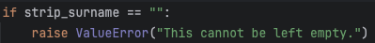

I tested my solution to ensure the ValueError raised was triggered and the validation worked as expected, it didn’t allow an empty string as an input. If the user tried to input an empty string it showed them the ValueError message above.

Test:
Surname
iii. Enter A
Screenshot(s) of output:
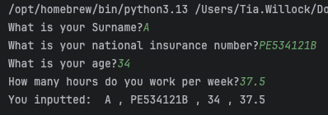
Result: Did the programme behave as expected ie syntactically and logically correct?

Pre Fix Comments
Yes, the programme behaved as expected, as I didn’t put any validation to stop the user inputting a one letter surname. A string was inputted by the user, and the same string was outputted by the programme without any issues. However, to improve I could do a minimum length checker to make sure the surname is valid.

Post Fix Comments
As mentioned in the previous test. I decided not to do a minimum length check due to other cultures having one letter surnames. However, as stated above, I added validation to avoid an empty string.

Once this validation was added, I completed this test again, and it behaved as expected, allowing the one letter surname.

Test:
Surname
iv. Enter 123
Screenshot(s) of output:

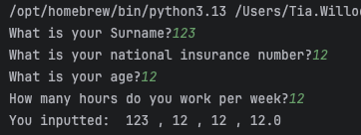

Result: Did the programme behave as expected ie syntactically and logically correct?

Pre Fix Comments
No, I expected it to throw an error. That was a result of my lack of foresight, as I forgot that I could input anything as a string. As I have written that the expected input is a string without validation, using this line won’t make it return a string.

To improve, I would need to add validation to ensure that the surname is in fact a string that does not include numbers.

Post Fix Comments
Upon doing some research, I found the easiest way to do this is through a regular expression (regex). Regex can be used to filter strings to only accept certain characters and throw an error when anything else is inputted.
This was the regex that I included in my code:
“name_regex = re.compile(r"^(?=.*[A-Za-z])[A-Za-z' -]+$")“.

Additionally, at the top of the page, I imported the Regex through “import re”.

Explanation of Regex
This regex scans the string to ensure there is at least one letter within the string which stops people inputting random characters that are not letters or leaving it blank. Within the second set of “ [] “, are the main characters allowed in this string. It allows A-Z in both capitals and lowercase. Furthermore, it allows hyphens and apostrophes to allow for example, Irish surnames and double-barrelled surnames.

What I did
I then used the syntax ‘.match()’ to check if the name inputted matched the regex. If not, the programme would then raise a ‘ValueError’ with a message letting the user know why their input was not accepted.

I originally declared with regex outside of my function as a global variable, but due to the fact it is only used inside the one function, I changed it to be declared inside the validate_surname function.

I then tested the code to make sure the validation was triggered by 123. The programme behaved as expected and outputted the ValueError messaged I inputted, letting the user know what characters they were allowed to use for the input.

Test:
National Insurance
i. Enter PE534121B
Screenshot(s) of output:

Result: Did the programme behave as expected ie syntactically and logically correct?

Yes, the programme behaved as expected. I inputted the string and it outputted the string. It’s syntactically correct and logically correct for this scenario, as the correct format was inputted and then outputted.

Test:
National Insurance
ii. Leaving blank
Screenshot(s) of output:
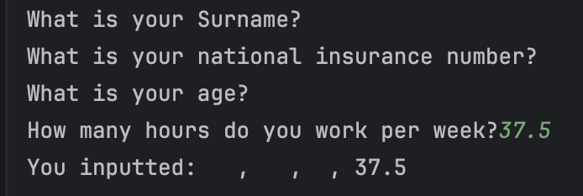
Result: Did the programme behave as expected ie syntactically and logically correct?

Pre Fix Comments
Syntactically, yes, the programme behaved as expected as I didn’t put any empty string or minimum length checkers in to ensure that the national insurance number couldn’t be left blank. Logically, this doesn’t make sense as we want the user to input this information.
To improve this, I would add a null checker to ensure the national insurance number cannot be left blank.

Post Fix Comments
Having done some research, I decided that a null checker was not the correct thing to use here, and the best thing to use was an empty string check, because the result from user input is a string, which means it can never be null. Even if they press enter and don’t input anything, it would just return an empty string.
To test for an empty string, I used the code below.

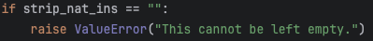

After adding this validation, I checked to see if it was triggered correctly. The programme behaved as expected. It raised the ValueError with this message to let the user know that wasn’t an acceptable input.

Test:
National Insurance
iii. Enter AB11223344556677 (ie too long for National Insurance number format)
Screenshot(s) of output:
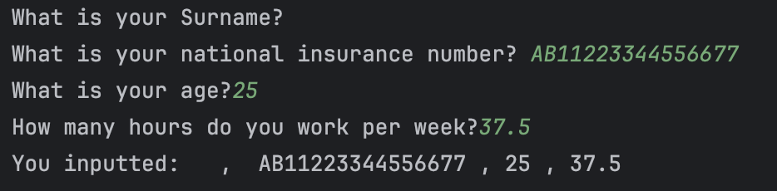
Result: Did the programme behave as expected ie syntactically and logically correct?

Pre Fix Comments
Syntactically yes, as I didn’t put any length checkers on the code. To fix this, I plan on using a minimum and maximum length check.

Post Fix Comments
I didn’t go with my original plan to fix this problem, as upon doing some research I realised the easiest solution was to use regular expressions and within this Regex, specifying how many characters there are allowed to be in the national insurance number which in turn fixes this issue.

I used:
“ nat_ins_regex = re.compile(r”^[A-CEGHJ-PR-TW-Z]{2}\s*\d{2}\s*\d{2}\s*\d{2}\s*[A-D]$”) “

Explanation of Regex
This regex allows two letters at the start, which can be any letter excluding D, F, I, Q, U, and V.
Following this, it allows 6 numbers, and lastly, one more letter, which can be any letter between A and D. I also allowed for spaces between each pair of characters as that is how they are sometimes inputted by users.

After implementing this fix, I retested the code to ensure it fixed the bug. It errored as expected when trying to enter a National Insurance Number that was too long because it didn’t match the format requirements.

Test:
National Insurance
iv. Enter 22PE4088A (ie wrong format)
Screenshot(s) of output:
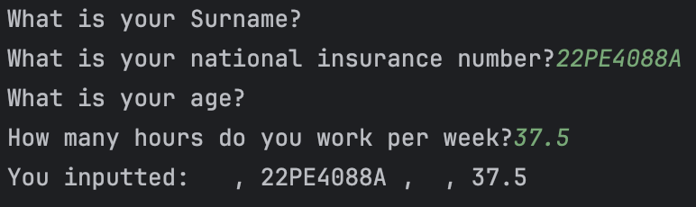
Result: Did the programme behave as expected ie syntactically and logically correct?

Pre Fix Comments
Syntactically, yes, as I didn’t specify what format the national insurance number needed to be.

As previously mentioned, to fix this, I would create a national insurance Regex, specifying how many characters of each kind are allowed to be inputted.

Post Fix Comments
As explained in the previous test, I used a regex.

After implementing this fix, I retested the code to ensure it fixed the bug. It errored as expected when trying to enter the National Insurance Number from this test, which was in the wrong format.

Test:
Age
i. Enter 34
Screenshot(s) of output:
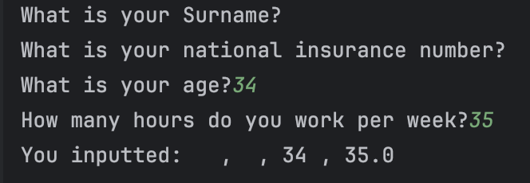
Result: Did the programme behave as expected ie syntactically and logically correct?

Pre Fix Comments
Yes, it did behave as expected. It outputted the value that was inputted without any issues.

However, upon inspecting my code, I realise that although the programme works as expected. I used str instead of int, which is pointless because input it always an string. Additionally, I need int to convert the string into an integer. So, although it works, the programme is reading it as a string which could cause problems if number was needed for future sums.
To improve I would change this error.

Post Fix Comments
I fixed this error and retested the programme, it still works as expected. The age is inputted and it outputs the number onto the screen without any errors.

Further Comments
Due to other tests, I ended up changing the format that impacted this test. It was still type int, it was just validated as the top of the ‘validate_age’ function with an error message, which I mention in test “age. iv”, where this was needed to validate incorrect formats.

Test:
Age
ii. Enter 150
Screenshot(s) of output:
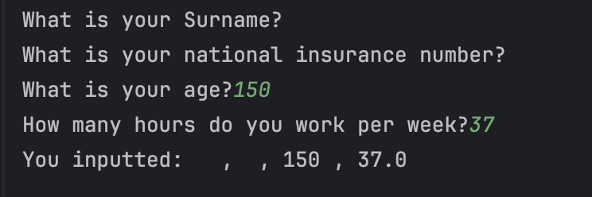
Result: Did the programme behave as expected ie syntactically and logically correct?

Pre Fix Comments
Yes, it behaved as expected syntactically, as no validation was added to ensure age must be within a certain range. However, logically nobody should be over 150 years old.
To improve, I would add validation checking the age is no higher than 100. Not many people make it past 100 so I feel this is a suitable age limit.

Post Fix Comments
I originally tried to fix this within an if statement but because I had other errors I wanted to include, it made more sense to add a try except block.

My solution involved using a nested if statement within my function that checked to make sure the age was under 100 years old and if not, raised a ValueError with a message for the user informing them of the error.

I ran this test again after adding this code and it behaved as expected, displaying the error message I inputted into the ValueError.

Test:
Age
iii. Enter -4
Screenshot(s) of output:
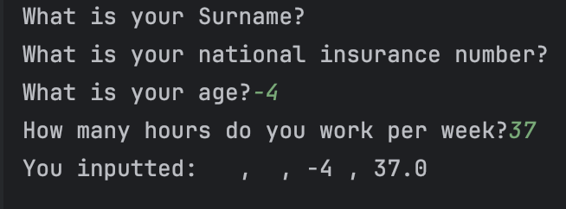
Result: Did the programme behave as expected ie syntactically and logically correct?

Pre Fix Comment
Yes, it behaved as expected syntactically, as no validation was added to ensure age must be within a certain range. However, logically, nobody can be a minus age. To improve, I would add validation checking the age is greater than zero.

Post Fix Comment
I added a raise ValueError which handled checking whether the age was greater than zero.
Due to the fact it needed a minimum and maximum age range, I decided to merge this with the maximum age check, to check the age was within the accepted range.

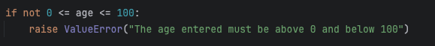

I ran this test again after adding the validation and the code behaved as expected, displaying the correct error message from the ValueError.

Test:
Age
iv. Enter a letter
Screenshot(s) of output:
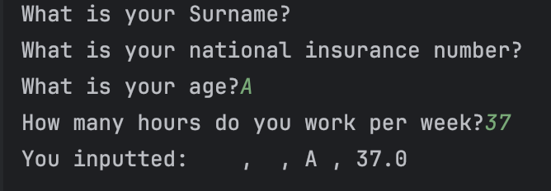
Result: Did the programme behave as expected ie syntactically and logically correct?

Pre Fix Comment
Due to my error with assigning the wrong type to age, it does allow letters. Therefore, although it’s doing what the code is designed to do, it’s logically wrong.

To fix this, I would change “age = str(input(“ to “age= int(input(“ .

Post Fix Comment
I changed the way I validated the age, due to implementing two functions.
I validated the age at the top of the validateAge function, by doing age = int(age). This indirectly validates the input as it checks to see if the string inputted by the user can be converted to a number and if not, it raises an ValueError.

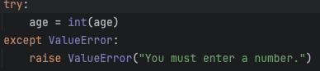

Due to the fact I added more than one form of validation, I created two functions, one function validated the data (validate_age) , the other function got the data and then outputted the result (get_age).

After adding this code, I tested it to ensure it worked. The programme behaved as expected and raised the ValueError and displayed the correct message to the user, letting them know that their input wasn’t valid and why.

Test:
Number of working hours per week:
i. Enter 37.5
Screenshot(s) of output:
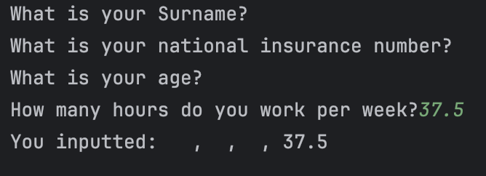
Result: Did the programme behave as expected ie syntactically and logically correct?

Pre Fix Comment
Yes, it did. I inputted a decimal number, and it printed the decimal number back out. This is because I validated it using type float.

Post Fix Comment
Although I did this in the original code, I changed the way it was displayed because of implementing two functions. So, I added it to the top of the validate_work_hours function as seen in the screenshot below.
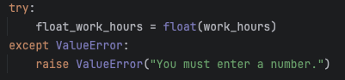

I tested this validation after I made the two functions. It behaved as expected, allowing the correct format to be inputted.

Test:
Number of working hours per week:
ii. Enter 150
Screenshot(s) of output:
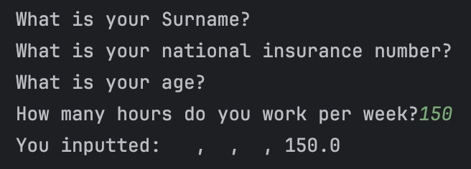
Result: Did the programme behave as expected ie syntactically and logically correct?

Pre Fix Comment
Yes, it behaved as expected, as I didn’t add any validation to stop it from accepting higher numbers. To improve, I’d add limit to the number of hours that would be accepted.

Post Fix Comment
I decided to make the maximum number the maximum number of hours in a week which is 168.

Due to the fact I added more than one form of validation, I created two functions. One function validated the data (validate_work_hours) , the other function got the data and then outputted the result of the validation (get_work_hours).

I tested this after adding the validation, the code still behaved as expected allowing 150 as an input.

Test:
Number of working hours per week:
iii. Enter 0
Screenshot(s) of output:
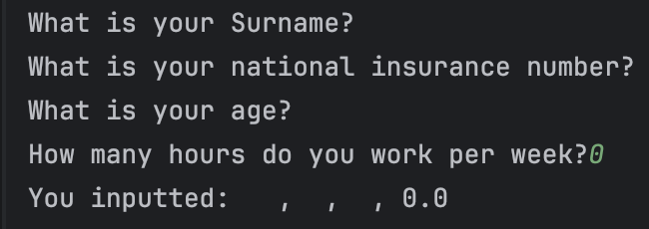
Result: Did the programme behave as expected ie. syntactically and logically correct?

Pre Fix Comment
Yes, it behaved as expected and although in most situations you want the user to input a value higher than 0, in this case I don’t believe it’s logically wrong.
It is highly possible that someone has worked 0 hours, as they might not be employed or be self-employed and not have any work.

Post Fix Comment
As there was a minimum and maximum number of hours someone could work a week, I merged them together to create an age bracket.

Once added to the function, I ran the test again. The programme behaved as expecting, still allowed the user to input 0, without triggering the ValueError.

Test:
Number of working hours per week:
iv. Enter -2
Screenshot(s) of output:
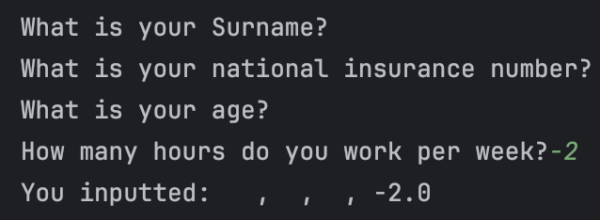
Result: Did the programme behave as expected ie. syntactically and logically correct?

Pre Fix Comment
Yes, it behaved as expected syntactically, as no validation was added to ensure working hours must be within a certain range. However, logically, nobody can work minus hours.
To improve, I would add validation checking the hours worked per week are not a minus number.

Post Fix Comment
This was covered in my previous fix by adding a minimum and maximum work hour limit.
This meant that when I typed in -2, it triggered the ValueError and outputted the correct error message.

- Consider the results of the above tests and revisit your code in order to solve the problems. (Note: you may not be able to solve all of them, but solve as many as you can.)

What functionality changes were made:

First change to note is the way the names were displayed, I was using camel case, but I changed this to python’s preferred snake case.

I originally tried to create a long if statement to do my validation, but I couldn’t get it to work. Upon doing some research, I realised the easiest way to validate my code, was use a try except statement; to raise and handle the errors and then depending on the error specified, it would output a corresponding error message.

When trying to add this validation, I realised it was hard to include all the validation I wanted to include, without wrapping it within a function. I tried to stick it all in one function, but this did not work. So as previously mentioned in the tests, I split the validation and actual input into two different functions.

To access the data from each function, I saved each value from the respective get functions under different variable names and then passed these variables into the print statement, as seen in the screenshots below.
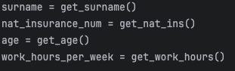

Furthermore, I also changed the wording of all the questions to say “Please enter your (x)” rather than “What is your (x)” as I felt it was more user friendly.

Additionally, as mentioned in Test 2, I added a maximum character limit, as it logically made sense to include even if it wasn’t being tested. I included this in my validate_surname function as a nested if statement.

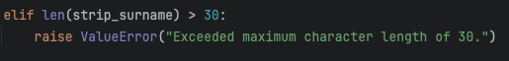

Furthermore, I chose to use ‘.strip’ to remove any white space at the beginning or the end of the user inputs. This means the format is consistent and if these entries were put into a database, it could avoid causing bugs. I did this for both the surname and the national insurance.
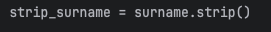

Paste your revised code here:

[Copy and paste your revised code here – note, do not use a screenshot]

import re
def validate_surname(surname) -> str:
name_regex = re.compile(r"^(?=.*[A-Za-z])[A-Za-z' -]+$")
while True:
strip_surname = surname.strip()
if strip_surname == "":
raise ValueError("This cannot be left empty.")
elif len(strip_surname) > 30:
raise ValueError("Exceeded maximum character length of 30.")
elif not name_regex.match(strip_surname):
raise ValueError("You can only use letters, apostrophes or hyphens.")
return strip_surname.capitalize()
def get_surname() -> str:
while True:
try:
return validate_surname(input("Please enter your surname: "))
except ValueError as error:
print(error)
def validate_nat_ins(nat_ins) -> str:
nat_ins_Regex = re.compile(r"^[A-CEGHJ-PR-TW-Z]{2}\s*\d{2}\s*\d{2}\s*\d{2}\s*[A-D]$")
while True:
strip_nat_ins = nat_ins.strip()
if strip_nat_ins == "":
raise ValueError("This cannot be left empty.")
elif not nat_ins_Regex.match(strip_nat_ins):
raise ValueError("Incorrect Format entered. \nIt should follow this format - 'QQ 12 34 56 A'.")
return strip_nat_ins
def get_nat_ins() -> str:
while True:
try:
return validate_nat_ins(input("Please enter your National Insurance Number: "))
except ValueError as error:
print(error)
def validate_age(age) -> int:
try:
int_age = int(age)
except ValueError:
raise ValueError("You must enter a number.")
if not 0 <= int_age <= 100:
raise ValueError("The age entered must be above 0 and below 100")
return int_age
def get_age() -> int:
while True:
try:
return validate_age(input("Please enter your age: "))
except ValueError as error:
print(error)
def validate_work_hours(work_hours) -> float:
try:
float_work_hours = float(work_hours)
except ValueError:
raise ValueError("You must enter a number.")
if not 0 <= float_work_hours <= 168:
raise ValueError("The hours entered must be above 0 and below 168")
return float_work_hours
def get_work_hours() -> float:
while True:
try:
return validate_work_hours(input("Please enter how many hours you work per week: "))
except ValueError as error:
print(error)
surname = get_surname()
nat_insurance_num = get_nat_ins()
age = get_age()
work_hours_per_week = get_work_hours()
print("You inputted: \nSurname:", surname, "\nNational Insurance Number:", nat_insurance_num, "\nAge:", age,
"\nHours worked per week:", work_hours_per_week)

