Module Name: Hotel Placement Research Project
Module Code: BMIH6008
Tutor Name: Ben Ka Po Chong

Assignment Title:
HOTEL RESEARCH PROJECT
STAFF SHORTAGE ISSUES AND THE IMPACT ON HAMPTON BY HILTON HOTEL, LUTON

Student Name: Roxana Mihaela Roman
Student Id: 2129008
28th February 2025

AI Acknowledgement
I confirm that I have not used any AI tools in the research and creation of this assignment. I confirm that I have not presented any AI generated materials as my own work. I confirm I have copies of my drafts, notes, and other resources I used, which I may be asked to provide in evidence.

Abstract
Purpose and objectives
The purpose of this research was to examine the topic of staff shortages considering the case study of Hampton by Hilton, Luton. It aimed to explore the key causes behind staff shortages and their impact on organisations like Hampton by Hilton. The purpose of this study was to understand the reasons behind issues such as staff shortage and explore strategies that can help the company mitigate the issues. It was noted that the research has contributed to developing strategies to mitigate staff shortages.
Key findings
Multiple critical outcomes have emerged from the completed research assignment dealing with the topic of staff shortage and its impact on the operations of the Hampton Hilton Luton Hotel. For example, the hotel has been found to employ 12 new starters in 2022 for different job roles like housekeeping and food and beverage (F&B) assistance. This is indicative of the fact that the hotel has not been fully capable of offering quality guest services and managing high-quality operations due to staff shortages. It has also been found from multiple reviews of the hotel employees that aspects like work-life balance, salary and career progression opportunities. Each of these reviews has generated a rating of less than 3.5 stars which indicates that none of these employee-friendly practices are properly sought in the hotel. As a result, the employees suffer from burnout and demotivation due to increasing workload. One of the outcomes has shown that the receptionist soiled the only jacket that a guest wore by spilling beer on the jacket which made it troublesome for the guest to wear the jacket for a flight the next day.
Recommendations
The company was recommended to foster transparent career development opportunities for its staff and incorporate AI technology for effective HR management. The company was also recommended to foster feedback mechanisms as well as foster flexible work arrangements and it was also suggested to leverage incentive programs and a competitive salary system while focusing on enhancing staff training and apprenticeship programs.

Table of Contents
1. Introduction 5
2. Literature Review 6
2.1 Reason behind staff shortages and workforce challenges 6
2.2 Impact of staff shortages on organisational performance 7
2.3 Relation between customer satisfaction and motivated Workforce 7
2.4 Existing strategies leveraged by businesses in retaining staff and mitigating shortages 8
2.5 Research gaps 9
3. Methods 9
3.1 Case study approach 9
3.2 Netnography 10
3.3 Secondary research 10
4. Case study hotel overview and findings 10
4.1 Overview of Hampton Hilton Luton Hotel 10
4.2 SWOT analysis of Hampton Hilton Luton Hotel 11
4.3 PEST analysis of Hampton Hilton Luton Hotel 14
4.4 Competitor analysis of Hampton Hilton Luton Hotel 16
4.5 Netnography 17
4.6 Reflective account 20
5. Discussion 21
5.1 Salary issues, lack of support from managers, work-life imbalance and lack of career progression opportunities have led to staff shortage in the Hampton Hilton Luton Hotel 21
5.2 Staff shortage leads to a negative impact on the organisational performance of the Hampton Hilton Luton Hotel 22
5.3 Staff shortage at the Hampton Hilton Luton Hotel affects employee motivation which impacts customer satisfaction 23
5.4 Career development opportunities, employee training, revised salary structure and refreshed HR policies can help enhance Hampton Hilton Luton Hotel’s operations and remove the issue of staff shortage 24
5.5 Acknowledging limitations 25
6. Conclusion and Recommendations 26
6.1 Conclusion 26
6.2 Recommendation 26
6.2.1 Providing Transparent Career Development Opportunities 26
6.2.2 Enhancing staff training and apprenticeship programs 27
6.2.3 Leveraging incentive programs and a competitive salary system 27
6.2.4 Fostering Flexible Work Arrangements 27
6.2.5 Foster feedback mechanism 28
6.2.6 Incorporating AI technology for effective HR management 28
References 29
Appendix 1: Hyde Mill’s review 39

Introduction
Staff shortages have become a pressing issue in the hospitality industry, especially post-Brexit and COVID-19. Issues such as staff shortages can hinder the organisation from attaining its desired goals and customer satisfaction. This research report seeks to explore the theme of staff shortages within Hampton by Hilton which is strategically located near the Airport. Hampton by Hilton is a mid-range affordable brand which has been a part of Hilton serving leisure travellers as well as business travellers (Hilton, 2025). This enables the brand to have efficient employees to maintain consistent guest satisfaction and service quality.
The hospitality industry is heavily dependent on a motivated and well-trained workforce in order to deliver high-quality customer experience to maintain its performance. However, the industry has been experiencing persistent shortages of staff due to various factors such as labour restrictions due to Brexit, post-pandemic, changing employee dynamics and increased market competition. It can be inferred that these challenges have been impacting hotels like Hampton by Hilton despite the strong support of its parent company, which is Hilton. This reflects the broader issues and trends in the hospitality industry of the United Kingdom. Hampton by Hilton is Hilton’s internationally operating powerhouse brand with more than 3000 properties across the globe. This brand has always been dedicated to innovation and friendly services (Hilton, 2025). However, as reported, after the COVID-19 restriction has eased, the company has been trying to attract staff since staff shortages have been impacting optimal recovery. In addition, Brexit has also led to the loss of foreign workers (Pegden, 2022). It was found that in 2023, there was a significant shortage in UK hospitality with more than 132,000 vacancies which is 48% more than pre-pandemic (UKHospitality, 2023). These issues have been hindering the operations and efficiency of hotel brands. Considering Hampton by Hilton as a case study in this research, the report will highlight the theme. The report will include a systemic analysis of the literature and identify the gaps. It will also present an overview of the case study and findings will be discussed to draw conclusions. At the end of the report, practical strategies will be recommended in order to support the hotel's placement to improve its operations and performance.
Aim: To explore the key causes behind staff shortages and their impact on organisations like Hampton by Hilton.
Objectives:
- To investigate the impact of staff shortages on the overall organisational performance
- To evaluate the causes behind staff shortages within the hospitality industry.
- To recognise potential strategies to mitigate staff shortages and enhance hotel operations.
Research Question:
- How do issues like staff shortages impact customer satisfaction and operational efficiency, and what strategies can be incorporated to mitigate the challenges?
Thus, by exploring these, the report seeks to offers valuable insights into human resource management, and contribute to the identification of actionable practices. These would help in overcoming the workforce challenges, especially within the hospitality industry and enhance workforce strategies.

2. Literature Review

2.1 Reason behind staff shortages and workforce challenges
According to the interpretation of Džakula et al. (2022), workforce shortages are referred to as not having the right number of staff with the right skills at the right time and right places in order to provide the right services to the people. As further elaborated by Oliinyk et al. (2021), there are different social as well as macroeconomic factors that contribute to the issues of staff shortages. Factors such as a lack of career progression opportunities or low wages contribute to an increase in turnover intention. There are various reasons that make employees leave the firm such as lack of training and feedback, and few opportunities for progress. Furthermore, many employees when they feel undervalued and under-recognised. One of the reasons include the stress of overwork and the imbalance between life and work. As highlighted by Al-Suraihi et al. (2021), Herzberg two two-factor theory of motivation links employee motivation and commitment to the organisation by two distinct factors. There are two motivating factors such as satisfiers and dissatisfiers. Satisfiers include the need for recognition, achievements work advancements and responsibilities, whereas dissatisfiers factors are working conditions, relationship with colleagues, salary, organisational policies and supervision. These factors are seen to affect the employee's commitment to stay. As reported, it is also noted that the primary cause of labour shortages is considered to be workload by 73%. Issues such as burnout are one of the issues within hospitality due to long working hours and stress levels by 69 and 68% respectively (Onrec, 2024). As stated by Sumption et al. (2022), many employers in the UK were heavily reliant on EU workers. After Brexit, they were not able to recruit due to visa restrictions, and on the other hand, they lost existing EU workers. Furthermore. Many employers in the hospitality sector are unable to recruit skilled employees due to a lack of skilled employees in the industry. Thus, job-related factors as well as macroeconomic factors have contributed to staff shortages.

2.2 Impact of staff shortages on organisational performance
According to Alhashedi et al. (2021), the workforce is a significant asset of an organisation, with many firms highly investing in staff hiring, development and management. Modern organisational theory highlights that a satisfied employee is key to organisational success. It is inferred that motivated employees and satisfied and committed employees tend to perform better for the organisation. When there are issues like shortages, the workloads and responsibilities of the existing members increase as a result leading to inefficiencies and errors. It also contributes to hurt customer care, individual performance, and ultimately organisational performance. As commented by Gabriel and Aguinis (2022), staff shortages can lead to the development of issues such as burnout. This also has negative consequences such as decreased individual performance and hinders creativity and innovation. Ma et al. (2024), highlight that Human Capital theory demonstrates the need for skilled staff for organisational performance. It also focuses on the need to educate and train the workforce to attain optimal benefits for its skilled workers. In this aspect, it can be stated that a lack of skilled employees can affect operations leading to a reduction in customer satisfaction. As elaborated by Ntwakumba (2022), understaffed workplaces within hospitality are not only seen to impact the existing staff with workloads but also compromise service delivery. This can potentially reduce customer satisfaction. Many restaurants and hotels face issues such as longer waiting times, limited service offerings, potential errors and loss of revenue. The reduced capacity is seen to have a direct impact on the organisational performance.

2.3 Relation between customer satisfaction and motivated Workforce
As opined by Gabon (2024), issues such as staff shortages have a high impact on employee motivation which also links to their lower morale and motivation. Motivated employees are considered to have a significant impact on customer satisfaction as they will reciprocate through their performance. Ahmad et al. (2023), demonstrate the social exchange theory developed by George Homans emphasising reciprocity and social exchanges over economic or negotiated changes. For instance, when the employees are valued, motivated or benefited, in return they tend to perform better for the organisation. In this aspect, staff will be more obligated and committed to employers which offer them growth opportunities, fair treatment, rewards or recognition. As stated by Rane et al. (2023), a motivated workforce is vital to ensure that customers receive consistent and high-quality services. Organisational success heavily relies on employee satisfaction as they will be more hardworking and get more involved with the organisation. As reported, staffs by 59% when staff are too strained and demotivated, the customer experience is affected in hospitality (The Catererm 2024). According to Demircioglu (2021), employee satisfaction and customer satisfaction are positively correlated. It is noted that employees when given an adequate level of tools and skills improve their ability to provide high-quality services. Thus, it can be inferred that hotel companies like Hampton will be required to focus on these factors to mitigate the issues of staff shortages.

2.4 Existing strategies leveraged by businesses in retaining staff and mitigating shortages
As stated by Groenewald et al. (2024), the hospitality industry has more labour shortages than any other sector due to irregular working hours and poor remuneration. However, there are various factors that help organisations retain staff and mitigate shortages such as giving employees a chance to be promoted. It also includes providing training and tools to adapt to the organisational needs. Furthermore, effective strategies such as opportunities for career development of the crucial needs of employees. A supportive work environment is seen to be an important factor for staff retention. As highlighted by Hasan et al. (2021), factors such as competitive salaries, and better working conditions are seen to be in demand among the workers to stay committed. As reported, in the hospitality industry, 58% consider flexible working conditions as a crucial component while an attractive wage is preferred by 52% (Onrec, 2024). Urme (2023), many employers are strengthening their recruitment process and are highly investing in training and development. Furthermore, many organistaion are promoting diversity by recruiting diverse groups to boost staff satisfaction and retention. However, as argued by Dabić et al. (2023), mitigating employee shortage not only requires cultural change but also requires adaptability at the macro-economic level. For instance, the incorporation of advanced technology can mitigate shortages. Many hotels are seen to replace staff with automatic technologies such as Artificial intelligence, Internet of Things (IoT) or machine learning. These help firms streamline their operations. However, the use of technology would impact lower-skilled workers shaping the aspects of the global market. According to Innerhofer et al. (2022), overcoming labour shortages requires a multifaceted approach which addresses staff wellbeing, recruitment as well as technological solutions. Organisations are required to emphasise fostering a supportive environment where they are motivated, engaged and supported. On the other hand, they must also ensure leveraging technology to stay competitive and provide training, and rewards to contribute to a sustainable workforce.

2.5 Research gaps
As revealed by Innerhofer et al. (2022), in literature, studies on employee shortages have primarily been focused on the supply and demand side of the employees or the employer’s demand side. However, less attention has been given to the hospitality sector as well as shortages of skilled workers. Thus, this research will address the gap by examining the impact of staff shortages and the reasons while focusing on the hospitality industry. It will emphasise practical hotels. It will consider Hampton by Hilton as the case study to evaluate the reason behind the staff shortages and how it has impacted the organisation.

3. Methods

3.1 Case study approach
The research will employ a case study methodological approach in this research considering Hampton by Hilton as the case study. According to Priya (2021), a case study is an increasingly growing approach in qualitative research. Case study research is an analysis and investigation of collective or single cases, which are examined to capture the complexity of the research object. This allows the researcher to explore contemporary and real-life issues. Thus, this case study approach in this study will help in exploring the real-life phenomena by considering Hampton by Hilton. This will also deeply explore the issues of staff shortages and explore how the company has been affected by the issues. This will also further support the areas of improvement for the company to mitigate staff shortages. However, as demonstrated by Walker and Carr (2021), the case study approach is often limited by its low generalisation ability and low reliability. Despite its relevance, the case study approach is often ignored by many researchers. It is important to ensure the concept is correctly evaluated and internal validity is adhered to. Since the current research is focused on analysing a single case study, it may limit its applicability to other sectors or brands. It can also be inferred that the case study approach is one of the effective tools to leverage theoretical knowledge to practical application and it may also help in developing reasoning skills (Råbu and Binder, 2024). Thus, this will help in fostering an in-depth understanding of the theme while developing actionable skills for the company.

3.2 Netnography
Along with the case study approach, the report will also include a netnographic approach. As stated by Kabel et al. (2024), ethnography is one of the effective data collection strategies for investigating the virtual landscape, especially on a sensitive subject. It is inferred that traditional qualitative research often poses limitations to the research, however, the netnograhic method was developed to assess virtual spaces. It is also considered an online ethnography. Thus, this strategy will help this research to focus on the analysis of experiences of people, and actions sharing the same interests. Insights from the online platforms will be taken rather than fostering surveys or reviews which will potentially help in reducing biases. This will assess platforms such as TripAdvisor, Skyscanner, Indeed and so forth to better understand the theme.

3.3 Secondary research
The study employs secondary research as it will collect data from the existing resources. The data will also be assessed from industry reports, online news articles, government publications as well as academic journals and articles to capture deeper insights into the issues while contemplating a case study of Hampton by Hilton Luton. The official websites of Hilton will also be assessed to collect data relevant to the case study. As stated by Collis and Hussey (2014), secondary data are received from already published sources instead of setting target audiences. It is one of the effective ways to collect data while allowing the researcher to save cost and time in terms of collecting data. However, the researcher does not have control over the quality of the data.

4. Case study hotel overview and findings

4.1 Overview of Hampton Hilton Luton Hotel
The location of Hampton Hilton Luton Hotel is quite good because of the accessibility benefits. For example, it is situated next to the DART transit system. As a result, the nearby Luton Airport can be reached in less than 5 minutes (Hilton, 2025). This is because Luton Airport is situated just 1 mile away from the hotel's location (Hilton, 2025). Furthermore, the hotel is also located adjacent to Luton Parkway Station (Travelweekly, 2025). This means that a train service is also available to reach this hotel. Hence, there is no issue for customers to reach this hotel since the airport and train station are quite nearby.
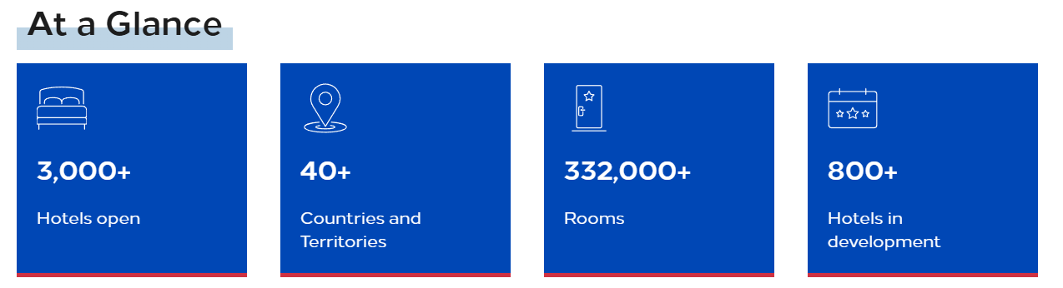
Figure 1: Information on Hampton by Hilton
(Source: Hilton, 2025)
Hampton by Hilton is a big hotel enterprise which is spread across 3,000 different locations in more than 40 countries and territories (Hilton, 2025). Furthermore, 800 hotels are currently being developed. Hampton by Hilton has been found to be one of the top-performing hotels for quite a few years. For example, according to Allianz’s and IdeaWorksCompany’s 2022 Report, the hotel had the highest room revenue of €9.97B (O’Neill, 2023). It was followed by second-placed Hilton Hotels and Resorts generating a revenue of €9.02B and the third-placed Marriott generating €8.57B in revenues.
With regard to culture, it can be said that the hotel possesses a healthy work culture. For example, the human rights policies and governance of the hotel are quite strong. As per the Responsible Sourcing Policy, malpractices like bonded labour, child labour, slave labour and human trafficking and recruitment fees are not a part of the hotel's social practices (Hilton, 2020). Functionalism Theory necessitates society to be considered as a structure with interrelated parts where the biological and social needs of individuals are met (Lumenlearning, 2025). It is visible that the hotel is able to respect social needs as per the theory's dictums because negative practices like bonded, child and slave labour are prohibited.

4.2 SWOT analysis of Hampton Hilton Luton Hotel
Strengths
One of the strengths of Hampton Hilton Luton Hotel is its food quality. This is because the hotel offers a variety of meal options like continental vegetarian, gluten-free, buffet, breakfast-to-go and full English (Booking, 2025). Hence, the food-to-go market growth prospect for the hotel is quite strong. Furthermore, the hotel is also able to post regular job vacancy posts to fill up employee gaps. For example, at present, 484 vacancies exist for which job ads are being posted over online job ad websites (Jooble, 2025). This indicates the ability of the hotel to make a planned approach to filling up staff shortages.
Weaknesses
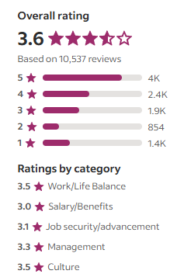
Figure 2: Different employee rating areas of Hampton Hilton Luton Hotel
(Source: Indeed, 2025)
One of the visible weak points of Hampton Hilton Luton Hotel is the salary. For example, as seen in the above figure, the overall rating is 3.6 stars where the lowest rating (3 stars) is for the salary element (Indeed, 2025). This indicates that the employees at the hotel are unable to earn a proper income. Hence, low salary is one of the contributing elements to the issue of persisting staff shortage at the hotel. It is also seen that the managers of the hotel are not supportive. This is because work hours are long and managers are unable to provide enough time to complete tasks (Indeed, 2025). Hence, this is another weakness which contributes to the issue of staff retention inability of the hotel.
Opportunities
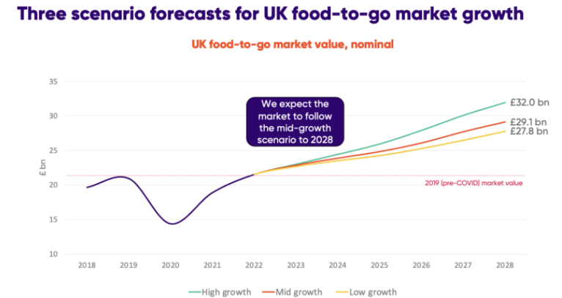
Figure 3: Food-to-go market growth scenario of the UK
(Source: Jooble, 2025)
As per the prediction of the food-to-go market trend in the UK, each of the three different projections portrays a strong pound growth. For example, while the low growth will be £27.8B by 2028, the high growth will be £32B by 2028 (Williammurray, 2023). This outcome is indicative of the fact that as Hampton Hilton Luton Hotel is trying hard to overcome staff shortage and is offering a variety of food options, the hotel will be able to conduct a more profitable business in the future supported by the sustained UK food-to-go market growth.
Threats
The average payment for a hotel sector employee in the UK is £8.15 per hour (TUC, 2019). In contrast, hotels like Travelodge pay their directors a salary between £1.2M and £5.4M. As a result, most low-level staff who comprise the maximum workforce in the UK's hotel industry are quitting jobs which is hampering operations. Similarly, Hampton Hilton Luton Hotel is also facing a similar threat because its salary rating is the worst, i.e., 3 stars. Furthermore, as per the UK government’s report concerning the hotel industry, managers take no responsibility for violations and inform workers that any action taken against the hotel is meaningless (Gov, 2019). This leads to frustration and employees quit jobs leading to staff scarcity issues in this sector. A similar threat looms over Hampton Hilton Luton Hotel because managers are unable to offer enough time to complete jobs which leaves the employees at a risk of being forced to work overtime which is a violation of job rules.

4.3 PEST analysis of Hampton Hilton Luton Hotel
Political
Politically, the support to the hotel sector which falls within the hospitality sector is quite bad in the UK at present. This is because as per the latest budget announcements in 2024, some changes in rules and recommendations for the UK hospitality sector will lead to a total increase of taxes by £40B (Stevens, 2024). In terms of cash, this is the largest tax-raising budget in UK's history. Hence, the impact of this decision on the UK hotels including the Hampton Hilton Luton Hotel will be quite destructive. Already, the hotel is facing staff shortages and an increase in tax will mean continued staff shortage because the hotel will not be able to pay an ideal wage to the workers due to increased taxation.
Economic
As per Mintel's 2024 forecast, the foodservice market will reach £166B by 2028 (Mintel, 2025). This is indicative of the fact that the hotel industry in the UK region is expected to witness constant and continual economic growth till 2028. This is one of the reasons behind Hampton hotels including the Hampton Hilton Luton Hotel contributing to the highest €9.97B room revenue in 2022 (O'Neill, 2023). This economic development of 2022 hints at the fact that the overall trend of increasing revenues in the food service market is aiding the hotel to earn more.
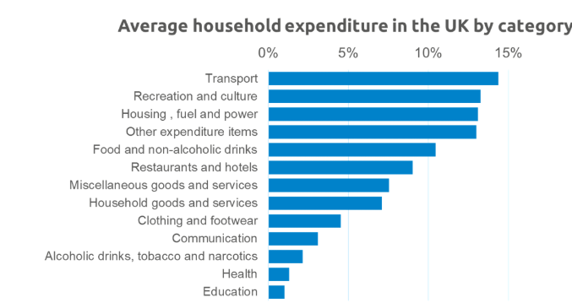
Figure 4: Different areas of expenditure in the UK
(Source: AHDB, 2020)
Furthermore, 58% of the British spend 25% of their annual income on dining out (Opentable, 2025). This practice is present among 58% of the British. It is further supported by the above figure displays an 11% spending on food and 9% spending on restaurants and hotels. As a result, the situation of the Hampton Hilton Luton Hotel will be further strengthened as more and more UK citizens will prefer to dine out like visiting the hotel's restaurant.
Social
The social situation of the UK hospitality sector is quite bad. At present, 132,4000 vacancies exist which is roughly 48% of the pre-pandemic levels (Ukhospitality, 2025). In this regard, hotels are witnessing a 10% staff shortage of head chefs and a 21% staff shortage of production chefs. In this regard, the Hilton Hotel is trying hard to fill this vacancy. In 2021, it took 100 new apprentices and in 2022, it took 350 more (Pegden, 2022). This outcome indicates that the branch named Hampton Hilton Luton Hotel is trying its best to overcome staff shortage issues which are harming business productivity like the shortage of housekeeping staff affecting the room cleanliness.
Technological
Technological support is being bolstered for hotel staff in the UK region. For example, Marriott International has started to implement an online learning platform named Marriott University offering access to training courses, certifications and assessments (Noblet, 2023). In this way, technological aid is being sought by UK hotels to overcome the challenge of staff shortage. In this context, the impact on the Hampton Hilton Luton Hotel is also going to be positive because the hotel could also benefit from leveraging online educational technology to ensure that the recruited staff are able to upskill themselves and enhance the customer management operations of the hotel.

4.4 Competitor analysis of Hampton Hilton Luton Hotel
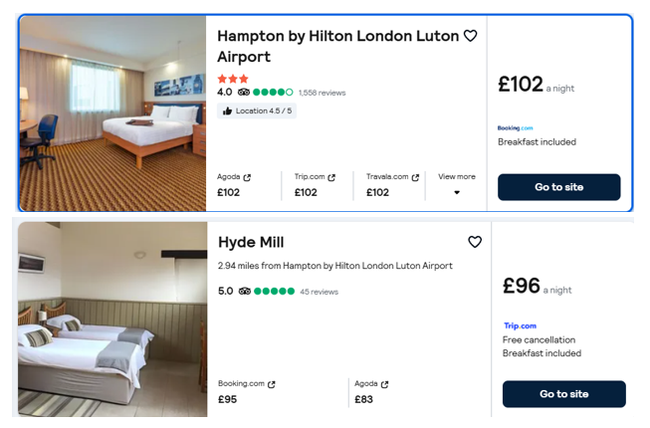
Figure 5: Hampton Hilton Luton Hotel vs. Hyde Mill
(Source: Skyscanner, 2025)
It is visible from the above image that Hampton Hilton Luton Hotel is both highly priced and less popular than Hyde Mill because the rating of the latter is 5 stars while the former is 4 stars (Skyscanner, 2025). This is because Hyde Mill's cleanliness core is 9.8 and the staff score is 9.9 [Refer to Appendix 1]. It indicates that the competitor has enough staff on its premises who offer quality service and treat guests respectfully.
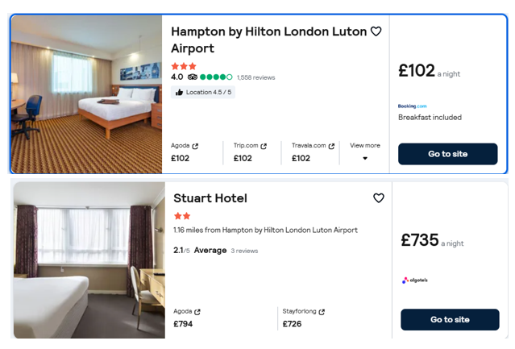
Figure 6: Hampton Hilton Luton Hotel vs. Stuart Hotel
(Source: Skyscanner, 2025)
It is visible from the above image that Hampton Hilton Luton Hotel is both low-priced and more popular than Stuart Hotel because the rating of the latter is 2.1 stars while the former is 4 stars (Skyscanner, 2025). Stuart Hotel, despite being expensive, is worse. Bugs are there in the bathroom and there is no control over the AC in rooms (Goibibo, 2025). Windows are mouldy and there is a false advertisement of an existing bar and restaurant.

4.5 Netnography
Ill management of staff at Hampton Hilton Luton Hotel
As seen in the above image, employee reviews of the Hampton Hilton Luton Hotel are not too good. One issue that is the payment is quite late as the salary is received after two months from the time of commencement of employment. This fact is also supported by a survey performed by CascadeHR involving 2,000 UK employees. 27% of the employees received late payments from their banks and 21% were unable to cover basic living costs like food and travel expenses (Hrzone, 2024). As a result of this similar issue faced by the Hampton Hilton Luton Hotel employees, they are less likely to stay and are more inclined to switch jobs or the company.
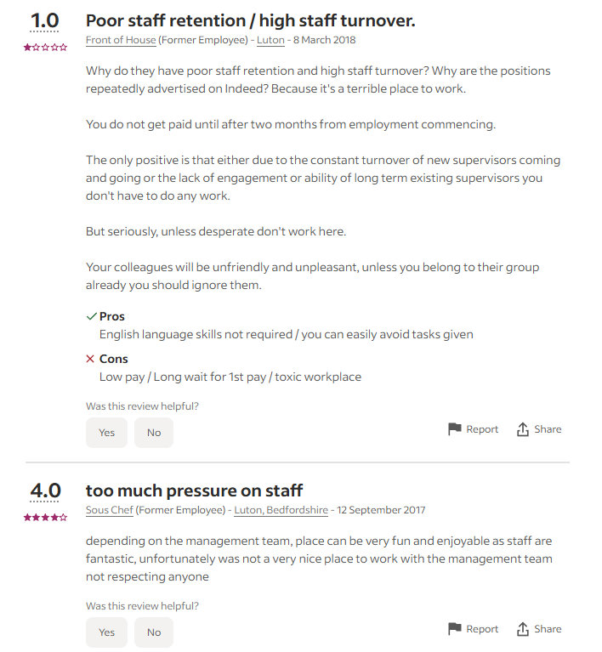
Figure 7: Hilton employee reviews in Luton
(Source: Indeed, 2025)
The Harvard Model of HRM focuses on the soft side of HRM while emphasising the interaction between managers and employees (Omar et al. 2023). Hence, employees are treated as organisational resources and as stakeholders, their interests and wants are considered critical to determining the success of manager-employee interaction. However, the employee review presented above reveals that the management team does not respect anyone. This is an indication of a lack of support for Hampton Hilton Luton Hotel's employees from the managers. As a result, the employees are frustrated and are constantly quitting jobs leading to the persistence of the staff shortage issue for the hotel.
Service quality issues at Hampton Hilton Luton Hotel
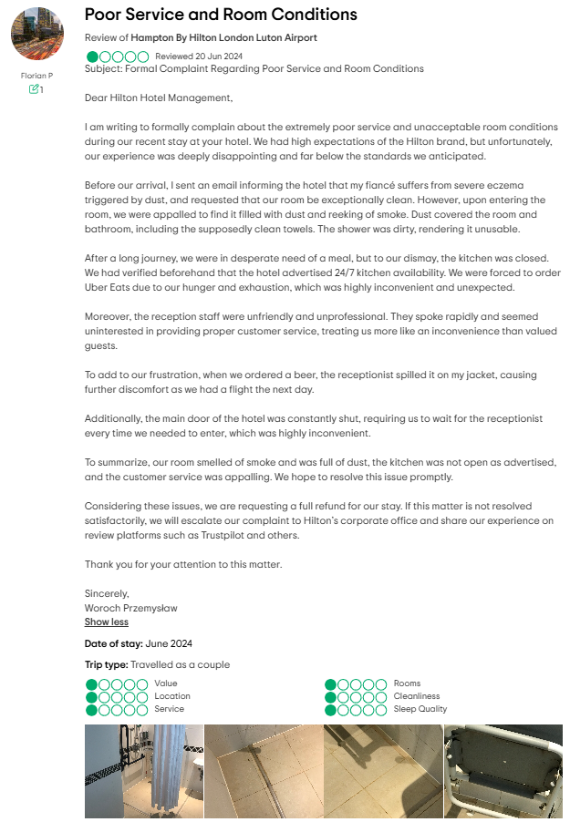
Figure 8: A detailed review of Hampton Hilton Luton Hotel offered by one of the guests
(Source: Tripadvisor, 2025)
According to Axonify's 2024 report, 69% of understaffing issues in UK hotels exist. This understaffing issue in UK hotels has led to a knock-on effect on service quality as 41% of the customers feel that the overall quality of service in the UK hotels has been downgraded (Axonify, 2024). The outcome emulates aspects of the Attribution Theory. According to Zhang et al. (2021), the emotions of customers are influenced by beliefs and causality. As soon as services emerge as ineffective, perceptions become negative as the expected high-quality beliefs are shattered. The same is the case with Hampton Hilton Luton Hotel. As seen in the above figure, the female customer informed the hotel that her fiancé suffered from eczema and thus, required an exceptionally clean room. However, contrary to her beliefs, the room was filled with dust which covered the room and bathroom (Tripadvisor, 2025). Thus, customer expectation was not respected as per the dictums of the Attribution Theory which led to negative reviews. This indicates that due to the scarcity of housekeeping employees at the hotel, the rooms are not clean which disrupts the quality of the hotel's room service operation.

4.6 Reflective account
Engagement with this assignment helped me to augment my knowledge due to being exposed to a variety of professional observations and experiences. For example, critical thinking skills help in gathering information and data and analysing and summarising the resultant outcomes (Sari and Prasetyo, 2021). As a result, I have been better able to identify the problems to be dealt with in this research work which aided me to target specific information and data like the salary of hotel employees. I am thus able to reflect on how low salaries for employees and the comparatively high salaries for managers have led to Hampton Hilton Luton Hotel facing employee scarcity which has downgraded service quality as there are few employees to cater to guest needs.
An assignment which is a project-based learning (PjBL), hugely aids in skimming and scanning skill development (Sari and Prasetyo, 2021). Skimming involves rapid reading to create a general overview of the material. In contrast, scanning involves rapid reading to identify specific facts (Butte, 2025). These two skill developments in this research project have helped me augment my ability to gather quality information in a short time. As a result, I am better at time management now because I can quickly identify and comprehend the meaning of facts so that I may easily draw valid conclusions.
The practice of data analysis in this assignment has enhanced my data visualisation skills. This skill requires the use of high-quality charts, graphs and relevant images to explicate data (Northeastern, 2025). I have been able to use informative graphs and credible review images to explain the issue of staff shortage affecting the organisational performance of Hampton Hilton Luton Hotel. This professional experience has boosted my ability to explain things through credible and valid images.

5. Discussion

5.1 Salary issues, lack of support from managers, work-life imbalance and lack of career progression opportunities have led to staff shortage in the Hampton Hilton Luton Hotel
The Indeed reviews show a 3-star rating for the element of salary in this hotel (Indeed, 2025). This is because hygiene factors like salaries as per Herzberg's Two-Factor Theory generate reasonable levels of employee satisfaction (Abdulkhamidova, 2021). However, as part of an exploitative practice, the hotel pays employees less and managers more. As a result, employees rampantly quit their jobs and the hotel is unable to retain employees which intensifies the staff shortage problem of the hotel.
It is said that a flexible HRM is positively related to employee management (Saks, 2022). This is because such an HRM allows employees to decide when, where and how long they will work. As a result, the balance between corporate and public life is established. However, as per employee reviews, the work-life balance in Hampton Hilton Luton Hotel possesses a 3.5-star rating (Indeed, 2025). Despite this requirement, the hotel’s managers force employees to work overtime which allows little space for family life. Hence, employees are leaving the hotel to find alternate employment.
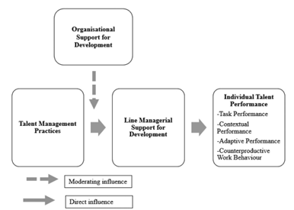
Figure 9: Support systems and impact on employees in an organisation
(Source: Mihalache and Mihalache, 2022)
According to Mihalache and Mihalache (2022), a line manager's implementation of effective HRM strategies influences employee attitudes like job satisfaction. Furthermore, Omar et al. (2023) state that the interests and wants of employees are necessary to be fulfilled by managers as per the dictums of the Harvard HRM Model. However, these requirements are witnessing a failure in their achievement in the context of the Hampton Hilton Luton Hotel. This is because as per the employee reviews, the hotel scores just 3.3 stars for management (Indeed, 2025). This indicates that the managers are unprofessional and unorganised. These discrepancies are negatively impacting staff motivation and hence, they are quitting leading to continued staff shortage issues for the hotel.
Firman (2021) used a simple linear regression to statistically show (t-value = 7.805) that career development opportunities boost employee performance. This directly hints at the fact that when employees receive enough opportunities for career growth, they are more likely to stay in particular organisations. However, in the case of Hampton Hilton Luton Hotel, the situation is not so. Job security/advancement rated by the hotel employees exhibits a low 3.1-star rating (Indeed, 2025). This shows employees of the hotel are unable to display skills and expertise to witness promotions. Hence, they are not staying and hence, staff shortage issues are continuing in this hotel.

5.2 Staff shortage leads to a negative impact on the organisational performance of the Hampton Hilton Luton Hotel
The workforce acts as a critical asset of a firm because the availability of ample workers leads to the effective handling of business activities. In this context, Alhashedi et al. (2021) state that when there is a staff shortage, the overall workload and responsibilities of the existing employees of a firm increase manifold leading to unnecessary errors. This results in a fall in the organisational performance level because of human errors. For example, one of the guests states that when beers were ordered, the receptionist of the Hampton Hilton Luton Hotel spilt the beer on his jacket (Tripadvisor, 2025). It led to anxiety because he had only one jacket which he was supposed to wear during a flight the next day. This shows that due to the increased workload, the receptionist was quite exhausted and hence, failed to properly handle the beer bottles. This led to the unwanted error of spilling the beer on the guest's jacket. This proves that staff shortage has led to physical exhaustion among the hotel's employees which is affecting the ability of the hotel to offer error-free customer service.
In contrast, Ma et al. (2024) feel that the presence of more skilled staff boosts organisational performance. This is because talented workers are able to fully utilise their theoretical and practical knowledge and skills to uplift the overall performance level of an organisation. This is the reason why the Hampton Hilton Luton Hotel tried to employ 1,000 more starters in different job roles like apprentice chef, housekeeping and food and beverage (F&B) assistance (Pegden, 2022). This kind of robust recruitment is meant to help the hotel access quality employees who can better handle different operational tasks of the hotel. The situation indirectly points to the fact that the hotel is unable to maintain the quality of operational performance since there is a scarcity of enough staff to handle critical tasks like preparing menus based on the cultural and geographical likes and dislikes of guests.
On a different note, Gabriel and Aguinis (2022) state that issues like staff burnout occur when there is a staff shortage in an organisation. This is because due to less than an ideal number of operating workers, existing workers are forced to bear more workload which is physically as well as emotionally taxing. In a similar fashion, Hampton Hilton Luton Hotel is also plagued with a decreased quality of organisational performance due to employee burnout caused by staff scarcity. For example, as per one of the negative reviews, a guest did not find the receptionist of the hotel helpful as she spoke fast and did not take care of the requirements of the guest (Tripadvisor, 2025). This indicates that the receptionist was already exhausted due to the heavy workload. Hence, her behaviour was starkly cold-hearted indicating ineffective services being rendered to the guest.

5.3 Staff shortage at the Hampton Hilton Luton Hotel affects employee motivation which impacts customer satisfaction
According to Axonify's 2024 report, 69% of understaffing issues in UK hotels have led to burnout issues among employees (Axonify, 2024). As a result, employee dedication toward helping customers is being harmed. For example, as seen in a guest review of Hampton Hilton Luton Hotel, the reception staff spoke rapidly and did not seem to offer service aid to the guests (Tripadvisor, 2025). This shows that as Hampton Hilton Luton Hotel suffers from reception staff scarcity, the operating staff are suffering from burnout due to a comparative increase in the workload. The staff seemed to treat the guests as inconvenient and hence, tried to shake them off as quickly as possible. The outcome exhibits the link between staff shortage and a lack of employee motivation in the hotel which directly diminishes the quality of customer service leading to a lower rate of customer satisfaction.
According to Xuecheng et al. (2022), Social Exchange Theory necessitates a person to repay the benefactor with devotion and positive behaviour. In this way, the employer-employee relationship decides the employee retention ability of an organisation. This is because as long as employees are valued, they are more inclined to perform better and stay for longer durations within an organisation. However, the situation at Hampton Hilton Luton Hotel is quite contrary to this because of staff shortage. According to one of the employee reviews, only 4 paid leaves are available and no medical leave is available in this hotel (Indeed, 2025). This shows that as the employee number is low, existing employees have to work extra hard to fill the gap. As a result, the job pressure is high and chances of burnout are high. This kind of negative situation causes demotivation among employees. For example, one of the guests stated that despite receiving a confirmation email of a twin-room booking, she did not find any booking record when she reached the hotel (Tripadvisor, 2025). This exhibits the fact that personnel concerned with managing room booking were too exhausted to cross-check the online booking. As a result, the customer was forced to book a double room with a sofa bed. As her mother faced a bad back problem, the customer had to sleep on an uncomfortable sofa bed. This exhibits failure in upholding quality customer service thereby leading to customer dissatisfaction.

5.4 Career development opportunities, employee training, revised salary structure and refreshed HR policies can help enhance Hampton Hilton Luton Hotel’s operations and remove the issue of staff shortage
It can be inferred that various strategies can help the organisation to develop a positive work environment. The research findings highlight how various initiatives and factors can contribute to mitigating Hampton Hilton’s operation and issues associated with staff shortages. Groenewald et al. (2024), highlight giving employees a chance to promote career progression is one of the effective strategies. It also includes training programs to help employees develop adequate skills for effective customer service. The data demonstrates that skills gaps lead to insufficient service delivery and emphasises the importance of training efforts. Oliinyk et al. (2021), also agree on the fact that lack of career development opportunities and training are areas that need to be addressed. As reported, it is found that training and reskilling initiatives yield positive returns in more than 3 quarters of the cases. To attain full benefits, more than 90% of the workers are required to be trained. In recent years, the digitalisation trend has been noted to widen the skill gaps among the workforce in every sector (McKinsey, 2020). Al-Suraihi et al. (2021), have highlighted Herzberg two two-factor theory of motivation stating efficient organisational policies help motivate employees to stay committed to the company. This indicates that inflexible HR policies can lead to staff shortages. Further, Hampton is also found to have a Responsible Sourcing Policy for effective workforce management (Hilton, 2020). This can help Hampton to retain its employees. It can also include flexible work arrangements, inclusive workplaces as well as well-being policies to help Hampton retain its staff. As reported, around 90% of the employees consider work-life balance as an important factor within their career which enables them autonomy and flexibility (Forbes, 2024). As stated by Hasan et al. (2021), a competitive salary structure is considered to help retain and attract employees. For instance, a clear approach to fair pay and compensation minimises the risk of turnover intention. This strategy is considered to help Hampton in retaining the existing staff while attracting new talents. However, it is found that in Hampton many staff have left their jobs due to its weaker pay structure (Indeed, 2025). It is also found that 1 in 10 hospitality staff have left the company in the past year years due to various reasons such as work/life balance inflexibility causing stress to the workforce (Blythe, 2024). Thus, a revised salary structure is required within Hampton which is aligned with the industry in order to stay relevant among the workforce to diminish attrition rate.

5.5 Acknowledging limitations
The overall research highlights how effective staff retention can contribute to organisational performance and customer satisfaction. However, it is important to note that challenges such as budget constraints should be considered while making decisions. As reported, despite the steady performance of UK hotels, many budget hotels are found to face difficulties and ongoing challenges due to increasing operational costs (Dabo, 2024). This challenge can also impact Hampton Hilton in investing in training, promotions or restructuring its pay structure. Balancing employee retention plans as well as cost maintenance would be crucial. Furthermore, some employees may also show resistance to change due to the potential changes in HR policies or organisational training as it may seem a burden. As stated by Khalid (2021), resistance to change is one of the barriers to organisational change. This limitation can also lead to the failure of such change initiatives and slow down progress. It is, therefore, important for the first to pay attention to careful planning as well as communication in order to execute the plan effectively. Additionally, investment in workforce management can bring different results. For instance, some employees still may leave the organisation despite pay adjustments or growth opportunities due to intensive competition.

6. Conclusion and Recommendations

6.1 Conclusion
It can be concluded that the case study analysis has recognised the underlying issues within the firm Hampton which directs with the issues of staff shortages. The company has been struggling to retain staff in its organisation highlighting various factors. It is found that factors such as career development opportunities, competitive salary, training and a supportive work environment are vital to organisations in order to keep retaining their employees. The report has analysed crucial theories such as Herzberg's two factors theory, social exchange theory Human Capital theory as well as functionalism theory to demonstrate the concept and highlight how effective HR management is vital to organisational success. Furthermore, it is also noted that employee satisfaction is vital to facilitate customer satisfaction. The findings reveal that Hampton Hilton Luton Hotel employees are less likely to stay and are more inclined to switch jobs or the company. Other external factors were noted to impact the workforce challenges such as Brexit-led labour shortages causing hotels to lose their EU workers. It is found that the company has been facing issues in retaining staffs. Staff shortage is seen to be one of the huge issues the hospitality industry has been facing. The report has shown the factors behind the issue which entails both the external and internal factors. For instance, the organisational culture as well as the macro-environmental factors such as Brexit or Covid are seen to influences the firm. The report has highlighted different suggestions to help the company retain its staff ranging from career development opportunities, trainings, flexible working arrangements and so forth. Some employees still may leave the firm despite the changes due to intense competition. It is found that staff shortage has a direct impact on customer satisfaction. Thus, in conclusion, it is important for Hampton Hilton Luton Hotel to mitigate the issues associated with staff shortages and implement carefully planned strategies in order to attain positive results.

6.2 Recommendation

6.2.1 Providing Transparent Career Development Opportunities
It is recommended that Hampton Hilton Luton Hotel provide clear and transparent career growth opportunities and pathways to keep retaining and engaging its employees. For instance, the firm can incorporate promotions strategies where staff can get insights on how they can grow professionally and personally within the firm. As highlighted by Susanto (2022) career development opportunities allow the employees to stay motivated, boost morale and diminish turnover rates. Around 25% of the employees in the UK find it difficult to access personal or career development (LinkedIn, 2023). This highlights the urgency for Hampton Hilton to incorporate career development policies within the firm.

6.2.2 Enhancing staff training and apprenticeship programs
Hampton Hilton Luton Hotel can develop robust onboarding programs to recruit new talents while offering Continuous Professional Development (CPD) training and courses. This can include subject areas such as customer service, technology usage, leadership and technical skills. Furthermore, it can also incorporate online learning opportunities which allows flexible learning opportunities. This is because online learning helps improve performance by 15% to 25% (Peck, 2025). According to Suhab (2023), a well-trained workforce is considered to be a competitive advantage for the organisation as it can help in driving efficiencies and hence quality standards.

6.2.3 Leveraging incentive programs and a competitive salary system
Hampton Hilton Luton Hotel is suggested to comply with the industry benchmark for offering competitive salaries and attracting talent. It is also suggested to offer monetary and non-monetary rewards and incentives to the staff to maintain their morale. For instance, it can offer discounts, free memberships to the gym or travel allowance. It can also recognise its employees for their optimal efforts to boost their engagement and motivation. As reported, around 70% of the employees in the UK want recognition from their firm (Brown, 2024). It is also important for Hampton Hilton Luton Hotel to recognise its employees from the lower level. It is also noted that around 50% of the employees felt that only managers receive more recognition. 52% of the employees also felt they were unrecognised for their achievements (Brown, 2024). Thus, it is important for the firm to pay attention to all levels of employees to maintain a positive work environment.

6.2.4 Fostering Flexible Work Arrangements
In the current labour market, a flexible working environment is in demand. The CIPD survey has shown that 46% of supervisors or managers are reluctant to provide flexible working arrangements in the UK (CIPD, 2023). It is recommended that Hampton Hilton Luton Hotel improve its policies on the work schedules to ensure employee wellbeing. It can introduce flexible arrangements in order to maintain operational efficiency. It can also hire part-time and full time with flexibility, thereby allowing the company to maintain its services during peak times. An inclusive workplace is vital for the employee which would require the company to provide flexibility and other benefits equally and fairly.

6.2.5 Foster feedback mechanism
It is also recommended to Hampton Hilton Luton Hotel to introduce a feedback mechanism in order to help managers and leaders understand the staff issues. For instance, the company can focus on establishing two-way channels where staff can raise their concerns without hesitating. It can also foster a participative channel where employees can make suggestions and contribute innovative ideas for the organisation. For example, as per a 2019 report, 89% of HR leaders believe per feedback as essential for successful organisational outcomes (Beheshti, 2019). Furthermore, it is also suggested to incorporate the Employee Assistance Program (EAP) for maintaining employee well-being. As commented by Franco and Landini (2022), the feedback mechanism is an important driver of a positive workforce and productivity. It is also considered to contribute to enhanced organisational performance. The feedback mechanism allows employees to understand their contribution to the firm and fosters a sense of purpose. Regular audits and feedback session is assumed to help the firm in getting insights into areas of development in the policies and practices.

6.2.6 Incorporating AI technology for effective HR management
Hampton Hilton Luton Hotel can incorporate advanced technology such as automated scheduling programs or AI to reduce imbalance. For instance, it can help in planning the employee’s shift and managing workloads. Technology can also help in improving collaboration and communication between the higher management and employers. HR technology such as AI-led chatbots can also be used in the recruitment process. It allows the company to screen applicants based on the algorithm and criteria which also supports decision making. Organisations which have implemented AI in the acquisition process have helped in reducing manual efforts by around 70%. HR technologies can also streamline the process and automate tasks such as payroll, onboarding and evaluating performance (HR Executive, 2024). Thus, this recommendation is assumed to help Hampton Hilton strengthen its HR management approach.

References
Abdulkhamidova, F. (2021) ‘Herzberg's Two-Factor Theory’, American University in the Emirates. Available at: https://www.researchgate.net/profile/Fazilat-Abdulkhamidova/publication/352465259_Herzberg's_Two-Factor_Theory/links/60ca3e2d458515dc17893ddb/Herzbergs-Two-Factor-Theory.pdf
AHDB (2020) ‘Why UK consumers spend 8% of their money on food’, AHDB, 03 February. Available at: https://ahdb.org.uk/news/consumer-insight-why-uk-consumers-spend-8-of-their-money-on-food (Accessed: 01 February 2025).
Alhashedi, A.A.A., Bardai, B., Al-Dubai, M.M.M. and Alaghbari, M.A., (2021). ‘Organizational citizenship behavior role in mediating the effect of transformational leadership on organizational performance in gold industry of Saudi Arabia’. Business: Theory and Practice, 22(1), pp.39-54.https://doi.org/10.3846/btp.2021.12774%0A
Al-Suraihi, W.A., Samikon, S.A., Al-Suraihi, A.H.A. and Ibrahim, I., (2021). ‘Employee turnover: Causes, importance and retention strategies’. European Journal of Business and Management Research, 6(3), pp.1-10.DOI: 10.24018/ejbmr.2021.6.3.893
Axonify (2024) ‘U.K. Hospitality Industry Faces Significant Challenges Amid Labour Shortages and Employee Burnout, Reveals New Survey’, Axonify, 22 August. Available at: https://axonify.com/en-uk/news/hospitality-survey-2024/ (Accessed: 01 February 2025).
Beheshti, N., 2019. 10 Timely Statistics About The Connection Between Employee Engagement And Wellness. Available at: https://www.forbes.com/sites/nazbeheshti/2019/01/16/10-timely-statistics-about-the-connection-between-employee-engagement-and-wellness/ (Accessed on 16 February 2025).
Blythe, T. (2024) ‘Employee turnover in hospitality: Causes and retention strategies’, The Hub | High Speed Training. Available at: https://www.highspeedtraining.co.uk/hub/employee-retention-in-hospitality/ (Accessed: 03 February 2025).
Booking (2025) ‘Hampton by Hilton Luton Airport’, Booking, 01 February. Available at: https://www.booking.com/hotel/gb/hampton-by-hilton-luton-airport.html#tab-main (Accessed: 01 February 2025).
Booking (2025) ‘Reviews of Hyde Mill’. Booking, 31 January. Available at: https://www.booking.com/reviews/gb/hotel/hyde-mill.en-gb.html (Accessed: 01 February 2025).
Brown, L. (2024) ‘Most workers want recognition from senior leaders but less than half get it, survey finds, Home’. Available at: https://www.peoplemanagement.co.uk/article/1880417/workers-want-recognition-senior-leaders-less-half-it-survey-finds (Accessed: 03 February 2025).
Butte (2025) ‘Skimming and Scanning’, Butte, 31 January. Available at: 28 January. Available at: https://www.butte.edu/departments/cas/tipsheets/readingstrategies/skimming_scanning.html (Accessed: 01 February 2025).
CIPD (2023) ‘Trends in flexible working arrangements, CIPD’. Available at: https://www.cipd.org/en/knowledge/reports/flexible-working-trends/ (Accessed: 03 February 2025).
Collis, J and Hussey, R (2014), ‘Business Research, A Practical Guide for Undergraduate and Post Graduate Students’, Palgrave, London
Dabić, M., Maley, J.F., Švarc, J. and Poček, J., (2023). ‘Future of digital work: Challenges for sustainable human resources management’. Journal of Innovation & Knowledge, 8(2), p.100353.https://doi.org/10.1016/j.jik.2023.100353
Dabo, M. (2024) ‘Luxury hotels dominate UK market as budget hotels face decline, Hotel Management Network’. Available at: https://www.hotelmanagement-network.com/features/luxury-hotels-dominate-uk-market-as-budget-hotels-face-decline/?cf-view (Accessed: 03 February 2025).
Demircioglu, M.A., (2021). ‘Sources of innovation, autonomy, and employee job satisfaction in public organizations’. Public Performance & Management Review, 44(1), pp.155-186.https://doi.org/10.1080/15309576.2020.1820350
Džakula, A., Relić, D. and Michelutti, P., 2022. ‘Health workforce shortage–doing the right things or doing things right?’. Croatian medical journal, 63(2), pp.107-109.https://doi.org/10.3325/cmj.2022.63.107
Firman, A. (2021) ‘The effect of career development on employee performance at Aswin Hotel and Spa Makassar’, Jurnal manajemen bisnis, 8(1), pp.133-146. Available at: https://scholar.archive.org/work/lk7i52foqbdofamgaa4fmytqyu/access/wayback/http://jurnal.fe.umi.ac.id/index.php/JMB/article/download/721/497
Forbes (2024) ‘How your company culture impacts employee retention’, Forbes. Available at: https://www.forbes.com/sites/allbusiness/2024/08/05/how-your-company-culture-impacts-employee-retention/ (Accessed: 03 February 2025).
Franco, C. and Landini, F., (2022). ‘Organizational drivers of innovation: The role of workforce agility’. Research Policy, 51(2), p.104423.
Gabon, S.R.A., (2024). ‘Sun And Moon: A Phenomenological Study on Work-Life Balance of Bank Employees’. Educational Research (IJMCER), 6(3), pp.257-296.
Gabriel, K.P. and Aguinis, H., (2022). ‘How to prevent and combat employee burnout and create healthier workplaces during crises and beyond’. Business horizons, 65(2), pp.183-192.https://doi.org/10.1016/j.bushor.2021.02.037
Goibibo (2025) ‘Stuart Hotel’, Goibibo, 31 January. Available at: https://www.goibibo.com/hotels-international/stuart-hotel-in-luton-7576182908151735052/?hquery={%22ci%22:%2220250207%22,%22co%22:%2220250208%22,%22r%22:%221-2-0%22,%22ibp%22:%22%22}&cc=GBR&vcid=7576182908151735052&locusId=CTLUTO&locusType=city&cityCode=CTLUTO&mmtId=202109102310372437&FS=GSU&city=Luton (Accessed: 01 February 2025).
Gov (2019) ‘How has the UK hotels sector been affected by the fissuring of the worker-employer relationship in the last 10 years?’, Gov, 13 July. Available at: https://assets.publishing.service.gov.uk/media/5d1dd8bce5274a08dd57c3be/UK_Hotels_Sector_Director_of_labour_market_enforcement_July_2019.pdf (Accessed: 01 February 2025).
Groenewald, C.A., Groenewald, E., Uy, F., Kilag, O.K., Abendan, C.F. and Pernites, M.J., (2024). ‘Adapting HRM Practices to Globalization: Strategies for Success in a Borderless Economy’. International Multidisciplinary Journal of Research for Innovation, Sustainability, and Excellence (IMJRISE), 1(3), pp.142-149.
Hasan, T., Jawaad, M. and Butt, I., (2021). ‘The influence of person–job fit, work–life balance, and work conditions on organizational commitment: investigating the mediation of job satisfaction in the private sector of the emerging market’. Sustainability, 13(12), p.6622.https://doi.org/10.3390/su13126622
Hilton (2020) ‘Hilton slavery and human trafficking statement’, Hilton, 01 February. Available at: https://cr.hilton.com/wp-content/uploads/2021/06/Hilton-Slavery-and-Trafficking-Statement-2020.pdf?_gl=1*1ekjgl1*_gcl_aw*R0NMLjE3Mzg1NjE2NzUuQ2p3S0NBaUF6UHk4QmhCb0Vpd0Fibk05TzZjazJIX2dmc3V1ckltOU5YOGdrSFJHTEJFNlFUUXBtbXJDN1cxbHFPeWM1cFQtOWtIOFZ4b0MwTDBRQXZEX0J3RQ..*_gcl_au*MTQwNzAyNjYuMTczODU2MTY2OA (Accessed: 01 February 2025).
Hilton (2025) ‘Hampton by Hilton Fact Sheet’ Hilton, 01 February. Available at: https://stories.hilton.com/hampton-by-hilton-fact-sheet (Accessed: 01 February 2025).
Hilton (2025) ‘Hampton by Hilton London Luton Airport’, Hilton, 01 February. Available at: https://www.hilton.com/en/hotels/ltnlahx-hampton-london-luton-airport/ (Accessed: 01 February 2025).
Hilton (2025) ‘Hampton by Hilton looks to the future with innovative North American prototype and a refreshed visual identity, Stories From Hilton’. Available at: https://stories.hilton.com/releases/hampton-by-hilton-looks-to-the-future-with-innovative-north-american-prototype-and-a-refreshed-visual-identity (Accessed: 03 February 2025).
Hilton (2025) ‘Hotels by Hilton - book the best rates across all brands’. Available at: https://www.hilton.com/en/ (Accessed: 03 February 2025).
Hilton (2025) ‘Location and transportation’, Hilton, 01 February. Available at: https://www.hilton.com/en/hotels/ltnlahx-hampton-london-luton-airport/hotel-location/ (Accessed: 01 February 2025).
HR Executive (2024) ‘The role of technology in human resource management, HR Executive’. Available at: https://hrexecutive.com/technology-in-human-resource-management/ (Accessed: 03 February 2025).
Hrzone (2024) ‘Late payments putting UK employees in the red’, Hrzone, 16 August. Available at: https://hrzone.com/late-payments-putting-uk-employees-in-the-red/ (Accessed: 01 February 2025).
Indeed (2025) ‘Hampton by Hilton Employee Reviews in Luton’, Indeed, 01 February. Available at: https://uk.indeed.com/cmp/Hampton-By-Hilton/reviews?fcountry=GB&floc=Luton (Accessed: 01 February 2025).
Indeed (2025) ‘Hampton by Hilton Pay & benefits reviews’, Indeed, 01 February. Available at: https://uk.indeed.com/cmp/Hampton-By-Hilton/reviews?ftopic=paybenefits (Accessed: 01 February 2025).
Indeed (2025) ‘Hampton by Hilton’, Indeed, 31 January. Available at: https://www.indeed.com/cmp/Hampton-By-Hilton/reviews/bad-management-and-no-organization?id=3cd8d48b964acab5 (Accessed: 01 February 2025).
Indeed (2025) ‘Hampton by Hilton’, Indeed, 31 January. Available at: https://www.indeed.com/cmp/Hampton-By-Hilton/reviews?fcountry=ALL (Accessed: 02 February 2025).
Indeed (2025) ‘Hilton Employee Reviews in Luton’, Indeed, 01 February. Available at: https://uk.indeed.com/cmp/Hilton/reviews?fcountry=GB&floc=Luton (Accessed: 01 February 2025).
Innerhofer, J., Nasta, L. and Zehrer, A., (2022). ‘Antecedents of labor shortage in the rural hospitality industry: a comparative study of employees and employers’. Journal of Hospitality and Tourism Insights, 7(1), pp.28-55.https://doi.org/10.1108/JHTI-04-2022-0125
Jooble (2025) ‘Hilton hotel jobs in Luton, Bedfordshire’, Jooble, 01 February. Available at: https://uk.jooble.org/jobs-hilton-hotel/Luton%2C-Bedfordshire (Accessed: 01 February 2025).
Kabel, D., Martin, J., Elg, M. and Witell, L., (2024). ‘Capturing the voice of the customer: focus groups versus netnography?’. Total Quality Management & Business Excellence, 35(11-12), pp.1359-1377.https://doi.org/10.1080/14783363.2024.2369592
Khalid, R., 2021. ‘Resistance To Organizational Change: Barrier Or Opportunity?’. Webology (ISSN: 1735-188X), 18(5).
LinkedIn (2023) ‘1 in 4 UK employees miss out on personal growth opportunities,’ LinkedIn. Available at: https://www.linkedin.com/pulse/1-4-uk-employees-miss-out-personal-growth/ (Accessed: 03 February 2025).
Lumenlearning (2025) ‘’, Lumen Learning, 01 February. Available at: https://courses.lumenlearning.com/wm-introductiontosociology/chapter/structural-functional-theory/ (Accessed: 01 February 2025).
Ma, X., Nakab, A. and Vidart, D., (2024). ‘Human capital investment and development: The role of on-the-job training’. Journal of Political Economy Macroeconomics, 2(1), pp.107-148.
McKinsey (2020) ‘The economic case for reskilling in the UK: How employers can thrive by Boosting Workers’ skills, McKinsey & Company’. Available at: https://www.mckinsey.com/capabilities/people-and-organizational-performance/our-insights/the-economic-case-for-reskilling-in-the-uk-how-employers-can-thrive-by-boosting-workers-skills (Accessed: 03 February 2025).
Mihalache, M. and Mihalache, O.R. (2022) ‘How workplace support for the COVID‐19 pandemic and personality traits affect changes in employees' affective commitment to the organization and job‐related well‐being’, Human resource management, 61(3), pp.295-314. Available at: https://doi.org/10.1080/09585192.2022.2032265
Mintel (2025) ‘UK Eating Out Review 2024’, Mintel, 02 February. Available at: https://store.mintel.com/report/uk-eating-out-review-market-report (Accessed: 01 February 2025).
Noblet, K. (2023) ‘Labor Shortage Crisis in Hospitality - Can Technology Save the Day?’, Thynk, 15 February. Available at: https://thynk.cloud/hotel-labor-shortage-technology (Accessed: 01 February 2025).
Northeastern (2025) ‘7 Must-Have Skills for Data Analysts’, Northeastern, 31 January. Available at: https://graduate.northeastern.edu/knowledge-hub/data-analyst-skills/ (Accessed: 01 February 2025).
Ntwakumba, A., (2022). ‘Staff turnover within restaurant kitchens in Cape Town central business district’
O’Neill, S. (2023) ‘Hilton’s Hampton Inn Leads in Revenue for Brands: Top Stories in Hotels’, Skift, 25 August. Available at: https://skift.com/2023/08/25/hiltons-hampton-inn-tops-revenue-for-all-hotel-brands/ (Accessed: 29 January 2025).
Oliinyk, O., Bilan, Y., Mishchuk, H., Akimov, O. and Vasa, L., (2021). ‘The impact of migration of highly skilled workers on the country's competitiveness and economic growth’. Montenegrin Journal of Economics.DOI: 10.14254/1800-5845/2021.17-3.1
Omar, S.S., Aris, N.F.M., Alias, S., Mu'min, R. and Arokiasamy, L. (2023) ‘Assessing the disparities between strategic human resource management and conventional human resource management: A theory-based review’, KnE Social Sciences, pp.588-613. Available at: https://doi.org/10.18502/kss.v8i20.14627
Onrec (2024) ‘UK hospitality industry faces significant challenges amid labour shortages and employee burnout, reveals new survey, Onrec’. Available at: https://www.onrec.com/news/news-archive/uk-hospitality-industry-faces-significant-challenges-amid-labour-shortages-and (Accessed: 03 February 2025).
Opentable (2025) ‘What’s the average spend per head in restaurants in the UK?’, Opentable, 30 January. Available at: https://www.opentable.co.uk/restaurant-solutions/resources/how-much-do-brits-spend-dining-out/ (Accessed: 01 February 2025).
Peck, D., 2025. Online Learning Statistics: The Ultimate List in 2025. Available at: https://www.devlinpeck.com/content/online-learning-statistics# (Accessed on 16 February 2025).
Pegden, T. (2022) ‘Hilton hotels taking on 1,000 new staff in UK and Ireland’, Business-live, 02 February. Available at: https://www.business-live.co.uk/retail-consumer/hilton-hotels-taking-1000-new-22963065 (Accessed: 01 February 2025).
Priya, A., (2021). ‘Case study methodology of qualitative research: Key attributes and navigating the conundrums in its application’. Sociological Bulletin, 70(1), pp.94-110.https://doi.org/10.1177/0038022920970318
Råbu, M. and Binder, P.E., (2024). ‘The Single Case Study is a Crucial Bridge between Research and Practice’. Journal of Contemporary Psychotherapy, pp.1-8.https://doi.org/10.1007/s10879-024-09658-2
Rane, N.L., Achari, A. and Choudhary, S.P., (2023). ‘Enhancing customer loyalty through quality of service: Effective strategies to improve customer satisfaction, experience, relationship, and engagement’. International Research Journal of Modernization in Engineering Technology and Science, 5(5), pp.427-452.https://www.doi.org/10.56726/IRJMETS38104
Saks, A.M. (2022) ‘Caring human resources management and employee engagement’, Human resource management review, 32(3), p.100835. Available at: https://doi.org/10.1016/j.hrmr.2021.100835
Sari, D.M.M. and Prasetyo, Y. (2021) ‘Project-based-learning on critical reading course to enhance critical thinking skills’, Studies in English Language and Education, 8(2), pp.442-456. Available at: https://jurnal.usk.ac.id/SiELE/article/download/18407/13924
Skyscanner (2025) ‘Hotels’, Skyscanner, 31 January. Available at: https://www.skyscanner.net/hotels/search?entity_id=113572785&checkin=2025-02-10&checkout=2025-02-11&adults=2&rooms=1&sort=-relevance (Accessed: 01 February 2025).
Stevens, P. (2024) ‘UK Budget to raise taxes by £40bn: Hospitality industry reacts’ Boutiquehotelnews, 31 October. Available at: https://boutiquehotelnews.com/news/industry/uk-budget-hospitality-reacts/ (Accessed: 01 February 2025).
Suhab, S.,(2023) ‘August. THE IMPORTANCE OF HEALTH QUALITY AS DRIVING FORCE OF PRODUCTIVITY TO SHAPE COMPETITIVENESS’. In Proceeding of International Conference on Innovations in Social Sciences Education and Engineering (Vol. 3, pp. 064-064).
Sumption, M., Forde, C., Alberti, G. and Walsh, P.W., (2022). ‘How is the end of free movement affecting the low-wage labour force in the UK. The Economics of Brexit: What Have We Learned’.
Susanto, P.C., (2022), ‘December. Employee Engagement Strategy: Analysis Of Organizational Commitment, Compensation, Career Development’. In International Conference of Humanities and Social Science (ICHSS) (pp. 96-103).
The Caterer (2024) ‘Staff shortages are damaging customer experience, The Caterer’. Available at: https://www.thecaterer.com/products--equipment/staff-shortages-damaging-customer-experience (Accessed: 03 February 2025).
Travelweekly (2025) ‘Hampton by Hilton London Luton Airport’, Hilton, 01 February. Available at: https://www.travelweekly.com/Hotels/Luton-England/Hampton-by-Hilton-London-Luton-Airport-p4542514 (Accessed: 01 February 2025).
Tripadvisor (2025) ‘Hampton By Hilton London Luton Airport’, Tripadvisor, 31 January. Available at: https://www.tripadvisor.com/ShowUserReviews-g190747-d3491242-r433709015-Hampton_By_Hilton_London_Luton_Airport-Luton_Bedfordshire_England.html (Accessed: 02 February 2025).
Tripadvisor (2025) ‘Hampton By Hilton London Luton Airport’, Tripadvisor, 20 June. Available at: https://www.tripadvisor.in/ShowUserReviews-g190747-d3491242-r955980215-Hampton_By_Hilton_London_Luton_Airport-Luton_Bedfordshire_England.html (Accessed: 01 February 2025).
TUC (2019) ‘Low pay in the hotel and accommodation sector’, TUC, 27 February. Available at: https://www.tuc.org.uk/research-analysis/reports/low-pay-hotel-and-accommodation-sector (Accessed: 01 February 2025).
UKHospitality (2023) ‘Worker shortages, UKHospitality’. Available at: https://www.ukhospitality.org.uk/campaigns/workforce/ (Accessed: 03 February 2025).
Ukhospitality (2025) ‘Worker shortages’, Ukhospitality, 30 January. Available at: https://www.ukhospitality.org.uk/campaigns/workforce/# (Accessed: 01 February 2025).
Urme, U.N., (2023). ‘The impact of talent management strategies on employee retention’. International Journal of Science and Business, 28(1), pp.127-146.DOI: 10.58970/IJSB.2209
Walker, S.G. and Carr, J.E., (2021). ‘Generality of findings from single-case designs: It’s not all about the “N”. Behavior Analysis in Practice’ 14(4), pp.991-995.https://doi.org/10.1007/s40617-020-00547-3Ahmad, R., Nawaz, M.R., Ishaq, M.I., Khan, M.M. and Ashraf, H.A., (2023). ‘Social exchange theory: Systematic review and future directions’. Frontiers in Psychology, 13, p.1015921. https://doi.org/10.3389/fpsyg.2022.1015921
Williammurray (2023) ‘Food-to-Go Forecasts. A look at the trends’, Williammurray, 15 July. Available at: https://www.williammurray.co.uk/2023/07/21/food-to-go-forecasts-a-look-at-the-trends/ (Accessed: 01 February 2025).
Xuecheng, W., Iqbal, Q. and Saina, B. (2022) ‘Factors affecting employee’s retention: Integration of situational leadership with social exchange theory’, Frontiers in psychology, 13, p.872105. Available at: https://doi.org/10.3389/fpsyg.2022.872105
Zhang, Y., Prayag, G. and Song, H. (2021), ‘Attribution theory and negative emotions in tourism experiences’, Tourism Management Perspectives, 40, p.100904. Available at: https://pure.hud.ac.uk/ws/files/40789065/Final_TMP_Paper.pdf

Appendix 1: Hyde Mill’s review
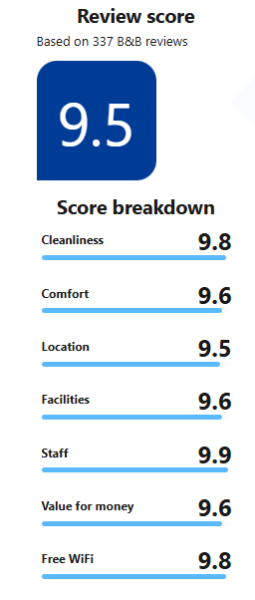
(Source: Booking, 2025)

