Module Title: Certificate of Higher Education in Skills for the Workplace

Assignment Title: BMSK4002 Effective Team Working and Communication

I declare that this report is mine own work.
Silviya Spasova – 1817128

Tutor:
Date of submission: 29/08/2019

Contents
Introduction 2
What is communication? 2
Communication process 2
Different type of communication 3
Verbal communication 3
Non-verbal communication 3
Face-to-face communication 3
Spoken communication using electronical devices 4
Writing communication 4
Personality addressed 4
Impersonality addressed 4
Workplace communicating and effective team working 5
What is workplace communication? 5
Centralised and decentralised communication 6
Virtual communication 7
Effective Communication Skills 7
Leadership 8
Conclusion 9
Bibliography 10

Introduction
In this class, I must attempt to explain why efficient teamwork can't be achieved without efficient communication. Teamwork is like human brain, every part of it have different function. All parts of the brain must operate together to carry out the job efficiently. To be successful all separate parts need good communication between them. What are varying kinds of communication and how they contribute to a healthy and efficient team? Good communication is the baseline for an efficient squad and enables the job to be carried out easily.
The right communication skills help management guide the team at its goal and help all members to become better integrated into the company.

What is communication?
“Communication is exchange of information through written or spoken words, symbols and actions to reach a common understanding” (Boddy, D. and Paton, S., 2011).
Communication is simply the act of transferring information from one place, person or group to other. With other words we can say every information spoken or not is called communication, but of course have a rule which need to exist. We need to have sender, massage and receiver to complete the circle of statement. This is looking easy, but it is very complicate topic. To understand better the process of communication we need to look deeply in it.

Communication process
At least two individual’s sender and receiver are needed for communication. Sender sends massages to recipient via channel (email, phone call, face to face etc.) into a form of word, which we called ‘code’. The receiver understands the request and gives his feedback to the sender, it is understood or not. The response is interpretive of the recipient.
We can se the full process shown on fig. under.
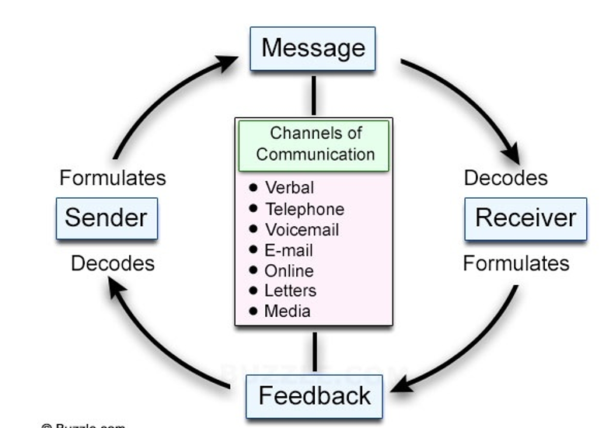
Fig. 1 Buzzle.com from lecture week 2
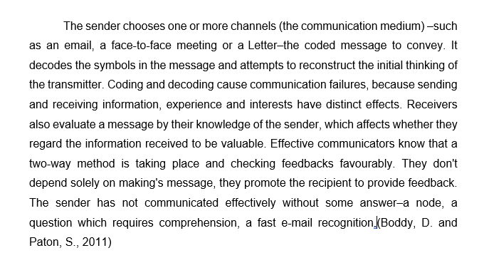

Different type of communication

Verbal communication
Words and language, we used to transmit massages is called verbal communication. It can be written, oral, face to face or over the telephone communication. We can say also everything we can express with words. The information here is sending and receiving fast. (Business Communication, 2013)

Non-verbal communication
That is wordless communication, we are not using letters or words. We use signals as facial expression, body language, gestures, postures, pictures, eye contact and others to communicate. The transmitting of massage here is longer, as we are trying to understand sender signals. The chances of confusion here are more than verbal communication. (Business Communication, 2013)

Face-to-face communication
One of the best communications because it is including verbal and non-verbal communication. You can see all face expression and hear all word and intonation when person spoke. It is advantages that in our dates we can make video conversation without traveling and felling comfortable speaking from home.

Spoken communication using electronical devices
Speaking through telephone and internet messenger we cannot see non-verbal expression but we here the intonation of voice. Feedback is quick and both sides can ask if everting that said is clear. But disadvantages are that you can’t see body languages

Writing communication
The personal benefit of person-to-person communication lies in the fact that it is directed to the recipient personally and tends to call for his or her attention. The sender can also send the message in a manner suitable for the reader. When both sides correctly exhibit their views and look for feedback, a high level of mutual understanding, which is also recorded, can be achieved. Even if individuals understand each other, they often follow up with a written e-mail, fax or letter.
Mail and social networking more lately (more emails are now sent via social networking websites than via email)

Personality addressed
Write messages to personal email or social network. Via email is good communicating because can exchange information and have time to think what the other person wants to say to you and have time to respond him

Impersonality addressed
This is when sending information to more receivers that can be on company website and don require response. Feedback missing and sometimes information can be over that people can accept.

Models of communication
Shannon and Weaver’s model
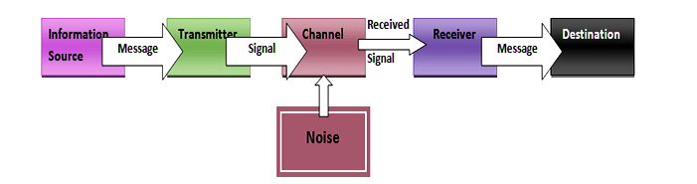
Fig. 2 https://www.qsstudy.com/business-studies/shannon-weaver-model-communication
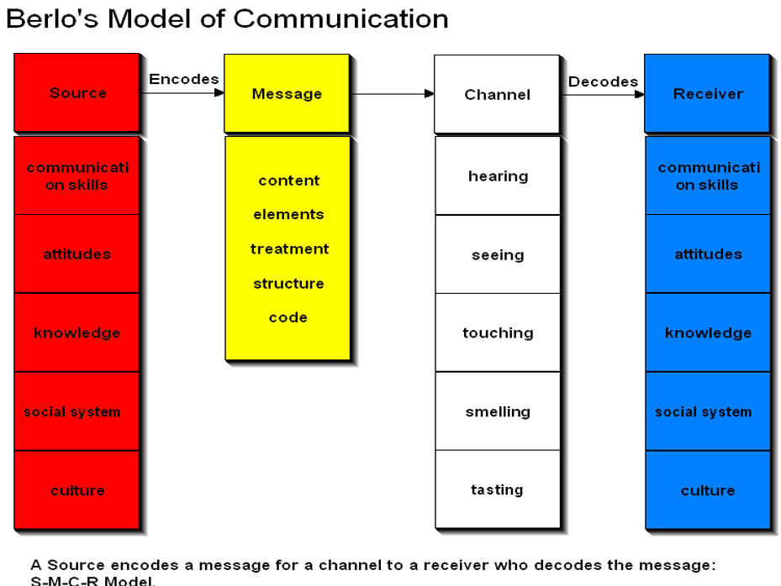
Fig.3 From lecture week 2
This is the rule for individual and group communication, but it will be same in group and team work situation or in organization.

Workplace communicating and effective team working

What is workplace communication?
It is called workplace communication to exchange information and ideas, both verbal and nonverbal, between one person / group and another person / group within an organization. It involves emails, text messages, notes, calls, and so on. Effective communication is critical in achieving the work, building a feeling of confidence and improving employee productivity (Faizal, F.,2018)
It is interesting to see how difference is handled by human beings. People have always had differences with what they have. Different religion, ethnicity, gender, age, training–there has always been a challenge for human humans to confront what is varying.
With someone like me, I feel more comfortable, safer. With someone distinct from me, I feel insecure–younger, or a stranger. But I recognize that I will learn a lot even if someone is different. We tend to dismiss what's distinct–and yet what's different is what we need. Because the only way we can develop is by confronting ourselves with what is different.

Centralised and decentralised communication
In order to comprehend how individuals, interact in a group, they need to have instruments to analyse interaction patterns. In a laboratory experiment Shaw (1978) determined which communications groups were used and how the job performance was influenced. Shaw see Figure bellow:
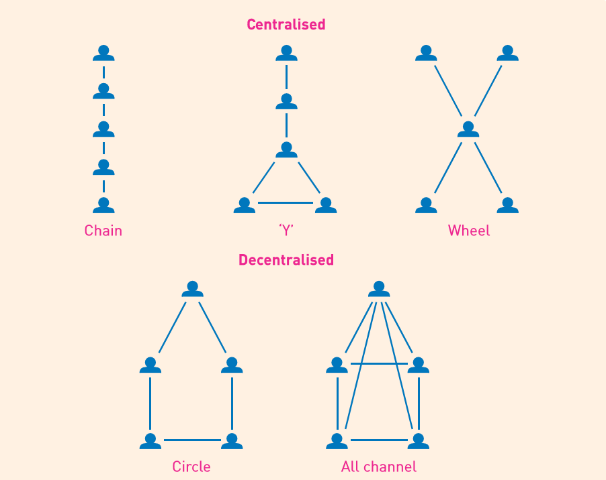
Fig. 4 Centralised and Decentralised communication source Shaw (1978) (Boddy, D. and Paton, S., 2011)
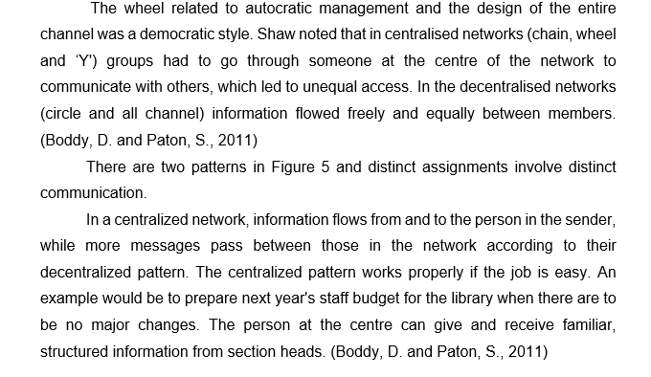

Virtual communication
It is when people didn’t speak face to face. This communication can be in social media like Facebook, Twitter, emails, web chat etc. It is called computer mediate communication (CMC). It favours the ability to see and hear one another in real time, simulating the experience of a physical visit. Such technology has been around for quite a few years, with the introduction of webcams in the 1990s. But what was once a poor-quality, non-secure, burdensome social experiment has developed into a productive technology that benefits families, friends and businesses alike. (Cheryl, F., 2018)

Effective Communication Skills
Communication is the basis of every facet of a business. Effective communication is communication between two or more people in order to successfully deliver, receive and understand the message. It is the method of exchanging data between team members in a manner that considers what you want to say, what you are saying, and what your audience is interpreting. (Kashyap, S., 2019)
For the future to grow better communication habits implies to practice efficient communication skills and to be a strong communicator. But what are the effective communication examples? Well, here are three communication skills that you should be working on: (Kashyap, S., 2019)
1. Be conscious of your body. Your body tells you a tale.
• Crossed or folded arms–defensiveness• Hands kept behind the body–confidence• Fixing clothes, accessories, watching–nervousness• Fingers clenched–anger or anxiety • Squeezing hands–self-reassuring
2. Active listening– Active listening is not just like hearing. We need to be more concentrate, to listen carefully and to understand the objectives of conversation. It is not easy as have a lot of distractions which can disturb our attention. We just need to make sure that we get as much information we can and not to think what to say after. There are many individuals who are bad listeners. They focus not on what the speaker says, but on what they're going to say as quickly as there's a break.
3. Confident delivery–By being patient, you need to create a powerful delivery. The topic is just as much component of the communication process as the message itself, and how you perceive it. You need to write a message that is apparent to the team and sufficiently complete to allow both to achieve mutual knowledge. This means how others interpret the message and eliminate potential sources of confusion.
4. Be empathic -- receivers are empathic when attempting to comprehend how the sender feels and attempting to inter-pert the message from the viewpoint of the sender, rather from their own situation. A junior staff member may raise an issue with a senior colleague that may reflect his / her inexperience. The senior might dismiss the application, suggesting that the suborn donate should understand how to handle the scenario. An empathetic reaction would take the inexperience into consideration and more knowledge would be given to the request.
5. Be positive – Finally, but not least, attempt to remain positive. Whatever you mind, it will save you from discussion by being positive.

Leadership and barrier
As leader, we must interact and communicate in logical manner. While we are incompatible, our supporters can get confused and their confidence in us can begin to weaken. Leader should have closer communication with individuals. Leader must have strong communication skills which will help the growth of company and relationship between him and workers will be good. Leaders must make future planes that helps as to achieve the workplace aids.
According to Zoller and Preston, (2015) barriers can be created by:
- Not beginning with the end in mind
- Not connecting and building relationships
- Lack of awareness
- Making Assumptions
- Not focusing on the details
- Not giving precise feedback
- Not adapting your communication style
- Not reacting professionally
- Not managing perception
Communication challenges
For me English is second language and challenges I met are:
- Misunderstanding of the topic of discussion
- Jargons language is unfamiliar to me
- Difference in viewpoint
- Difficulties showing non-verbal communication as in country I am coming from we don’t make an eye contact when we speak for example.
- Even the stress when I speak, is a barrier for me.
- Sometimes the terminology used is also big challenge for me.

Conclusion
Now we learn many aspects of communication and that knowledge will help as in our workplace to have good and successful communication. That will happen when we choice the properly channels to communicate with other employees. An in final of my assignment, as evidence of all learn in university for communication and skills I develop through classes, I am loading all my home and class work in pdf.
Communication homework https://d.docs.live.net/50b5230688e0cee1/Documents/Silvia%20assigment/assigments/communication%20understanding%20homework.pdf
Class Work https://d.docs.live.net/50b5230688e0cee1/Documents/Silvia%20assigment/assigments/Informal-or-Formal%20class%20work%20.pdf
https://d.docs.live.net/50b5230688e0cee1/Documents/Silvia%20assigment/assigments/class%20work%20.pdf

Bibliography

Boddy. D. and Paton. S. Management an introduction. Fifth Edition. (Pearson, 2011)
Cheryl, F. (2018). What is virtual communication technology. [Online]. Available from: https://www.techwalla.com/articles/what-is-virtual-communication-technology [Assessed :19/08/2019]
Faizal. F. (2018). What is workplace communication? (& Why does it matter). Feedough.com. [Online]. Available from: https://www.feedough.com/what-is-workplace-communication-why-does-it-matter/ [Assessed: 17/08/2019]

`Kashyap’s. (2019). Here’s How Effective Communication is in the Hands of 73% of Professionals. ProofHub. [Online]. Available from: https://www.proofhub.com/articles/effective-communication?fbclid=IwAR3we_QCwgaskn4DytutQcmrOcEBfhojdMBgvs6n9QnJLqCPgmDExLoLdTQ []Assessed: 18/08/2019]

The Business Communication (2013). What is verbal and non-verbal communication? . The Business Communication. [Online]. Availablefrom:https://thebusinesscommunication.com/what-is-verbal-communication-and-non-verbal-communication/ [Assessed on 16/08/2019]
Spasova S. (2019). Communication Homework. [online]. available from : https://d.docs.live.net/50b5230688e0cee1/Documents/Silvia%20assigment/assigments/communication%20understanding%20homework.pdf (week 9)
Spasova S. (2019) Class Work. [online] Available from: https://d.docs.live.net/50b5230688e0cee1/Documents/Silvia%20assigment/assigments/Informal-or-Formal%20class%20work%20.pdf (week 4) https://d.docs.live.net/50b5230688e0cee1/Documents/Silvia%20assigment/assigments/class%20work%20.pdf (week 4 )
Zoller, K. and Preston, K. (2015). You said what?!Career Press, p.5

