Lewis Gray
Ministry of Defence
Word count: 1384

Titration of Hydrogen Chloride and Sodium Hydroxide.

Contents

Aim

Theory

Chemicals and equipment

Procedure

Observations

Results

Calculations

Conclusion

Evaluation

Aim
To determine the concentration of hydrogen chloride (HCl) using a known concentration of sodium hydroxide (NaOH) using titration.

Theory
A titration is the slow introduction of a standard solution (a solution of accurately known concentration) of reagent, called a titrant, to a known volume of unknown concentration, called a titrand, until neutralisation occurs. The volume of titrant used to achieve neutralisation can then be used to calculate the concentration of the titrand using the formula:
C_{A} = C_{B} x V_{B} / V_{A}
Where C_{A} is the unknown concentration of titrand, C_{B} is the concentration of the standard solution of the titrant, V_{B} is the volume of the titrant and V_{A} is the volume of the titrand.
The addition of an indicator is used to determine the equivalence point at which neutralisation occurs. An indicator is a solution where the colour changes based on the potential of hydrogen (pH) of the solution.
Neutralisation occurs when the acidic H⁺ ions and basic OH⁻ ions are balanced and the pH of the solution is around seven.
In the case of the reaction between hydrogen chloride and sodium hydroxide, both are strong acids and bases respectively meaning that they completely dissociate to form an aqueous solution. The equation can be written as:
HCl (aq) + NaOH (aq) → NaCl (aq) + H₂O (l)
Dissociation is a general process where molecules split into other things like radicals or ions. Dissociation is usually a reversable reaction, and the general formula can be written as: AB → A+B
NaOH → Na⁺ → OH⁻
HCl → H⁺ → Cl⁻
The net ionic equation can be written by removing spectator ions. Spectator ions are ions that are present but do not participate in the reaction. In this case, the spectator ions are Cl⁻ and Na⁺, so the net ionic equation can be written as:
H⁺ (aq) + OH⁻ (aq) → H₂O (l)
The aforementioned equation shows one of most crucial ideas of a strong acid/base reaction, whereby ions from the strong acid and base react together to form water and a salt which is neutral. This is consistent with Brønsted–Lowry theory, which states that when an acid and base react, conjugate acids and bases are formed by the exchange of hydrogen ions, as in reality the hydrogen ion is a hydroxonium molecule which is formed by the protonation of water and is a conjugate acid:

H₃O⁺ (aq) + OH⁻ (aq) → 2H₂O (l)

In industry, titrations are incredibly useful as they are simple, cheap and have a range of uses. It is used in the analysis of wastewater and can be used to determine what harmful chemicals and present and how strong they are. It is also famously used in the cheese industry to determine the acidity of the milk used in the initial process as the microbes present in the cheese are sensitive to pH levels and the wrong pH could be detrimental to the quality of the final product.^{[1]} It can also be used in the munitions industry as some explosive chemicals are pH sensitive. A pH too high or low could denature the explosive and render it dangerous. Titrations are therefore important for the safety and wellbeing of manufacturers and those working with and on munitions.

Chemicals and equipment
- One hundred millilitres of 0.1002M NaOH.
- One hundred millilitres of HCl of unknown concentration.
- Phenolphthalein indicator.
- Burette (50ml).
- Pipette (10ml).
- Conical flask
- Small funnel.
- Waste beaker (250ml).
- White tile.

Procedure
The pipette, burette and conical flask were first rinsed with hydrochloric acid, sodium hydroxide and deionised water respectively to remove any contaminants. The conical flask does not have to be dry as the water does not contain any ions which could affect the equivalence point. The burette was then filled with NaOH with care being taken to fill the bottom of the tap and to remove any air bubbles. The bottom of the meniscus was filled to the zero mark. The pipette was then used to transfer 10ml of the HCl to the conical flask along with a few drops of phenolphthalein. The conical flask was then placed on a white tile to better observe a colour change. The burette was then used to slowly add the sodium hydroxide until a colour change was noticed. When the colourless solution in the conical flask shifted to a light pink the reading on the burette was recorded. This was repeated until three concordant results were obtained. Concordant results fall within 0.10ml of each other.

Observations
At the start of the titration the area immediately around the stream of hydroxide going into the hydrochloric acid turned purple. This was due to the presence of phenolphthalein in the acid which turns purple in the presence of an alkali solution. The phenolphthalein turned pink in the local basic environment, but the colour quickly dissipated due to the hydroxide reacting with the acid. This eliminated the basic OH⁻ ions which formed water with the acidic H⁺ ions.
As the titration continued and the equivalence point drew closer, the pink colour from the phenolphthalein persisted for a short time before returning to its colourless form. This was due to a decreased level of acid to react with the base. After a quick swirl of the conical flask, the hydroxide encountered hydrogen chloride molecules and reacted to form NaCl and H₂O.
At the equivalence point, the colour of the solution in the conical flask rapidly turned from being colourless to a bright pink. This was the result of adding the phenolphthalein indicator as it turns bright pink in the presence of an alkali solution. The strength of the pink colour given off by the phenolphthalein depended on how basic the resultant solution was. A pH slightly above 7 would produce a very faint pink tinge in the solution whereas a higher pH would produce a stronger pink.
The aim was to achieve a pH as close to 7 as possible so a faint pink hue in the conical solution was desirable.

Results
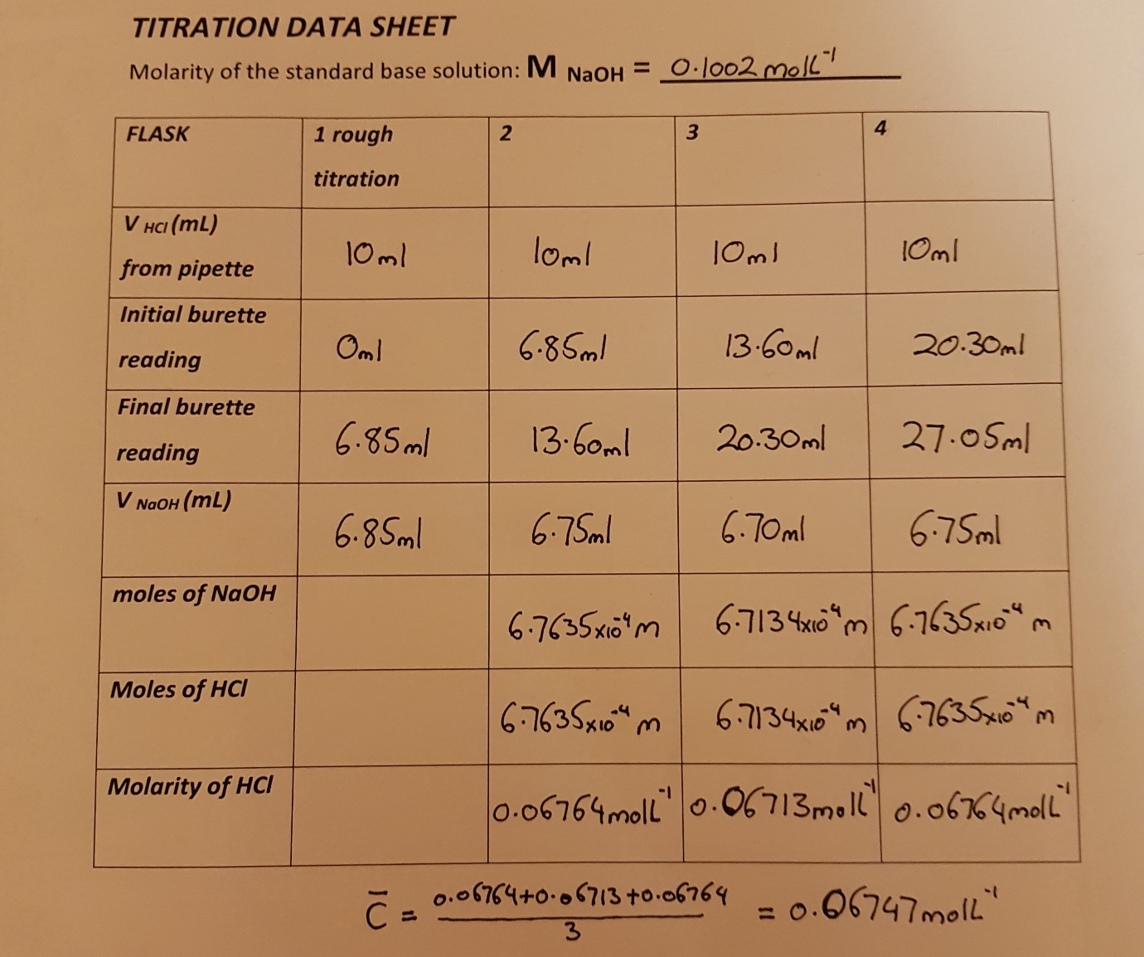

Calculations
By using the equation C_{A} = C_{B} x V_{B} / V_{A}, the unknown concentration of acid can be determined. The units for the calculation is molL⁻¹ for concentration and litres for volume. A calculation was done for each titre and an average was calculated to determine the concentration of the titrand:
C_{A} = C_{B} x V_{B} / V_{A}
C_{A} = 0.1002molL⁻¹ x 6.75_{x10-4}L / 10_{x10-3}L
C_{A} = 0.06764molL⁻¹

Conclusion
In conclusion, the concentration of the unknown solution of hydrogen chloride was calculated to be “” and this was done using a standard solution of sodium hydroxide.

Evaluation
The indicator phenolphthalein was used to determine the equivalence point of the reaction. A disadvantage of using this indicator is that it changes colour very suddenly when the end point is reached. The bright pink colour is only present when in a basic environment so although a neutral solution was the aim of the titration, a basic solution was produced by overshooting the end point, resulting in a strong pink colour in the conical flask. A better solution would have been universal indicator. Universal indicator changes colour though the titration to allow for a better judgement of the true equivalence point. As the pH nears neutral, the colour of the solution with shift from red to yellow and finally to green in a gradual colour shift which makes it easier to anticipate and determine the end point of the titration.

There is also the uncertainty of the glassware that was used in the experiment. Although very accurate, the burette and pipette are manufactured with tolerances that can affect the overall accuracy of the experiment. The tolerance of the 10ml pipette is ±0.08ml which results in a percentage uncertainty of 0.008% while the burette has an uncertainty of ±0.05ml which results in a percentage uncertainty of 0.0075%.
For the last titration, a someone different conducted the procedure which may have affected the precision of the experiment. There was a different technique being employed and a different result may have been obtained.

References
[1] L. Bell-Young, “What is Titration Used For in Real Life? | The Chemistry Blog,” ReAgent Chemicals, Oct. 20, 2021. https://www.chemicals.co.uk/blog/what-is-titration-used-for-in-real-life

‌Data Sheet


