

Paul Newman 1805494
Module ACCA5034
Prof. Carlene Campbell

Task 1 – Research in Data Security and Compliance

TASK 2 – CASE SCENARIO FLOW-TECH

Introducion
Task One
In this task we look at three subjects and go in a brief detail of how they have changed though history and how they have helped shape the world at large and where it could go in the future.
Task Two
Is a make-believe computer company FlowTech in its infancy and how and what it would need to not only grow but keep its customers infatuation safe from attacks.

Task 1 – Research in Data Security and Compliance

Table of contents
1 Task 1 – Research in Data Security and Compliance 1
2 TASK 2 – CASE SCENARIO FLOW-TECH 1
3 Cryptography 5
4 Physical Security 9
4.1 Risk Avoidance 9
4.2 Risk Acceptance 9
4.3 Risk Transfer 9
4.4 Server rooms 10
4.5 Door types for physical protection 10
4.6 Lock types for physical protection 12
4.7 Biometrics 13
5 Firewalls and VPNs 16
6 Task Two 17
6.1 Compliance (Laws and Ethics) 17
6.2 Governance and Strategic Planning for Security 18
6.3 Risk Management 18
7 Conclusion 21
8 Bibliography 22

Table of Figures
Figure 1 "Scytale" [2] 5
Figure 2 Dr Claude E Shannon [3] 5
Figure 3 Differential analyser [4] 6
Figure 4 Alan Turing [5] 6
Figure 5 Lorenz Cipher Machine [4] 6
Figure 6 Bruce Schneier [7] 7
Figure 7 Cryptography and Security [8] 8
Figure 8 Song Y. Yan [8] 8
Figure 9 Public and Secret keys [8] 9
Figure 10 Strip Doors [12] 10
Figure 11 Sliding Doors [13] 11
Figure 12 Hinge Doors [14] 11
Figure 13 Typical Keypad [15] 12
Figure 14 Key cards and Fobs [16] 12
Figure 15 Eye scanner [17] 13
Figure 16 Audrey [18] 14
Figure 17 Faraday cage for routers [20] 14
Figure 18 DFC cameras [21] 14
Figure 19 ANPR Camera [21] 15
Figure 20 Dome Camera [21] 15
Figure 21 Bullet Camera [21] 15
Figure 22 PTZ-Pan Camera [21] 15
Figure 23 Infrared Camera [21] 16

Cryptography
The first form of Cryptography that is known to man was invented in 600 BC by the Spartans, the Spartans would use leather staps wrapped around a wooden rod called a “Scytale”, as cryptography descended though the millennia many other civilizations created new and more advanced forms of cryptography. [1]
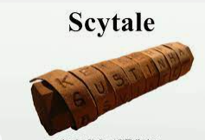
Figure 1 "Scytale" [2]
During the 1940s Claude E. Shannon started the more modern form of cryptography using mathematics.
“The American mathematician and computer scientist who conceived and laid the foundations for information theory. His theories laid the groundwork for the electronic communications networks that now lace the earth.” [3]
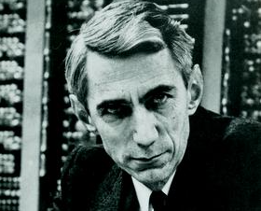
Figure 2 Dr Claude E Shannon [3]
Dr Shannon and Dr. Vannevar Bush both worked on one of the early analogy calculating machines, called the "differential analyzer," which used gears, wheels, shafts, and disks to calculate and solve calculus. [3] Analog machines did not last long and made way for more advanced digital machines, Dr Shannon came up with the idea of applying a mathematical logic using “Boolean algebra” to design relay switch circuits, this idea transformed circuit design almost overnight, and it is still the remains the foundation of chip and circuit design today. [3]
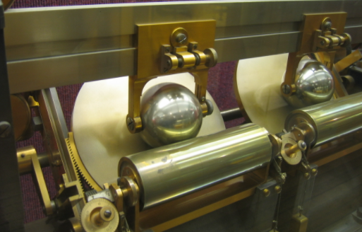
Figure 3 Differential analyser [4]
During the second world war Alan Turning a mathematician helped crack the “Enigma Machine” with the “Bombe” Mr Turning was already working for the British Government (part-time) in the Code and Cypher department “GCHQ”. [5]
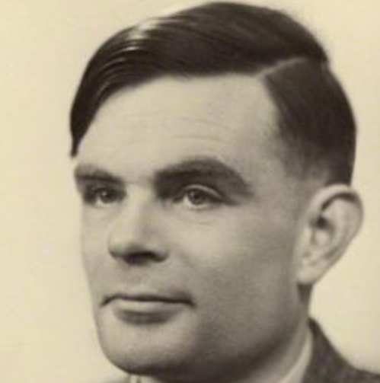
Figure 4 Alan Turing [5]
Mr Turing and others in GCHQ had their work cut out for them as the Germans Enigma machine would change the codes daily as the Polish had already cracked the German codes, little did the Germans know that Mr Turning was also a vital part of the “Lorenz Cipher Machine” which did crack the German codes in 1942 which helped shorten the war by years. [5]
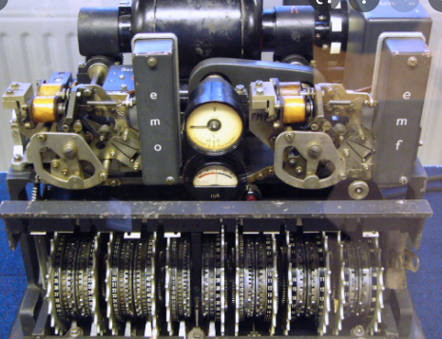
Figure 5 Lorenz Cipher Machine [4]

IBM started digital cryptography in the late 1960’s in a lab in New York headed by Mr Thomas J. Watson, the Encryption was called “Lucifer” it was designed to be used for Lloyds Bank for their ATM machines in the UK. Later the U.S. government enlisted IBM to create security for civilians and Military. [6]

Lucifer’s algorithm was updated with the help of the U.S. National Security Agency later in 1977 the NBS adapted Lucifer algorithm as the first DES (Data Encryption Standard). [6]


Figure 6 Bruce Schneier [7]
“Almost all of the encryption algorithms ... can trace their roots back to DES.” Bruce Schneier: [6]
When the public was introduced to the Internet in the late 1990’s cryptographies changed forever, it became a more commonplace for interactions between the public and government agencies. Hence SSL (Secure Sockets Layer), TLS (Transport Layer Security) and IPsec (IP Security) where born, later HMAC (Hash-based Message Authentication Code) was devised. IKE (Internet Key Exchange) is a key part of IPsec and VPNs (virtual private networks). [6] IBM where at the frontier of most cryptographic solutions such as storage encryption and other security technologies including reverse engineering and tampering and later lattice-based cryptosystems, Chosen-Ciphertext Attack (CCA) encryption and homomorphic encryption. [6]
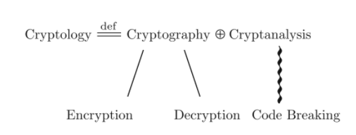
Figure 7 Cryptography and Security [8]


Figure 8 Song Y. Yan [8]
The basics of cryptography is to send encrypted messages to private and public server’s safely and receive them back again (decrypt), there are two basic types of cryptographic.
- Secret-key (symmetric-key)
Secret-key can be used for both encryption/decryptions the algorithm is converted in a form that cannot be understood unless the user has the secret-key to decipher the message. [8]
- Public-key (asymmetric-key)
Public-Key is different, it uses two keys both public (is used for encryption) and private-key (is used for decryption) Public-key has dual nature: one it has encryption and two gives a digital signature, Transport Layer Security (TLS) and Secure Sockets Layer SSL which makes Hypertext Transfer Protocol Secure HTTPS possible. [8]

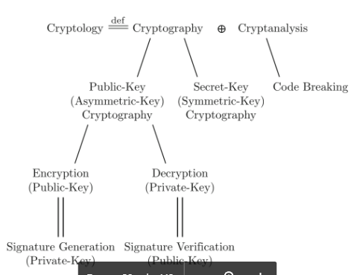
Figure 9 Public and Secret keys [8]

Physical Security

Risk Avoidance
To truly avoid a risk, it is necessary to change a company’s understanding in all matters of security such as Physical defences, even to risks that are very rarely arise depending on what type of data/information is currently being safeguarded by the company such as Military, Government or banking. [9]

Risk Acceptance
Risk acceptance normally happens when the company believes that there are no more practical, cost-effective means to keep reducing the probability or impact of an attack and therefore decides to accept the risk (this on the other hand has had dire consequences) . [9]

Risk Transfer
Risk transfer is where a third-party insurance company agrees to pay out to cover for a financial loss in case an attack happens, and data/information is corrupted or lost. Risk transfer can be a way of dealing with some security risks. [9]

Server rooms
Server rooms are the heart of all high-performance companies. To keep your network safe from physical attacks to storing sensitive data and information, server rooms are the essential to keep the operations of the company uninterrupted. As server rooms are often very expensive, they are financially expensive and need to be treated as an investment. Due to these reasons, server room’s need to be monitored 24 hours a day. [10]
To protect the server room’s equipment from intrusion. All doors should be always locked. Door alarms should be Installed at each access point to the server room. You should have some type of video surveillance. [10] All visitor policies should be strict with non-stop video and alarm monitoring. There should be ID badges for authorised staff members to enter restrict access points. [10]

Door types for physical protection

There are three main types of doors:
- Strip doors are used to close off air and are easy access to information and data, most are anti-static to ground employees so no static shocks or loss of data happens. [11]
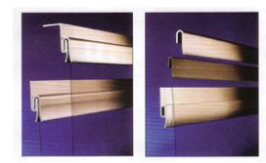
Figure 10 Strip Doors [12]

- Sliding doors are used for air flow control and containment, used for busy traffic, and can be used to seal off server stacks. [11]
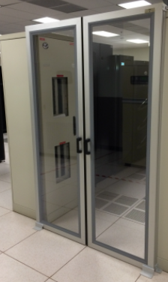
Figure 11 Sliding Doors [13]

- Hinge doors are used for optimal air flow and temp control, they are airtight and very good for data centres. [11]

Figure 12 Hinge Doors [14]

Lock types for physical protection

- Keypads are cheap to install but over time the ink/paint on the keypads fail and leaves it clear which numbers or letters are used, same goes for grease from your fingers can taint the buttons if not cleaned.
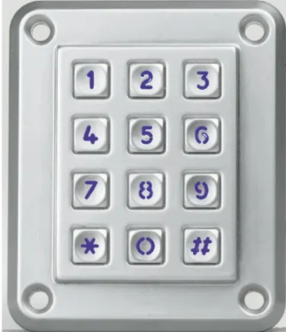
Figure 13 Typical Keypad [15]

- Lock and Cardkey/fobs
Key Cards and fobs are a fast and effective way for authorised staff to gain access to busy doors that need a basic amount of security, most key cards/fobs are programmed to only let certain authorised staff in to selected areas, there are now apps that can be downloaded on to smart phones but just like key cards and fobs all can be lost or stolen.
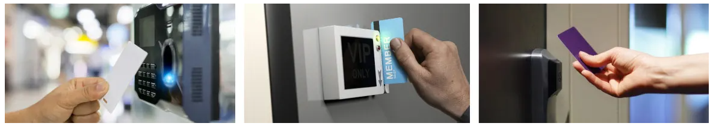
Figure 14 Key cards and Fobs [16]

Biometrics
In the ever-changing world of security, it is far more difficult to keep important areas safe and secure from attacks. this is where biometrics comes into play, Biometrics use anything from finger, handprint, voice, eye, and facial recognition to make it far more difficult to infiltrate sensitive areas and here are just a few:
- Eye-scanner and Hand scanners
Eye-scanners and hand scanners are very good to identify and authenticate staff and customers for access to restricted areas, the Hand scanners use the size and shape as well as the fingerprint of the user and is much more difficult to impersonate. Fingerprint readers use the unique characteristics of a person’s fingers to identify them, Eye-scanners scan the retina and the blood vessels different patterns and colour of each person. Facial recognition much like the hand scanner scans the size, shape, and bone structure.
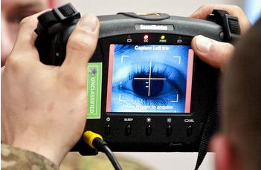
Figure 15 Eye scanner [17]
- Voice scanner
Voice scanner or voice recognition software are used on many devices and decodes human voices, the first voice scanner was made in 1952 called Audrey a digit recognizer, it was not computerized but mechanical, it was able to read the human voice. Automatic Speech Recognition (ASR) is now used in almost every technological field today such as air traffic controllers, pilots, medical records and many more. [18]
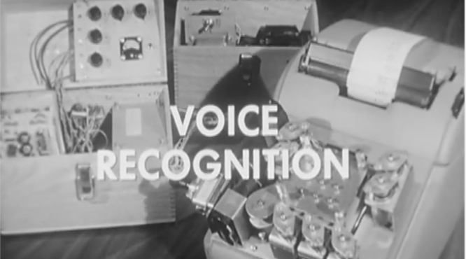
Figure 16 Audrey [18]
- Faraday cages
Faraday cages can block all external electrical fields, and keeps out Wi-Fi, radio, and mobile phone signals, this stops hackers form reading data from the server rooms, Faraday cages are also very good at protecting from solar storms, lightning strikes and Electro-magnetic pulse (EMP) weapons. [19]
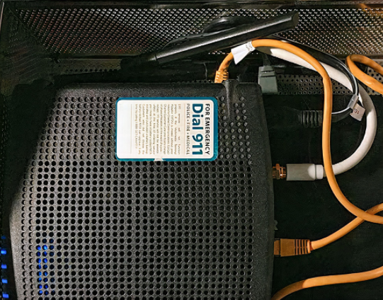
Figure 17 Faraday cage for routers [20]

- CCTV
There are a lot of Close-Circuit Television (CCTV) to choose from nowadays each specialised for different types of security: -
- Dark Fighter Cameras (DFC) are very affective in low light and can pick up colours, with scanning sensors it is able to pick up audio and face detection. [21]
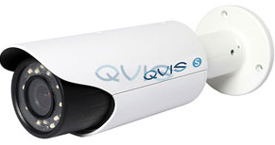
Figure 18 DFC cameras [21]
- ANPR/LPR cameras can read and store information and can recognise vehicle plates even in a high travel area. [21]
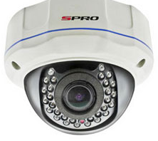
Figure 19 ANPR Camera [21]

- Dome Cameras are very common as people cannot tell in which direction the camera is pointing and it also has IR night vision, excellent for inside and outside. [21]
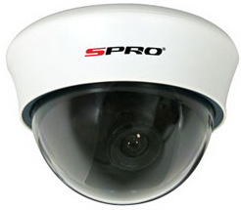
Figure 20 Dome Camera [21]
- Bullet cameras are cylindrical shaped and are very good for outdoor security and has shielding from elemental problems. [21]
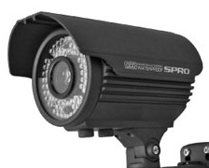
Figure 21 Bullet Camera [21]
- PTZ-Pan cameras can tilt, turn 360 degrees, and zoom in and out to get better surveillance on some wood be intruder. [21]
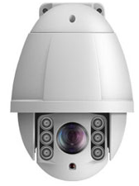
Figure 22 PTZ-Pan Camera [21]
- Infrared cameras are excellent for day or night surveillance in quiet or busy traffic areas, they can pick up figures moving in complete darkness. [21]
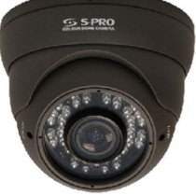
Figure 23 Infrared Camera [21]

Firewalls and VPNs

- Firewalls
Firewall is a computer software device to keep virus and preventing hackers form accessing your computer via unauthorized control. The three main types of firewalls are:

Proxy Server
Is a router or gateway to the internet via a private network, protecting against attackers. [22]

- Stateful Inspection
Or dynamic packet filtering which is a firewall that monitors the connections to determine what network to allow entry though the firewall. [22]
- Packet Filters
Is a technique to control access to networks via monitoring incoming and outgoing traffic and either allowing them to give access or not. [22]

- Visual Private Network (VPNS)
Encrypts the packets and authenticate the data when accessing a single host or a subnet, The VPN can hide the users address from internet providers. [23]

Task Two
In this Task FlowTech is an imaginary cyber security tech company that is up and coming and very popular cyber-Security company where they will have security contracts with various government agencies and governments around the world, protection for these governments and the agencies that are under contract with flow tech are paramount in this field and are the highest security concern against cyber-attacks, hacking and government espionage.

Compliance (Laws and Ethics)
Leadership is making sure that past mistakes are not repeated and to highlight the achievements of today while maintain a well-grounded foundation to foresee future problems of the company. The Leadership has a responsibility to maintain the Laws and Ethics of not only the of the country of origin but also of the country the company maybe residing in, such as: -
- The Foreign Corrupt Practices Act (FCPA)
Which prevents the corrupt and illegal payment to forging and domestic government officials in gaining improper business advantages.
- Any company that is registered on the U.S. stock exchange.
Must have to maintain accurate records and books.
Any company that does business in the foreign market and companies with employees and business partners all need to be versed in the Foreign Corrupt Practices Act FCPA and must work within the parameters of the act, or the fines for that company can cost in the tens of millions and possibly of prison time many companies have been closed due to the long and expensive investigations. [24]

Governance and Strategic Planning for Security
Is a set of responsibilities and practice’s that a governing board of management with the purpose of strategic plans to make sure the objectives and goals of the company are to achieve, the 3 main components that the governing board need to insure are 1.) Risk Management 2.) Information Security governance and 3.) Regulatory compliance.

Risk Management
There are several types of risk management that all companies must take into consideration such as: -
Compliance Risks
There are different risks in any company, and some are more dangerous than others some of these can even kill or maim an employee, but all are just as important as each other in maintaining safety and security for the employee.
- Fall Protection
Before any staff are exposed to any fall/falling hazards, it is up to the safety professional to teach the staff that use machines that used fall protection systems. [25]

- Confined entry space
Confined space entry is one of the most hazardous activities in any industrial area, on average 2 people die in a confined space because one getting hurt and the other trying to rescue the other, due to unforeseen dangers. [26]
- Hazardous Materials
Hazardous materials can be ambiguous and continuous in nature, collection of such hazardous refuse is collected and stored on the companies’ premises and may need to be disposed of once or twice a week if it is very hazardous then it may be take daily, storing and moving the hazardous material in it self can be very dangerous and all safety procedures must be observed. [27]
- Childcare
In some companies they have a childcare department for single parents to leave there offspring, the company would have to employ nursery school professionals to look after and keep children safe.
- Alcohol and Drugs
Due to high stress all companies should have testing methods for substance abuse, as more and more stress is put on employees in this current business environment of fast passed working conditions more and more people are scumming to substance abuse to ease the stress. Recreational drugs are at an all time high in high level companies, a drug and alcohol testing with blood and/or urine, hair and saliva can help deter if not slow down the consumption so said substance. [28]
- Hazardous Energy
Anywhere employees have contact with electricity is classed as a potentially hazardous area, Arc flashes can leave an employee with severe injuries or even death most electricity injuries are very traumatic and can be very costly for the employee and the company itself. As the human body has a complex Emotional, neurological, and physical trauma it can be very costly for the company to pay out for rehabilitation. Not only the damage done to the employee there is also the company’s infrastructure to think of in case the company’s data/ critical equipment
is lost or damage due to the accident. [29]
- Domestic violence
Domestic violence and bullying in the workplace can at best isolate a person from others and at worst cause someone to either implode (suicide) or explode (murder) other employees, there are multiple reasons that slowly increase with intensity that can cause some one to hurt them self or others due to the stress of bullying, it is difficult to understand what make people tick and what upsets them, one person might be able to take it as just Banta where are other’s would take it to heart. There is no full proof way to stop some one from hurting them self, but you can check for tell tail markers to tell if they are on the edge and counselling can be given to reduce the chances of a death. [30]
- Prohibiting top level VIPs from traveling together to prevent kidnapping or black mail
Frequent international travellers from big companies are at risk the higher the position the higher the likely hood of kidnap or blackmail, VIPs should take necessary measures to reduce the chances of said attacks. If the company is doing business in countries that have a high rate of kidnapping the company should find out the threat level for that county at those times to make an accurate assessment of safety Evan the hotel and the street it is in can sometimes make the difference in threat level. The company should do recon on the hotel, the streets close by and if there are any known terrorists that operate in the area. [31]
- Natural Disaster management Risks
When a company decides to expand and build in other parts of the country or other countries, they must consider the landscape and any natural disasters common or uncommon to that region as part of project design e.g., tornadoes, earthquakes, tsunamis, and other disasters, would it be a safe place for employees? how much would it cost to make the building resistant to said disasters? And many more important questions. [32]
- OSHA
Occupational Safety and Health Administration (OSHA) started in the U.S. in 1970 and was to maintain safety in the workplace, while implementing health programs and keeping to the Laws and regulations of the region. [33]
- Employee Searches including Lockers and bags
Companies have the right to search employees’ lockers, bags, and their person if the company believes with reasonable basis for a search that the employee has stolen from the company.
- Vehicle protection and search
It important that the company keep the employees’ vehicles safe due to acts of violence such as bomb’s depending on the country, they are in but to also search the employee’s vehicle in case of industrial theft of data.

- Flammables and poisonous chemicals protection
Flammables and poisonous chemicals are a big part of project design, Fire and poisonous chemicals should be integrated with the building in mind to protect the company and its employees when being built or refitted in its plan. [34]
- Freedom of Information Act (FOIA) and the Law
If the company is working for a government agency, then the public can request a FOIA to disclose of any public based records. [35]
- Monitoring E-mails and phone calls
In some cases, the company may require keeping monitoring of e-mails and phone calls of their employees to maintain company secrets and to prevent blackmail and espionage.
- Local and International Terrorism
The security professionals would need to invest a considerable amount of time on intelligence
Gathering of the area and the political climate of that country or city, to maintain safety for the company and its employees. [36]
- Travel Restrictions due to Sickness and pandemics
Due to the current climate around the world security professionals should now take into account pandemics, so staff can either work from home or have a lock in (where staff are isolated) in case they are unable work from home as the company’s server’s may not be accessible outside the building and may have to stay on the premises.

Above are just some of the types of safety and security risks Flow Tech could have, The CEO would have to employ a safety professional Management team to assess all the above and more to keep Flow Tech on a day to day running smoothly.

Conclusion
If Flow Tech is to maintain a safe and secure data shortage for governments and governments agencies around the world, they world must implement the highest of standards to keep the data safe, not only the techno-ology side but physically side as well. To survive in this world cyber hacking, industrial espionage and spies they would have to implement the following:
- Faraday cages
The Faraday cage would prevent any Electro-magnetic pulse (EMP) weapons from wiping any data on the servers while blocking all external electrical fields and keeping the servers safe from lightning strikes.
- Biometrics
Biometrics would make it almost impossible with the aid of security staff on hand for industrial espionage and spies to enter the server room with 3 security stations before the server room entrance here are the following suggestions:
- Hand and Fingerprint scanners
Hand and finger scanners should be at the first security checkpoint along with security staff checking photo I.D. at the first station.
- Voice scanner
Voice scanners should be deployed at the second check point which would be a few yards from the first check point with security staff looking on from the second station.
- Facial Recognition
And finally Facial recognition at the door, here the security staff would be close at hand to check the system that the person who enters is who they claim to be.

- Lock and Cardkey/fobs
Cardkey on the doors to entrance to the server room to help stop imposters, again under the watchful eye of security personnel.
- CCTV
Flow Tech would benefit from at least 3 different types of Cameras:
- PTZ-Pan cameras would be an excellent camera for inside of the security sections as it can tilt, turn 360 degrees, and zoom in and out.
- ANPR/LPR cameras would be excellent for car parks as it can read and store information and can recognise vehicle plates.
- Bullet cameras would be good for external security as its very good and has shielding from elemental problems.
- Infrared cameras would be good for the rest of the facility where there is busy traffic as it can, pick up figures moving in complete darkness.

Bibliography

[1] | “thalesgroup.com/,” [Online]. Available: https://www.thalesgroup.com/.
[2] | “i.ytimg.com/vi/TZv_dZB0YBg/maxresdefault.jpg,” [Online]. Available: https://i.ytimg.com/vi/TZv_dZB0YBg/maxresdefault.jpg. [Accessed 2021 10 6].
[3] | “itsoc.org,” IEEE, [Online]. Available: https://www.itsoc.org/. [Accessed 2021 10 6].
[4] | “wikipedia.org,” [Online]. Available: https://en.wikipedia.org/. [Accessed 6 10 2021].
[5] | “iwm.org.uk,” IWM, [Online]. Available: https://www.iwm.org.uk/. [Accessed 6 10 2021].
[6] | IBM, “ibm.com,” [Online]. Available: https://www.ibm.com/. [Accessed 11 10 2021].
[7] | hks.harvard, “hks.harvard.edu,” [Online]. Available: https://www.hks.harvard.edu/. [Accessed 11 10 2021].
[8] | S. Y.Yan, “Cyercrypotography,” in Cryptography for Cyberspace Security, Springer, 2019, p. 13.
[9] | R. M. C. •. S. Hakim, “Cyber-Physical Security,” in Protecting Critical Infrastructure at the State, Springer, 2017, pp. 26-27.
[10] | “getkisi.com,” kisi, [Online]. Available: https://www.getkisi.com/. [Accessed 22 10 2021].
[11] | “datacenterenclosure.com,” [Online]. Available: https://datacenterenclosure.com/. [Accessed 22 10 2021].
[12] | “dacocorp.com,” [Online]. Available: https://www.dacocorp.com/. [Accessed 22 10 2021].
[13] | “longden.com,” [Online]. Available: https://www.longden.com/. [Accessed 22 10 2021].
[14] | “datacenterresources.com,” [Online]. Available: https://datacenterresources.com/. [Accessed 22 10 2021].
[15] | “uk.rs-online.com,” [Online]. Available: https://uk.rs-online.com/. [Accessed 22 10 2021].
[16] | “openpath.com,” [Online]. Available: https://www.openpath.com/. [Accessed 1 11 2021].
[17] | “explainthatstuff.com,” [Online]. Available: https://www.explainthatstuff.com/. [Accessed 8 11 2021].
[18] | “medium.com,” [Online]. Available: https://medium.com. [Accessed 8 11 2021].
[19] | “faradaycages.com,” [Online]. Available: https://faradaycages.com/. [Accessed 19 11 2021].
[20] | “techeblog.com,” [Online]. Available: https://www.techeblog.com/. [Accessed 19 11 2021].
[21] | “caughtoncamera.net/,” [Online]. Available: https://www.caughtoncamera.net/. [Accessed 19 11 2021].
[22] | “techtarget.com/,” [Online]. Available: https://www.techtarget.com/. [Accessed 19 11 2021].
[23] | K. B. Paul Wouters, “Building and Integrating Virtual Private Networks with,” 2006 Packt Publishing.
[24] | M. &. F. LLP., “The Foreign Corrupt Practices Act, UK Bribery Act, and Anti-Corruption Compliance,” InfoPAKSM.
[25] | “dffiller.com,” [Online]. Available: https://www.pdffiller.com/. [Accessed 11 12 2021].
[26] | G. V. P. H. Greg Coleman, “Confined Space Entry,” in BP Process Safety Series, 2005 BP International Limited, 2005, p. 1.
[27] | J. T. Pfeffer, “SOLID WASTE Management,” 1992 by Prentice-Hall, Inc., 1992, p. chapter 6.
[28] | K. Wolff, “Drug & Alcohol Studies,” SAGE Publications.
[29] | J. Das, “ARC FLASH HAZARD ANALYSIS AND MITIGATION,” A JOHN WILEY & SONS, INC., PUBLICATION.
[30] | B. Losey, “Bullying, Suicide, and Homicide,” Routledge.
[31] | R. P. Wright, “Kidnap for Ransom,” in Resolving the Unthinkable, © 2009 by Taylor & Francis Group, LLC.
[32] | P. Hopkin, “Fundamentals of Risk Management,” The Institute of Risk Management, 2010.
[33] | P. M. David Michaels, “OSHA Field Safety and Health Manual,” U.S. Department of Labor.
[34] | D. P. NOLAN, “FIRE AND EXPLOSION PROTECTION ENGINEERING PRINCIPLES,” 2014 Elsevier Inc..
[35] | B. Schuette, “MICHIGAN’S FREEDOM OF INFORMATION ACT,” OFFICE OF THE ATTORNEY GENERAL.
[36] | M. Haberfeld, “Terrorism Within Comparative International Context,” Singer.

marking criteria and Student FEEDBACK

This section details the assessment criteria. The extent to which these are demonstrated by you determines your mark. The marks available for each criterion are shown. Lecturers will use the space provided to comment on the achievement of the task(s), including those areas in which you have performed well and areas that would benefit from development/improvement.

Common Assessment Criteria Applied (Assignment 1) | Marks available | Marks  awarded
1. Engagement with Literature Skills
Extent of research and/or own reading, selection of credible sources, application of appropriate referencing conventions.
Your work has demonstrated that you have done your own research. While you have used relevant content. Your references could utilise more updated sources from creditable peer reviewed articles. (Grade mark: 67.50%) | 20 | 13.5
2. Knowledge and Understanding Skills
Extent of knowledge and understanding of concepts and underlying principles associated with the discipline.
To showcase your knowledge and understanding more try to incorporate more critical appraisal of the literature. However, you have shown application of skills and research in the assignment. (Grade mark: 67.00%) | 10 | 6.7
3. Cognitive and Intellectual Skills
Analysis, evaluation and synthesis; logic, argument and judgement; analytical reflection; organisation of ideas and evidence
Task 1 gives a good historical journey of cryptography and physical journey. Task 2 discuss the compliance and governance but need to interrelate more to the case study (how it is relevant to it, how the company will benefit from them in a productive way). (Grade mark: 72.00%) | 25 | 18
4. Practical Application Skills
Deployment of methods, materials, tools and techniques; application of concepts; formulation of innovative and creative solutions to solve problems.
Not done. Marks will be awarded based on the quality of and level  of detail provided for the design approach; diagrams, tables, charts and any other design methods  (Grade mark: 0.00%) | 25 | 0
5. Transferable Skills for Life and Professional Practice
Attributes in professional practice: individual and collaborative working; deployment of appropriate media; presentation and organisation.
Your work flow very good but could do with could formatting and justify alignment. You have not used the IEEE report format. (Grade mark: 75.00%) | 20 | 15

Assignment Mark (Assessment marks are subject to ratification at the Exam Board. These comments and marks are to give feedback on module work and are for guidance only until they are confirmed. ) | Late Submission Penalties (tick if appropriate) |  | 53%
 | Up to four weeks late |  | 53%
 | First Attempt? |  | 53%

