MODULE Name: Digital Skills and Research Methods
MODULE CODE: BMSW4003
STUDENT NAME: Bianca Madalina Maciuca
STUDENT ID: 1917414
NAME OF LECTURE: Gasso Wilson Mwaluseke

Table of Contents
1.0 Introduction 3
2.0 Background 3
Literature review 3
3.0 Aim and objectives 5
Gantt chart 5
4.0 Method 6
5.0 Results 7
Discussion 11
7.0 Conclusion 13
Reference list 14
Appendix……………………………………………………………………………………..15

1.0 Introduction
Virtual learning environments (VLEs) are primarily used in educational institutions in a broader context. It has become a preferred way of learning where students can continue their learning even in complicated situations (Veasuvalingam, B. and Goodson, M.L., 2020). VLEs have become essential for students as well as institutions in this Covid-19 pandemic. Moreover, many universities and learning institutions have adopted VLEs for enhancing the teaching, learning and communication process in this lockdown period. This research work has been done by establishing the impact of VLE on the University of Wales Trinity Saint David London Campus students learning experience.
Therefore, the reason behind this research is to analyse the impact of VLEs on students learning because, in this lockdown period, this has become the most effective way of learning. However, there must be some issues regarding the virtual learning environment. Therefore, this study has demonstrated a complete overview of the impact of VLE on students learning. Therefore, VLE enables a range of opportunities to students for their learning as well as teachers for their teaching. VLE has become the only way of learning from distance without issues. However, there are some problems associated with the VLE, which has been demonstrated in this research.

2.0 Background

Literature review
According to Hettiarachchi and Wickramasinghe (2016), in the last 10-year, education has been benefitted with technologies. Most of the universities, schools, and educational institutions now have started adopting and functioning virtual learning environment (VLE). VLEs have become the heart of e-learning for all the educational institution in recent days. A VLE or a learning platform can be defined as an online system, which allows professors and teachers to share educational materials with their students via the web. Many famous and effective VLEs are available such as Moodle, WebCT and Blackboard. In these platforms, students can access a virtual room, like duplicate or extension of their physical classroom, where teachers and students share and receive educational materials. As stated by Hettiarachchi and Wickramasinghe (2016), the cloud-based system is highly crucial to provide uninterrupted e-learning facilities to students, including many other learning facilities such as online library management, educational resources, and many others. Therefore, it immensely enhances the learning and support students with all educational resources. However, cloud-based implementation or IT infrastructure is a bit costly. Therefore, many of the educational institutions cannot adequately establish their cloud-system. Installation charge and maintenance cost is approximately US $170 per month. Therefore, the cost can hamper the implementation and the students learning might be interrupted.
In contrast, Lyndon and Hale (2014) said that VLEs increase the flexibility of students in their learning. Therefore, students can find their study materials in VLE platforms so that they can access them whenever they need and manage their time adequately. Moreover, VLEs also reduce the disengagement of students and teachers and enhances the confidence and engagement of students. Nevertheless, some of the online activities have significant potential to support students in their learning of higher skills. However, VLEs have been criticised for providing and reading experiences. Through VLEs, students can communicate with their teachers effortlessly; on the other hand, communication is not as smooth as in traditional learning.
On the other hand, Lyndon and Hale (2014) stated that some of the issues are associated with VLEs for both teachers and students. For teachers, habitual issues may present significant barriers. Many of the students also do not like learning through VLEs because they are habituated with traditional learning and feel uncomfortable with the new process of learning. Therefore, it affects their study and learning process negatively, and besides, it also creates complexities in learning. However, in the recent period, most of the students and teachers are habituated with VLEs and continue their teaching and learning process with it.
According to Chua and Montalbo (2014), VLE is found to be a useful and supportive tool to supplement traditional classroom learning. The adequate use of VLE may transform the learning experience of students into an enjoyable, satisfying, and useful way of learning. On the other hand, young and non-experienced users may face difficulties to use of VLE. The VLE, powered by the Moodle platform, is intended in the beginning to supplement face-to-face teaching in classes. As students are benefitted with VLEs, the same also happens for teachers. In the VLE platform, such as Moodle, and the students can collect their learning materials and submit their assignments through Moodle or any other VLE platform. Therefore, professors in that college check students’ assignments through the VLE platform, which is associated with their college or school.
According to Tsay et al. (2020), educational gamification has positive learning in students' learning outcome. From a study, it has been found that most of the students are satisfied with the learning with VLEs. Mainly VLEs enhance the engagement with each other so that their learning is enhanced. However, learners in the higher education context often faced the novelty effect. However, they became habituated with them by continuous using of VLE. In contrast, Blin and Munro (2008) stated that internet or connectivity disrupt the teaching and learning practices through VLE. It is because, without proper internet connection and technologies, it is not possible to learn through VLEs. Students who do not have better internet connectivity cannot be able to learn in a better way. Also, universities and schools struggle with the implementation of e-learning technologies, which harm students' learning.
Conclusion
From the above literature review, it can be understood that VLEs has its significant importance on students learning. Students can continue their learning through VLE without any issues even in the better way. However, people still suffer with some issues with VLEs due to their unfamiliarity and lack of knowledge in technology.

3.0 Aim and objectives
Aim:
The research aims to investigate the impact of VLE on students learning experiences at UWTSD London campus. In order to accomplish the aim, some objectives have been set. Through this objective, the research met its aim and made significant findings from it.
Objectives
- To design a questionnaire for collecting primary data
- To analyse data for making findings of the research
- To collect secondary data

Gantt chart
Tasks | Wk1 | Wk2 | Wk3 | W4 | W5 | W6 | W7 | W8 | W9
Setting aim and objectives
Preparing questionnaire
Research methods
Literature review
Data collection
Data analysis
Findings
Final submission
Table 1: Gantt chart

4.0 Method
The entire investigation process involves responses from the students and the teachers. In order to make this investigation successful, the students and teachers of the university were interviewed based on a questionnaire that was sent to them. The questions were created through Google forms and were sent to the students to answer and send responses. The questions consisted of specific aspects that highlight the importance and need of a VLE, and therefore, it was quite a successful survey. The research was primarily carried out inside the university as they had adopted the usage of VLE since the Covid-19 pandemic. A total of 30 participants were included in the survey that was selected using the snowball sampling method.
The reason for using this method was to focus on the fact that the people were selected at random, and therefore it ensured that no room is left for any bias within the entire structure. The questions that were selected included a wide variety of topics. The questions initially consisted of demographic questions to focus on the male and female section of the participants. From there onwards, the questions focused on the various ideas related to VLE's. It included the importance of VLE, the adaptability of VLE, the ease of VLE, the role played by VLE during the Corona pandemic, the advantage of VLE in the field and the future of VLE. Finally, a question related to the experience of students at UWTSD was also included. Overall, it ensured that the current state of VLE and the view of students on VLE as the future of online studying is being studied and understood.

5.0 Results
The questionnaire selected for the survey has been provided in the table below

Questions | Very Poor | Poor | Average | Good | Very Good
How Good is VLE a method? | - | 10% | 33.3% | 20% | 36.7%
Experience of VLE during Covid-19? | 3.4% | 17.2% | 20.7% | 34.5% | 24.1%
Internet Connection Quality required | 6.7% | 10% | 20% | 33.3% | 30%
The adaptability of Teachers to VLE | 10.3% | 13.8% | 34.5% | 27.6% | 13.8%
The adaptability of Students to VLE | 6.7% | 20% | 26.7% | 33.3% | 13.3%
Effect of VLE in saving time | 10% | 13.3% | 30% | 30% | 16.7%
Experience of VLE in research work | - | 7.1% | 25% | 46.4% | 21.4%
Experience of students at UWTSD | 3.3% | 16.7% | 26.7% | 36.7% | 16.7%
Table 2: Survey responses

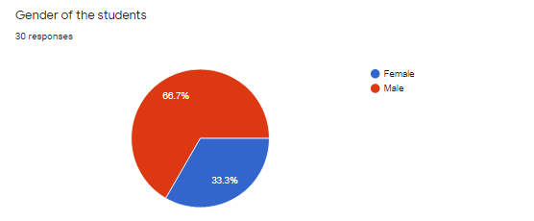
Graph 1
From the above graph it can be seen that most of the students are men with 66.7%, and females are 33.3%
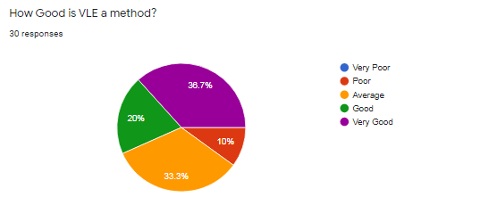
Graph 2
As per the above chart most of the students have stated that VLE is a good method; however, a few them have also denied.
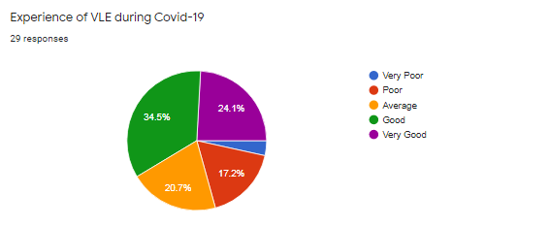
Graph 3
According to the above chart, it can be observed that the experience in VLE is very good in students’ perspective
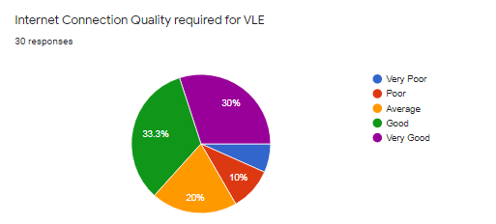
Graph 4
In the above chart, most of the students have mentioned that high quality internet connection is required to run VLE.
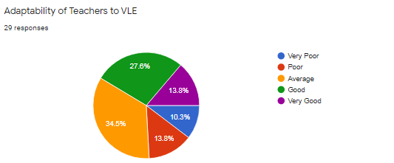
Graph 5
As per the above chart, students think that the adaptability of teachers to VLE is average.
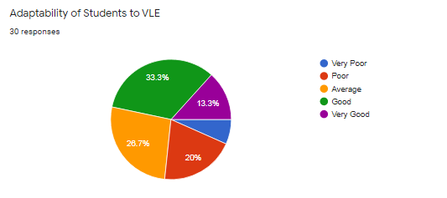
Graph 6
According to the above chart, students are much efficient in adapting VLEs.
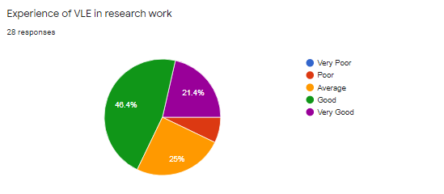
Graph 7
Almost every student stated that their experience is significantly good in research work.
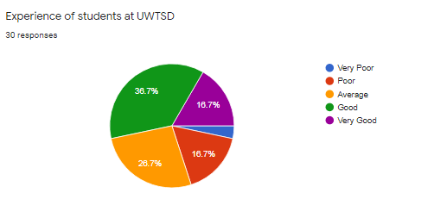
Graph 8
As per the above chart, most of the students in UWTSD have good overall experience.
Secondary data
The impact of VLE on student learning
It has been found that the impact of VLE on student learning is significant. Students can learn in a better way through VLE as compared to the traditional learning format. However, it has been found that many of the students have stated that they are not comfortable with the format of VLE, especially teachers; even they feel it less accessible for them (Jani et al., 2018). This problem is associated with the students because of their unfamiliarity with the technology. On the other hand, for some of the students, internet connection is the primary matter. This is the common aspect which has been found that quality internet connection is required to run VLE. People who live in a rural area, they cannot get better connectivity of the internet which is significantly essential for using VLE (Primo, Ulbricht and Fadel, 2017). Therefore, in this case, they feel it complicated and inaccessible in learning. Moreover, it disrupts the learning of students. However, due to the pandemic and lockdown situation, students cannot physically attend class in their schools and universities. Therefore, VLE is the only way of active learning and increase engagement with others.

Discussion
From the above survey results and graphs, it can be seen that most of the respondents are male. It has been found the majority of respondents, which is 36.7% have mentioned that VLE method is significantly useful for them. However, 33.3% of students also think that VLE is an average method for them. Therefore, as the majority says it is an excellent method. Therefore, VLE can be considered a suitable method for students of UWTSD. Moreover, from the above analysis, it has been found that the experience of VLE during Covid-19 is significantly useful for students. 34.5% of the students have mentioned that the experience is excellent. However, 17.2% of the students have stated that the experience is poor for them. It is because they might be unfamiliar with the VLEs systems. Therefore, it can be stated that the overall experience of VLE during Covid-19 for students is excellent.
It has also been found that 33.3% of the students stated that strong internet connection is essentially required for using VLE. However, 10% and 20% of the total students think that without a strong internet connection, they can access VLEs. Furthermore, it has been found that the adaptability of teachers to VLE is not that much high those students think. 34.5% of the students said that it is an average adaptability of teachers to VLE. However, the adaptability of students to VLE is significantly good as compared to the teachers. Therefore, there is no issue regarding the adaptability of VLE. Students are delighted with the use of VLE. Most of the students, like almost 60%, believe that VLE is very useful in saving time. It is because they do not need to go anywhere and attend online classes within the proper time. Moreover, they can find their study materials efficiently, which saves time for students. 46.4% of the students have mentioned that their experience in researching with the help of VLE is significantly better. However, some people do not experience better regarding their research work with the help of VLE. Therefore, from the final question, it has been found that the overall experience of students in UWTSD is significantly better. However, some people do not have a better experience with VLE
Recommendations
From the above discussion, teachers should be more familiar with the VLE processes, so that they can enhance their teaching practice, which will enhance the learning of students. Moreover, universities and schools should invest in their IT infrastructure to enhance their VLE and e-learning systems. Moreover, students should also get training which will enhance their adaptability of VLE and learn in a better way.

7.0 Conclusion
The research study has been successful in highlighting the impact of VLEs on student learning experience at UWTSD. As a conclusion, it can be said that the impact of VLEs is significantly excellent on student learning. Through the survey, it has been found the positive outcome from students of UWTSD. Moreover, it has been found that in the Covid-19 situation, VLE is the only way where students can continue their learning without facing any hurdle. Not only in this pandemic situation but also through VLEs, students can be flexible with their learning style because they can access them whenever they need.

Reference list
Blin, F. and Munro, M., 2008. Why hasn’t technology disrupted academics’ teaching practices? Understanding resistance to change through the lens of activity theory. Computers & education, 50(2), pp.475-490.
Chua, C. and Montalbo, J., 2014. Assessing students’ satisfaction on the use of virtual learning environment (VLE): An input to a campus-wide e-learning design and implementation. In Information and Knowledge Management (Vol. 3, No. 4, pp. 108-116).
Hettiarachchi, S. and Wickramasinghe, S., 2016, July. Impact of virtual learning for improving quality of learning in higher education. In 2 nd International Conference on Education and Distance Learning–1 st July.
Jani, J., Muszali, R., Nathan, S. and Abdullah, M.S., 2018. Blended learning approach using frog vle platform towards students’ achievement in teaching games for understanding. Journal of Fundamental and Applied Sciences, 10(5S), pp.1130-1141.
Lyndon, S. and Hale, B., 2014. Evaluation of how the blended use of a virtual learning environment (VLE) can impact on learning and teaching in a specific module. Enhancing learning in the Social Sciences, 6(1), pp.56-65.
Primo, L., Ulbricht, V. and Fadel, L.M., 2017, April. Accessibility in the virtual learning environment moodle identification of problems’ class. In World Conference on Information Systems and Technologies (pp. 571-580). Springer, Cham.
Tsay, C.H.H., Kofinas, A.K., Trivedi, S.K. and Yang, Y., 2020. Overcoming the novelty effect in online gamified learning systems: An empirical evaluation of student engagement and performance. Journal of Computer Assisted Learning, 36(2), pp.128-146.
Veasuvalingam, B. and Goodson, M.L., 2020. Falling back on technology mindfully during COVID-19 pandemic: NUMed campus experience. MedEdPublish, 9. pp.25-36.

Appendix

Questionnaire

