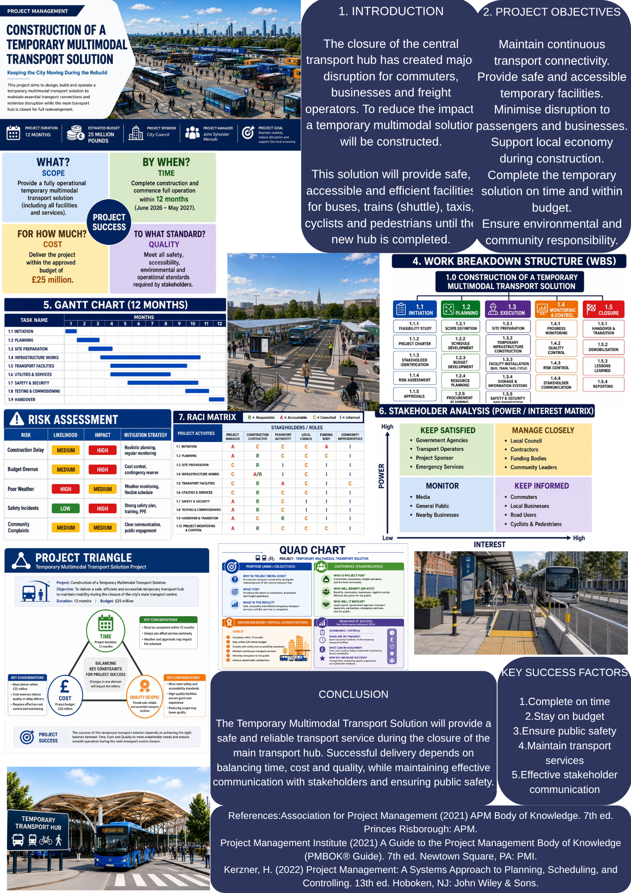
Critical Reflection on Tutor and Peer Feedback
After presenting my project poster, I reflected critically on the feedback received from my tutor and peers. Overall, the feedback showed that the project was relevant, well structured and supported by appropriate project management tools. At the same time, it identified several areas that need further development in the final project management plan.
One key strength was the clear selection and justification of the project. The temporary multimodal transport solution directly responds to the closure of the central transport hub and aims to maintain transport connectivity during the redevelopment period. My tutor considered the project aim and objectives clear and realistic. Peers also recognised that the poster explained the benefits for commuters, local businesses, freight operators and the wider community. This confirmed that the project addresses an important operational and social problem.
Another strength was the use of project management techniques. The poster included a Work Breakdown Structure, Gantt Chart, Quad Chart, stakeholder power and interest matrix, RACI matrix, risk assessment and project triangle. The feedback suggested that these tools gave the project a logical structure and demonstrated an understanding of planning, scheduling, responsibility allocation and stakeholder engagement. The twelve-month timescale and £25 million budget also made the proposal more specific and measurable.
However, the feedback also identified areas for improvement. The main issue was that some sections contained too much information and used small text. The RACI matrix, risk assessment and project triangle were particularly difficult to read. Some peers also felt that the introduction and objectives could be more concise. I agree with this feedback because a poster should communicate key information quickly and clearly. In the final project management plan, I will use clear headings, shorter paragraphs and larger tables. Each project management tool will be presented separately and supported by explanation.
The tutor feedback also indicated that some tools required more detail. For example, the Gantt Chart presented the main activities but did not clearly show dependencies, milestones or the critical path. The risk assessment included likelihood, impact and mitigation measures, but it did not identify risk owners, contingency actions or review dates. In response, the final plan will include a more detailed schedule, key milestones and links between dependent tasks. The risk register will include risk scores, responsible owners, preventive actions, contingency measures and
Critical Reflection on Tutor and Peer Feedback
After presenting my project poster, I reflected critically on the feedback received from my tutor and peers. Overall, the feedback showed that the project was relevant, well structured and supported by appropriate project management tools. At the same time, it identified several areas that need further development in the final project management plan.
One key strength was the clear selection and justification of the project. The temporary multimodal transport solution directly responds to the closure of the central transport hub and aims to maintain transport connectivity during the redevelopment period. My tutor considered the project aim and objectives clear and realistic. Peers also recognised that the poster explained the benefits for commuters, local businesses, freight operators and the wider community. This confirmed that the project addresses an important operational and social problem.
Another strength was the use of project management techniques. The poster included a Work Breakdown Structure, Gantt Chart, Quad Chart, stakeholder power and interest matrix, RACI matrix, risk assessment and project triangle. The feedback suggested that these tools gave the project a logical structure and demonstrated an understanding of planning, scheduling, responsibility allocation and stakeholder engagement. The twelve-month timescale and £25 million budget also made the proposal more specific and measurable.
However, the feedback also identified areas for improvement. The main issue was that some sections contained too much information and used small text. The RACI matrix, risk assessment and project triangle were particularly difficult to read. Some peers also felt that the introduction and objectives could be more concise. I agree with this feedback because a poster should communicate key information quickly and clearly. In the final project management plan, I will use clear headings, shorter paragraphs and larger tables. Each project management tool will be presented separately and supported by explanation.
The tutor feedback also indicated that some tools required more detail. For example, the Gantt Chart presented the main activities but did not clearly show dependencies, milestones or the critical path. The risk assessment included likelihood, impact and mitigation measures, but it did not identify risk owners, contingency actions or review dates. In response, the final plan will include a more detailed schedule, key milestones and links between dependent tasks. The risk register will include risk scores, responsible owners, preventive actions, contingency measures and monitoring arrangements.
Another improvement concerns academic support and justification. Because of limited space, the poster included only a small number of references and did not fully explain why particular methods were selected. In the final project plan, I will use at least twelve scholarly and professional sources in Harvard style. These sources will support decisions relating to scope, scheduling, resources, risk, stakeholder management and project governance.
Overall, the feedback confirmed that the poster provided a strong visual summary, but the final plan must be more detailed, analytical and evidence based. The changes identified through tutor feedback, peer comments and personal reflection will improve the clarity, practicality and academic quality of the final project management plan.
1. Introduction
In November 2025, a major metropolitan city in the United Kingdom announced an urgent regeneration programme after the closure of its central transport hub. The facility, which had been in operation for more than 40 years, no longer met modern safety, accessibility, and operational standards. As a result, the closure caused significant disruption to public transport services, freight logistics, local businesses, and daily commuters. The situation created economic losses and reduced public confidence in the city’s transport infrastructure.
Local authorities therefore required an immediate solution that would maintain transport services while the permanent redevelopment of the hub was carried out (Association for Project Management (APM), 2021).
This Project Management Plan focuses on the Construction of a Temporary Multimodal Transport Solution, which was selected as the preferred project option from the regeneration programme. The project aims to provide temporary transport facilities for buses, shuttle rail services, taxis, cyclists, and pedestrians, ensuring that transport operations continue safely and efficiently throughout the redevelopment period. The temporary solution will minimise disruption, maintain accessibility, support local businesses, and contribute to the city’s wider environmental and sustainability objectives.
Successful delivery of this project requires the application of recognised project management approaches and techniques. According to the Project Management Institute (PMI, 2021), effective planning, stakeholder engagement, resource management, scheduling, and risk control are essential for delivering complex infrastructure projects within agreed time, cost, and quality constraints. Similarly, the Association for Project Management (APM, 2021) highlights the importance of governance, communication, and continuous monitoring to achieve successful project outcomes.
This report presents a comprehensive Project Management Plan for the proposed temporary transport solution. It applies key project management tools, including the Work Breakdown Structure (WBS), Quad Chart, Gantt Chart, Stakeholder Analysis, Resource Allocation, and Risk Analysis, to demonstrate how the project will be planned, managed, monitored, and successfully delivered. The report also explains how these techniques support informed decision-making and help achieve the project’s strategic objectives while meeting stakeholder expectations.

2. Project Description
The proposed project involves the construction of a Temporary Multimodal Transport Solution to maintain transport services while the existing central transport hub is redeveloped. Following the closure of the transport hub due to structural safety concerns, an immediate solution is required to reduce disruption to passengers, freight operators, and local businesses. The temporary facility will provide safe, reliable, and accessible transport services until the permanent transport hub is completed (PMI, 2021).
The project has been selected because it offers the fastest and most practical response to the current transport crisis. Unlike constructing a new permanent transport hub, which would require several years to complete, a temporary multimodal solution can be delivered within twelve months. This approach ensures that public transport services continue to operate while long-term redevelopment activities are undertaken. As a result, economic disruption is reduced, supply chains remain operational, and public confidence in the city’s transport network is maintained (APM, 2021).
The project will include the construction of temporary bus terminals, shuttle rail facilities, taxi ranks, pedestrian walkways, cycle lanes, traffic management systems, temporary passenger waiting areas, and clear directional signage. In addition, the project will provide accessible routes for people with disabilities and install appropriate health and safety measures to comply with current UK regulations. These facilities will allow passengers to transfer efficiently between different modes of transport while maintaining high standards of safety and service quality.
The primary aim of the project is to maintain transport connectivity throughout the redevelopment period. To achieve this aim, the project has several objectives: to minimise disruption to commuters and businesses, complete construction within the approved budget of £25 million, deliver all project activities within 12 months, improve passenger safety and accessibility, and support the city’s environmental sustainability goals through efficient transport planning.
The successful delivery of this project depends on effective planning, stakeholder engagement, resource management, and continuous monitoring throughout the project lifecycle. Therefore, recognised project management tools, including the Work Breakdown Structure (WBS), Quad Chart, Gantt Chart, Stakeholder Analysis, Resource Allocation Plan, and Risk Analysis, will be applied to ensure the project is delivered on time, within budget, and to the required quality standards. These techniques provide a structured framework for controlling project performance and achieving the expected outcomes (Kerzner, 2022).

3. Project Scope
The project scope defines the work that will be completed to deliver the Temporary Multimodal Transport Solution successfully. A clearly defined scope helps control project activities, manage stakeholder expectations, and reduce the risk of scope creep, which may lead to delays, increased costs, and reduced project performance (PMI, 2021).
The project focuses on providing a temporary transport solution that allows public transport and freight services to continue operating while the permanent transport hub is redeveloped. All project activities are planned to be completed within 12 months, with an approved budget of £25 million. The project will be delivered in accordance with UK safety regulations, accessibility standards, and environmental requirements.
In Scope
The project includes the following activities:
Construction of temporary bus terminals.
Installation of temporary shuttle rail facilities.
Development of taxi ranks and passenger drop-off areas.
Construction of safe pedestrian walkways and cycle lanes.
Installation of temporary passenger waiting areas and shelters.
Traffic management systems and temporary road signage.
Health and safety measures, including emergency access routes.
Accessible facilities for people with disabilities.
Utility connections, lighting, and security systems.
Testing, commissioning, and operational handover of the temporary transport facilities.
These activities ensure that transport services continue safely and efficiently throughout the redevelopment of the existing transport hub.
Out of Scope
The following activities are excluded from this project:
Construction of the permanent transport hub.
Redevelopment of surrounding commercial or residential buildings.
Expansion of the existing railway network.
Long-term urban regeneration programmes.
Permanent digital transport infrastructure beyond the temporary facility.
Future maintenance after the temporary transport solution has been handed over to the operating authority.
Excluding these activities allows the project team to remain focused on delivering the temporary transport solution within the agreed schedule, budget, and quality requirements.
The project scope will be monitored throughout the project lifecycle using formal change control procedures. Any requested changes to the scope will be reviewed by the Project Manager and key stakeholders before approval. This process helps ensure that additional work does not negatively affect project cost, schedule, quality, or project objectives (APM, 2021).
Overall, the defined project scope establishes clear project boundaries and provides a strong foundation for planning, resource allocation, risk management, and project control. It also ensures that all stakeholders have a shared understanding of what the project will deliver and what is outside its responsibility.

4. Work Breakdown Structure (WBS)
A Work Breakdown Structure (WBS) is a project management tool used to divide a project into smaller, manageable work packages. It helps the project team organise activities, allocate responsibilities, estimate resources, and monitor project progress more effectively. According to the Project Management Institute (PMI, 2021), a well-developed WBS improves project planning by providing a clear structure for delivering project objectives.
Figure 1 presents the Work Breakdown Structure developed for the Temporary Multimodal Transport Solution project.
The WBS divides the project into five main phases: Project Initiation, Project Planning, Project Execution, Project Monitoring and Control, and Project Closure. Each phase is further divided into specific tasks, ensuring that all project activities are clearly identified and managed throughout the project lifecycle.
Figure 1. Work Breakdown Structure for the Temporary Multimodal Transport Solution.
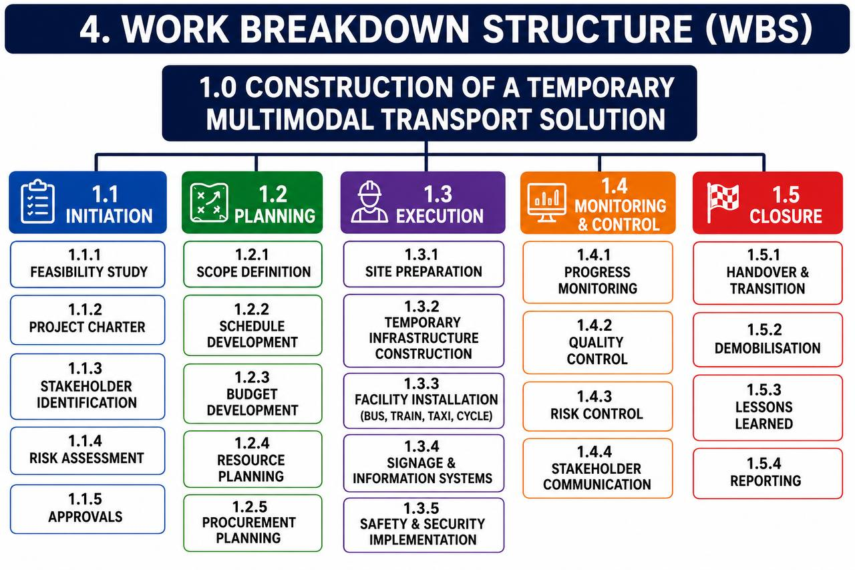

The Project Initiation phase includes the feasibility study, project charter, stakeholder identification, and initial risk assessment. These activities establish the project’s objectives, identify key stakeholders, and confirm that the project is both technically and financially feasible.
The Project Planning phase focuses on defining the project scope, preparing the project schedule, estimating costs, allocating resources, and developing procurement and communication plans. Careful planning reduces uncertainty and provides a clear roadmap for project delivery (Kerzner, 2022).
The Project Execution phase represents the largest part of the project and includes site preparation, construction of temporary transport facilities, installation of traffic management systems, pedestrian walkways, cycle lanes, signage, lighting, and safety infrastructure. During this phase, project resources are coordinated to ensure that construction activities are completed according to the approved schedule and quality standards.
The Project Monitoring and Control phase runs throughout the project lifecycle. Progress is monitored against the project schedule and budget while quality inspections, risk monitoring, stakeholder communication, and performance reporting ensure that project objectives continue to be achieved. Any deviations are addressed through appropriate corrective actions to minimise delays and cost overruns (APM, 2021).
The final phase, Project Closure, includes final inspections, commissioning, handover of the temporary transport facilities, project documentation, financial closure, and lessons learned. These activities confirm that the project has met its objectives and provide valuable knowledge for future infrastructure projects.
The WBS provides a structured framework that improves planning, communication, and project control. By breaking the project into manageable components, the project team can monitor progress more effectively, allocate resources efficiently, and reduce the likelihood of delays or scope changes. As a result, the WBS plays a critical role in supporting the successful delivery of the Temporary Multimodal Transport Solution.

5. Quad Chart
A Quad Chart is a project management tool that provides a concise overview of the project’s purpose, stakeholders, expected outcomes, and success measures. It enables stakeholders to understand the project’s priorities quickly and supports effective decision-making throughout the project lifecycle (Association for Project Management (APM), 2021).
Figure 2 presents the Quad Chart developed for the Temporary Multimodal Transport Solution project. It summarises the project’s strategic objectives and expected outcomes.
Figure 2. Quad Chart for the Temporary Multimodal Transport Solution
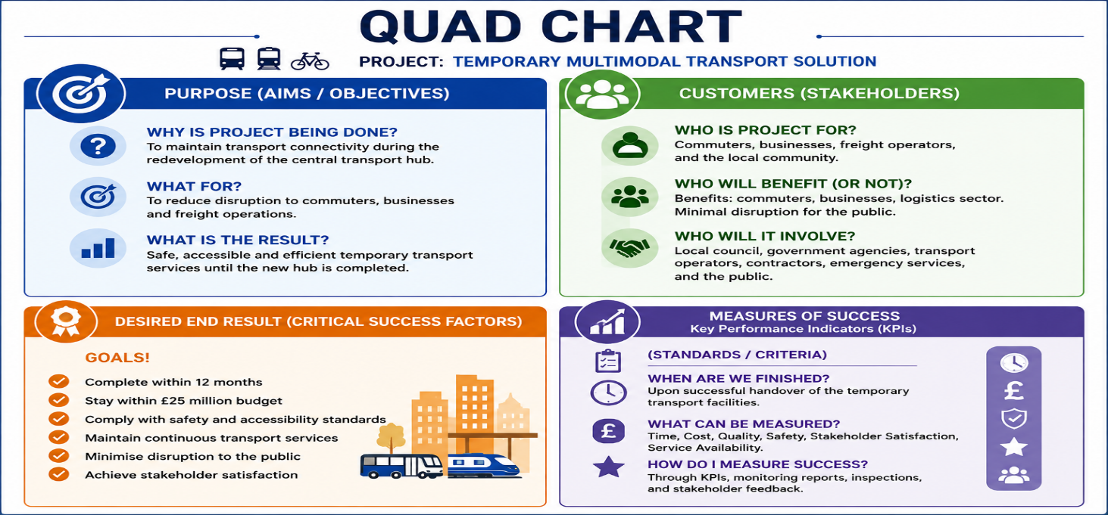
The Purpose section explains why the project is required. The temporary transport solution will maintain transport connectivity while the permanent transport hub is redeveloped. It aims to minimise disruption to commuters, businesses, and freight operators by providing safe and accessible transport facilities.
The Customers (Stakeholders) section identifies the groups involved in the project, including the Local Council, government agencies, transport operators, contractors, commuters, local businesses, emergency services, cyclists, and pedestrians. Effective stakeholder engagement is essential to ensure successful project delivery (PMI, 2021).
The Desired End Results define the project’s critical success factors.
The project should be completed within 12 months, remain within the approved £25 million budget, meet safety and accessibility standards, maintain transport services, and achieve stakeholder satisfaction.
The Measures of Success establish the Key Performance Indicators (KPIs) used to monitor project performance. These include schedule completion, budget control, compliance with health and safety regulations, service availability, quality standards, and stakeholder satisfaction. Regular monitoring of these indicators enables the Project Manager to identify issues early and take corrective action where necessary (Kerzner, 2022).
Overall, the Quad Chart provides a simple but effective summary of the project’s objectives, stakeholders, critical success factors, and performance measures. It supports communication, improves project governance, and helps ensure that all stakeholders have a shared understanding of the project’s goals.

6. Gantt Chart
A Gantt Chart is a project scheduling tool used to plan, monitor, and control project activities over time. It provides a visual timeline of project tasks, allowing the Project Manager to monitor progress, identify dependencies, allocate resources, and ensure that project milestones are achieved within the agreed schedule (Project Management Institute (PMI), 2021).
Figure 3 presents the Gantt Chart for the Temporary Multimodal Transport Solution project. The schedule covers a 12-month period and illustrates the sequence and duration of the main project activities.
Figure 3. Gantt Chart for the Temporary Multimodal Transport Solution
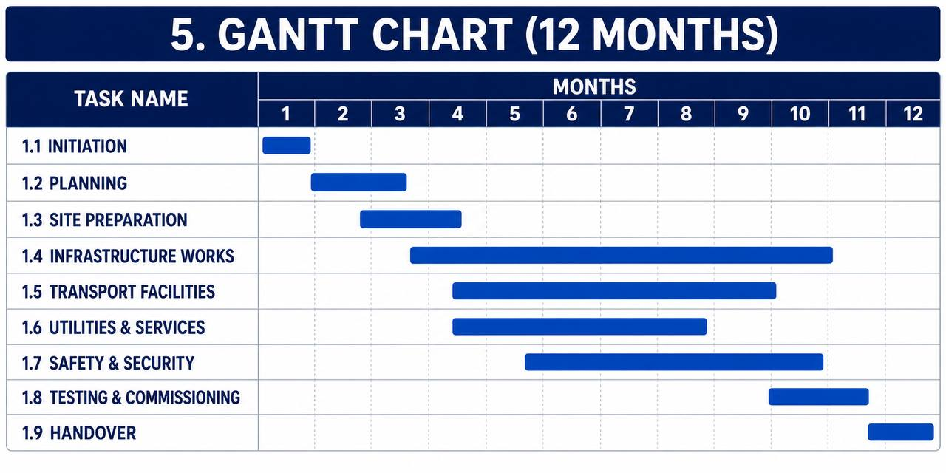
The project begins with the Initiation phase, which includes the feasibility study, project approval, and stakeholder identification. This is followed by the Planning phase, where the project scope, schedule, budget, procurement strategy, and resource plan are developed.
The Execution phase includes site preparation, construction of temporary transport facilities, installation of utilities, traffic management systems, passenger facilities, and safety infrastructure. These activities represent the largest part of the project and are carefully scheduled to minimise disruption to transport services.
The final stages include Testing and Commissioning, followed by Project Handover, where the temporary transport facilities are inspected, approved, and transferred to the operating authority.
The Gantt Chart also identifies important project milestones, including project approval, completion of construction, operational testing, and final handover. Monitoring these milestones enables the Project Manager to track progress and take corrective action if delays occur.
Overall, the Gantt Chart provides a clear project schedule and supports effective time management. It improves coordination between project activities, assists with resource planning, and helps ensure that the Temporary Multimodal Transport Solution is completed within the planned 12-month timeframe while meeting the project’s quality and budget objectives (Kerzner, 2022).

7. Stakeholder Involvement
Effective stakeholder involvement is essential for the successful delivery of the Temporary Multimodal Transport Solution. Stakeholders influence project decisions, provide resources, approve key milestones, and are directly affected by project outcomes. Early engagement and regular communication help reduce conflicts, manage expectations, and improve project performance (Project Management Institute (PMI), 2021).
Figure 4 presents the Stakeholder Power/Interest Matrix used for this project. The matrix identifies stakeholders according to their level of influence and interest, allowing the Project Manager to apply appropriate communication and engagement strategies.
Figure 4. Stakeholder Power/Interest Matrix
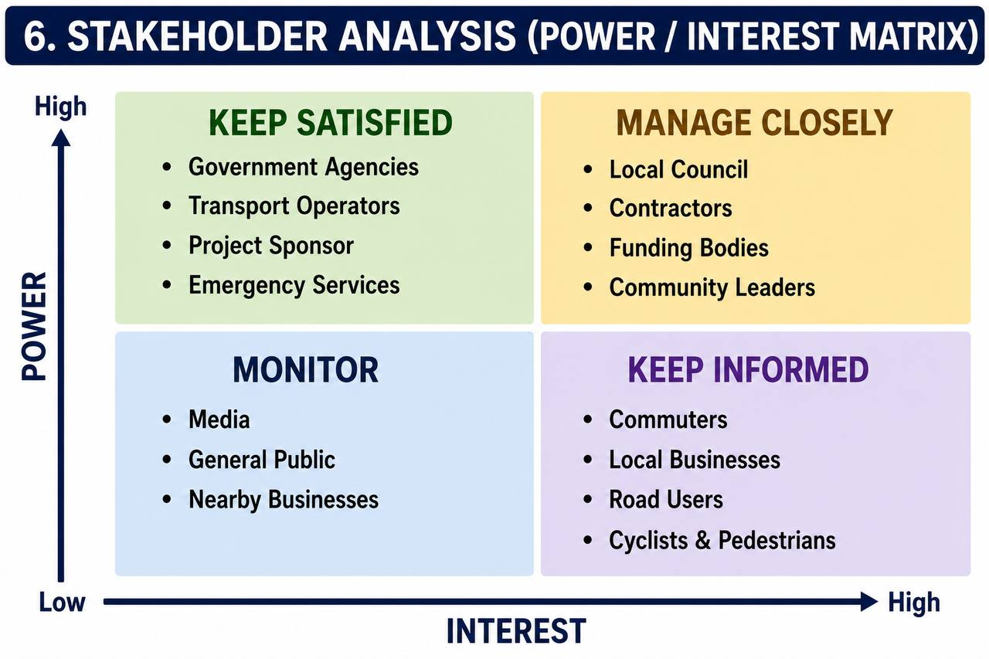

Stakeholders with high power and high interest, such as the Local Council, Project Sponsor, Contractors, and Funding Bodies, are managed closely because they make key decisions, approve budgets, and monitor project progress. Regular meetings, progress reports, and risk reviews ensure that these stakeholders remain fully informed throughout the project.
Stakeholders with high power but lower interest, including Government Agencies, Transport Operators, and Emergency Services, are kept satisfied through regular project updates and compliance reporting. Maintaining their support is essential for regulatory approval and operational continuity.
Stakeholders with high interest but lower power, such as commuters, local businesses, road users, cyclists, and pedestrians, are kept informed through public announcements, consultation meetings, and progress updates. Their feedback helps minimise disruption and improve public satisfaction during construction.
The project also applies a RACI Matrix to define stakeholder responsibilities. The Project Manager is accountable for project delivery, while contractors and engineers are responsible for completing construction activities. Local authorities, transport operators, and emergency services are consulted during planning and implementation, while community representatives and the public are kept informed of project progress.
Clear stakeholder communication improves collaboration, supports timely decision-making, and reduces project risks. By applying both the Stakeholder Power/Interest Matrix and the RACI Matrix, the project team can ensure effective governance, maintain stakeholder confidence, and contribute to the successful delivery of the Temporary Multimodal Transport Solution (APM, 2021).

8. Allocation of Resources
Effective resource allocation is essential to ensure that the Temporary Multimodal Transport Solution is delivered within the approved budget, schedule, and quality standards. Resources must be planned and monitored throughout the project lifecycle to avoid delays, cost overruns, and operational disruptions (Project Management Institute (PMI), 2021).
The project requires a combination of human, financial, physical, and technical resources. Human resources include the Project Manager, Site Engineers, Construction Workers, Health and Safety Officers, Electricians, Traffic Management Officers, and Administrative Staff. Each team member has clearly defined responsibilities to ensure efficient coordination and effective project delivery.
Financial resources are managed through the approved project budget of £25 million. The budget covers construction costs, temporary transport facilities, labour, equipment, materials, utilities, safety systems, and contingency funding for unforeseen risks. Regular financial monitoring and cost control procedures help ensure that project expenditure remains within the approved budget.
Physical resources include construction machinery, cranes, excavators, temporary buildings, safety barriers, lighting systems, traffic signs, passenger shelters, and utility installations. These resources are scheduled according to the project programme to maximise efficiency and minimise idle time.
The project also requires technical resources such as project management software, scheduling tools, communication systems, and digital reporting platforms. These technologies support project planning, resource tracking, document management, and communication between stakeholders.
Resource allocation will be reviewed regularly throughout the project lifecycle to ensure that sufficient personnel, equipment, and funding are available for each phase of the project. Effective resource management improves productivity, supports timely decision-making, and contributes to the successful completion of the Temporary Multimodal Transport Solution within the planned 12-month schedule and required quality standards (Kerzner, 2022).

9. Risk Analysis
Risk management is an essential part of project management because it helps identify potential threats, reduce uncertainty, and improve the likelihood of successful project delivery. For the Temporary Multimodal Transport Solution, effective risk management ensures that the project is completed within the approved 12-month schedule, £25 million budget, and required quality standards (Project Management Institute (PMI), 2021).
Table 1 presents the main project risks identified during the planning stage. Each risk has been assessed according to its likelihood, impact, and appropriate mitigation measures.
Table 1. Project Risk Assessment
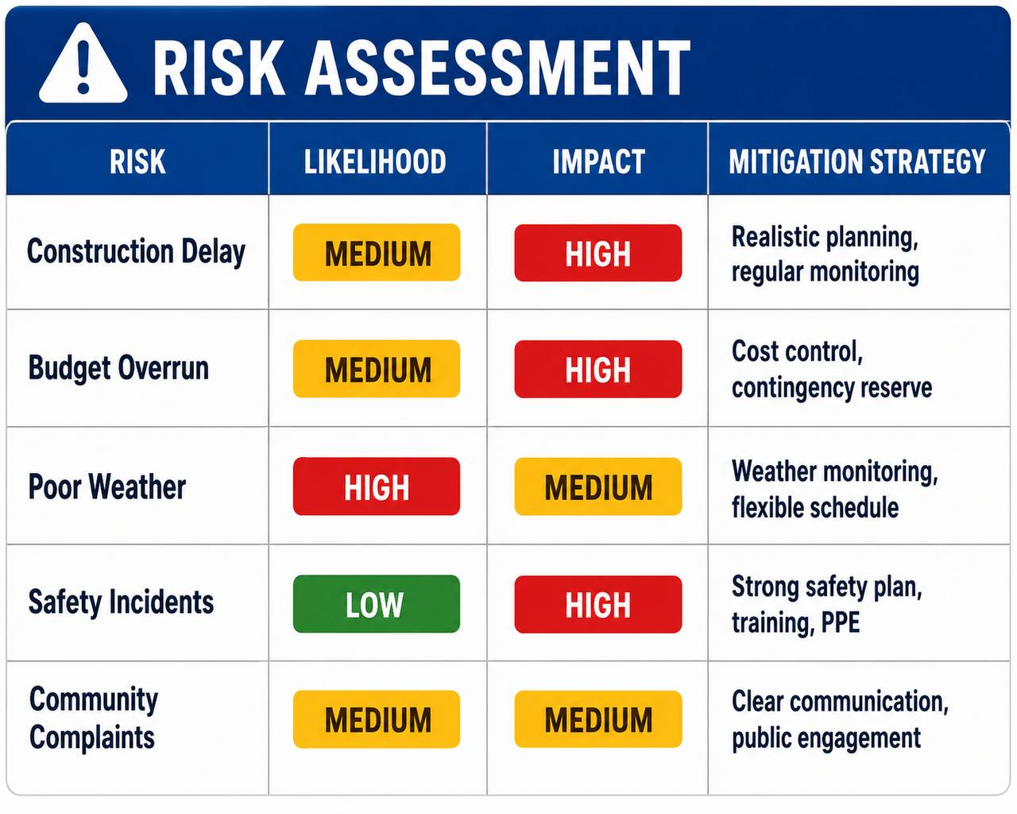
The most significant risks include construction delays, budget overruns, health and safety incidents, adverse weather conditions, and stakeholder opposition. Construction delays may occur because of unexpected site conditions or supply chain disruptions. These risks will be reduced through detailed planning, regular progress reviews, and close coordination with contractors.
Budget overruns represent another important risk. Financial performance will be monitored throughout the project using regular cost reviews and contingency funding. Any significant variance from the approved budget will be investigated immediately to minimise financial impact.
Health and safety remain a priority throughout the project. All construction activities will comply with UK health and safety regulations. Regular site inspections, staff training, and the use of appropriate personal protective equipment (PPE) will reduce the likelihood of accidents.
Stakeholder communication also plays an important role in risk management. Regular meetings, progress reports, and public updates will help address concerns early and maintain stakeholder confidence. Continuous monitoring and periodic risk reviews will ensure that new risks are identified and managed throughout the project lifecycle (Association for Project Management (APM), 2021).
Overall, effective risk management supports informed decision-making, improves project control, and increases the likelihood of delivering the Temporary Multimodal Transport Solution safely, on time, within budget, and to the required quality standards.

Action | Responsible Person | Timeframe | Resources Required | Expected Outcome
Conduct feasibility study and approve project | Project Manager & Local Council | Month 1 | Project team, feasibility report | Project approved
Develop project plan and secure resources | Project Manager | Month 1–2 | Budget, planning software, project team | Complete project planning
Procure contractors and materials | Procurement Manager | Month 2 | Suppliers, contracts, procurement budget | Resources available
Prepare construction site | Site Manager | Month 3 | Construction workers, machinery | Site ready for construction
Construct temporary transport facilities | Contractors | Month 4–8 | Labour, equipment, materials | Temporary facilities completed
Install utilities, signage and safety systems | Engineers & Contractors | Month 7–9 | Electrical systems, signage, safety equipment | Operational infrastructure installed
Test transport facilities and safety systems | Quality Manager | Month 10–11 | Inspection team, testing equipment | Facilities meet quality standards
Final inspection and project handover | Project Manager & Local Council | Month 12 | Project documentation, inspection reports | Temporary transport solution operational

10. Conclusion
This Project Management Plan has presented a structured approach for delivering the Temporary Multimodal Transport Solution in response to the closure of the city’s central transport hub. The project aims to maintain safe, reliable, and accessible transport services while the permanent redevelopment is carried out.
The report has demonstrated the application of key project management tools, including the Work Breakdown Structure (WBS), Quad Chart, Gantt Chart, Stakeholder Analysis, Resource Allocation, and Risk Analysis.
These tools provide a clear framework for planning, organising, monitoring, and controlling project activities throughout the project lifecycle.
Effective stakeholder engagement, efficient resource management, and continuous risk monitoring are essential to achieving the project’s objectives within the approved 12-month schedule and £25 million budget. Regular communication and performance monitoring will help ensure that project risks are managed effectively and that stakeholder expectations are met.
Overall, the proposed project provides a practical and sustainable solution to minimise transport disruption during the regeneration programme. By applying recognised project management principles and techniques, the Temporary Multimodal Transport Solution can be delivered successfully, supporting transport continuity, public safety, and long-term economic stability for the city.

References
Association for Project Management (APM) (2021) APM Body of Knowledge. 7th edn. Buckinghamshire: Association for Project Management.
Burke, R. (2023) Project Management: Planning and Control Techniques. 9th edn. Chichester: John Wiley & Sons.
Heldman, K. (2022) Project Management JumpStart. 5th edn. Indianapolis: Wiley.
International Organization for Standardization (ISO) (2021) ISO 21502:2021 Project, Programme and Portfolio Management – Guidance on Project Management. Geneva: ISO.
Kerzner, H. (2022) Project Management: A Systems Approach to Planning, Scheduling, and Controlling. 13th edn. Hoboken, NJ: John Wiley & Sons.
Lock, D. (2020) Project Management. 11th edn. London: Routledge.
Maylor, H. (2024) Project Management. 6th edn. Harlow: Pearson Education.
Meredith, J.R., Mantel, S.J. and Shafer, S.M. (2022) Project Management: A Managerial Approach. 10th edn. Hoboken, NJ: John Wiley & Sons.
Nicholas, J.M. and Steyn, H. (2020) Project Management for Engineering, Business and Technology. 6th edn. London: Routledge.
Office of Government Commerce (2023) Managing Successful Projects with PRINCE2. 7th edn. Norwich: The Stationery Office.
Project Management Institute (PMI) (2021) A Guide to the Project Management Body of Knowledge (PMBOK® Guide). 7th edn. Newtown Square, PA: Project Management Institute.
Turner, J.R. (2022) Handbook of Project Management. 6th edn. New York: McGraw-Hill Education.
Walker, A. (2023) Project Management in Construction. 8th edn. Oxford: Wiley-Blackwell.
Winch, G.M. (2020) Managing Construction Projects. 3rd edn. Chichester: John Wiley & Sons.
Young, T.L. (2022) Successful Project Management. 7th edn. London: Kogan Page.

